Additional file 3. Questionnaires and scales

System Usability Scale (SUS) (Brooke, 1986)

This scale is used to evaluate the usability and acceptability of a technology or application.
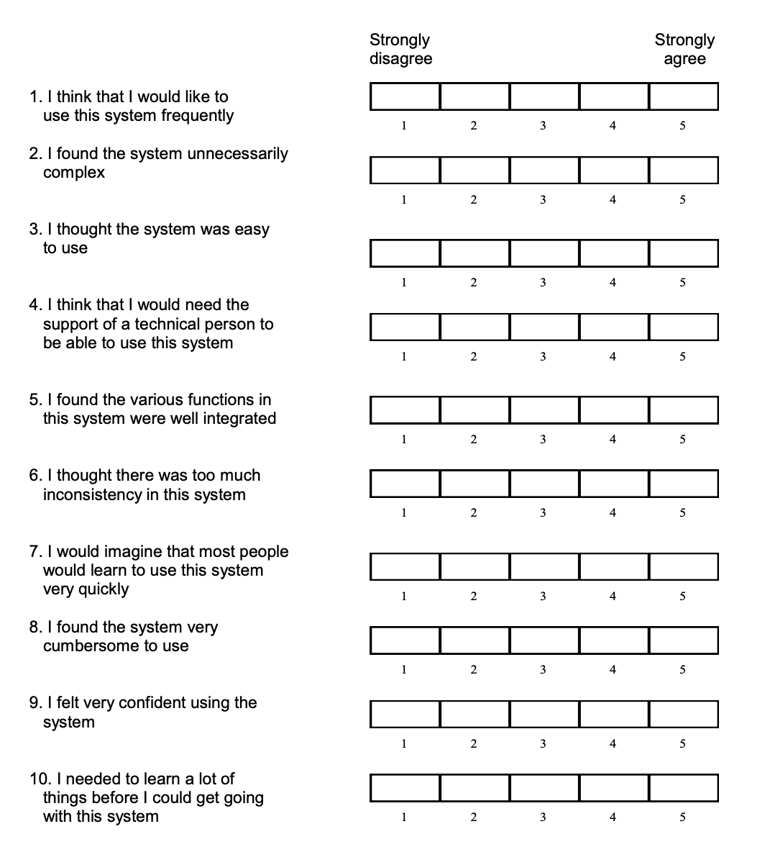

Visual analogic scale (VAS) – Pain and anxiety (Castarlenas et al., 2017)

The visual analog scale (VAS) is a self-evaluation scale that allows the patient to evaluate his or her feelings by means of a cursor.
This visual scale makes it possible to evaluate different criteria with the same tool. Thus, the use of this scale can be used to evaluate both the anxiety and the pain of the patient. To do this, the patient is asked about his current state.

Example of a VAS for pain:

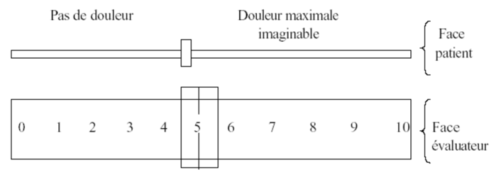

Physiological measurements – Oximeter

Medical device for measuring heart and respiratory rates, blood pressure and oxygen in the blood.
Example :
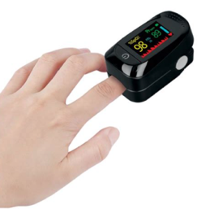

Algoplus scale (Rat et al., 2011)

This hetero-evaluative scale allows, thanks to clinical observation, to evaluate the acute pain of an old person. This scale includes 5 items focusing on the face, complaints, gaze, body and behavior.

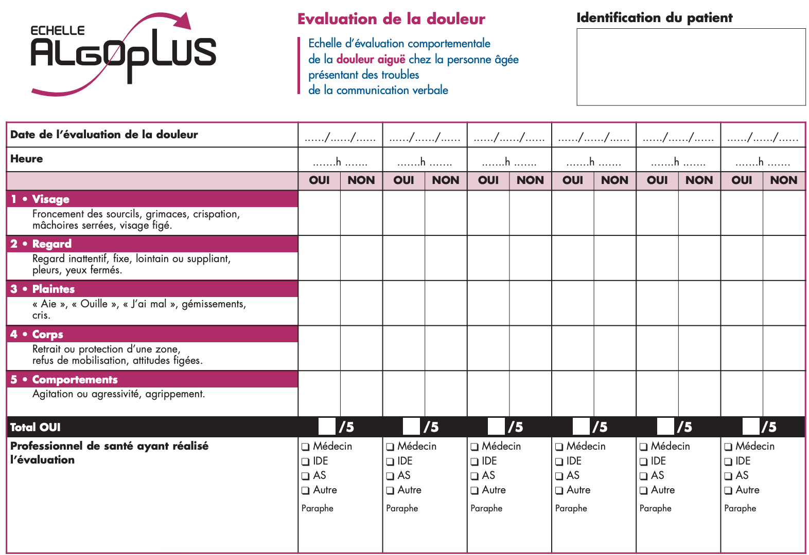

Digital Care Completion Scale
The Associate Investigator will ask the caregiver after the care to complete this scale to assess their experience of care.

Difficulty
Can you indicate the difficulty of the care you have just performed ?

Very Very
easy difficult

Fatigue
Can you indicate your level of fatigue after the care ?
Not at all Very
tired tired

Discomfort
Can you indicate the level of discomfort observed in the patient?
Not at all Very
discomfort comfortable

Anxiety
Can you indicate the level of anxiety observed in the patient?
Not at all Very anxious anxious

Pain
Can you indicate the level of pain observed in the patient?
Not at all Very painful painful

Hospital Anxiety and Depression Scale (HADS)

For this study, we will only use the "anxiety" items of the scale.

D | A |  | D | A
 |  | I feel tense or 'wound up': |  |  | I feel as if I am slowed down:
 | 3 | Most of the time | 3 |  | Nearly all the time
 | 2 | A lot of the time | 2 |  | Very often
 | 1 | From time to time, occasionally | 1 |  | Sometimes
 | 0 | Not at all | 0 |  | Not at all
 |  | I still enjoy the things I used to enjoy: |  |  | I get a sort of frightened feeling like 'butterflies' in the stomach:
0 |  | Definitely as much |  | 0 | Not at all
1 |  | Not quite so much |  | 1 | Occasionally
2 |  | Only a little |  | 2 | Quite Often
3 |  | Hardly at all |  | 3 | Very Often
 |  | I get a sort of frightened feeling as if  something awful is about to happen: |  |  | I have lost interest in my appearance:
 | 3 | Very definitely and quite badly | 3 |  | Definitely
 | 2 | Yes, but not too badly | 2 |  | I don't take as much care as I should
 | 1 | A little, but it doesn't worry me | 1 |  | I may not take quite as much care
 | 0 | Not at all | 0 |  | I take just as much care as ever
 |  | I can laugh and see the funny side of things: |  |  | I feel restless as I have to be on the move:
0 |  | As much as I always could |  | 3 | Very much indeed
1 |  | Not quite so much now |  | 2 | Quite a lot
2 |  | Definitely not so much now |  | 1 | Not very much
3 |  | Not at all |  | 0 | Not at all
 |  | Worrying thoughts go through my mind: |  |  | I look forward with enjoyment to things:
 | 3 | A great deal of the time | 0 |  | As much as I ever did
 | 2 | A lot of the time | 1 |  | Rather less than I used to
 | 1 | From time to time, but not too often | 2 |  | Definitely less than I used to
 | 0 | Only occasionally | 3 |  | Hardly at all
 |  | I feel cheerful: |  |  | I get sudden feelings of panic:
3 |  | Not at all |  | 3 | Very often indeed
2 |  | Not often |  | 2 | Quite often
1 |  | Sometimes |  | 1 | Not very often
0 |  | Most of the time |  | 0 | Not at all
 |  | I can sit at ease and feel relaxed: |  |  | I can enjoy a good book or radio or TV program:
 | 0 | Definitely | 0 |  | Often
 | 1 | Usually, | 1 |  | Sometimes
 | 2 | Not Often | 2 |  | Not often
 | 3 | Not at all | 3 |  | Very seldom

Scoring:
Total score: Depression (D) ___________ Anxiety (A) ______________

0-7 = Normal 8-10 = Borderline abnormal (borderline case) 11-21 = Abnormal (case)

