Supplemental Tables/Figures

STable 1. Comparison between full ABCD sample and subset for study analyses, comparing demographic and socioeconomic characteristics, and baseline pollutant levels.
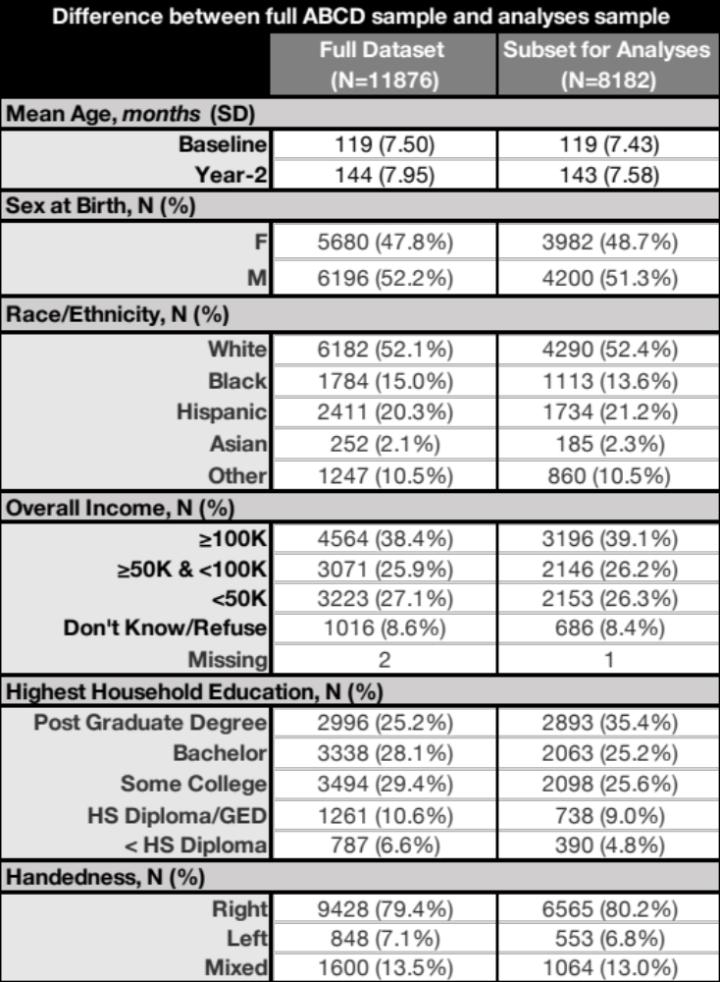

SFigure 1. Correlations between baseline pollutant concentrations.
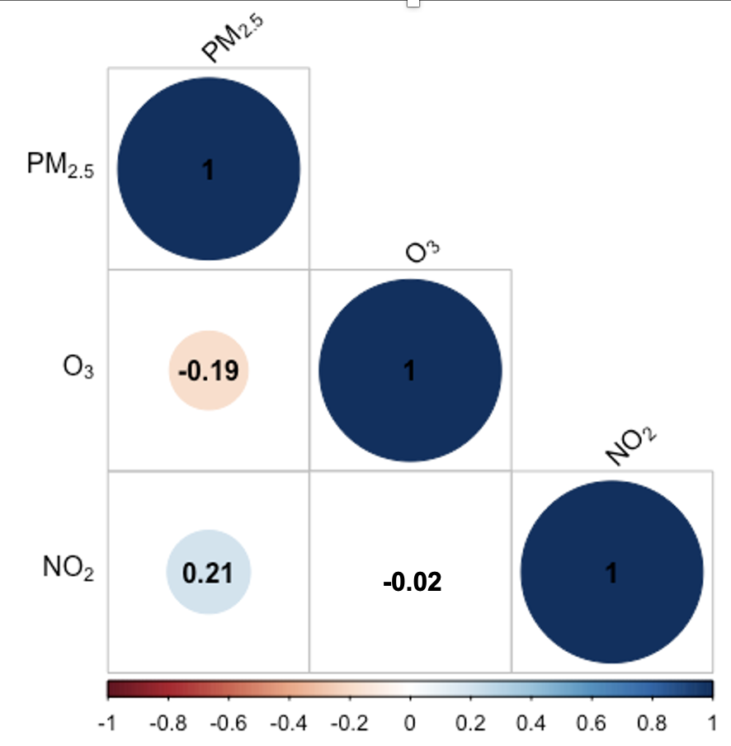

STable2. Associations between age, sex, and age-by-sex, including standardized betas and 95% confidence intervals for RNI and RND in each white matter tract. Significant models (FDR-p < 0.05) are bolded with one asterisk (*).
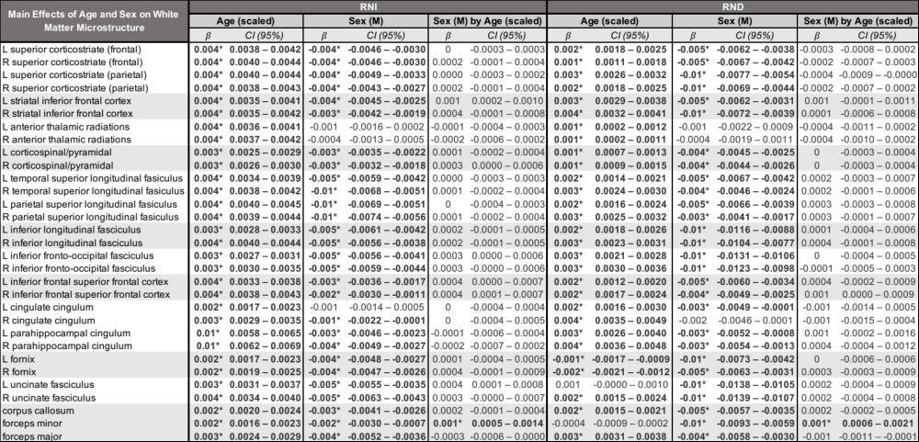

SFIgure 2. Significant (FDR-p < 0.05) effects of age-by-sex interaction on RNI (A) and RND (B) of the forceps minor only after adjusting for all covariates, representing the effect of sex on change of this tract over time. Age is scaled, so that 0 = 9 years.
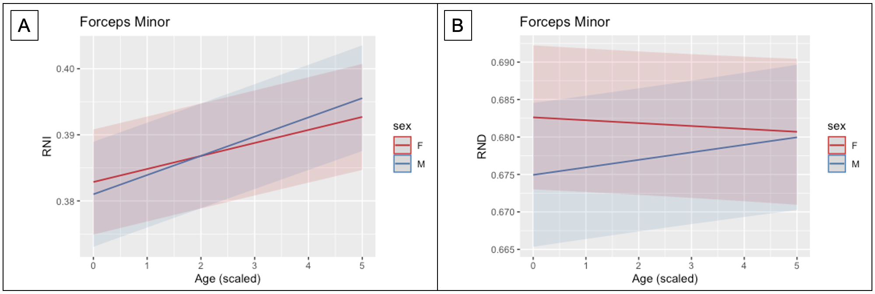

STable 3. Associations between PM2.5 and age-by-PM2.5, including standardized betas and 95% confidence intervals for RNI and RND in each white matter tract. Significant models (FDR-p < 0.05) are bolded with one asterisk (*).
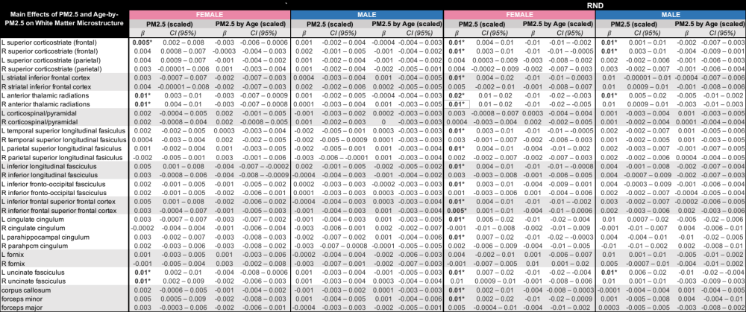

STable 4. Associations between NO2 and age-by-NO2, including standardized betas and 95% confidence intervals for RNI and RND in each white matter tract. Significant models (FDR-p < 0.05) are bolded with one asterisk (*).
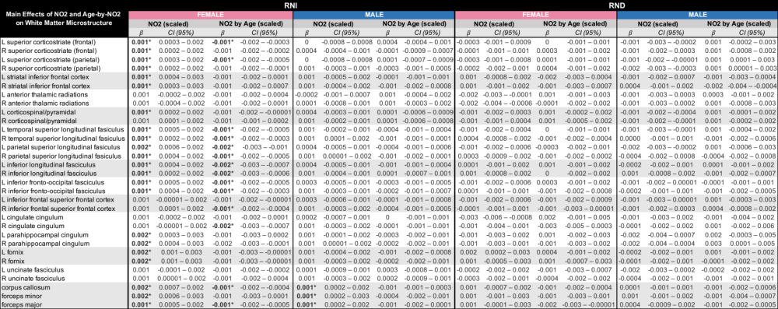

STable 5. Associations between O3 and age-by-O3, including standardized betas and 95% confidence intervals for RNI and RND in each white matter tract. Significant models (FDR-p < 0.05) are bolded with one asterisk (*).
