Supplementary Information for

Nano iron oxide closes the gap between climate regulation and food security trade-offs

Yongjie Yu^{1,2}, Youzhi Feng^{3,4,5}, Yingliang Yu², Lihong Xue², Linzhang Yang², Manuel Delgado-Baquerizo^{6*}, Shiying He^{2,7*}

*Corresponding authors:
hshiying@hotmail.com; m.delgado.baquerizo@csic.es

Figure S1. The CH₄ and N₂O emission rate during the whole rice growth season under different fertilization at the fourth year. Fertilization treatments: No, no fertilization (negative control); Urea, normal fertilization with 240 kg N kg^{–1} urea (positive control); FeONPs, 10 mg kg⁻¹ nanoparticle and urea fertilization.

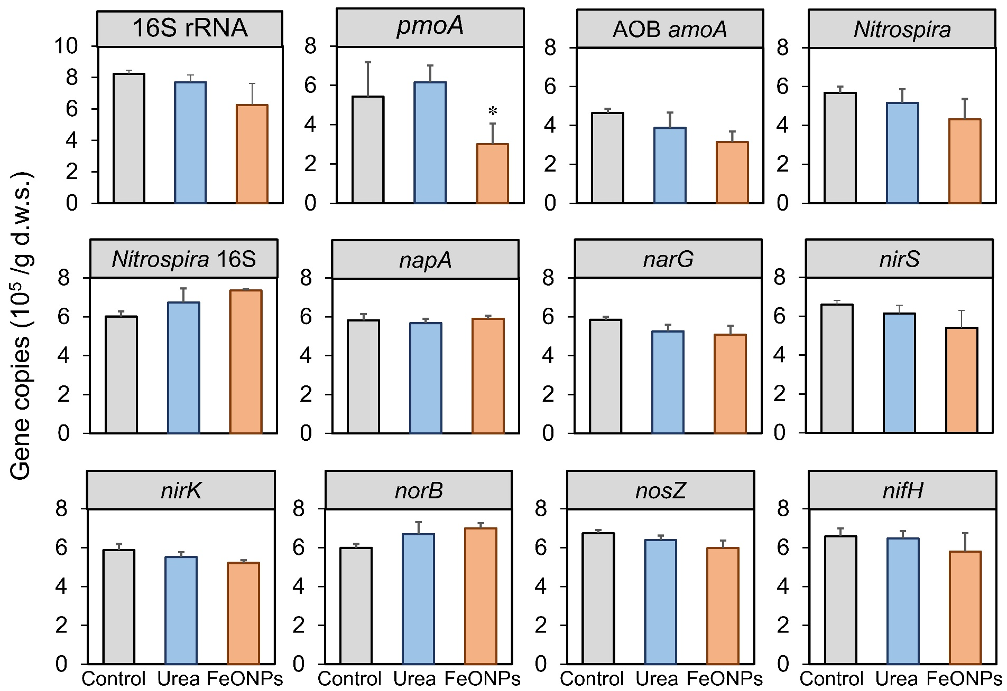
Figure S2. The responses of microbial functional gene abundance to different fertilizations. Values are presented as the mean ± S.D. The asterisk (*) above column means the significant difference at 0.05 level (ANOVA with Turkey’s test).

Figure S3. TEM image of Fe₃O₄ nanoparticles

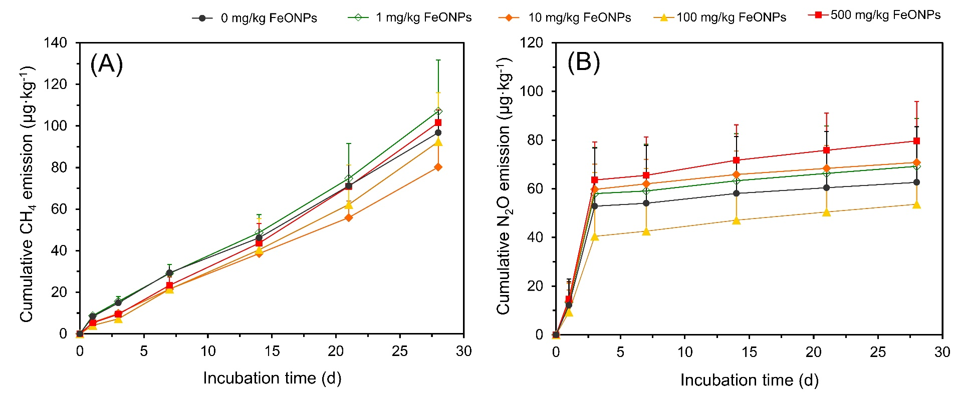
Figure S4. Preliminary microcosm assays to address different concentrations of FeONPs on greenhouse gas emission during 30 days lab incubation. (A), cumulative CH₄ emission; (B), cumulative N₂O emission. The error bars represented standard deviation.

Table S1 The enzymes activities in different soils under different fertilizations
Soil enzyme activities |  | FeONPs | Urea
Hydrolases | β-glucosidase (mg g⁻¹ d⁻¹) | 8.18±0.95 | 10.79±0.22
Hydrolases | acidic phosphatase (mg g⁻¹ d⁻¹) | 3.11±0.13 | 3.88±0.34
Hydrolases | urease (mg g⁻¹ d⁻¹) | 0.99±0.05 | 1.33±0.11
Oxidases | phenol oxidase (mg g⁻¹ d⁻¹) | 0.78±0.09 | 1.07±0.14
Oxidases | catalase (mg g⁻¹ d⁻¹) | 0.19±0.02 | 0.38±0.08

Table S2 The basic soil properties of this test paddy field
Soil properties | Value
pH | 7.10
Soil organic matter | 12.43 g·kg⁻¹
Total N | 1.75 g·kg⁻¹
Total P | 0.71 g·kg⁻¹
Available P | 30.27 mg·kg⁻¹
Available K | 101.8 mg·kg⁻¹

Table S3 Primers used for q-PCR
Genes | Primer (5’-3’) | Thermal protocol | Reference
16S bacterial rRNA gene | 515F: GTG CCA GCM GCC GCG G  907R: CCG TCA ATT CMT TTR AGT TT | 95℃, 30s; 35×(95℃, 20s; 55℃, 30s; 72℃, 30s with plate read); Melt curve 65.0℃ to 95.0℃, increment 0.5℃，5 s plate read | ¹
Methanogenic mrcA gene | MCRf: TAY GAY CAR ATH TGG YT  MCRr: ACR TTC ATN GCR TAR TT | 95℃, 30 s, 40×(95℃, 30s; 57℃, 30s; 72℃, 45s with plate read); Melt curve 65.0℃ to 95.0℃, increment 0.5℃，5 s plate read | ²
Methanotrophic pmoA gene | pmoA-A189: GGN GAC TGG GAC TTC TGG  pmoA-mb661: CCG GMG CAA CGT CYT TAC C | 95℃, 30 s, 40×(95℃, 30s; 55℃, 30s; 72℃, 45s with plate read); Melt curve 65.0℃ to 95.0℃, increment 0.5℃，5 s plate read | ³
Nitrifying amoA gene | amoA-1F: GGG GTT TCT ACT GGT GGT  amoA-2R: CCC CTC KGS AAA GCC TTC TTC | 95℃, 30 s, 40×(95℃, 30s; 55℃, 30s; 72℃, 45s with plate read); Melt curve 65.0℃ to 95.0℃, increment 0.5℃，5 s plate read | ⁴
Nitrospira gene | F1nxrA: CAG ACC GAC GTG TGC GAA AG  R2nxrA: TCC ACA AGG AAC GGA AGG TC | 95℃, 30 s, 40×(95℃, 30s; 55℃, 30s; 72℃, 45s with plate read); Melt curve 65.0℃ to 95.0℃, increment 0.5℃，5 s plate read | ⁵
Nitrospira 16S gene | Nspra675f: GCG GTG AAA TGC GTA GAK ATC G  Nspra746r: TCA GCG TCA GRW AYG TTC CAG AG | 95℃, 30 s, 40×(95℃, 30s; 58℃, 30s; 72℃, 45s with plate read); Melt curve 65.0℃ to 95.0℃, increment 0.5℃，5 s plate read | ⁶
Denitrifying napA gene | napAf1: CTG GAC IAT GGG YTT IAA CCA  napAr1: CCT TCY TTY TCI ACC CAC AT | 95℃, 30 s, 40×(95℃, 30s; 60℃, 30s; 72℃, 45s with plate read); Melt curve 65.0℃ to 95.0℃, increment 0.5℃，5 s plate read | ⁷
Diazotrophic nifH gene | PolFI: TGC GAI CCS AAI GCI GAC TC  AQER: GAC GAT GTA GAT YTC CTG | 95℃, 30 s, 40×(95℃, 30s; 56℃, 30s; 72℃, 45s with plate read); Melt curve 65.0℃ to 95.0℃, increment 0.5℃，5 s plate read | ⁸
Denitrifying narG gene | narG1960f: TAY GTS GGS CAR GAR AA  narG2650r: TTY TCR TAC CAB GTB GC | 95℃, 30 s; 40×(95℃, 15s; 55℃, 15s; 72℃, 20s with plate read); Melt curve 65.0℃ to 95.0℃, increment 0.5℃，5 s plate read | ⁹
Denitrifying nirK gene | nirKF1aCu: ATC ATG GTS CTG CCG CG  nirKR3Cu: GCC TCG ATC AGR TTG TGG TT | 95℃, 30 s; 40×(95℃, 10s; 57℃, 10s; 72℃, 15s with plate read); Melt curve 65.0℃ to 95.0℃, increment 0.5℃，5 s plate read | ¹⁰
Denitrifying nirS gene | nirSCd3aF：AAC GYS AAG GAR ACS GG  nirSR3cd：GAS TTC GGR TGS GTC TTG A | 95°C, 30 s; 40×(95°C, 20s; 57°C, 30s; 72℃, 30s with plate read); Melt curve 65.0℃ to 95.0℃, increment 0.5℃，5 s plate read | ¹¹
Denitrifying norB gene | cnorB_{B}F: AIG TGG TCG AGA AGT GGC TCT A  cnorB_{B}R: TCT GIA CGG TGA AGA TCA CC | 95℃, 30 s; 40×(95℃, 20s; 57℃, 30s; 72℃, 30s with plate read); Melt curve 65.0℃ to 95.0℃, increment 0.5℃，5 s plate read | ¹²
Denitrifying nosZ gene | nosZ2F:CGC RAC GGC AAS AAG GTS MSS GT  nosZ2R:CAK RTG CAK SGC RTG GCA GAA | 95℃, 30 s; 40×(95℃, 10s; 62℃, 30s; 72℃, 45s with plate read); Melt curve 65.0℃ to 95.0℃, increment 0.5℃，5 s plate read | ¹³

SI References
1 Liu, W. et al. Multikingdom interactions govern the microbiome in subterranean cultural heritage sites. Proceedings of the National Academy of Sciences 119, e2121141119, doi:10.1073/pnas.2121141119 (2022).
2 Springer, E., Sachs, M. S., Woese, C. R. & Boone, D. R. Partial Gene Sequences for the A Subunit of Methyl-Coenzyme M Reductase (mcrI) as a Phylogenetic Tool for the Family Methanosarcinaceae. International Journal of Systematic and Evolutionary Microbiology 45, 554-559, doi:https://doi.org/10.1099/00207713-45-3-554 (1995).
3 Lafuente, A. et al. Global drivers of methane oxidation and denitrifying gene distribution in drylands. Global Ecol Biogeogr 28, 1230-1243 (2019).
4 Rotthauwe, J. H., Witzel, K. & Liesack, W. The ammonia monooxygenase structural gene amoA as a functional marker: molecular fine-scale analysis of natural ammonia-oxidizing populations. Appl Environ Microb 63, 4704 - 4712 (1997).
5 Poly, F., Wertz, S., Brothier, E. & Degrange, V. First exploration of Nitrobacter diversity in soils by a PCR cloning-sequencing approach targeting functional gene nxrA. FEMS Microbiology Ecology 63, 132-140, doi:https://doi.org/10.1111/j.1574-6941.2007.00404.x (2008).
6 Graham, D. W. et al. Experimental demonstration of chaotic instability in biological nitrification. The ISME Journal 1, 385-393, doi:10.1038/ismej.2007.45 (2007).
7 Smith, C. J., Nedwell, D. B., Dong, L. F. & Osborn, A. M. Diversity and abundance of nitrate reductase genes (narG and napA), nitrite reductase genes (nirS and nrfA), and their transcripts in estuarine sediments. Appl Environ Microb 73, 3612-3622, doi:Doi 10.1128/Aem.02894-06 (2007).
8 Poly, F., Monrozier, L. J. & Bally, R. Improvement in the RFLP procedure for studying the diversity of nifH genes in communities of nitrogen fixers in soil. Research in Microbiology 152, 95-103, doi:https://doi.org/10.1016/S0923-2508(00)01172-4 (2001).
9 Philippot, L., Piutti, S., Martin-Laurent, F., Hallet, S. & Germon Jean, C. Molecular Analysis of the Nitrate-Reducing Community from Unplanted and Maize-Planted Soils. Appl Environ Microb 68, 6121-6128, doi:10.1128/AEM.68.12.6121-6128.2002 (2002).
10 Henry, S. et al. Disentangling the rhizosphere effect on nitrate reducers and denitrifiers: insight into the role of root exudates. Environ Microbiol 10, 3082-3092, doi:DOI 10.1111/j.1462-2920.2008.01599.x (2008).
11 Throbäck, I. N., Enwall, K., Jarvis, Å. & Hallin, S. Reassessing PCR primers targeting nirS, nirK and nosZ genes for community surveys of denitrifying bacteria with DGGE. FEMS Microbiol Lett 49, 401-417, doi:10.1016/j.femsec.2004.04.011 (2004).
12 Braker, G. & Tiedje James, M. Nitric Oxide Reductase (norB) Genes from Pure Cultures and Environmental Samples. Appl Environ Microb 69, 3476-3483, doi:10.1128/AEM.69.6.3476-3483.2003 (2003).
13 Henry, S., Bru, D., Stres, B., Hallet, S. & Philippot, L. Quantitative detection of the nosZ gene, encoding nitrous oxide reductase, and comparison of the abundances of 16S rRNA, narG, nirK, and nosZ genes in soils. Appl Environ Microb 72, 5181-5189, doi:Doi 10.1128/Aem.00231-06 (2006).

