In situ sulfonated mesoporous polydivinylbenzene as a solid acid catalyzed the condensation of phenol and acetone

Ning Wei*ª, Qingyin Wang*^{b}, Li Guo ª, Danjun Wang ª, Tong Chen*^{b} and Gongying Wang ^{b}
ª Shanxi Key Laboratory of Chemical Reaction Engineering, College of Chemistry & Chemical Engineering, Yan'an University, 580 Shengdi Ave., Yan'an, P. R. China
^{b} Chengdu Institute of Organic Chemistry, Chinese Academy of Sciences, Chengdu 610041, PR China

Supplementary Material

Fig. S1. The SEM image of PDVB

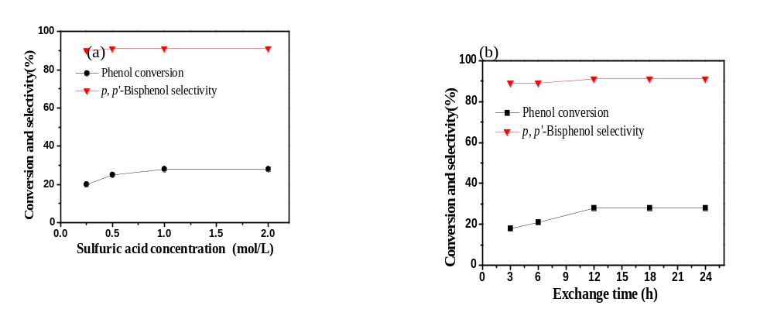
Fig. S2. Effects of (a) sulfuric acid concentration and (b) ion exchange time on the catalytic performance of PDVB-SO₃H-IS
Reaction conditions：phenol 120 mmol, molar ratio phenol:acetone = 5:1, catalyst 0.8 g, temperature 90 ºC, time 6 h.

Calculation of conversion rate, selectivity:
Conversion of phenol (C) and the selectivity of p,p’-Bisphenol-A (S) were defined according to the following equation:
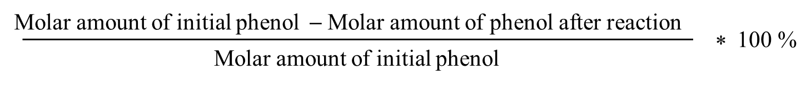
C% =
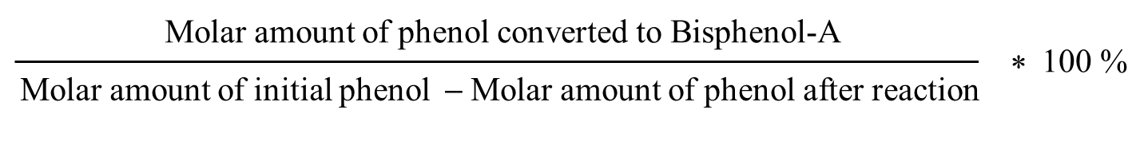
S% =

