Extended data

Supplementary Table 1
Feature name | Parametrization options
Raw Hjorth | Specific for raw signals and frequency band filtered signals
Bandpass filter | - Different frequency bands  - Different segment length per frequency band  - Log transform  - Kalman filtering
Short Time Fourier Transform | - Different window lengths  - Log transform  - Kalman filtering
Fast Fourier Transform | - Different window lengths  - Log transform  - Kalman filtering
Temporal Waveform Shape | - Features: prominence, interval, decay and rise time, rise -and decay steepness, slope ratio, width  - Different frequency bands  - Different estimators: mean, median, max, min, variance  - Peak and trough detection parameters: min. distance  - Option to take maximum between peaks and troughs
Fooof | - Aperiodic exponent and offset  Periodic center frequency, band width, height over aperiodic component  - Fooof parametrization: max_n_peaks, min_peak_heigth, peak threshold, frequency range, knee
Burst features | - Definition of threshold, burst time duration, different frequency bands  - Burst features: duration, amplitude, burst rate, in burst state
Line length | Line length calculation per batch
Coherence | - Different channel pair combinations  - Mean and max for different frequency bands  - Coherence and imaginary part of coherence
Nonlinear dynamical features | - Sample entropy, correlation dimension, Lyapunov exponent, hurst exponent, detrended fluctuation analysis  - Feature calculation for raw data for bandpass filtered data
MNE connectivity | Wrapper for Phase Locked Value, pairwise phase consistency, phase lag index
Supplementary Table 1: Feature parametrization

Supplementary Table 2
Cohort-ID | Age | Gender | UPDRS
Berlin-001 | 50 | f | n.a.
Berlin-002 | 62 | m | 21
Berlin-003 | 56 | f | 31
Berlin-004 | 45 | f | 36
Berlin-005 | 43 | f | 31
Berlin-006 | 57 | m | 36
Berlin-007 | 55 | m | 59
Berlin-008 | 66 | m | 24
Berlin-009 | 59 | m | 27
Berlin-010 | 66 | f | 30
Berlin-011 | 67 | m | 39
Berlin-012 | 54 | m | 31
Berlin-013 | 64 | m | 35
Beijing-001 | 66 | f | 61
Beijing-002 | 70 | m | 70
Beijing-003 | 73 | f | 51
Beijing-004 | 67 | f | 52
Beijing-005 | 59 | f | 58
Beijing-007 | 76 | m | 41
Beijing-008 | 66 | f | 55
Beijing-009 | 66 | f | 39
Beijing-010 | 67 | f | 27
Beijing-011 | 72 | f | 47
Pittsburgh-001 | 60.3 | m | 28
Pittsburgh-002 | 51.2 | m | 27
Pittsburgh-003 | 63.8 | m | 40
Pittsburgh-004 | 54.7 | f | n.a.
Pittsburgh-005 | 53.8 | m | 33
Pittsburgh-006 | 44.2 | m | 31
Pittsburgh-007 | 63.6 | m | 32
Pittsburgh-008 | 59.6 | m | 52
Pittsburgh-009 | 71.6 | m | 55
Pittsburgh-010 | 52.5 | m | 50
Pittsburgh-011 | 66.8 | f | 62
Pittsburgh-012 | 65.2 | f | 54
Pittsburgh-013 | 54.4 | m | 34
Pittsburgh-014 | 67.9 | m | 48
Pittsburgh-015 | 69 | f | 31
Pittsburgh-016 | 67 | m | 42
Supplementary Table 2: Parkinson’s disease cohort information
Supplementary Table 3
Cohort-ID | ID Intern | Age | Gender | Handedness | Grid Location | Seizure Focus
Washington-001 | bp | 18 | f | R | L Frontoparietal | n.a.
Washington-002 | ca | 31 | m | R | R Frontotemporal | R Temporal
Washington-003 | cc | 21 | m | R | R Frontotemporal | R Frontal
Washington-004 | de | 49 | f | R | R Temporal-Parietal | R Temporal
Washington-005 | fp | 23 | m | R | L Frontotemporal | L Temporal
Washington-006 | gc | 24 | m | R | L Anterior Frontotemporal | L Anterior Frontal
Washington-007 | gf | 24 | f | R | R Frontotemporal | R Orbitofrontal/Temporal
Washington-008 | hh | n.a. | n.a. | n.a. | R Fronto-temporo-parietal | n.a.
Washington-009 | hl | 42 | m | R | L Frontotemporal | n.a.
Washington-010 | jc | 18 | f | R | L Frontal | n.a.
Washington-011 | jf | n.a. | n.a. | n.a. | Subtemporal / Occipital | n.a.
Washington-012 | jm | 41 | m | L | L Frontotemporal | L Temporal
Washington-013 | jp | 35 | f | R | L Fronto-Temporal | n.a.
Washington-014 | jt | n.a. | n.a. | n.a. | R Fronto-temporo-parietal and Subtemporal / Occipita | n.a.
Washington-015 | rh | 38 | m | R | R Frontal | R Frontal
Washington-016 | rr | n.a. | n.a. | n.a. | R Fronto-temporo-parieta | n.a.
Washington-017 | ug | 39 | f | R | R Frontal | R Frontal
Washington-018 | wc | 32 | m | R | L Fronto-temporal-parietal | n.a.
Washington-019 | zt | 27 | f | R | L Fronto-temporal-parietal | n.a.
Supplementary Table 3: Epilepsy cohort Movement decoding

Supplementary Table 4
Patient number | Age | Sex | BDI | 24 months DBS BDI follow up
1 | 49 | F | 35 | 32
2 | 61 | F | 22 | 1
3 | 48 | F | 46 | 36
4 | 60 | F | 36 | 12
5 | 36 | M | 57 | 52
6 | 50 | M | 41 | 37
7 | 55 | M | 43 | 31
8 | 25 | M | 30 | 37
Supplementary Table 4: Patient characteristics treatment-resistant Depression patients²⁰

Supplementary Table 5
This table is separately uploaded as an excel sheet.
Supplementary Table 5: Patient characteristic responsive neurostimulation, ILAE – International League against Epilepsy

Supplementary Table 6
Preprocessing option | Parametrization
Raw resampling | Specify resampling frequency
Notch filtering | Power-line frequency notch filtering
Re-referencing | - Bipolar re-referencing  - Common Average Re-referencing  - Individualized re-referencing options based on summation / subtraction
Raw-data normalization | - Normalization options: mean, median, z-score, z-score-median, quantile, power, robust, minmax normalization  - Different normalization window  - Clipping option based on different amplitudes
Supplementary Table 6: Preprocessing parametrization

Supplementary Table 7
Postprocessing option | Parametrization
Feature normalization | - Normalization options: mean, median, z-score, z-score-median, quantile, power, robust, minmax normalization  - Different normalization window  - Clipping option based on different amplitudes
Projection to pre-defined cortical or subcortical grid | Projection minimal distance separately for cortical and subcortical grids
Supplementary Table 7: Postprocessing parametrization

Supplementary Table 8
Name | Rereference | Used | Target | Type | Status | New_name
LFP_RIGHT_0 | LFP_RIGHT_2 | 1 | 0 | dbs | good | LFP_RIGHT_0-LFP_RIGHT_2
LFP_RIGHT_1 | LFP_RIGHT_0 | 1 | 0 | dbs | good | LFP_RIGHT_1-LFP_RIGHT_0
LFP_RIGHT_2 | LFP_RIGHT_1 | 1 | 0 | dbs | good | LFP_RIGHT_2-LFP_RIGHT_1
ECOG_RIGHT_0 | average | 1 | 0 | ecog | good | ECOG_RIGHT_0-avgref
ECOG_RIGHT_1 | average | 1 | 0 | ecog | good | ECOG_RIGHT_1-avgref
ECOG_RIGHT_2 | average | 1 | 0 | ecog | good | ECOG_RIGHT_2-avgref
ECOG_RIGHT_3 | average | 1 | 0 | ecog | good | ECOG_RIGHT_3-avgref
ECOG_RIGHT_4 | average | 1 | 0 | ecog | good | ECOG_RIGHT_4-avgref
ECOG_RIGHT_5 | average | 1 | 0 | ecog | good | ECOG_RIGHT_5-avgref
MOV_RIGHT | None | 0 | 0 | misc | good | MOV_RIGHT
MOV_LEFT | None | 0 | 0 | misc | good | MOV_LEFT
MOV_RIGHT_CLEAN | None | 0 | 1 | misc | good | MOV_RIGHT_CLEAN
MOV_LEFT_CLEAN | None | 0 | 0 | misc | good | MOV_LEFT_CLEAN
Supplementary Table 8: Channel specific parametrization in the nm_channels.tsv. Channel selection, re-referencing and target definition is specified.

Supplementary Video
Supplementary Video 1 Real-time movement decoding of a Parkinson’s disease patient at Charité University Medicine Berlin without patient individual training. The patient performed a hand rotation movmenet. Raw ECoG time signals and the classifier predictions are displayed. Decoding was significantly above chance.

Supplementary Figures
Supplementary Fig. 1
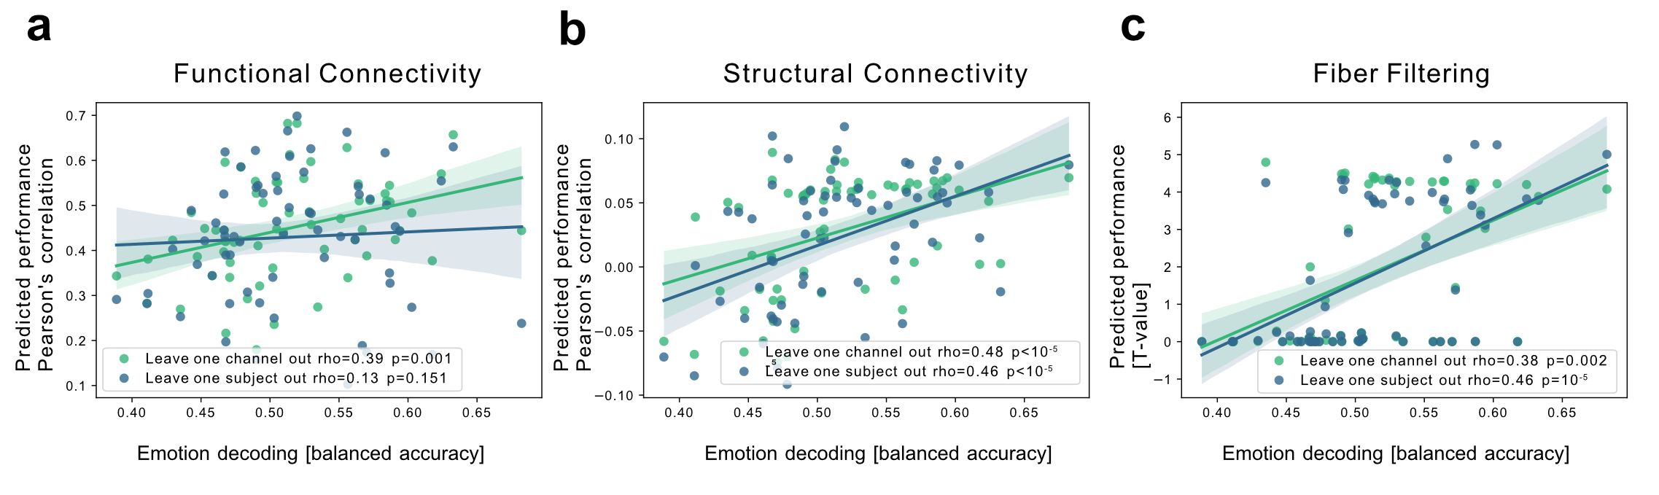
Supplementary Fig. 1 Cross validation of connectivity profiles predicting emotional decoding performances. Functional (A), diffusion weighted structural MRI (B), and fiber filtering connectivity profiles (C) could each significantly predict neutral vs pleasant and unpleasant emotion decoding performances using leave one channel out cross validation. Structural and fiber-filtering connectivity could further predict performances using leave one subject out cross validation.

Supplementary Fig. 2
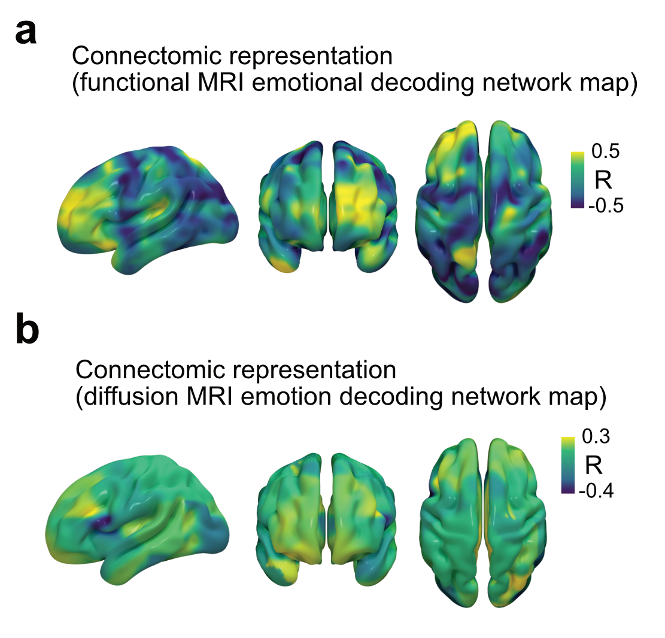
Supplementary Fig. 2 Connectomic emotion decoding network maps. (A) Functional MRI connectivity and (B) diffusion MRI emotion decoding network map.

