Electronic Supplementary Material

Polyoxometalate decorated gold nanoparticles inhibit β-amyloid aggregation and cross the blood brain barrier in a µphysiological model.
Marta Perxés Perich^{1,2,†,╡}, Sujey Palma-Florez^{2†}, Clara Solé², Sara Goberna-Ferrón^{1,╧}, Josep Samitier^{2,3,4}, Pedro Gómez-Romero¹, Mònica Mir^{2,3,4,&} () and Anna Lagunas^{2,3,&} (),

1. Catalan Institute of Nanoscience and Nanotechnology, ICN2 (CSIC-BIST), Campus UAB, Bellaterra, Barcelona, E-08193, Spain.
2. Nanobioengineering Group, Institute for Bioengineering of Catalonia (IBEC) Barcelona Institute of Science and Technology (BIST), 08028 Barcelona, Spain.
3. CIBER-BBN, ISCIII, 28029 Madrid, Spain.
4. Department of Electronics and Biomedical Engineering, University of Barcelona, Martí i Franquès 1, 08028 Barcelona, Spain.
† Both authors contributed equally.
& Both authors contributed equally.
╡Materials Chemistry and Catalysis, Debye Institute for Nanomaterials Science, Utrecht University, 3584 CG Utrecht, The Netherlands
╧Instituto Universitario de Tecnología Química (CSIC-UPV), Universitat Politècnica de València, Avda. De los Naranjos s/n, Valencia 46022, Spain

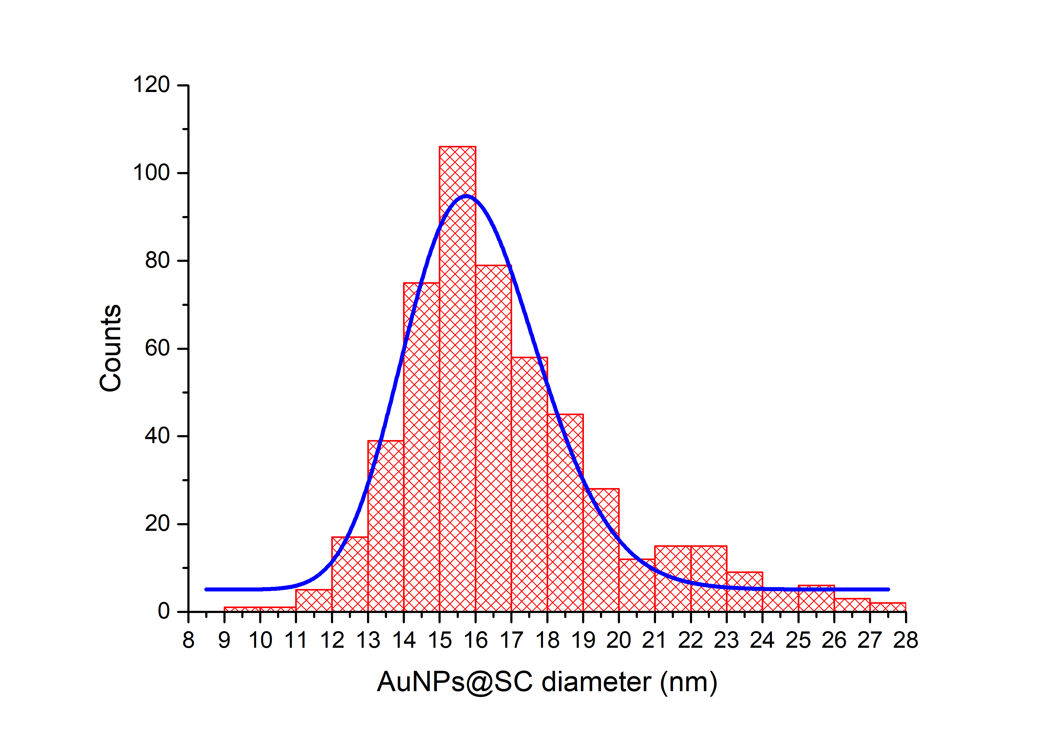
Figure S1. Histogram of citrate capped gold nanoparticles (AuNPs@SC), fitted to a LogNormal distribution with the following parameters: Center = 15.95 nm, offset = 5,06 and log standard deviation = 0.11 nm. The size distribution was obtained by measuring the size of n = 522 particles from three different synthesis batches in Bright Field Scanning Transmission Electron Microscopy (BF-STEM) images.

Table S1: IR peaks of different compounds synthetized compared in the last two columns with the literature.
AuNPs@ POM | AuNPs@POM@PEG | POM | POM ^{1,2} | PEG ³
 | 1350.2 |  |  | 1343
 | 1298.1 |  |  | 1279
 | 1249.9 |  |  | 1240
 | 1137.5 |  |  | 1130
 | 1095.6 |  |  | 1094
987.6 | 987.6 | 989,5 | 988
943.2 | 941.3 | 943,2 | 945 | 951
869.9 | 868.0 | 872,9 | 875
858.3 | 852.5 | 852,5 | 855 | 840
798.5 | 796.6 | 790,8 | 805
731.0 | 727.2 | 713,7 | 730
513.1 | 509.2 | 505,6

Scheme S1. Structure of the β2 isomer of the monolacunary Keggin ion [SiW₁₁O₃₉]⁻⁸ with labelling of the different oxygen atoms. WO₆ octahedra (blue) and SiO₄ tetrahedra (yellow). Adapted from (Chermette and Lefebvre, 2012). ⁴

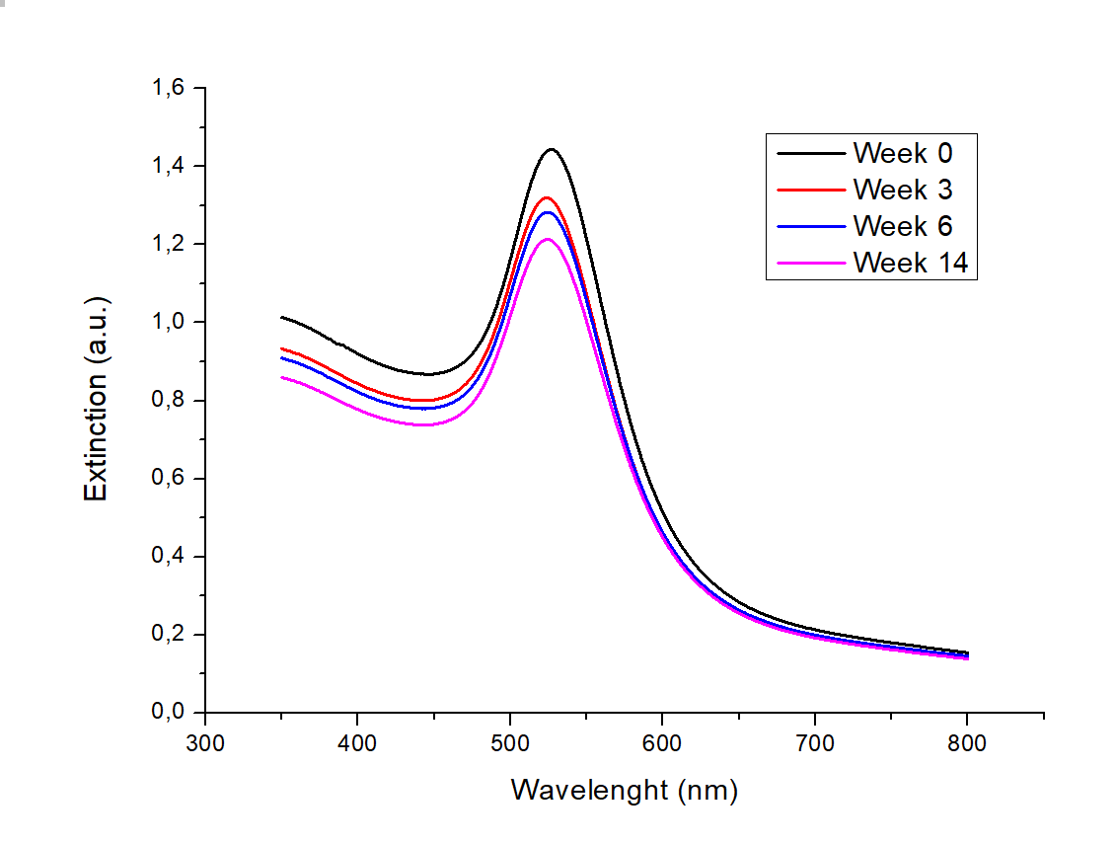
Figure S2. Non normalized UV-Vis spectra of AuNPs@POM@PEG in PBS after up to 14 weeks, showing particle long-term stability.
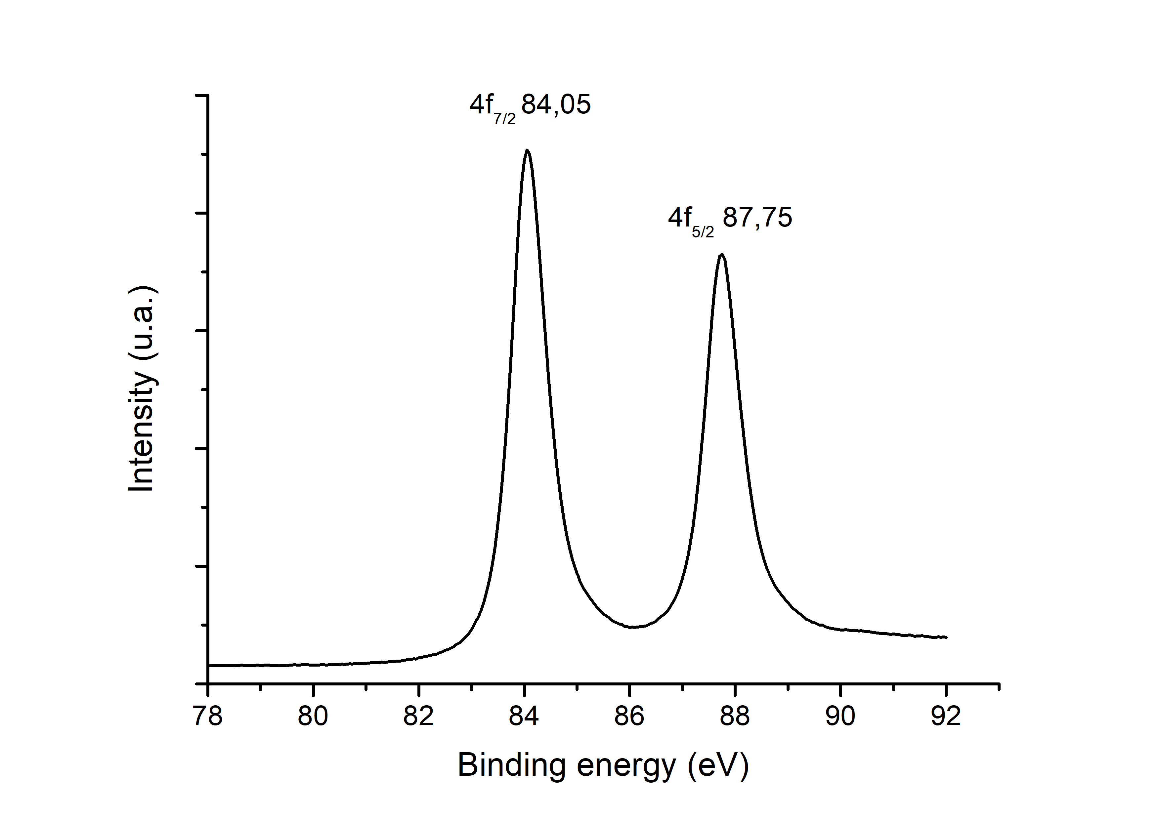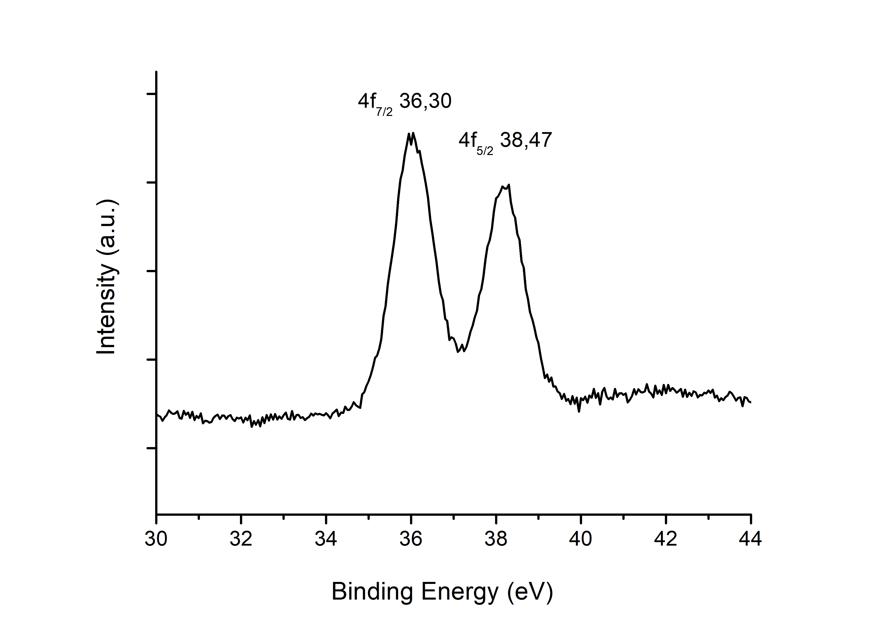
Figure S3. XPS spectra of AuNPs@POM. On the left, Au peaks. On the right, W peaks.

Figure S4. Representative fluorescence images of the Live/Dead assay obtained for endothelial cells under different treatment conditions. Green, red and blue signal indicate alive, death cells and cell nuclei, respectively.

References
1 A. Tézé and G. Hervé, Journal of Inorganic and Nuclear Chemistry, 1977, 39, 999–1002.
2 Alvin P. Ginsberg, Ed., Inorganic Syntheses, John Wiley & Sons Ltd, New York, 1991.
3 K. Shameli, M. Bin Ahmad, S. D. Jazayeri, S. Sedaghat, P. Shabanzadeh, H. Jahangirian, M. Mahdavi and Y. Abdollahi, Int J Mol Sci, 2012, 13, 6639–6650.
4 H. Chermette and F. Lefebvre, Comptes Rendus Chimie, 2012, 15, 143–151.

