A theoretical study on the mechanism of small carbon clusters growth in low-temperature plasma
Yulia G. Polynskaya,ª Nikita A. Matsokin,^{a,b} Yegor M. Kedalo,*^{c,a,d} Andrey A. Knizhnik,^{a,d} Alex S. Sinitsa^{a,d} and Boris V. Potapkin^{a,d}
ª Kintech Lab Ltd, Moscow, Russia
^{b} M. V. Lomonosov Moscow State University, Moscow, Russia
^{c} Moscow Institute of Physics and Technology, Dolgoprudny, Russia
^{d} National Research Center “Kurchatov Institute”, Moscow, Russia

Method verification
To verify the quantum-chemistry method, the growth of dust particles in pure silane plasma was investigated. In accordance with previous studies ^{13,14} two pathways of silicon hydride clustering were considered:
- reaction between the silylene anion (Si₂H₄⁻) and silane
SiH₃-SiH⁻ + SiH₄ SiH₃SiH₂SiH⁻ + H₂;
- reaction between the silyl anion (Si₂H₅⁻) and silane
SiH₃-SiH₂⁻ + SiH₄ SiH₃SiH₂SiH₂⁻ + H₂.
At first step in both considered pathways Si-H bond in silane rupture was observed. After that two reactions are possible: (1) H reaction transfer to the ion; (2) SiH₃ reaction transfer to the ion.
Calculated activation energies (E_{a}), reaction energies (ΔE_{r}), and optimized structures of reagents, products, intermediates (IN), and transition states (TS) were compared with data from the work ¹⁴. In that study, Truhlar et al. investigated above processes using global-hybrid meta-GGA density functional M08-HX, which was found to be the best-performing functional for barrier heights, reaction energies, and thermodynamics.³⁰
The reaction energy profile between the silylene anion and neutral silane is presented in Figure 1. All activation energies and reaction energies were calculated relative to complex Si₂H₄⁻---SiH₄. The first step is Si-H bond rupture in silane, then formed SiH₃-group interacts with silylene anion. The reaction goes through the transition state TS1 with an energy of 0.76 eV, which is close to the barrier height of 0.82 eV found in the work.¹³ Formation of trisilan-1,2-diyl (Si₃H₆⁻) radical and H₂ molecule is a thermoneutral process, reaction energy is about ‒0.01 eV. Second step is an intramolecular 1,2 hydrogen transfer from trisilan-1,2-diyl isomer to the trisilan-1,1-diyl isomer. The activation energy of this step is about 0.58 eV, which is lower than the activation energy (0.83 eV) calculated by Truhlar et al.¹³ The final product is Si₃H₆⁻ anion with SiH-group at the end, which can be active in subsequent clustering. Reaction energy of the overall process (SiH₃-SiH⁻ + SiH₄ SiH₃SiH₂SiH⁻ + H₂) is ‒0.26 eV, which is close to that energy (‒0.16 eV) in the work ¹³.
The reaction pathway between the silyl anion (Si₂H₅-) and silane is presented in Figure 2. All energies were also calculated relative to the Si₂H₅⁻---SiH₄ complex energy. In the work ¹³ the reaction mechanism starts with H atom abstraction from SiH₄ by Si₂H₅⁻ to form disilane and SiH₃⁻ . This reaction goes with an activation energy of 0.54 eV; the process is endothermic (∆E_{r} = 0.5 eV) with very small activation barrier for the reverse process (0.04 eV). In our investigation, the corresponding product is unstable and the first step of the process is the addition of silane to the silyl anion, followed by hydrogen molecule desorption and trisilan-1-yl anion (Si₃H₇⁻) formation, which corresponds to the product resulting from the second step of the mechanism.¹³ Reaction proceeds with activation energy of 0.93 eV, which is slightly higher than the activation energy 0.77 eV, obtained in the work.¹³ This process is weakly exothermic, reaction energy is about ‒0.18 eV. The final step is an intramolecular 1,2 hydrogen transfer from trisilan-1-yl to trisilan-2-yl anion. This process is characterized by an activation energy of 1.29 eV, reaction energy is about ‒0.25 eV. Obtained values of E_{a} and ΔE_{r} agree reasonably well with the calculated data by Truhlar et al.¹³
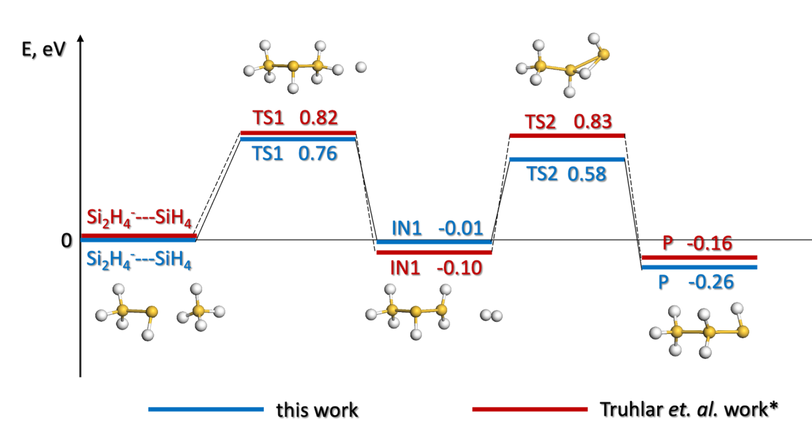
Figure 1. Calculated reaction energy profile for Si₂H₄⁻ + SiH₄; blue line – this work, red line -work¹⁴. Yellow balls are silicon atoms, and white balls are hydrogen atoms. TS, IN, and P are the notations for the transition, intermediate states, and product, respectively.
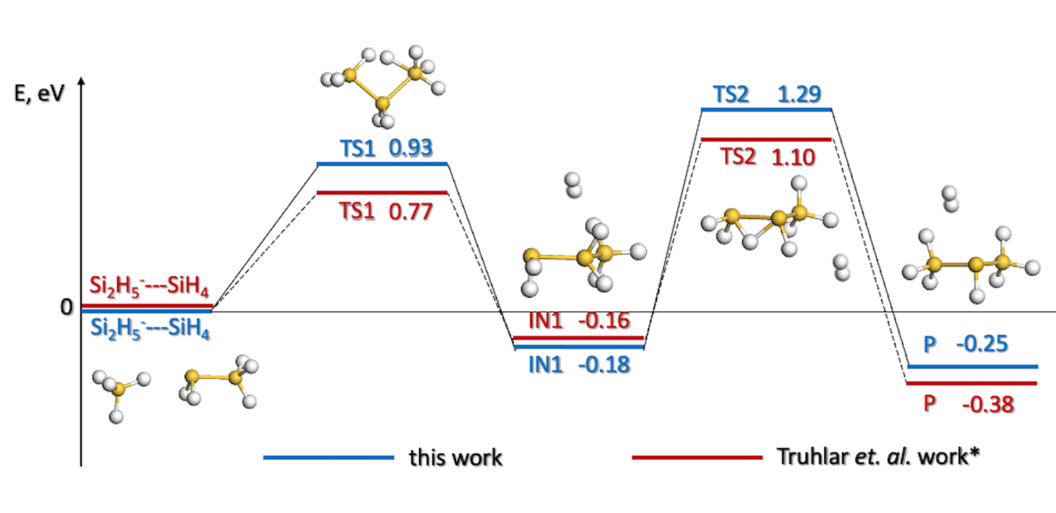
Figure 2. Calculated reaction energy profile for Si₂H₅⁻ + SiH₄; blue line – this work, red line -work.¹³ Yellow balls are silicon atoms, and white balls are hydrogen atoms. TS, IN, and P are the notations for the transition, intermediate states, and product, respectively.
Comparison of activation energies and reaction energies values calculated by the DFT/PBE level of theory with literature data ¹³ demonstrated that DFT/PBE method gives reliable results for the calculation of reaction thermodynamics. In particular, the difference between reaction energies (ΔE_{r}) calculated by PBE and the more accurate M08-HX method is less than 0.1 eV. For computed activation energies, this discrepancy is in the range 0.06 – 0.25 eV. It should be noted that it is difficult to achieve accuracy better than 0.2 eV for calculated barrier heights using density functional methods.³⁰ So, a comparison of both mechanisms with the literature data showed that the DFT/PBE level of theory is reliable for barrier height and thermodynamics calculation for considered clustering processes. Thus, in what following this method will be used to investigate mechanisms of clustering reactions in carbon plasma.
To compare calculated reaction profiles with experimental data, one should also note that complexes like Si₂H₄⁻---SiH₄, Si₂H₅⁻---SiH₄ have binding energy about 0.2-0.3 eV due to ion-molecular interaction. These binding energies of complexes reduce effective barriers for the silane cluster growth down to about 0.5 eV, which is typical for thermo-neutral ion-molecular reactions.³¹

Figure 3. Calculated reaction energy profile for C₂H₅⁺ + CH₄; magenta line – DFT/PBE, green line -CCSDT. Grey balls are carbon atoms, and white balls are hydrogen atoms. TS, IN, and P are the notations for the transition, intermediate states, and product, respectively.

