Supporting Information

Size-Dependent Effects of Silver Nanoparticles in Colorectal Cancer Treatment: Apoptosis Activation, Anti-metastatic Properties, and Tissue Accumulation

Serdar KARAKURT^{*a}, Irem Mukaddes BILGISEVENª, Sumeyya CINARª, Deniz SEZLEV BILECEN^{b}, Sinan KANDIR^{c},
kserdar1@yahoo.com (ORCID ID: 0000-0002-4449-6103)
iremdurmuss73@gmail.com (ORCID ID: 0000-0002-3162-8381),
eyyemus90@gmail.com (ORCID ID: 0000-0002-5291-2672
dsezlev@gmail.com (ORCID ID: 0000-0002-5708-2276),

skandir@gmail.com (ORCID ID: 0000-0002-8404-7994)

ª Selcuk University, Department of Biochemistry, Konya, Turkey

^{b} Konya Food and Agriculture University, Department of Molecular Biology and Genetics, Konya, Turkey
^{c}Cukurova University, Ceyhan Faculty of Veterinary Medicine, Department of Physiology, Adana, Turkey

*Corresponding author: Serdar KARAKURT
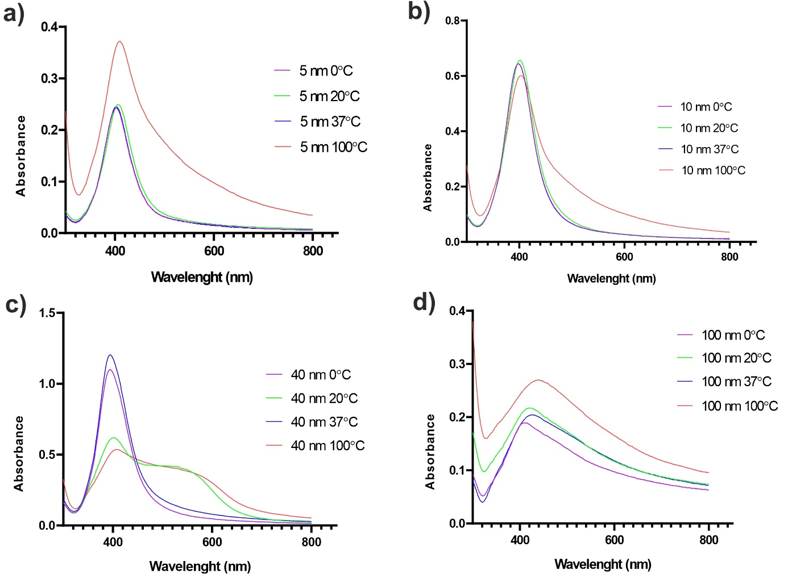
Fig S1 Effect of different temperatures (0°C, 20°C, 37°C and 100°C) on AgNPs a) 5 nm AgNP b) 10 nm AgNP c) 40 nm AgNP d) 100 nm AgNP
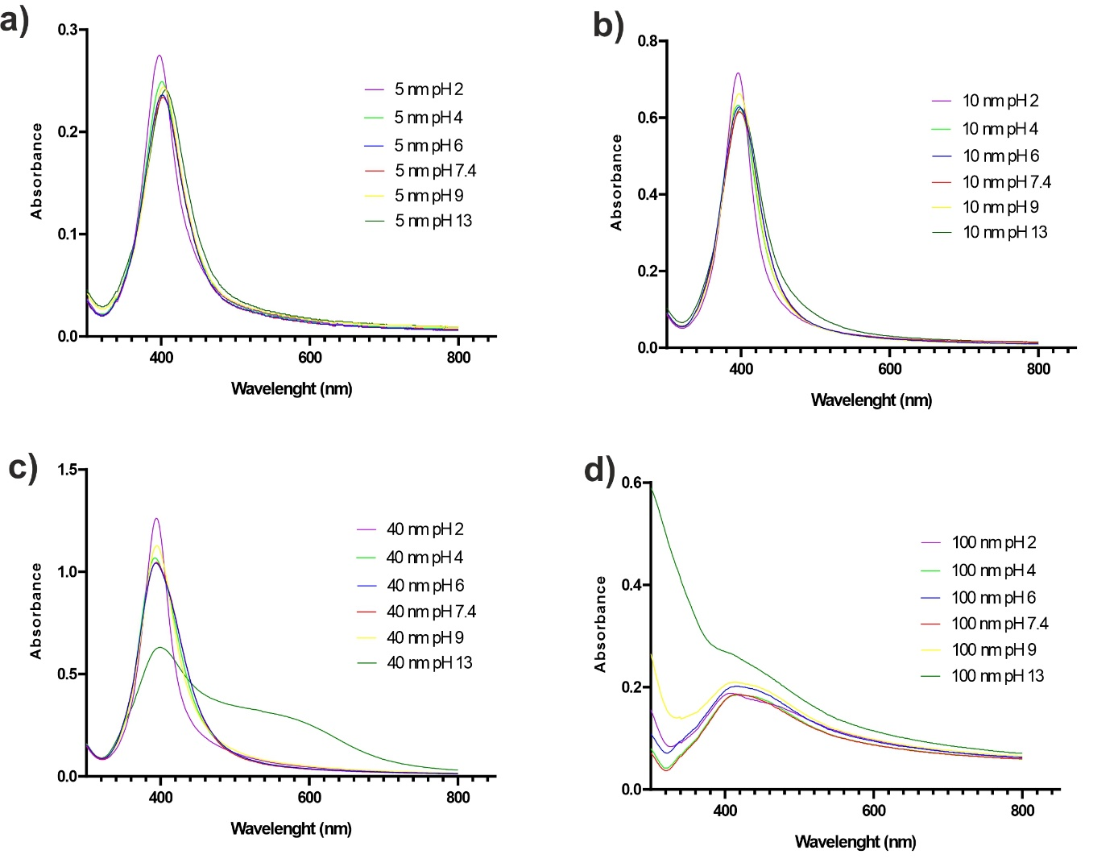
Fig S2 Effect of different pH values (pH 2, 4, 6, 7.4, 9 and 13) on AgNPs a) 5 nm AgNP b) 10 nm AgNP c) 40 nm AgNP d) 100 nm AgNP
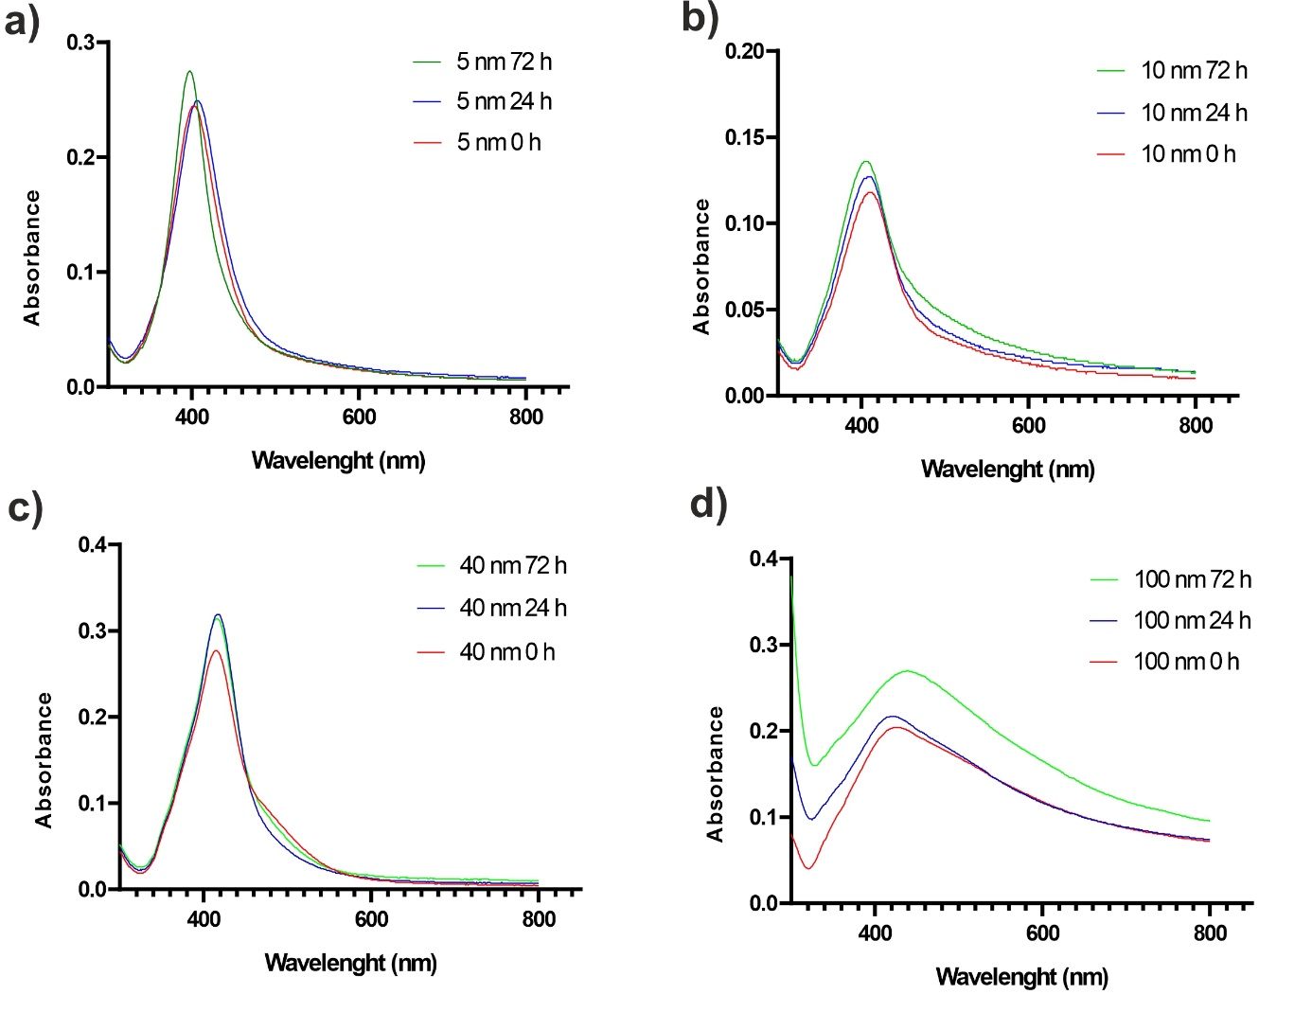
Fig S3 Effect of different times (0 h, 24 h and 72 h) on AgNPs a) 5 nm AgNP b) 10 nm AgNP c) 40 nm AgNP d) 100 nm AgNP

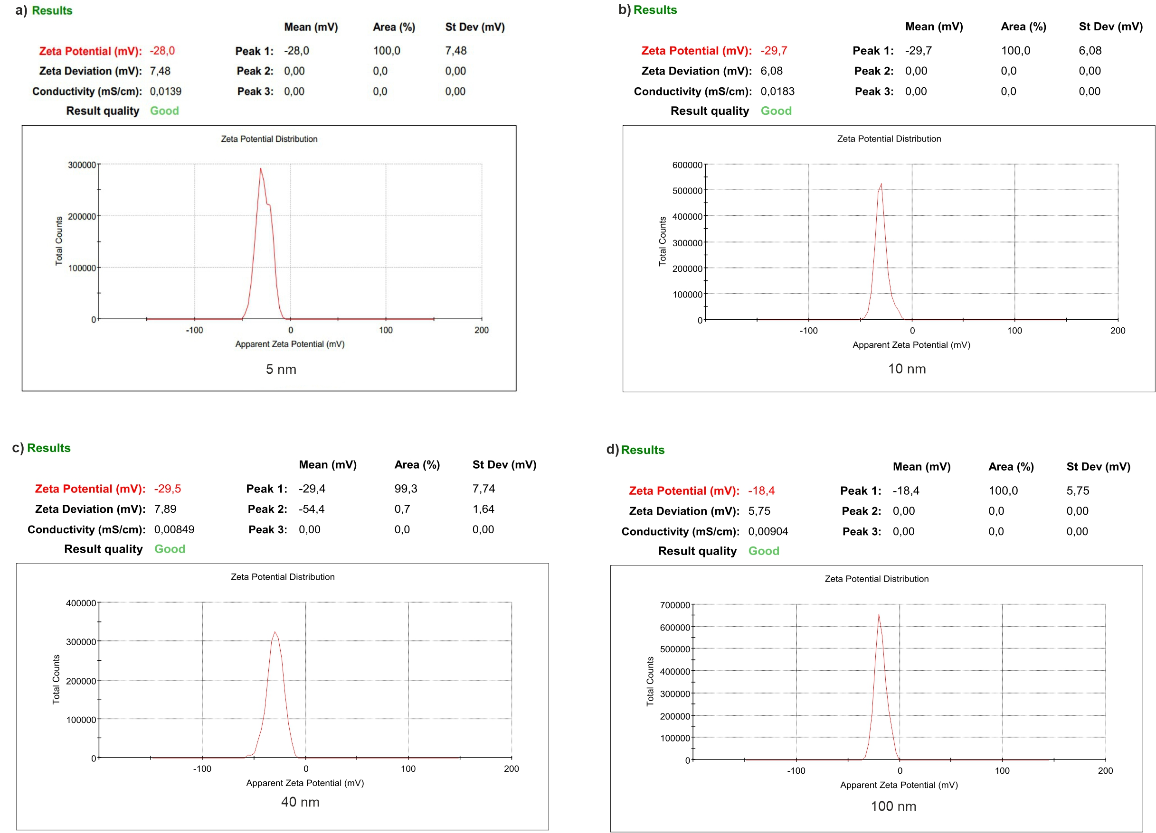
Fig S4 Zeta Potential Distributions of AgNPs a) 5 nm AgNP b) 10 nm AgNP c) 40 nm AgNP d) 100 nm AgNP

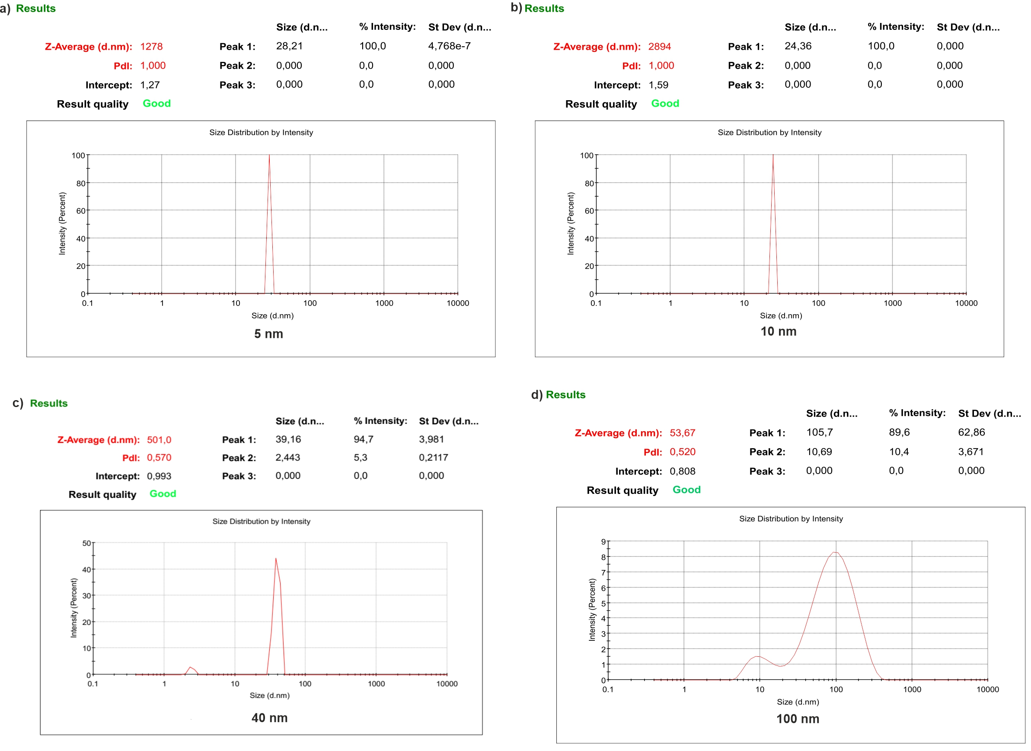
Fig S5 Particle size distribution of AgNPs a) 5 nm AgNP b) 10 nm AgNP c) 40 nm AgNP d) 100 nm AgNP

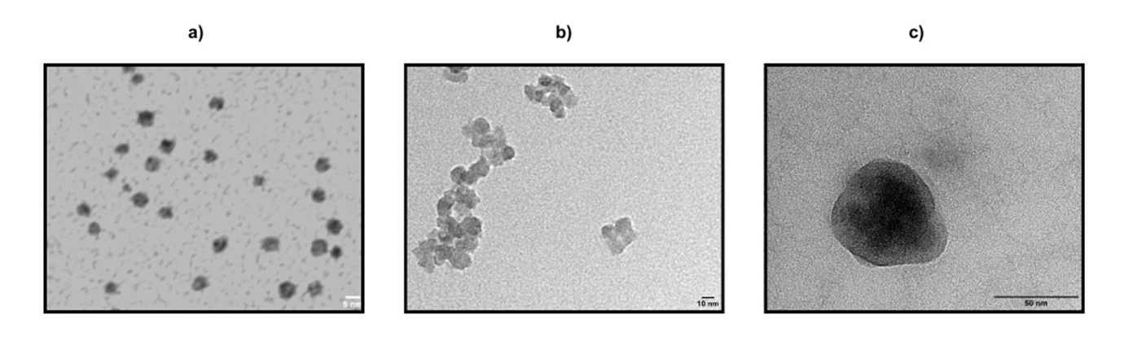
Fig S6 TEM images of AgNPs a) 5 nm AgNP b) 10 nm AgNP c) 40 nm AgNP

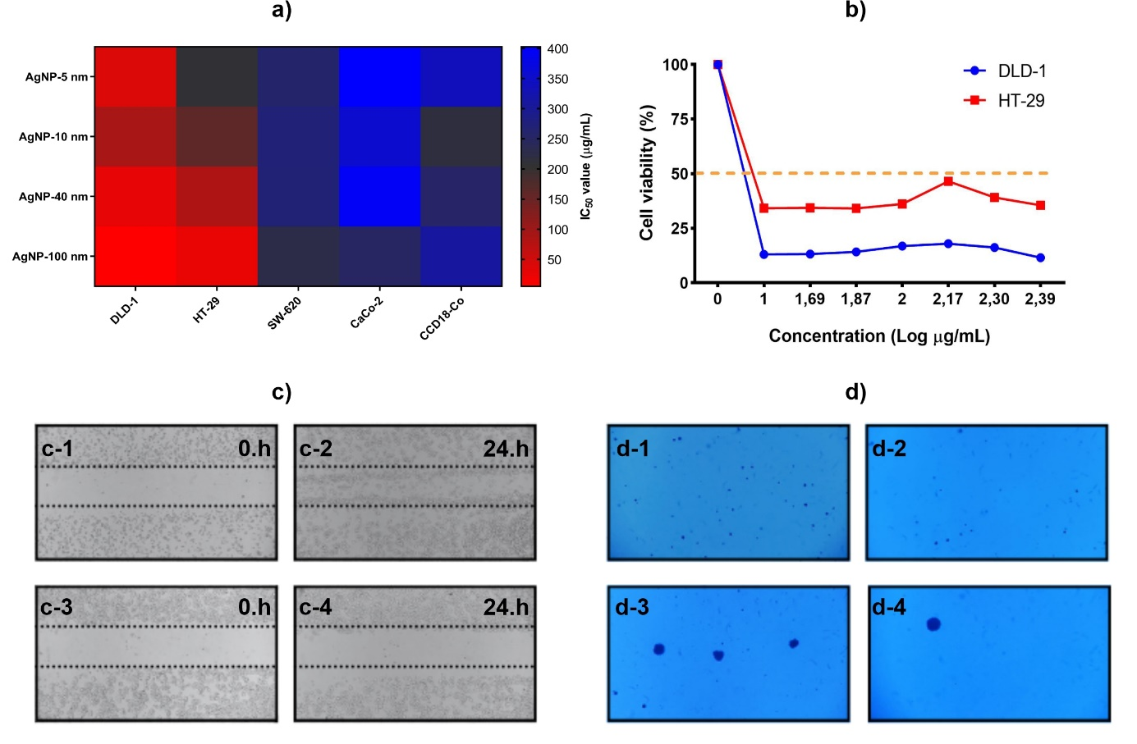Fig S7. Cell culture studies of AgNPs a) Heat map analyses of cytotoxicity on CRC cells b) Sigmoidal graph of % cell viability and log concentration of 100 nm AgNPs c) in vitro metastasis studies c-1 and c-2) 0 h and 24 h images of the non-treated group (NT) c-3 and c-4) 0 h and 24 h images of the group treated with 100 nm AgNP d) Soft agar colony formation assay d-1) Colony images represent non-treated group d-2) 5 nm AgNPs d-3) 40 nm AgNPs d-4) 100 nm AgNPs

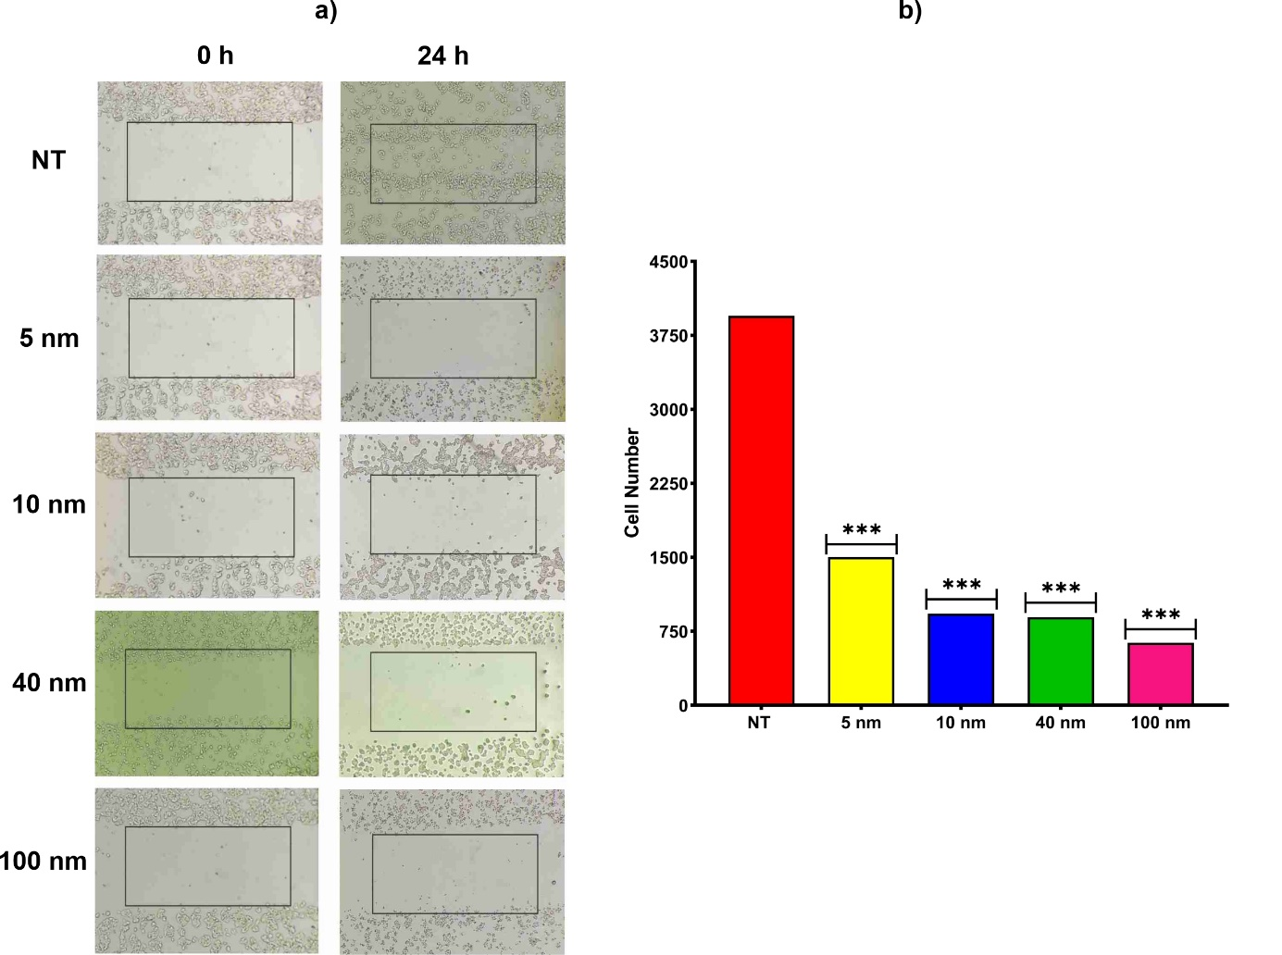
Fig S8 in vitro metastasis studies in HT-29 cell line a) 0 h and 24 h images of the non-treated group (NT) and AgNPs b) Cumulative plot of metastatic cell number after AgNP treatment. The number of cells was counted using the Image J Cell Counter software.
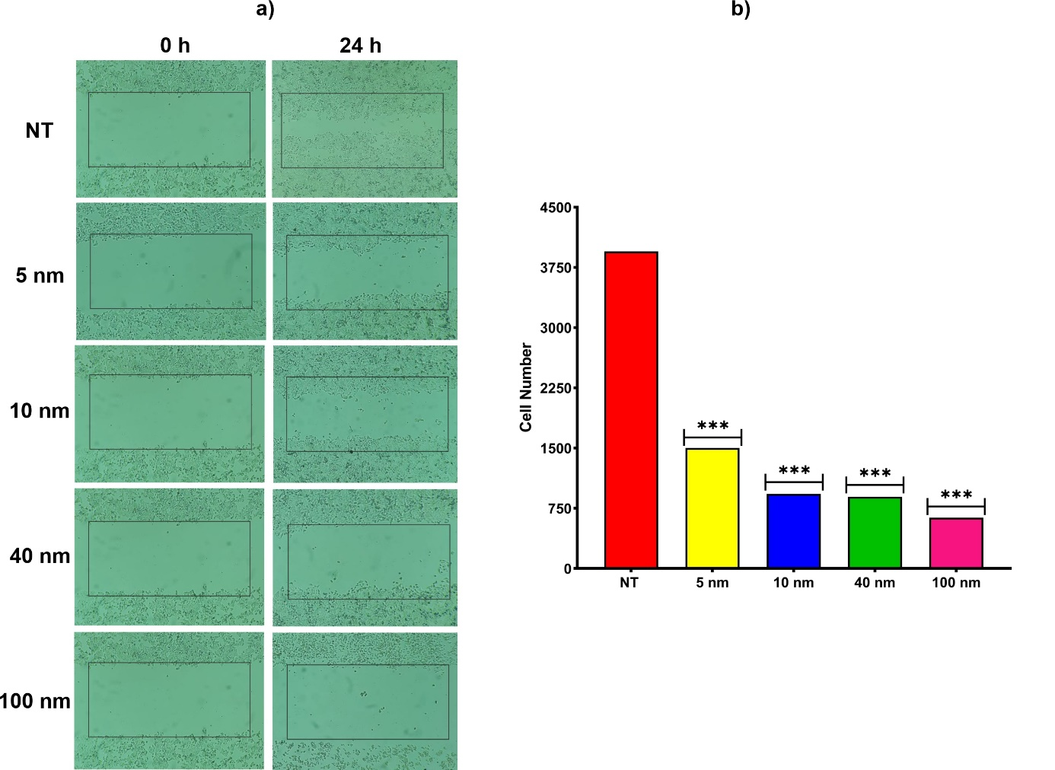
Fig S9 In vitro metastasis studies in DLD-1 cell line a) 0 h and 24 h images of the non-treated group (NT) and AgNPs b) Cumulative plot of metastatic cell number after AgNP treatment. The number of cells was counted using the Image J Cell Counter software.
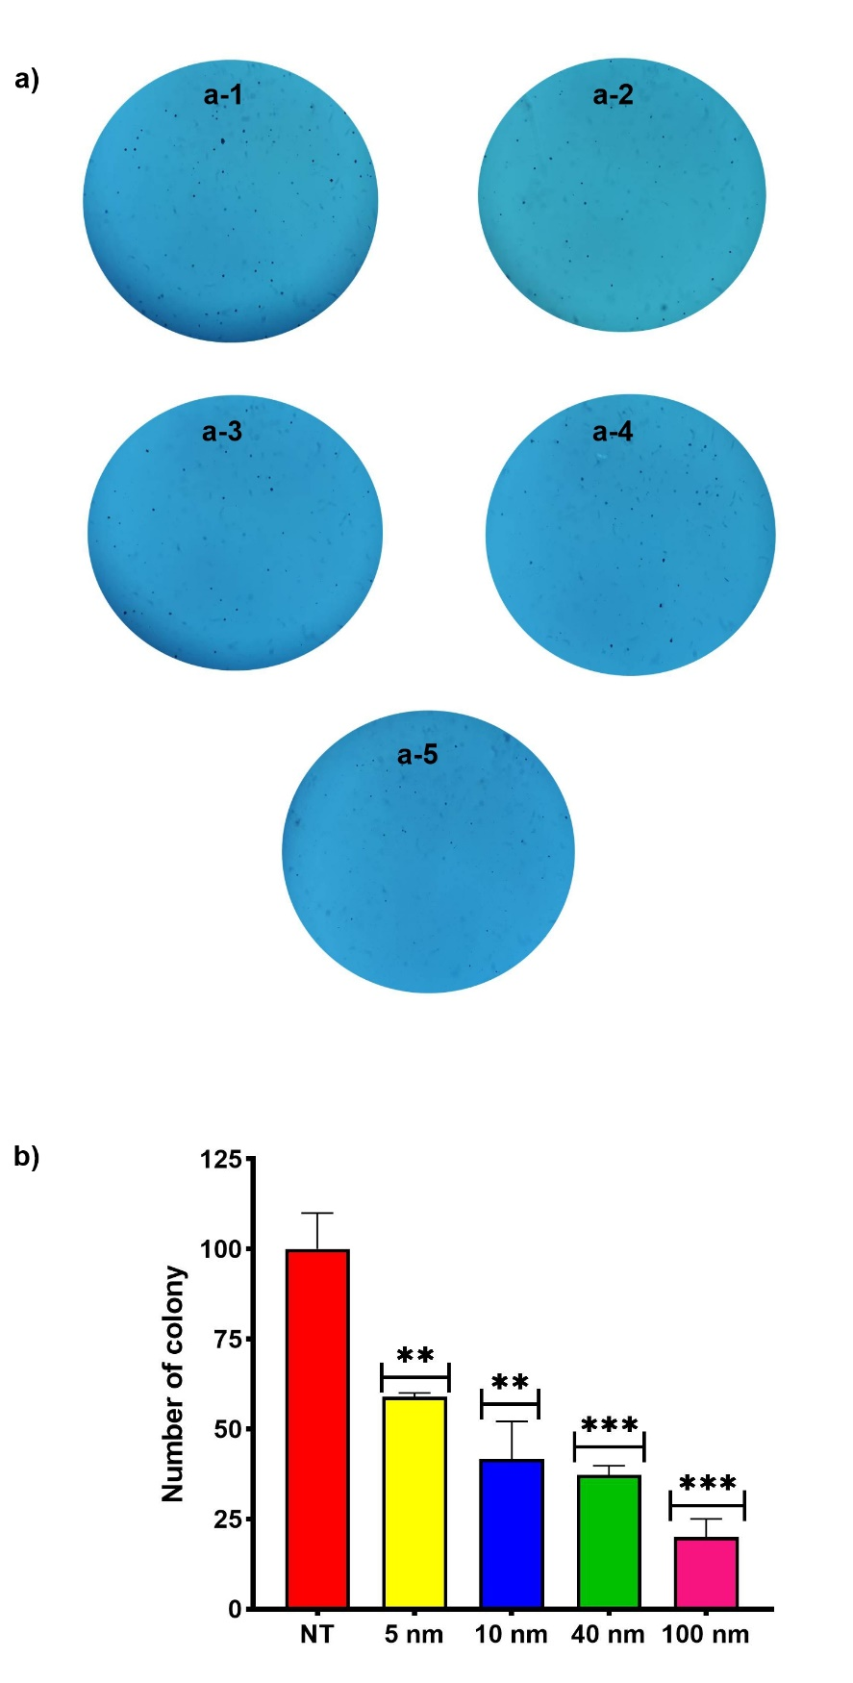
Fig S10 Soft agar colony formation assay in HT-29 cell line a) Colony images represent non-treated group (NT) and AgNPs a-1) NT, a-2) 5 nm, a-3) 10 nm, a-4) 40 nm and a-5) 100 nm. b) Cumulative plot of colony number after AgNP treatment. The number of colonies was counted using the Image J Cell Counter software.
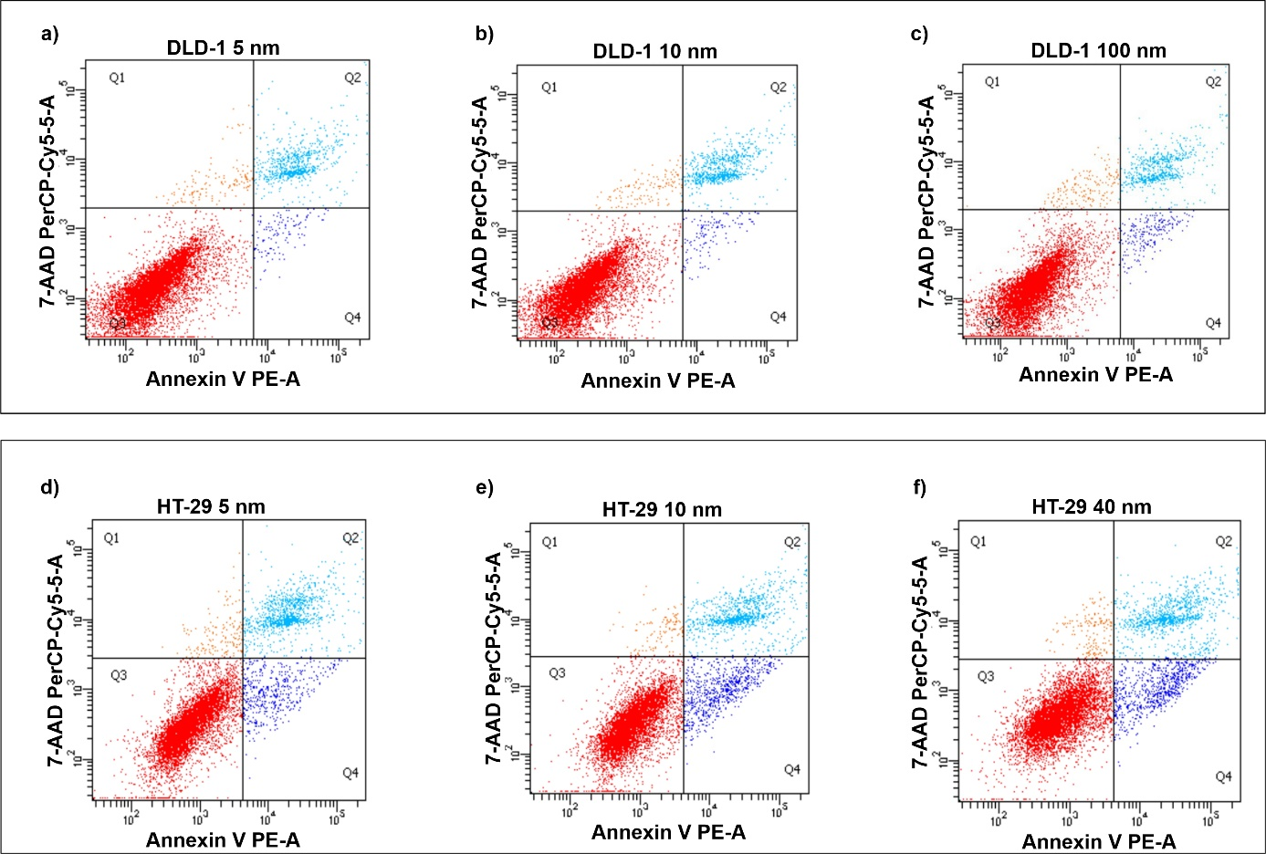
Fig S 11 Apoptosis dot plots of AgNPs. a) 5 nm b) 10 nm c) 100 nm in DLD-1 cells, d) 5 nm e) 10 nm f) 40 nm in HT-29 cells.

