Additional Files
Additional File 1: Home Exercise Programme

Dear
Can a form of physiotherapy reduce stiffness in the foot joints of people with diabetes?

This leaflet provides written explanation and should act as a reminder of the exercises prescribed to you by your physiotherapist. These exercises should NOT cause you any pain but you should feel a sensation of “pulling”, “stretching” or “tightness” in the area that you are stretching. If any of these exercises cause you pain or discomfort you should stop them immediately and inform your physiotherapist at your next appointment.
Calf stretches
Standing with the leg to be stretched at the back and both hands against a wall at shoulder height.
EXERCISE 1: Bending the front leg at knee level and leaning forwards, keeping the back leg and knee straight and pushing the heel down into the floor; 20-30 sec hold, 2 times each leg twice daily.
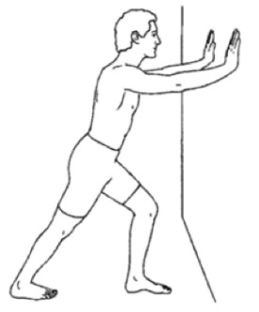
EXERCISE 2: Bending both legs at knee level and pushing the heel of the back leg down into the floor; 20-30 sec hold, 2 times each leg twice daily.
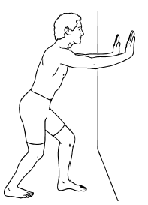
Plantar fascia stretch
EXERCISE 3: Place your toes, concentrating on your big toe, against a wall and lean forward or push your knee forward over your toes; 20-30 hold, 2 times each leg twice daily.
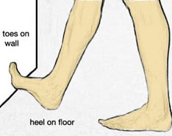

If you feel confused on how to carry out any of the exercises or you would like further explanation, please let your physiotherapist know who will be happy to demonstrate to you how to perform these exercises efficiently and safely.

Please record the exercises by ticking them as appropriately in your exercise diary sheet supplied to you.

What if I have any further questions or require further information?

Contact:
Jon Marsden
01752 587 590
jonathan.marsden@plymouth.ac.uk (Mon Friday)

Alec Rickard
01752 588850
alec.rickard@plymouth.ac.uk

Thank you for taking part in the study

Additional File 2: Foot and Ankle Mobilisation in Diabetic Peripheral Neuropathy

Participant Exercise Diary

Participant Number

Exercise 1 Exercise 2 Exercise 3
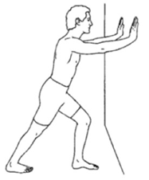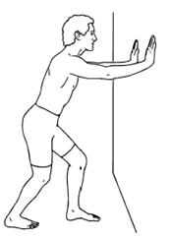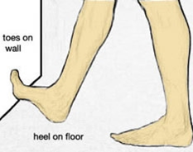
Welcome! Thank you once again for volunteering for this study. As part of the study we would like you to complete this diary every day.
Exercise aims: These exercises aim to increase the movement in your foot and ankle. We expect a more mobile foot and ankle will be associated with lower loads under your foot while walking and lead to a reduced risk of foot ulcers. It may also make walking easier.
On each day we would like you to tick ☑ which exercises you have done. This includes the three exercises prescribed by your therapist which are numbered in your home exercise sheet (quick reference at the front of this pack). In the next column we would like you to indicate the volume of exercises by ticking ☑ if you have done them. If you were not able to complete the prescribed amount of exercises, use the “comments” box to inform your therapist how much you have exercised. In the end of this booklet, you will find two questions. Answering these will give us valuable information to understand what enabled you or stopped you from carrying out these exercises.
It is important to be as accurate as you can but don’t worry if you cannot exercise every day. Your treating therapist will collect your exercise diary weekly so it is important to remember to bring this with you on each appointment. You will collect a new diary by your therapist each week.
In the meantime if you have any questions please contact:
Jon Marsden 01752 587 590 jonathan.marsden@plymouth.ac.uk (mon-friday)
A large print version of this booklet is available on request

Tick each exercise as appropriately ☑
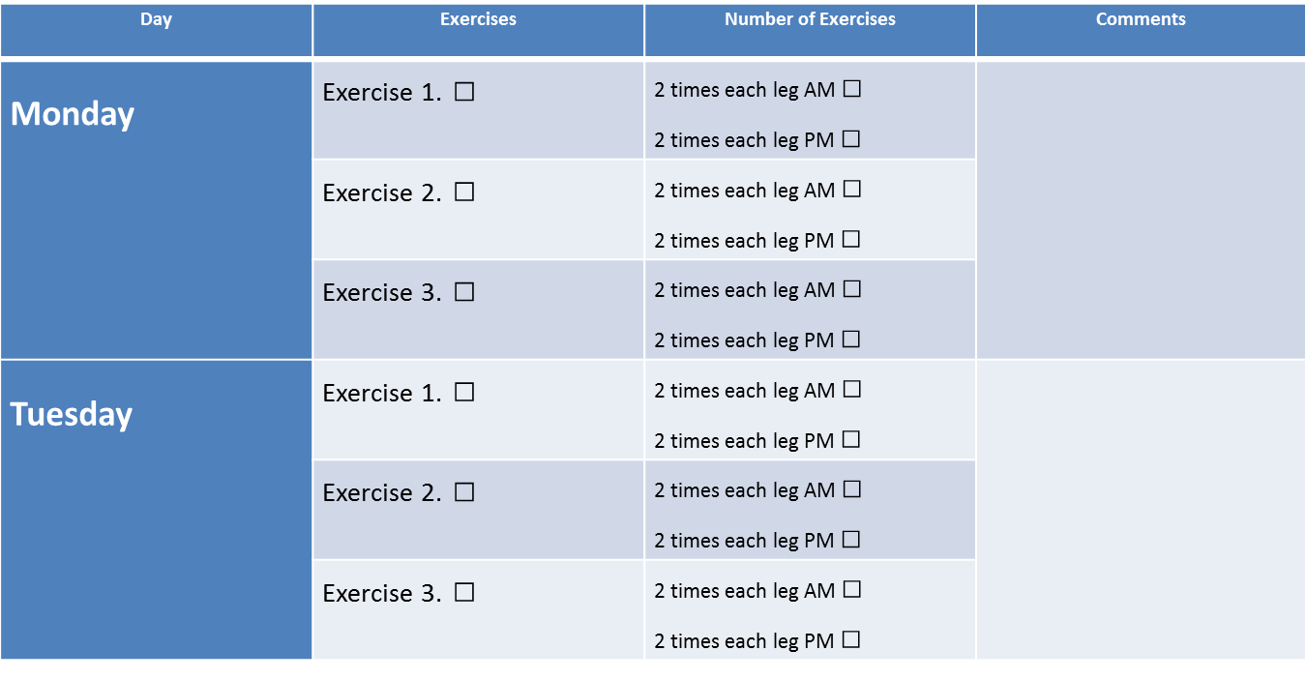

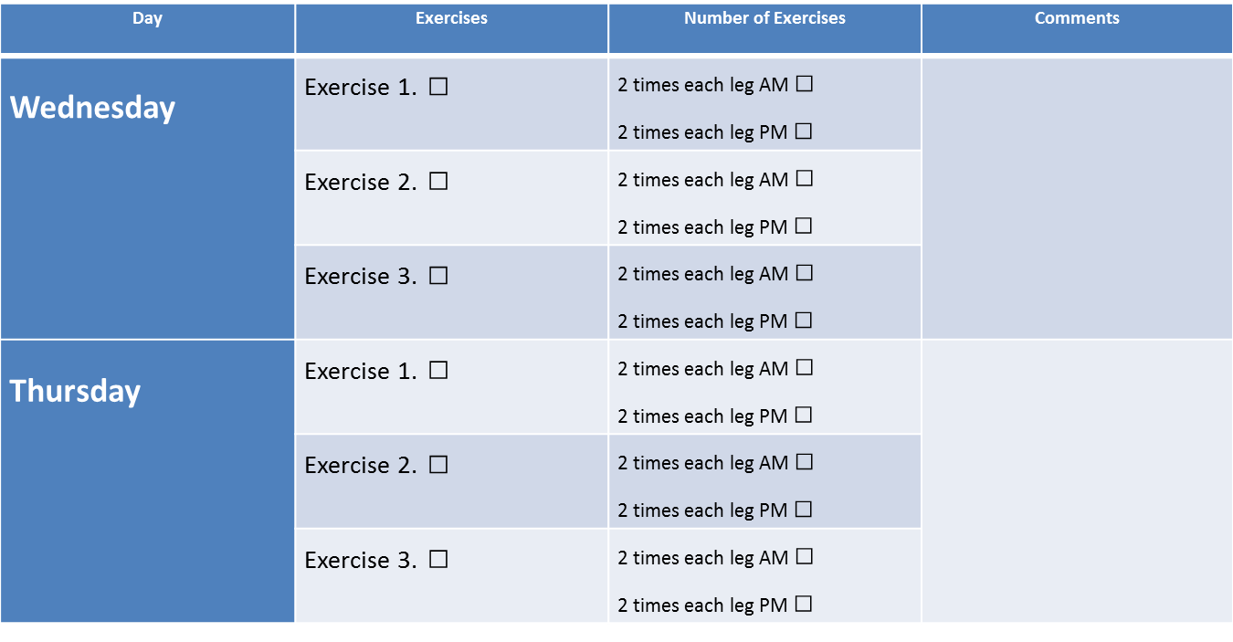

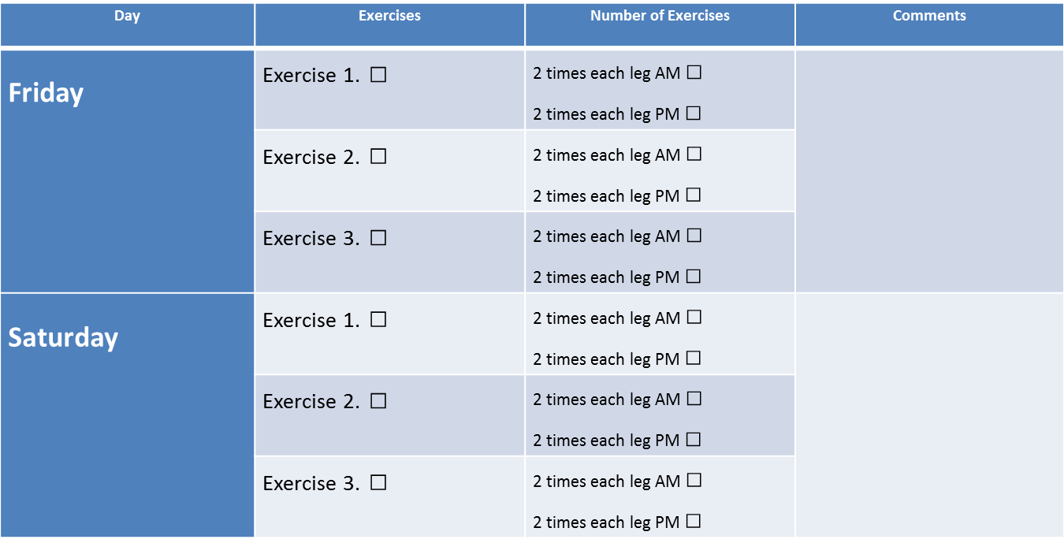

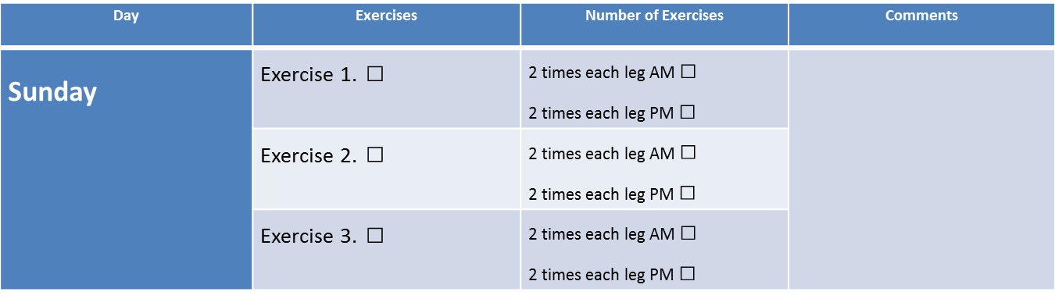
Congratulations, you have completed your first week of exercises!


Question 1: What helped you to decide to do the exercises this week? (For example: it might improve your walking or ability to stand)

Question 2: What stopped you from doing the exercises this week? (For example: lack of time, couldn’t be bothered, physical pain in muscles or joints from doing the exercises)
Thank you for taking the time to complete this diary

Additional file 3: Physiotherapy treatment proforma sheet
Date:
Session number:
Reported issues following last treatment (soreness, pain, swelling, redness):

(if none reported please put NONE in the box above)
Treatment dosage (as per treatment protocol)
Ankle traction
R/Ankle: 2 x 2-min sets of traction (1-min rest btw sets) Completed Yes □ No □
Reasons for no completion:  Dosage delivered: | R
L/Ankle: 2 x 2-min sets of traction (1-min rest btw sets) Completed Yes □ No □
Reasons for no completion:  Dosage delivered: | L

Big toe traction
R/1st MTPJ: 2 x 1 min sets of traction (30-sec rest btw sets) Completed Yes □ No □
Reasons for no completion:  Dosage delivered: | R
L/1st MTPJ: 2 x 1 min sets of traction (30-sec rest btw sets) Completed Yes □ No □
Reasons for no completion:  Dosage delivered: | L

Ankle Gd III AP mobs
R/Ankle: 4 x 2 mins sets of mobs (1-min rest btw sets) Completed Yes □ No □
Reasons for no completion:  Dosage delivered: | R

L/Ankle: 4 x 2 mins sets of mobs (1-min rest btw sets) Completed Yes □ No □
Reasons for no completion:  Dosage delivered: | L
Big toe Gd III PA mobs
R/1st MTPJ: 2 x 2 mins sets of mobs (1-min rest btw sets) Completed Yes □ No □
Reasons for no completion:  Dosage delivered: | R
L/1st MTPJ: 2 x 2 mins sets of mobs (1-min rest btw sets) Completed Yes □ No □
Reasons for no completion:  Dosage delivered: | L

Additional treatment notes:

Home exercise programme
Weekly Exercise sheet checked and completed (handed-in): Yes □ No □
If no, please state action taken:

Exercises visually checked (demo by participant): Yes □ No □
Advise required? Yes □ No □
Demo exercises (by therapist): Yes □ No □
Treatment completed by: | Date:

Additional file 4: Exercise adherence – explanation of equations

Adherence was assessed via the diaries by determining:
- Percentage of people who returned diaries as defined by:
No. people retuning a diary in the intervention group x 100 (equ 1)
Number of participants in the intervention group

- Percentage of weekly diaries returned as defined by:

Percentage diary returns per person*___________ (equ 2)
31 (total number of participant in intervention group)

*Where percentage diary returns =
No. of diaries returned per person_____ x100 (equ 3)
6 (total number of possible diary returns)

- Average percentage exercise compliance as defined by:

Percentage exercise compliance* _____________ (equ 4)
31 (total number of participant in intervention group)

*Where percentage exercise compliance=
No. exercise sessions ticked x100 (equ 5)
No. diaries returned x 42
where 42 indicates the total number of prescribed sessions per week (7 days x 2 sessions / day x3 exercise per session). If people indicated that they undertook more than two sessions in a day these were counted and it is therefore possible to have over 100% compliance using this measure.

