Acacia nodule-associated bacteria induced plant growth promotion and soil N availability

Lina Yu ^{a, b}, Fang You ^{a,} *, Songlin Wu ª, Zhaohua Lu ^{b,} Longbin Huang ^{b}

ª Centre for Mined Land Rehabilitation, Sustainable Minerals Institute, The University of Queensland, Brisbane, Queensland 4072, Australia

^{b} School of Chemical and Environmental Engineering, China University of Mining and Technology (Beijing), Beijing 100083, China

* Corresponding author: Fang You fang.you@uq.edu.au

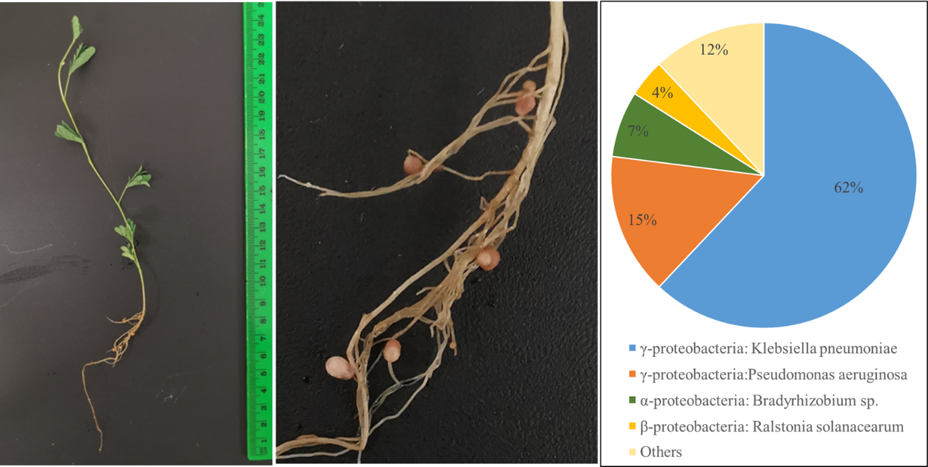
Fig. S1. Pink round nodules formed in 2 weeks old Acacia holosericea and the nodule associated bacterial communities’ composition, comprising of bacteria closest to Klebsiella pneumoniae strain CRKP_45 (62%), Pseudomonas aeruginosa strain PALA39 (15%), Bradyrhizobium sp. STM8087 (7%) and Ralstonia solanacearum strain FJAT130 (4%).
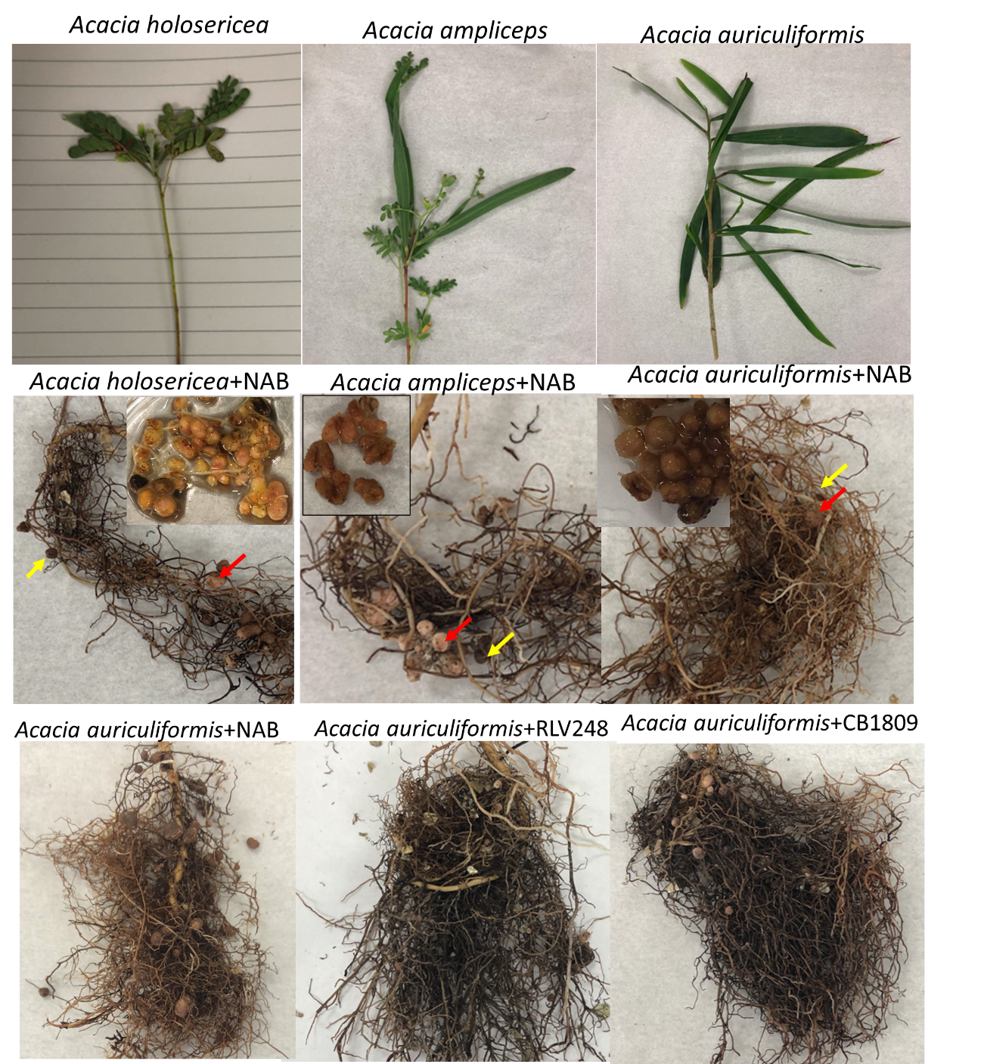
Fig. S2. Illustrations of three Acacia seedlings (A. holosericea, A. auriculiformis, A. ampliceps) and both black (yellow arrow) and pick (red arrow) nodules formed in the roots after inoculation with three bacteria inoculum (Nodule associated bacteria: NAB, Bradyrhizobium japonicum CB1809 :CB1809 and Rhizobium leguminosarum bv viciae RLV248 : RLV248). Nodule morphology clearly differentiate Acacia species. Nodules from A. holosericea is determinate, desmodioid, mostly spherical with lenticels, and their diameter ranged between 1-5mm; Nodules from A. auriculiformis is also determinate, desmodioid, mostly spherical with lenticels, and their diameter ranged between 1.5-3mm; Nodules from A. ampliceps are indeterminate with two or three branches, and their diameter ranged between 1.5-3mm. Nodule morphology are similar in the same Acacia species with different bacteria inoculum.

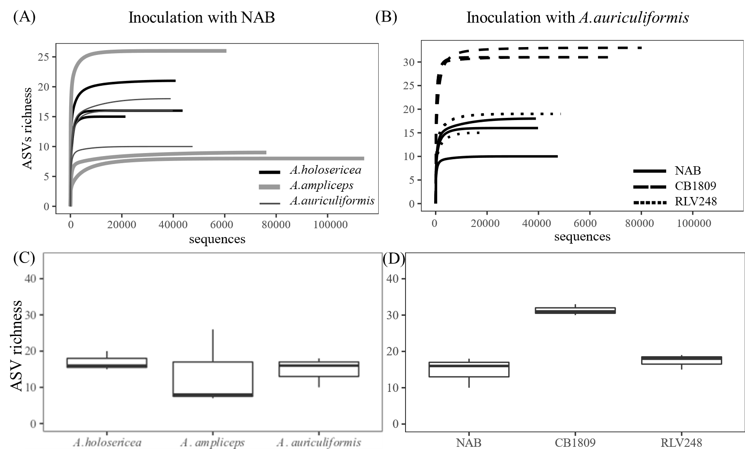
Fig. S3. The rarefraction curve (A) and boxplot ASVs richness (C) of bacterial communities in the three Acacia nodules (A. holosericea, A. auriculiformis, A. ampliceps) which were inoculated with NAB at 8 weeks old; The rarefraction curve (B) and boxplot of ASVs richness in A. auriculiformis nodules inoducated with the bacterial inoculums (Nodule associated bacteria: NAB, Bradyrhizobium japonicum CB1809 :CB1809, and Rhizobium leguminosarum bv viciae RLV248 : RLV248).
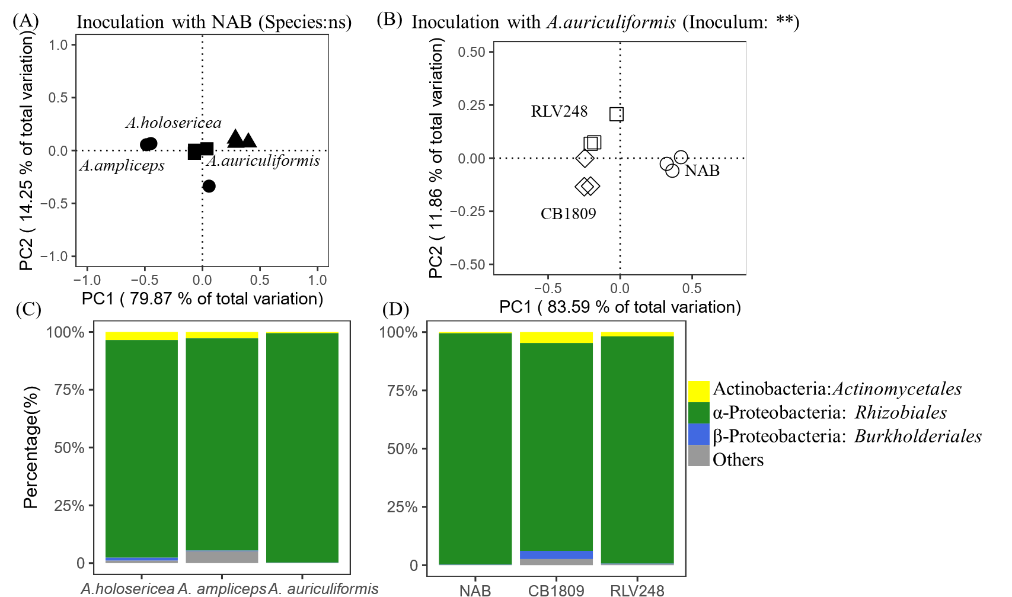
Fig. S4. Unconstrained principal coordinates analysis (PCoA) plots illustrating the similarities in individual samples based on Bray-Curtis distance of square root transformed relative abundance of ASVs (A) and composition of bacterial communities at the order level (C) of the three Acacia nodules (A. holosericea, A. ampliceps, A. auriculiformis) which were inoculated with NAB at 8 weeks old; PCoA (B) and composition of bacterial communities at the order level (D) in A. auriculiformis nodules inoducated with the bacterial inoculums (Nodule associated bacteria: NAB, Bradyrhizobium japonicum CB1809 :CB1809 and Rhizobium leguminosarum bv viciae RLV248 : RLV248).
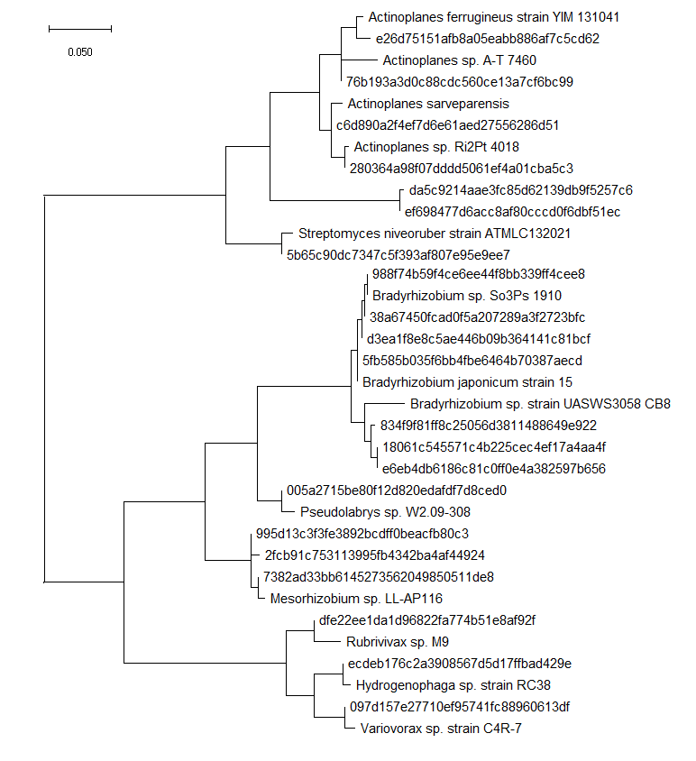
Fig. S5 The maximum likelihood phylogeny of the 16S rRNA gene of representative sequences and their closest strains. The tree is rooted and provides a visual representation of the genetic distance between these sequences.

Table S1. Summary of results of nodule development, plant growth and N uptake and availability in relation to the experimental treatments using two-way anova analysis. The significance levels are presented for each parameter.
Treatment factors  Parameters |  | Experiment 1 |  | Experiment 2
 |  | Age | Inoculum | Species | Inoculum
Plant Growth | Shoot height | *** | ** | * | ns
Plant Growth | Shoot biomass | *** | * | *** | ***
Plant Growth | Root biomass | *** | ns | *** | **
Nodule development | Nodule number per gram root | ** | ** | ** | **
Nodule development | Nodule fresh biomass | ** | * | ** | ***
Plant N | Shoot N concentration | *** | ns | ** | **
Plant N | N content in shoot | *** | ns | *** | **
Soil N | Ammonium N (NH₄-N) | ns | *** | ns | ***
Soil N | Nitrite/Nitrate-N (NO_{X}-N) | ns | *** | ns | ***
ns: not-significant; *P<0.05; **P<0.01; ***P<0.001
Table S2. Summary of statistical table ASV richness and the top 4 abundant bacterial order in the nodules among different Acacia species or with different bacterial inoculum with A. aurifuliformis using one way ANOVA analysis.
 | Three Acacia with NAB |  | Three bacteria inoculum with A. auriculiformis
Factors | Species |  | Inoculum
Two-way ANOVA statistics | F | P | F | P
ASV richness | 0.179 | 0.84 | 20.54 | 0.002
Actinobacteria: Actinomycetales | 0.616 | 0.57 | 1.898 | 0.18
Chloroplast: Streptophyta | 2.578 | 0.16 | 2.747 | 0.08
Alphaproteobacteria: Rhizobiales | 1.046 | 0.41 | 1.229 | 0.34
Alphaproteobacteria: Rickettsiales | 2.141 | 0.20 | 0.495 | 0.69

