Supporting Information

One-pot synthesis and in vitro bioactivity of novel 4-aminopyrazolo[3,4-b]pyridine derivatives as potential antimicrobial compounds
Ranjana Aggarwal ^{1,2}*, Suresh Kumar², Garima Sumran³, Deepansh Sharma⁴
¹ CSIR-National Institute of Science, Communication and Policy Research, New Delhi, 110012, India
² Department of Chemistry, Kurukshetra University, Kurukshetra-136119, Haryana, India
³ Department of Chemistry, D. A. V. College (Lahore), Ambala City 134003, Haryana, India
⁴ Amity Institute of Microbial Technology, Amity University, Jaipur, Rajasthan, India.

*e-mail: ranjanaaggarwal67@gmail.com

Table of Contents
1. Spectral data
- ¹H NMR of 3,6-Bis(4-bromophenyl)-1-phenylpyrazolo[3,4-b]pyridin-4-amine (11a) S3
- ¹³C NMR of 3,6-Bis(4-bromophenyl)-1-phenylpyrazolo[3,4-b]pyridin-4-amine (11a) S4
- ¹H NMR of 6-(4-Bromophenyl)-1-phenyl-3-(4-chlorophenyl)pyrazolo[3,4-b]pyridin-4-amine (11c) S5
- ¹³C NMR of 6-(4-Bromophenyl)-1-phenyl-3-(4-chlorophenyl)pyrazolo[3,4-b]pyridin-4-amine (11c) S6
- ¹H NMR of 6-(4-Bromophenyl)-1-phenyl-3-(4-fluorophenyl)pyrazolo[3,4-b]pyridin-4-amine (11d) S7-S8
- ¹³C NMR of 6-(4-Bromophenyl)-1-phenyl-3-(4-fluorophenyl)pyrazolo[3,4-b]pyridin-4-amine (11d) S9
- IR of 6-(4-Methylphenyl)-1-phenyl-3-(4-fluorophenyl)pyrazolo[3,4-b]pyridin-4-amine (11f) S10
- ¹H NMR of 6-(4-Methylphenyl)-1-phenyl-3-(4-fluorophenyl)pyrazolo[3,4-b]pyridin-4-amine (11f) S11
- ¹³C NMR of 6-(4-Methylphenyl)-1-phenyl-3-(4-fluorophenyl)pyrazolo[3,4-b]pyridin-4-amine (11f) S12
- IR of 3-(4-Methylphenyl)-1-phenyl-6-(4-bromophenyl)pyrazolo[3,4-b]pyridin-4-amine (11g) S13
- ¹H NMR of 3-(4-Methylphenyl)-1-phenyl-6-(4-bromophenyl)pyrazolo[3,4-b]pyridin-4-amine (11g) S14-S15
- ¹³C NMR of 3-(4-Methylphenyl)-1-phenyl-6-(4-bromophenyl)pyrazolo[3,4-b]pyridin-4-amine (11g) S16
- IR of 6-(4-Chlorophenyl)-1,3-diphenylpyrazolo[3,4-b]pyridin-4-amine (11h) S17
- ¹H NMR of 6-(4-Chlorophenyl)-1,3-diphenylpyrazolo[3,4-b]pyridin-4-amine (11h) S18
- ¹³C NMR of 6-(4-Chlorophenyl)-1,3-diphenylpyrazolo[3,4-b]pyridin-4-amine (11h) S19
- ¹H NMR of 6-(4-Bromophenyl)-1,3-diphenylpyrazolo[3,4-b]pyridin-4-amine (11i) S20-S21
¹³C NMR of 6-(4-Bromophenyl)-1,3-diphenylpyrazolo[3,4-b]pyridin-4-amine (11i) S22
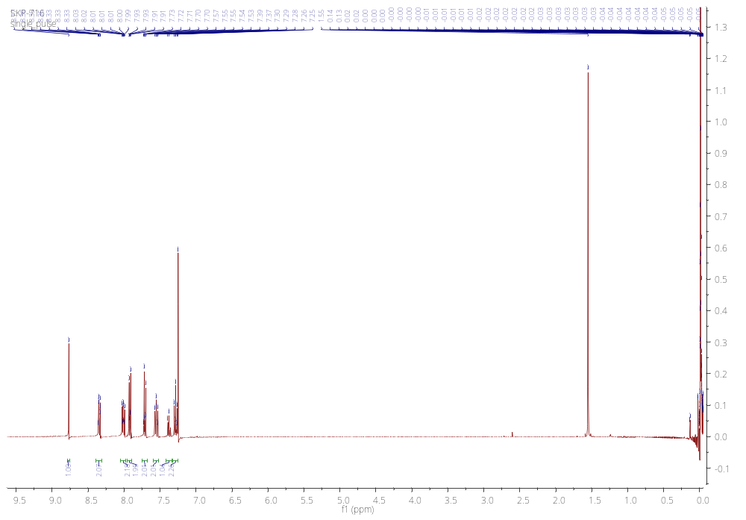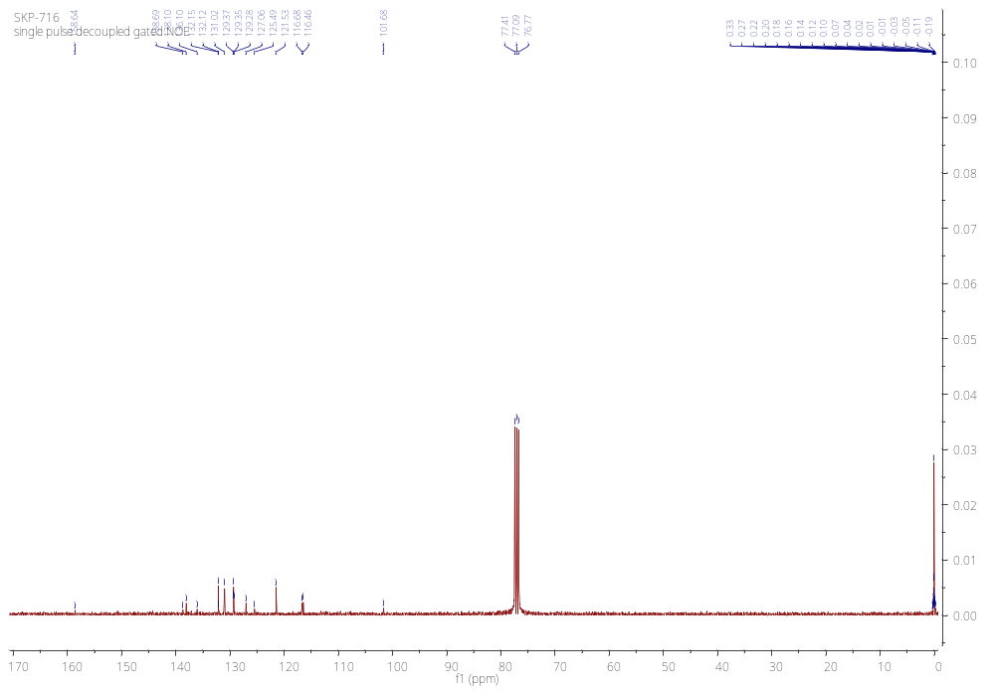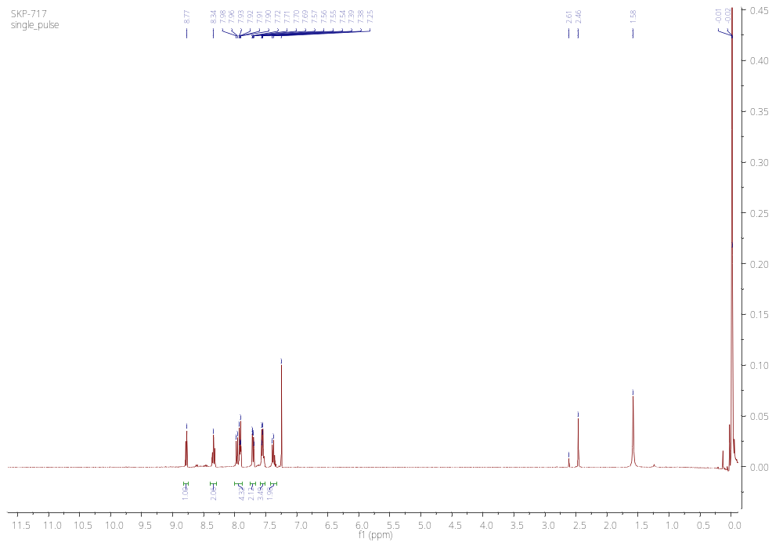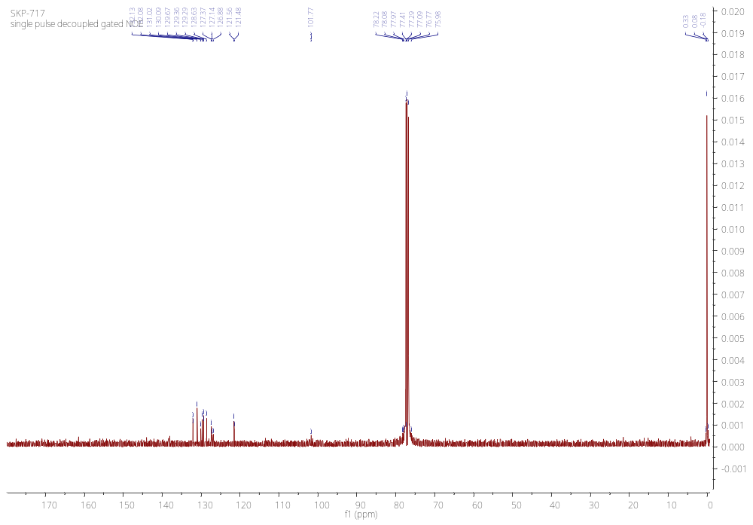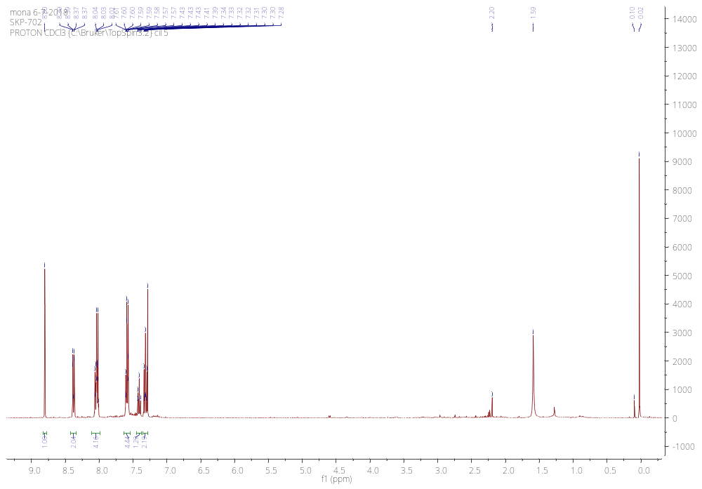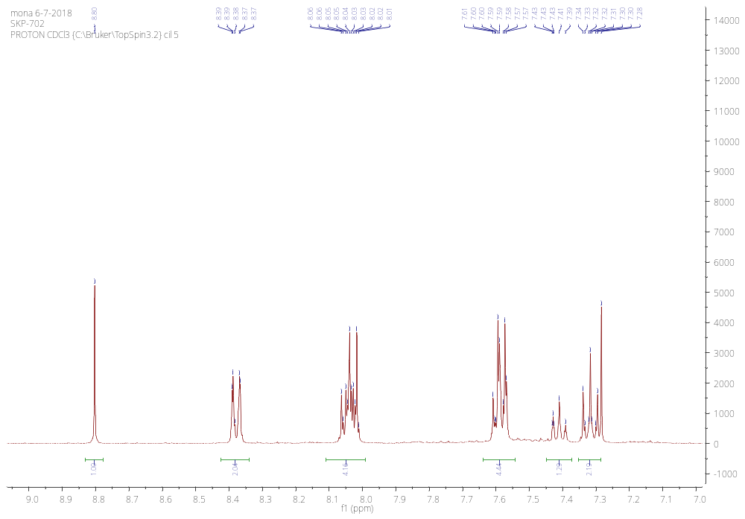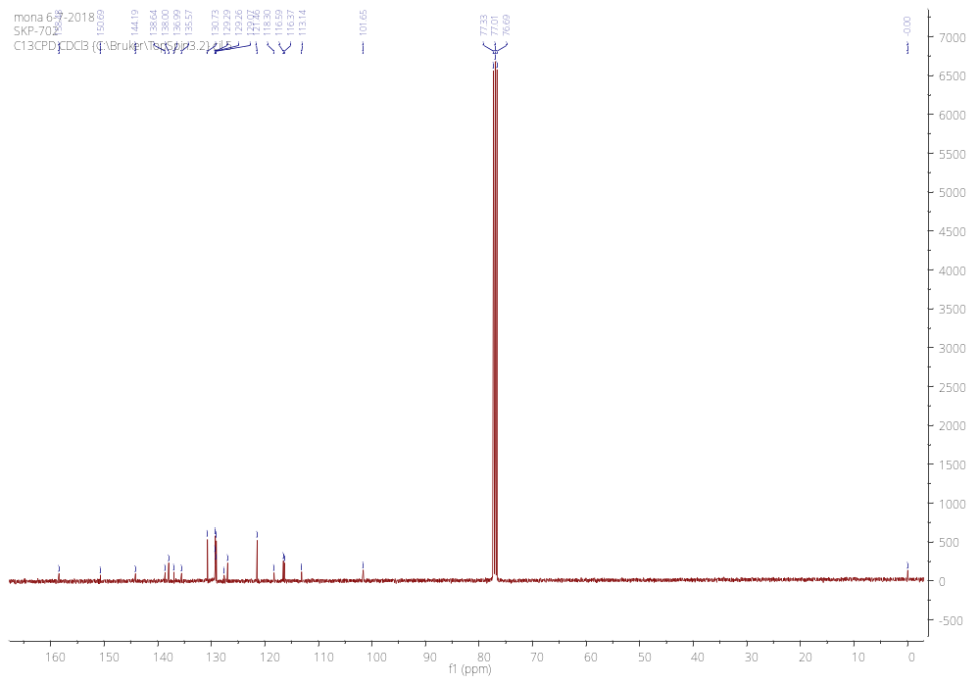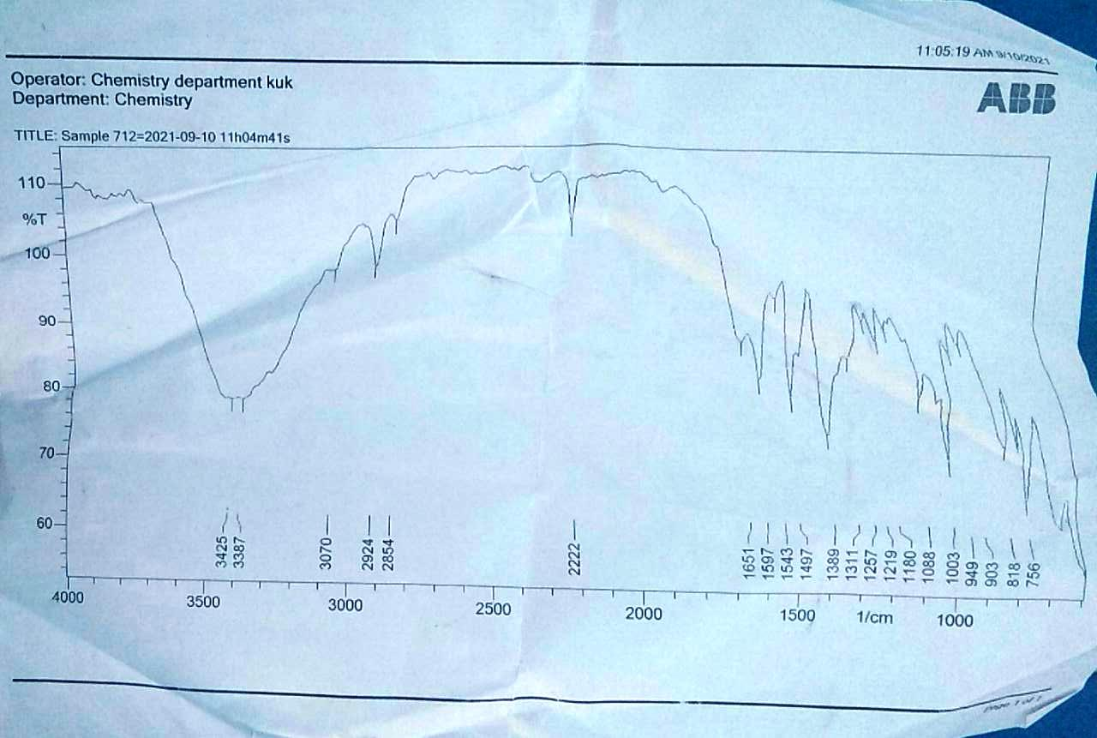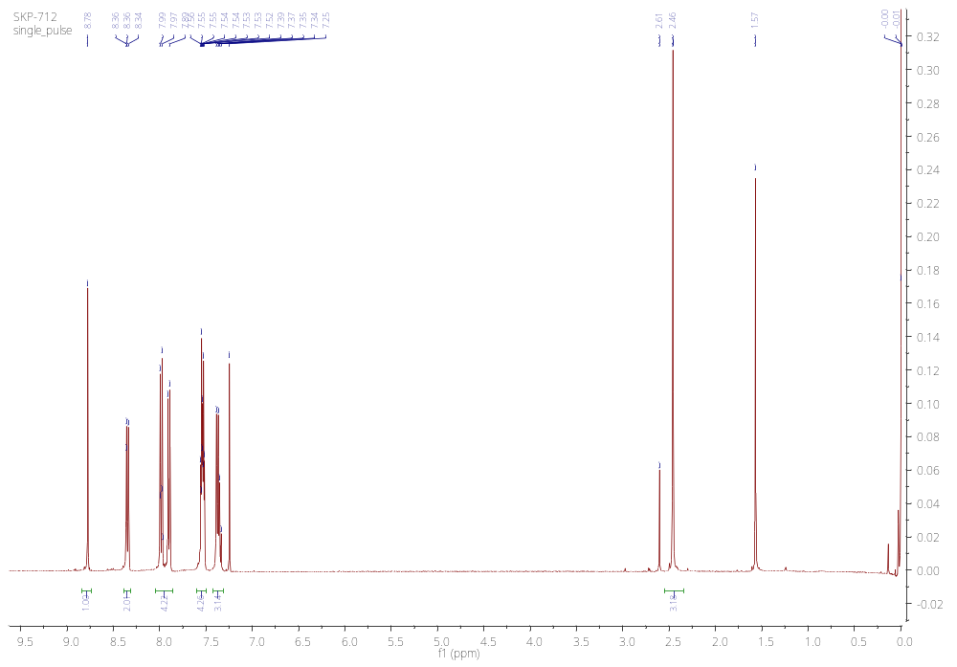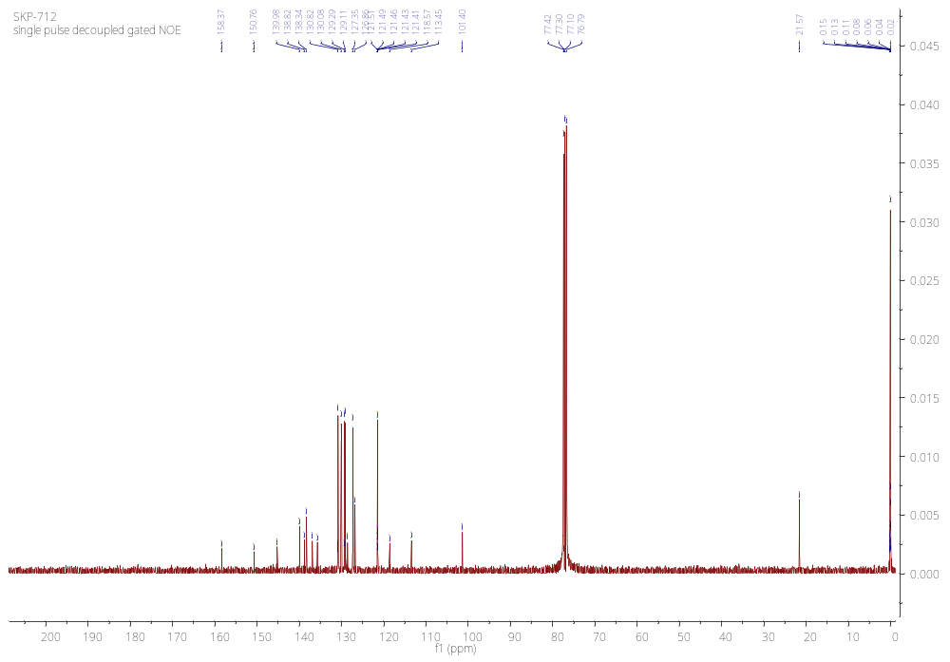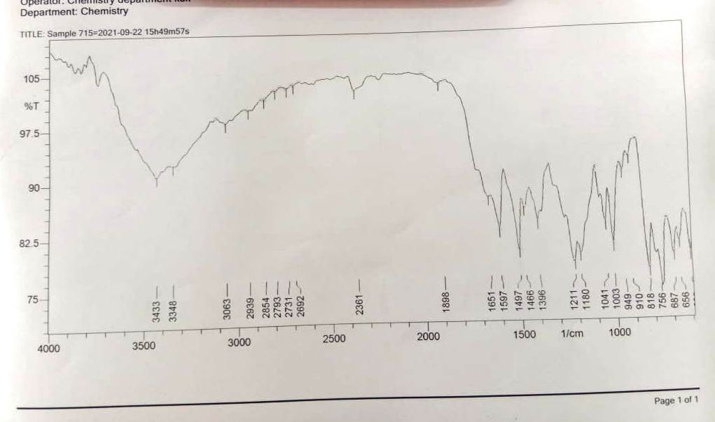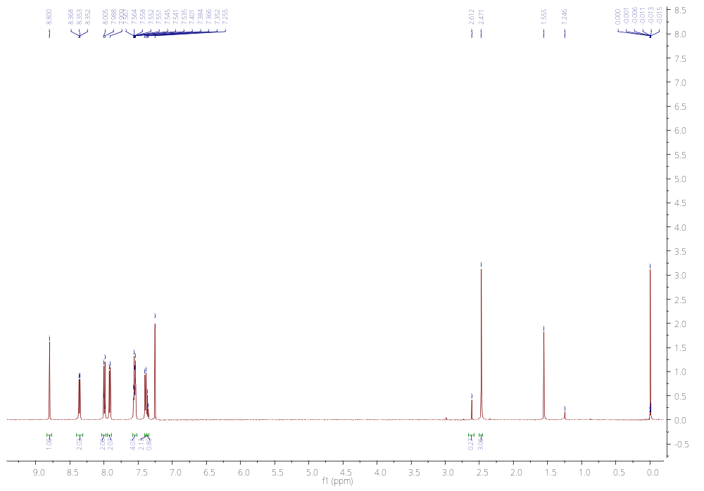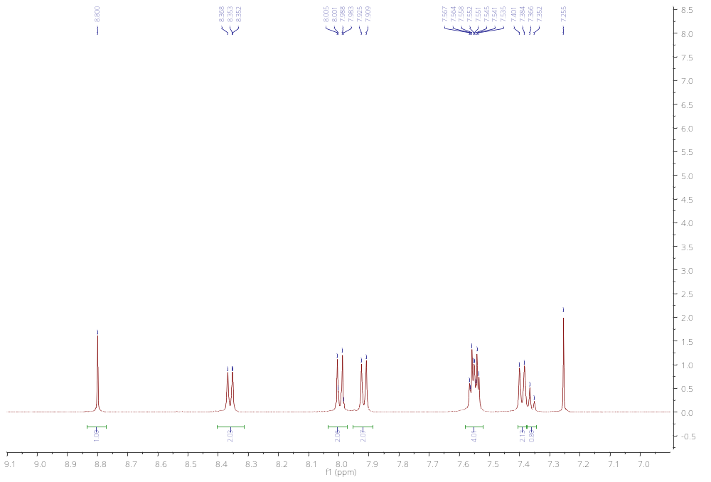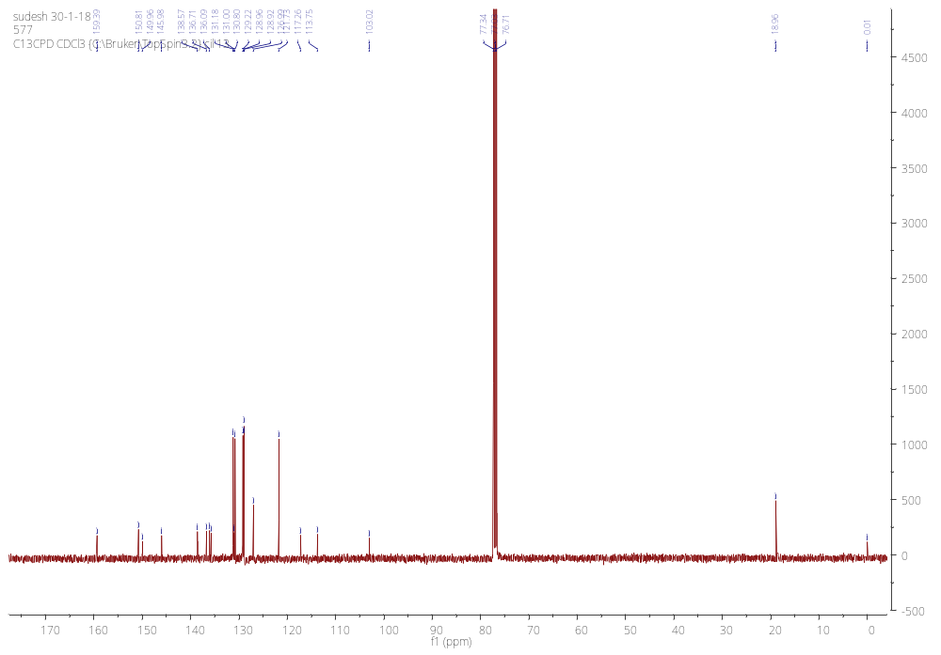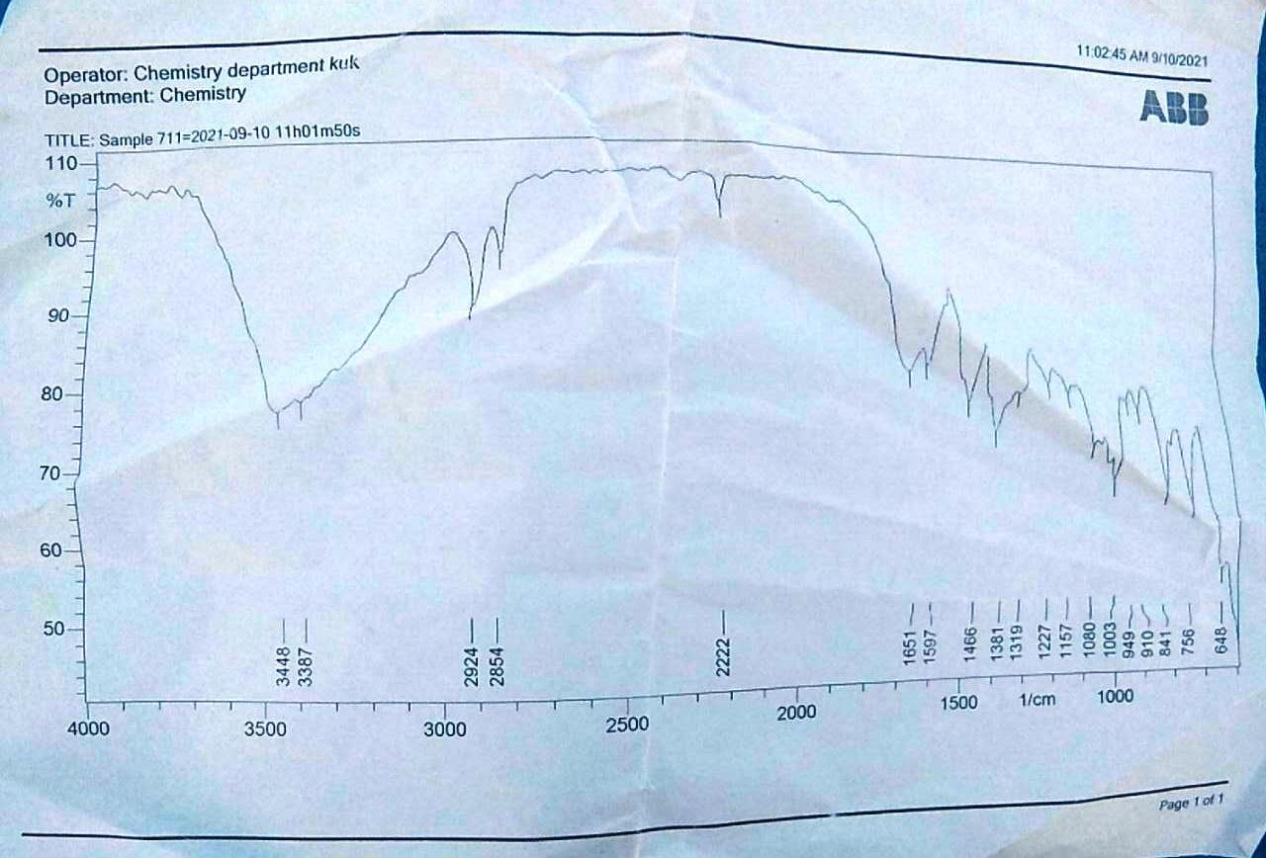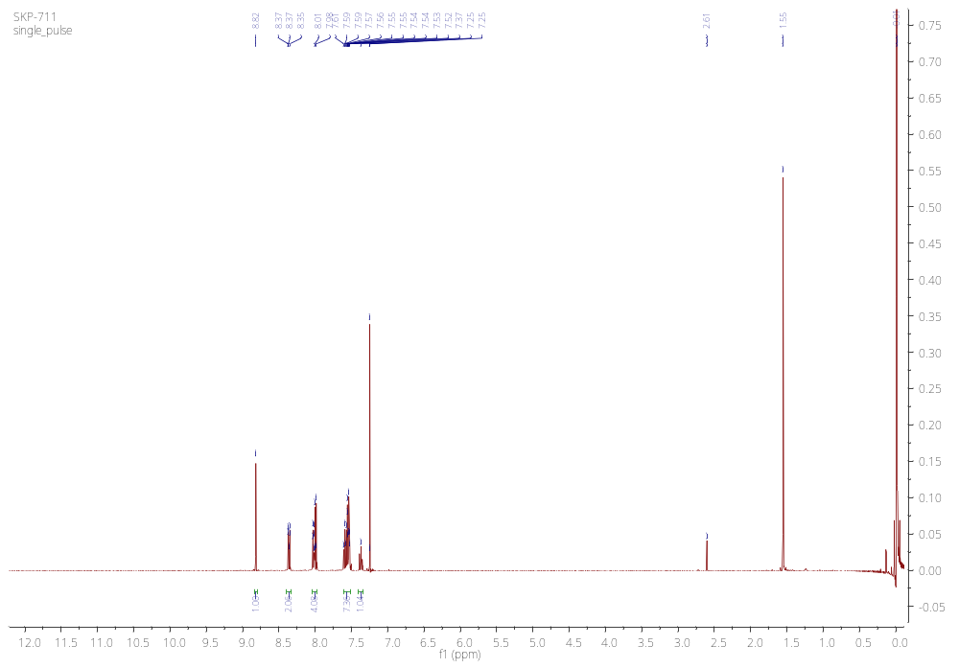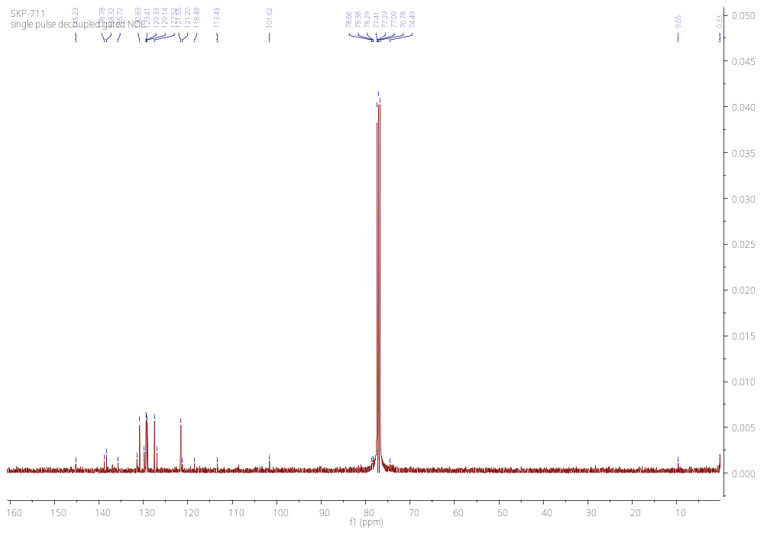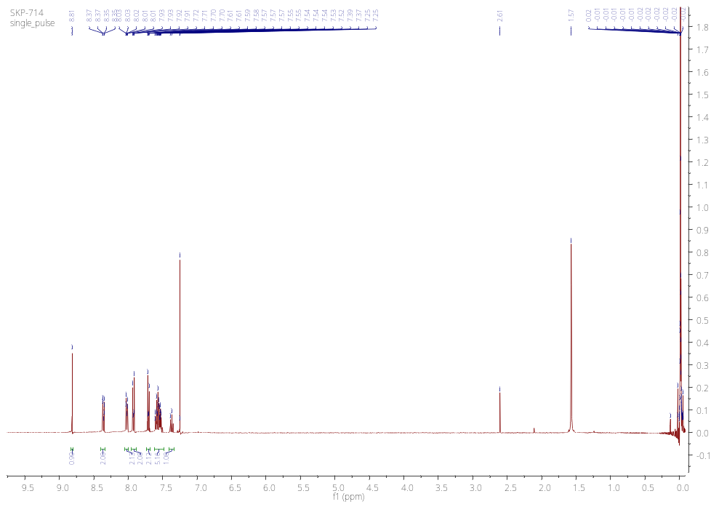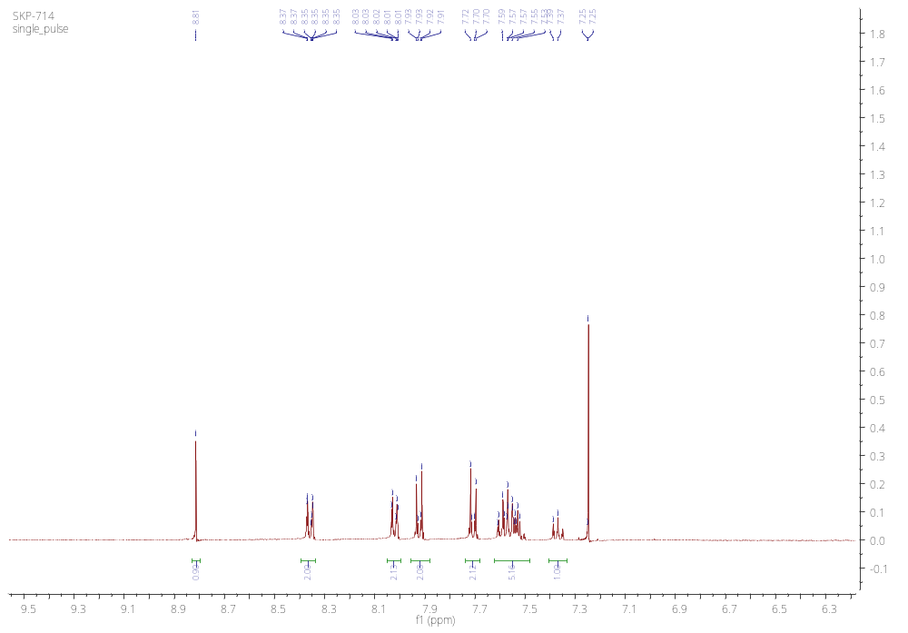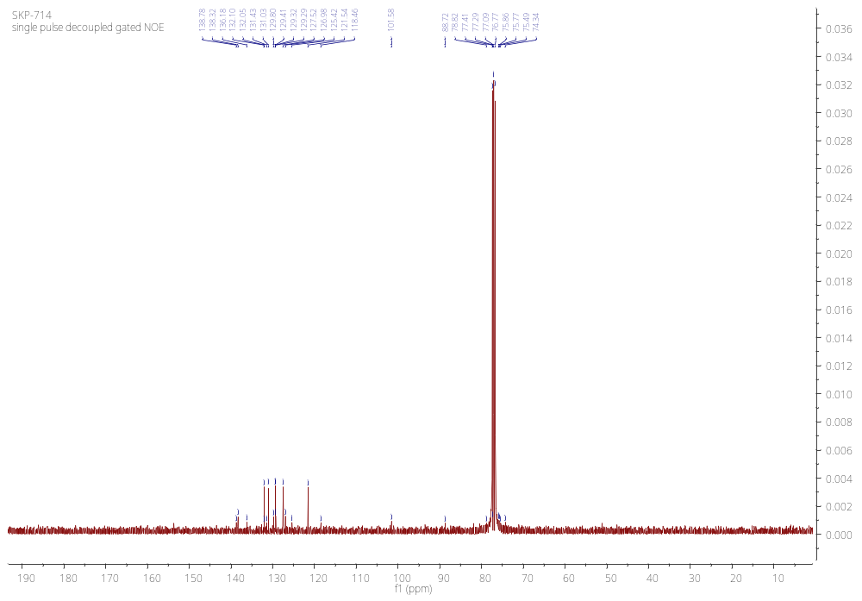
11a
11a
11c
11c
11d
11d
11d
11f
11f
11f
11g
11g
11g
11g
11h
11h
11h
11i
11i
11i

