Supplementary Table 1. Baseline characteristics of patients in the meta-analysis.
Author, year | Mean age  (years) | Male (%) | Disease duration (years) | Previous TNF antagonist use (%) | Immunomodulators use at baseline (%) | Corticosteroid use at baseline (%) | Disease site (I/C/IC, %) | Mean CDAI
Feagan, Brian G. 2017 | 37.5 | 39 | 13 | 88 | 26 | 31 | 31/55/81 | 297.5 (Median)
Sands, B. E.  2017 | 36.5 | 37.8 | 12.2 | 100 | 27 | 40 | 27/29/44 | 318.6
D'Haens, Geert 2022 | 37·5 | 54 | 8·8 | 96 | 24 | 30 | 15/36/50 | 313·0
D'Haens, Geert 2022 | 39·6 | 51 | 11·7 | 95 | 23 | 34 | 14/39/47 | 314·2
Sands, B. E.  2022 | 38.8 | 48.6 | 9.6 | 59 | 32 | 30 | 17/39/43 | 313.9
Sandborn, W. J. 2022 | 38.8 | 59.2 | 8.8 | 53 | 36 | 37 | 29/42/29 | 309.0
Sandborn, W. J. 2012 | 39.0 | 41.3 | 12.3 | 99 | 24 | 50 | -- | 323.9
Feagan, B. G. 2016 | 37.3 | 42.7 | 12.2 | 0 | 31 | 46 | 14/17/69 | 322.5
Feagan, B. G. 2016 | 39.2 | 46.7 | 9.3 | 68 | 29 | 39 | 23/20/57 | 302.8
Sandborn, W. J. 2022 | 38.8 | 59.2 | 8.8 | 53 | 36 | 37 | 29/42/29 | 309
TNF, Tumor Necrosis Factor; I, Ileum; C, Colon; IC, Ileum and colon; CDAI, Crohn’s Disease Activity Index.

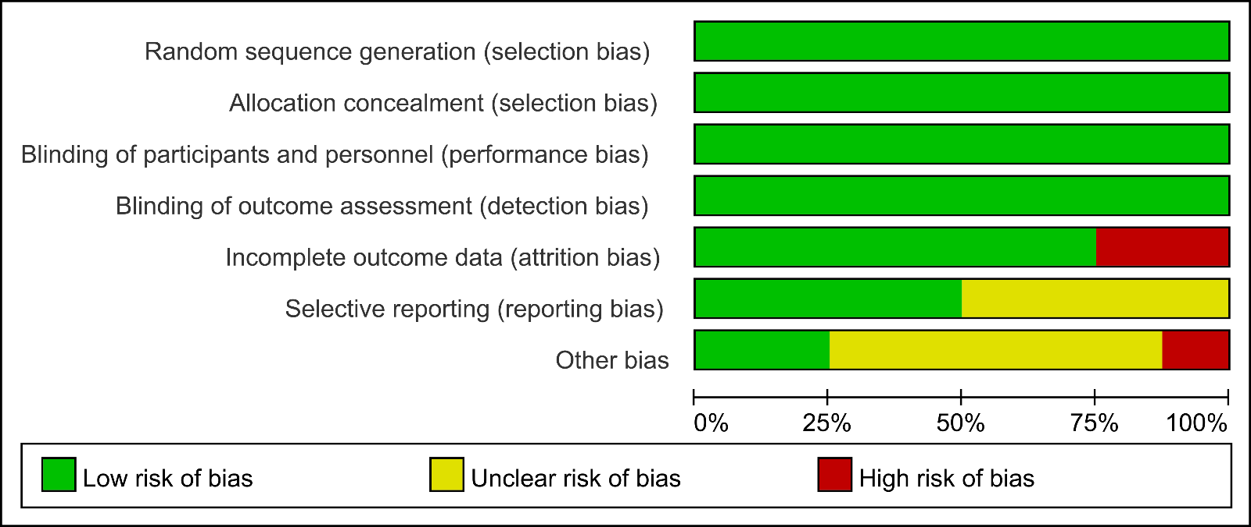
SFig.1 Quality assessment of each study included in this meta-analysis.
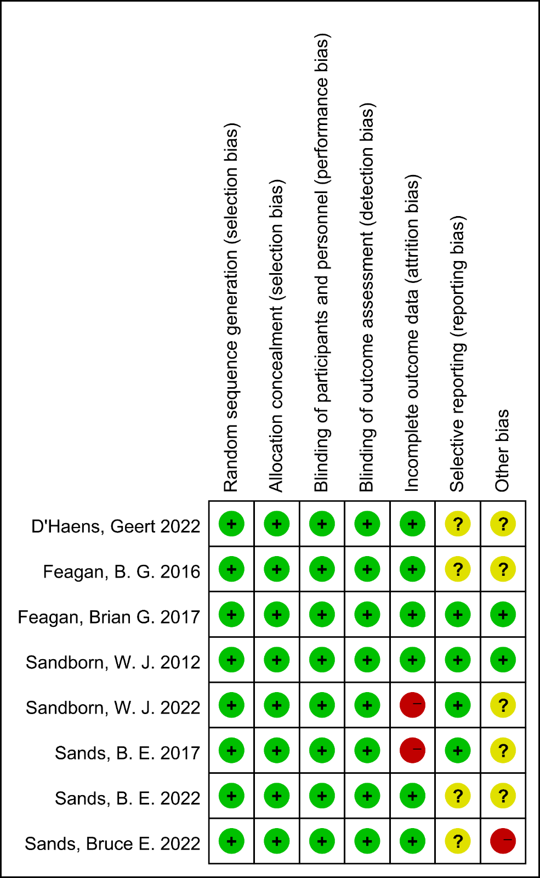
SFig.2 Quality assessment of studies included in this meta-analysis (Risk of bias summary).

