Supplementary Figure 2

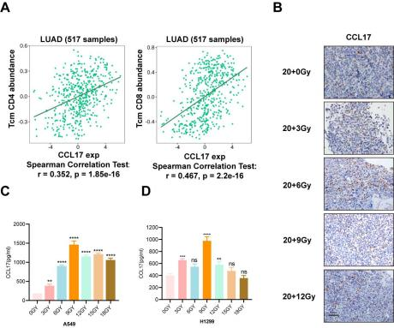

Fig. S2.
(A) Correlation between CCL17 and CD4 and CD8 expression in lung adenocarcinoma. (B) Immunohistochemistry of CD8 and CCL17. (C) Secretion of CCL17 in A549 cells after different doses of irradiation. (D) Secretion of CCL17 in H1299 cells after different doses of irradiation. **P < 0.01, ***P < 0.001, ****P < 0.0001.

