Supplementary Figure 1

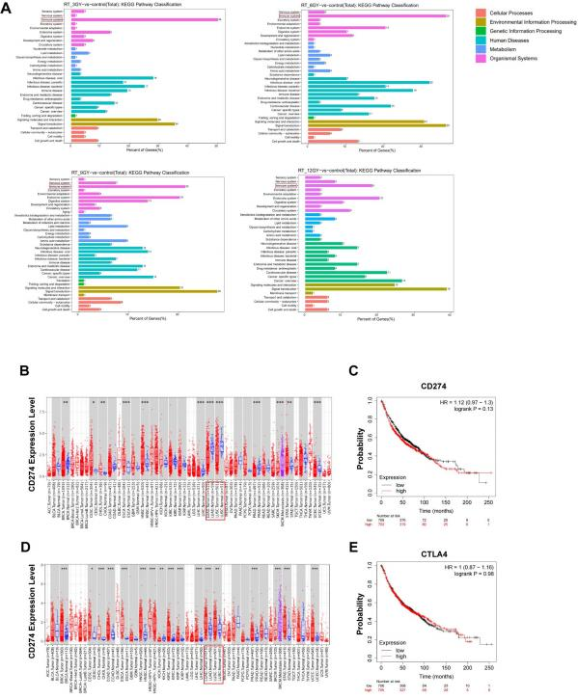

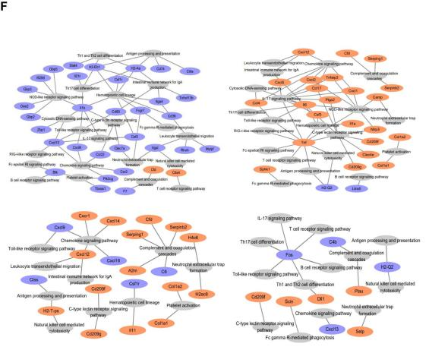

Fig. S1.
(A) KEGG pathway enrichment analysis. (B) Differences in CD274 expression levels in different tumors in the TIMER database; (C) Survival curve of CD274 in the Kaplan‒ Meier database. (D) Differences in CTLA4 expression levels in different tumors in the TIMER database. (E) Survival curve of CTLA4 in the Kaplan‒ Meier database; (F) Pathway enrichment of immune system-related differential genes (orange for up-regulated differential genes in the immune system, blue for down-regulated differential genes)。

