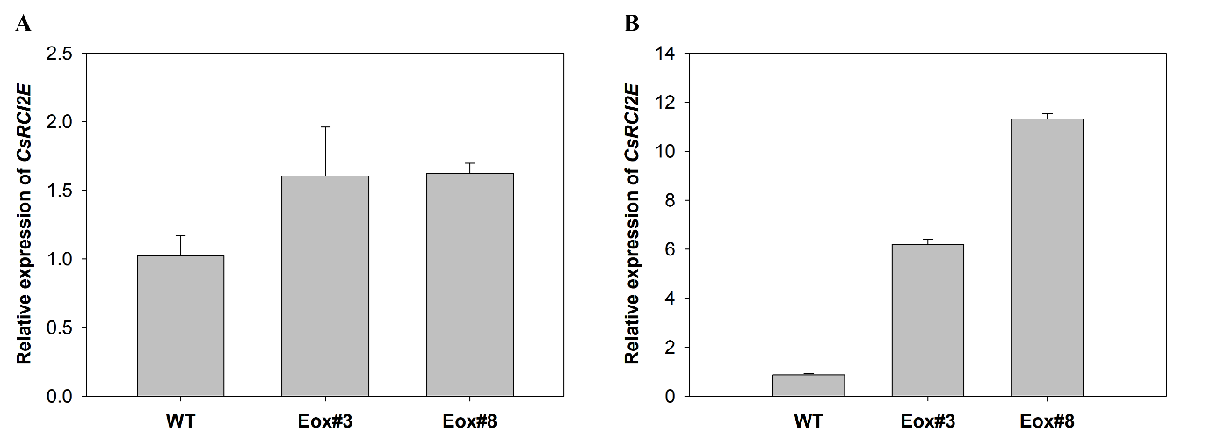
Supplementary Figure 1. The transcription of CsRCI2E in transgenic Camelina. Camelina seedlings were grown in a hydroponics system for 7 d and then the plants were treated without (A) or with 150 mM NaCl (B) for 24 h. The whole plants were harvested when the light was turned on. The quantitative expression of CsRCI2E was analyzed using qRT-PCR. Bars and error bars indicate mean ± SE (n = 3).

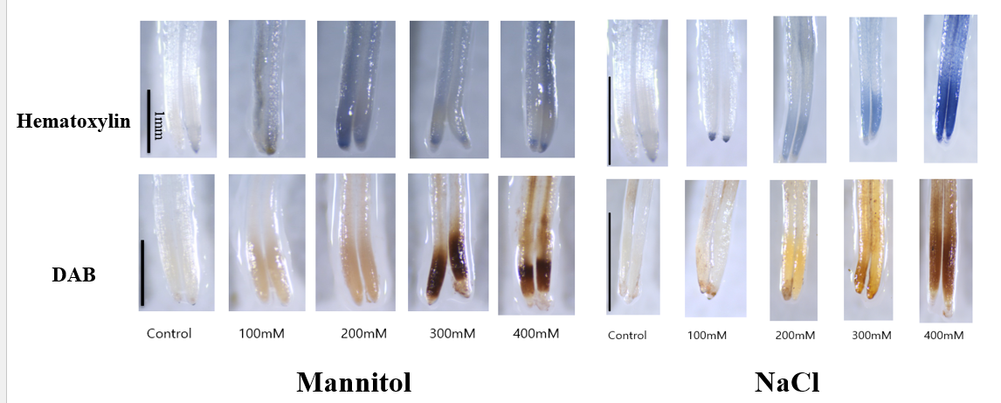

Supplementary Figure 2. Mannitol and NaCl stresses induced cell damage in Camelina seedlings. Camelina seedlings (7-d-old) were treated with mannitol or NaCl for 24 h. The seedlings were stained with hematoxylin and DAB to observe cell damage and ROS accumulation, respectively. The root samples were observed using a stereo microscope.

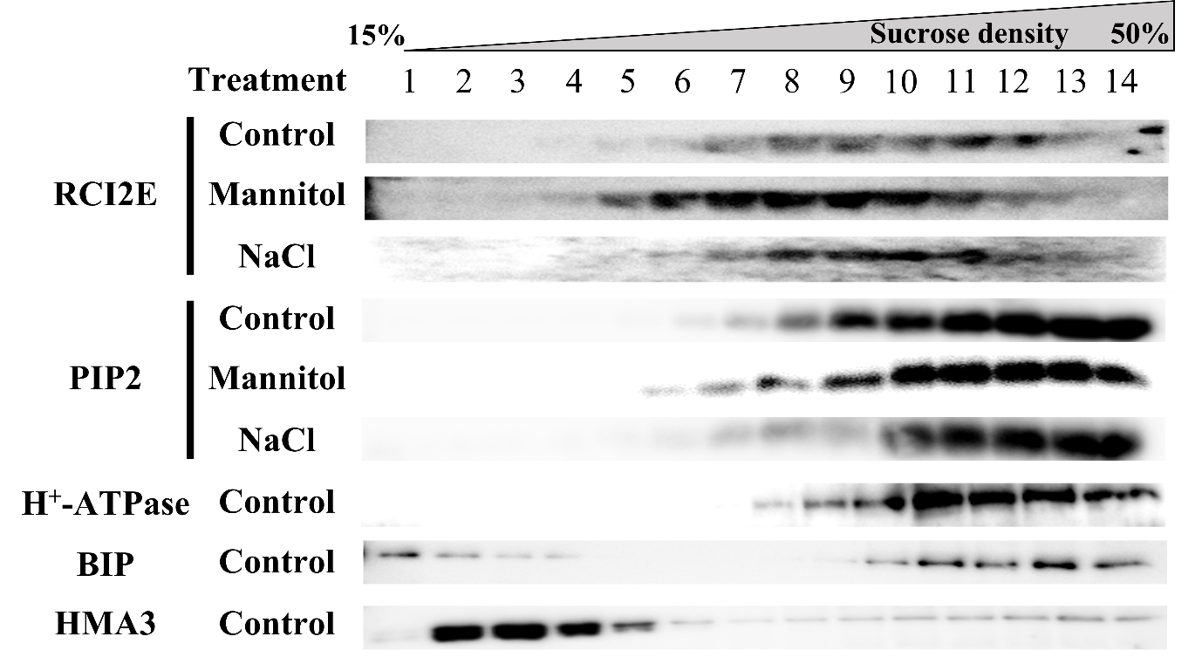
Supplementary Figure 3. The subcellular localization of CsRCI2E and CsPIP2 at the cell membrane during mannitol and NaCl stress. Camelina seedlings (7-d-old) were transplanted to a nutrient solution containing 300 mM mannitol or 150 mM NaCl for 24 h. The RCI2E, H+-ATPase, BiP, and HMA3 bands were detected at approximately 8, 105, 74, and 58 kDa, respectively.

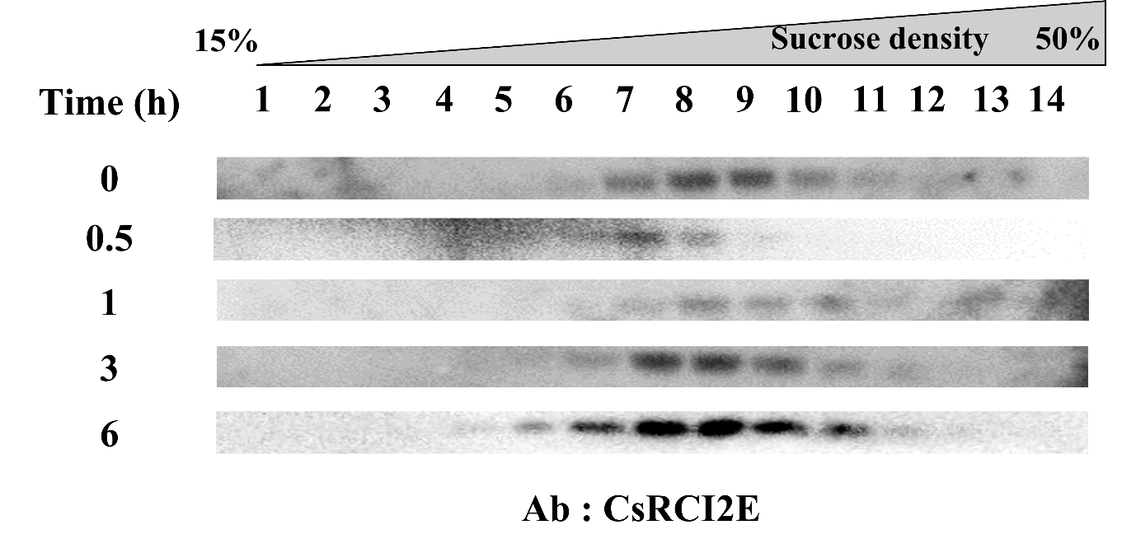
Supplementary Figure 4. The subcellular redistribution of CsRCI2E during NaCl stress. Camelina seedlings (7-d-old) were transplanted to a nutrient solution with 150 mM NaCl for 0.5, 1, 3, and 6 h. The CsRCI2E contents in each fraction were analyzed using the anti-RCI2E antibody. The RCI2E bands were detected at approximately 8 kDa.

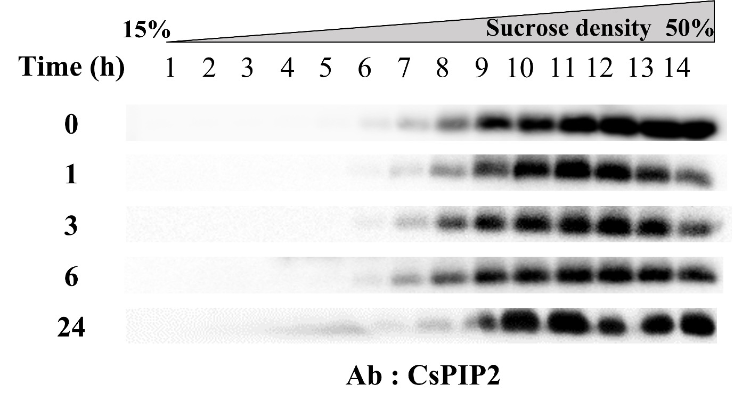
Supplementary Figure 5. The time-dependent subcellular redistribution of CsPIP2 under NaCl stress. Camelina seedlings (7-d-old) were transplanted to a nutrient solution containing 150 mM NaCl for 1, 3, 6, and 24 h. The detection of CsPIP2 in each fraction was conducted using anti-PIP2. The PIP2 bands were detected at approximately 25 kDa.

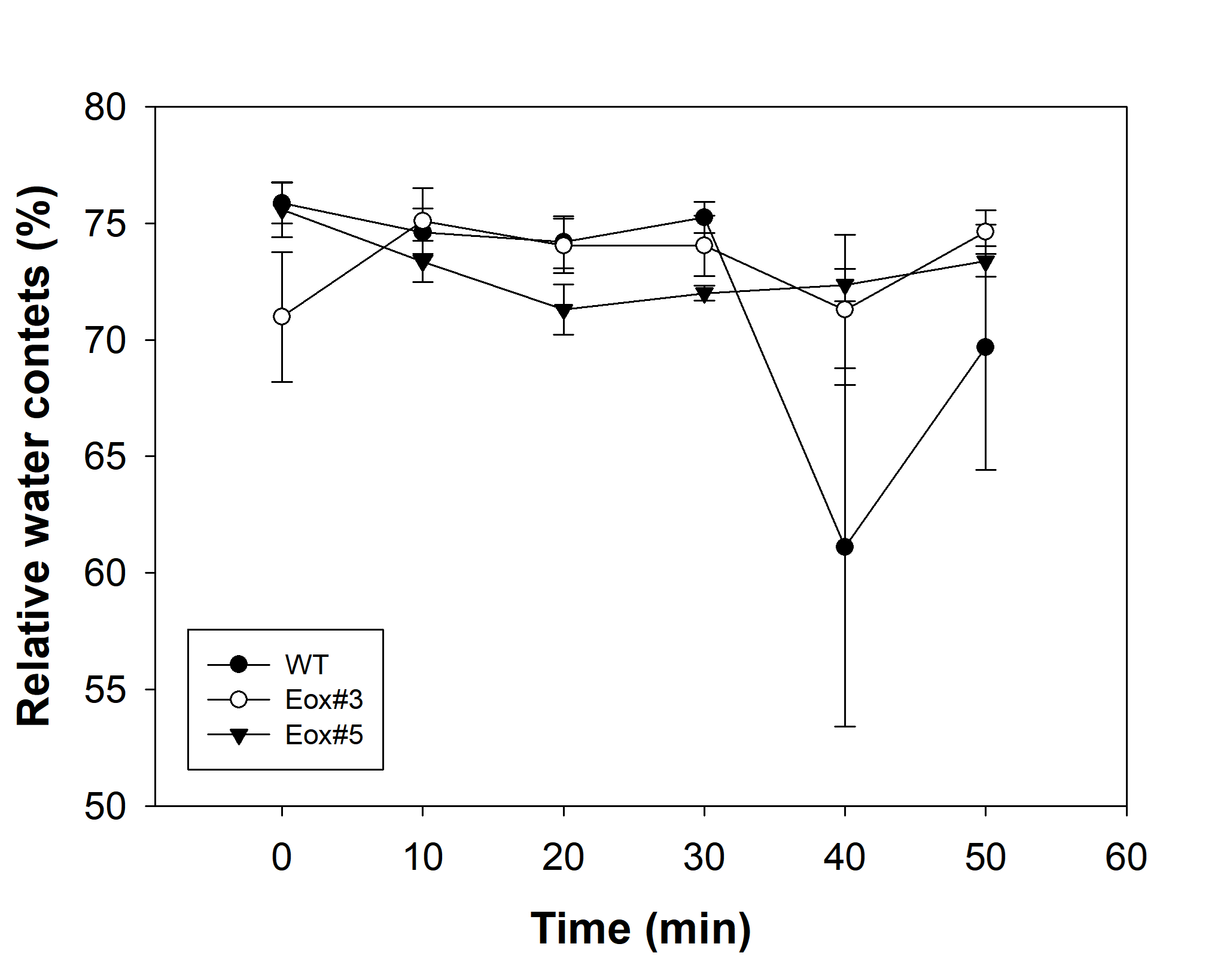
Supplementary Figure 6. The relative water contents in the WT and CsRCI2E-overexpressing Camelina plants under NaCl stress. Camelina plants (3-wk-old) were treated with 150 mM NaCl for 0, 10, 20, 30, 40, and 50 min. Then, the weight of fresh, turgid, and dried secondary leaf samples was measured (n = 3).

