Supplement
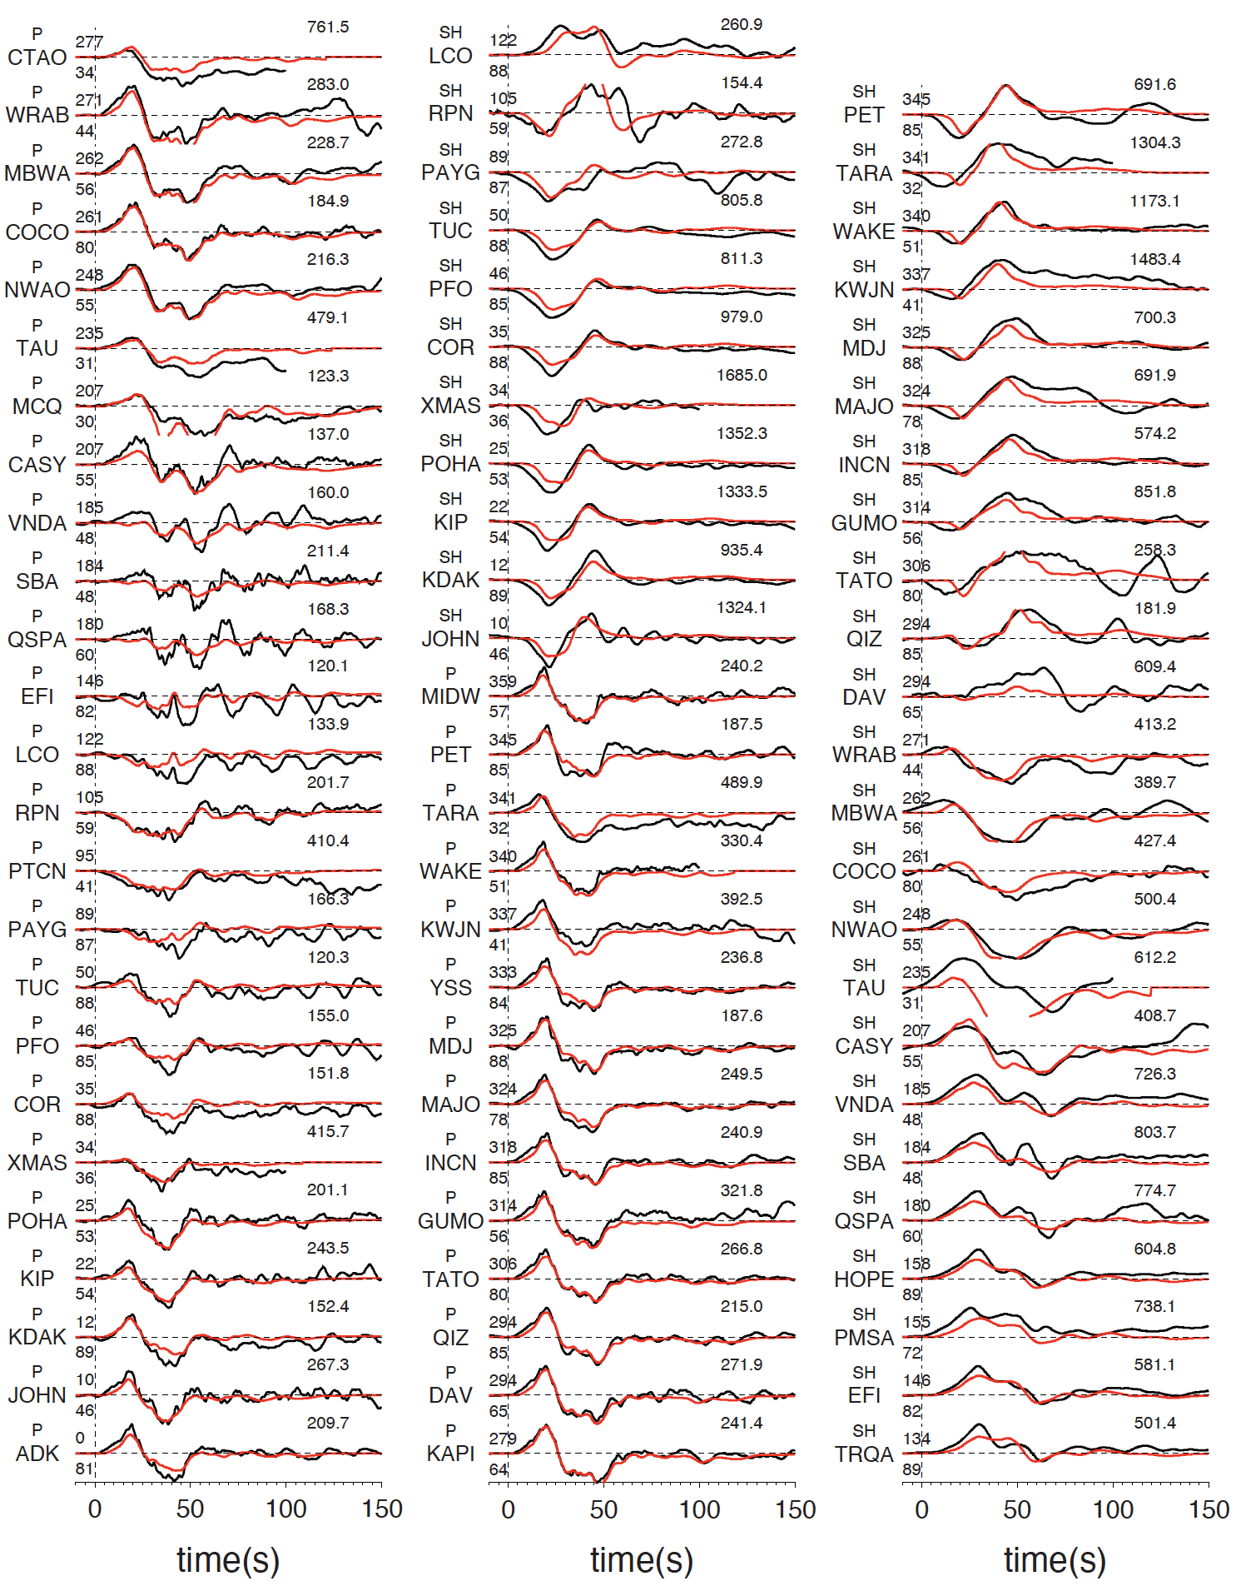
Figure S1. Teleseismic body waveform fitting for the preferred joint inversion slip model. Both data (black) and synthetics (red) are in displacement, with station ID and component name (P or SH) indicated at the beginning of each waveform pair. Nex to the station ID are azimuth (upper) and distance (lower) of the station in degree. Maximum displacement amplitude in micrometer is shown at the end of each waveform pair.
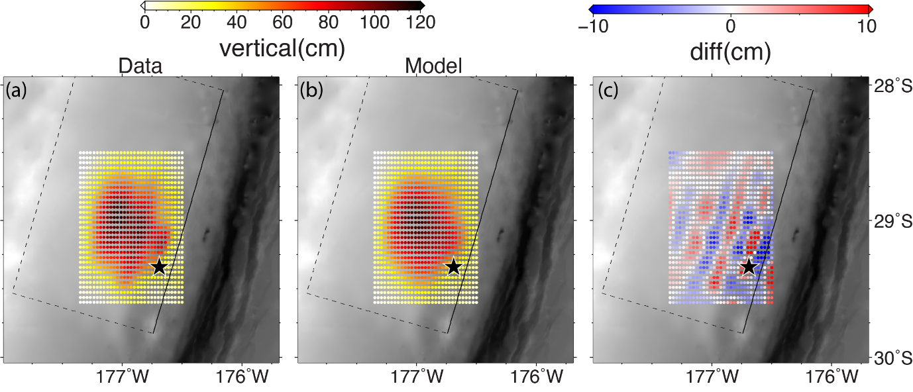
Figure S2. (a) Sea floor vertical deformation constrained by tsunami waveform inversion [Romano et al., 2021] (b) Sea floor vertical deformation from preferred joint inversion slip model. (c) Difference between (a) and (b).
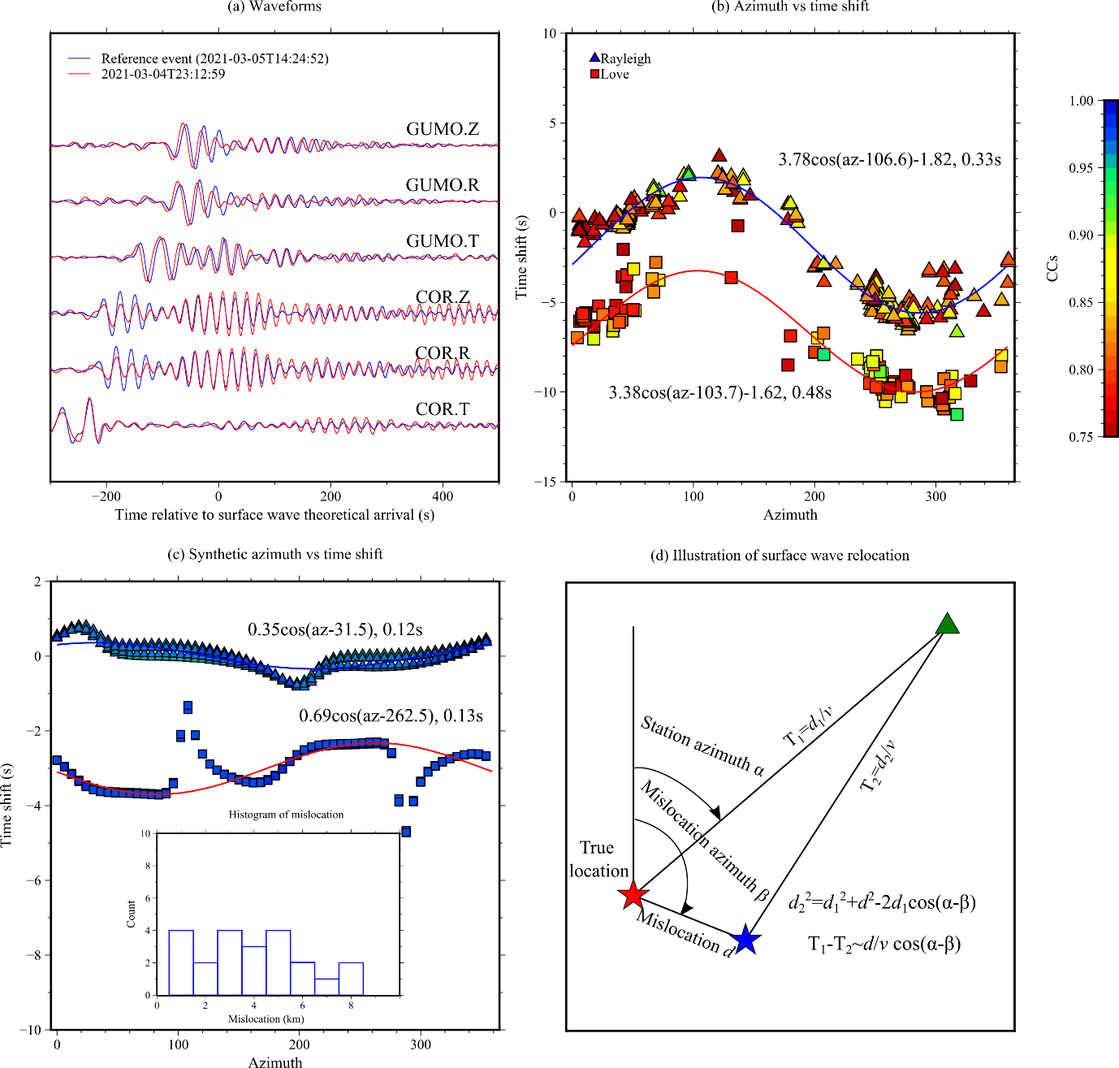
Figure S3. Illustration of the surface wave relocation method. (a) One example for two events having highly similar surface waveforms. (b) The relationship between the station azimuth and the time shift derived using cross-correlation for surface waves between the target event, 202103042312 and the reference event. (c) Same as (b) but using synthetic waveforms for events with focal mechanism derived in Lythgoe et al. (submitted). The inset in (c) shows the histogram of the mis-location derived using synthetic data. (d) Illustration of the principle of the surface wave relocation technique.
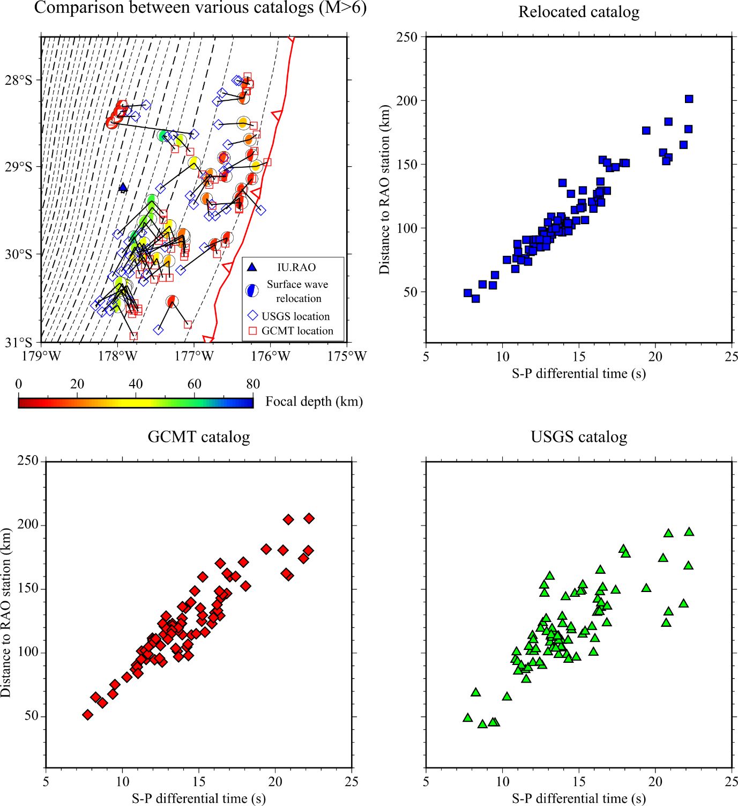
Figure S4. The relationship between the S-P differential travel-times manually picked from the IU.RAO station (blue triangle in upper-left pannel) records and the distance to the IU.RAO station from earthquake epicenters in our relocated, GCMT and USGS catalogs. Compared with other two catalogs, our relocated catalog results in a better and more compact lineation.
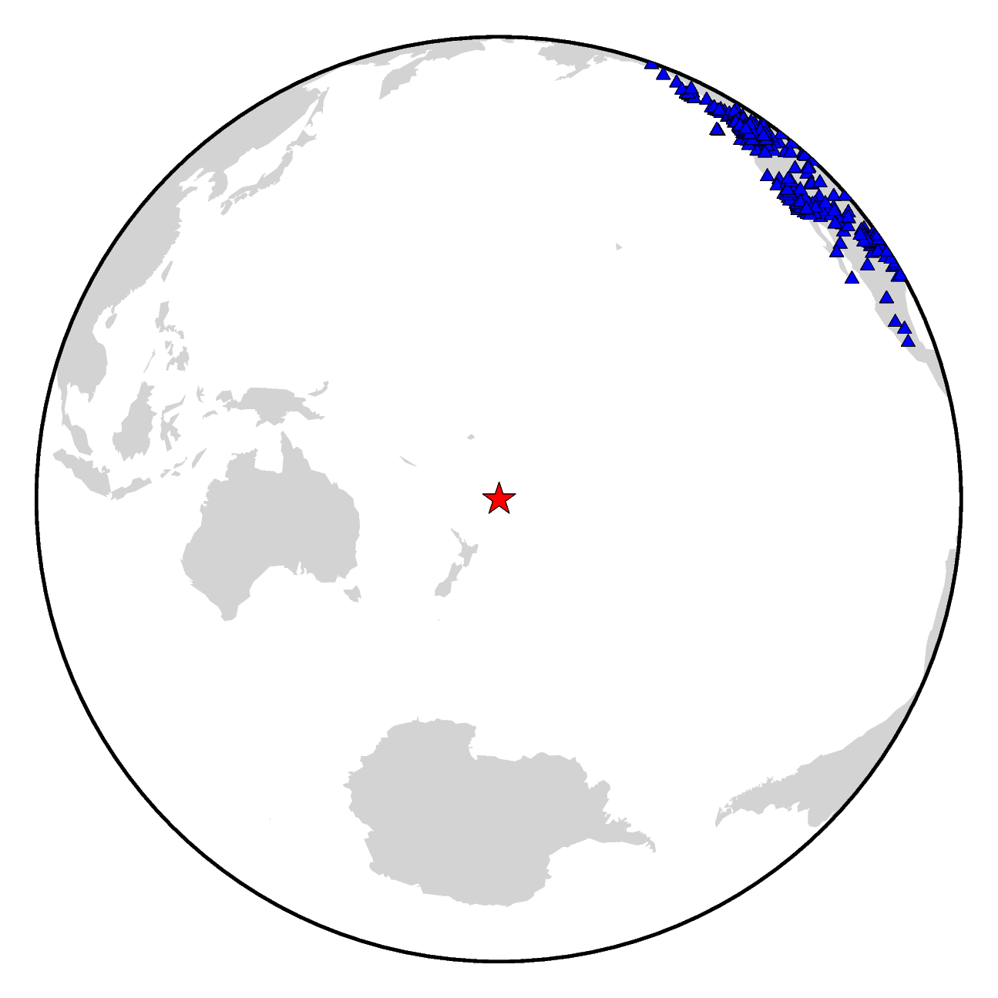
Figure S5. Stations (blue triangles) used to refine earthquake depth.
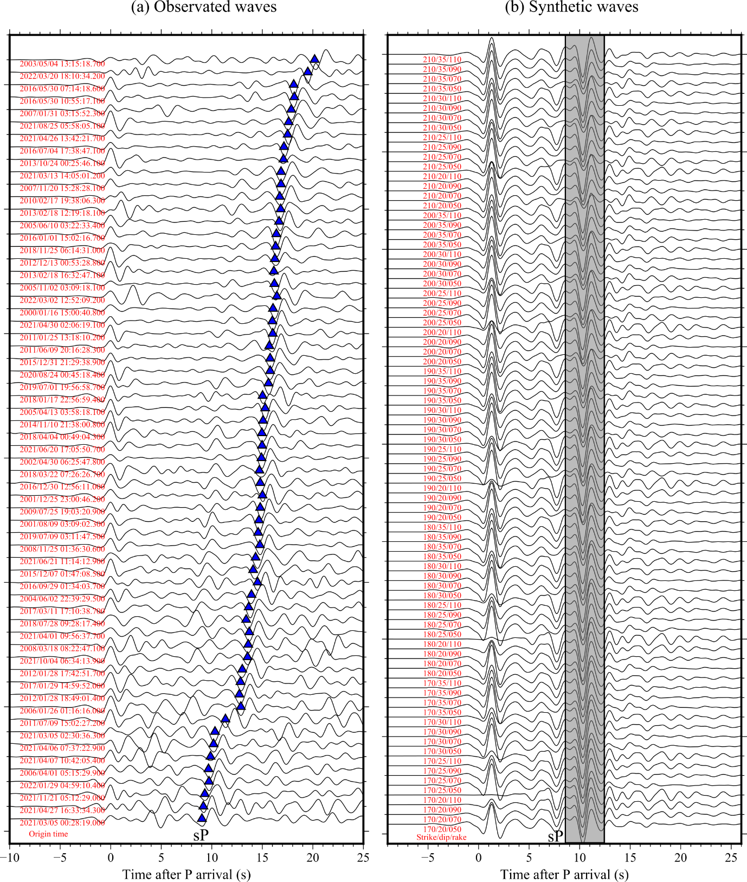
Figure S6. (a) Stacked waveforms for events having clear sP phases (marked by blue triangles). (b) Synthetic waveforms for events with varying focal mechanisms (red numbers) and constant depths (30 km). In the synthetic waveforms, we clearly see that once there are strong sP phases (highlighted by the gray shadow), the sP arriving time will not vary with the focal mechanism.

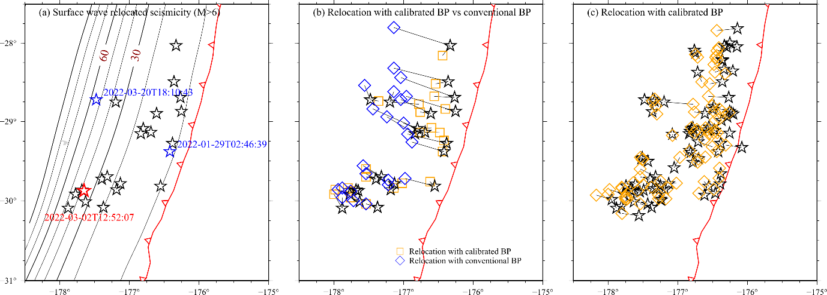
Figure S7. Comparison between relocation using calibrated and conventional BP. (a) Seismicity (M>6) distribution. The red and blue stars are events used to calibrate the travel-time error with events’ origin time shown. The travel-time error of the red star event is applied to other events to conduct conventional BP. (b) Comparison between relocation of events with magnitude > 6 using calibrated (squares) and conventional (diamonds) BP. (c) Relocation using calibrated BP of all events (Mw > 5.5) relocated with the surface wave relocation method.
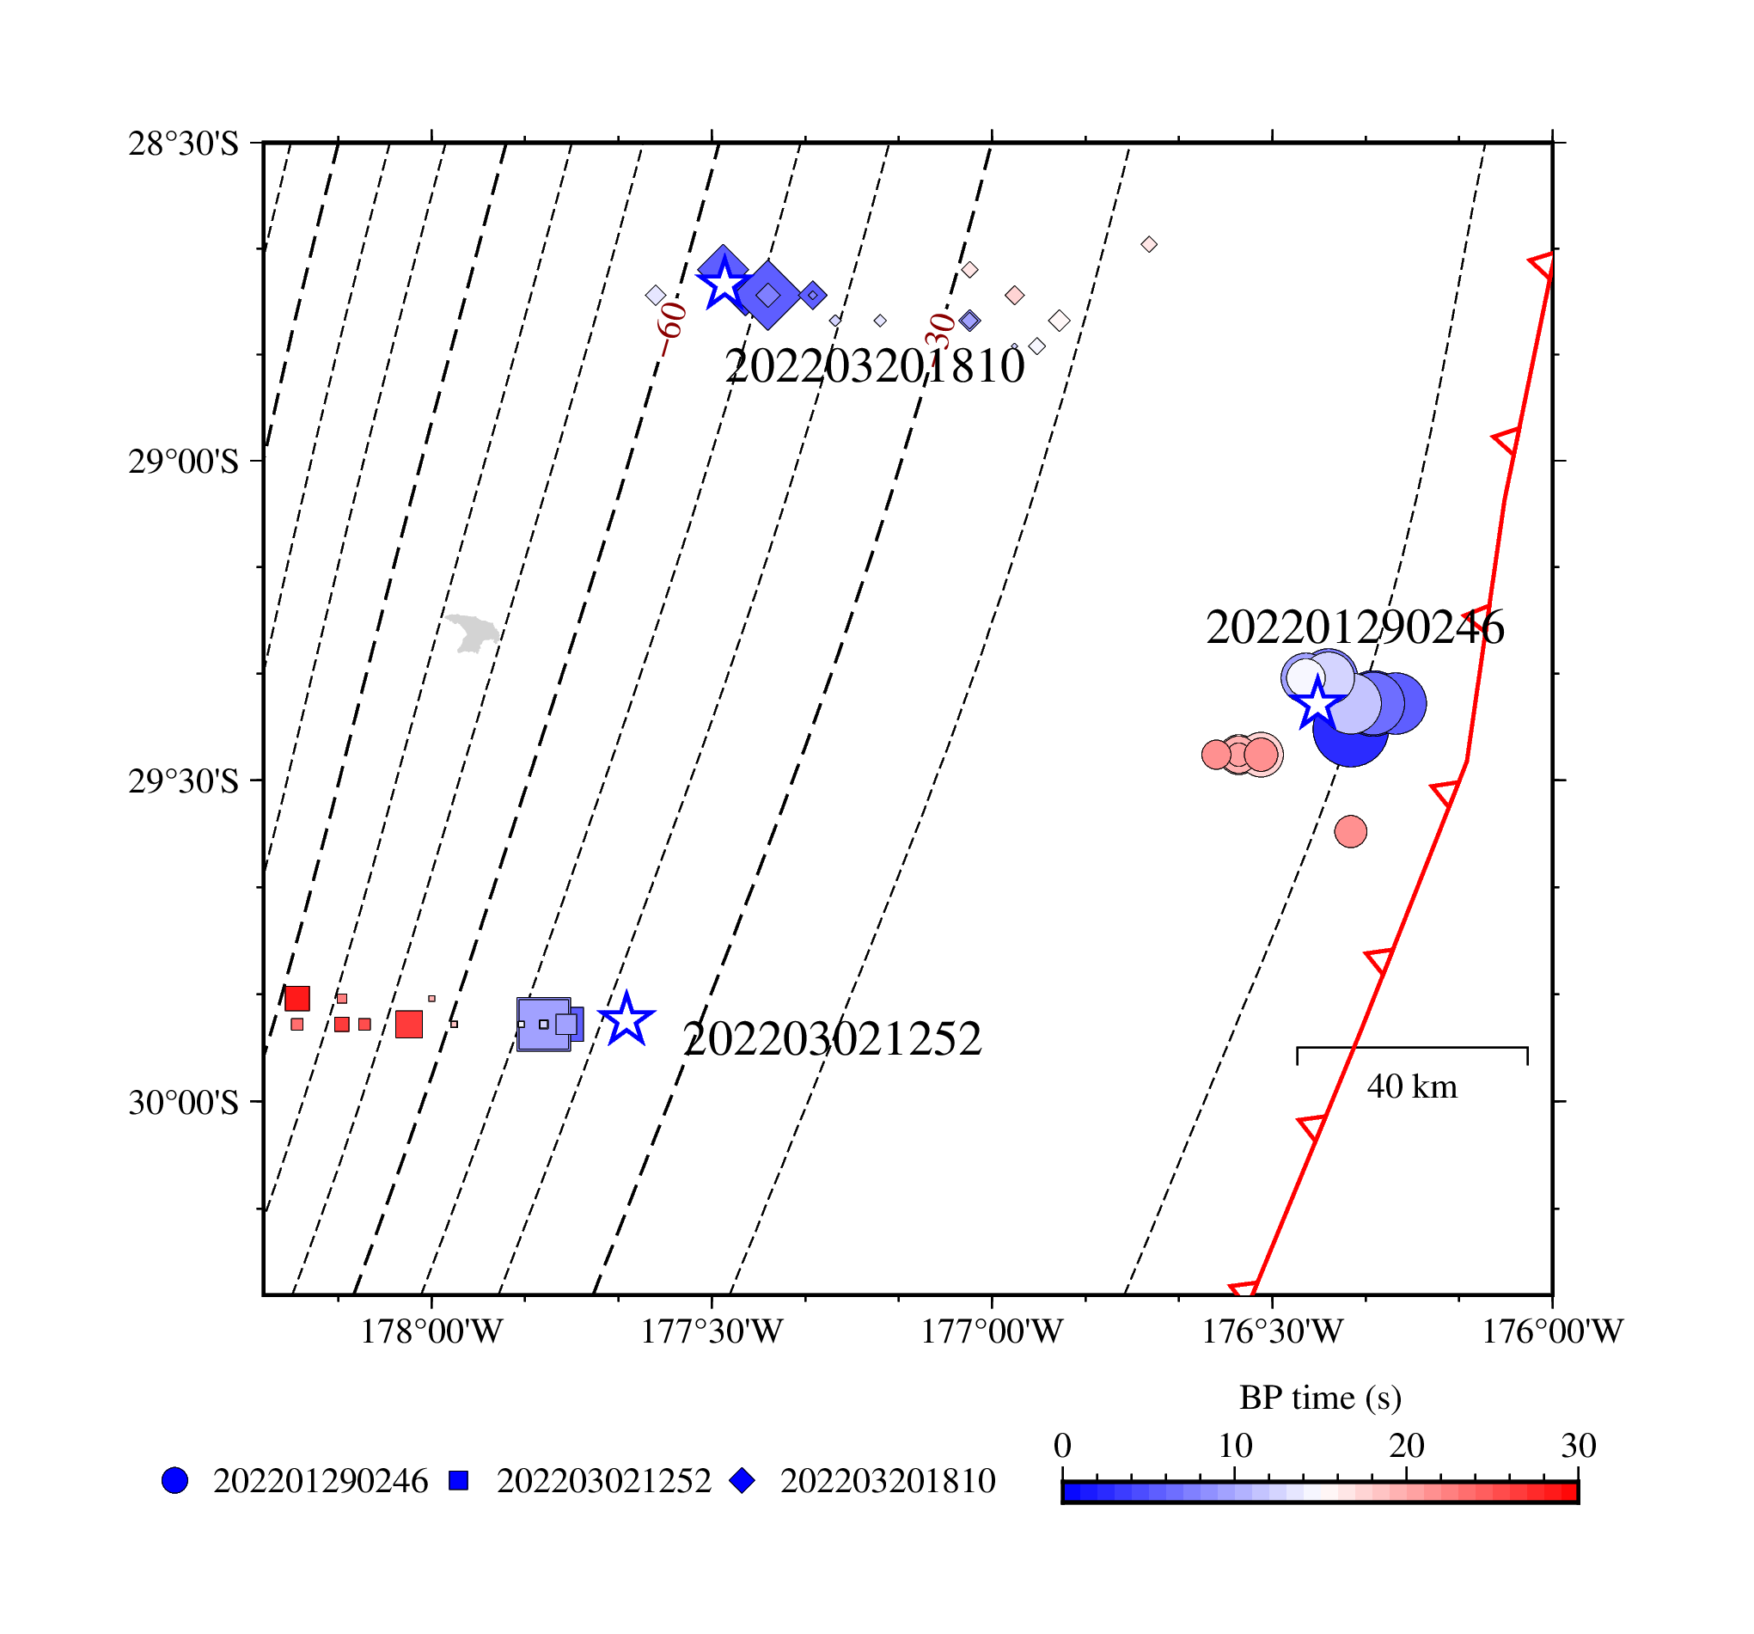
Figure S8. Calibrated BP results for the 202103042312, 202201290246, 202203021252 and 202203201810 events.
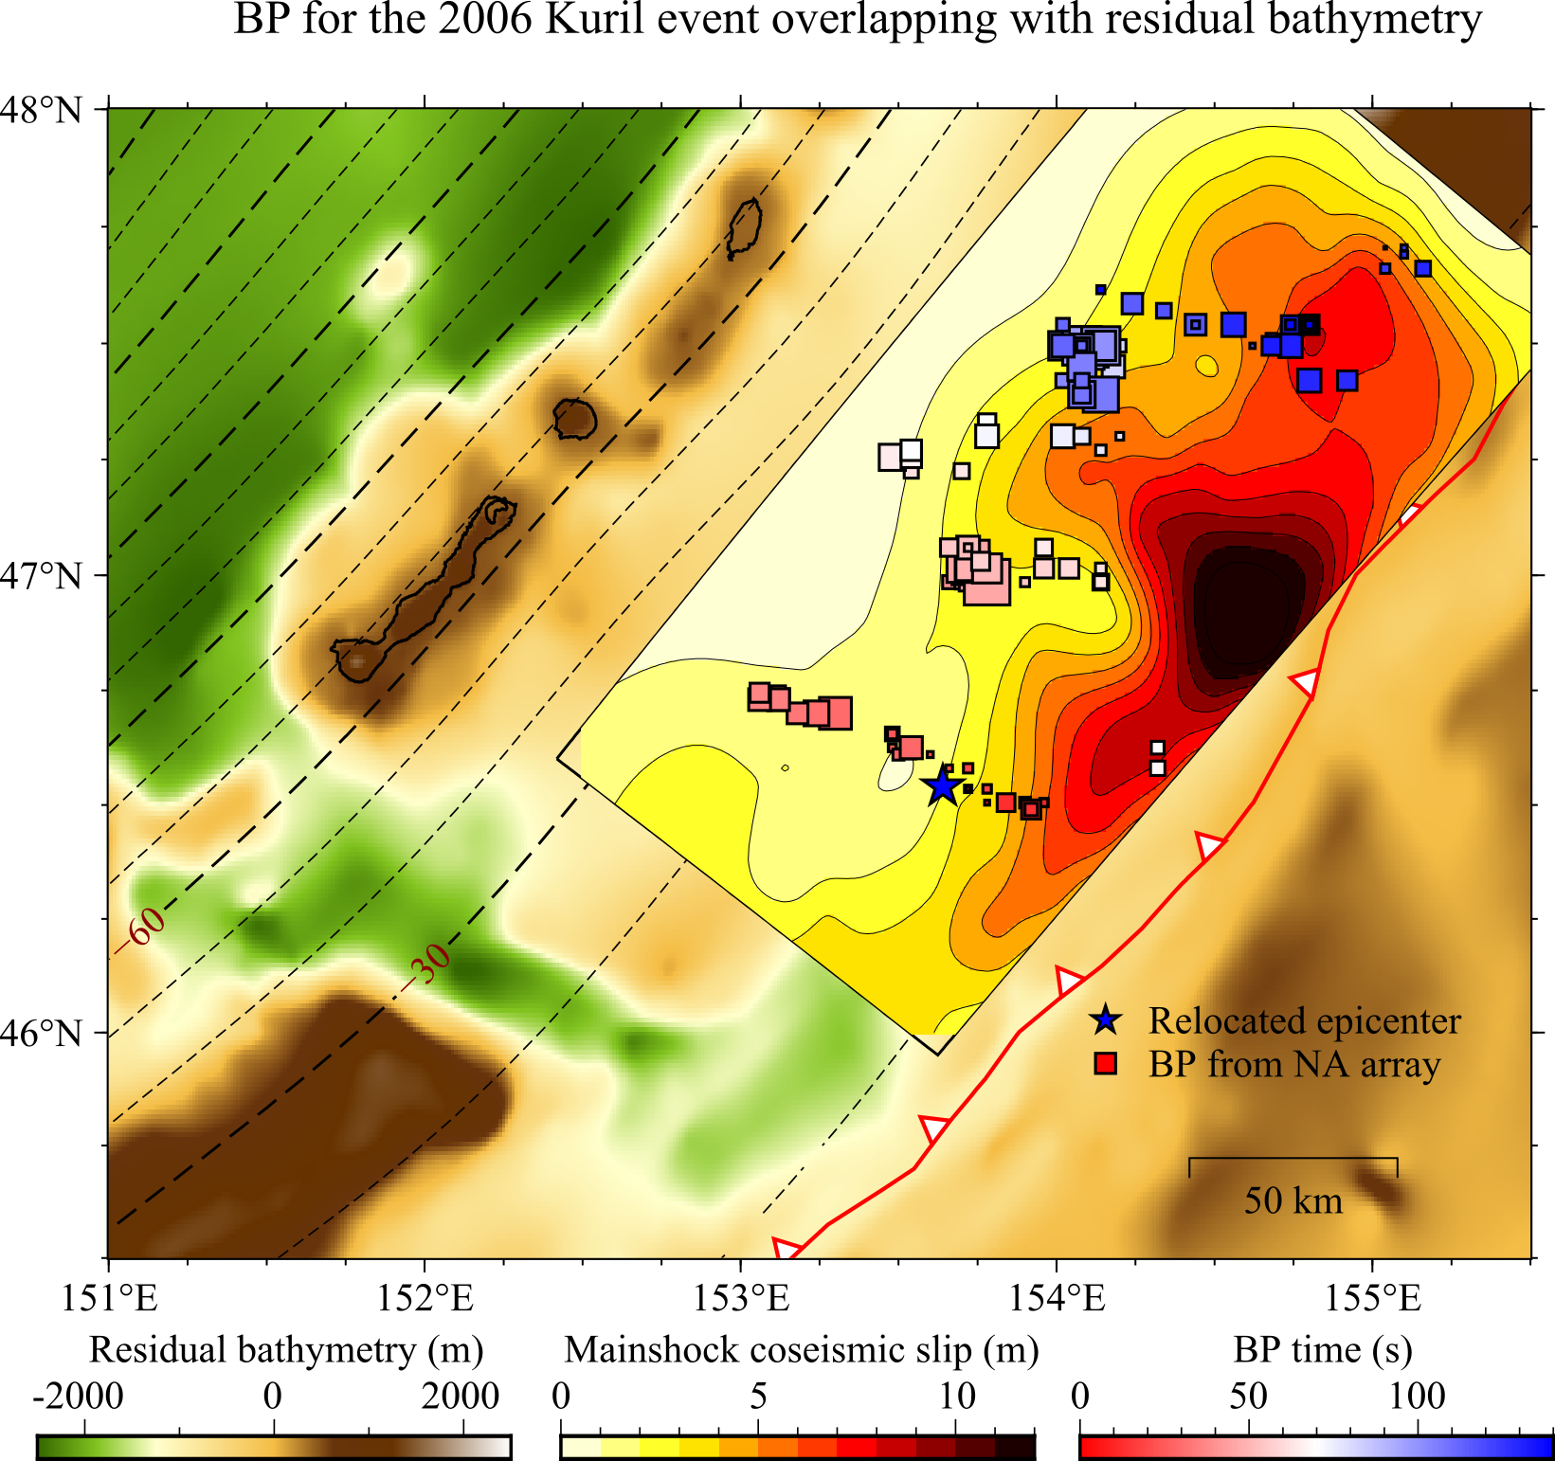
Figure S9. Rupture model for the 2006 Mw 8.3 Kuril Islands thrust earthquake. The coseismic model is from Lay, et al. ¹. Residual bathymetry is from Bassett and Watts ².

1 Lay, T. et al. The 2006–2007 Kuril Islands great earthquake sequence. Journal of Geophysical Research: Solid Earth 114 (2009).
2 Bassett, D. & Watts, A. B. Gravity anomalies, crustal structure, and seismicity at subduction zones: 1. Seafloor roughness and subducting relief. Geochem Geophy Geosy 16, 1508-1540, doi:10.1002/2014gc005684 (2015).

