Supplemental Material
Industrial determinants of metal exposure among Gulf Coast residents
Joyce J.Y. Lin^{1*}, Emily Werder², Kaitlyn G. Lawrence², W. Braxton Jackson II³, Dale P. Sandler², Aisha S. Dickerson⁴, Lawrence S. Engel^{2,5}, Ana M. Rule¹
¹Department of Environmental Health and Engineering, Johns Hopkins Bloomberg School of Public Health, Baltimore, MD, USA.
²Epidemiology Branch, National Institute of Environmental Health Sciences, National Institutes of Health, Research Triangle Park, NC, USA
³Social & Scientific Systems, Inc., Durham, NC, USA.
⁴Department of Epidemiology, Johns Hopkins Bloomberg School of Public Health, Baltimore, MD, USA.
⁵Department of Epidemiology, University of North Carolina Gillings School of Global Public Health, Chapel Hill, NC, USA.

Contents

Supplemental Figure 1. Distance from nearest NEI site by race and income category
Supplemental Figure 2. Stratified analysis by race
Supplemental Figure 3. Difference in blood elemental concentrations comparing Black participants to White participants in the GuLF BTEX sub-study
Supplemental Figure 4. Comparisons of blood elemental concentrations from GuLF BTEX sub-study to NHANES by race
Supplemental Figure 5. Toenail elemental concentrations by income category
Supplemental Figure 6. Racial differences in neighborhood poverty by state and income category
Supplemental Table 1. Covariates associated with toenail Pb and Hg concentrations

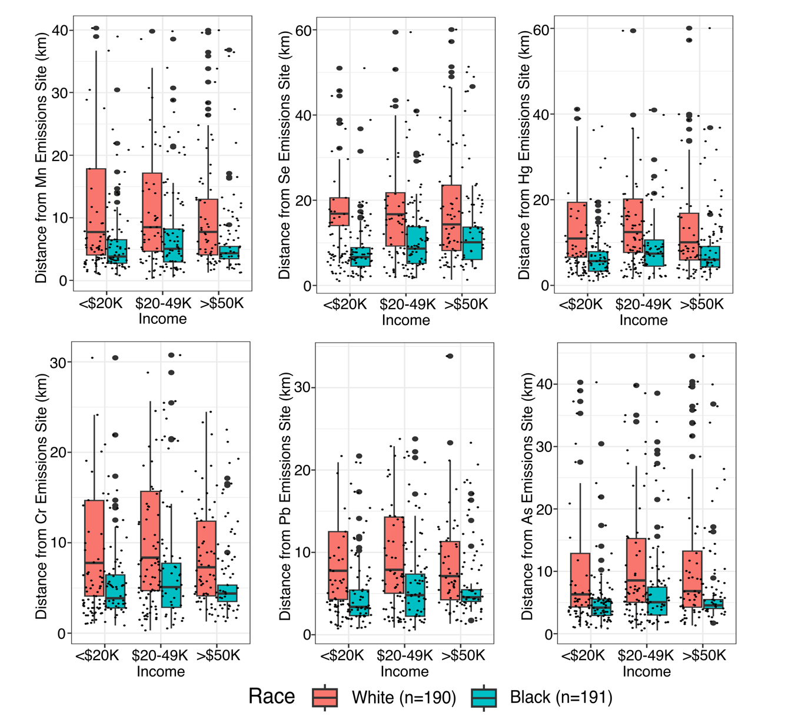
Supplemental Figure 1. Distance from nearest NEI site by race and income category

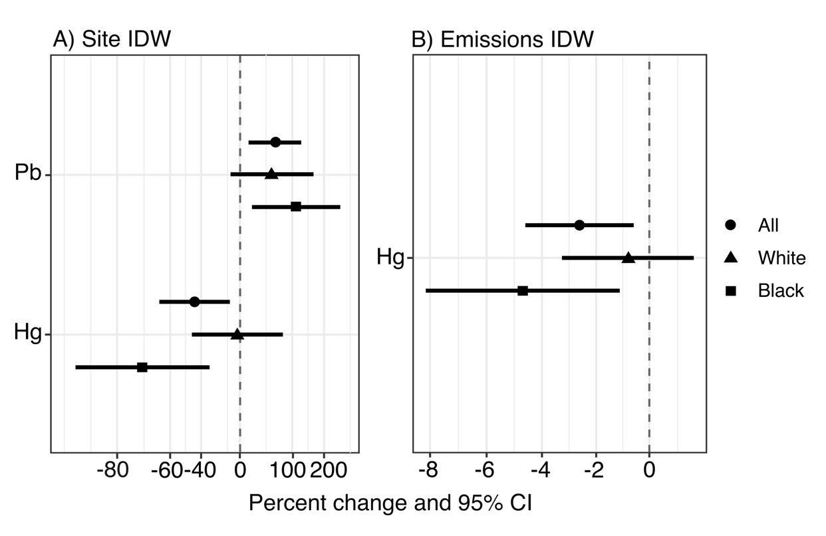
Supplemental Figure 2. Stratified analysis by race

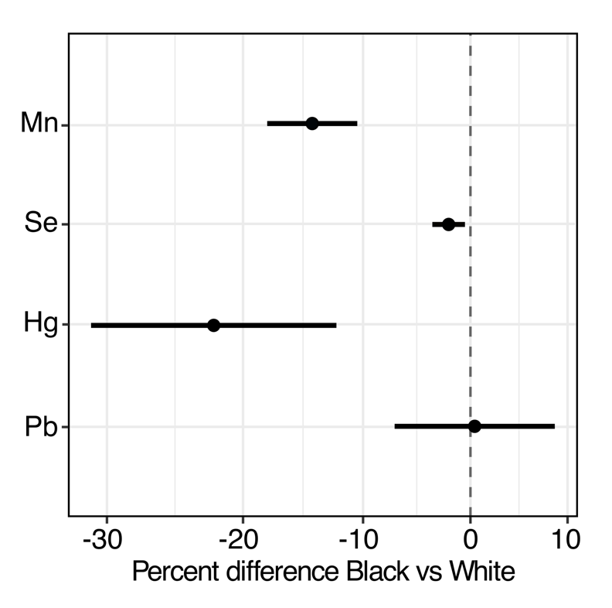
Supplemental Figure 3. Difference in blood elemental concentrations comparing Black participants to White participants in the GuLF BTEX sub-study (n = 723)

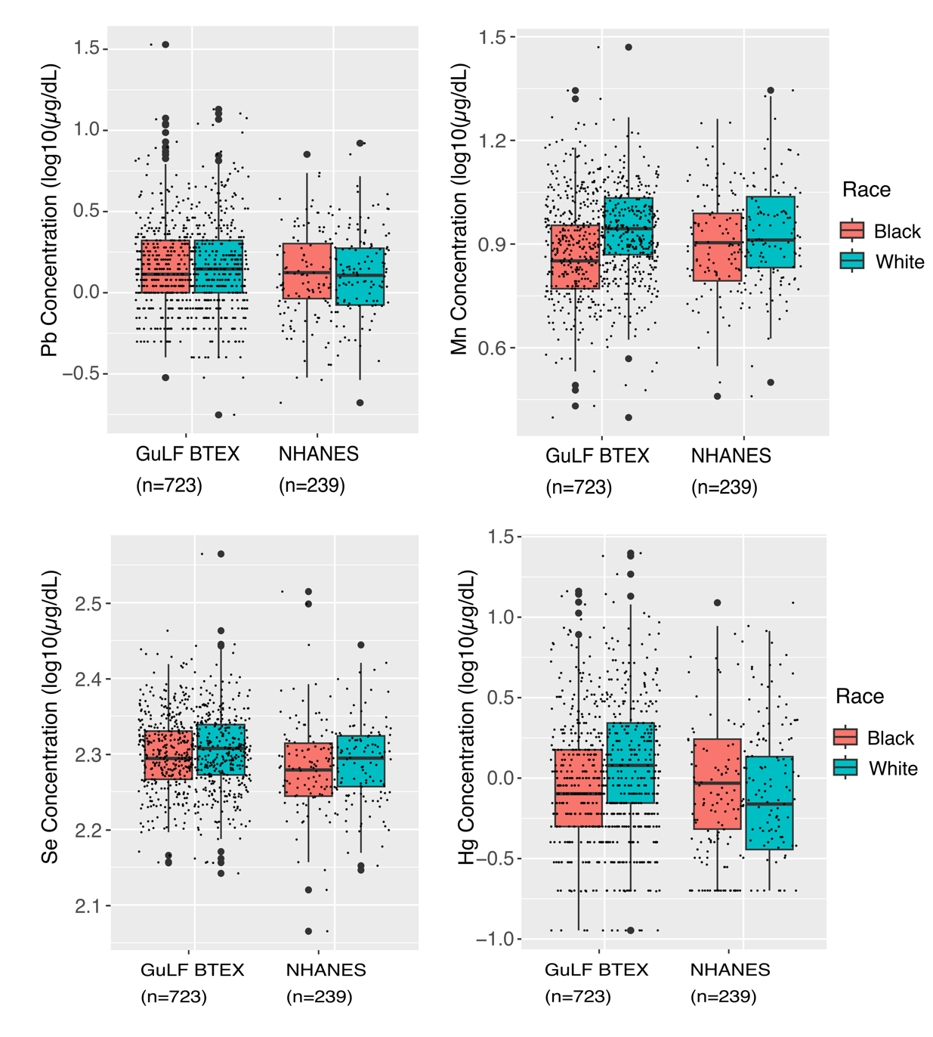Supplemental Figure 4. Comparisons of blood elemental concentrations from GuLF BTEX sub-study to NHANES by race

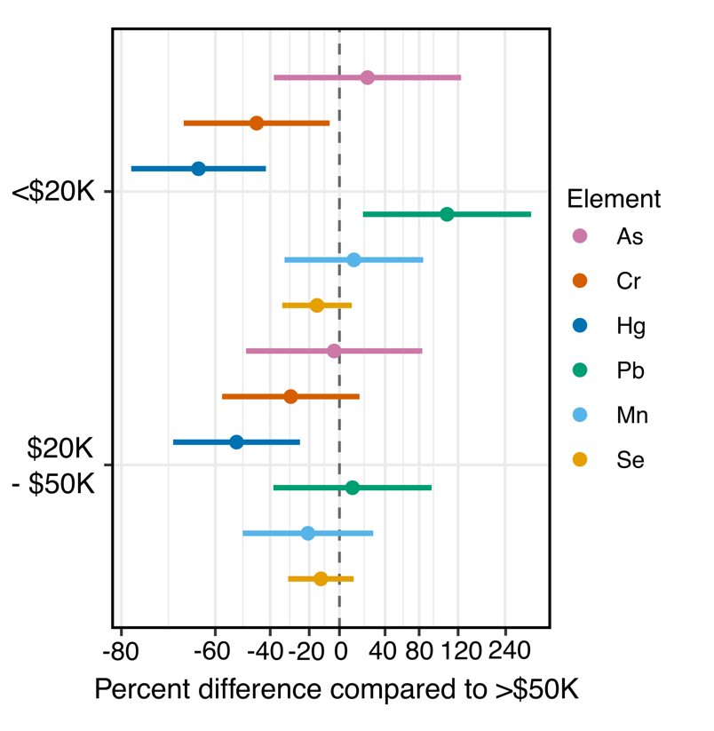
Supplemental Figure 5. Toenail elemental concentrations by income category

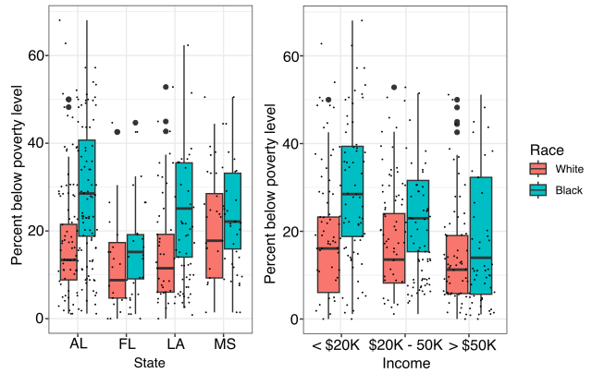
Supplemental Figure 6. Racial differences in neighborhood poverty by state and income category

Supplemental Table 1. Covariates associated with toenail Pb and Hg concentrations
 | Pb | Hg
 | Beta Coefficient (p-value) | Beta Coefficient (p-value)
Age |  | 0.0090 (0.0052)
Race |  | -0.40 (5.5e-7)
Education (years) | -0.03 (0.017) | 0.032 (0.015)
Passive smoke exposure |  | -0.21 (0.029)
Percent below poverty level* | 0.0093 (0.0049) | -0.0080 (0.0031)
Median year structures built* | -0.0096 (0.0017) | 0.011 (7.74e-6)
* Census block group level, included in separate models

