Appendix 1: Semi-Structured Interview Guide

Standardised Preamble: Thank you for agreeing to speak with me today. As mentioned in the letter of information, this interview is part of a research study examining the experiences we as oncology trainees have with regards to moral distress and mentorship.
For the purposes of this study, moral distress refers to the psychological or emotional response which results from a situation clashing values, beliefs, or ethical stances, especially when there are perceived morally-correct actions that one is unable to follow, for whatever reason. For example, a physician may feel that the best treatment for a patient is a chemotherapy called Abraxane; however, a global shortage of Abraxane prevents the physician from prescribing this for the patient. The physician’s ensuing psychological distress caused by this situation is moral distress. Likewise, the COVID-19 pandemic has caused a number of hospitals to institute policies restricting visitors. A physician may experience moral distress if asked by COVID-positive relatives to visit a terminally ill patient, as they may feel obligations to the patient and family to allow one final reunion, to the hospital to follow policies, and to the other patients to protect them from COVID. Please see these two cartoons for examples of situations causing moral distress in the resident.
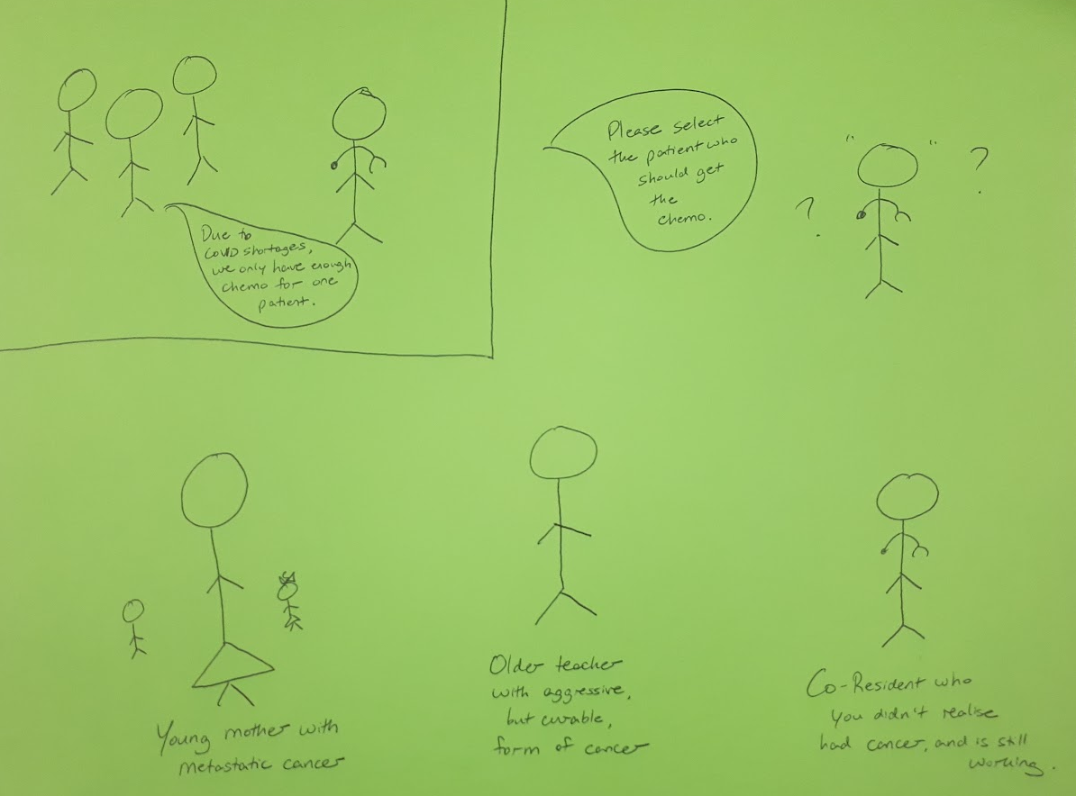
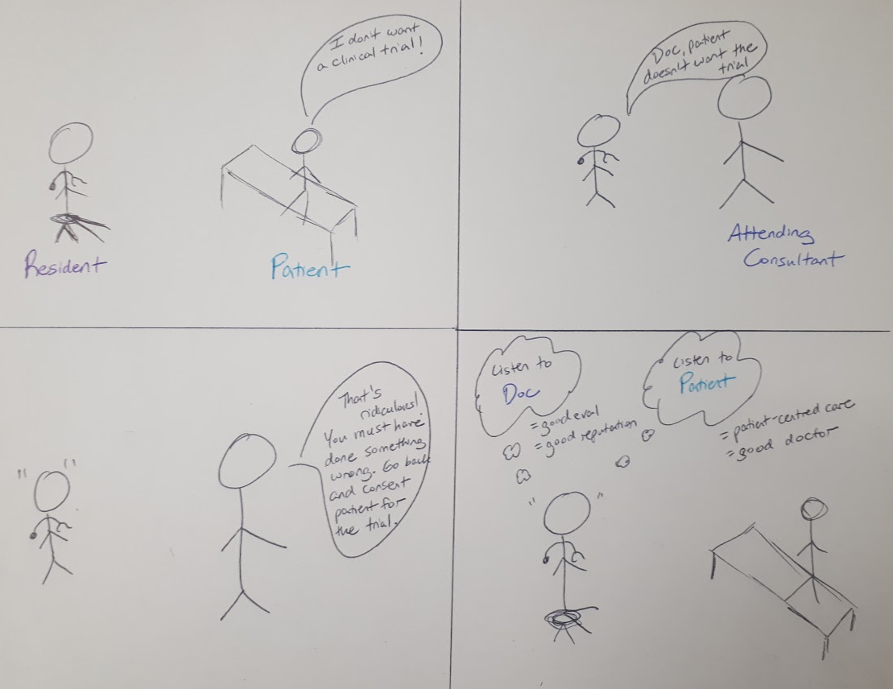
During this study, we will also be discussing mentorship, which is the process of being advised, guided, or otherwise supported by another person. Please see this cartoon for a visual representation of some of the different forms of mentorship. As you can see, not all forms of mentorship are formal or between senior-junior individuals.
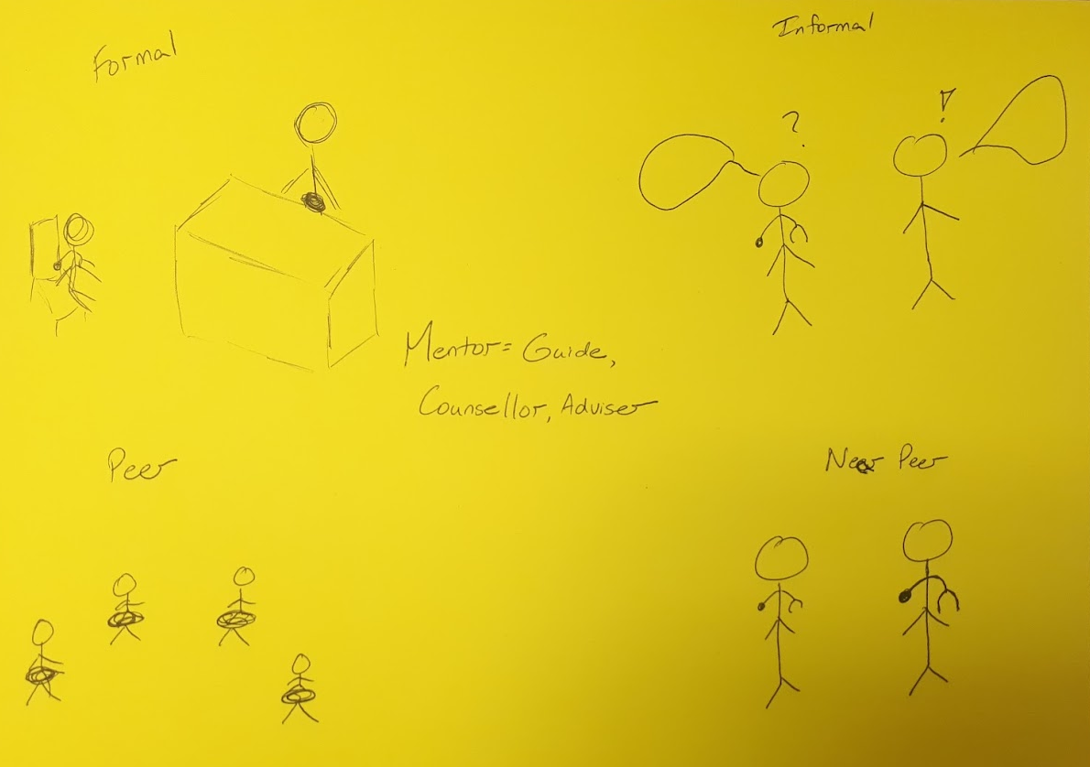
As it is realised that discussing such experiences can itself induced psychological distress, I do want to direct you to available resources if needed, including the PARO (resident union) helpline and the local London mental health resources. With regards to the study, I will be recording and transcribing our conversation today; however, everything here will remain between us and my supervisor, and your name will not be used at any point. After transcription, I will be sending you a copy of the preliminary coded data in order to ensure your experience has been captured in the manner intended. You are free to withdraw your consent to participate at any time, up until all of the coded data has been combined into a thematic analysis, as at that point removing individual data would be impossible.
Do you have any questions? Do I have your permission to proceed?
I would also like to ask that you refrain from using names or other identifiers whenever possible, to help with maintaining anonymity, and that no examples are used where I, Beatrice, was involved. Is this okay with you?
<<turn on recorder>>
Interview prompts:
- Can you share an example of a time you experienced moral distress, as it relates to your training in oncology?
  - Do you think oncology trainees experience moral distress?
  - What might be some triggers for moral distress/what do you experience as triggers for moral distress?
- Can you share an example of a time you experienced mentorship, as it relates to your training?
  - If not, can you think of a time when mentorship might be helpful? What would that look like for you?
  - If so, can you think of other times when mentorship might be helpful? What would that look like for you?
- Have you ever experienced mentorship during after an encounter inducing moral distress in an oncology setting? Can you tell me about this?
  - If not, do you think mentorship could have been beneficial? Why?
- Have you experienced an encounter inducing moral distress where you did not experience mentorship? How did this differ?
- Can you recall an encounter where you mentored someone else through a period of moral distress?
- Based on your experiences, and the experiences you have shared, what would you say are the aspects of helpful vs unhelpful mentorship in these contexts?
  - Are there characteristics of mentors or mentorship relationships which help you as a trainee navigate moral distress?

Appendix 2: Composite Narrative
Moral distress? Yeah, that’s pretty common. I feel that way a lot…helpless, powerless, frustrated. Alone. And it doesn’t always stay at work; sometimes the worst parts are when I go home, or a couple days after the encounter, when I’m thinking things over, and I don’t have anyone to speak to. Then the feeling changes, less acute and painful, and more something that stays with you long-term. And you remember it, remember feeling this way, and it gets worse next time you face something similar.
I think there are different things that can trigger this kind of feeling. Sometimes it’s because of systemic problems, like wait times or delays getting scans. Those affect patient care, and can even lead to worse outcomes for the patients. But everyone is in the same situation, and there’s not a whole lot one person can do to fix it. That doesn’t make it any easier, though. Something that’s on a smaller scale would be a patient wanting to do something I don’t think is the best option for them. That’s hard, because you want to respect the patient’s autonomy, you don’t want to be paternalistic, but you also want what’s best for them. And we have knowledge from our training, and experience, that patients don’t, and you’re not always sure they understand the decision they’re making. So that can be hard to balance out.
Often I feel this kind of distress because I don’t agree with how a patient is being treated or managed. Especially when there is a bad outcome, like bad side effects from treatment, or even death. But the consultant is in charge, I have to do what they tell me to do. That’s the way medicine is, I’m just the resident, a learner. And sometimes, if I remind myself of that, it makes the distress a little easier to manage. It’s ultimately the consultant’s responsibility, and I don’t have as much knowledge or experience as them. Sometimes I do get caught between different consultants or nurses or other healthcare providers telling me what to do. That can be hard, especially up on the ward, because who do you know who to listen to? And when do you start listening to yourself?
It's especially hard to know when to say something, when to speak up, versus when to just go along with things. You don’t want the consultant to think you’re questioning them – some of them really wouldn’t take kindly to it. And even if you do say something, then it might even just be disregarded. Because you’re just a learner, a trainee…you don’t have the knowledge or experience of the consultant. And sometimes it’s hard to know, do I just not have the knowledge, is this something I don’t know, or is there actually something wrong happening here? Sometimes I try to ask a question, frame it like it’s for my learning, but beyond that, I don’t think you can safely do anything else. You have to protect yourself. You don’t want a reputation as a troublemaker.
I think everyone feels moral distress, but some people – like me – feel it more than others. Sometimes people tell me it’s because of how I was raised, or how I interact with my family, or my religious beliefs, that make me feel more distressed by these kinds of situations. And sometimes people tell me it’s because I’m sensitive, or introverted, or because I don’t have a very big support network of people to speak with.
It’s horrible, having no one to speak to, when things aren’t going well. Because then all you do is think, and wonder if you could have done things differently, if you should have done things differently. And sometimes it is difficult to think rationally, when you are feeling so distressed already.
But it’s hard to find someone to speak to, if you don’t already have someone. When I was in internal medicine residency, I was assigned a mentor. He didn’t care about me at all. He just wanted me to do his research, and he did not respect my time. He would sometimes be hours late for our meetings, and then just go through the checklist of things we had to speak about. Even when we were working together clinically, it would only be about research. I could tell the only reason he took me as a mentee was to have someone to help with research. That wasn’t someone I could speak with at all.
These days, I know I can speak with my co-residents. We all speak pretty openly in the resident room. I hear a lot of stories about the different consultants, and how they do things. Like last week, a patient I saw a few times on call ended up dying from chemo side effects. I thought they were too sick for chemo, but maybe I didn’t make that clear enough in my notes or handover, because they gave chemo anyway. Dr X gave chemo anyway. But the other residents, they told me, that is Dr X’s way, she is aggressive, and a lot of her patients die in hospital, so it isn’t my fault. But it still feels like my fault. At least a little. I keep wondering, is there something I should have done differently? I feel like I let the patient down, like they trusted me, and I failed.
Yeah…my co-residents are good, but sometimes our discussions are just complaints. You know, residency is hard, training is hard, and I do value very much the advice and support of my co-residents. But sometimes I just wish there were someone a bit more experienced who could give some advice. Someone calmer, who’s been through it and understands. There is a really nice, kind, supportive consultant that one of the senior residents has a good relationship with. She says he is very respectful, empathetic, and compassionate towards trainees, and helps them reflect about difficult situations, and how they can learn from them and improve. But I’m not sure I could trust a consultant that much, to be open with them. After all – they are all consultants. They’re in charge of our evaluations, of course, but also hiring decisions, fellowship decisions, recommendation letters – your whole reputation. Oncology is a small community. People talk. What if they don’t like me complaining about their colleagues? What if they think I complain too much? They might tell my programme director. And, even if they don’t mean to, people talk, and your reputation can get damaged really easily. How are hiring decisions made, anyway? By how much you like someone, right??? I don’t want the consultants to be spreading rumours about me, that could impact my whole career! And how could I work clinically with someone who knows about all of these feelings, all of these things – what if I’ve messed up? What if I’ve made a mistake? They won’t want me to work with them. They won’t trust me. It would be so awkward to work with them!!!!
I don’t know if it’s worth the risk. I’d certainly trust someone I reached out to more than someone assigned to me. But how do I even reach out? What would I say? What if they don’t appreciate me reaching out? My senior resident says that it’s really helpful to hear the perspectives and wisdom from the older consultants, and it’s helped her a lot. But I still am not sure…it sounds so risky!!! I don’t know what is best to do….

