APPENDIX

Appendix 1

PRISMA FLOWCHART

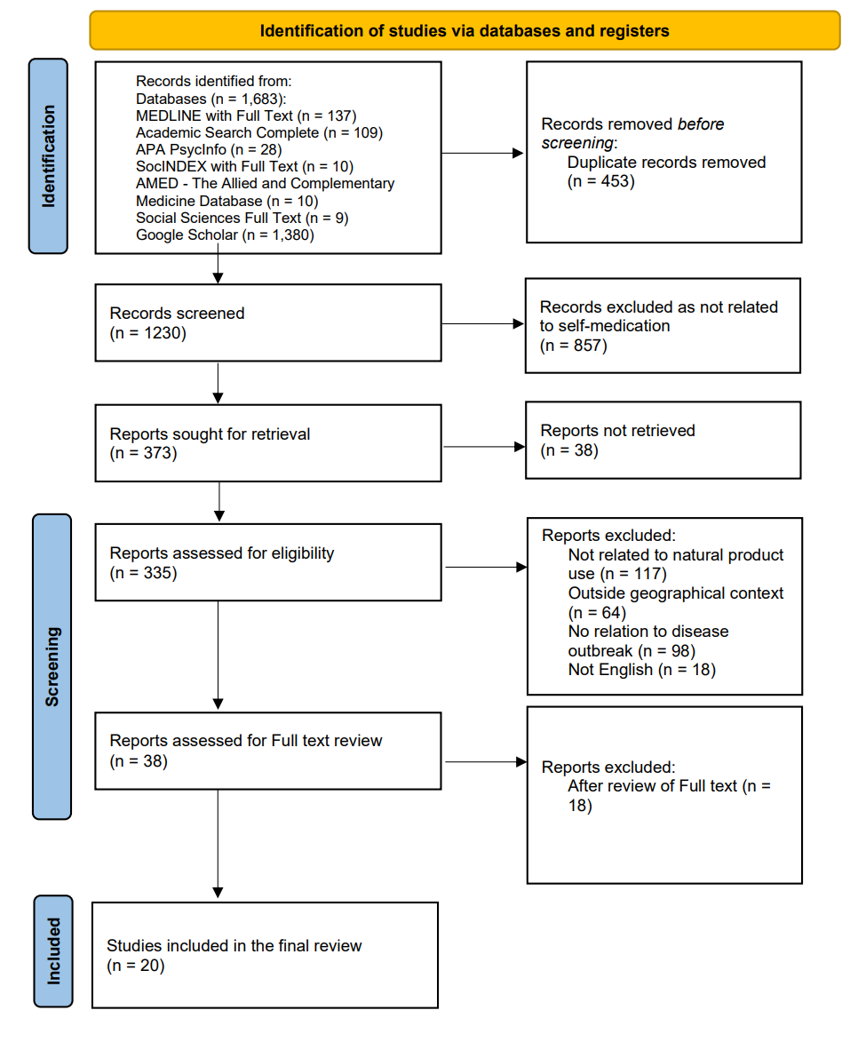

Figure 1: PRISMA flowchart showing study selection protocol

Appendix 2

GOOGLE SCHOLAR SEARCH

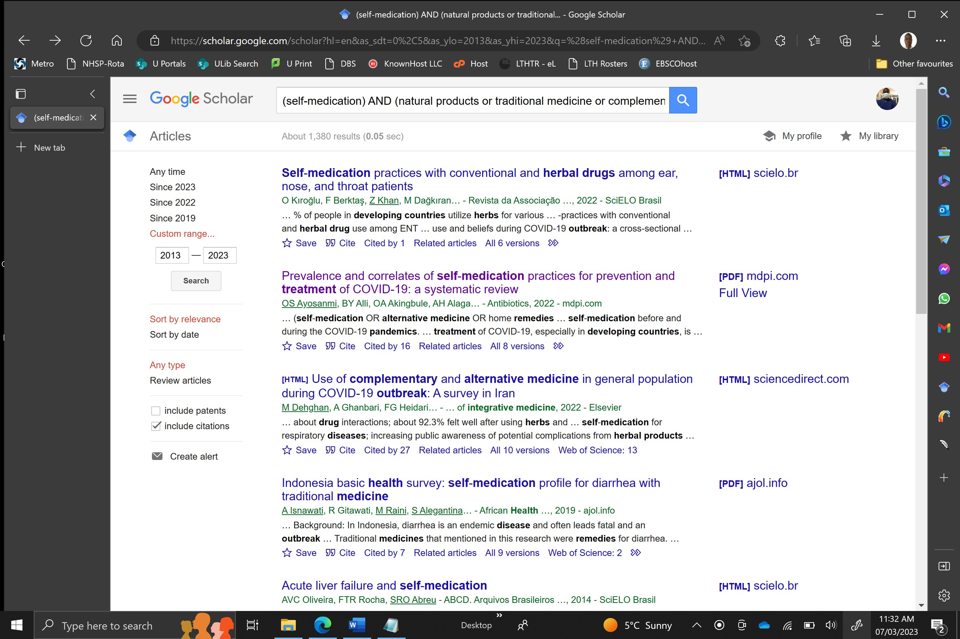

Figure 2: Screenshot of Google scholar search results

Google Scholar Search Strategy:

S1 = 1380 Results (Date Range = 2013-2023)

S1 = (self-medication) AND (natural products or traditional medicine or complementary or alternative medicine or herb medicine) AND (disease outbreaks) AND (developing countries)

Appendix 3

EBSCOHOST SEARCH

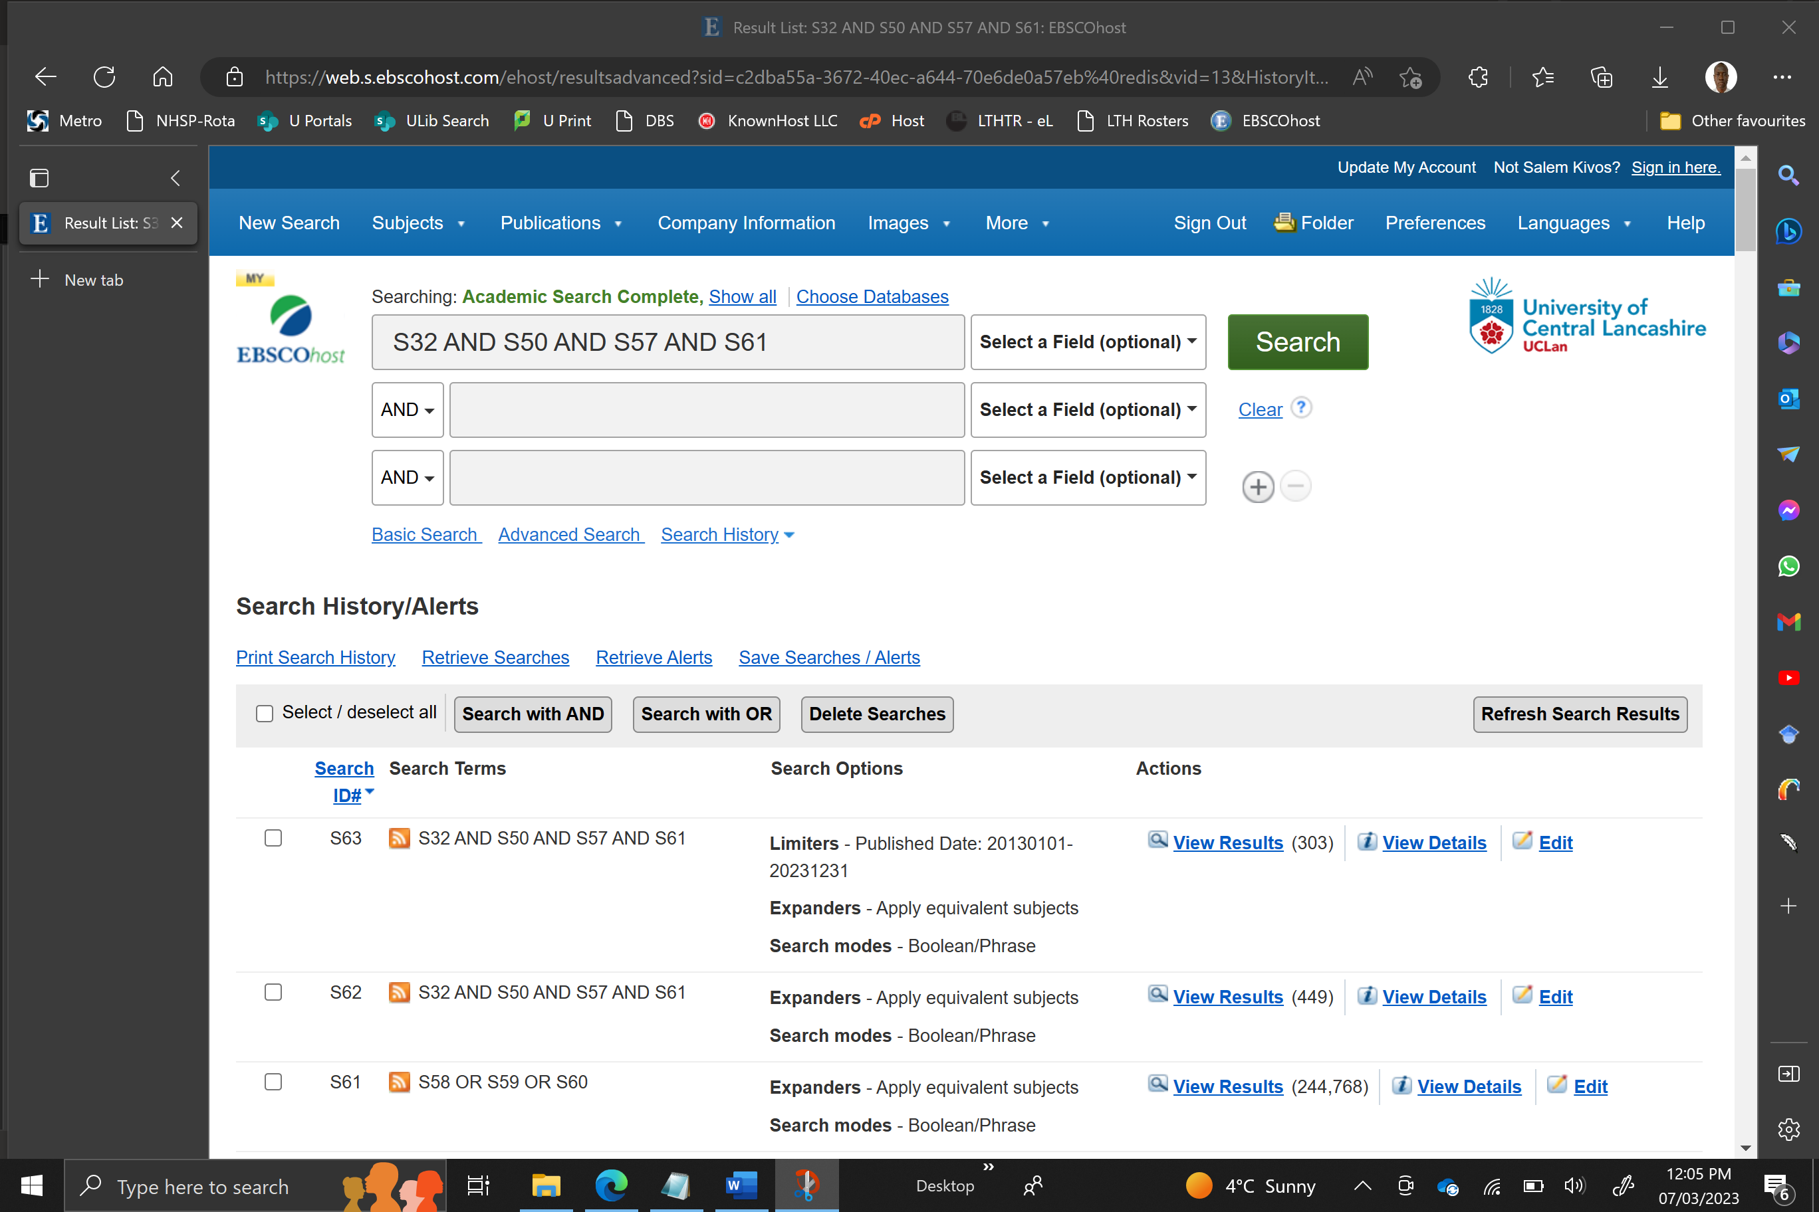
Figure 3a: Screenshot of EBSCOHost search results

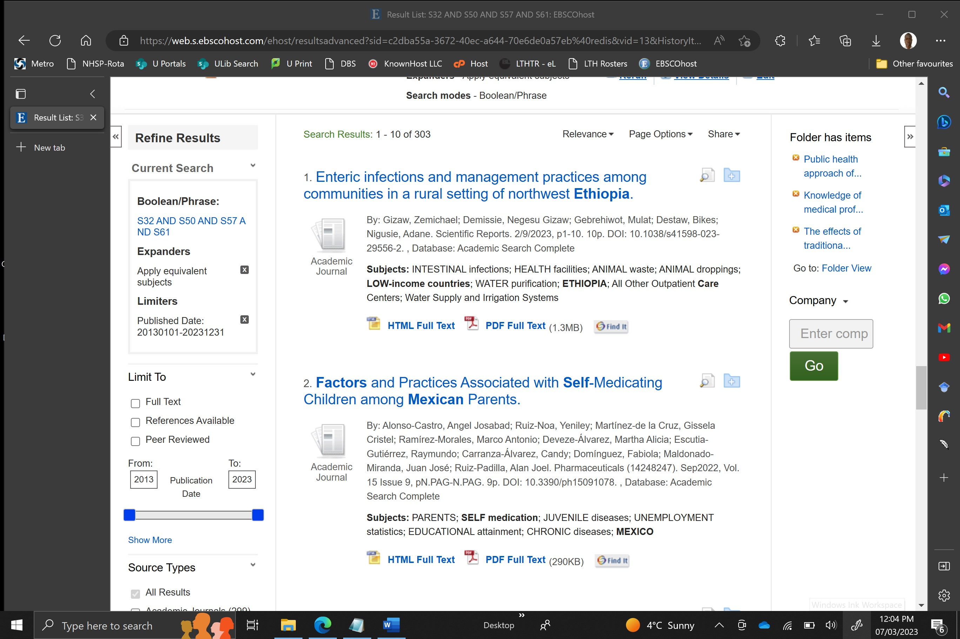
Figure 3b: Screenshot of EBSCOHost search results

EBSCOHost Search Strategy:

S62 = 303 Results (Date Range = 2013-2023)

S62 S32 AND S50 AND S57 AND S61

S61 S58 OR S59 OR S60
S60 self medication or self-medication
S59 self care or self-care
S58 self treatment or self-treatment

S57 S51 OR S52 OR S53 OR S54 OR S55 OR S56
S56 abuse
S55 implication
S54 influences
S53 factors
S52 determinants
S51 predictors

S50 S33 OR S34 OR S35 OR S36 OR S37 OR S38 OR S39 OR S40 OR S41 OR S42 OR S43 OR S44 OR S45 OR S46 OR S47 OR S48 OR S49
S49 natural products
S48 traditional medicine
S47 herbal medicines
S46 traditional Chinese medicine
S45 traditional African medicine
S44 traditional Korean medicine
S43 Unani medicine
S42 Siddha medicine
S41 Ayurveda medicine
S40 traditional Indian medicine
S39 Yunani medicine
S38 traditional Perso-Arabic medicine
S37 traditional Perso-Arabic medicine
S36 complementary medicine
S35 traditional and complementary medicine
S34 complementary and integrative medicine
S33 complementary and alternative medicine

S32 S1 OR S2 OR S3 OR S4 OR S5 OR S6 OR S7 OR S8 OR S9 OR S10 OR S11 OR S12 OR S13 OR S14 OR S15 OR S16 OR S17 OR S18 OR S19 OR S20 OR S21 OR S22 OR S23 OR S24 OR S25 OR S26 OR S27 OR S28 OR S29 OR S30 OR S31
S31 Latin America
S30 Middle east
S29 Africa
S28 Asia
S27 low income countries
S26 third world
S25 developing nations
S24 developing countries
S23 Ethiopia
S22 Sierra Leone
S21 Cameroon
S20 Peru
S19 Nigeria
S18 South African
S17 Vietnam
S16 Taiwanese
S15 Serbia
S14 Malawi
S13 Bangladesh
S12 Uganda
S11 Turkey
S10 Iran
S9 Jordan
S8 United Arab Emirates
S7 China
S6 Indonesia
S5 Ghana
S4 Saudi Arabia
S3 Vietnam
S2 Mexico
S1 Kuwait

Appendix 4

CONCEPTUAL FRAMEWORK

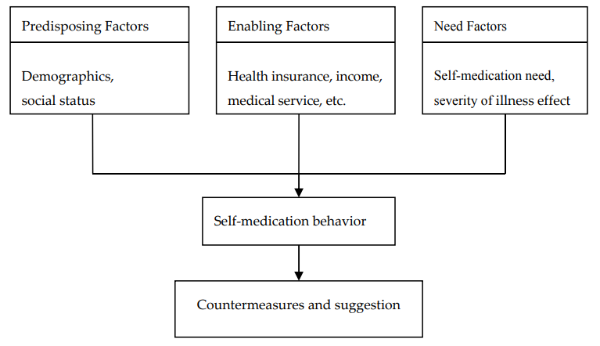
Figure 4: Conceptual framework for self-medication behaviour (Lei et al., 2018)

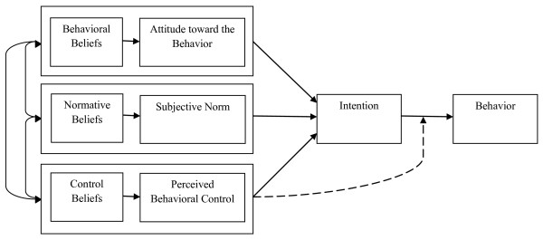
Figure 5: Theory of Planned Behaviour (TPB) (Ajzen, 1991)

Appendix 5

INCLUDED STUDIES

S/N | Author and Year | Study location | Disease Outbreak | Natural products | Source | Factors or determinants | Implications | Solutions | Prevalence data (per participants)
S1 | Ismail & Al Hashel, 2021). | Kuwait | COVID-19 | HM | NR | Worsening of headaches,  Inadequate quality of medical care,  Psychosocial stressors | Higher frequency and severity of migraine, Less compliance to treatment, Less communication with physicians | Neurological intervention | 39.9% of 1018
S2 | Alonso-Castro et al., 2021 | Mexico | COVID-19 | HM | NR | Factors  Advice from friends  Determinants  Female, Low education, Unmarried, Unemployment, No health insurance, Mental illness | Drowsiness, Dizziness, Fatigue/tiredness, Nausea/vomiting, Headache, Anxiety, Tremors, Insomnia, Hallucinations, Anger, Depression, Hunger, Diarrheal, Gastritis, Stomach pain, Sweating | Public health campaigns | 61% of 2100
S3 | Nguyen et al., 2021 | Vietnam | COVID-19 | HM | Personal garden, Markets, Herbal drug stores | Factors  Previous personal experiences, considered natural, Ease of access, Availability, Advice from family.  Determinants  Married, Urban dwelling, medium income, perception of health status | NR | NR | 49% of 508
S4 | Alotiby et al., 2021 | Saudi Arabia | COVID-19 | HM | NR | Factors  Social media, Family/ friends influence, Previous positive experience, published articles, Health care staff, Internet (YouTube/ google)  Determinants  Socio-demographic factors, Age | Diarrhoea, Abdominal pain, Constipation, Headache, Hypotension, Hyperglycaemia | NR | 92.7% of 1054
S5 | Kretchy et al., 2022 | Ghana | COVID-19 | CAM | NR | Factors  Strong belief of efficacy, Deemed Safe,  Self-decided, Media (e.g. TV, Radio, Newspapers), Friends/Relatives, Social media, Internet  Determinants  Female, Having children, Covid-19 status | NR | Public health policy,  Clinically validated CAM treatments,  isolating lead herbal compounds by pharmaceutical companies | 82.5% of 1195
S6 | AlNajrany et al., 2021 | Saudi Arabia | COVID-19 | HM | NR | Factors  Coping with stress  Determinants  Female, Age increase by 10 years, Unemployment, Comorbidities,  On prescription medication, Higher education | NR | Public awareness campaigns | 64% of 1473
S7 | Kurniasih & Juwita (2021) | Indonesia | COVID-19 | HM | NR | Factors  Considered safe,  From nature, used over generations, Boost Immune system | itching,  nausea,  vomiting,  unexplained effects | NR | 83% of 68
S8 | Aprilio & Wilar, (2021). | Africa,  India,  China | COVID-19 | HM | NR | Factors  Considered safe,  From nature,  Easier Access  Cultural values | Interaction with other medication | Appropriating health education to a society’s particular  Culture.  Local wisdom through ethnomedicine should work in health promotion and education | NR
S9 | Nuertey et al., 2022 | Ghana | COVID-19 | HM | NR | Factors  Social media, Family/ friends, Previous use  Determinants  Younger people, Married, Female | Steam inhalation and herbal baths increased risk of COVID-19 infection. | NR | 29.6% of 882
S10 | Kristianto et al., 2022 | Indonesia | COVID-19 | HM | NR | Factors  Magical health beliefs, holistic health belief, knowledge, and attitudes  Determinants  Young adults, Religion (Muslim), Married,  Higher Education, High Income, Urban dwelling, Having Insurance, High perceived risk of having COVID-19 | NR | NR | 62% of 1621
S11 | Kladar et al., 2022 | Serbia | COVID-19 | CAM | NR | Factors  Expected effects on immune and respiratory system, populistic thematic literature, Internet.  Determinants  Younger people (21-35), Higher education, Employed, Higher income,  Married | NR | NR | 23.24% of 1704
S12 | Mwangomilo, 2021 | Tanzania | COVID-19 | TM | NR | Factors  Natural origin of traditional medicines,  Approval of traditional medicine,  Preservation and duration of expiration of some traditional medicines,  Cost of preparation and time,  Use of traditional medicine, | NR | promote proper use of traditional medicine | 100% 0f 16
S13 | Erarslan & Kültür (2021) | Turkey | COVID-19 | HM | Herbalist  Pharmacist  Friends-relatives  TV,  Internet | Factors  Safety, Efficacy, Recognition, Recommendation of friends-relatives,  Price  Determinants  Female,  Being a healthcare professional, Housewives, Having a Covid-19  positive family member | NR | NR | 54.4% of 871
S14 | Tran et al., 2021 | Vietnam | COVID-19 | HM | Home gardens,  herbal drugstores  traditional medicine hospital | Factors  A natural source of medicine,  Having positive previous personal experience, Being used it before pandemic, Ease of accessibility, Availability  Determinants  Education, marital status, self-perception of health status | NR | NR | 46.8 % of 787
S15 | Amuzie et al., 2022 | Nigeria | Covid-19 | HM |  | Factors  Family members influence, Fear of isolation, Fear of stigmatization,  Doctor, Colleagues, Internet, Fear of infection, Death of a colleague, friend or family member, Media  Determinants  Older age, Lower educational status,  Perception to cost |  |  | 43.7% of 469
S16 | Thebe, 2022 | Zimbabwe | Covid-19 | HM | NR | Factors  desire, need, fear, suffering, strain, pain, illness, hospitals considered a death sentence, mistrust of western medicines and institutions, conspiracies theories about vaccines and COVID-19,  need to pursue livelihood despite the pandemic | coughing,  sneezing,  difficulty in breathing | NR | NR
S17 | James et al., 2020 | Sierra Leone | Ebola | T&CM | NR | Factors  Immune booster, Personal experience of efficacy, Low side effects, a holistic approach to health, easier to talk to a T&CM practitioner.  Determinants  Adult age (34-49), Female,  Secondary education, Muslim,  Married, Middle Income, Urban dwelling,  Low perception about one health,  Absence of a chronic disease | NR | Public education,  practitioner–survivors communication  promoting regulation and research | 45.5% of 358
S18 | James et al., 2020 | Sierra Leone | Ebola | T&CM | NR | Health system factors  Non-availability of drugs at the health care facilities, Negative attitude of healthcare providers and other patients,  Perceived ineffectiveness of conventional medicine, Long distance from the health facility  Patient factors  Unaffordability of drugs at the health care facilities, Previous positive experience with T&CM use, Adherence to traditional practices, | NR | NR | 100% of 41
S19 | Hughes et al., 2012 | South Africa | HIV/AIDS | TM | NR | Factors  Self, Family/Friends, Previous use of TM,  Perceived efficacy,  Determinants  Adults (38-62), Rural, No schooling,  Unmarried, Employed, Have a source of income, No health insurance, | NR | NR | 15.5% of 97
S20 | Shiferaw et al., 2020 | Ethiopia | HIV/AIDS | HM | NR | Factors  Wanting personal control over health, Reduced side-effects, improved general wellbeing, Family, Culture, Tradition  Determinants  Age (above 60), Female, Having side-effects from antiretroviral therapy (ART) | NR | NR | 37.35% of 318

Key:
HM = Herbal Medicine
CAM = Complementary and alternative medicine
TM = Traditional Chinese Medicine
CIM = Complementary and integrative medicine
T&CM = Traditional and Complementary medicine
TM = Traditional Medicine

Appendix 6

INCLUDED STUDIES CHARACTERISTICS

Assessment Parameters |  | Ismail & Al Hashel, 2021 | Alonso-Castro et al., 2021 | Nguyen et al., 2021 | Alotiby et al., 2021 | Kretchy et al., 2022 | AlNajrany et al., 2021 | Kurniasih & Juwita (2021) | Aprilio & Wilar, (2021) | Nuertey et al., 2022 | Kristianto et al., 2022 | Kladar et al., 2022 | Mwangomilo, 2021 | Erarslan & Kültür (2021) | Tran et al., 2021 | Amuzie et al., 2022 | Thebe, 2022 | James et al., 2020 | James et al., 2020 | Hughes et al., 2012 | Shiferaw et al., 2020 | TOTAL
 |  | S1 | S2 | S3 | S4 | S5 | C6 | S7 | S8 | S9 | S10 | S11 | S12 | S13 | S14 | S15 | C16 | S17 | S18 | S19 | S20
Data type
Primary |  | Y | Y | Y | Y | Y | Y | Y |  | Y | Y | Y | Y | Y | Y | Y | Y | Y | Y | Y | Y | 19
Secondary |  |  |  |  |  |  |  |  | Y |  |  |  |  |  |  |  |  |  |  |  |  | 1
Article Type
Published (Journal) |  | Y | Y | Y | Y | Y | Y | Y | Y | Y | Y | Y |  | Y | Y | Y | Y | Y | Y | Y | Y | 19
Unpublished (Dissertation) |  |  |  |  |  |  |  |  |  |  |  |  | Y |  |  |  |  |  |  |  |  | 1
Study type
Quantitative |  | Y | Y | Y | Y | Y | Y | Y |  | Y | Y | Y |  | Y | Y | Y |  |  |  | Y | Y | 15
Qualitative |  |  |  |  |  |  |  |  |  |  |  |  | Y |  |  |  | Y | Y | Y |  |  | 4
Mixed method |  |  |  |  |  |  |  |  | Y |  |  |  |  |  |  |  |  |  |  |  |  | 1
Method
Cross sectional study |  | Y | Y | Y | Y | Y | Y | Y |  |  | Y | Y |  | Y | Y | Y |  |  |  | Y | Y | 14
Case control |  |  |  |  |  |  |  |  |  | Y |  |  |  |  |  |  |  |  |  |  |  | 1
Literature review |  |  |  |  |  |  |  |  | Y |  |  |  |  |  |  |  |  |  |  |  |  | 1
In depth Interviews |  |  |  |  |  |  |  |  |  |  |  |  | Y |  |  |  |  | Y |  |  |  | 2
Narrative Synthesis |  |  |  |  |  |  |  |  |  |  |  |  |  |  |  |  | Y |  |  |  |  | 1
Focused Group Discussion |  |  |  |  |  |  |  |  |  |  |  |  |  |  |  |  |  |  | Y |  |  | 1

Appendix 7

QUALITY AND BIAS ASSESSMENT OF INCLUDED ARTICLES

Assessment Parameters |  | Ismail & Al Hashel, 2021 | Alonso-Castro et al., 2021 | Nguyen et al., 2021 | Alotiby et al., 2021 | Kretchy et al., 2022 | AlNajrany et al., 2021 | Kurniasih & Juwita (2021) | Aprilio & Wilar, (2021) | Nuertey et al., 2022 | Kristianto et al., 2022 | Kladar et al., 2022 | Mwangomilo, 2021 | Erarslan & Kültür (2021) | Tran et al., 2021 | Amuzie et al., 2022 | Thebe, 2022 | James et al., 2020 | James et al., 2020 | Hughes et al., 2012 | Shiferaw et al., 2020
 |  | S1 | S2 | S3 | S4 | S5 | S6 | S7 | S8 | S9 | S10 | S11 | S12 | S13 | S14 | S15 | S16 | S17 | S18 | S19 | S20
 | Introduction
1. Were the aims/objectives of the study clear? |  | Y | Y | Y | Y | Y | Y | Y | NA | NA | Y | Y | NA | YG | YG | Y | NA | NA | NA | Y | Y
 | Methods
2. Was the study design appropriate for the stated aim(s)? |  | Y | Y | Y | Y | Y | Y | Y | NA | NA | Y | Y | NA | Y | Y | Y | NA | NA | NA | Y | Y
3. Was the sample size justified? |  | N | Y | Y | Y | N | N | N | NA | NA | N | N | NA | N | Y | Y | NA | NA | NA | N | Y
4. Was the target/reference population clearly defined? (Is it clear who the research was about?) |  | Y | Y | Y | Y | Y | Y | Y | NA | NA | Y | Y | NA | Y | Y | Y | NA | NA | NA | Y | Y
5. Was the sample frame taken from an appropriate population base so that it closely represented the target/reference population under investigation? |  | NR | NR | Y | Y | N | N | N | NA | NA | Y | N | NA | NR | Y | Y | NA | NA | NA | Y | Y
6. Was the selection process likely to select subjects/participants that were representative of the target/reference population under investigation? |  | NR | NR | Y | Y | N | N | N | NA | NA | Y | N | NA | NR | Y | Y | NA | NA | NA | Y | Y
7. Were measures undertaken to address and categorize non-responders? |  | NR | Y | Y | NR | Y | Y | NR | NA | NA | NR | NR | NA | NR | NR | Y | NA | NA | NA | NR | NR
8. Were the risk factor and outcome variables measured appropriate to the aims of the study? |  | Y | Y | Y | Y | Y | Y | Y | NA | NA | Y | Y | NA | NR | Y | Y | NA | NA | NA | Y | Y
9. Were the risk factor and outcome variables measured correctly using instruments/measurements that had been trialled, piloted or published previously? |  | Y | Y | Y | Y | Y | Y | Y | NA | NA | Y | Y | NA | N | N | Y | NA | NA | NA | Y | Y
10. Is it clear what was used to determine statistical significance and/or precision estimates? (e.g.,p values, CIs) |  | Y | Y | Y | Y | Y | Y | NR | NA | NA | Y | Y | NA | Y | Y | Y | NA | NA | NA | N | Y
11. Were the methods (including statistical methods) sufficiently described to enable them to be repeated? |  | N | Y | Y | Y | Y | Y | Y | NA | NA | Y | Y | NA | Y | Y | Y | NA | NA | NA | Y | Y
Result  12. Were the basic data adequately described? |  | N | Y | Y | Y | Y | Y | Y | NA | NA | Y | Y | NA | Y | Y | Y | NA | NA | NA | Y | Y
13. Did the response rate not raise concerns about non-response bias? |  | N | Y | Y | N | Y | Y | N | NA | NA | N | N | NA | N | N | Y | NA | NA | NA | N | N
14. If appropriate, was information about non-responders described? |  | N | N | Y | N | Y | Y | N | NA | NA | N | NR | NA | N | N | Y | NA | NA | NA | NR | N
15. Were the results internally consistent? ALPHA |  | Y | Y | Y | Y | Y | Y | Y | NA | NA | Y | Y | NA | Y | Y | Y | NA | NA | NA | Y | Y
16. Were the results for the analyses, as described in the methods, presented? |  | Y | Y | Y | Y | Y | Y | Y | NA |  | Y | Y | NA | Y | Y | Y | NA | NA | NA | Y | Y
 | Discussion
17. Were the authors’ discussions and conclusions justified by the results? |  | Y | Y | Y | Y | Y | Y | Y | NA | NA | Y | Y | NA | Y | Y | Y | NA | NA | NA | Y | Y
18. Were the limitations of the study discussed? |  | N | Y | Y | N | Y | Y | N | NA | NA | Y | Y | NA | N | Y | Y | NA | NA | NA | Y | Y
 | Others
19. Was there information about any funding sources or conflicts of interest and/or how it may affect the authors’ interpretation of the results? |  | N | Y | N | N | Y | Y | N | NA | NA | N | Y | NA | NR | N | N | NA | NA | NA | Y | N
20. Was ethical approval or consent of participants attained? |  | NR | Y | Y | Y | Y | Y | N | NA | NA | Y | Y | NA | Y | Y | Y | NA | NA | NA | Y | Y
 | Score
Aggregate risk of bias rating |  | 9/20 | 17/20 | 19/20 | 15/20 | 17/20 | 17/20 | 10/20 | NA | NA | 15/20 | 14/20 | NA | 10/20 | 15/20 | 19/20 | NA | NA | NA | 15/20 | 16/20
Questionnaire administration |  | OFF | OFF | ON | ON | ON | OFF | ON | NA | NA | OFF | ON | NA | ON | ON | OFF | NA | NA | NA | OFF

Key:
Y – Yes
N - No
NR - Not Reported
NA - Not Applicable (Study not included)
ON – Online
OFF - Offline
Aggregate score: all “N” and “NR” were added up and subtracted from the number of “Y” to obtain the aggregate risk of bias.

