Supplementary figure
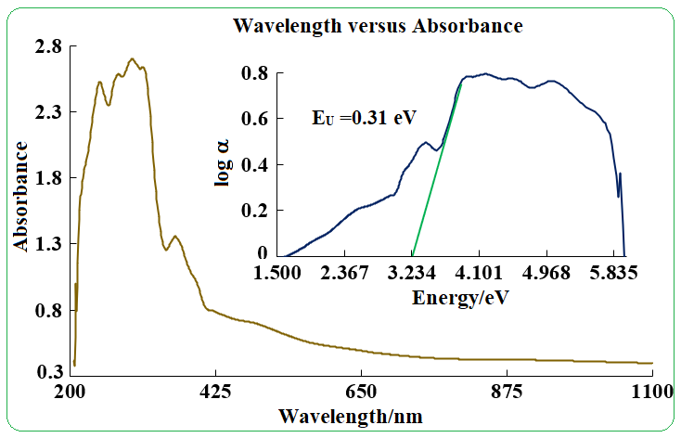
Fig.S1 Absorbance spectrum of moderately fluoride contaminated soil.

