Supporting Information (SI)

Feasibility of microwave drying for analysis and processing of medicinal plants
Esha Balaª, Saurav Dey^{b}, Sanjukta Patra^{c}, Siddhartha Singha*ª
ªSchool of Agro and Rural Technology, Indian Institute of Technology, Guwahati, Guwahati-781039, Assam, India, esha176154001@iitg.ac.in
^{b}Guwahati Biotech Park, Government of Assam, Guwahati, Guwahati-781031, Assam, India, s.dey@guwahatibiotechpark.com.
^{c}Biosciences and Bioengineering, Indian Institute of Technology, Guwahati, Guwahati-781039, Assam, India, sanjukta@iitg.ac.in
∗ Corresponding author: siddharthafp@iitg.ac.in

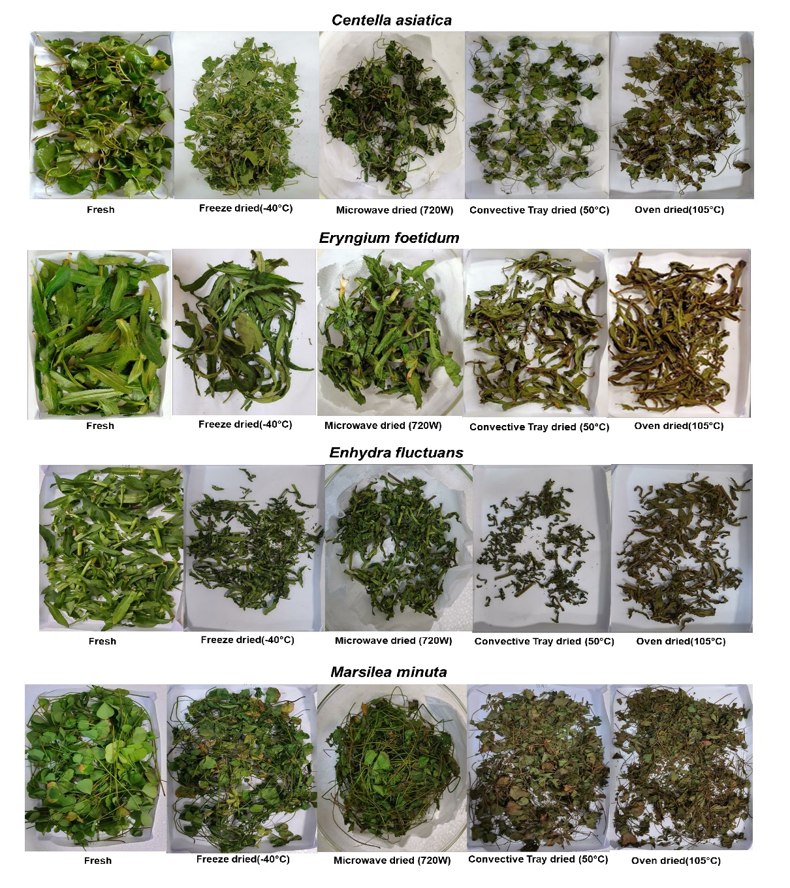
Fig. SI1 Fresh and dried form of four herbal plants at different methods

Table SI1 Effect of different percentages of volatilization and also effect of different degrees of incomplete drying on 90% moisture content of a sample
90 % Moisture | Loss of solid (1-15 %)
Amount of solid lost from 5 g sample | 0.005 | 0.01 | 0.03 | 0.05 | 0.07 | 0.09 | 0.11 | 0.13 | 0.15 | 0.2
BDM 0.5 g | 0.4975 | 0.495 | 0.485 | 0.475 | 0.465 | 0.455 | 0.445 | 0.435 | 0.425 | 0.4
BDM 0.5 g | 90.05% | 90.10% | 90.30% | 90.50% | 90.70% | 90.90% | 91.10% | 91.30% | 91.50% | 92.00%
BDM 0.5 g | 0.05% | 0.10% | 0.30% | 0.50% | 0.70% | 0.90% | 1.10% | 1.30% | 1.50% | 2.00%
BDM 0.5 g | 0.005 | 0.01 | 0.03 | 0.05 | 0.07 | 0.09 | 0.11 | 0.13 | 0.15 | 0.2
BDM 0.5 g | 89.55% | 89.10% | 87.30% | 85.50% | 83.70% | 81.90% | 80.10% | 78.30% | 76.50% | 72.00%
BDM 0.5 g | 4.4775 | 4.455 | 4.365 | 4.275 | 4.185 | 4.095 | 4.005 | 3.915 | 3.825 | 3.6
BDM 0.5 g | 0.5225 | 0.545 | 0.635 | 0.725 | 0.815 | 0.905 | 0.995 | 1.085 | 1.175 | 1.4
BDM 0.5 g | -0.45% | -0.90% | -2.70% | -4.50% | -6.30% | -8.10% | -9.90% | -11.70% | -13.50% | -18.00%
BDM: Bone Dry Mass

Table SI2 Effect of different percentages of volatilization and also effect of different degrees of incomplete drying on 10% moisture content of a sample
10 % Moisture | Loss of solid (1-15 %)
Amount of solid lost from 5 g sample | 0.005 | 0.01 | 0.03 | 0.05 | 0.07 | 0.09 | 0.11 | 0.13 | 0.15 | 0.2
BDM 4.5 g | 4.4775 | 4.455 | 4.365 | 4.275 | 4.185 | 4.095 | 4.005 | 3.915 | 3.825 | 3.6
BDM 4.5 g | 10.45% | 10.90% | 12.70% | 14.50% | 16.30% | 18.10% | 19.90% | 21.70% | 23.50% | 28.00%
BDM 4.5 g | 0.45% | 0.90% | 2.70% | 4.50% | 6.30% | 8.10% | 9.90% | 11.70% | 13.50% | 18.00%
BDM 4.5 g | 0.005 | 0.01 | 0.03 | 0.05 | 0.07 | 0.09 | 0.11 | 0.13 | 0.15 | 0.2
BDM 4.5 g | 89.55% | 89.10% | 87.30% | 85.50% | 83.70% | 81.90% | 80.10% | 78.30% | 76.50% | 72.00%
BDM 4.5 g | 4.4775 | 4.455 | 4.365 | 4.275 | 4.185 | 4.095 | 4.005 | 3.915 | 3.825 | 3.6
BDM 0.5 g | 0.5225 | 0.545 | 0.635 | 0.725 | 0.815 | 0.905 | 0.995 | 1.085 | 1.175 | 1.4
BDM 0.5 g | -0.45% | -0.90% | -2.70% | -4.50% | -6.30% | -8.10% | -9.90% | -11.70% | -13.50% | -18.00%
BDM: Bone Dry Mass

Table SI3 Water activity of four herbal plants
Sample Name | OD (105°C) | MW (720 W) | TD (50°C) | FD (-40°C)
CA | 0.11±0.04 | 0.11±0.03 | 0.20±0.04 | 0.27±0.02
ENF | 0.24±0.05 | 0.13±0.02 | 0.31±0.07 | 0.23±0.03
EGF | 0.17±0.02 | 0.18±0.03 | 0.32±0.04 | 0.26±0.04
MN | 0.10±0.02 | 0.16±0.02 | 0.32±0.05 | 0.19±0.03
CA: Centella asiatica; EGF: Eryngium foetidum; ENF: Enhydra fluctuans; MN: Marsilea minuta; TD: Convective tray dried; MW: Microwave dried; FD: Freeze dried Results were expressed as mean ± standard error of triplicate runs.

Table SI4 Comparative study of HPLC spectra of all the dried samples of four plants
- Centella asiatica (CA)
 | CA (height mAU)
Sl. No. | Retention time (min) | Tray dried (50°C) | Microwave dried (720W) | Freeze dried  (-40°C) | Compound Identified
1. | 1.149 | 91.01 | 48.85 | 44.67
2. | 1.55 | 25.35 | 4.87 | 3.86
3. | 3.34 | ND | 4.11 | 3.13
4. | 3.60 | ND | 13.43 | 10.54
5. | 5.25 | ND | 7.92 | 10.97 | Chlorogenic acid
6. | 14.02 | ND | 38.04 | 39.92 | Rutin
7. | 14.25 | ND | 5.31 | 7.18
8. | 14.38 | 18.90 | ND | ND
9. | 14.48 | ND | 3.08 | 4.29
10. | 14.73 | 52.48 | ND | ND
11. | 15.09 | 3.87 | 68.15 | 72.72
12. | 15.39 | 1.84 | 117.56 | 91.18
13. | 15.72 | ND | 5.75 | 7.10 | Ethyl protocatechuate
14. | 16.06 | ND | 9.09 | 10.31 | Naringin
15. | 16.12 | 9.64 | 29.22 | 34.36
16. | 16.79 | ND | 17.23 | 17.02 | Myricetin
17. | 17.55 | ND | 3.49 | 4.37
18. | 18.37 | 7.53 | 4.08 | ND
19. | 19.18 | 11.65 | ND | ND
20. | 19.39 | 27.61 | ND | ND
21. | 19.67 | 1.91 | ND | 3.64 | Apigenin
22. | 21.34 | ND | ND | 4.65
23. | 24.03 | 2.86 | ND | ND
24. | 24.54 | ND | ND | ND
25. | 25.95 | ND | 3.70 | 4.73
 |  | 274.25 | 409.03 | 394.12 | Total peak height
 |  | 1862.11 | 2940.74 | 3158.46 | Area under the curve
 |  | 12 | 17 | 18 | No of peaks
ND: Not detected
- Enhydra fluctuans (ENF)
 | ENF (height mAU)
Sl. No. | Retention time (min) | Tray dried(50°C) | Microwave dried(720W) | Freeze dried  (-40°C) | Compound Identified
1. | 1.38 | ND | ND | 107.98
2. | 1.47 | 28.18 | 39.99 | 54.91
3. | 1.63 | 33.36 | 28.14 | 63.90
4. | 1.7 | ND | 17.82 | 64.88
5. | 2.03 | ND | ND | 20.26
6. | 4.48 | 3.36 | ND | 9.83
7. | 4.63 | ND | 10.51 | ND
8. | 5.07 | ND | ND | 6.62
9. | 6.36 | 26.07 | 24.41 | 35.23 | Catechin
10. | 9.07 | ND | ND | 7.56 | Indole-3-acetic acid
11. | 15.22 | 7.21 | ND | ND
12. | 15.34 | 7.17 | 18.94 | 41.94
13. | 15.66 | 46.63 | 14.17 | ND
14. | 15.86 | 103.69 | 61.23 | ND
15. | 16.02 | ND | 155.67 | 190.97 | Naringin
16. | 16.24 | 87.55 | 151.23 | 166.75
17. | 16.82 | 27.91 | 30.11 | 9.52
18. | 17.97 | 15.95 | 15.72 | ND | Trans-resveratrol
19. | 18.25 | 34.10 | 50.76 | 14.90 | Cinnamic acid
20. | 18.53 | ND | 23.42 | 35.62
21. | 18.74 | 9.45 | 7.92 | 16.99 | Luteolin
22. | 19.38 | ND | ND | 2.73
23. | 19.83 | 3.33 | 5.54 | 4.49 | Kaempferol
24. | 21.23 | 12.77 | 13.49 | 15.03
 |  | 471.48 | 698.30 | 887.94 | Total peak height
 |  | 7103.61 | 9531.97 | 1.257e4 | Area under the curve
 |  | 15 | 17 | 19 | No of peaks
ND: Not detected

- Eryngium foetidum (EGF)
 | EGF (height mAU)
Sl. No. | Retention time (min) | Tray dried(50°C) | Microwave dried (720W) | Freeze dried  (-40°C) | Compound Identified
1. | 1.31 | ND | 34.41 | 70.76
2. | 1.40 | 40.95 | ND | 8.88
3. | 1.59 | 18.09 | 35.42 | 8.95
4. | 1.67 | 15.94 | ND | 14.00
5. | 1.91 | ND | 2.37 | 12.91
6. | 2.03 | 2.98 | ND | ND
7. | 2.31 | ND | 2.30 | ND
8. | 2.97 | ND | 2.06 | ND | Protocatechuic acid
9. | 4.17 | 2.07 | ND | ND
10. | 4.89 | ND | 5.32 | ND | p-Hydroxybenzoic acid
11. | 5.86 | 14.34 | ND | ND
12. | 5.98 | ND | 28.18 | 10.74
13. | 15.97 | 7.82 | ND | ND
14. | 16.15 | 11.05 | 13.50 | 13.10 | Naringin
15. | 16.71 | ND | 78.26 | 47.30 | Myricetin
16. | 16.85 | 28.27 | ND | ND
17. | 17.05 | ND | 35.46 | 20.12
18. | 18.16 | ND | 2.84 | 1.91 | Cinnamic acid
19. | 18.90 | ND | ND | 1.75 | Quercetin
20. | 19.70 | ND | 2.97 | 2.99
21. | 19.83 | 4.49 | ND | ND | Kaempferol
22. | 19.94 | 2.22 | 2.64 | 3.83
23. | 24.23 | 2.70 | ND | 2.89
24. | 24.96 | ND | ND | 2.85
25. | 26.42 | 4.07 | 7.40 | 6.30
26. | 26.96 | 6.87 | 8.67 | 8.36
 |  | 163.87 | 267.83 | 241.14 | Total peak height
 |  | 2618.49 | 4544.75 | 3099.78 | Area under the curve
 |  | 14 | 15 | 17 | No of peaks
ND: Not detected

- Marsilea minuta (MN)
 | MN (height mAU)
Sl. No. | Retention time (min) | Tray dried(50°C) | Microwave dried(720W) | Freeze dried  (-40°C) | Compound Identified
1. | 1.23 | 34.98 | 35.03 | ND
2. | 1.27 | 71.57 | ND | ND
3. | 1.3 | ND | 81.24 | 117.14
4. | 1.45 | 21.03 | 31.09 | 43.04
5. | 1.57 | ND | 21.08 | 27.06
6. | 4.10 | 2.66 | 2.86 | 3.20
7. | 5.92 | ND | 6.75 | 4.81
8. | 6.25 | 4.73 | ND | ND | Catechin
9. | 12.34 | ND | 6.07 | 8.58
10. | 12.72 | 5.39 | 2.33 | 3.17 | Ferulic acid
11. | 13.068 | 2.25 | ND | ND
12. | 15.19 | 1.75 | ND | ND
13. | 16.01 | ND | 5.24 | 4.24 | Naringin
14. | 16.25 | 4.77 | ND | ND
15. | 17.36 | ND | ND | 2.24
16. | 17.55 | 7.05 | 7.44 | 5.42
17. | 18.62 | ND | 5.20 | 3.95
18. | 18.71 | 6.26 | 6.64 | 4.49 | Luteolin
 |  | 170.66 | 221.05 | 242.66 | Total peak height
 |  | 1764.40 | 2151.46 | 2357.79 | Area under the curve
 |  | 11 | 12 | 12 | No of peaks
ND: Not detected

