In-Situ Graphene Synthesis Study in Inductively Coupled Radio-Frequency Thermal Plasma Reactor using Methane Precursor.
Reem Mahmoudª, François Gitzhoferª, Jasmin Blanchard^{b}, Nicolas Abatzoglou^{a, *}.
Reem.Mahmoud@usherbrooke.ca; Francois.Gitzhofer@usherbrooke.ca; jblanchard@kwipolymers.com ; Nicolas.Abatzoglou@usherbrooke.ca.
ª Department of Chemical and Biotechnological Engineering, Université de Sherbrooke, Sherbrooke, QC J1K 2R1, Canada.
^{b} KWI Polymers, Boisbriand, QC J7H1M9, Canada.
* Corresponding author.
APPENDIX A: Normal residual plots of the reduced models

(b)
(a)
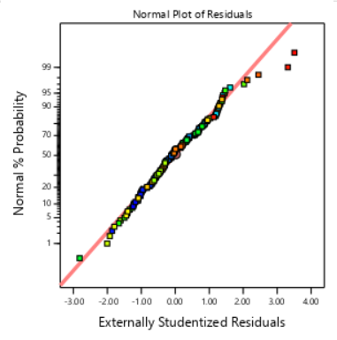  (c) | 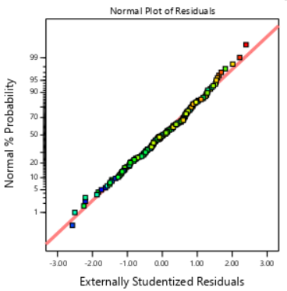  (d)
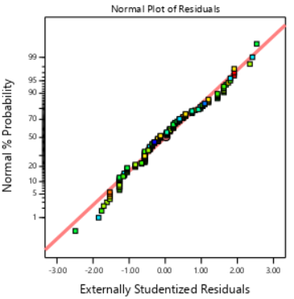 | 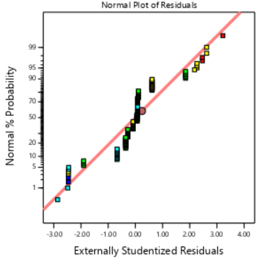
(e) | (f)
Figure A.1: (a-f) externally studentized residuals vs normal probability for H₂, C₂H₂, C₂H₄, CH₄,C₃H₆ and C₆H₆, respectively.

