TABLE AND FIGURES

Deficiency encephalopathy: what if it is only one symptom of a systemicinflammatory disease? A case report.

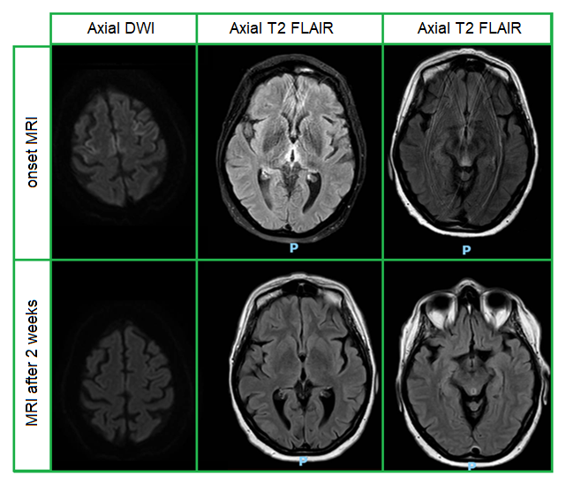
Table 1. The table shows MRI images comparing the first exam with the one carried out two weeks later, following vitamin replacement. Note, in addition to the improvement of imaging, the patient's greater compliance; at the many artifacts were present, because of the marked disorientation and agitation.

