Extended Data Figures
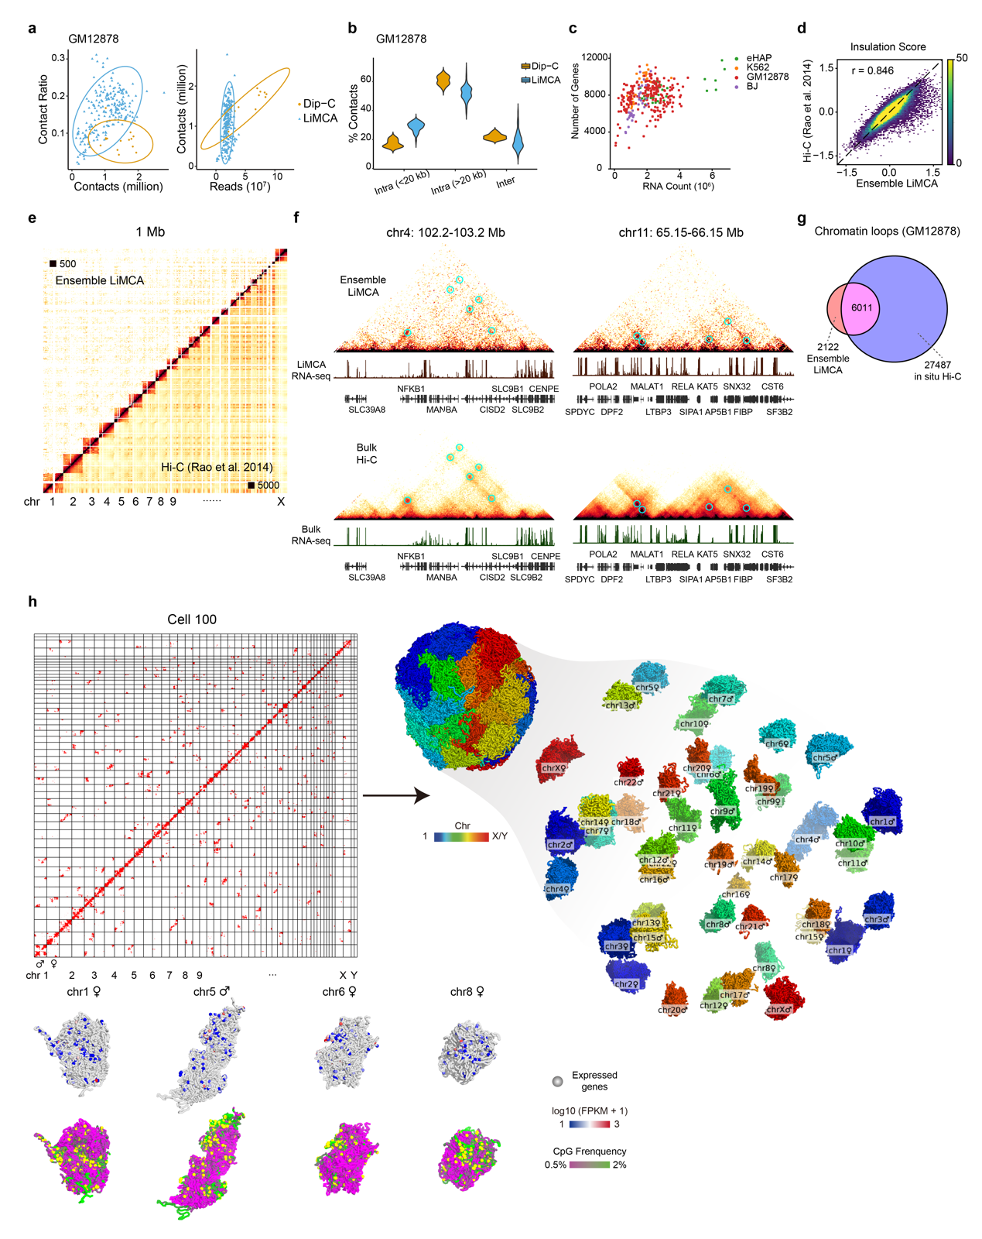
Extended Data Fig. 1 | Validation of LiMCA. a, Comparison between LiMCA and Dip-C, scatter plot for contacts number versus contact ratio (left) and reads number versus contact number (right). b, Violin plot showing the proportion of cis and trans contacts. c, Scatter plot showing reads number versus detected genes for RNA. d, Insulation score of ensemble LiMCA is high concordant to bulk Hi-C, calculated at 50 kb resolution. e, Contact maps comparison between ensemble LiMCA and bulk Hi-C at 1Mb resolution, all chromosomes are shown. f, Two selected regions showing ensemble can detect chromatin loops, RNA-seq tracks are shown below. g, Venn diagram showing chromatin loops detected by ensemble LiMCA and bulk Hi-C, loops are called with HICCUPS. h, A imputed contact map of a representative GM12878 cells and the reconstructed 3D structure at 20 kb resolution (Top). Four chromosomes with expressed genes projected.

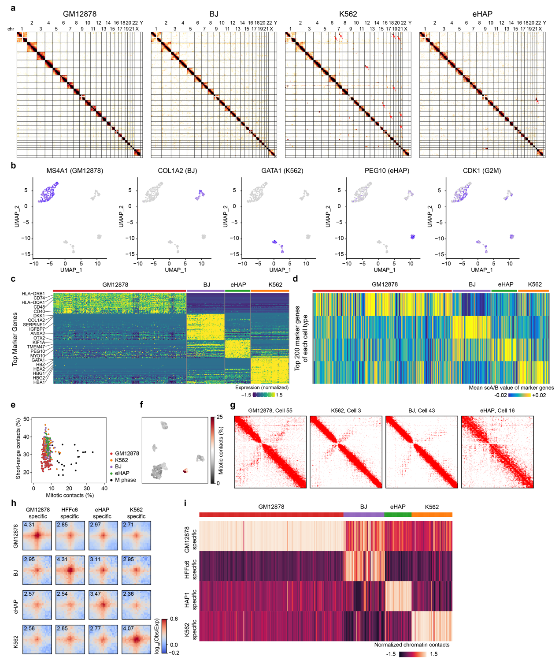
Extended Data Fig. 2 | LiMCA accurately detects cell-type-specific gene expression and chromatin structures. a, Ensemble contacts maps of four cell lines at 1Mb resolution, translocations are highlighted with red arrow. b, UMAP showing four represented markers for each cell type and one maker gene of G2M phase. c, Expression of top cell-type-specific marker genes for each cell type, top 20 of each cell type are shown. d, Mean scA/B value of cell-type-specific marker genes among single cells. For each cell types, the top 200 marker genes were identified from the paired transcriptome data. e, Scatterplot showing the mitotic contact band (2-12 Mb) ratio versus short-range contacts (< 2 Mb) ratio. f, UMAP visualizing the mitotic band ratio of cell line embedding. g, Represented contact maps of cells in metaphase cluster. h, Pile-up of cell-type-specific chromatin loops using ensemble interaction profiles from each cell type. i, Heatmap showing the enrichment of cell-type-specific chromatin loops among single cells.

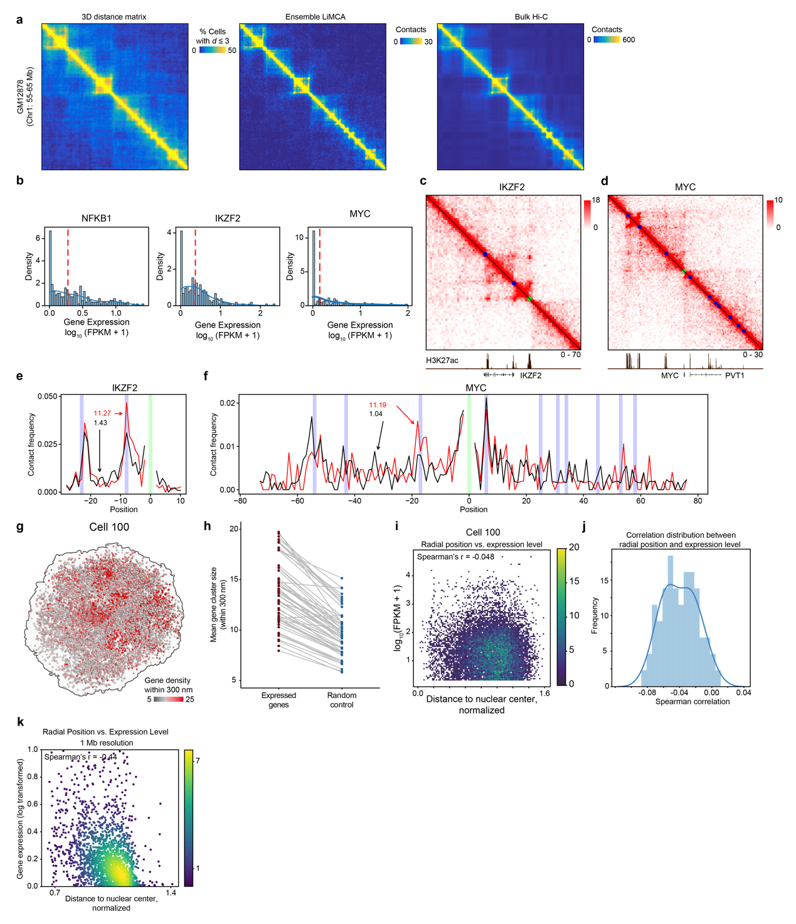
Extended Data Fig. 3 | The relationship between 3D genome organization and expression. a, Comparison of pairwise 3D distance matrix and ensemble single-cell contact map and bulk Hi-C contact map. b, Histogram of expression level distribution for NFKB1 (left), IKZF2 (middle) and MYC (right). c, Ensemble contact maps comparing cells above median expression (bottom left) and below median expression (top right) for IKZF2. d, The same as c but for MYC. e, 4C visualization of interactions between enhancer and the expressed gene, viewpoint centered at downstream enhancer. f, 4C visualization of interactions between enhancer and the expressed gene, viewpoint centered at MYC promoter. g, Expressed genes spatial distribution of a representative GM12878 cell, genes are colored by gene number within 300 nm. h, Scatterplot showing the median gene cluster size within 300 nm for expressed genes and randomly selected genes, the same cell was connected with line. i, Scatterplot of normalized radial position versus expression level at 20 kb resolution of a representative GM12878 cells. j, Correlation distribution of normalized radial position versus expression level among single cells. k, The same as i, but for median radial position across cell population versus mean expression level at 1 Mb resolution.
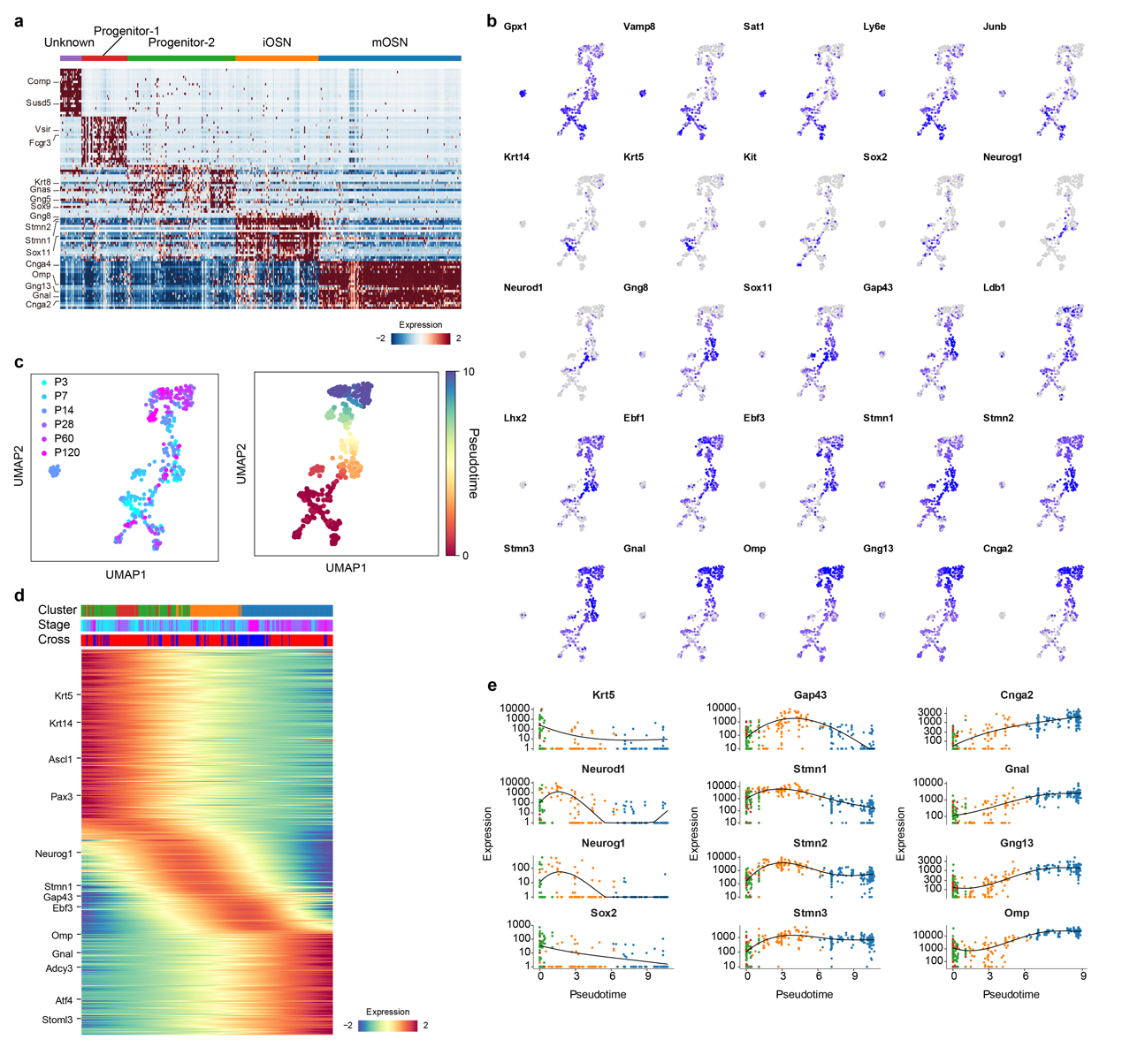
Extended Data Fig. 4 | Gene expression of the single-cell LiMCA multi-omics atlas recapitulate the continuous OSN genesis and marker gene expression. a, Expression of top cell-type-specific marker genes. The top 20 maker genes are plotted. b, UMAP projection of known maker genes for OSN progenitors, iOSNs and mOSNs. c, The same as Fig. 2c (left), colored by sample age and pseudo-time. d, Heatmap showing the continuous gene expression change along OSNs genesis using pseudo-time. e, Scatterplot showing the dynamic gene expression of known maker genes.

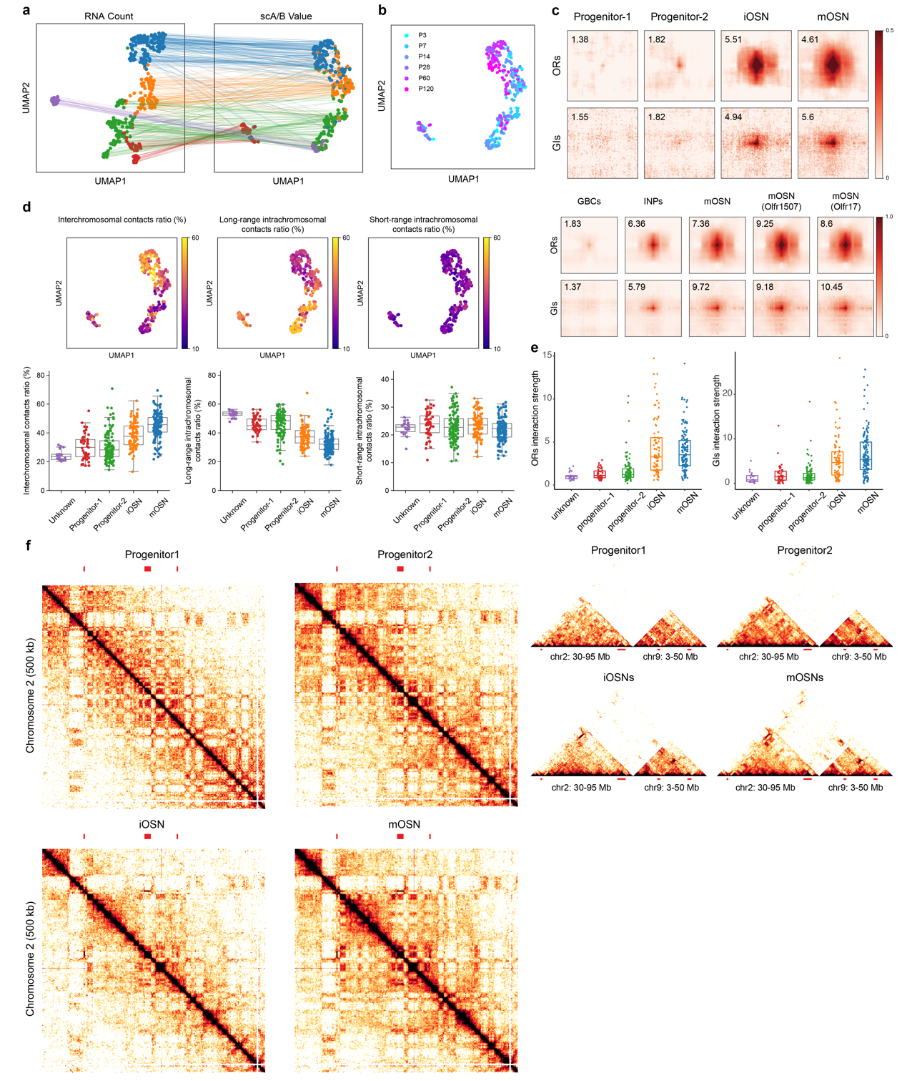
Extended Data Fig. 5 | Chromatin structure offered by LiMCA recaptures the characteristic reorganization along OSNs development. a, The same as Fig. 2c, The same cell was connected in the two embeddings. b, The same as Fig. 2d (right), cells were colored by sample age. c, Pile-up of interactions between ORs and GIs of ensemble interaction profiles from each cluster (top), and bulk Hi-C datasets from Monahan et al., (2019) (bottom). d, UMAP visualization of inter-chromosomal contact ratio, long-range (> 20 kb) intra-chromosomal ratio and short-range (< 20 kb) intra-chromosomal ratio (top), and the scatterplot quantification of these values, the black horizontal line and the box represent the median and quartiles, respectively (bottom). e, Scatterplot showing the gradual increasing of OR-OR, GI-GI interaction strength along OSN development. f, Contact maps of ensemble interaction profiles of single cells from each cell cluster of chromosome 2 (left) and regions of chr2: 30-95 Mb and chr9: 3-50 Mb, OR gene clusters are indicated.

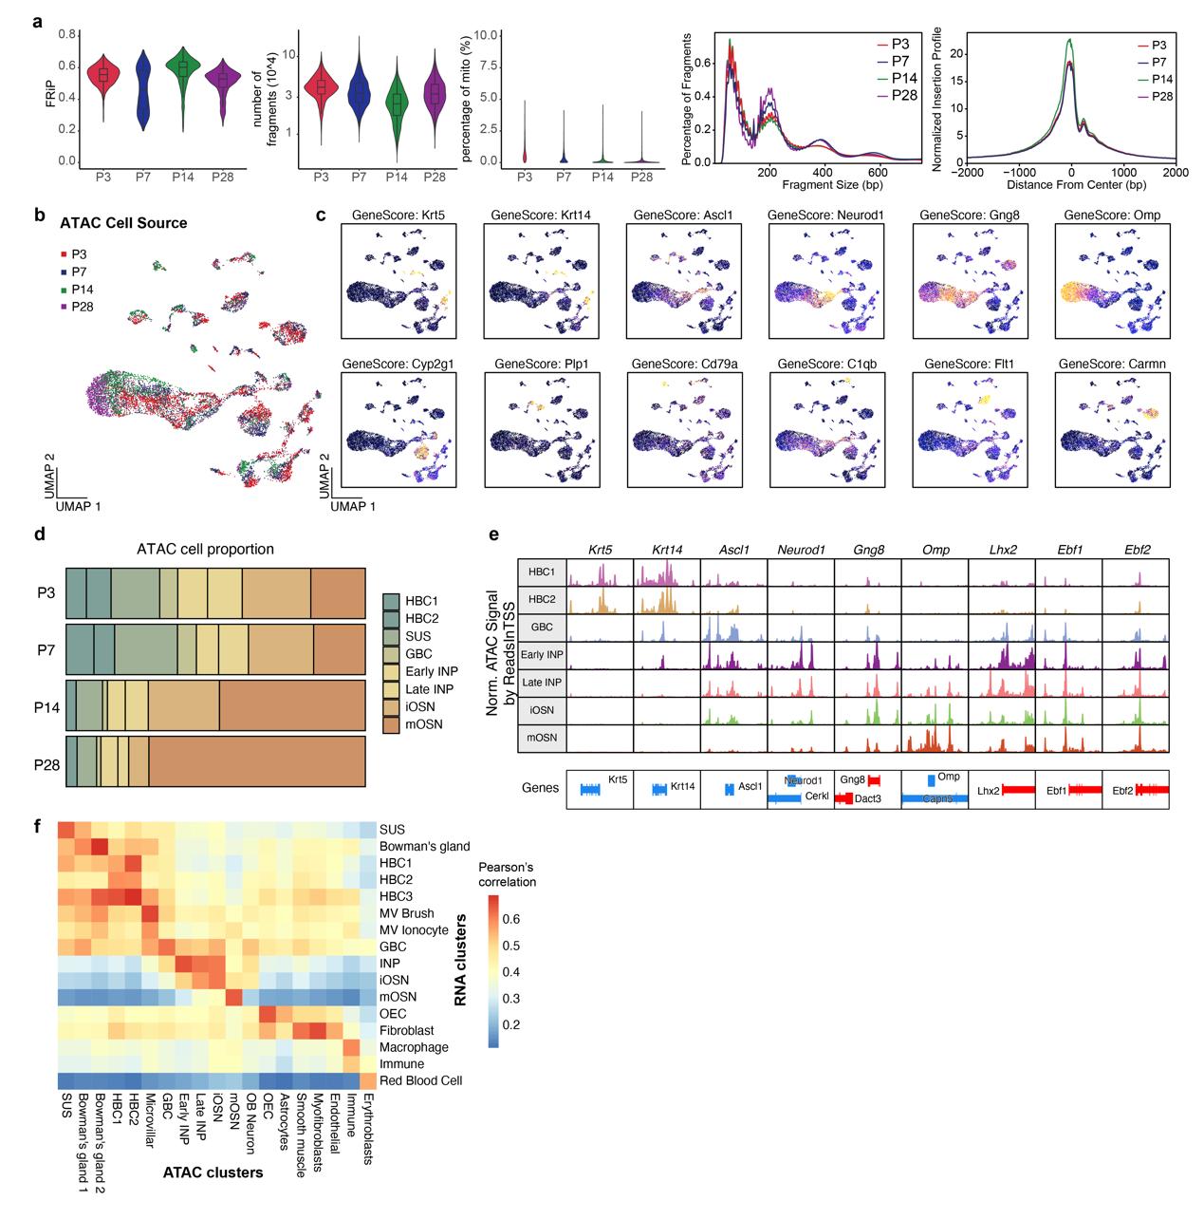
Extended Data Fig. 6 | Quality control and overview of MOE METATAC results. a, Quality control metrics for METATAC dataset, from left to right are Distribution of ratio of decontaminated fragments in peaks (FRiP), number of decontaminated fragments, percentage of mitochondrial fragments, fragment sizes distribution, and TSS enrichment for METATAC cells of four batches, respectively. Numbers of cells are 4090, 3146, 2850, 1794, for P3, P4, P14, and P28, respectively. b-c, UMAP of MOE METATAC cells colored by (b) cell source batches, and (c) gene scores of marker genes. d, Proportion of cell types associated with MOE development for cells from P3, P7, P14, and P28 mice. e, Tracks of METATAC signals normalized by number of reads in TSS near the promoter of marker genes of HBCs, GBCs, INPs, and OSNs. f, Heatmap shows the correlation coefficients between cell clusters of MOE 10x scRNA-seq and METATAC.

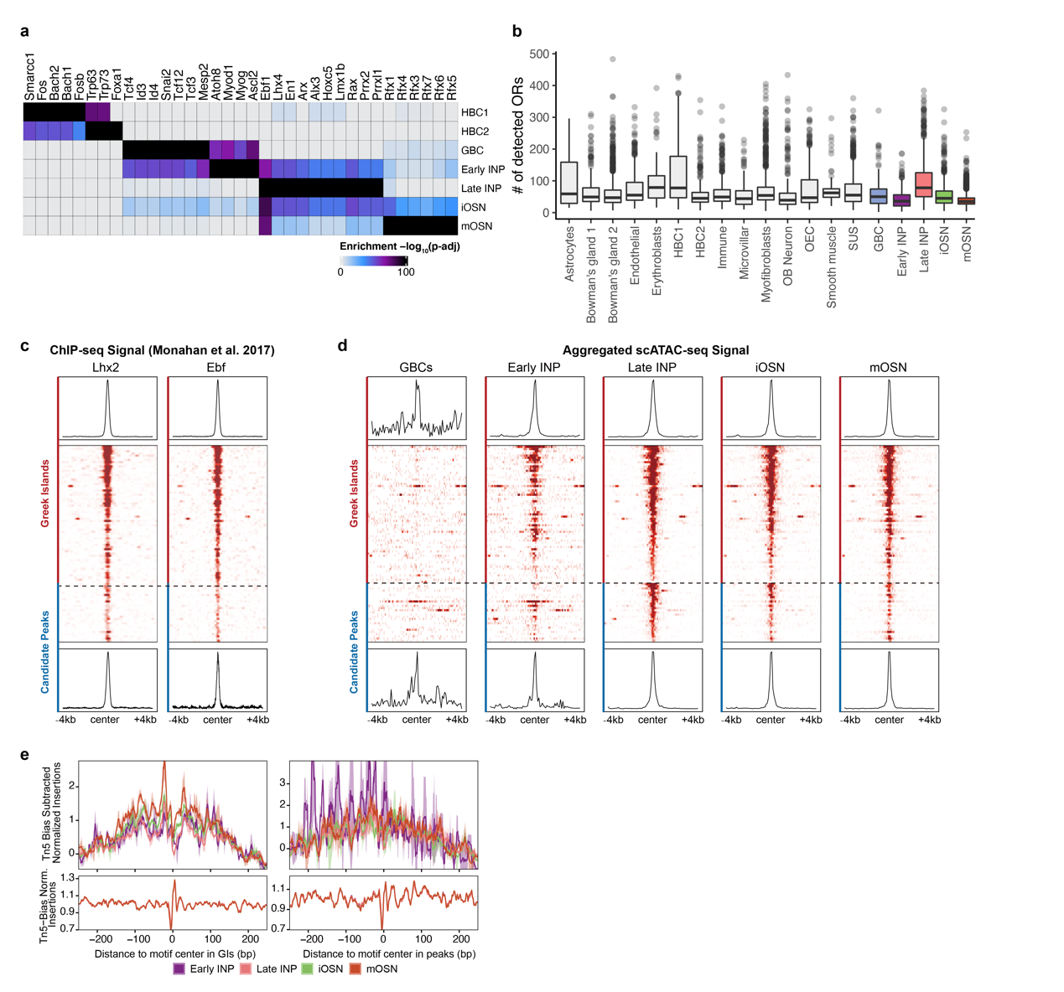
Extended Data Fig. 7 | Additional MOE METATAC results and identification of candidate OR enhancers. a, TF-binding motifs enriched in HBCs, GBCs, INPs, and OSNs. b, Numbers of detected OR genes in various cell types are shown as a boxplot. An OR gene is considered to be detected if it has a gene score > 0 as calculated by ArchR. c-d, Lhx2 and Ebf ChIP-seq signals (c) and METATAC signals of different MOE cell development stages (d) at previously defined 63 Greek Islands and 27 candidate regulatory peaks identified in this study. Aggregated signal of all GIs or peaks are shown above or below the heatmap, respectively. e, METATAC footprints at composite motif sites in GIs or identified peaks. Aggregated normalized METATAC insertions and the Tn5 bias corrected are shown.

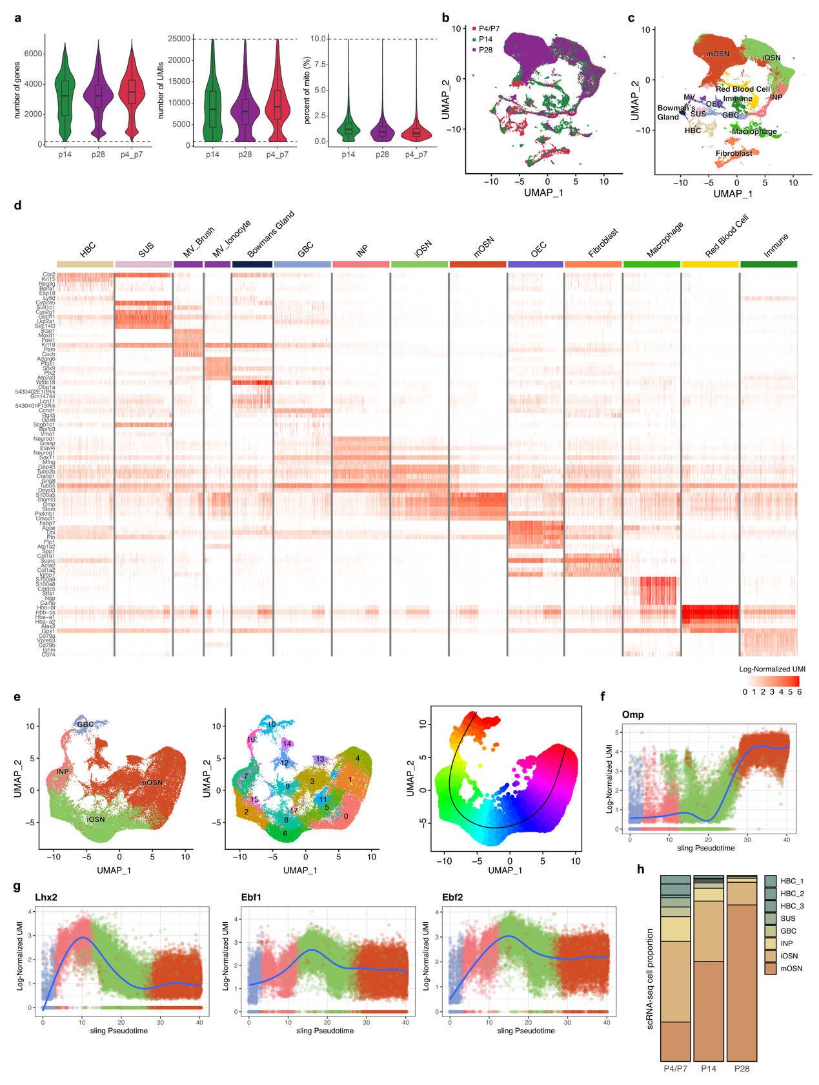
Extended Data Fig. 8 | Quality control and overview of MOE scRNA-seq results. a, Number of detected genes, UMI counts, and percentage of mitochondrial UMIs for cells from P4/P7 (N=28,303), P14 (N=24,116), and P28 (N=21,158) mice. b-c, UMAP of scRNA-seq data colored by origin batch (b) and cell types (c). d, Heatmap shows the expression of marker genes of each cell type. For cell types with more than 1,000 cells, top 1,000 representative cells with the highest UMI counts are shown. e, UMAP of the subset of scRNA-seq dataset including GBCs, INPs, iOSNs, and mOSNs, colored by previously identified cell types (left), new clusters (middle), and pseudotime (right). f-g, Dynamics of the expression of Omp (f), and Lhx2, Ebf1, Ebf2 (g) during the development of MOE. h, Proportion of cell types associated with MOE development for cells from P4/P7, P14, and P28 mice in the scRNA-seq dataset.

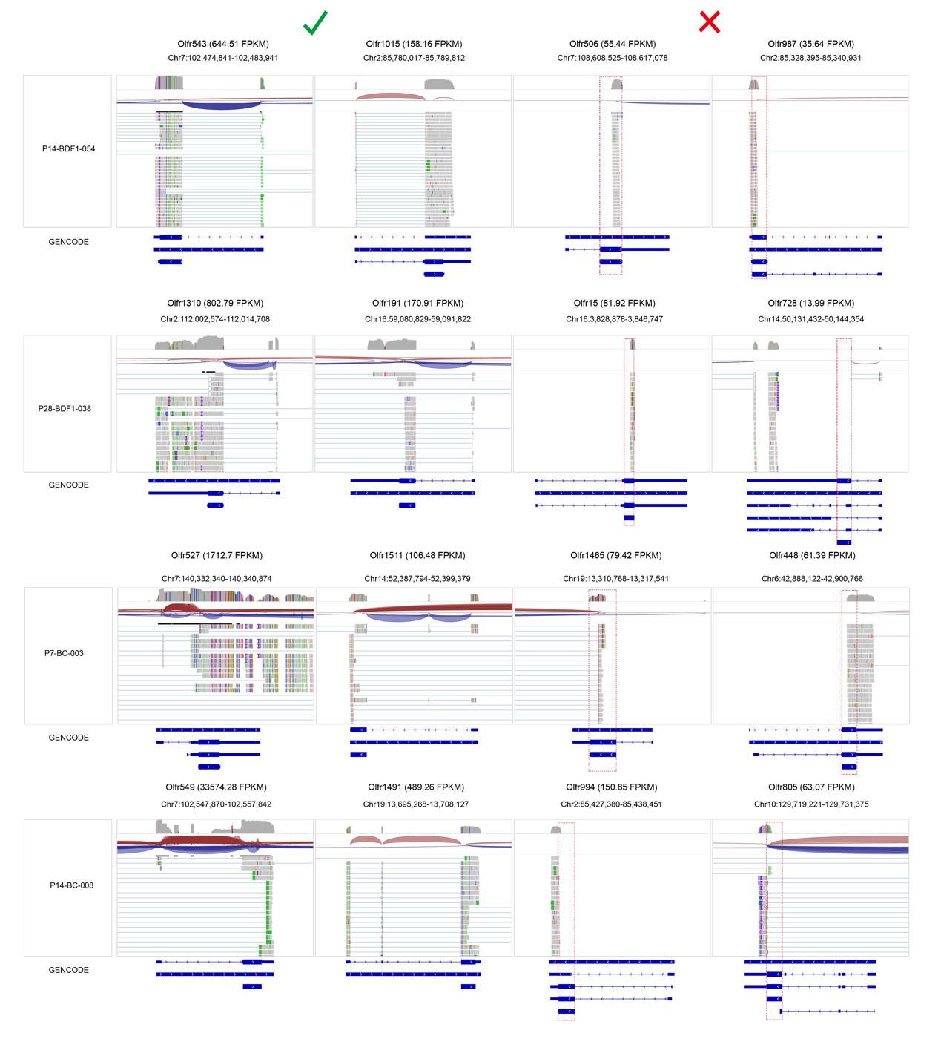
Extended Data Fig. 9 | Identification of genuine OR expression with full-length gene expression information.

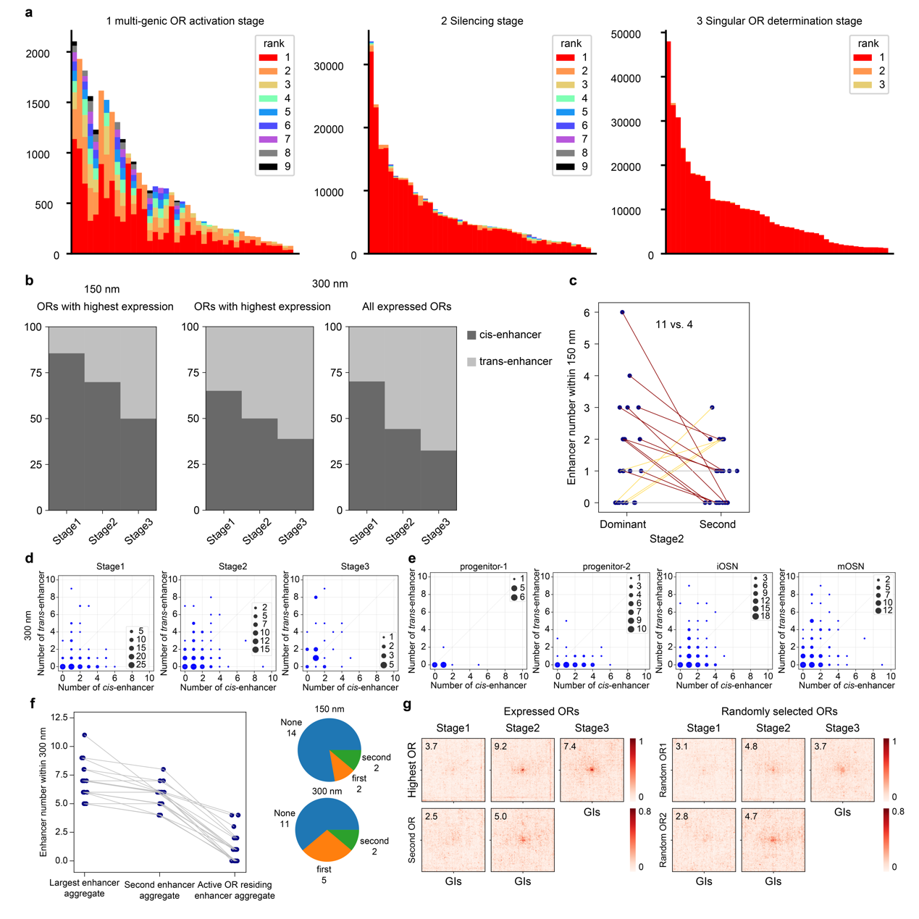
Extended Data Fig. 10 | The spatial relationship between expressed OR genes and their enhancers. a, OR FPKM values within single cells of each stage. Each color represents an individual OR, except black, which represents all OR ranked below 8. b, Composition of cis or trans GIs within 150 nm or 300 nm from expressed ORs (considering all expressed ORs). c, Same as Fig. 3f but for the number of GIs within 2.5 particle radii (150 nm) from each expressed OR in single cells. d, Summary of the number of nearby cis- and trans-GIs for each OR in different stages. e, Same as d but grouped by different cell types. f, Same as Fig. 3g but for the number of GIs within 2.5 particle radii (150nm) from each OR in cells of the singular OR determination stage (left panel); pie chart depicting the number of cells with rank 1 OR (with the highest expression) near the largest GI aggregate, the second largest GI aggregate, and others (right panel). g, Average contact density of inter-chromosomal contacts between OR with the highest or second highest expression and all trans GIs. Random ORs are taken as control.

