Supplementary file 3 | Example of Visual Feedback Report
Bar-chart

Radar-plot
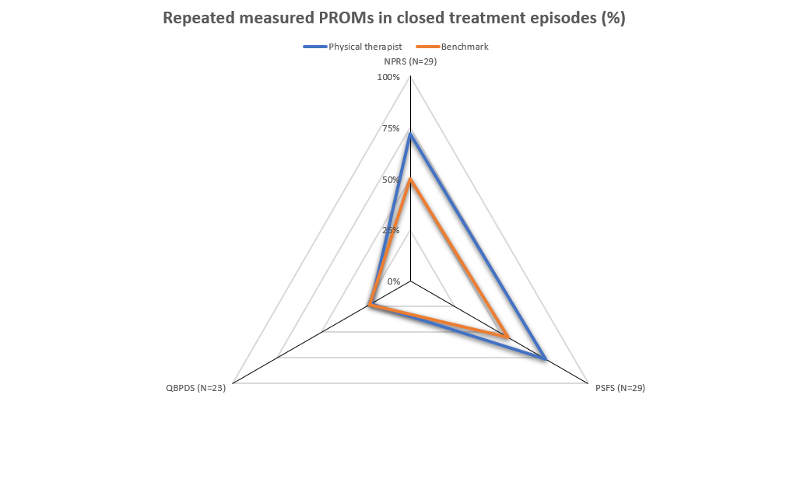

Chart
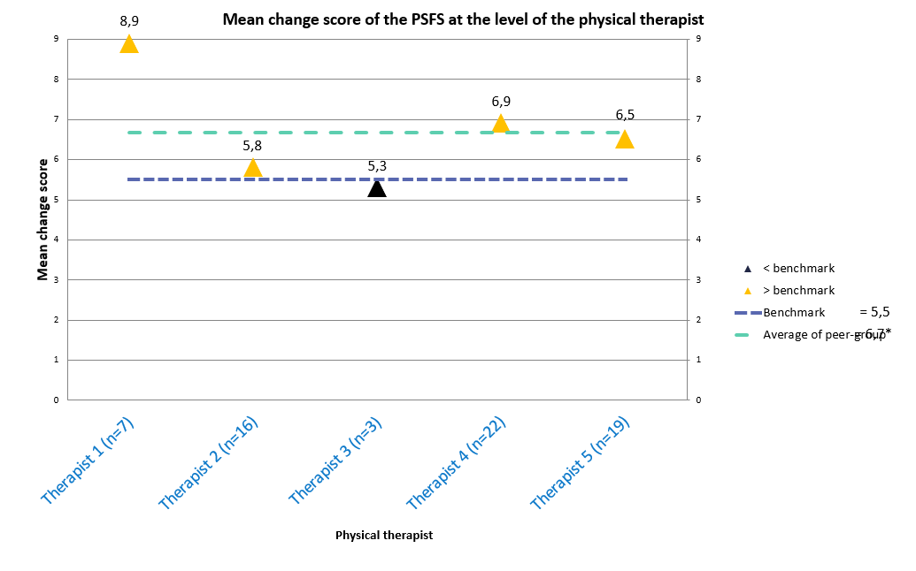

Numerical Table
