Supplementary Material
Causal associations between gut microbiota and three prostate diseases: A bidirectional two-sample Mendelian randomization study
Xiaoyang Liu1 Luchen Yang1 Zhufeng Peng1 Pan Song1 Zhenghuan Liu1 Jing Zhou1 Kai Ma1 Yunfei Yu1
* Correspondence: Dong Qiang:dongqiang@scu.edu.cn

exposure | nsnp | or | or_lci95 | or_uci95 | pval | p_BH
genus
Sutterella | 12 | 1.31 | 1.03 | 1.68 | 0.03 | 0.76
Erysipelatoclostridium | 15 | 0.82 | 0.68 | 0.99 | 0.04 | 0.76
RuminococcaceaeUCG010 | 6 | 1.37 | 1.00 | 1.88 | 0.05 | 0.76
Odoribacter | 7 | 1.44 | 1.04 | 2.00 | 0.03 | 0.76
Eubacteriumeligensgroup | 6 | 0.69 | 0.48 | 0.99 | 0.05 | 0.76
family
Methanobacteriaceae | 9 | 0.81 | 0.69 | 0.95 | 0.01 | 0.26
order
Gastranaerophilales | 9 | 1.35 | 1.12 | 1.64 | <0.01 | 0.04
NB1n | 12 | 1.19 | 1.02 | 1.38 | 0.03 | 0.18
Methanobacteriales | 9 | 0.81 | 0.69 | 0.95 | 0.01 | 0.08
class
Methanobacteria | 9 | 0.81 | 0.69 | 0.95 | 0.01 | 0.08
Melainabacteria | 10 | 1.27 | 1.06 | 1.53 | 0.01 | 0.08
phylum
Cyanobacteria | 8 | 1.27 | 1.02 | 1.58 | 0.03 | 0.28

Supplement Table S1. Sensitivity analysis and BH test for prostatitis (fix effect model)

exposure | nsnp | or | or_lci95 | or_uci95 | pval | p_BH
genus
Flavonifractor | 5 | 0.84 | 0.76 | 0.94 | <0.01 | 0.16
Coprobacter | 11 | 0.92 | 0.87 | 0.98 | 0.01 | 0.16
Roseburia | 14 | 0.90 | 0.83 | 0.98 | 0.02 | 0.26
Dorea | 9 | 1.13 | 1.02 | 1.25 | 0.02 | 0.29
Ruminococcusgauvreauiigroup | 12 | 1.10 | 1.01 | 1.19 | 0.03 | 0.29
Adlercreutzia | 8 | 0.89 | 0.82 | 0.97 | 0.01 | 0.16
Eubacteriumnodatumgroup | 11 | 1.06 | 1.02 | 1.11 | 0.01 | 0.16
ChristensenellaceaeR.7group | 9 | 1.12 | 1.01 | 1.25 | 0.03 | 0.29
Eubacteriumfissicatenagroup | 9 | 1.08 | 1.02 | 1.13 | 0.01 | 0.16
RuminococcaceaeUCG004 | 9 | 0.91 | 0.84 | 0.99 | 0.03 | 0.29
Odoribacter | 7 | 1.17 | 1.05 | 1.31 | <0.01 | 0.16
Holdemania | 15 | 0.93 | 0.88 | 0.99 | 0.01 | 0.21
Allisonella | 6 | 0.93 | 0.89 | 0.99 | 0.01 | 0.21
family
Rhodospirillaceae | 15 | 0.94 | 0.89 | 1.00 | 0.04 | 0.58
Lachnospiraceae | 17 | 1.08 | 1.00 | 1.16 | 0.05 | 0.58
order
Rhodospirillales | 14 | 0.91 | 0.86 | 0.97 | <0.01 | 0.06
class
Alphaproteobacteria | 7 | 0.84 | 0.76 | 0.92 | <0.01 | <0.01

Supplement Table S2. Sensitivity analysis and BH test for prostate cancer (fix effect model)

exposure | nsnp | or | or_lci95 | or_uci95 | pval | p_BH
genus
Flavonifractor | 5 | 0.85 | 0.73 | 0.98 | 0.02 | 0.64
Escherichia.Shigella | 10 | 1.19 | 1.06 | 1.34 | <0.01 | 0.21
RuminococcaceaeUCG009 | 11 | 0.88 | 0.82 | 0.96 | <0.01 | 0.21
Eisenbergiella | 11 | 0.92 | 0.85 | 0.99 | 0.02 | 0.64
FamilyXIIIAD3011group | 13 | 1.12 | 1.01 | 1.25 | 0.03 | 0.64
Marvinbryantia | 10 | 0.88 | 0.79 | 0.99 | 0.03 | 0.64
family
Acidaminococcaceae | 7 | 1.14 | 1.01 | 1.28 | 0.03 | 0.79
Methanobacteriaceae | 9 | 0.93 | 0.87 | 1.00 | 0.05 | 0.79
order
Methanobacteriales | 9 | 0.93 | 0.87 | 1.00 | 0.05 | 0.31
Clostridiales | 11 | 1.16 | 1.02 | 1.31 | 0.02 | 0.24
Selenomonadales | 12 | 0.87 | 0.77 | 0.98 | 0.02 | 0.24
class
Methanobacteria | 9 | 0.93 | 0.87 | 1.00 | 0.05 | 0.39
Negativicutes | 12 | 0.87 | 0.77 | 0.98 | 0.02 | 0.33

Supplement Table S3. Sensitivity analysis and BH test for benign prostatic hyperplasia (fix effect model)

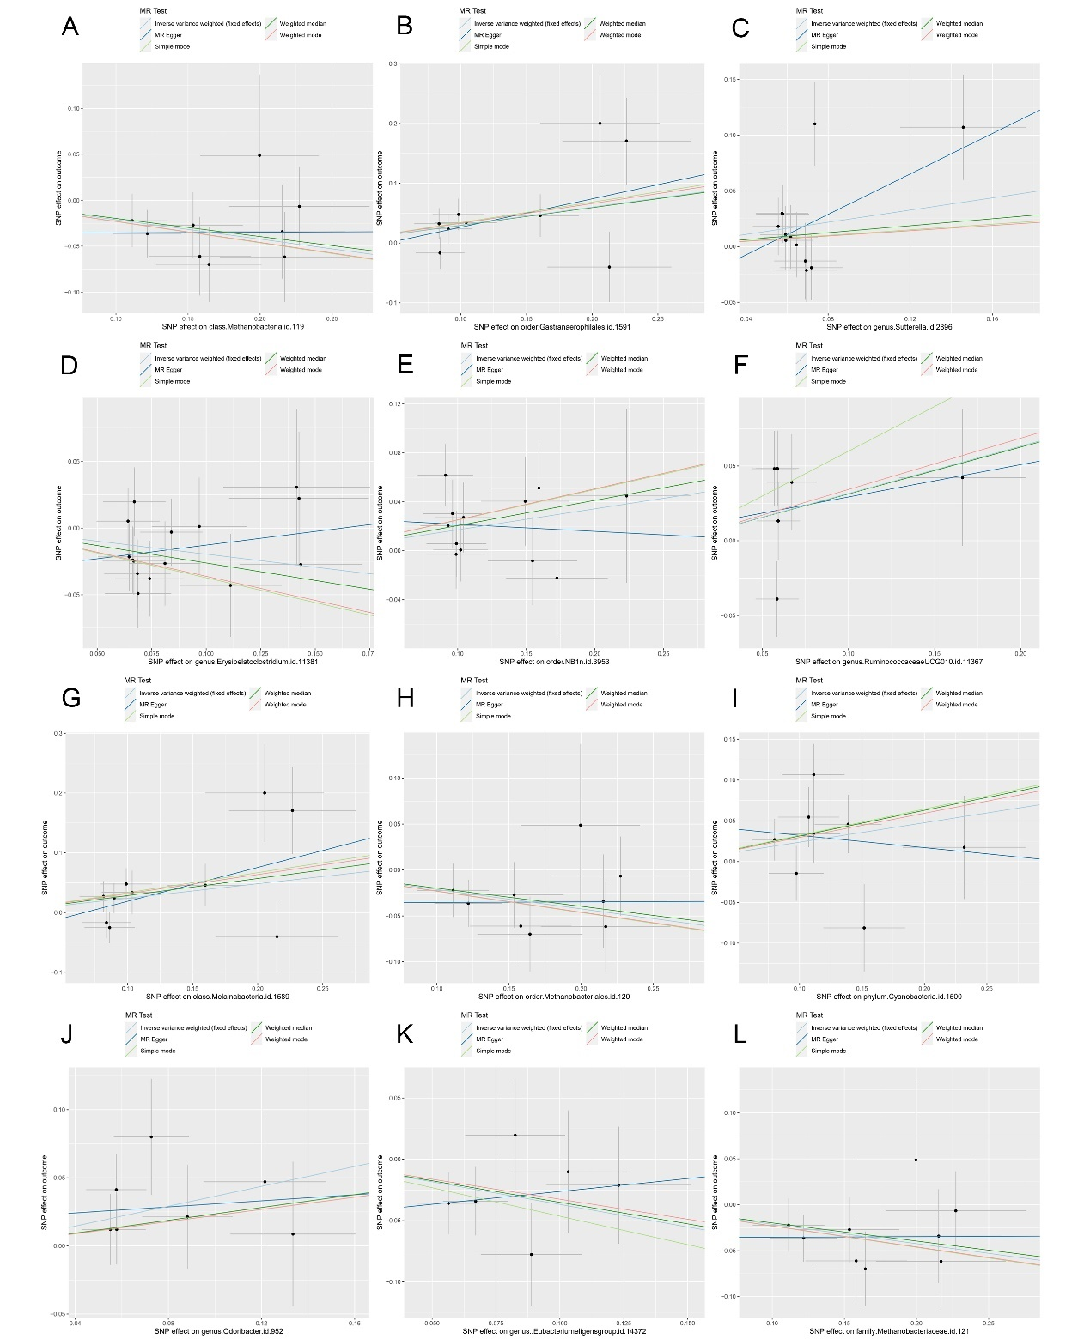

Supplement Figure S1
Scatter plots of significant and nominal significant estimates from genetically predicted
microbiotas(A) Family Methanobacteriaceae; (B) Order Gastranaerophilales; (C) Genus Sutterella; (D) Genus Erysipelatoclostridium; (E) Order NB1n ; (F) Genus RuminococcaceaeUCG010; (G) Class Melainabacteria; (H) Order Methanobacteriales; (I) Phylum Cyanobacteria;(J) Genus Odoribacter;(K) GenusEubacterium eligens group;(L) Family Methanobacteriaceae on prostatitis

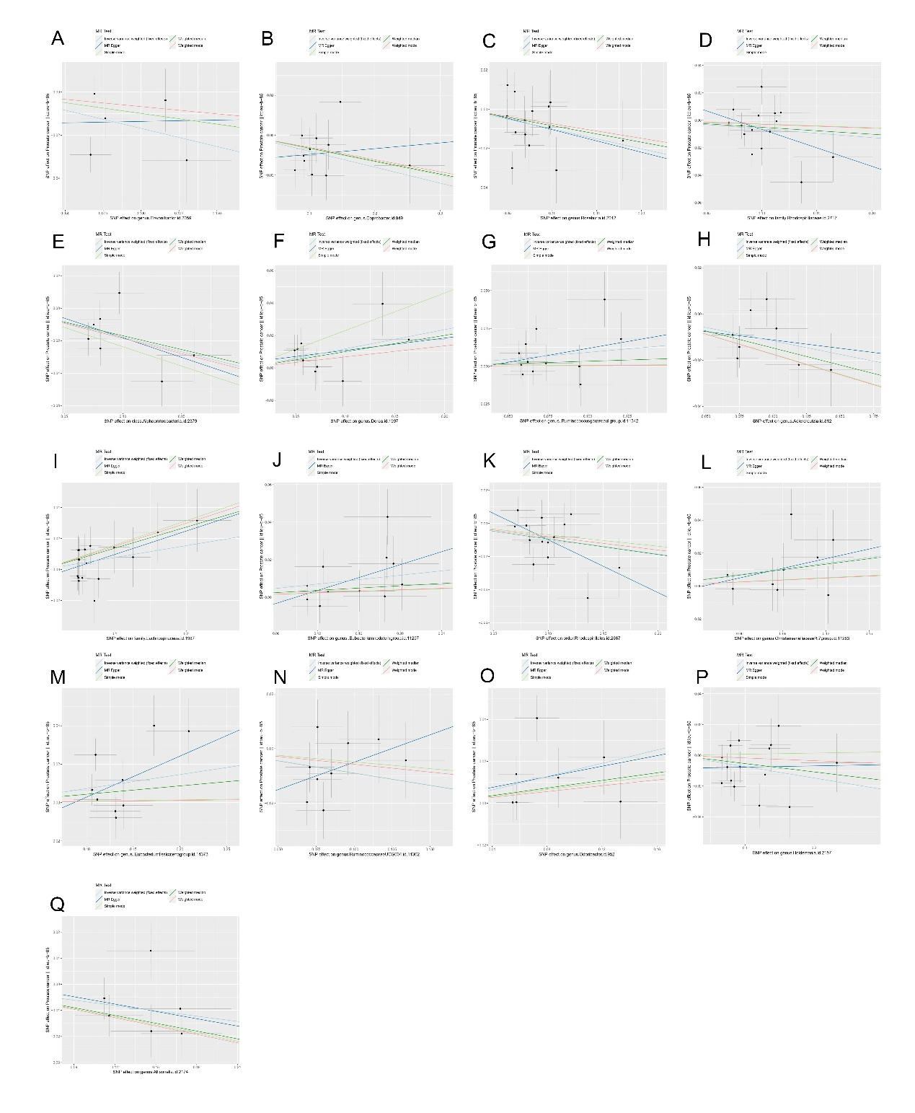
Supplement Figure S2
Scatter plots of significant and nominal significant estimates from genetically predicted
microbiotas(A) Genus.Flavonifractor; (B) Genus Coprobacter; (C) Genus Roseburia; (D) Family Rhodospirillaceae; (E) Class Alphaproteobacteria ; (F) Genus Dorea; (G) Genus Ruminococcus gauvreauii group; (H) Genus Adlercreutzia; (I) Family Lachnospiraceae;(J) Genus Eubacteriumnodatumgroup (K) Order Rhodospirillales;(L) Genus ChristensenellaceaeR 7group;(M) Genus Eubacteriumfissicatena group;(N) Genus RuminococcaceaeUCG004;(O) Genus Odoribacter;(P) Genus Holdemania;(Q) Genus Allisonella on prostate cancer.

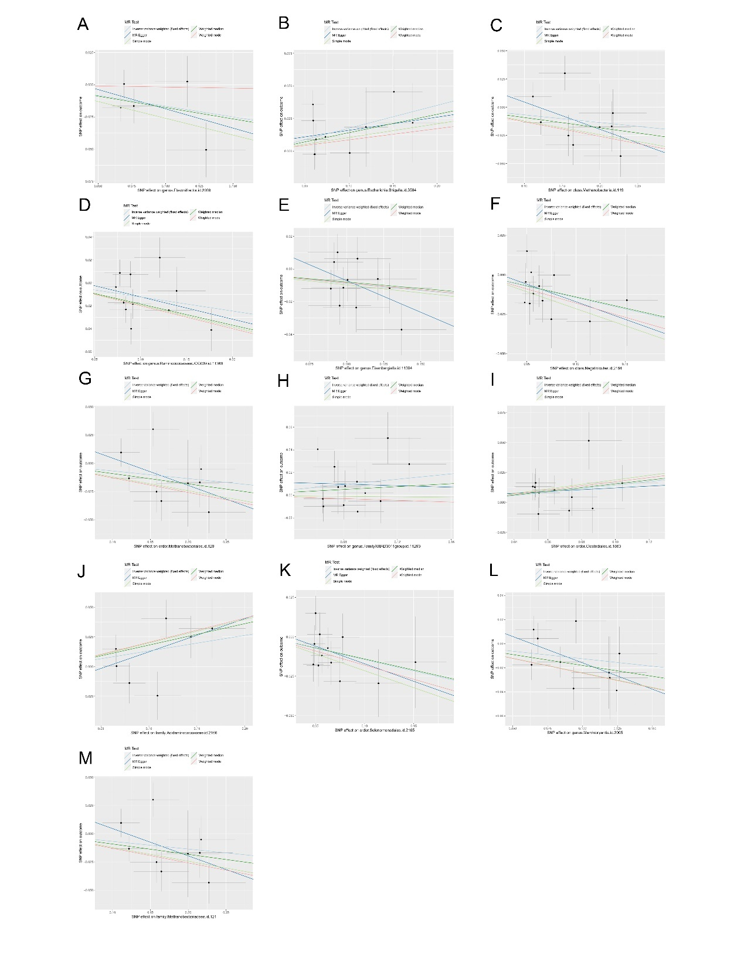

Supplement Figure S3
Scatter plots of significant and nominal significant estimates from genetically predicted
microbiotas(A) Genus Flavonifractor; (B) Genus Escherichia.Shigella (C) Class Methanobacteria (D) Genus Ruminococcaceae UCG009; (E) Genus Eisenbergiella ; (F) Class Negativicutes (G) Order Methanobacteriales; (H) Genus FamilyXIIIAD3011 group; (I) Order Clostridiales;(J) Family Acidaminococcaceae (K) Order Selenomonadales (L) Genus Marvinbryantia;(M) Family Methanobacteriaceae; on benign prostatic hyperplasia.
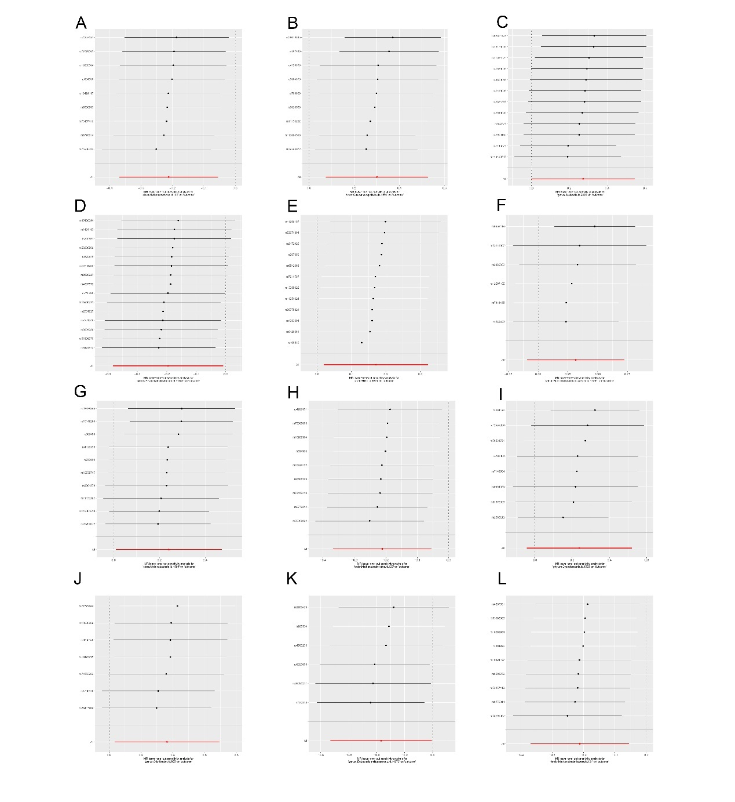
Supplement Figure S4
Leave-one-out plots of significant and nominal significant estimates from genetically predicted microbiotas (A) Family Methanobacteriaceae; (B) Order Gastranaerophilales; (C) Genus Sutterella; (D) Genus Erysipelatoclostridium; (E) Order NB1n ; (F) Genus RuminococcaceaeUCG010; (G) Class Melainabacteria; (H) Order Methanobacteriales; (I) Phylum Cyanobacteria;(J) Genus Odoribacter;(K) GenusEubacterium eligens group;(L) Family Methanobacteriaceae on prostatitis

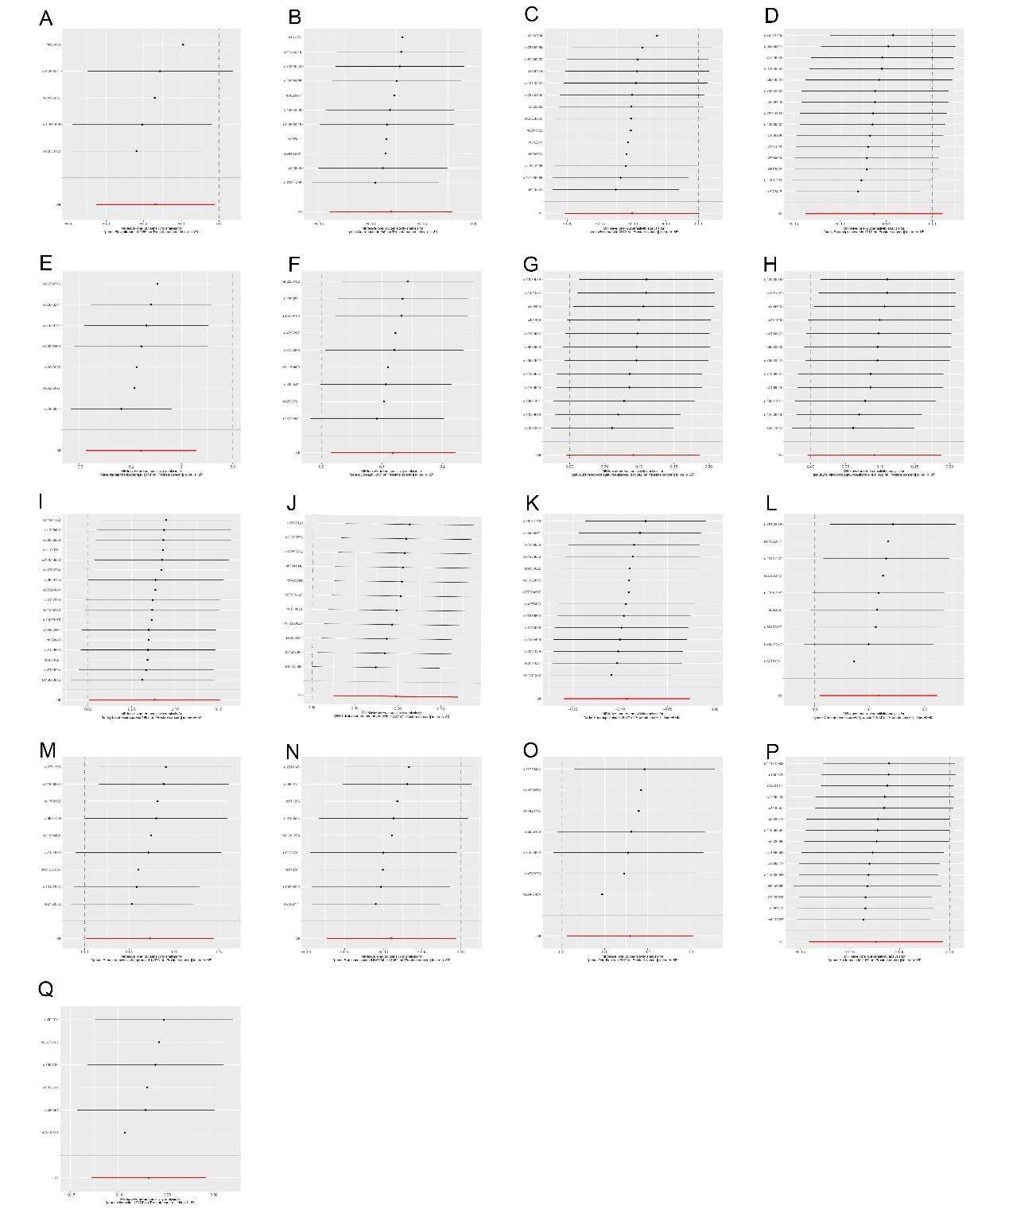

Supplement Figure S5
Leave-one-out plots of significant and nominal significant estimates from genetically predicted microbiotas (A) Genus.Flavonifractor; (B) Genus Coprobacter; (C) Genus Roseburia; (D) Family Rhodospirillaceae; (E) Class Alphaproteobacteria ; (F) Genus Dorea; (G) Genus Ruminococcus gauvreauii group; (H) Genus Adlercreutzia; (I) Family Lachnospiraceae;(J) Genus Eubacteriumnodatumgroup (K) Order Rhodospirillales;(L) Genus ChristensenellaceaeR 7group;(M) Genus Eubacteriumfissicatena group;(N) Genus RuminococcaceaeUCG004;(O) Genus Odoribacter;(P) Genus Holdemania;(Q) Genus Allisonella on prostate cancer.

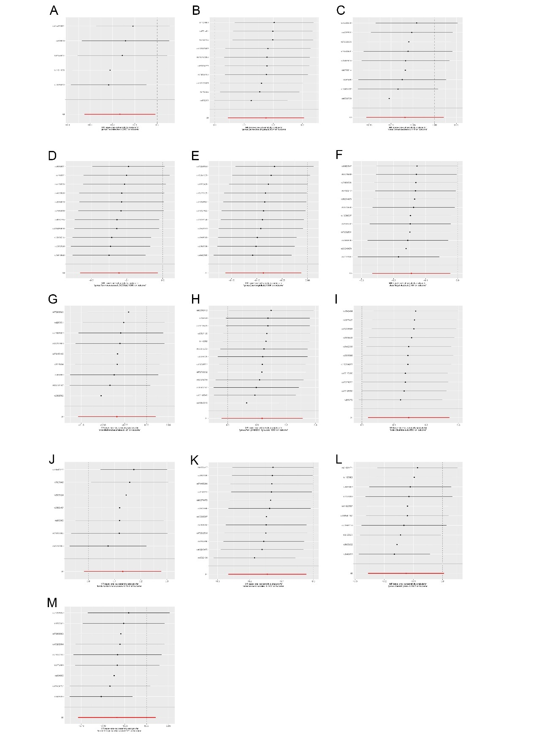
Supplement Figure S6
Leave-one-out plots of significant and nominal significant estimates from genetically predicted microbiotas (A) Genus Flavonifractor; (B) Genus Escherichia.Shigella (C) Class Methanobacteria (D) Genus Ruminococcaceae UCG009; (E) Genus Eisenbergiella ; (F) Class Negativicutes (G) Order Methanobacteriales; (H) Genus FamilyXIIIAD3011 group; (I) Order Clostridiales;(J) Family Acidaminococcaceae (K) Order Selenomonadales (L) Genus Marvinbryantia;(M) Family Methanobacteriaceae; on benign prostatic hyperplasia.

