Supplementary Materials for

Earthquake detection capacity of Dense Oceanfloor Network system for Earthquakes and Tsunamis (DONET)

K. Z. Nanjo*, Y. Yamamoto, K. Ariyoshi, H. Horikawa, S. Yada, N. Takahashi
*Correspondence to: nanjo@u-shizuoka-ken.ac.jp

This file includes: Supplementary Figs. S1-S3.

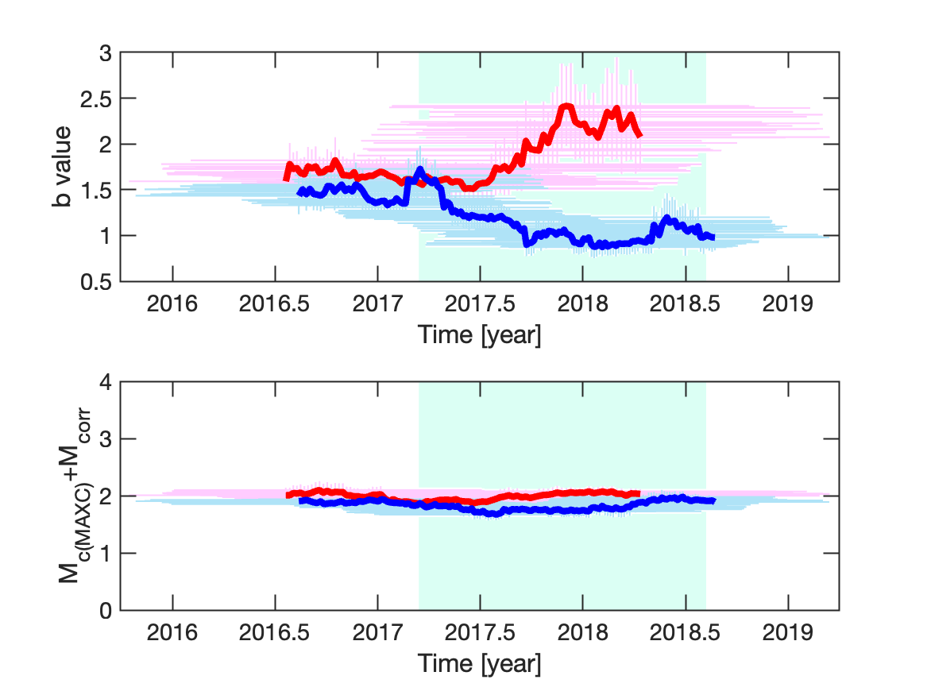
Supplementary Fig. S1. Same as the thick red and blue curves in Fig. 6a,b, but the windows covering 80 events (horizontal bars) are included in the top and bottom panels.

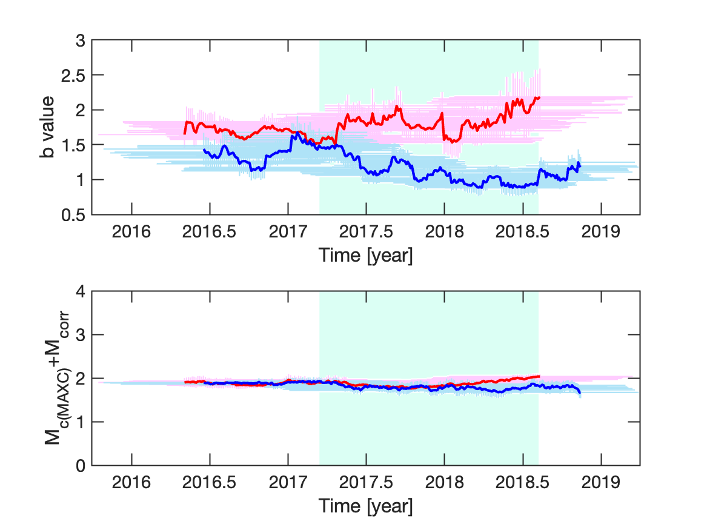
Supplementary Fig. S2. Same as the thin red and blue curves in Fig. 6a,b, but the windows covering 80 events (horizontal bars) are included in the top and bottom panels.
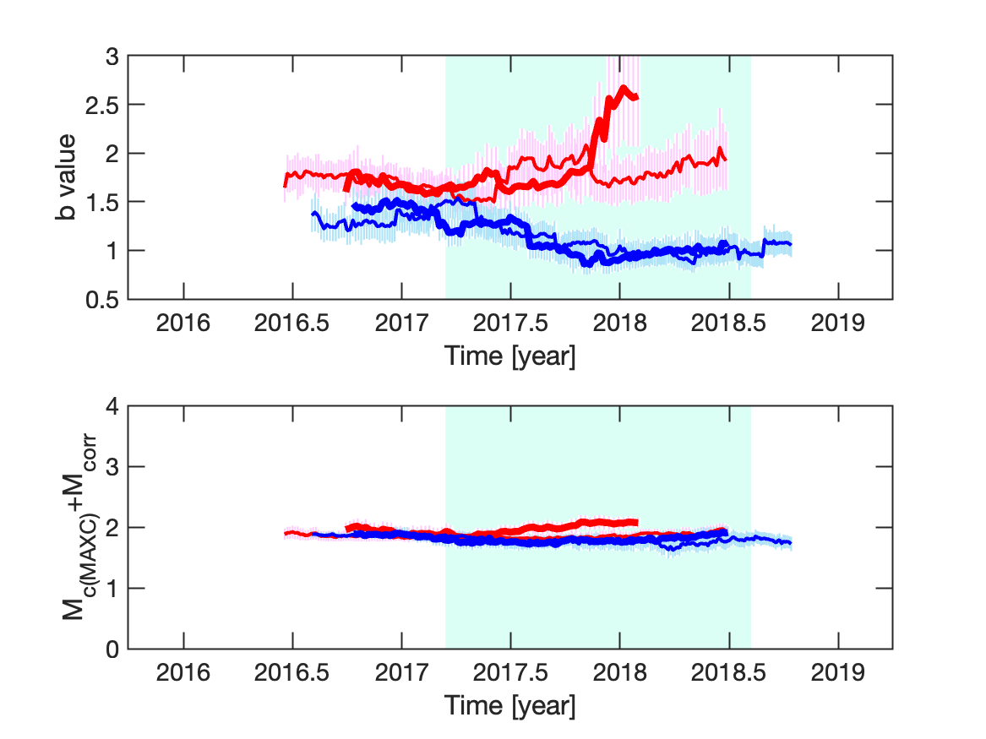
Supplementary Fig. S3. Same as Fig. 6a,b for the window covering 100 events.

