Supplementary figure 1: Flow chart of sclerostin meta-analysis and instrument selection.

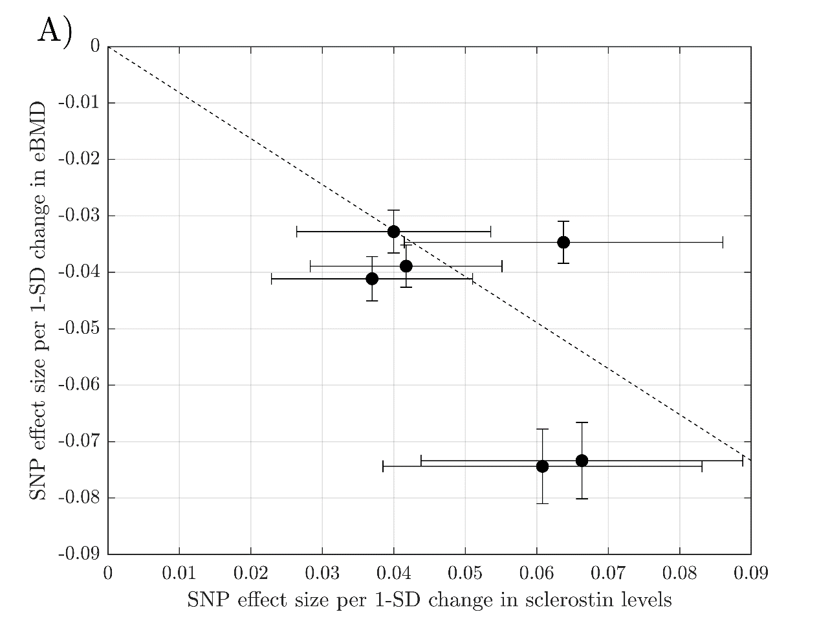
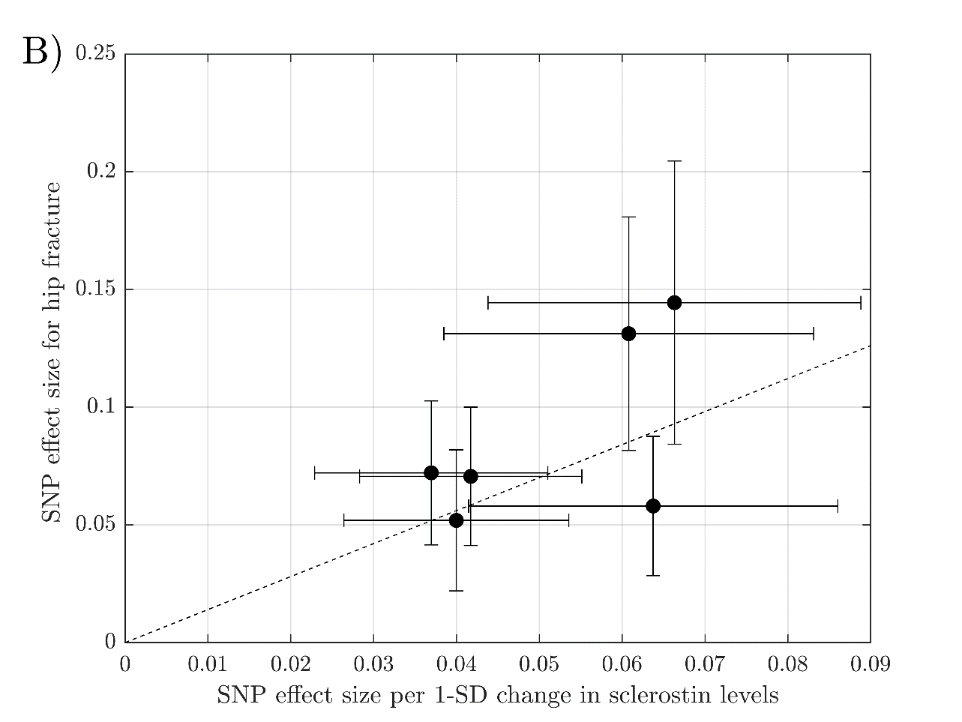
Supplementary figure 2: SNP effects on the outcomes are plotted against SNP effects on the exposure (all SNPs with negative effects on the exposure are shown to be positive, with the sign of the effect on the outcome flipped). The slope of the line represents the causal association (MR estimate) obtained using a generalized IVW regression. (A) The vertical axis is the SNP effect size per 1-SD change in eBMD and, (B) the vertical axis is the SNP effect size for hip fracture.

Supplementary figure 3: Flow chart of the selection process of participants in UK Biobank.

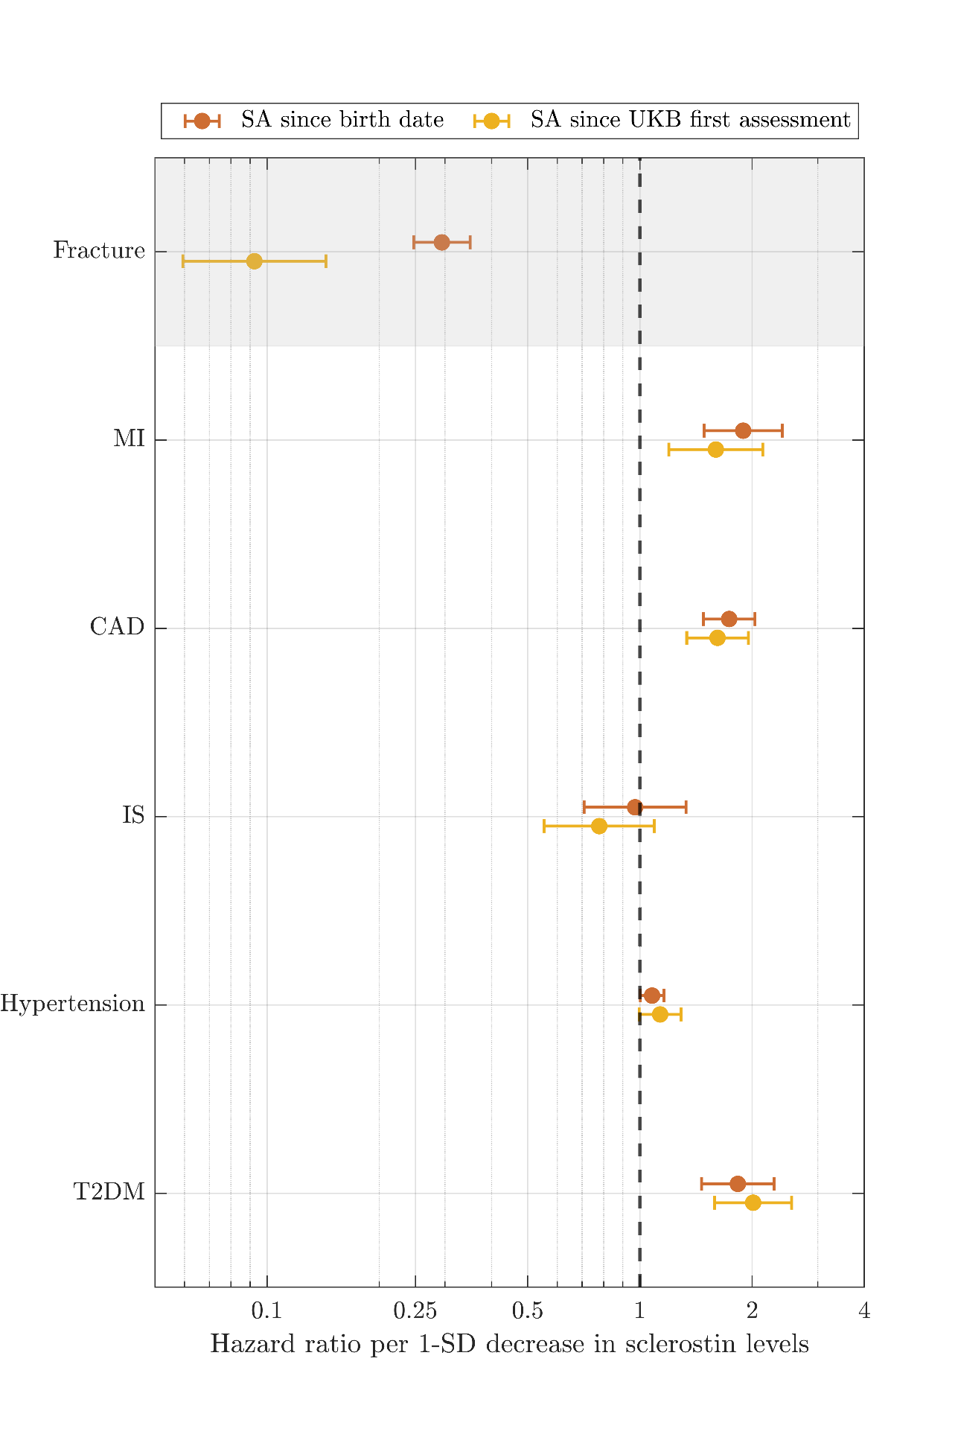
Supplementary figure 4: Forest plot of the results obtained using a cox regression to calculate the effect size from birth date (in orange) and from UK Biobank first assessment (in yellow). Note: SA = Survival analysis, UKB = UK Biobank.

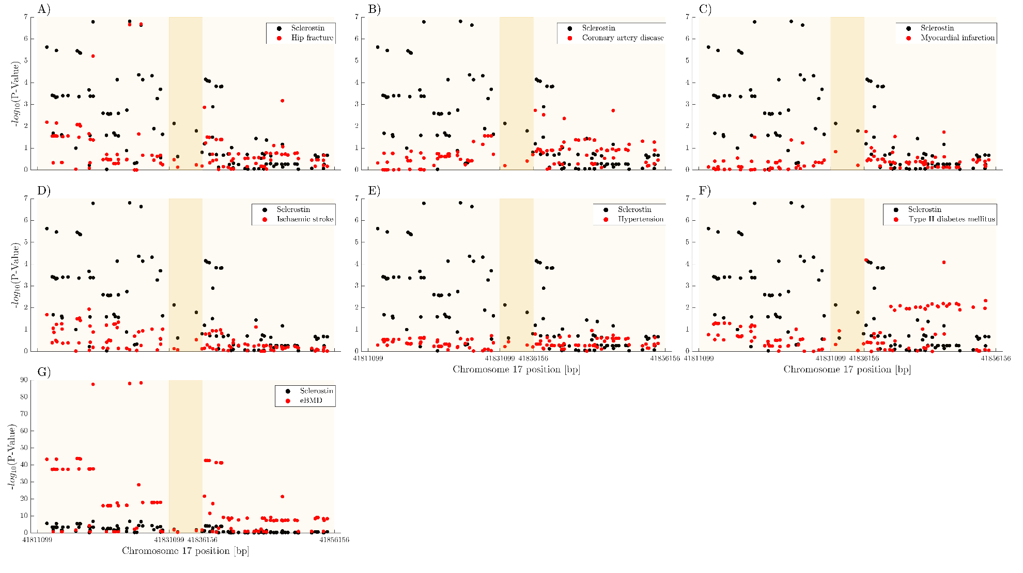
Supplementary figure 5: Colocalization analysis within ±20kb SOST gene. In dark yellow is the SOST gene. In light yellow is the area ±20kbp from the beginning and end of the SOST gene. (A) Regional plot for hip fracture, (B) Regional plot for coronary artery disease. (C) Regional plot for myocardial infarction. (D) Regional plot for ischaemic stroke. (E) Regional plot for hypertension. (F) Regional plot for type II diabetes mellitus. (G) Regional plot for estimated heel bone mineral density (eBMD).

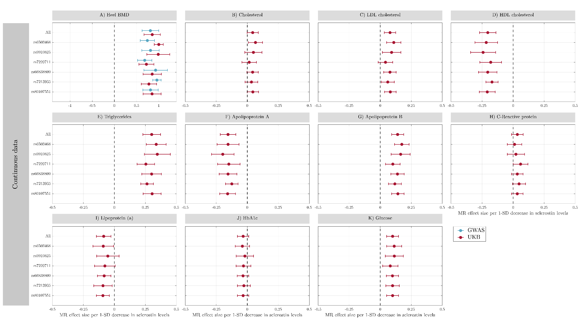
Supplementary figure 6: Forest plot of the sensitivity analysis “Leave one out” using GWAS summary statistics (in blue) and a linear regression to calculate the effect size of the SNPs on the outcomes (in maroon). Only continuous outcomes are included. Each row for each outcome corresponds to conducting the MR analysis using all the instruments (All) and removing one SNP (the one appearing in the vertical axis) as an instrument. The horizontal axis is the MR effect size (beta) per 1-SD decrease in sclerostin levels. Note: UKB = UK Biobank, SD = Standard deviation, MR = Mendelian randomization, BMD = Bone mineral density, LDL = Low density lipoprotein, HDL = High density lipoprotein.
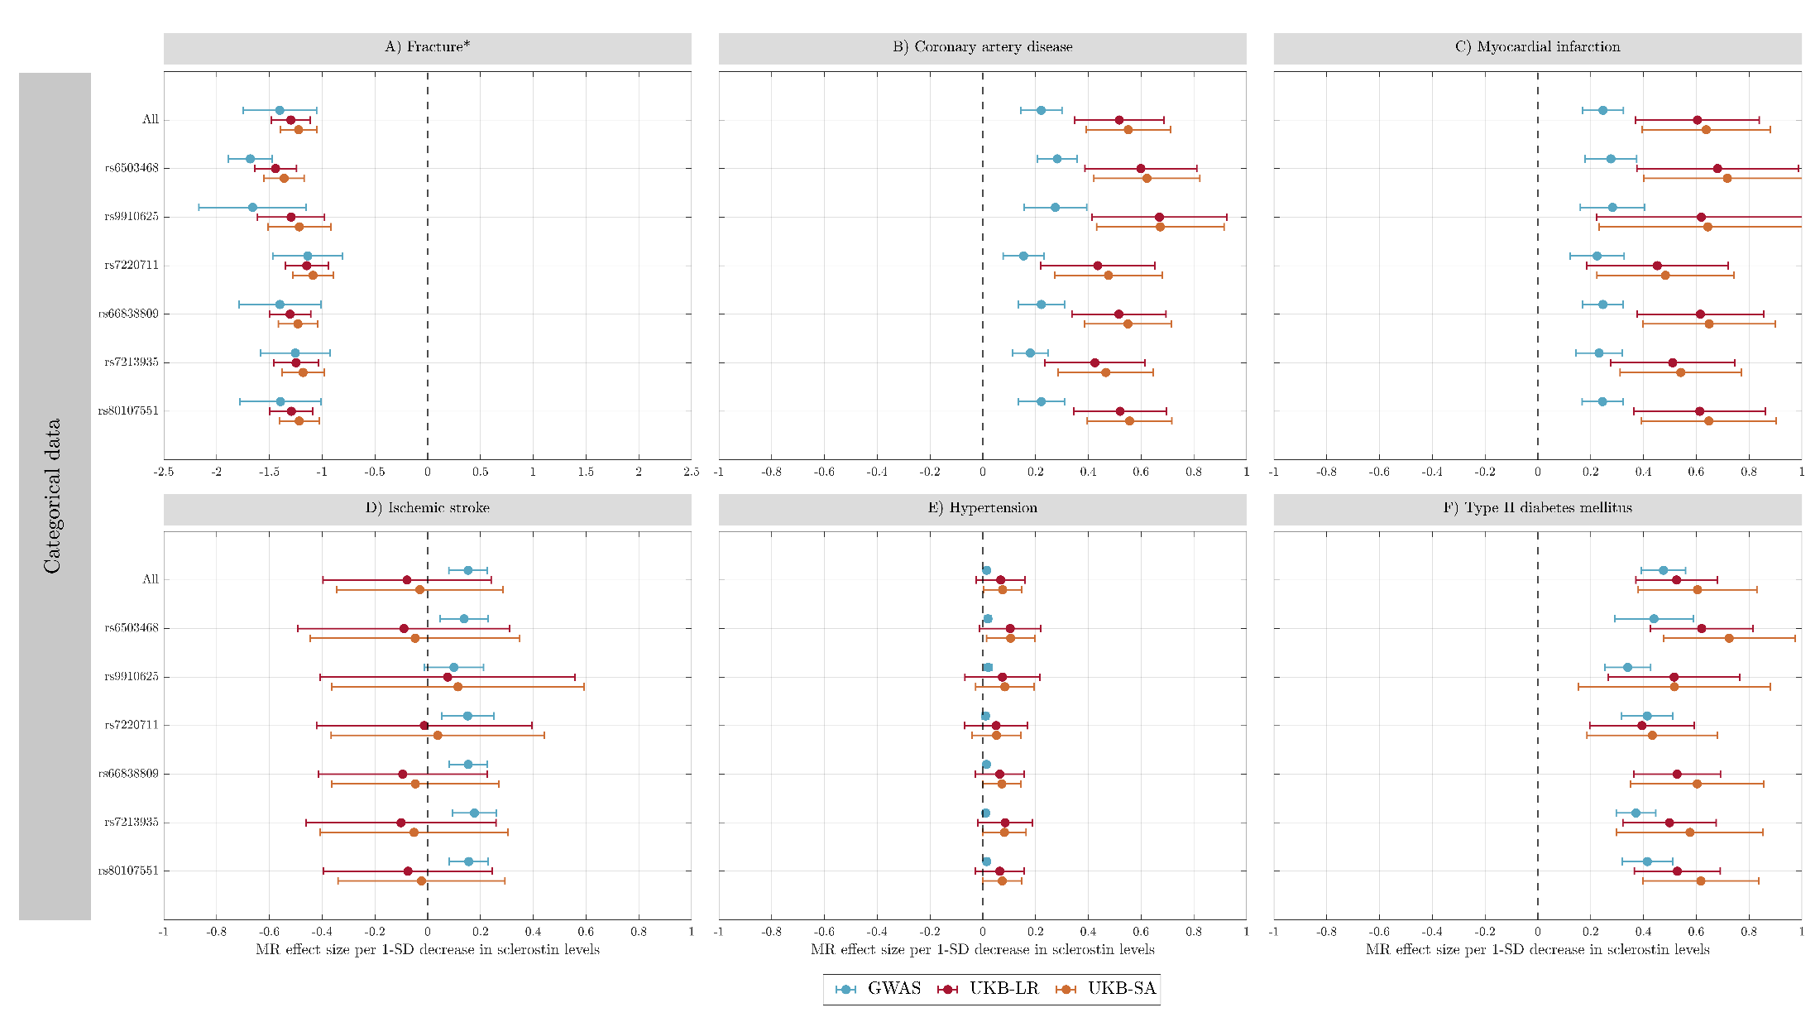
Supplementary figure 7: Forest plot of the sensitivity analysis “Leave one out” using GWAS summary statistics of the outcomes (blue) and using both, logistic regression (in maroon) and cox regression (in orange) to calculate the effect of the SNPs on the UK Biobank outcomes. Only categorical outcomes are included. Each row for each outcome corresponds to conducting the MR analysis using all the instruments (All) and removing one SNP (the one appearing in the vertical axis) as an instrument. The horizontal axis is the MR effect size (beta) per 1-SD decrease in sclerostin levels. *: GWAS of fracture only includes hip fracture, whereas fracture phenotype in UK Biobank is fracture risk. Note: UKB-LR = UK Biobank logistic regression adjustment, UKB-SA = UK Biobank survival analysis SD = Standard deviation.

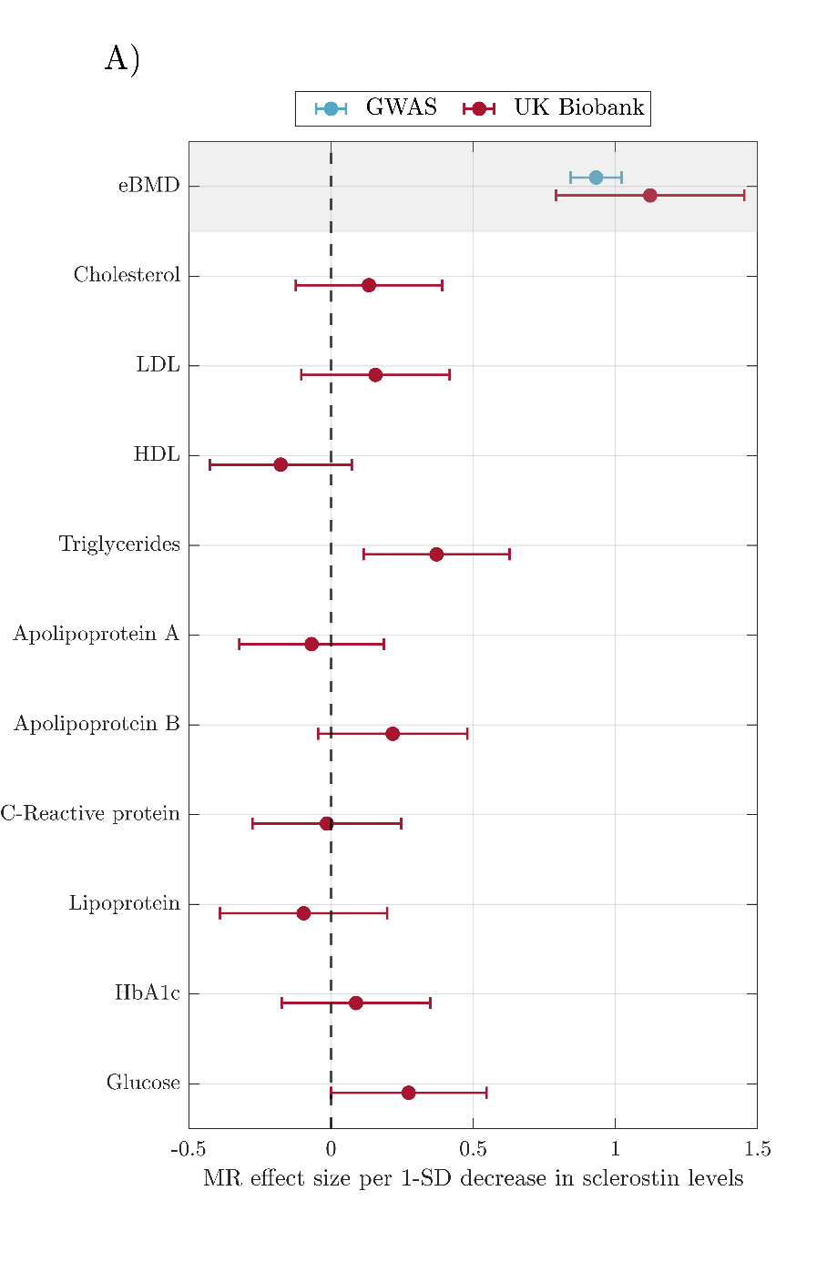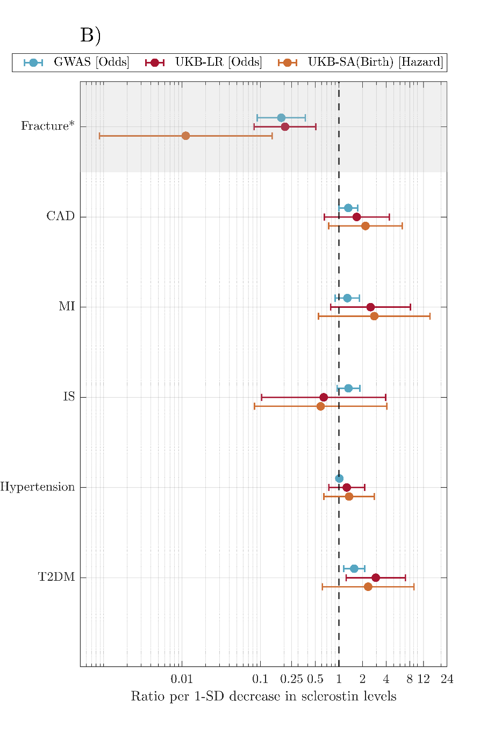
Supplementary figure 8: Forest plot of the results from the sensitivity analysis using one SNP as an instrument: rs7220711. In blue there are the results using GWAS summary statistics to compute the effect between SNPs and the outcome, in maroon the results obtained using a linear regression (for continuous outcomes) and logistic regression (for categorical outcomes) to calculate the effect of the SNP on the UK Biobank outcomes, and in yellow the results using cox regression (for UK Biobank categorical outcomes). (A) The horizontal axis is the 1-SD increase (95% CI) per 1SD decrease in sclerostin levels. (B) The horizontal axis is the odds ratio (95% CI) per 1SD decrease in sclerostin levels. *: GWAS of fracture only includes hip fracture, whereas fracture phenotype in UK Biobank is fracture risk. Note: UKB-LR = UK Biobank linear regression, UKB-SA = UK Biobank survival analysis, eBMD = heel estimated bone mineral density, LDL = low density lipoprotein, HDL = high density lipoprotein, CAD = coronary artery disease, MI = Myocardial infarction, IS = ischaemic stroke, T2DM = type II diabetes mellitus.

