Supporting information (Figures) of the manuscript:

Geographic origin and host’s phylogeny are predictors of the gut mucosal microbiota diversity and composition in Mediterranean scorpionfishes (Scorpaena spp.)

Authors
Lilli G. *¹, Sirot C.², Campbell H.³, Brophy D.³, Graham C.T.³, George. I.F¹.
¹Laboratoire d'Ecologie des Systèmes Aquatiques (ESA), Université Libre de Bruxelles, Bruxelles, Belgium
²Centre de Recherches Insulaires et Observatoire de l’Environnement (CRIOBE), University of Perpignan, Perpignan, France
³Marine and Freshwater Research Centre, Atlantic Technological University, Dublin Road, Galway, Ireland
*Corrisponding author : Lilli.Ginevra@ulb.be

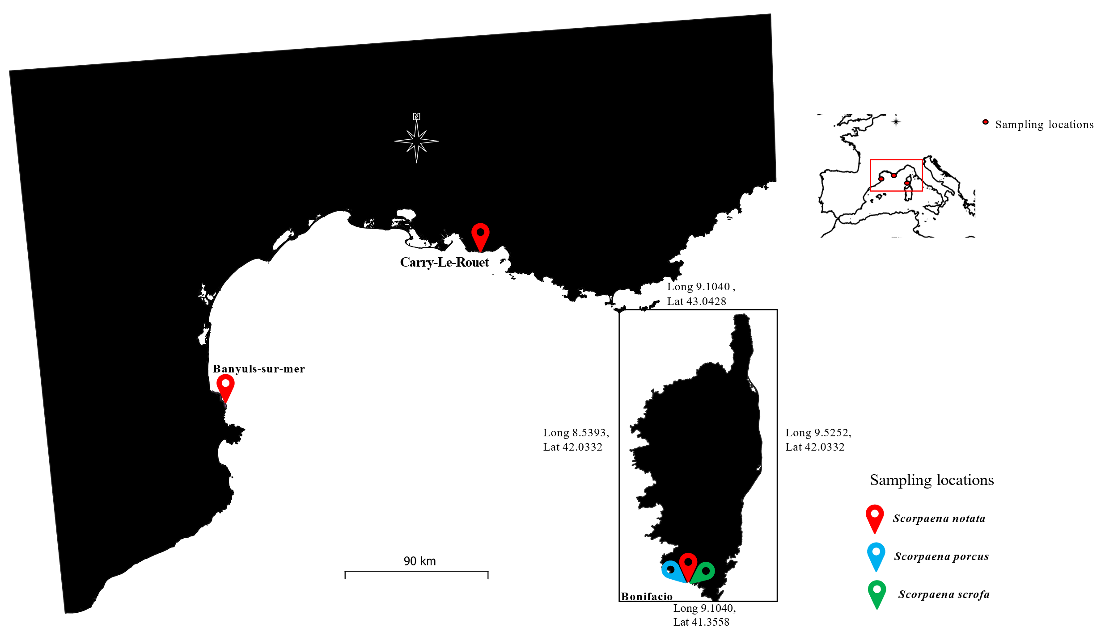
Figure S 1: Sampling locations for the three species of Scorpaena in the Mediterranean Sea.
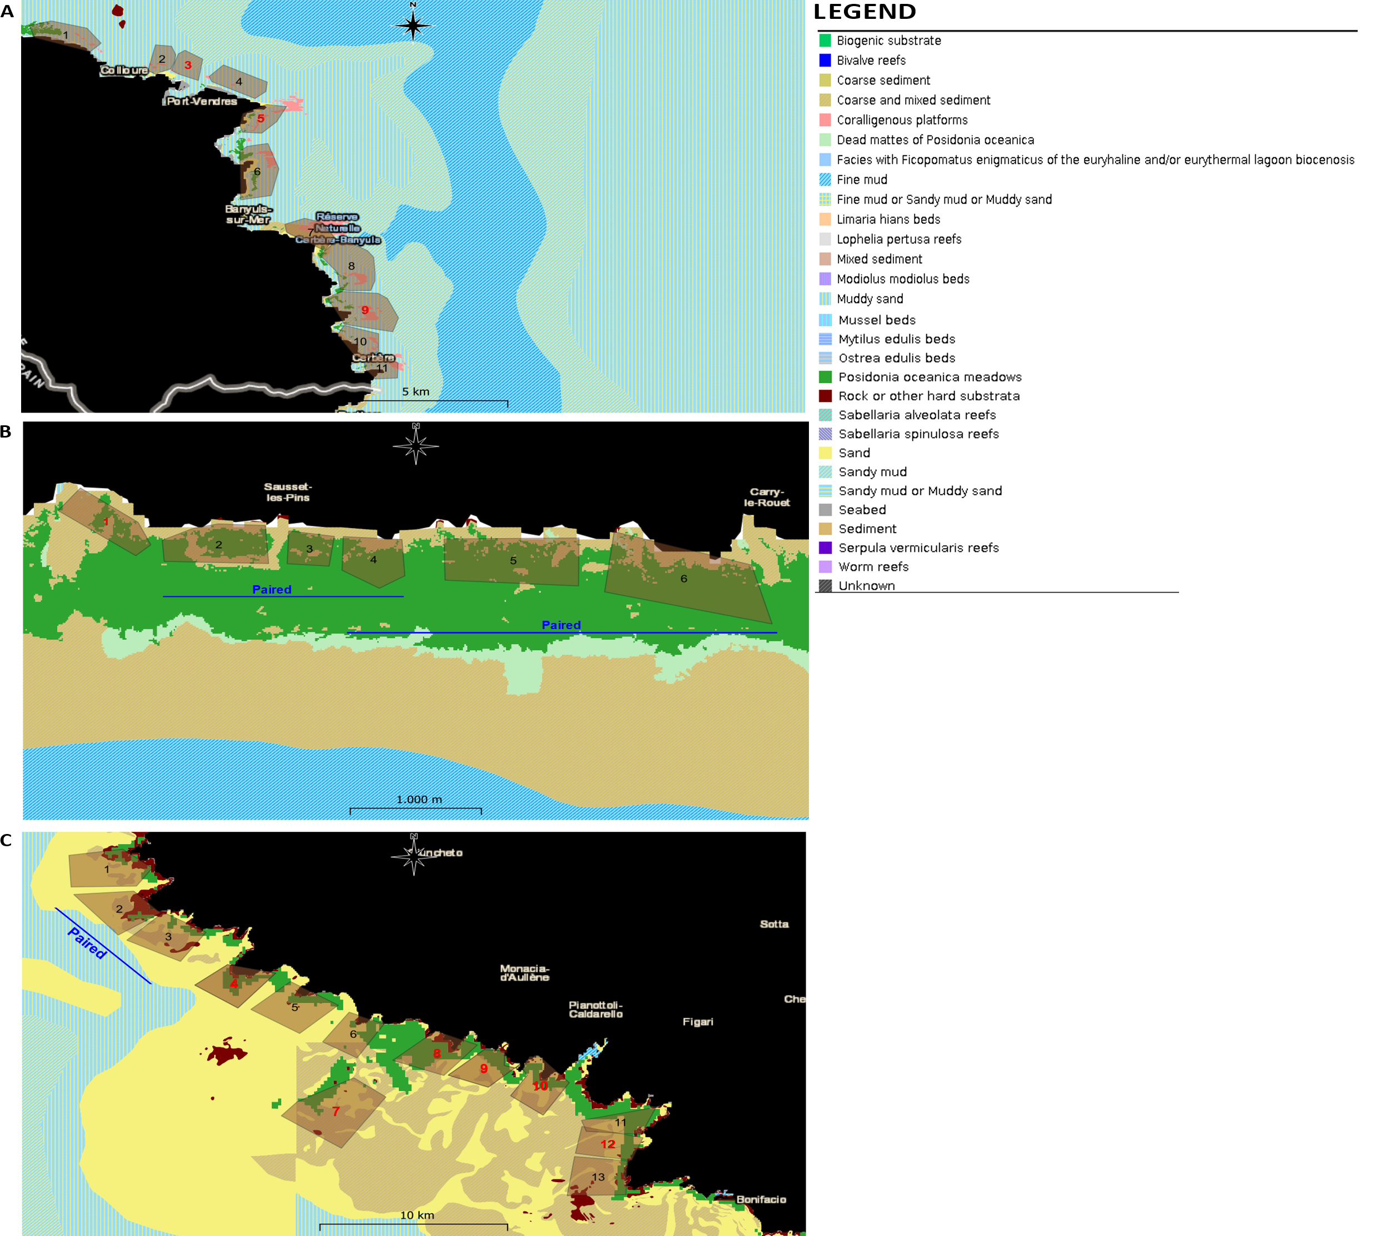
Figure S 2 (A,B,C): Fishing locations selected for the samplings and their substrate type. The locations labeled in red were not included in the study (as they were not exploited by the fishermen). The fishing locations exploited by the fishermen through the same fishing net are paired and labeled by a blue line. These maps of substrate type were obtained from the map database “EUSeaMap 2021 – EMODnet broad-scale seabed habitat map for Europe”(Vasquez, 2021).

Mickaël Vasquez. (2021). EMODnet Thematic Lot n ° 2 Seabed Habitats.

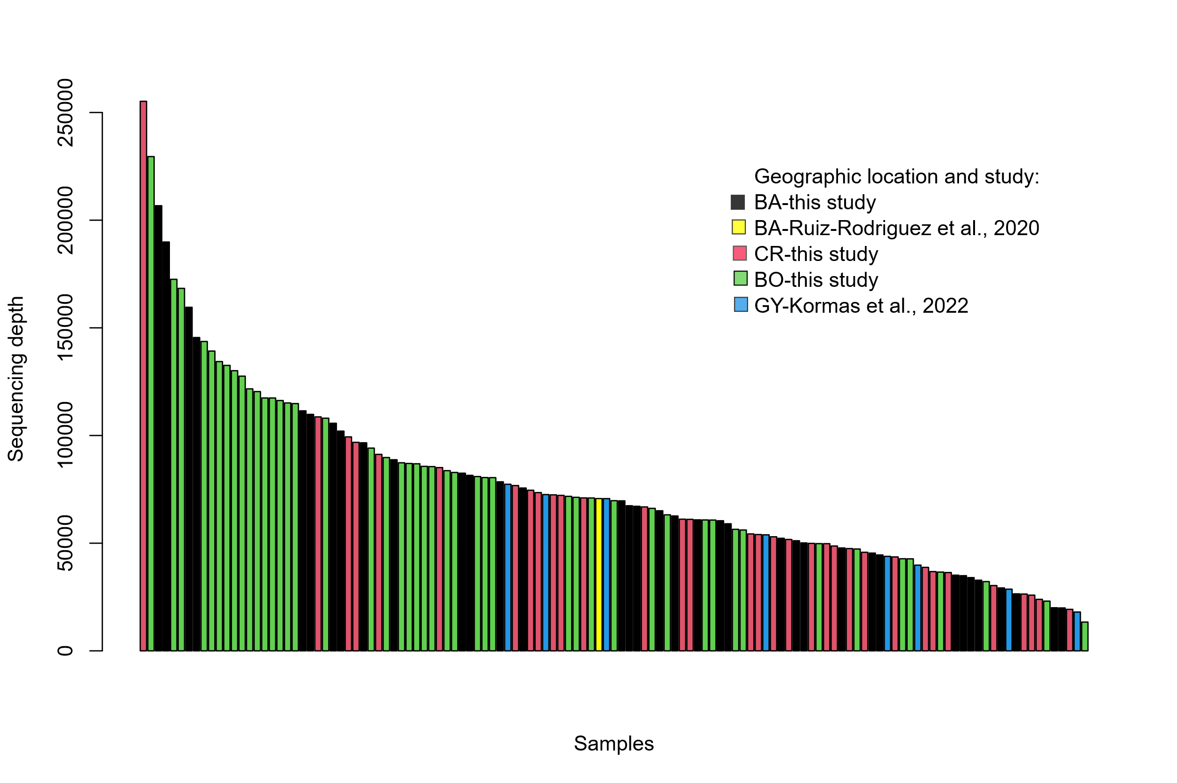
Figure S 3: histogram representing the number of reads per sample included in the study (N=125 samples).

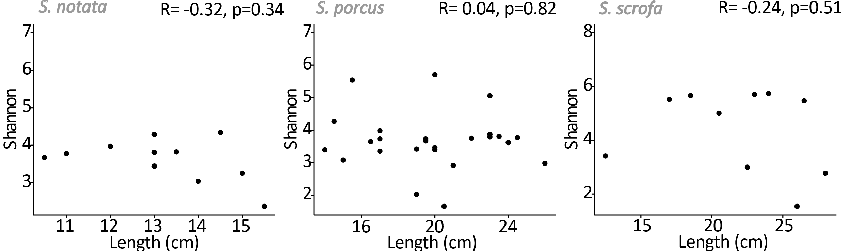

Figure S 4: Relationships between the total length of the fishes and the Shannon’s diversity index of the bacterial communities for the three Scorpaena species collected in BO.

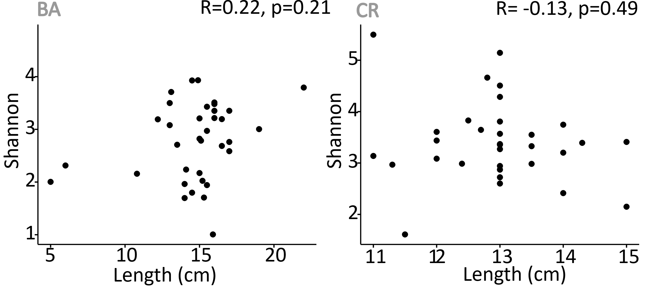

Figure S 5: Relationships between the total length of the fishes and the Shannon’s diversity index of the microbial community for the individuals of S. notata collected in BA and CR.

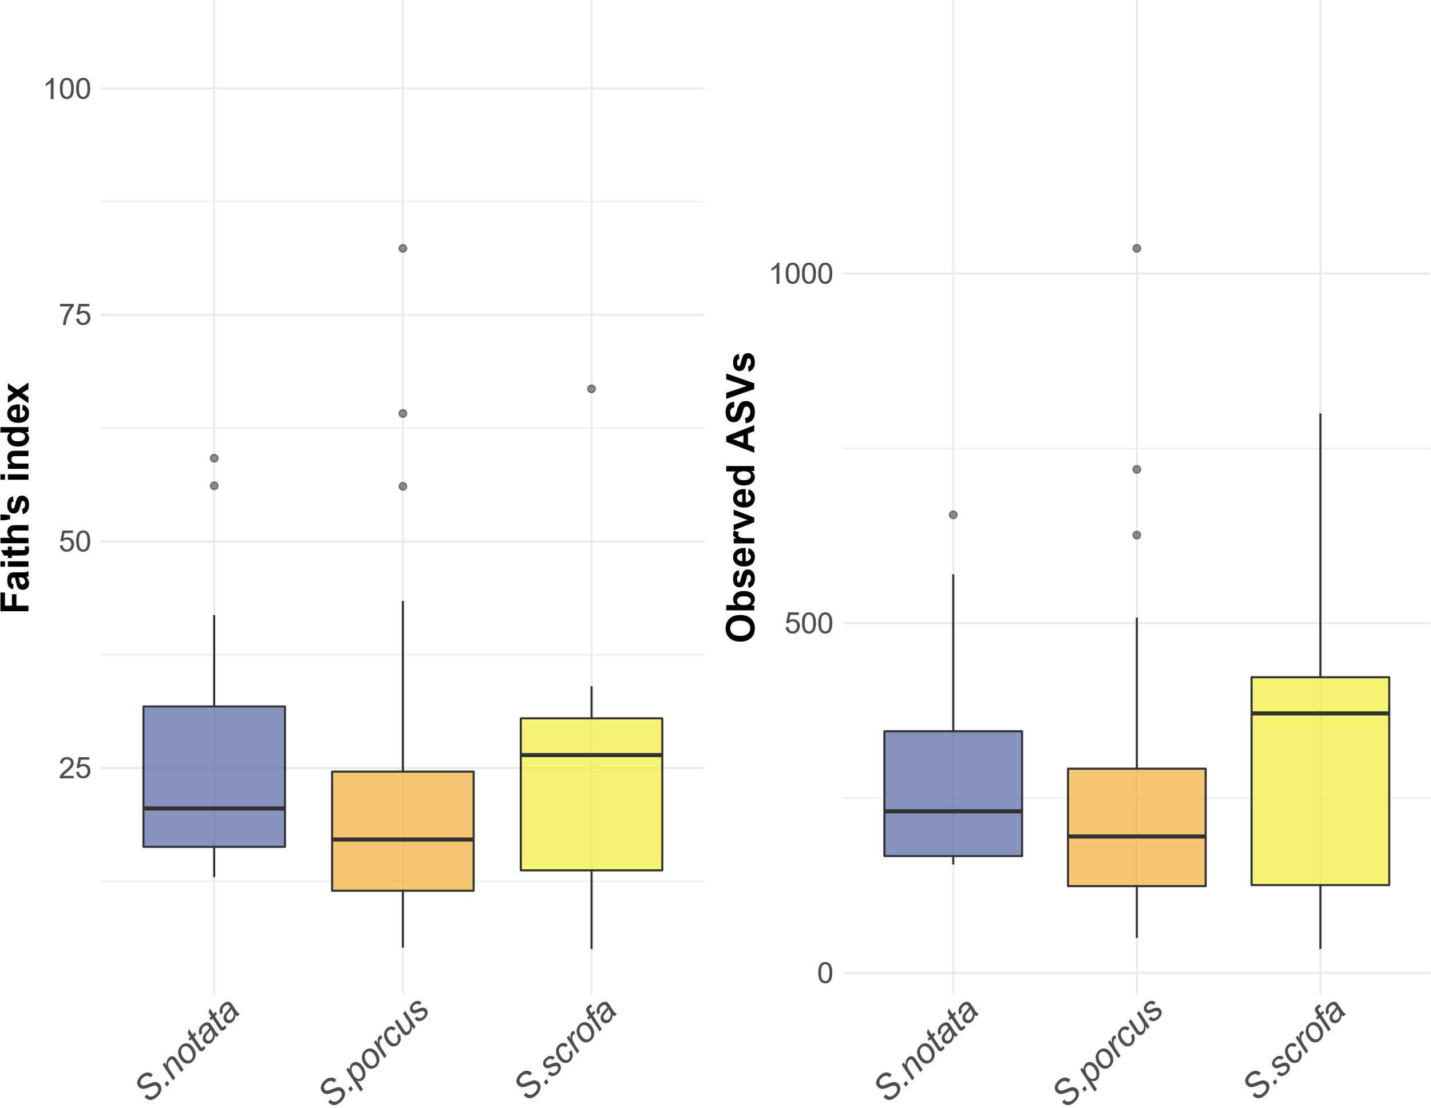

Figure S 6: Alpha diversity indexes (Faith phylogenetic diversity and total number of observed ASVs) in the three different Scorpaena species. A Kruskal Wallis’ test was performed among the three species (Faith, P value = 0.70; Observed ASVs, P value = 0.63).
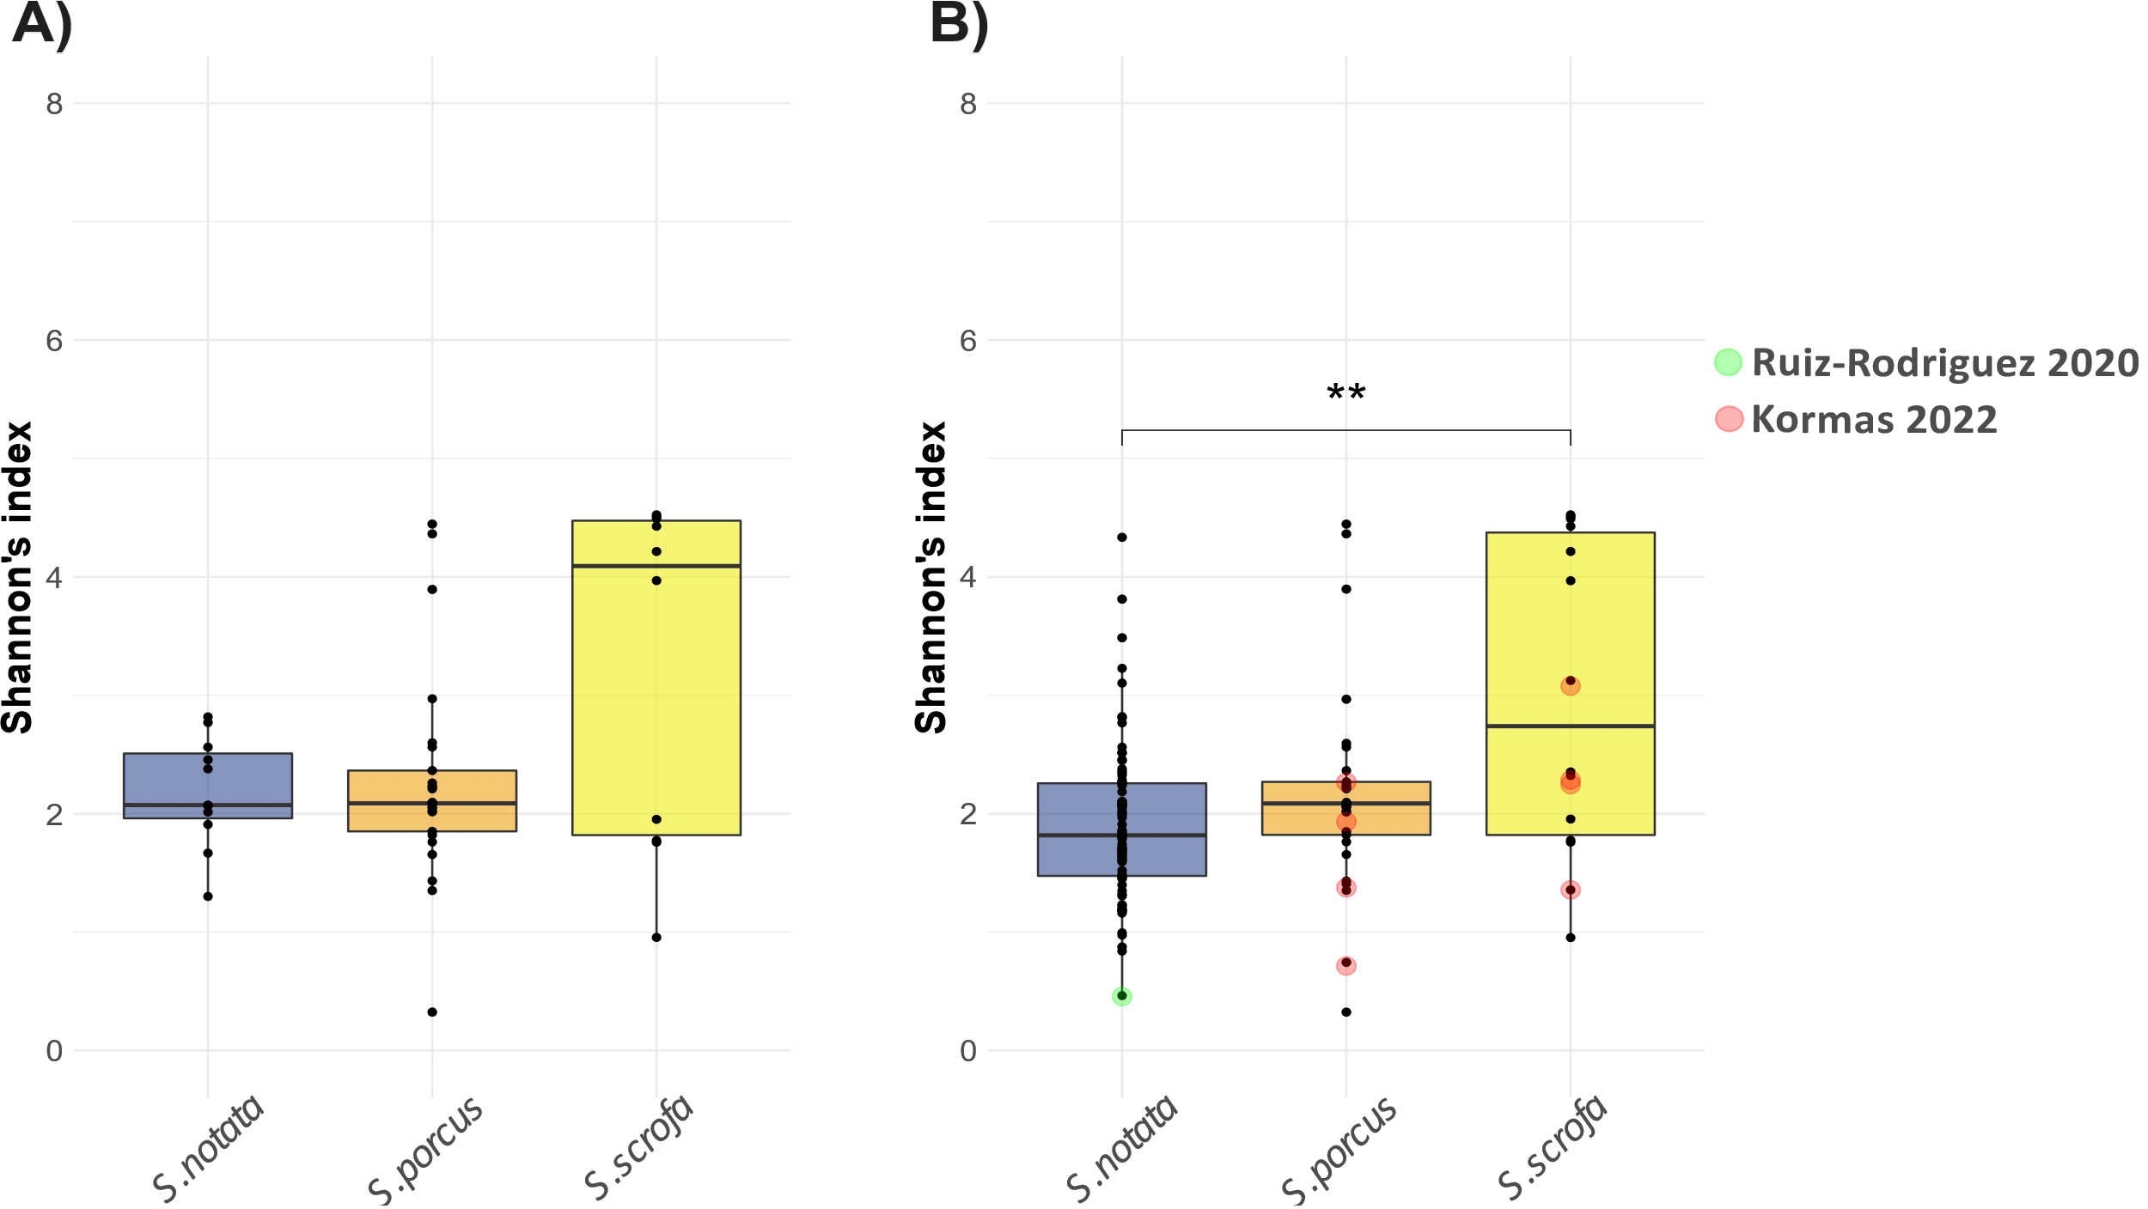
Figure S 7: Shannon’s index of alpha diversity of the three different Scorpaena species with ASVs agglomerated at the genus level. The datasets used to create this graph are (A) the Species-dataset , only including the samples from BO and (B) the Extended-dataset including the samples from all the locations considered in this study (BA, CR, BO, GY). Only significant comparisons are presented (Dunn’s test) : ** P value =0.01. Data points corresponding to data retrieved from the literature are colored.
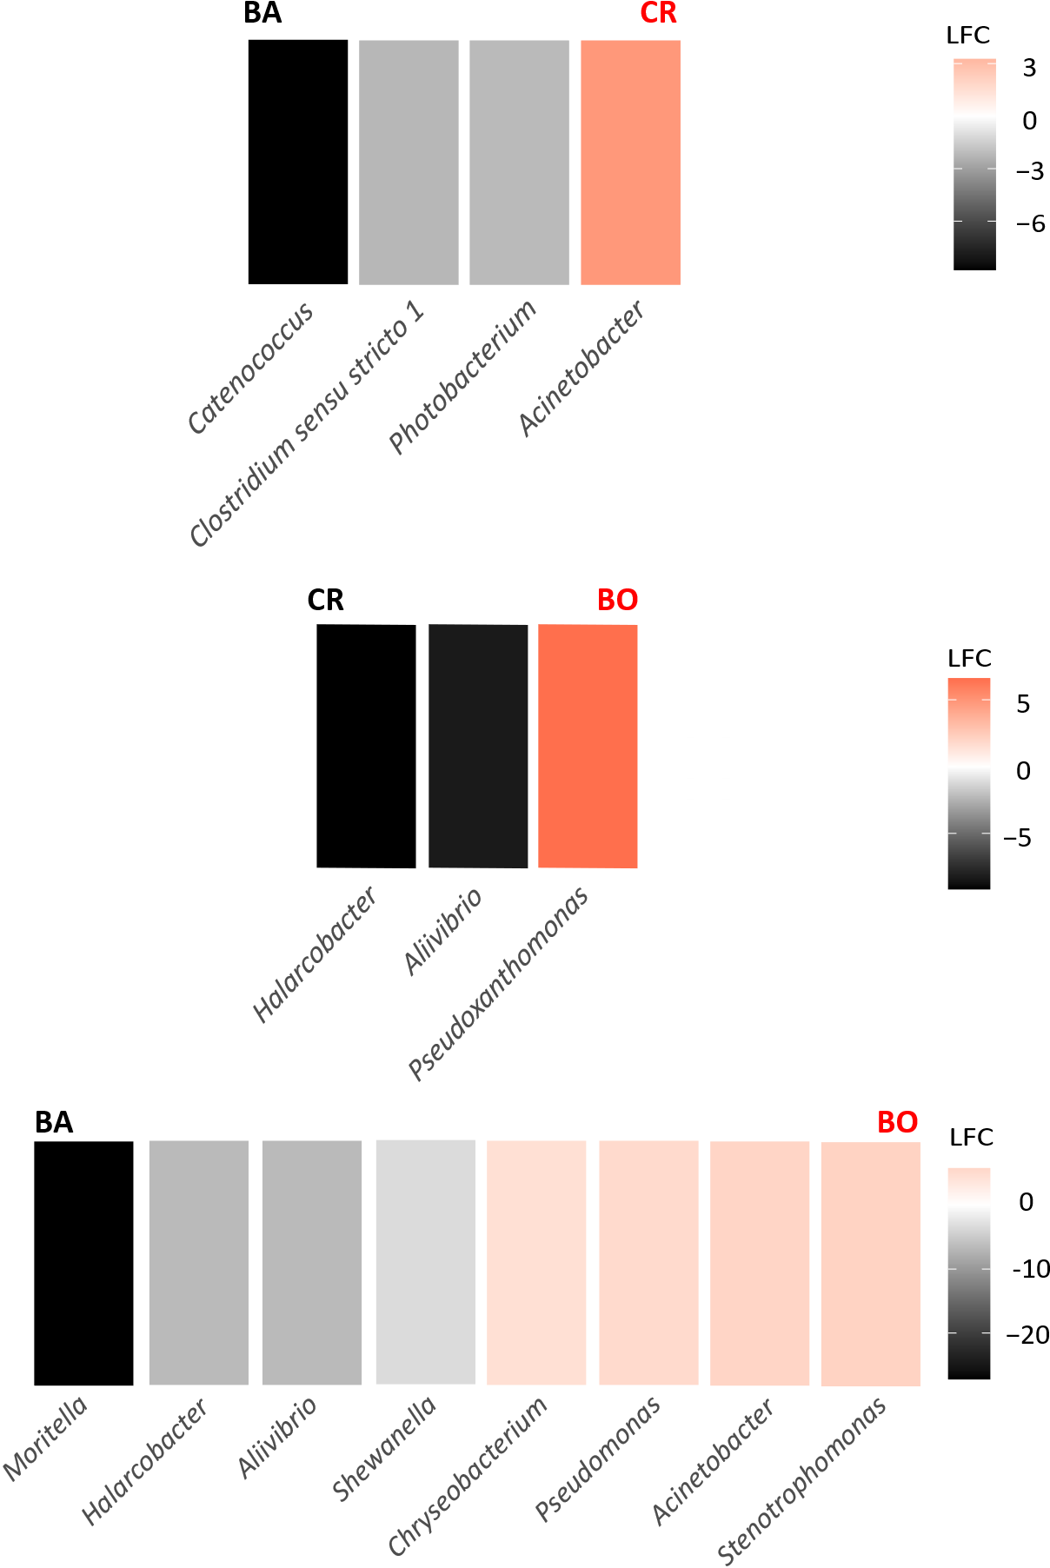
Figure S 8 : Bacterial genera differently abundant in the gut microbiota of S.notata collected in the three different geographic locations, analyzed in pairs (pair 1: BA vs CR (reference is BA); pair 2: CR vs BO (reference is CR); pair 3: BA vs BO (reference is BA). DeSEQ2 and ANCOM II were implemented to determine the bacterial genera whose abundance was significantly different (adj.P-value < 0.05). A negative/positive change on a Log2Fold scale indicates that the taxa are more abundant in the reference/compared group, respectively.

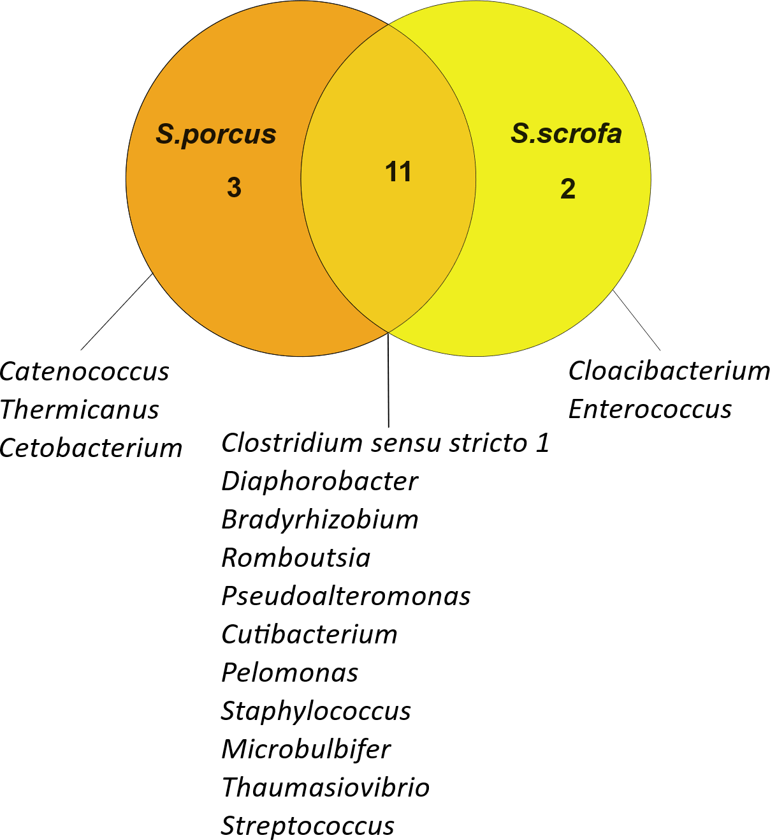
Figure S 9 : Venn diagram representing the number and names of the core bacteria genera unique and shared between the specimen of S. scrofa and S. porcus from GY (Kormas et al. 2022).

Figure S 10 : rarefaction curves of all samples and threshold (vertical line) at 20.000 reads per sample.

