Tibetan umbilical cord mesenchymal stem cell exosomes improve hypoxic pulmonary hypertension by inhibiting pulmonary vascular remodeling
Qingqing Zhang^{1,2,3,4,5}，Hong Liu^{1,2,3,4}，Chuanchuan Liu^{1,2,3,4}，Yuxiang Wang^{1,2,3,4}，Pan Huang^{1,2,3,4}，Xiaobo Wang^{1,2,3,4}，Yougang Ma^{1,2,3,4}，Lan Ma^{1,2,3,4*}，Rili Ge^{1,2,3,4*}

Western blot
Figure 1:
Tibetan-MSC-exo Tibetan-MSC Han-MSC-exo Han-MSC
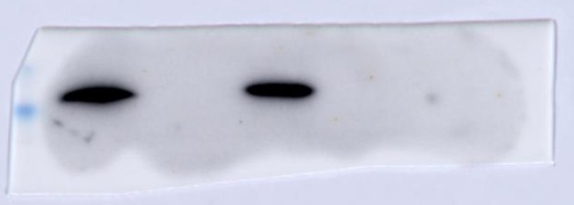CD63
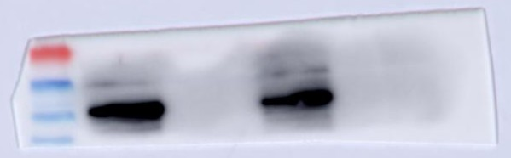CD81
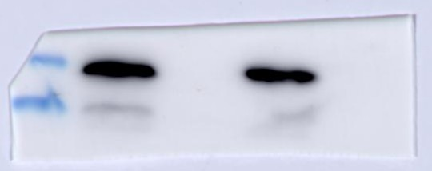Tsg101

Figure 4:
Normoxia Hypoxia Han-MSC-exo Tibetan-MSC-exo
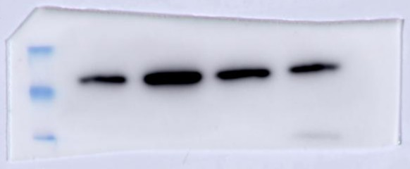PCNA

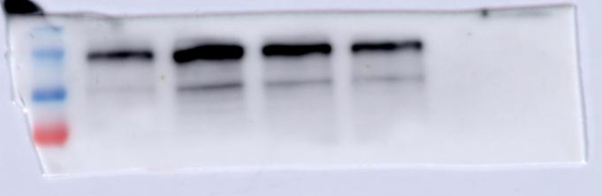CyclinD1
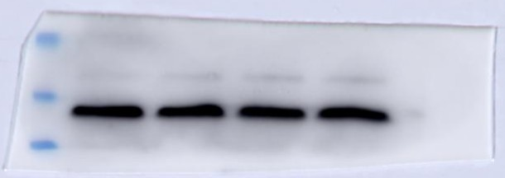β-actin

Figure5:
Normoxia Hypoxia Han-MSC-exo Tibetan-MSC-exo
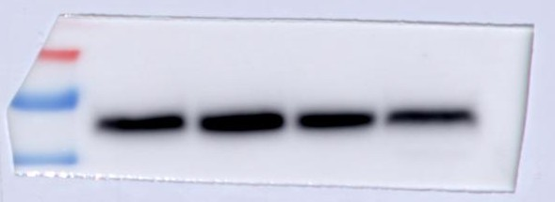TGFβ1
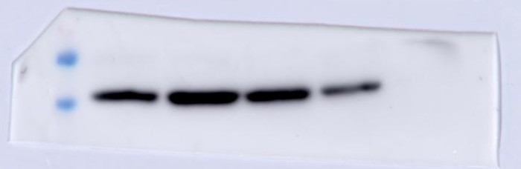P-Smad2/3
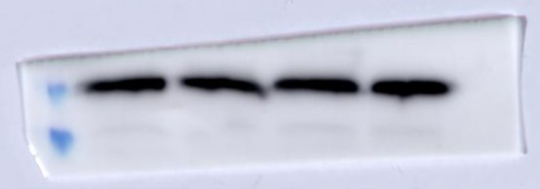Smad2/3

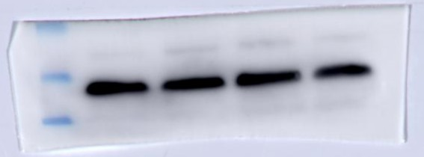β-actin

Normoxia Hypoxia Han-MSC-exo Tibetan-MSC-exo
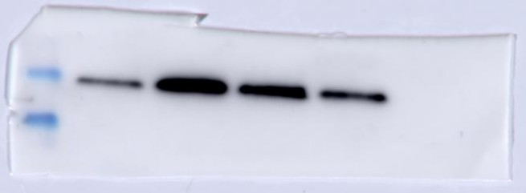TGFβ1
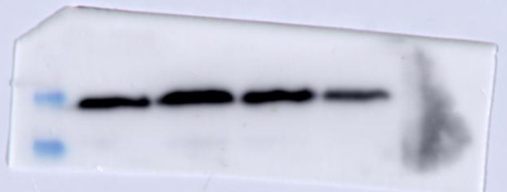P-Smad2/3
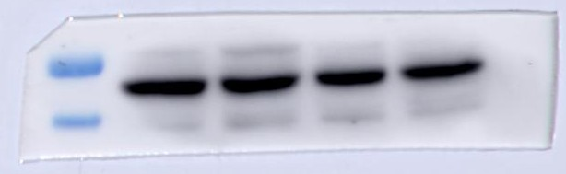Smad2/3
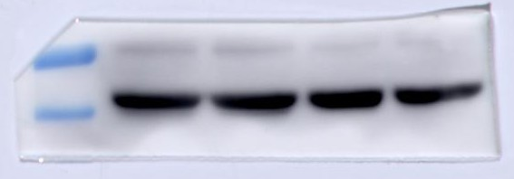β-actin

Figure6:
Hypoxia Hyp+SRI011381 Han-MSC-exo Han-MSC-exo+SRI011381 Tibetan-MSC-exo Tibetan-MSC-exo+SRI011381
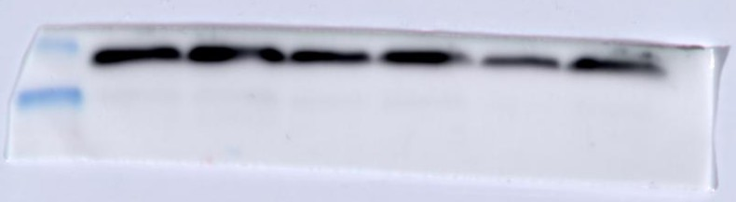TGFβ1
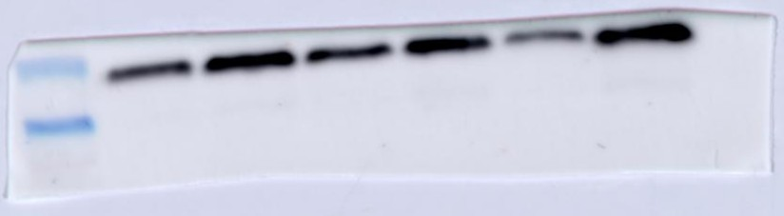p-Smad2/3

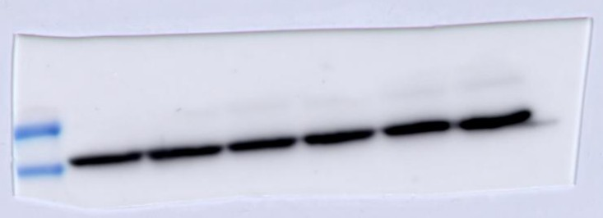β-actin

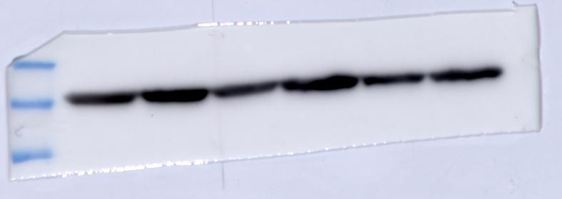PCNA
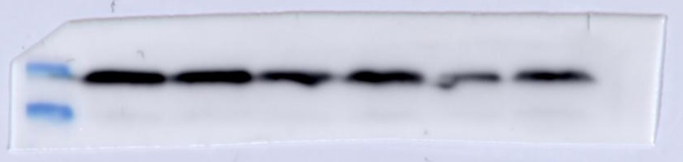CyclinD1
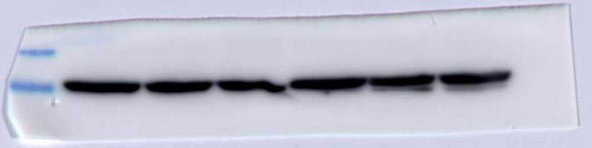β-actin

