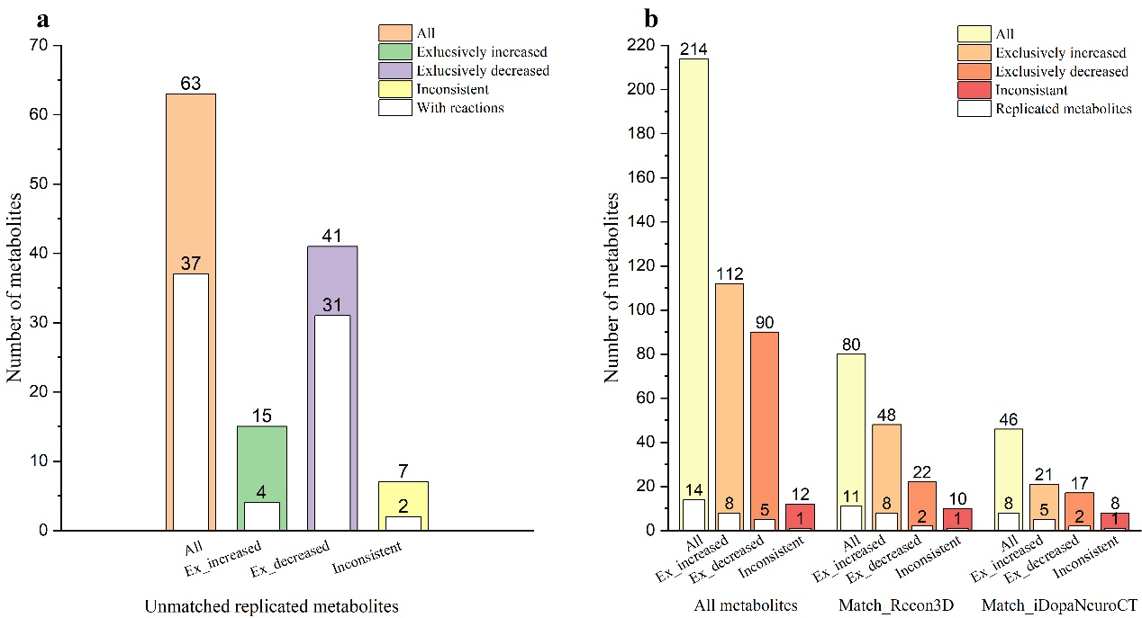
Figure 1. Statistics of PD metabolites. a Unmatched replicated metabolites of diagnosis-related metabolites. b Data statistics of progression-related metabolites of PD.

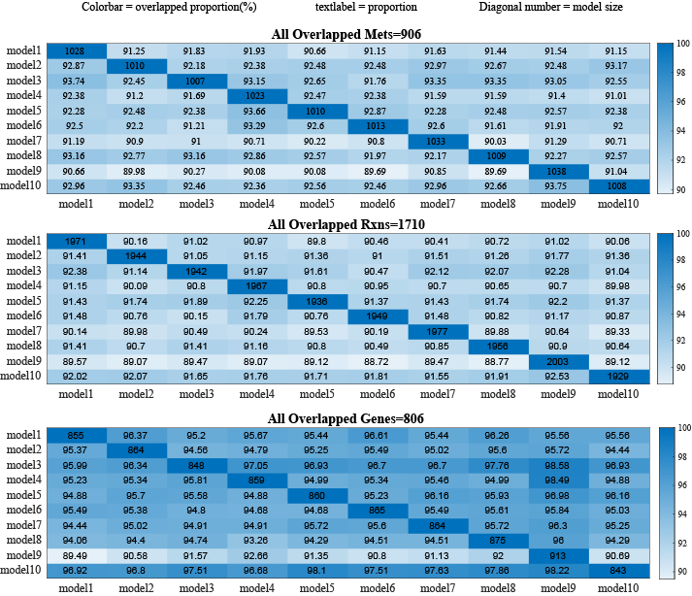
Figure 2. The heat maps for overlapped metabolites, reactions and genes between the randomly generated 10 models. The diagonal label represents the number of metabolites, reactions and genes in each model, respectively. Other labels and the colourbar represent the shared proportion between each pair of models. All shared metabolites, reactions and genes over ten models were listed on the top of the map, respectively.

