Supplementary Figures
Cui et al.,
Mutual cross-feeding drives marine biofilm assembly on various carbon sources

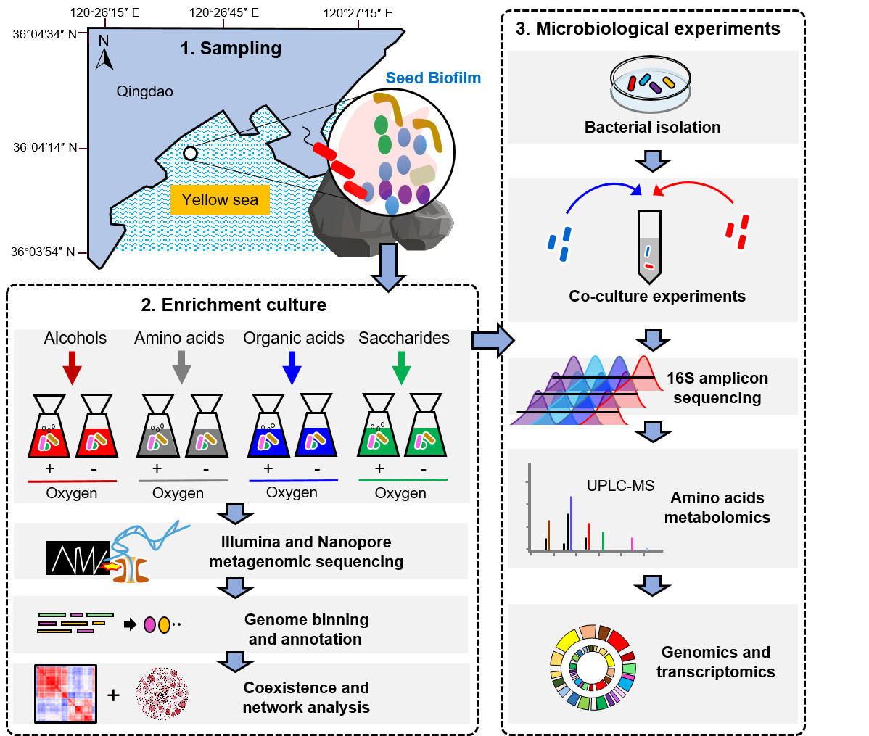
Supplementary Fig. 1 Study design. A coastal marine biofilm was collected and cultured in 69 different carbon sources under aerobic and anaerobic conditions, resulting in 138 metagenomes. The carbon sources employed in the study were classified into alcohols, amino acids, organic acids, and saccharides. Bacterial strains were isolated from the enriched biofilms and used for co-culture experiments.

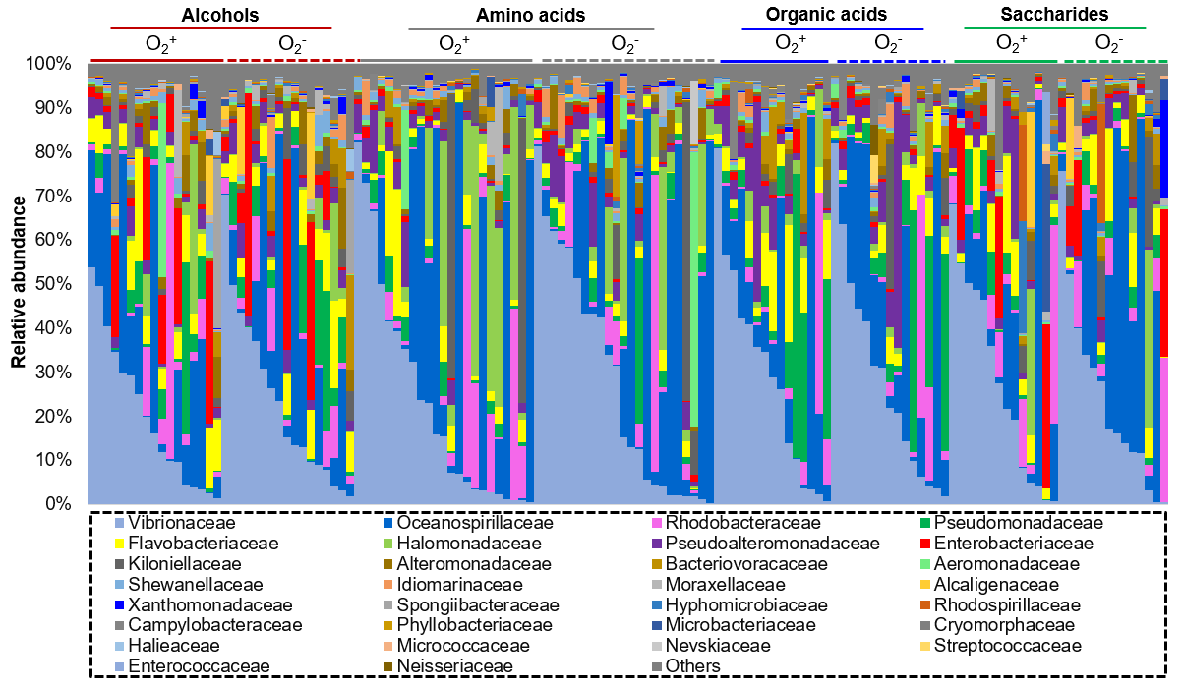
Supplementary Fig. 2 Community structure visualized at the family level. The 30 most abundant families (in terms of maximum relative abundance) based on miTags are shown, and the remaining were merged into “Others”. O₂⁺: aerobic condition; O₂⁻: anaerobic condition.
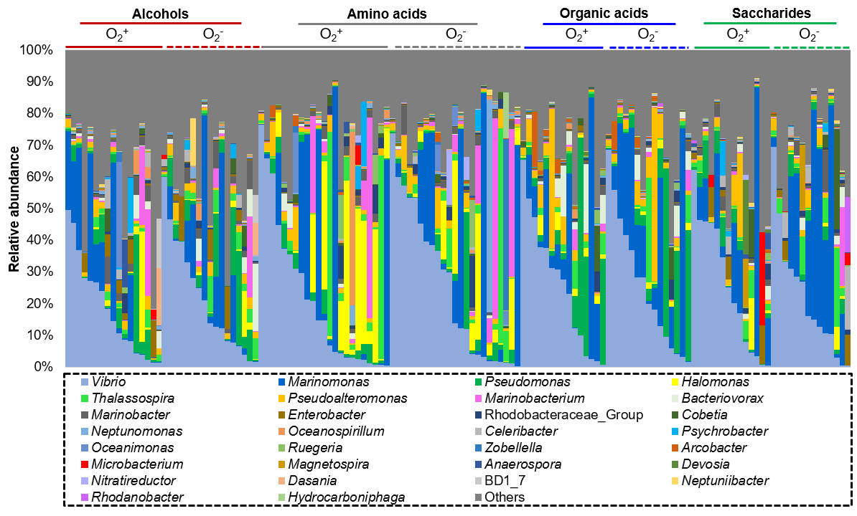
Supplementary Fig. 3 Community structure visualized at the genus level. The 30 most abundant genera (in terms of maximum relative abundance) based on miTags are shown, and the remaining were merged into “Others”. O₂⁺: aerobic condition; O₂⁻: anaerobic condition.

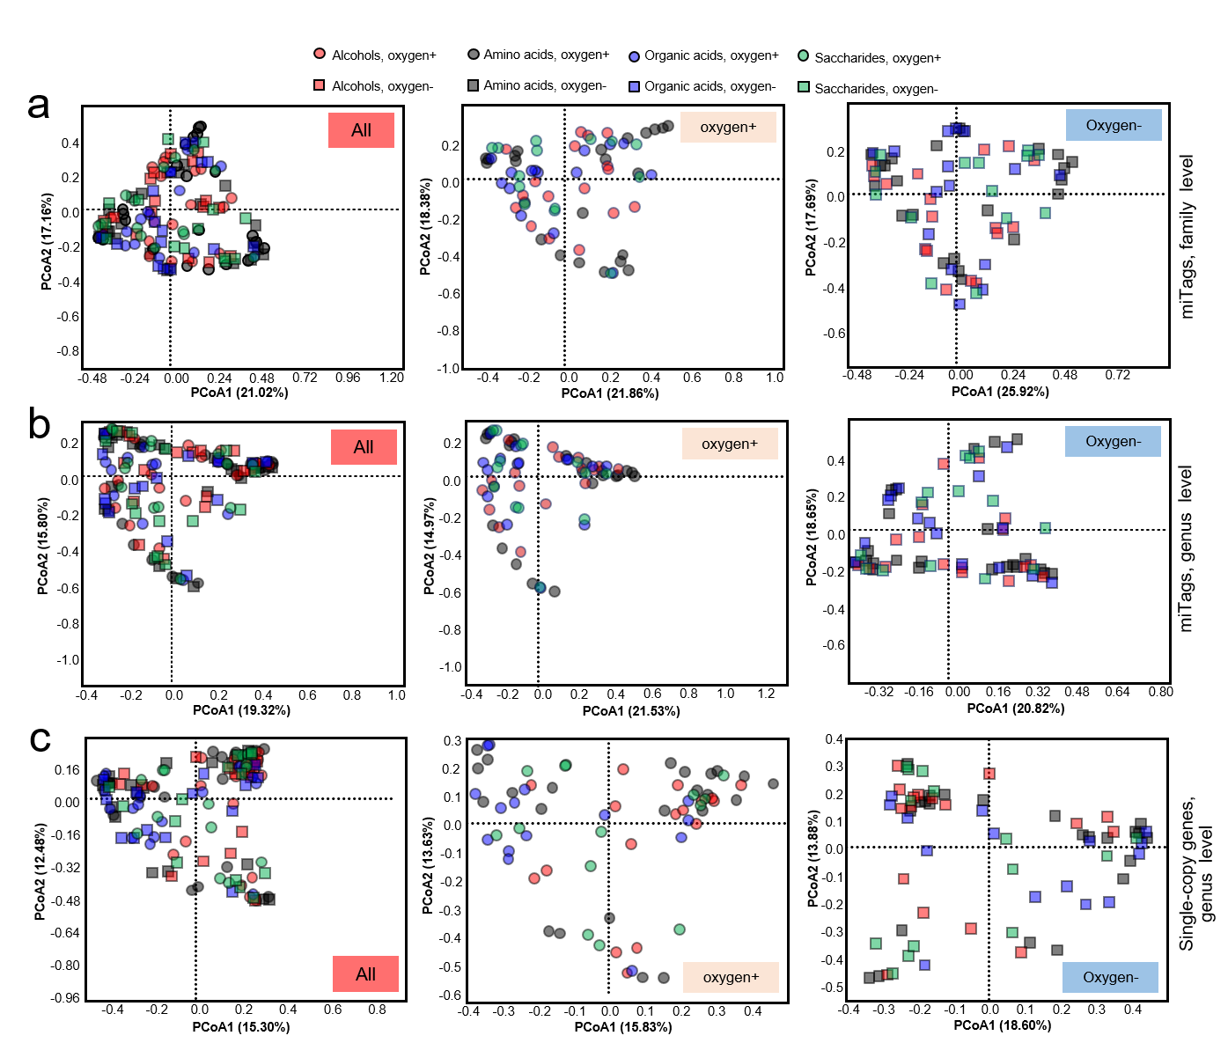 Supplementary Fig. 4 Principal coordinate analyses of the community structures of the enriched biofilms. The structural similarity was analyzed based on Bray-Curtis distances generated with different matrix. a, Family-level composition generated with miTags. b, Genus-level composition generated with miTags. c, Genus-level composition generated with single-copy genes. In all the analyses, the biofilm cultured under aerobic and anaerobic conditions were investigated separately or together. O₂⁺: aerobic condition; O₂⁻: anaerobic condition.

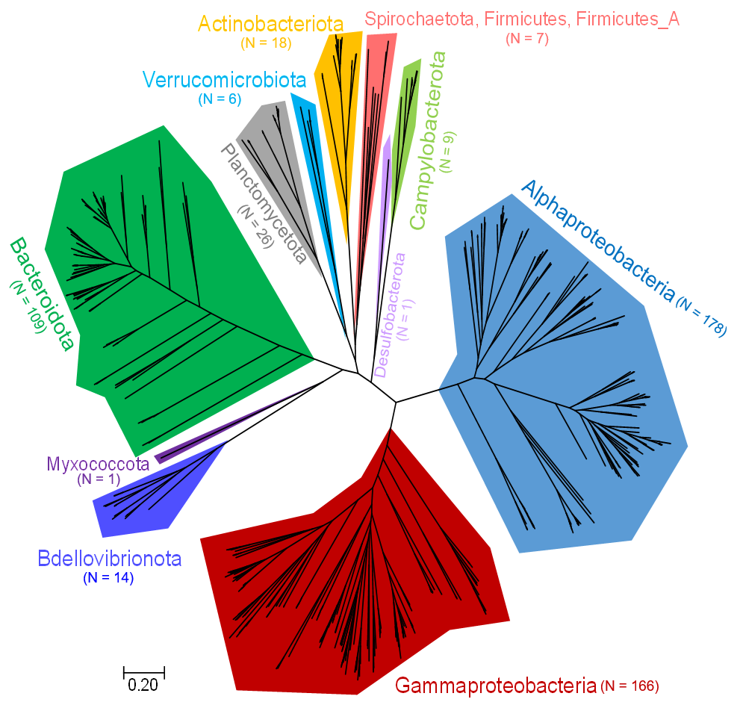
Supplementary Fig. 5 Phylogenetic analysis of the 535 metagenome-assembled genomes (MAGs). The number of MAGs enclosed in each phylum is labeled.

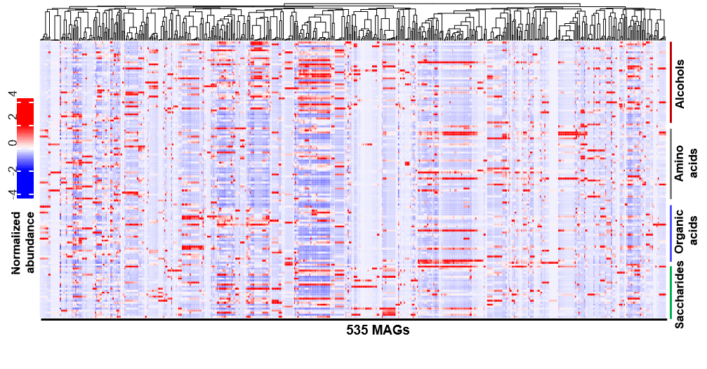
Supplementary Fig. 6 Distribution of the 535 MAGs across the biofilms. The relative abundance of these MAGs are indicated by the number of recruited reads from the metagenomes.

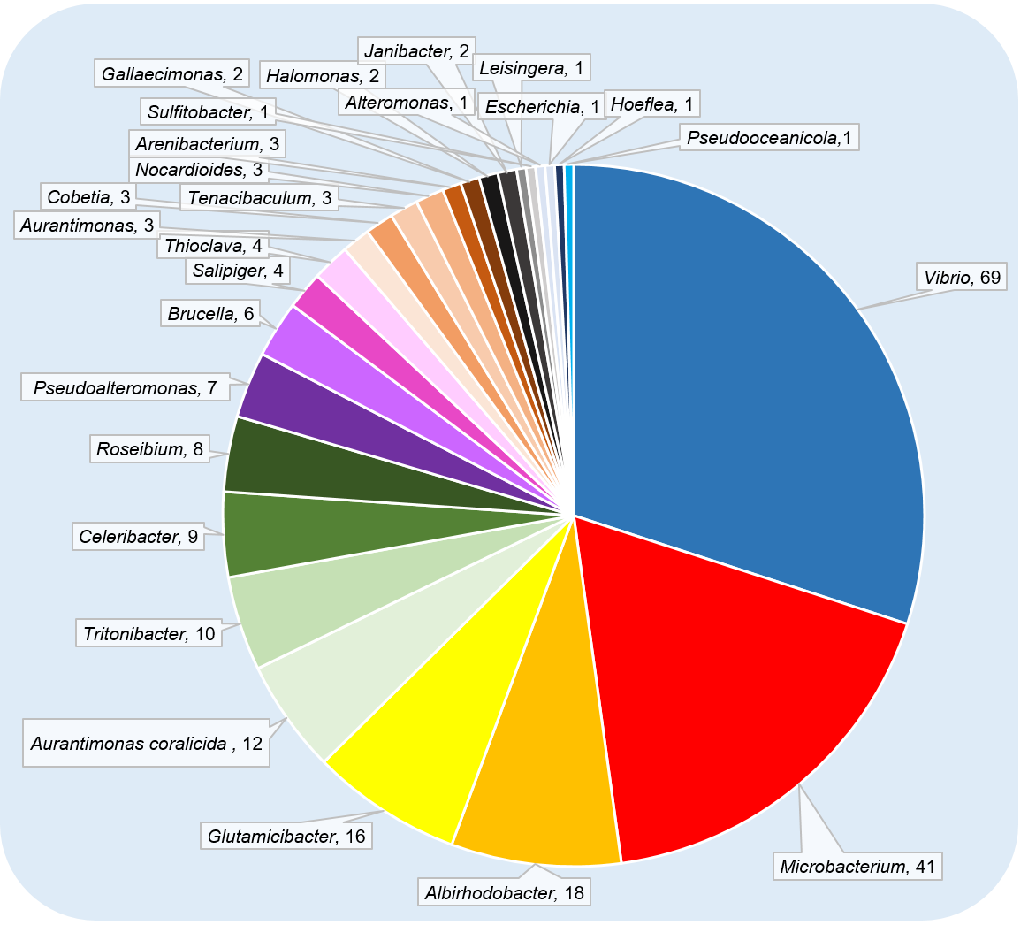
Supplementary Fig. 7 Genus-level affiliations of the isolated strains. Taxonomic classification was based on 16S rRNA gene sequences generated using Sanger sequencing.

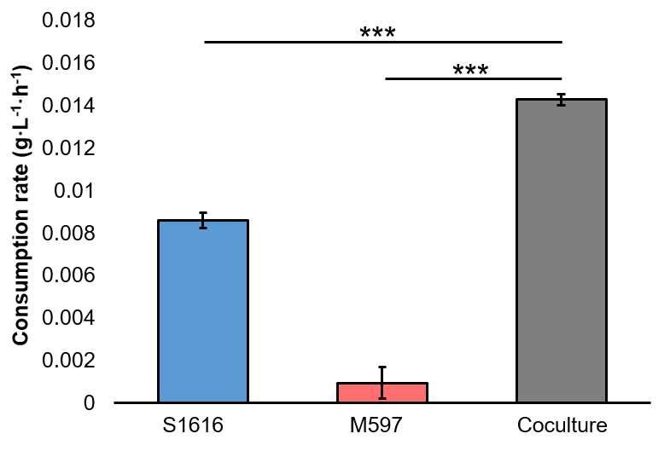
Supplementary Fig. 8 The consumption of D-gluconic acid during co-culture of S1616 and M597. The rates were calculated after cultivation for 24 hours. Error bars represent standard deviations of three biological replicates. *** represents P-value < 0.001 in Students’ t-test. Source data are provided as a Source Data file.

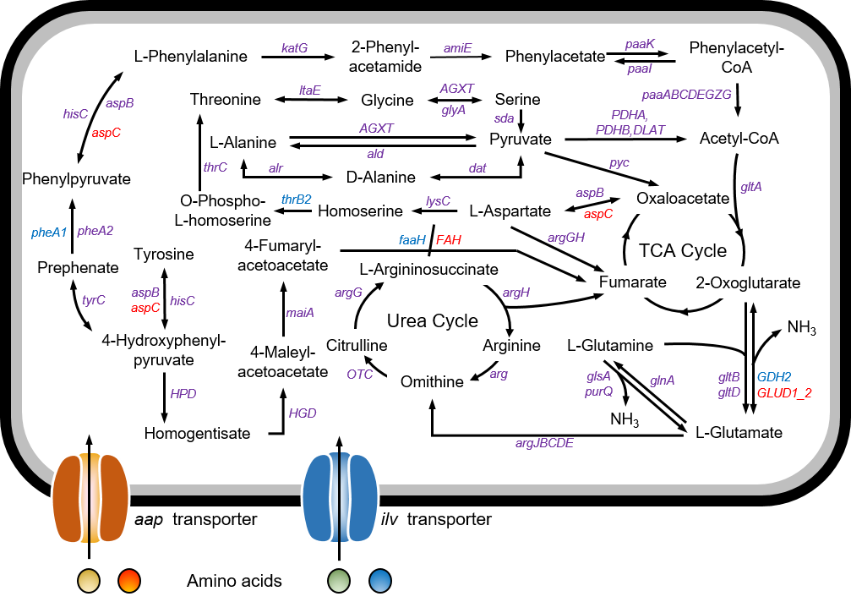
Supplementary Fig. 9 Amino acid metabolic pathways in S1616 and M597 based on KEGG annotation. The shared and specific genes are indicated by different colors. Purple: shared genes. Blue: S1616 specific genes. Red: M597 specific genes.

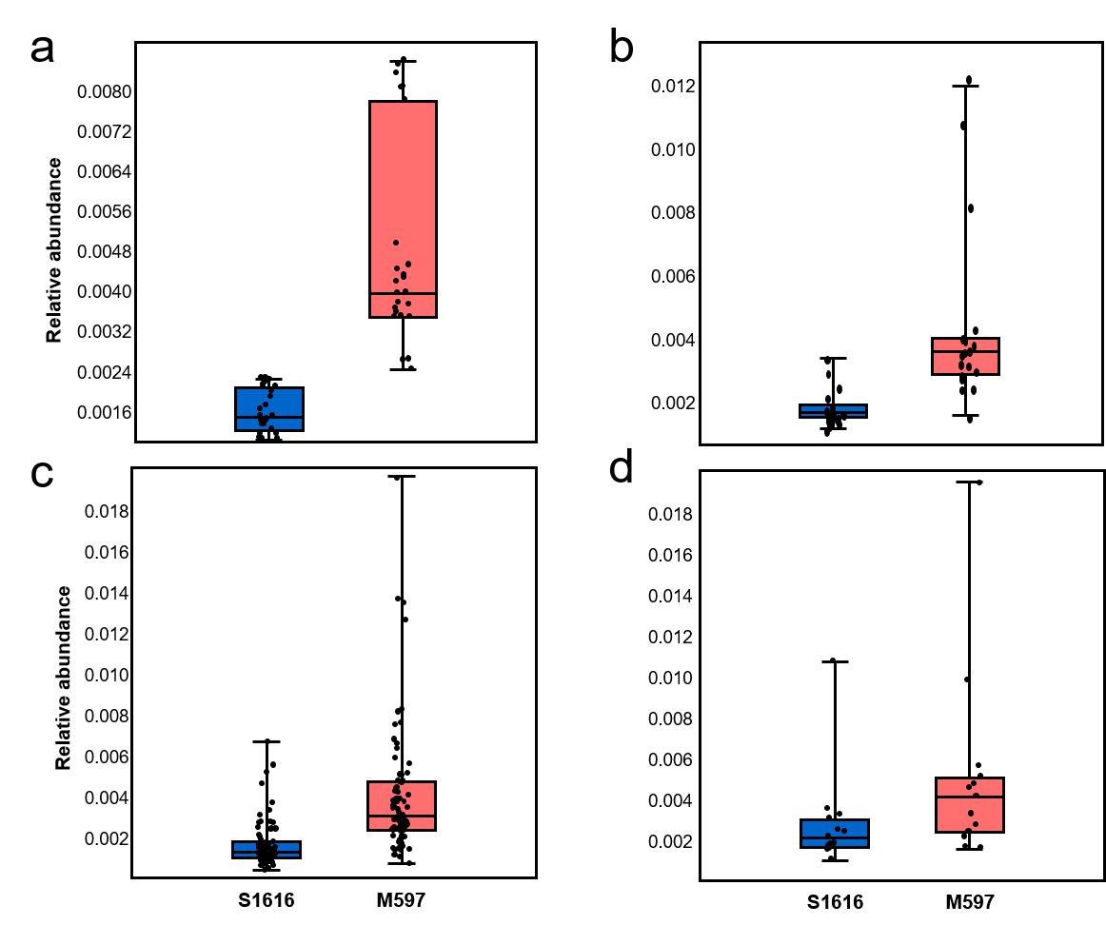
Supplementary Fig. 10 Relative abundance of S1616 and M597 in marine biofilms. The biofilms were classified into four groups based on their substrates. a, Glass and plastic particles. b, Metal panels. c, Plastic panels. d, Stone surfaces. All the metagenomes included for analysis were normalized to 1,000,000 reads with a read length of 101 bp. In all boxplots, central line represents the median, bounds represent upper and lower quartiles, and whiskers represent maximum and minimum. Information of these biofilm metagenomes is given in Supplementary Table 9. Source data are provided as a Source Data file.

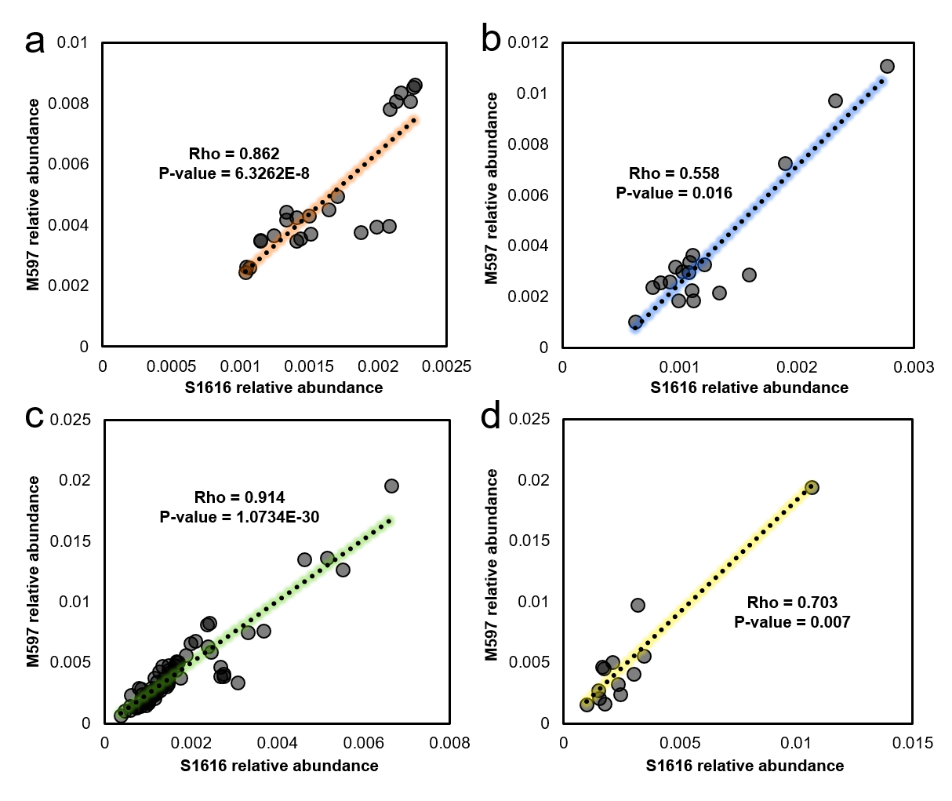
Supplementary Fig. 11 Distribution and correlation of S1616 and M597 in global ocean biofilms. The biofilms were classified into four groups based on their substrates. a, Glass and plastic particles. b, Metal panels. c, Plastic panels. d, Stone surfaces. The correlations were indicated by Spearman's Rho values and P-values. Source data are provided as a Source Data file.

