Supporting Information: A Robust Real-Time S-Wave Detection Method with Low Computational Cost Based on Modified STA/LTA
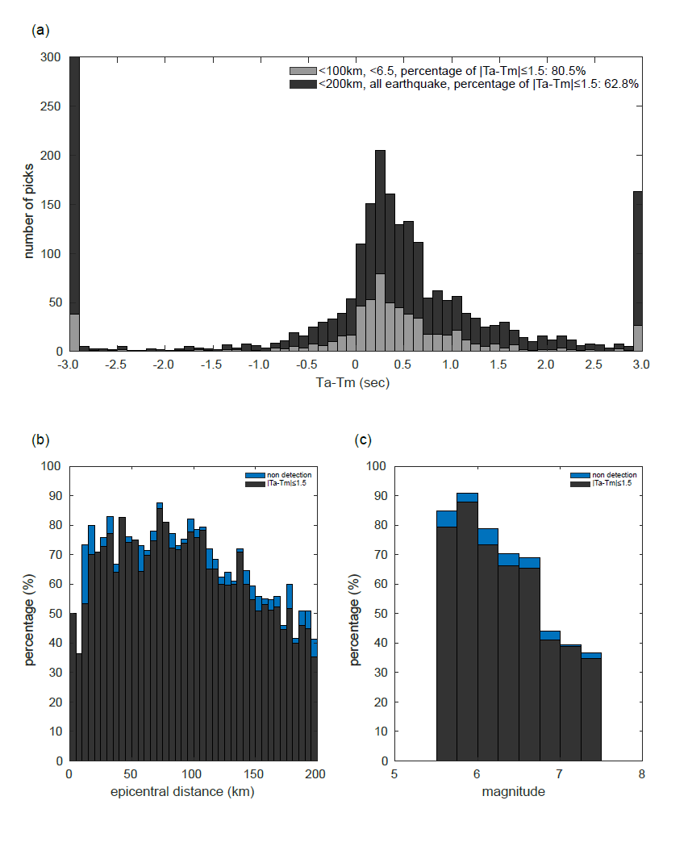
Figure. S1. The error of $T_{a}$, obtained from the waveform filtered within the frequency range of 0.01-20Hz, is presented. The remaining captions are consistent with those provided in Figure 3.

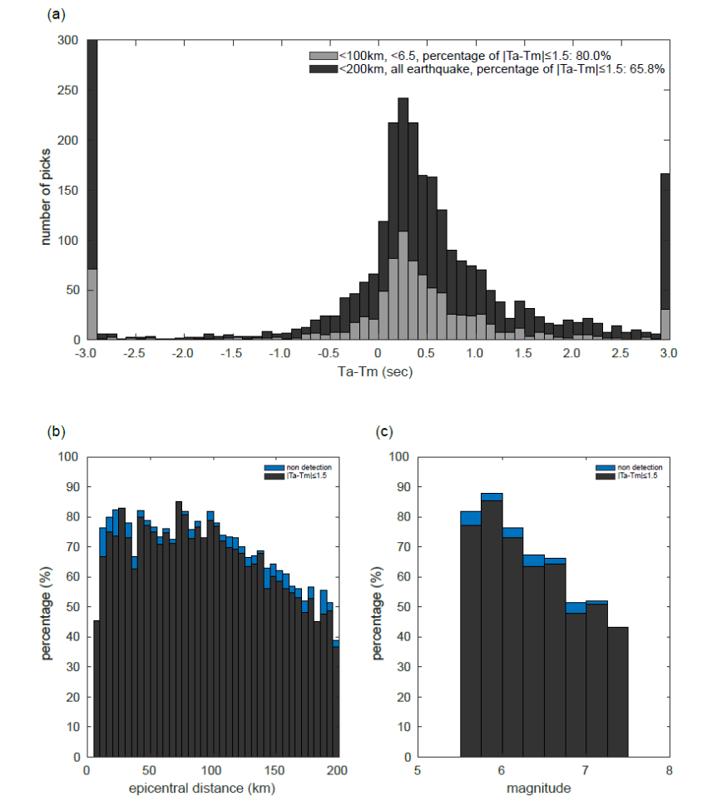
Figure. S2. The error of $T_{a}$, obtained from the waveform filtered within the frequency range of 0.05-20Hz, is presented. The remaining captions are consistent with those provided in Figure 3.

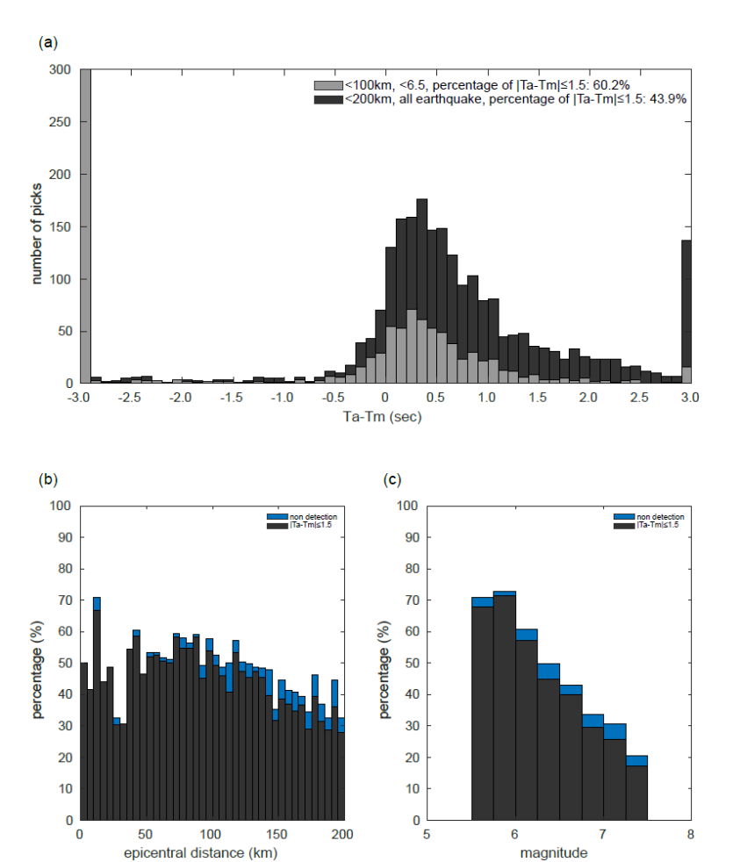
Figure. S3. The error of $T_{a}$, obtained from the waveform filtered within the frequency range of 0.5-20Hz, is presented. The remaining captions are consistent with those provided in Figure 3.

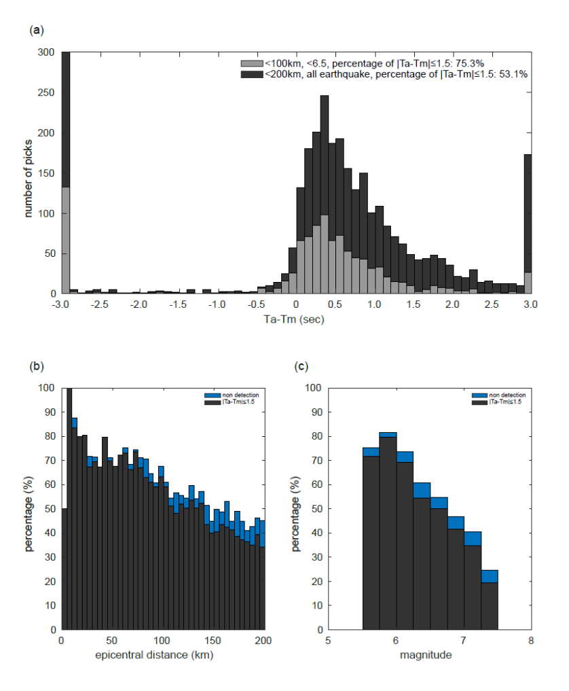
Figure. S4. The error of $T_{a}$, obtained from the waveform filtered within the frequency range of 1-20Hz, is presented. The remaining captions are consistent with those provided in Figure 3.

