Supplement data

Fig S1 Schematic illustration of the experimental design. The experiment lasted for 98 days, in which 250 mg/kg BW of NMU was injected on day 1 and day 32. On days 40-49, rats were administered estradiol for 10 days. The rats received PFPE 3 times per week from day 6 to day 97. On days 21 and days 67, blood was collected from the lateral tail vein for cytokine array assay. On day 98, rats were euthanized, and samples were collected for further biochemical analysis, histopathological examination and western blot analysis

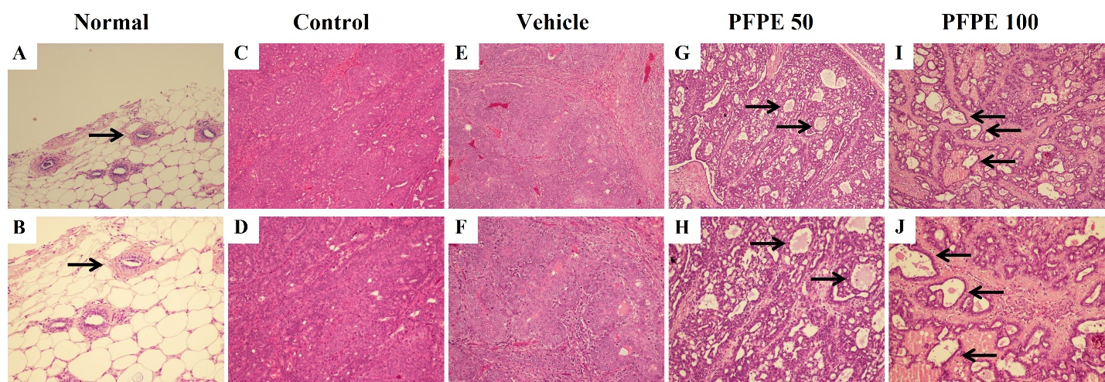
Fig S2 Effects of PFPE on tumor pathology in mammary tumor rats. Normal group (A, B), normal breast tissue was found, consisting of the milk ducts and adipose tissue. Control (C, D) and vehicle (E, F) groups found large amounts of cancer cells crowded into the tumor. The group received 50 (G, H) and 100 (I, J) mg/kg BW of PFPE, cancer cell count was small and not as crowded as in the control groups and exhibited the site of inflammation and cell death (according to the arrow pointing). Original magnification for A, C, E, G, I was 100×; Original magnification for B, D, F, H, J was 200×.

Table S1. Phytichemical ranking found in PFPE using GC-MS analysis
Ranking | Chemicl component | Structure formula | Peak area (%) | Biological activity
1 | Caryophyllene | C₁₅H₂₄ | 24.54 | Antimicrobial activity (Li moo et al., 2022), anti-inflammatory effect (Ku and Lin, 2013; Francomano et al., 2019)
2 | Piperine | C₁₇H₁₉NO₃ | 14.99 | Immunomodulatory activity (Haq et al., 2021), Anti-inflammatory (Kim and Lee, 2009), anticancer (Lat et al., 2012) and antioxidant (Thampuran, 2000)
3 | Piperolein B | C₂₁H₂₉NO₃ | 4.657 | Insecticidal activity (Hwang et al., 2017)
4 | Piperolein A | C₁₉H₂₅NO₃ | 3.735 | Insecticidal activity (Simas et al., 2007)
5 | β-Selinene | C₁₅H₂₄ | 3.67 | Antimicrobial and anti-inflammatory (Sitarek et al., 2017)
6 | Pellitorine | C₁₄H₂₅NO | 2.87 | Anticancer (Ee et al., 2010; Ku et al., 2014), enhancing immune response (Sharma et al., 2010),
7 | D-limonene | C₁₀H₁₆ | 2.54 | Modulates T lymphocyte activity and viability (Lappas and Lappas, 2012), increased NK activity (Li et al., 2009).
8 | Caryophyllene oxide | C₁₅H₂₄O | 2.50 | Anticancer and anti-inflammatory (Fidyt et al., 2016)
9 | 3-Carene | C₁₀H₁₆ | 2.37 | Antimicrobial activity (Shu et al., 2019), anticancer (Basholli-Salihu et al., 2017), anti-inflammatory (Yang et al., 2021).
10 | Pipersintenamide | C₁₉H₂₃NO₃ | 2.02 | Anti-inflammatory (Chen et al., 2002)
11 | β-Elemene | C₁₅H₂₄ | 1.94 | Anti-inflammatory (Xie et al., 2022), anticancer (Wang et al., 2018), promotes T lymphocyte activity (Ni et al., 2013).
12 | Kusunokinin | C₂₁H₂₂O₆ | 1.76 | Anticancer activity (Sriwiriyajan et al., 2017; Rattanaburee et al., 2019; Tedasen et al., 2020; Mad-adam et al., 2021; Rattanaburee et al., 2021)
13 | Piperettin | C₁₉H₂₁NO₃ | 1.49 | Antioxidant and anti-cholinesterest (Tu et al., 2016)
14 | Piperlonguminine | C₁₆H₁₉NO₃ | 1.35 | Anticancer (Li et al., 2015; Zhou et al., 2020), regulating immune response (Afolabi et al., 2021; Liang et al., 2022)
15 | (2E,4E,14E)-N-Isobutylicosa-2,4,14-trienamide | C₂₄H₄₃NO | 1.34 | Cytoprotective activity on L929 cell lines and hepatoprotective activity (Matsuda et al., 2009)
16 | Copaene | C₁₅H₂₄ | 1.297 | Antimicrobial activity (Martins et al., 2015)
17 | β-Bisabolene | C₁₅H₂₄ | 1.17 | Anticancer (Yeo et al., 2016)
18 | β-Pinene | C₁₀H₁₆ | 1.04 | Anticancer (Zhang et al., 2015; Wang et al., 2019), increased NK activity (Li et al., 2009)

