SUPPLEMENTARY MATERIAL:
Comparative transcriptome analysis of differentially expressed genes in the ovary and testis and identification of transformer-2 gene of the corn pest, Athetis dissimilis
Yue-Qin Song¹, Sheng-Jie Han¹, Tian-Si Zhang¹, Hao-Hao He² & Huizhong Sun¹
¹College of Horticulture and Plant Protection, Henan University of Science and Technology, Luoyang 471000, China. ² Zhumadian Tobacco Company, Zhumadian 463000, China.
Correspondence and requests for materials should be addressed to Y.-Q.S. (email: songyueqin6@163.com)
Abstract: Insects have developed a variety of sex-determining regulatory mechanisms throughout their evolution. In this study, we analyzed differentially expressed genes (DEG) from the ovary and testis transcriptomes of Athetis dissimilis. A total of 11065 differentially expressed genes (DEGs) between the males and females were identified, of which 6685 genes were up-regulated and 4380 genes were down-regulated in females. A AdisTra-2 (525 bp) gene was obtained from the transcriptome of A. dissimilis, and sequence alignment with other related species revealed a highly conserved RRM domain. Phylogenetic analysis showed that the AdisTra-2 protein is a close relative of the lepidopterous Tra-2 protein. The qRT-PCR of the Adistra-2 temporal and spatial expression pattern showed that it is more abundant during embryonic development than other stages, and its expression was higher in ovaries than in testes. This work provides a theoretical reference for the sex differentiation and genetic manipulation of this insect.
Keywords: Athetis dissimilis; Testis; Ovary; Differentially expressed genes; Transformer-2

CONTENT
Stable 1. Statistical table of correlation between samples
Sfigure 1. Volcano and MA maps of differentially expressed genes
Sfigure 2. Cluster map of expression patterns of differentially expressed genes
Sfigure 3. Annotated statistical map of GO secondary nodes of differentially expressed genes
Sfigure 4. KEGG pathway rich distribution map of differentially expressed genes

Stable 1. Statistical table of correlation between samples
sample | Ovary-1 | Ovary-2 | Ovary-3 | Testis-1 | Testis-2 | Testis-3
Ovary-1 | 1 | 0.9668 | 0.9464 | 0.004 | 0.0108 | 0.0112
Ovary-2 | 0.9668 | 1 | 0.9577 | 0.0039 | 0.0107 | 0.0109
Ovary-3 | 0.9464 | 0.9577 | 1 | 0.0036 | 0.0094 | 0.009
Testis-1 | 0.004 | 0.0039 | 0.0036 | 1 | 0.9486 | 0.9424
Testis-2 | 0.0108 | 0.0107 | 0.0094 | 0.9486 | 1 | 0.95
Testis-3 | 0.0112 | 0.0109 | 0.009 | 0.9424 | 0.95 | 1

Sfigure 1. Volcano and MA maps of differentially expressed genes
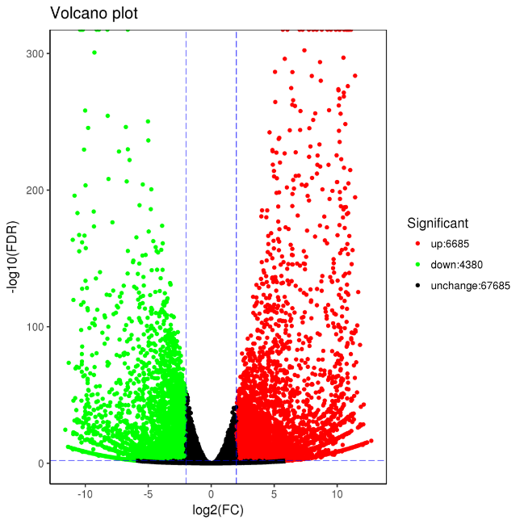
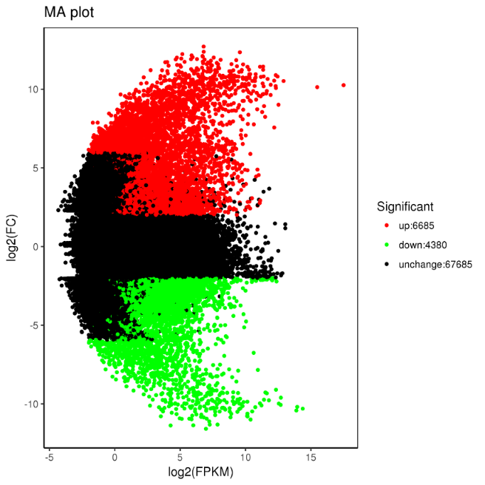

Sfigure 2. Cluster map of expression patterns of differentially expressed genes
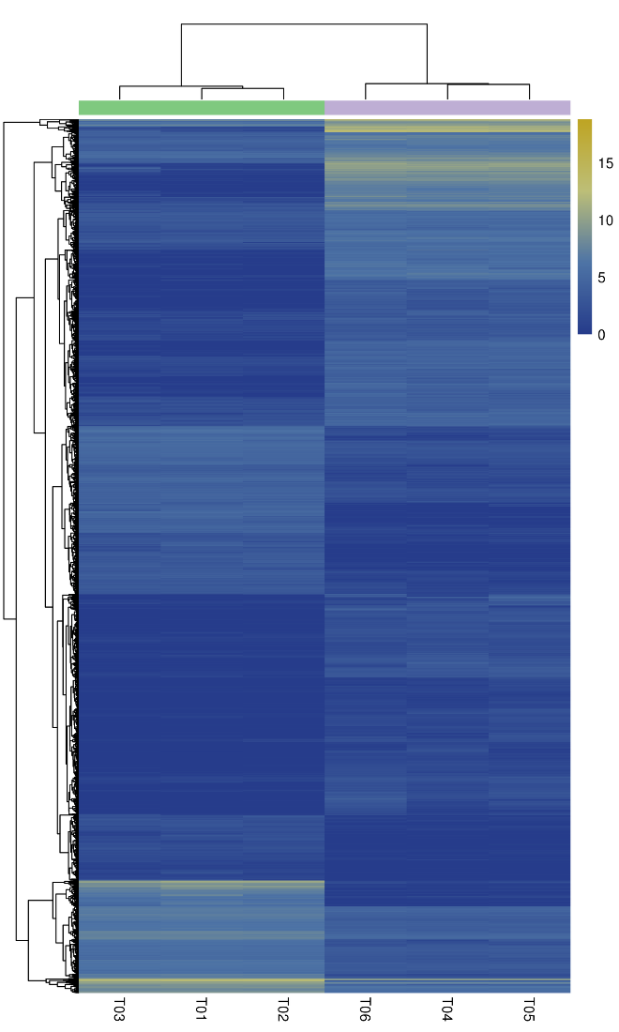
Ovary-1
Ovary-2
Ovary-3
Testis-1
Testis-2
Testis-3

Sfigure 3. Annotated statistical map of GO secondary nodes of differentially expressed genes

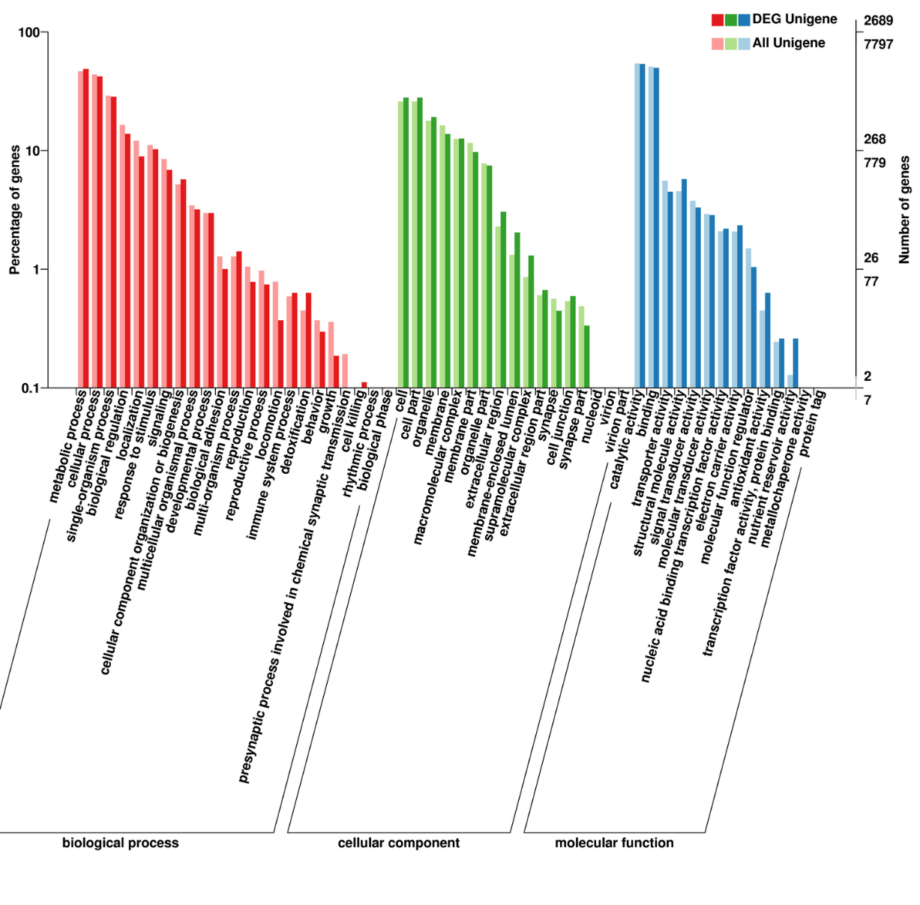

Sfigure 4. KEGG pathway rich distribution map of differentially expressed genes

