– Supporting Information –

Towards sub-second Solution Exchange Dynamics in Liquid-Phase TEM Flow Reactors

AUTHORS
Stefan Merkens,^{1,2} Christopher Tollan,¹ Giuseppe De Salvo,^{1,2} Katarzyna Bejtka,^{3,4} Marco Fontana,^{3,4} Angelica Chiodoni,³ Marek Grzelczak,^{5,6} Andreas Seifert,^{1,7} Andrey Chuvilin^{1,7}

AFFILIATION
- CIC nanoGUNE BRTA, Tolosa Hiribidea 76, 20018 Donostia – San Sebastián, Spain
- Department of Physics, Euskal Herriko Unibertsitatea (UPV/EHU), 20018 Donostia – San Sebastián, Spain
- Center for Sustainable Future Technologies@Polito, Istituto Italiano di Tecnologia (IIT), Via Livorno, 60, 10144 Torino TO, Italy
- Department of Applied Science and Technology (DISAT) , Politecnico di Torino, corso Duca degli Abruzzi 24, 10129 Torino, Italy
- Donostia International Physics Center (DIPC), Paseo Manuel de Lardizabal 4, 20018 Donostia – San Sebastián, Spain
- Centro de Física de Materiales CSIC-UPV/EHU, Paseo Manuel de Lardizabal 5, 20018 Donostia – San Sebastián, Spain
- IKERBASQUE, Basque Foundation for Science, Plaza Euskadi 5, 48009 Bilbao, Spain

CORRESPONDING AUTHOR
Stefan Merkens (s.merkens@nanogune.eu)

Contents
1. Materials & Methods 2
2. Theoretic Background 3
3. Flow Channel Resistance in LP-TEM Flow Systems with Diffusion Cells 5
4. Virtual Prototyping of Diffusion Cells 7
5. Model refinements 10
6. Physical Prototyping of ex situ Sample Holder 12
7. Further Scenarios & Improved Experimental Methods 16

- Materials & Methods
  - Material
Milli-Q water (resistivity 18.2 MΩ∙cm at 25º C) was used in all experiments. Phosphor tungstic acid (PTA, 99.995%) and potassium permanganate (KMnO₄, > 99.0%) were purchased from Sigma-Aldrich.
Gasket and O-rings for sealing of the liquid cell, PTFE tubings as well as small and large Poseidon E-chips were obtained directly from Protochips, Inc.¹ All used small E-chips had e-beam-transparent SiN membranes of nominal 550 μm x 20 μm expansion and flow spacers with 150 nm thickness (serial number: EPB-52DNF). As large E-chips, standard EPT-55W were used.

  - Flow System Assembly
Liquid cells, both flow and diffusion cells, were assembled in the sample holder’s tip under wet conditions by enclosing tiny amounts of pristine water between two pre-treated E-chips (methanol & acetone; 10% O₂ plasma during 1 min). Standard large E-chips were combined with modified small E-chips.² Flow reactors were sealed using gasket and O-rings, respectively. Prior to experiments and inserting the holder into the microscope, optical, vacuum (<10⁻⁵ mbar) and flow (Q_{total} = 3000 µL/h for 1 h) checks were conducted to validate the reactor assembly.

  - Optical Contrast Variation Method
For the experiments discussed in the main manuscript, an image contrast variation method was applied as introduced previously.³ For ex situ experiments, the method was adjusted for optical spectroscopy (see section 6). In optical experiments, $I_{norm}$ is obtained from the absorbance, A (Eq. S1 & S2):
$A= εzc$ (S1)
$A=\log_{10}\left(\frac{1}{I_{norm}}\right)$ (S2)
Eq. S1 is known as Beer Lambert law and commonly used to determine the concentration of solutes (e.g., optical dyes) absorbing light in the UV-vis regime, with $ε=ε(λ)$ denoting their wavelength-dependent molar extinction coefficient. The wavelength of maximal extinction ($λ_{max}$) was determined by acquiring A in the spectral range from 200 to 800 nm in ex situ UV-vis measurements (liquid thickness z_{liquid} = 1 cm; compare section 6).
As chemical aspects (e.g., dimerization effects) limit the linearity of Beer Lambert law to rather low solute concentrations, most optical dyes are ruled out for flow experiments unless their high extinction coefficients found in literature. Potassium permanganate (KMnO_{4,} $ε$_{max} = 2.66∙10⁴ M⁻¹cm⁻¹ at $λ$_{max} = 546 nm)⁴ was identified as suited candidate. Saturated solutions of ~ 7 mM were used.
UV-vis measurements were performed on a Cary UV-Vis-NIR 3500 spectrometer (Agilent Technologies, Inc.). The window of the liquid cell was aligned to be fully located inside the beam path (spot size: 1 mm diameter). Average absorbance (A) curves from the entire window area were acquired at an interval of 0.1 s between data points.

- Theoretic Background
  - Fundamental Equations for Single Flow Channel
The mean travel time, t, for convective transport follows from Eq. S3, where s is the travelled distance and $\overline{v}$ is the mean flow velocity:

$t=s/\overline{v}$ (S3)

The volumetric flow rate, Q_{total}, is related to $\overline{v}$ through Eq. S4, where A is the channel cross-section:

$Q_{total}=\overline{v}A$ (S4)

The general definition of flow channel resistance, R, is provided in Eq. S5, where $Δp$ denotes the pressure gradient along the flow channel:

$R=Δp/Q_{total}$ (S5)

  - Fundamental Equations for multiple parallel Flow Channels
When multiple flow channel compartments are arranged in parallel, the total volumetric flow rate, Q_{total}, follows as the sum of the fractions Q_{i} passing through each segment (Eq. S6).

$Q_{total}=\sum_{i}{Q_{i}}$ (S6)

Inserting Eq. S6 in Eq. S5 results in an expression for the resistance of each channel compartment (Eq. S7):
$R_{total}=\frac{Δp}{Q_{total}}= \frac{Δp}{\sum_{i}{Q_{i}}}$ (S7)
$\frac{1}{R_{total}}=\sum_{i}{\frac{1}{R_{i}}}$ (S8)
$R_{i}=\frac{Δp}{Q_{i}}$ (S9)

  - Poiseuille Plane Flow
Poiseuille plane flow describes flow through channels with rectangular cross-section of high aspect ratio (width >> height). The parabolic velocity profile along the short channel dimension (y) through a Poiseuille plane is described by Eq. S10.

$v\left(y\right)= -\frac{1}{2µ}\left(\frac{dp}{dx}\right)\left(h^{2}-y^{2}\right)$ (S10)

The mean and the maximum velocity in Poiseuille planes are related (Eq. S11.1). Following Eq. S10, $\overline{v}$ is defined by Eq. S11.2.

$\overline{v}=\frac{2}{3}v_{max}$ (S11.1)
$=v\left(y=0\right)=\frac{dp}{dx}\left(\frac{h^{2}}{3µ}\right)$ (S11.2)

  - Convective Transport in NC
The fundamentals of Eq. S3 – S11.2 can be applied to derive the time constant, t_{C}, for convective transport in the nanochannel of diffusion cell configurations. By applying Eq. S3 and S4, assuming $R_{BP}≪R_{NC}$, where $R_{BP}$ combines both on- and off-chip bypass compartments (compare section 3), for t_{C} follows:
$t_{C}=\frac{\left(\frac{w_{NC}}{2}\right)}{\left(\frac{Q_{NC}}{A_{NC}}\right)}$ (S12.1)
$= \frac{w_{NC}^{2}}{2Q_{total}}\left(\frac{{R_{NC}+R}_{BP}}{R_{BP}}\right)$ (S12.2)
$≈\frac{w_{NC}^{2}}{2Q_{total}}\left(\frac{R_{NC}}{R_{BP}}\right)$ (S12.3)
$=\frac{w_{NC}^{2}}{2Q_{total}}\left(\frac{Q_{total}-Q_{NC}}{Q_{NC}}\right)$ (S12.4)
$≈\frac{w_{NC}^{2}}{2Q_{NC}}$ (S12.5)

With Eq. S4 and Eq. S11.2, one obtains:
$=\frac{w_{NC}^{2}}{2}\frac{\left(3µ\right)}{\left(\frac{dp}{dx}\right)h_{NC}^{3}w_{NC}}$ (S12.6)
$=\frac{w_{NC}}{2}\frac{3µ}{\left(\frac{dp}{dx}\right)h_{NC}^{3}}$ (S12.7)
With $\left(\frac{dp}{dx}\right)=\frac{Δp}{L} =\frac{Δp}{w_{NC}}$, one obtains:
$=\frac{3µ}{2}\frac{w_{NC}}{\left(\frac{Δp}{w_{NC}}\right)h_{NC}^{3}}$ (S12.8)
$=\frac{3µ}{2}\frac{w_{NC}^{2}}{Δp h_{NC}^{3}}$ (S12.9)

With Eq. S9 and $R_{BP}\sim L=w_{NC}$ and $Q_{BP}≈Q_{total}$, it follows:

$=\frac{3µ}{{2h}_{NC}^{3}}\frac{w_{NC}^{2}}{R_{B}Q_{B}}$ (S12.10)
$\frac{3µ}{{2h}_{NC}^{3}}\frac{w_{NC}^{2}}{R_{BP}Q_{BP}}$ (S12.11)
$\sim \frac{w_{NC}^{2}}{w_{NC}Q_{total}}$ (S12.12)

Thus, $t_{C}$ can finally be expressed as:
$t_{C}\sim \frac{w_{NC}}{Q_{total}}$ (S12.13)

- Flow Channel Resistance in LP-TEM Flow Systems with Diffusion Cells
When additional on-chip bypass compartments are included, the total flow resistance is affected. The total resistance, R_{PR}, in the direct flow/premixing setups with diffusion cells can be expressed by Eq. S13, following from symmetry considerations similar to those presented in Supporting Information of previous manuscript:³

$\frac{1}{R_{PR}}≈\left(\frac{2}{2R_{G}+2R_{off}}+\frac{1}{R_{NC'}}+\frac{1}{2R_{on}}+\frac{1}{2R_{on}}\right)$ (S13.1)
$≈\left(\frac{2}{2R_{G}+2R_{off}}+\frac{1}{R_{NC'}}+\frac{2}{2R_{on}}\right)$ (S13.2)

In Eq. S13, R_{G} and R_{NC’} correspond to the resistance of a leak channel at each individual gasket, the resistance of the central nanochannel with reduced expansion in horizontal plane. R_{off} and R_{on} denote the resistance that corresponds to one quarter of the entire off-chip and on-chip bypass channel, respectively. Note that R_{off} is equivalent to R_{BP} in ³. R_{BP,PR} can thus be reassigned to further simplify Eq. S13.2:

$\frac{1}{R_{PR}}≈\left(\frac{1}{R_{BP,PR}}+\frac{1}{R_{NC'}}\right)$, (S13.3)

where
$\frac{1}{R_{BP,PR}}=\frac{2\left(2R_{G}+2R_{off}\right)+2(2R_{on})}{(2R_{G}+2R_{off})2R_{on}}$ . (S14)

The total resistance, $R_{OS}$, in the bathtub/onsite mixing configuration with diffusion cells can be approximated as follow: ³

$\frac{1}{R_{OS}}≈\left(\frac{4}{3R_{off}}+\frac{1}{R_{NC'}}+\frac{4}{3R_{on}}\right)$ . (S15.1)

Note that also in Eq. S15.1, R_{off} is equivalent to R_{BP} in ³. R_{BP,OS} can thus be reassigned to further simplify Eq. S15.1:

$\frac{1}{R_{OS}}≈\left(\frac{1}{R_{BP,OS}}+\frac{1}{R_{NC'}}\right)$, (S15.2)
where
$\frac{1}{R_{BP,OS}}=\frac{12R_{off}+12R_{on}}{144R_{on}R_{off}}= \frac{R_{off}+R_{on}}{12R_{on}R_{off}}$ . (S16)

In context of the virtual prototyping reported in Fig. 3, R_{G} and R_{BP} remain unchanged whereas R_{on} and R_{NC’} are varied. $R_{on}$ scales with w_{NC} and inversely with the height of the on-chip bypass channel. R_{NC’} scales strongly with w_{NC} and is significantly reduced with respect to R_{NC} describing the default nanochannel with nominal extension of 2 x 2 mm². Note that R_{NC’} and R_{on} are related through w_{NC} – widening one compartment, shrinks the other. Refer to previous literature for the dependence of flow resistance on the channel geometry.³

- Virtual Prototyping of Diffusion Cells
  - Convective vs. Diffusive Transport
    - Dependence on Flow Rate – Direct Flow/Premixing Configuration
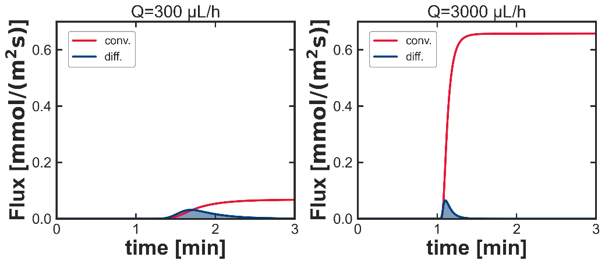
Fig. S1: Contribution of convective and diffusive flux to solution replacement dynamics in direct flow/premixing configuration with diffusion cells (w_{NC}=0.2 mm) at different flow rates. Contribution of convective (red line) and diffusive (blue) flux are depicted for flow rates of Q_{total} = 300 µL/h (a) and Q_{total} = 3000 µL/h (b). With increasing flow rate, the relevance of convective flux increases. The diffusion coefficient was D = 10⁻¹⁰ m²/s. Note the conceptual difference between convective (continuous) and diffusive (depending on concentration gradients) flux.

    - Dependence on Diffusion Coefficient – Direct Flow/Premixing Configuration
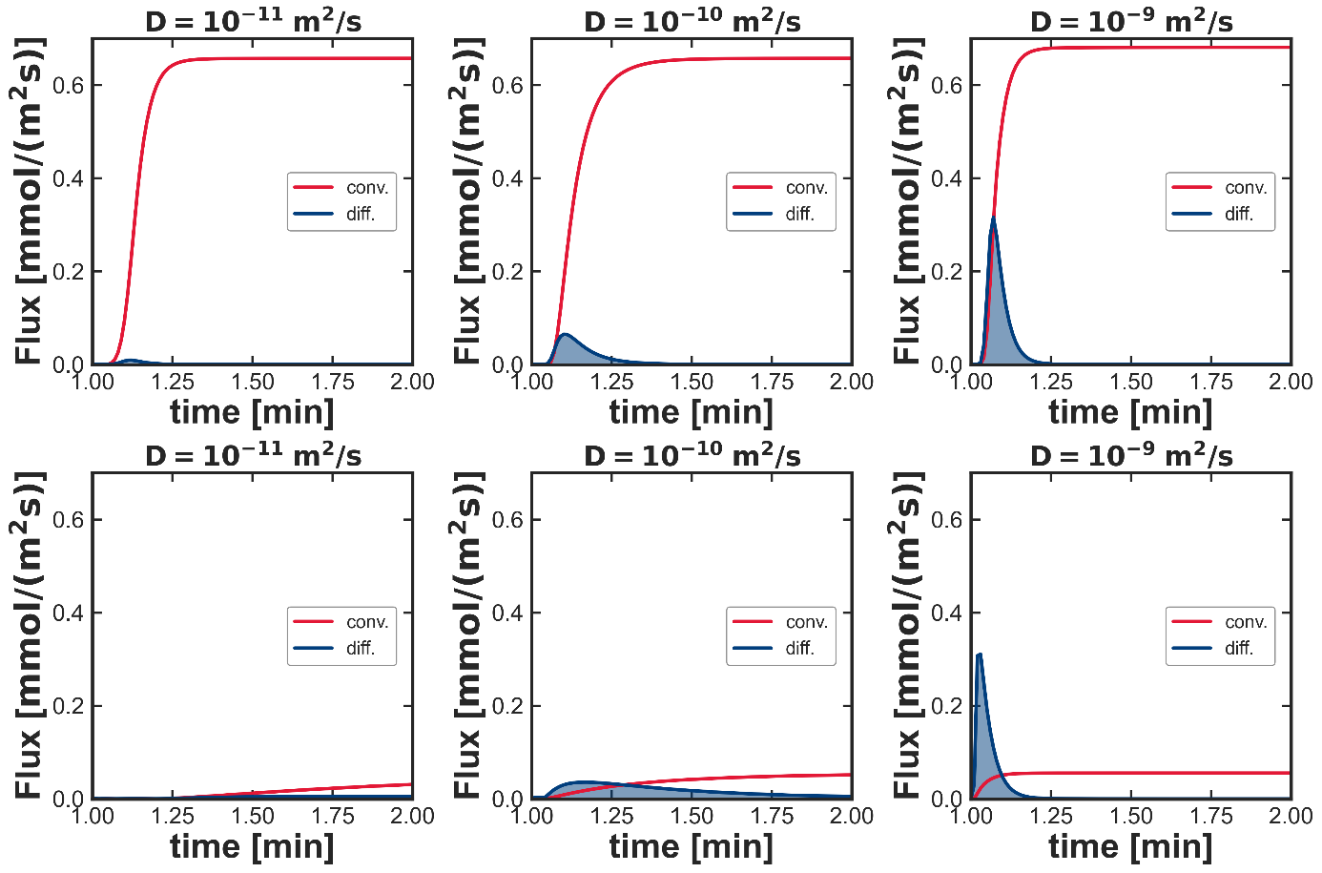
Fig. S2: Contribution of convective and diffusive flux to solution replacement dynamics in premixing configuration with diffusion cells (w_{NC}=0.2 mm) at different diffusion coefficients. Contribution of convective (red curve) and diffusive (blue curve) flux to the solution replacement in the premixing configuration at a) D = 10⁻¹¹ m²/s, b) D = 10⁻¹⁰ m²/s and c) D = 10⁻⁹ m²/s. Relevance of diffusive flux increases with increasing D. Flow rate was Q_{total}=3000 µL/h.

    - Dependence on Diffusion Coefficient – Bathtub/Onsite Mixing Configuration
Fig. S3: Contribution of convective and diffusive flux to solution replacement dynamics in bathtub/onsite mixing configuration with diffusion cells (w_{NC}=0.2 mm) at different diffusion coefficients. Contribution of convective (red curve) and diffusive (blue curve) flux to the solution replacement in the bathtub/onsite mixing configuration at a) D = 10⁻¹¹ m²/s, b) D = 10⁻¹⁰ m²/s and c) D = 10⁻⁹ m²/s. Diffusive flux has significant effect on solution replacement for a wide range of D. Flow rate was Q_{total} = 3000 µL/h.

  - In-depth discussion of virtual Prototyping
Find below an in-depth discussion of the effect of geometrical (w_{NC} & h_{BP}) and experimental (Q_{total}) parameters on the monitored hydrodynamic parameters ($Δp, v_{c}, Δt \& τ$) for direct flow/premixing and bathtub/onsite mixing configuration with diffusion cells depicted in Fig. 3. For theoretic background refer to section 2 and 3 and previous literature.³
a-c) The overall pressure gradient Δp decreases when additional on-chip BPs are inserted (a & b). This reflects the decrease of the overall flow resistance R_{total} with increasing w_{NC} and h_{BP} in both direct flow/premixing and bathtub/onsite mixing configuration with diffusion cells, respectively (compare Eq. S3). For identic on-chip BP dimensions, the Δp-values are larger for the premixing than for the onsite mixing configuration, due to the substantially blocked off-chip BP (gasket technology^{1,3}) resulting in larger R_{total}. Therefore, the biggest difference is observed in the setups with default flow cell (red cross and blue circle). However, the difference between both configurations decreases with increasing size of the on-chip BP (refer to b). This mainly is because the flow resistance, R_{on}, of the on-chip BP increasingly dominates R_{total} as 1/R_{on} is growing with w_{NC}, and more significantly with h_{BP} (compare Eq. S13.1 & S15.1). Ultimately, limiting values of Δp are obtained with increasing w_{NC} (compare a) and eventually h_{BP}. The achievable minima are at larger Δp in a than in b due to stronger geometric limitations (width of the on-chip BP: w_{on} = 2 mm – w_{NC} with 0 < w_{NC} < 2). The cross-section, A, of the on-chip BP in a (A = w_{on}·h_{BP} = 1.95 mm·10 µm = 0.0195 mm²) is restricted to significantly smaller values compared to those achievable by increasing h_{BP} (A= w_{on}·h_{BP} =1.95 mm·50 µm = 0.09 mm² for the last point in b).
Δp further increases with the applied overall flow rate, Q_{total} (c). This reflects the direct proportionality between both quantities as follows from Eq. S4 & S5.

d-f) The dependence of $v_{c}$ on w_{NC} and h_{BP} largely resembles that of Δp (a & b). The majority of the flow is guided through the available bypass channels and around the central nanochannel due to its relatively large resistance. In parallel assemblies, fractions of Q_{total} are redistributed in the different channel compartments based on their relative flow resistance, R_{i} (compare Eq. S9). In fact, the similarities between $v_{c}$ and Δp are more pronounced for the premixing configuration, reflecting its direct flow characteristics with flow symmetrically passing the central nanochannel on both sides (compare Fig. 1). In contrast, vc in onsite mixing configuration with diffusion cell displays slight increase with decreasing w_{NC} < 1.8 mm and at intermediate h_{BP} of 5 to 10 µm. The increase with decreasing w_{NC} (d) and at intermediate h_{BP} is due to decreasing flow resistance of the central nanochannel and flow being redirected closer to the NC of lower resistance (vs default configuration). The decrease at higher h_{BP} is due to an overall velocity decrease due to drastically enlarged cross section A (compare Eq. S4 & S5).
$v_{c}$ is further increases with the applied overall flow rate, Q_{total,} (c). According to Eq. S4 & S11.1, both quantities are directly proportional.

g-l) Overall, both mixing time constants ($Δt$ & $τ$) decrease with increasing size of the on-chip BP. The trends of $τ$ (j & k) largely resembles those of $Δt$ (g & h) as both quantities are interconnected.³ In the onsite mixing configuration, both time constants decrease with decreasing w_{NC} and increasing h_{BP} due to the reduced diffusion length (w_{NC}) and increased convective flux in close proximity to the IA, respectively. In the premixing configuration, an increase of both time constants is observed at intermediate w_{NC} which is because the drop in convective transport inside the NC (see drop in flow velocity in d) is not (yet) compensated by the accelerated diffusive transport over too long diffusion lengths (w_{NC} > 1.2). The decrease with h_{BP} is rather abrupt, while the changes with w_{NC} are more gradual due to corresponding variation in relevant geometric parameters (BP cross-section and distance from the IA). Both for w_{NC} and h_{BP}, the improvements in the onsite mixing configuration (~ 2 orders) exceed those for the premixing configuration (~ 1 order) as latter is significantly accelerated by convective transport in the NC of the default scenario already.
Further, $Δt$ decreases with the applied overall flow rate, Q_{total}, for both configurations operated with diffusion cells (i). This reflects the dependence of the travel time on Q_{total}. Over the entire range of Q_{total}, the absolute $Δt$-values remain larger for the premixing than for the onsite mixing configuration, reflecting the intrinsic delay caused by the extended premixing channel. In the premixing configuration, $τ$ depicts a slight dependence on Q_{total.} The effect of the premixing channel can even be compensated with respect to the onsite mixing configuration. This is because solution replacement in the onsite mixing configuration is entirely dominated by diffusion, while convection is negligible (compare e).

- Model refinements
  - Diffusive Broadening – Zero Flow
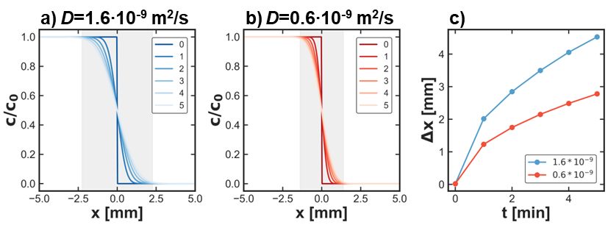
Fig. S4: Diffusive broadening of sharp concentration interfaces (zero flow). a) & b) Concentration profiles along initially sharp solute interface with increasing time (up to 5 min) for two diffusion coefficients, i.e., 1.6∙10⁻⁹ and 0.6∙10⁻⁹ m²/s. c) Width, Δx, of the concentration gradient upon diffusive broadening with time t. Δx at t = 5 min is indicated in grey in a) & b), respectively. The broadening affects the inflow concentration gradient when initially stopped inlets are switched on, e.g., in a solution replacement experiment. Refer to Fig. S6 for effect on time constants.

  - Window Bulging
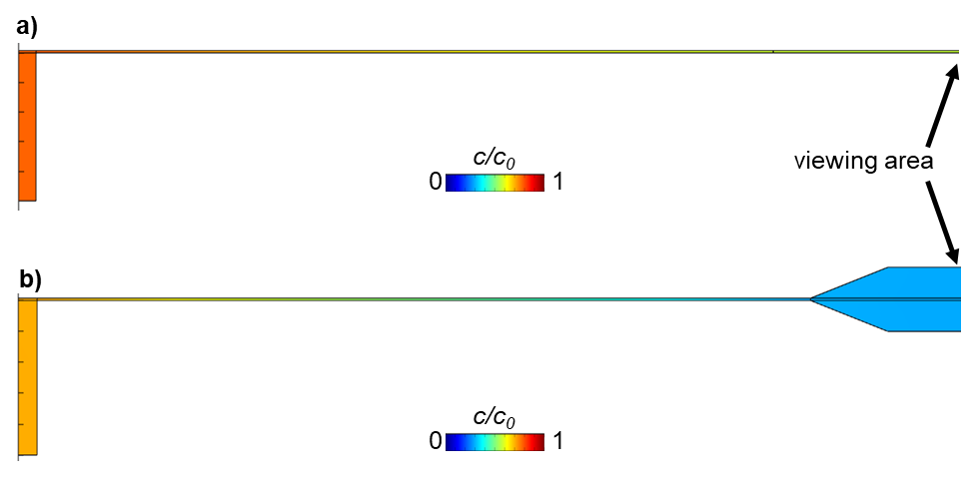
Fig. S5: The effect of window bulging on solution replacement in the central nanochannel. a) & b) 2D concentration profile of solute in onsite mixing configuration neglecting (a) and considering (b) window bulging at 6 s after applying contrast agent flow (w_{NC} = 0.2 mm, Q_{total} = 1200 µL/h). Bulged window in b) is qualitatively approximated with truncated pyramids (width: w = 20 µm; height: h = 2 µm) for meshing purposes. Solution in the additional volume is replaced predominantly via diffusion resulting in a delayed and more gradual replacement in the viewing area. Refer to Fig. S6 for effect on time constants.
  - Time constants
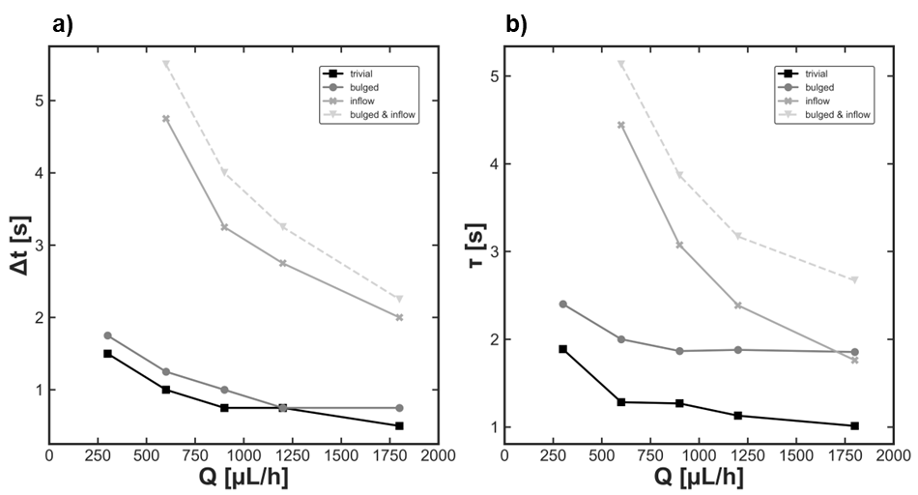
Fig. S6: Refinement of simulated time constant of solution replacement in bathtub/onsite mixing configuration with diffusion cells (compare Fig. 4). Flow rate dependence of delay time (a) and decay time constant (b) for different models. The black rectangles correspond to the non-refined trivial model which considers geometry of the diffusion cell predicting too rapid solution replacement dynamics. More sophisticated models estimate window bulging (dark grey circles), inflow gradients (grey crosses); note the rather low/strong dependence of window bulging and inflow gradients on flow rate, respectively. The combination of both effects shows accurate agreement with experimental values (light grey triangles) as depicted in Fig. 4f-i (main manuscript).

- Physical Prototyping of ex situ Sample Holder
The development of LP-TEM sample holder and the experimental quantification through electron microscopical methods are expensive and time-consuming. Due to economic constraints, both regarding fabrication and further experimental verification we developed ex situ prototyping routines comprising ex situ prototypes and optical means for their characterization.

  - Fabrication of ex situ Sample Holders
An ex situ prototype of a direct flow/onsite mixing setup was purchased from external collaborators (Mondragon University) upon specific request. The internal geometry of the manufactured prototype was derived from the Poseidon sample holder series of Protochips company.¹ Hence, the channel geometry in the bathtub region was identical to that of the Poseidon Select sample holder (computer-aided design (CAD) files were obtained from Protochips Inc. under non-disclosure agreement, NDA); however, no premixing channel is present to supply liquids. Instead, external channels are connected directly to three individual pockets (with the two inlets opposing each other) as characteristic for the Poseidon 200 setup.³ The external features of the ex situ prototype were designed to fit those of standard UV-vis cuvettes (1 x 1 x 4 cm³). The frontside view of the ex situ prototype is depicted in Fig. S9b. In- and outlet tubings were connected directly from the backside.

  - Optical Image Contrast Variation Method
The image contrast variation method (established for TEM previously³) was adapted for UV-vis spectroscopy to quantify solution replacement dynamics of LP-TEM flow reactor prototypes. Optical methods are widely applied for the hydrodynamic characterization and quantification of microfluidic devices where typical channel thicknesses of several hundreds of micrometres allow to operate at low optical contrast agent (dye) concentrations leading to satisfying (image) contrast variations.⁵ The main challenge of adapting the spectroscopic approach to LP-TEM systems was in the miniaturization of central nanochannel, and consequently identifying contrast agents that induce measurable contrast variations given average nominal liquid thickness of ≤ 1 µm. Potassium permanganate (KMnO_{4,} $ε$_{max}= 2.66∙10⁴ M⁻¹cm⁻¹)⁴ was identified as suitable candidate; saturated KMnO₄ solutions of ~ 7 mM induced ~ 8% variation of the measured transmitted intensity at maximum extinction wavelength, $λ$_{max} = 546 nm. The strong oxidizing character of the permanganate and the risk of MnO₂ precipitation, should be noted to possibly limit its applicability for hydrodynamic characterization of LP-TEM reactors.^{6,7} Details on the ex situ and in situ concentration calibration by optical means are depicted in Fig. S7 and S8, respectively.
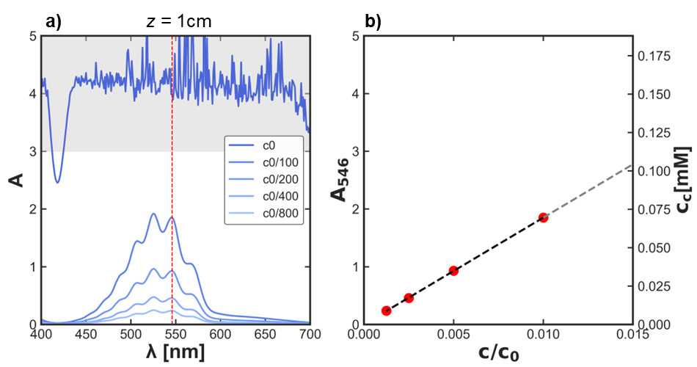
Fig. S7: Concentration calibration of KMnO₄ solution in ex situ UV-vis measurements (optical path z = 1 cm). a) Absorbance, A, of KmnO4 solution in the wavelength range 400 < $λ$< 700 nm for various concentrations, c. c₀ denotes the concentration of the concentrated solution used for hydrodynamic calibration described in the main manuscript; its optical signal exceeds the detection limit (grey area) in classical ex situ experiments with cuvettes of 1 cm. b) Absorbance, A₅₄₆, extracted at wavelength of the maximum ($λ$_{max} = 546 nm; red dashed line in a) from the curves in a). The measured data points fall into the linear regime of Beer’s law; linear extrapolation assuming ε_{KMnO4,546 nm} = 2.66$∙$10⁴ M⁻¹cm⁻¹ for the extinction coefficient of KMnO₄ at 546 nm allows to estimate c₀ ~ 7 mM.⁴

  - Data Post-Processing
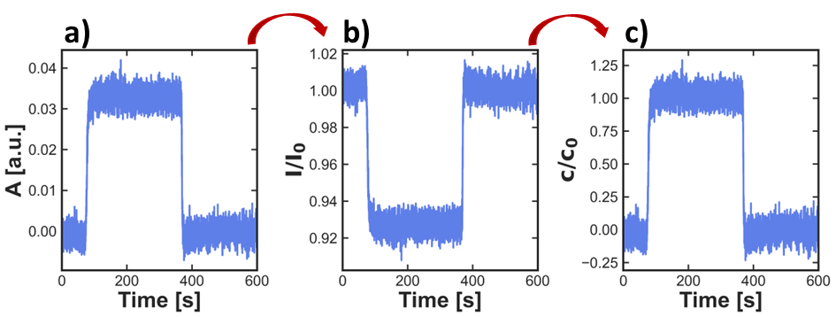
Fig. S8: Post-processing routine for hydrodynamic calibration via UV-vis spectroscopy. A) The absorbance, A, is measured across the entire viewing area; b) it is converted in normalized intensity, I/I₀; which is finally c) expressed as normalized concentration, c/c₀, following concentration calibration routines.³

  - Hydrodynamic Characterization
To quantify the hydrodynamic properties of diffusion cells operated in the direct flow/onsite mixing ex situ prototype, a spectrometer was used to acquire time-dependent concentration profiles (see Fig. S9c) by tracking changes of the measured absorbance, A, (see section 1 for conversion into transmitted intensity and solute concentration) at 10 Hz across the entire viewing area (~ 20 x 20 µm²). The solute-induced signal variation was well above noise level and reproducible, yet fluctuations were more pronounced than in TEM data. Characteristic time constants were extracted to quantify improved replacement dynamics.

Quantitative analysis (Fig. S9d & e) shows that the delay time and decay time constant were Δt = 12 s & τ = 1.8 s (corresponding to 90% of solution being replaced in ~ 4 s; Q_{total} = 2400 µL/h), respectively. This acceleration with respect to data depicted in Fig. 4 can only be partially ascribed to geometrical improvements given the faster diffusion of the optical dye D_{MnO4-} ~ 1.6·10⁻⁹ m²/s > D_{PTA}^{3,4} The experimental constants of solution replacement, particularly τ, are accurately reproduced with a refined numeric model which estimates window bulging and adjusted gradual inflow gradients (grey triangles in Fig. S9d & e; compare section 5).

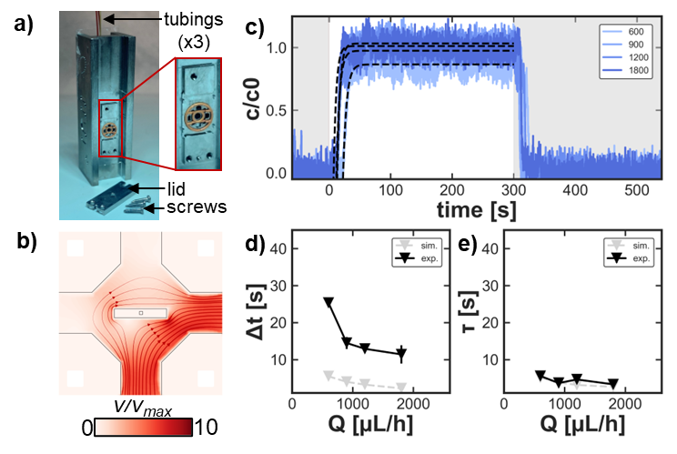
Fig. S9: Hydrodynamic quantification of direct flow/onsite mixing LP-TEM flow setup with diffusion cells. a) Prototype of a direct flow/onsite mixing configuration constructed on the basis of Protochips’ Poseidon holders. The system relies on gasket technology for sealing; no premixing channel is present as tubings are directly connected to individual pockets from behind. b) Illustrative representation of the flow profile in the diffusion cell. Note that the velocity is increased compared to the bathtub/onsite mixing setup due to reduced off-chip bypass. Refer to main manuscript for details. c-e) The system was used for ex situ flow calibration via UV-vis spectroscopy. Example curves of normalized concentration (blue) for different flow rates, Q (c) tracked across the entire IA using potassium permanganate (KMnO₄; D_{MnO4-}~1.6·10⁻⁹ m²/s) as optical contrast agent. Black dashed lines in c represent exponential fits. Experimental delay times, Δt (d), and decay time constants, τ, (e) of solution replacement (black triangles) were reproduced by numeric modelling (grey).

- Further Scenarios & Improved Experimental Methods
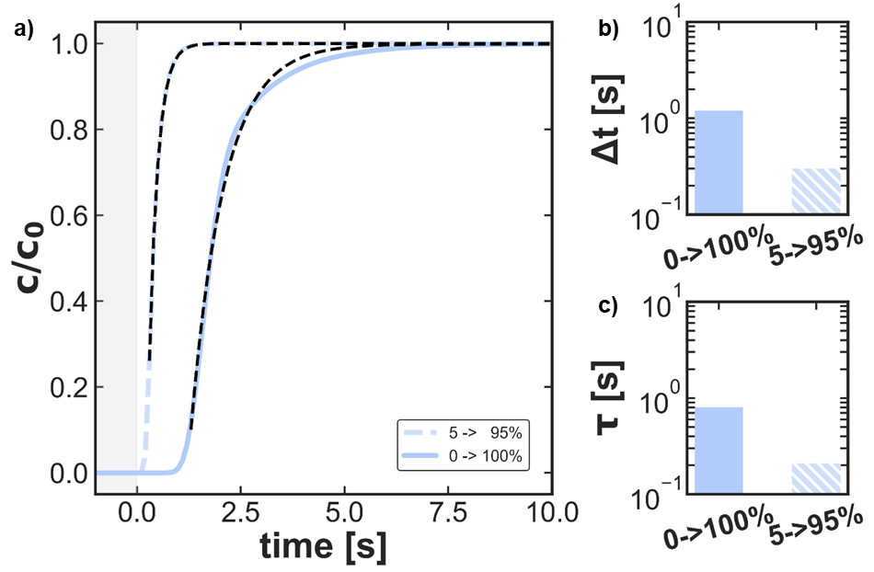
  - Direct Flow/Onsite mixing Setup derived from Poseidon 200 Sample Holder
Fig. S10: Solution replacement in direct flow/onsite mixing configuration under optimized experimental conditions. a) Simulated time-dependent concentration profile at the center of the nanochannel induced through conventional (Q_{CA}: 0 à 1∙Q_{total}) and optimized (Q_{CA}: 0.05∙Q_{total} à 0.95∙Q_{total}; reproduced from Fig. 5c) experimental methodology. Characteristic parameters were: w_{NC} = 0.05 mm, l_{NC} = 0.65 mm, h_{NC} = 150 nm, h_{BP}=50 µm. Dashed black lines represent exponential fits. b, c) Extracted time constants of solution replacement, Δt (b) and τ (c), for the curves in a. Preventing mixing at the channel entrance results in significantly (> 1 order of magnitude) improved time constants leading the way to sub-second solution replacement dynamics. The diffusion coefficient was D = 1.3∙10⁻⁹ m²/s to reflect more realistic scenarios of diffusing small molecules.

  - Virtual double-inlet Diffusion Cell for DENSsolutions’ Stream System
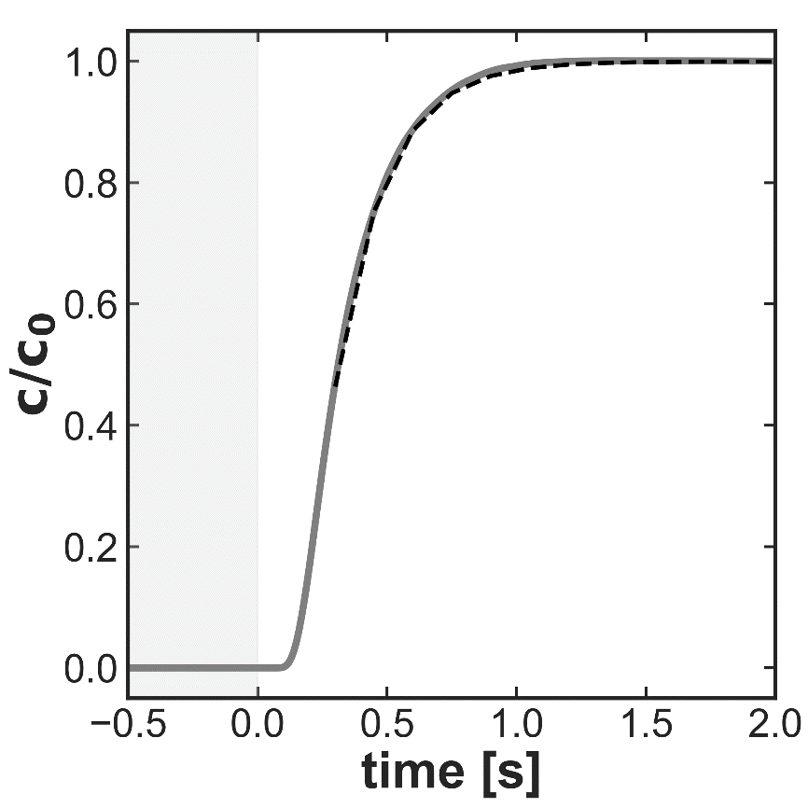
Fig. S11: Solution replacement in virtual double-inlet diffusion cell compatible with DENSsolutions Stream system. a) Simulated time-dependent concentration profile at the IA. The geometrical parameters were h_{BP} = 50 µm, w_{channel} = 1 mm, w_{NC} = 50µm, Q_{total} = 3000 µL/h (resulting in Δp ~ 25 mbar and v_{c} = 3.5·10⁻⁷ m/s) and D = 1.3·10⁻⁹ m²/s. Dashed black lines represent exponential fits. Delay time and decay time constants were determined Δt = 0.15 s and τ = 0.19 s.

REFERENCES
1. Protochips Inc. Protochips. https://www.protochips.com/ https://www.protochips.com/ (2023).
2. Protochips Inc. Protochips’ Guide to Poseidon E-chips Version 1.3 Copyright 2018 14. https://academic.oup.com/toxsci/article/1676330/Table_of_Contents (2018).
3. Merkens, S. et al. Quantification of reagent mixing in liquid flow cells for Liquid Phase-TEM. Ultramicroscopy 245, 113654 (2023).
4. Zenita Devi, O., Basavaiah, K. & Vinay, K. B. Application of Potassium Permanganate to spectrophotometric assay of metclopramide hydrochloride in Pharmaceuticals. J Appl Spectrosc 78, 873–883 (2011).
5. Vakili, M. et al. 3D Micromachined Polyimide Mixing Devices for in Situ X-ray Imaging of Solution-Based Block Copolymer Phase Transitions. Langmuir 35, (2019).
6. Swain, H. A., Lee, C. & Rozelle, R. B. Determination of the Solubility of Manganese Hydroxide and Manganese Dioxide at 25°C by Atomic Absorption Spectrometry. Anal Chem 47, 1135–1137 (1975).
7. Cohen, J. U. & Oddy, R. W. The stability of permanganate solutions. Journal of the Society of Chemical Industry 9, 17–18 (1890).

