TRIM37 maintains 5hmC levels and stemness through preventing DNMT1 alternative splicing

Supplementary Information

Inventory:
Figure S1 – Figure S7

Table S1 – Table S9

a
Early-passage
Late-passage
Middle-passage
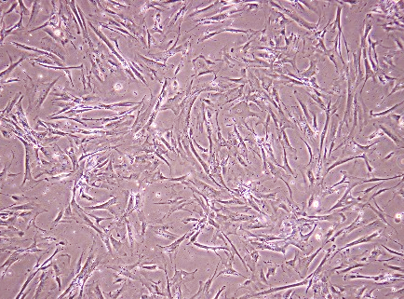
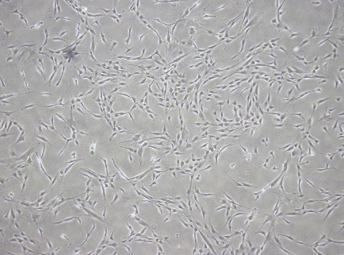
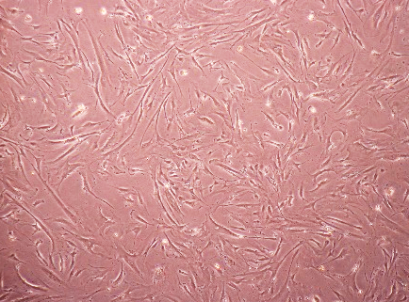

b
c
Early Late
kDa
28
Early
Late
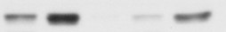
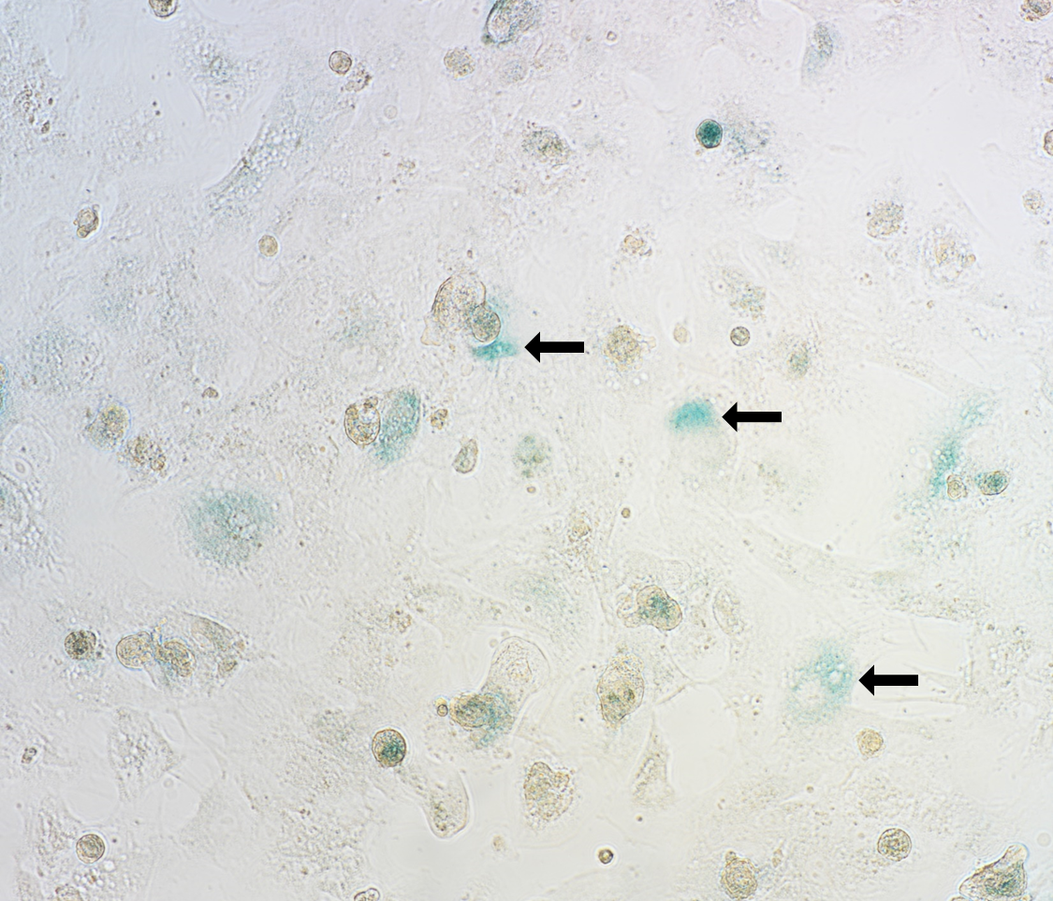
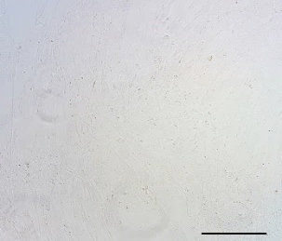
P21
100
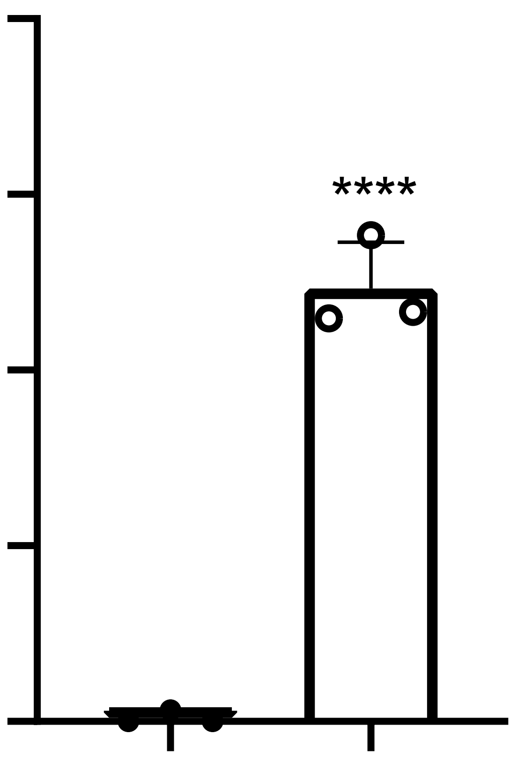
P16
17
SA-β-gal⁺ cell (%)
75
SA-β-gal
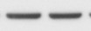
β-actin
48
50
25
0
Late
Early

Figure S1. Morphology and senescence marker expression in early and late passage MSCs. (a) Morphology of early-passage (P2-4), middle-passage (P7-9) and late-passage MSCs (P10-12). (b) Westering blotting showing the increase of senescence markers, p16 and p21 in late MSCs. (c Left) Senescent cells in late MSCs were detected by Senescence-associated β-galactosidase (SA-β-gal) staining (Arrows). (c Right) Quantification of SA-β-gal⁺ percentage. Results are expressed as the mean ± SD of three independent experiments. ****p < 0.0001; unpaired t-test. Scale bar, 500 μm.

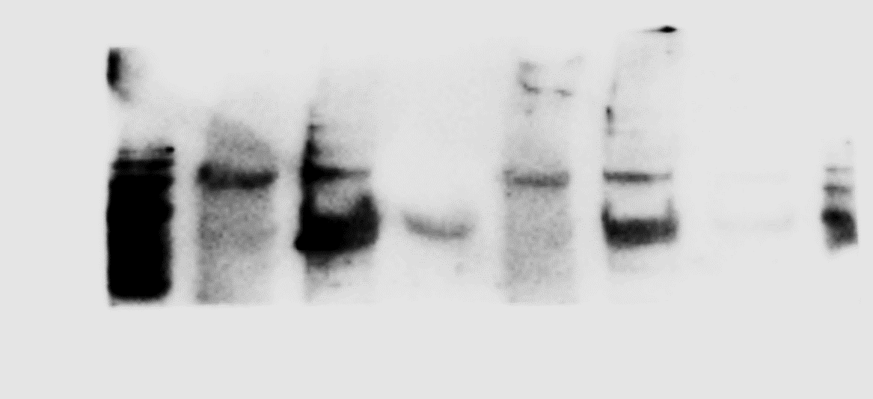
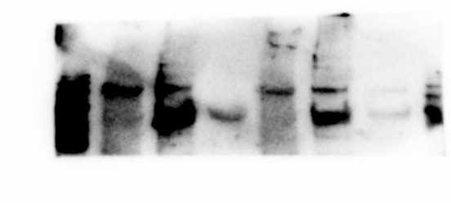


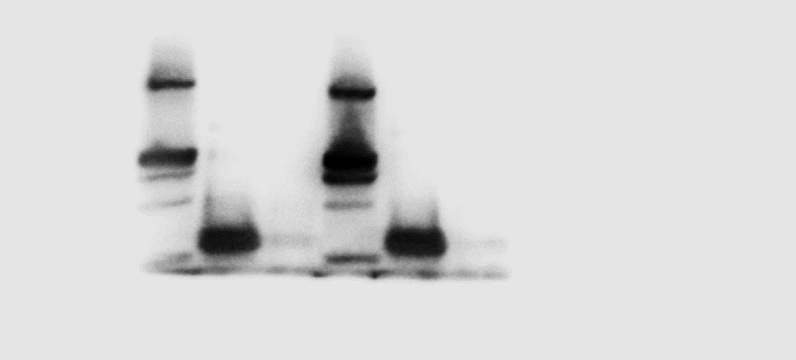
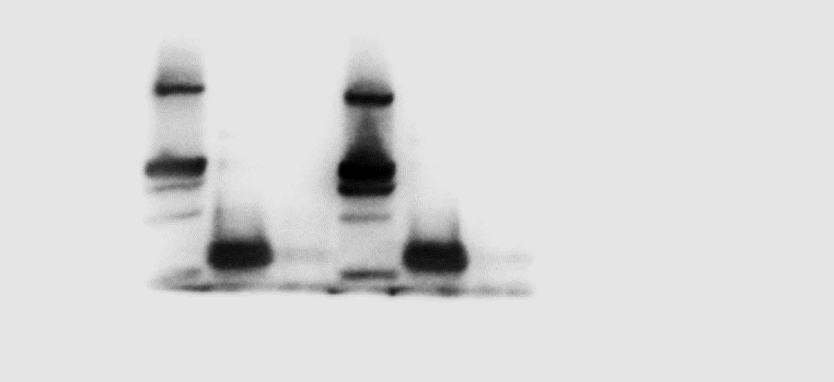
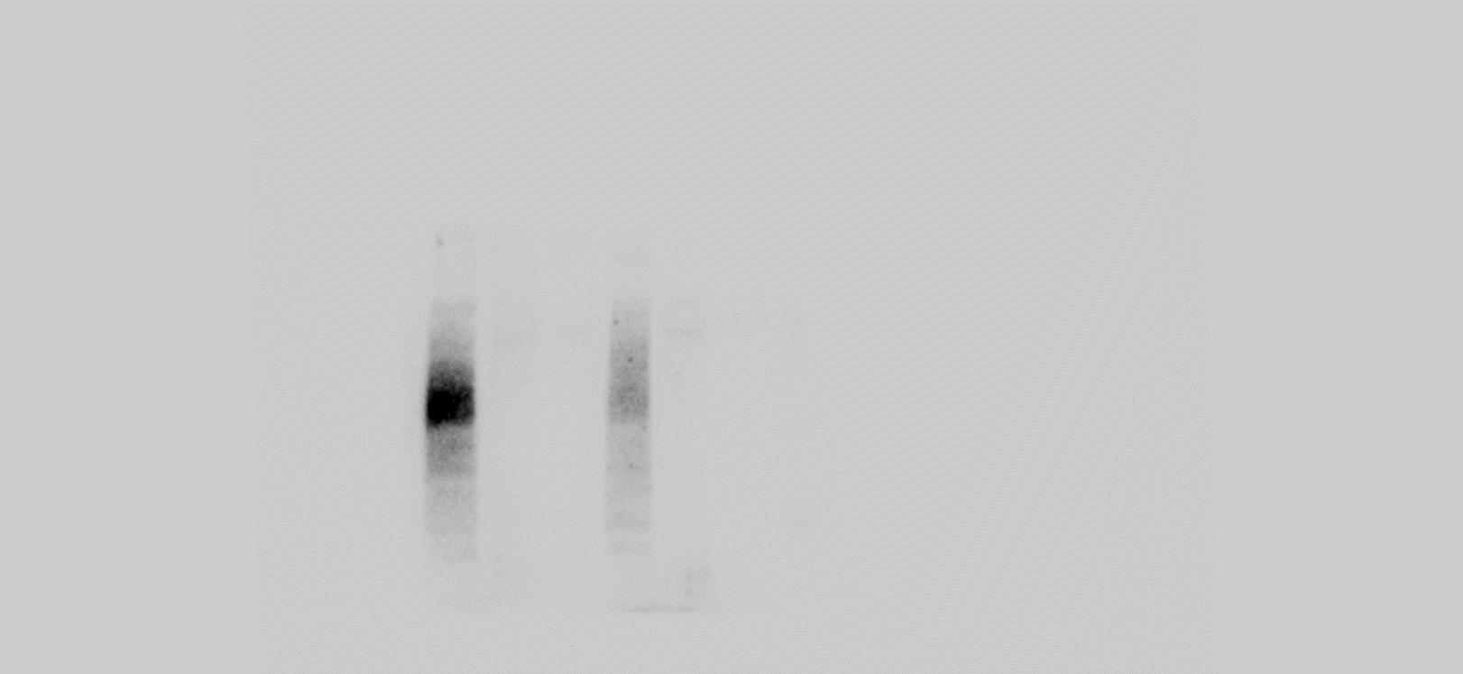
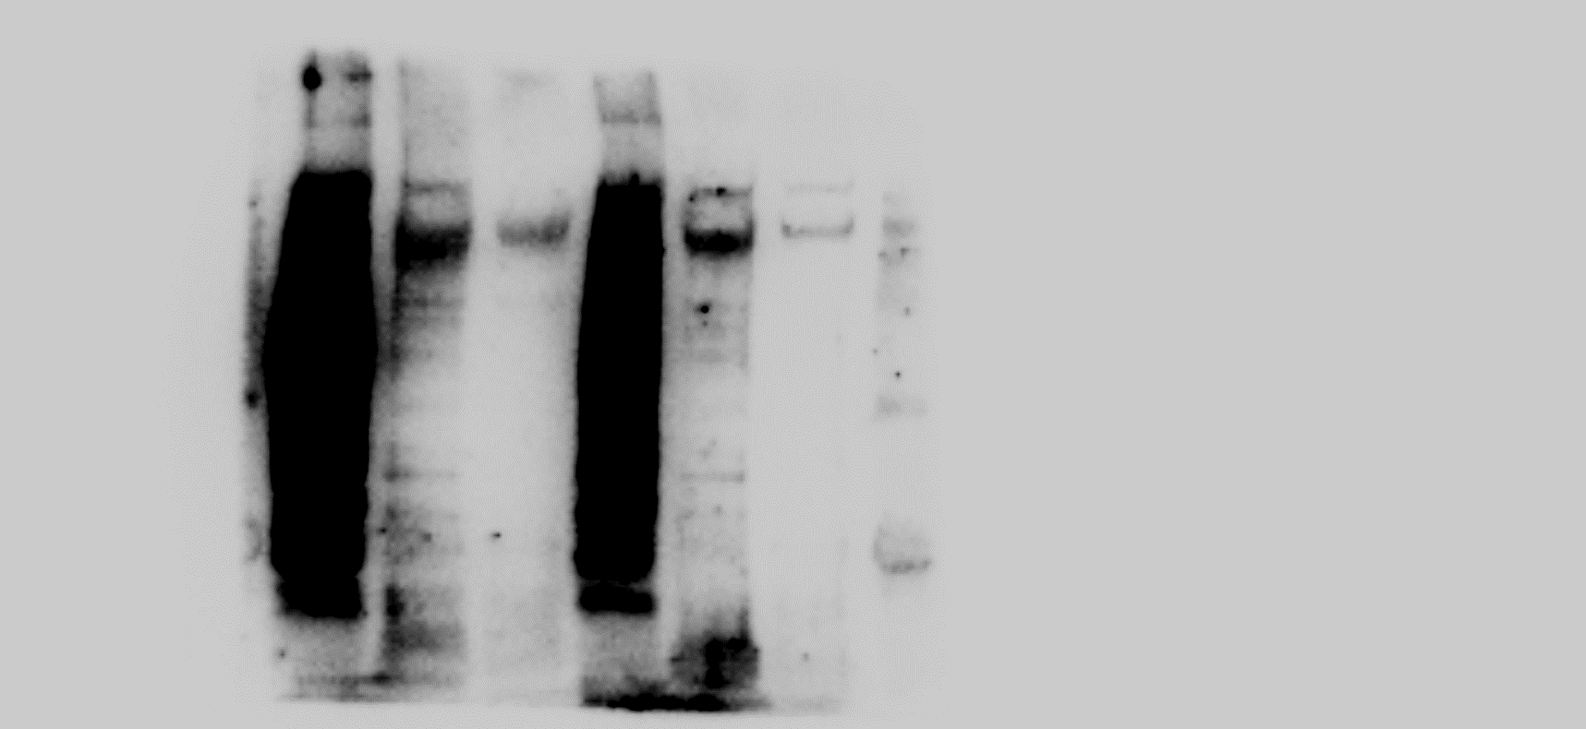
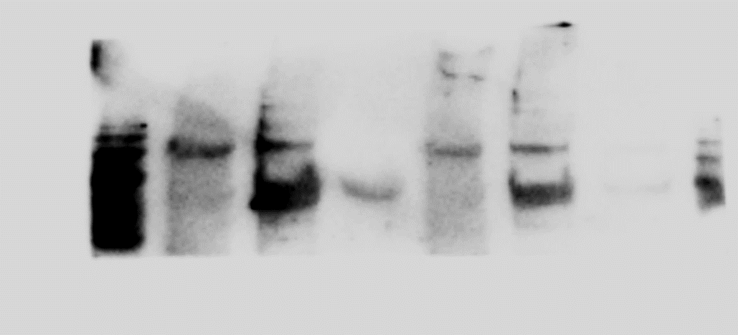
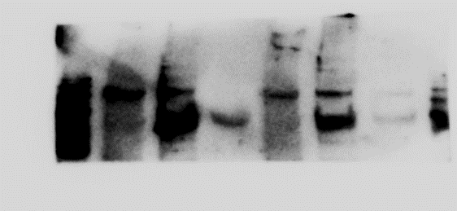
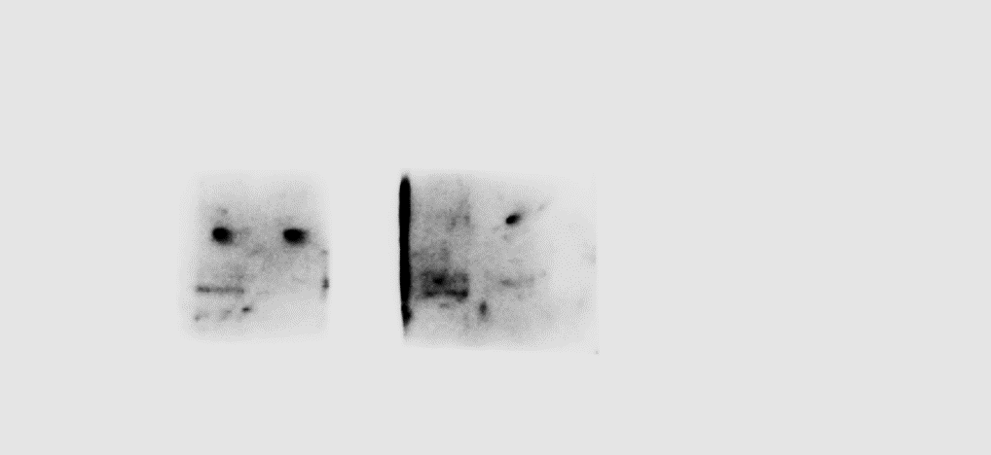
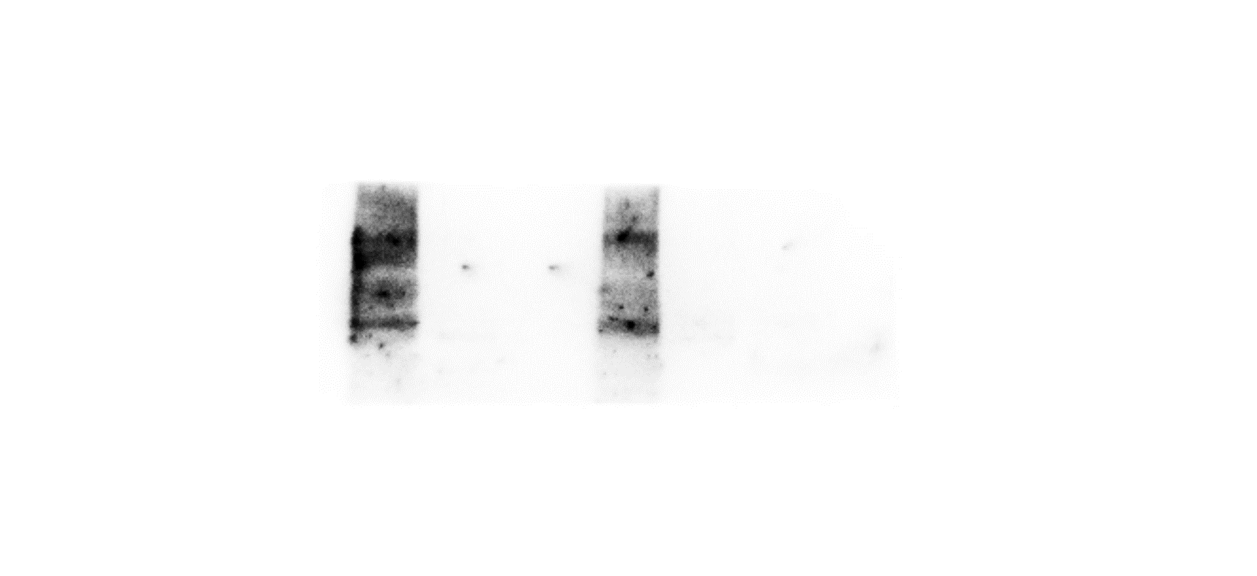
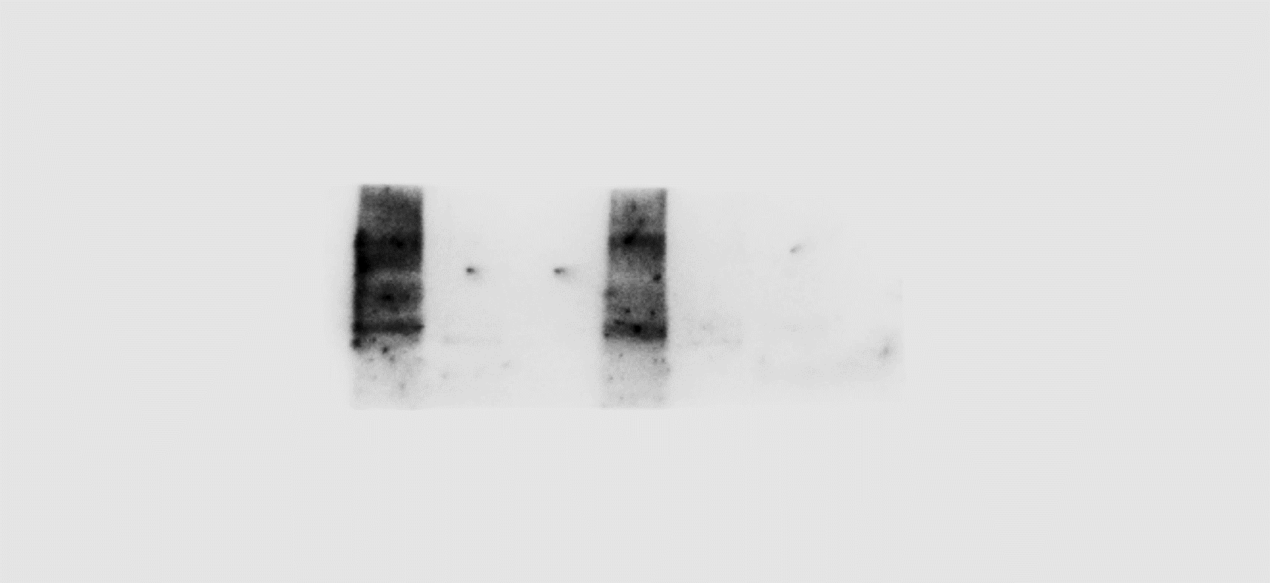
IgG
Input
CTR
TET1
PARP1
PAR
αΤΕΤ1
IgG
Input
PJ34
αΤΕΤ1
245
100
kDa
130
100
180
CTCF
100

Figure S2. Direct interaction of PARP1, TET1 and CTCF in early MSCs. Cell lysates of MSCs treated without (CTR) or with PJ34 (5 μM) for 24 h were subjected to immunoprecipitation with antibodies against TET1 or Isotype IgG, followed by immunoblotting. PJ34 treatment resulted in loss of PAR levels but not inhibited the interaction of PARP1, TET1 and CTCF.

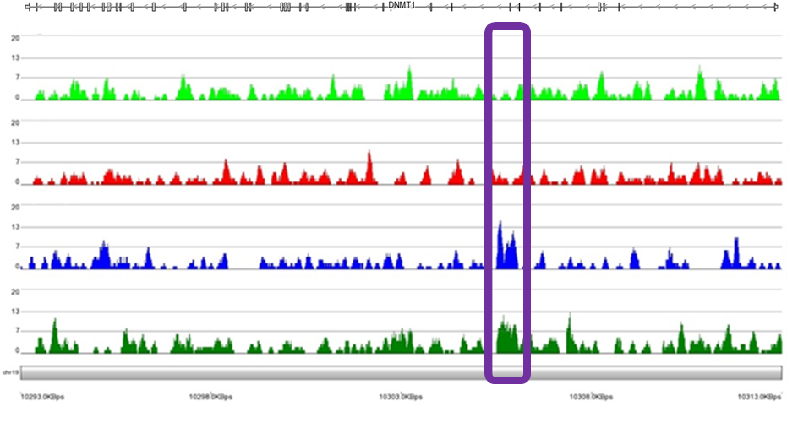
Early MSC
Late MSC
DNMT1
Early MSC
αPARP1
Early MSC
αTET1
ChIP-seq.
Input

Figure S3. PARP1 and TET1 ChIP-seq analysis revealed that the transcription start site (TSS) of DNMT1 was enriched with PARP1 and TET1 in early MSCs.

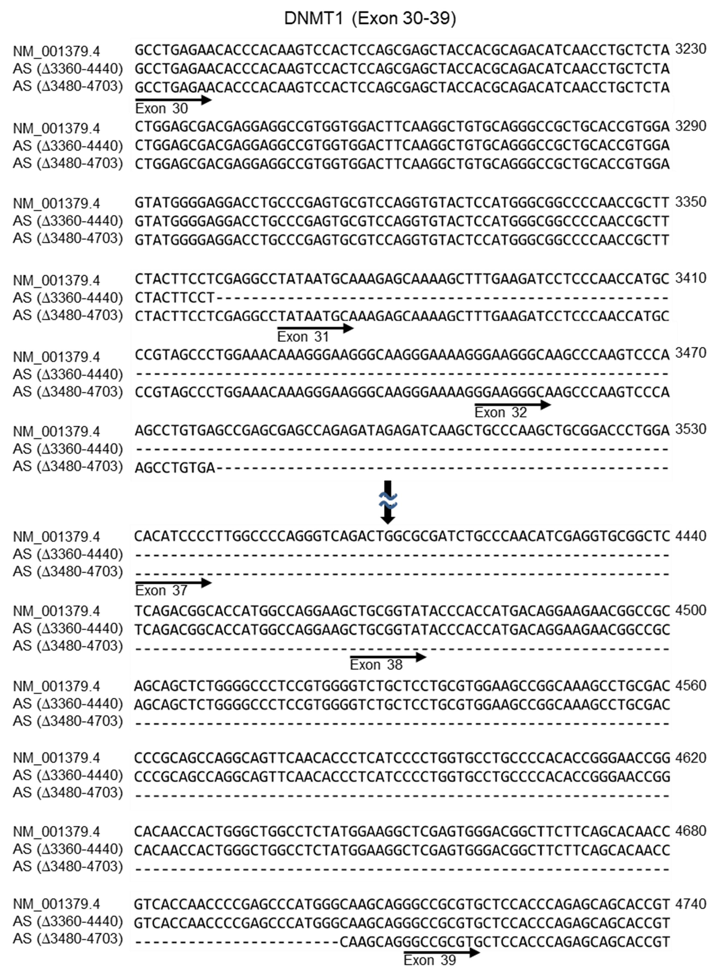
Figure S4. Alignment of full-length and alternative splicing (AS) DNMT1. Two AS forms of DNMT1 with different truncated sites (Δ3360-4440 and Δ3480-4703) were identified. Sequences from Exon 30 to 39 are shown. Part of the sequence is omitted.

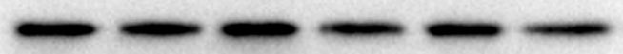
MG132: CTR 5µM 10µM
Late
Early
Early
Late
Late
Early

DNMT1
245
180
140
100
75
45
35
60
25
20
10
15
35

GAPDH

Figure S5. Cell lysates of MSCs treated without (CTR) or with MG132 for 24 h were subjected to western blotting with anti-DNMT1 antibody. MG132 treatment did not enrich the isoform of DNMT1 in late MSCs.

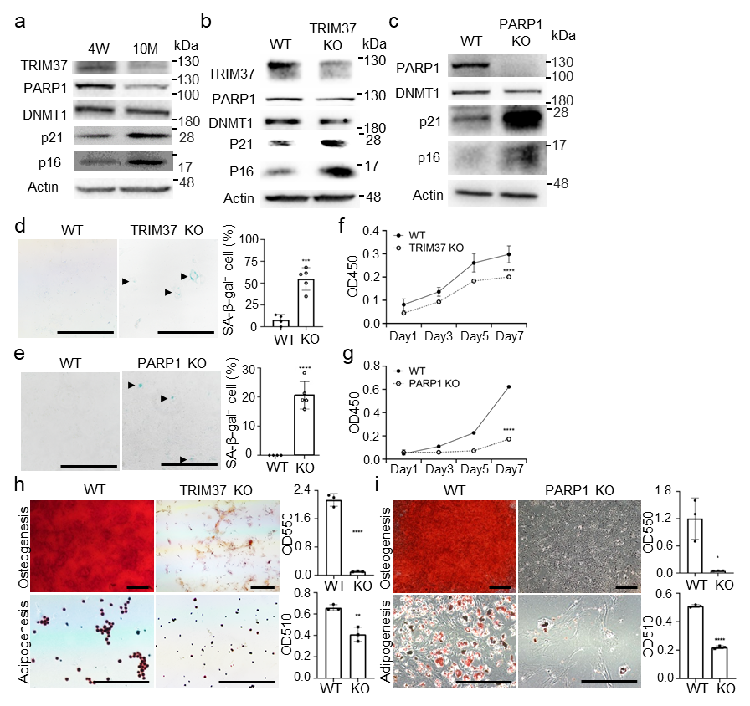
Figure S6. TRIM37 or PARP1 KO suppresses regenerative ability of MSCs in vivo. (a) MSCs isolated from 4 week (4W) and 10 month (10M) old B6 mice were briefly expanded in vitro before being subjected to western blotting analysis. (b-h) MSCs isolated from wild type (WT), TRIM37-deficient (TRIM37 KO) and PARP1-deficient (PARP1 KO) mice at 8 weeks of age were briefly expanded, followed by (b, c) western blotting analysis, (d, e) senescence-associated β-galactosidase (SA-β-gal) staining, (f, g) growth capacity comparisons, and (h, i) differentiation potential comparisons into osteoblasts and adipocytes. Arrows indicate SA-β-gal stained cells. Results are expressed as the mean ± SD of three independent experiments. **p < 0.01; ***p < 0.001; ****p < 0.0001; unpaired t-test and one-way analysis of variance (ANOVA). Scale bar, 500 μm.

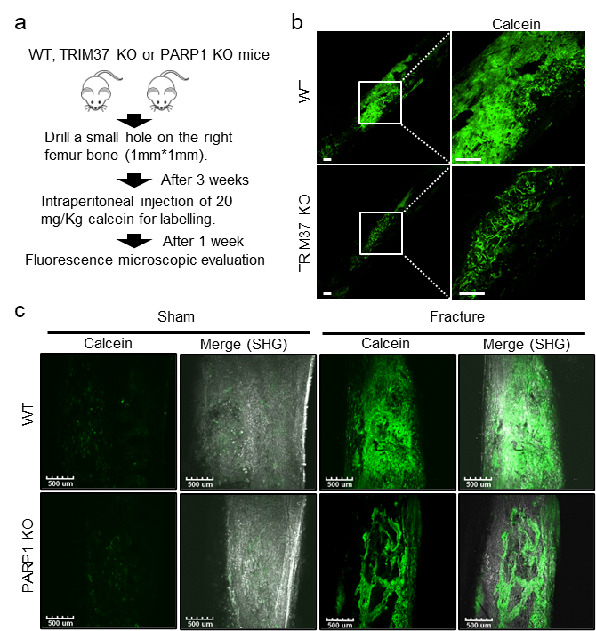
Figure S7. TRIM37 or PARP1 KO disrupts bone regeneration in vivo.
(a-c) The right femoral shafts of wild type (WT), TRIM37-deficient (TRIM37 KO) and PARP1-deficient (PARP1 KO) mice were drilled at 8 weeks of age, followed by calcein injection 3 weeks later and fluorescence microscopy analysis of new bone formation another 1 week later. The representative fluorescent images from more than three independent experiments are taken through (b) single-photon microscope and (c) two-photon microscope. Rectangular areas are magnified in the right. SHG: Second Harmonic Generation. Scale bar, 500 μm.

Table S1. List of intersection genes or regions
Gene Symbol | Description | PARP1_CHIP overlap percent | TET1_CHIP overlap percent | Protein length (a.a.) | Transcript ID
BAGE2 | BAGE family member 2; B melanoma antigen 2 precursor | 100 | 100 | 109 | NM_182482
BAGE3 | BAGE family member 3; B melanoma antigen 3 precursor | 100 | 100 | 109 | NM_182481
BAGE4 | BAGE family member 4; B melanoma antigen 4 precursor | 100 | 100 | 39 | NM_181704
BAGE5 | BAGE family member 5; B melanoma antigen 5 precursor | 100 | 100 | 43 | NM_182484
DNMT1 | DNA Methyltransferase 1 | 100 | 96.9828 | 1632 | NM_001130823.3
FAM153B | Family with sequence similarity 153 member B | 100 | 100 | 310 | NM_001265615
GUSBP1 | GUSB pseudogene 1 | 86.5275 | 100 | - | NR_027026 and NR_027028
LOC100506990 | Uncharacterized gene | 67.6674 | 100 | - | NR_040091 and NR_040092
LOC729732 | Uncharacterized gene | 59.6639 | 100 | - | NR_047662
LPA | Lipoprotein(A) | 63.2388 | 100 | 2040 | NM_005577
NBPF20 | NBPF member 20 | 100 | 100 | 5207 | NM_001278267
NBPF9 | NBPF member 9 | 100 | 100 | 1111 | NM_001277444.1
NBPF25P | NBPF member 25, pseudogene | 100 | 100 | - | NR_104217.2
NOTCH2NL | Notch 2 N-terminal like A | 73.7143 | 100 | 236 | NM_203458
PARP1 | Poly(ADP-ribose) polymerase 1 | 100 | 100 | 1014 | NM_001618
PDE4DIP | Phosphodiesterase 4D Interacting Protein | 45.7143 | 100 | 141~2346 | NM_001198832, NM_001198834, NM_014644, NM_001002812, NM_001002810, NM_001195260, NM_001195261, and NM_022359
PGK1 | Phosphoglycerate kinase 1 | 80.3609 | 100 | 417 | NM_000291
PLXNA4 | Plexin A4 | 88.1671 | 100 | 1894 | NM_020911
POLR2J3 | RNA polymerase II subunit J3 | 59.1696 | 100 | 115 | NM_001097615
USP17L17 | ubiquitin specific peptidase 17 like family member 17 | 90 | 100 | 530 | NM_001256857

Table S2. Alternative splicing counts of 5 types by rMATS
Type* | Difference# > 0.2 | Difference < -0.2
A. Late vs Early
SE | 533 | 541
A5SS | 233 | 210
A3SS | 212 | 205
MXE | 216 | 215
RI | 22 | 32
Total | 1,216 | 1,203
B. Early with PARP1-KD vs Early
SE | 180 | 217
A5SS | 76 | 62
A3SS | 297 | 269
MXE | 355 | 324
RI | 123 | 120
Total | 1,031 | 992
C. Early with TET1-KD vs Early
SE | 640 | 783
A5SS | 281 | 295
A3SS | 260 | 299
MXE | 366 | 358
RI | 122 | 117
Total | 1,669 | 1,852
The reference groups in A, B, C are late, Early with PARP1-KD and Early with TET1-KD, respectively.
* SE: skipped exon, A5SS: alternative 5’ splice site, A3SS: alternative 3’ splice site, MXE: mutually exclusive exons and RI: retained intron events.
# Difference in cutoff p-value < 0.05 and |ΔPSI| > 0.2:

Table S3. Prediction of CTCF binding sites in 20-triple overlapping enrichment genes by CTCFBSDB 2.0
Gene Symbol | Number of predicted CTCF binding motif (Promoter/Intragenic region) | RefSeq ID
BAGE2 | 0/2 | NM_182482
BAGE3 | 0/3 | NM_182481
BAGE4 | 0/4 | NM_181704
BAGE5 | 0/3 | NM_182484
DNMT1 | 1/11 | NG_028016.3; NM_001379.4
FAM153B | 0/3 | NC_000005.10 (Range 176063055..176127142); NM_001265615
GUSBP1 | - | N/A
LOC100506990 | - | N/A
LOC729732 | - | N/A
LPA | 1/19 | NG_016147.1; NM_005577
NBPF20 | 0/7 | NG_034048.1; NM_001278267
NBPF9 | 0/6 | NC_000001.11 (Range 149052186..149103551); NM_001277444.1
NBPF25P | - | N/A
NOTCH2NL | 0/3 | NC_000001.11 (Range 226360691..226408093); NM_203458
PARP1 | 0/5 | NC_000001.11 (Range 146151908..146229032); NM_001618
PDE4DIP | 2/2 | NG_027693.2; NM_014644
PGK1 | 1/5 | NG_008862.1; NM_000291
PLXNA4 | 0/3 | NC_000007.14 (Range 132123340..132648688); NM_020911
POLR2J3 | 0/4 | NC_000007.14 (Range 102537919..102572621); NM_001097615
USP17L17 | 0/2 | NC_000004.12 (Range 9243879..9245471); NM_001256857
Table S4. Prediction of CTCF binding sites of DNMT1 by CTCFBSDB 2.0
Binding region of NG_028016.3* | Exon number | Motif sequence | Score | Position weight matrices
81516~81535 | 21 | AGGCCAGAAGGAGGAACCGT | 7.72797 | MIT_LM7
87378~87396 | 27 | CAGCCAACAGAGGACAACA | 7.34699 | MIT_LM2
94118~94131 | 30 | CCTGCTCTACTGGA | -1.95647 | EMBL_M1
94129~94148 | 30 | GGAGCGACGAGGAGGCCGTG | -10.5112 | REN_20
94205~94224 | 30 | AGTACACCTGGACGCACTCG | -6.35624 | MIT_LM23
99027~99040 | 37 | TGCCCGCATGCGGC | -0.0187699 | EMBL_M1
99081~99100 | 37 | CAACATCGAGGTGCGGCTCT | -2.01415 | MIT_LM7
99160~99168 | 37 | AGAGCTGCT | 5.94758 | EMBL_M2
100452~100471 | 39 | TCACCACACGGTGCTGCTCT | 9.55539 | MIT_LM23
100503~100522 | 39 | AGAGCCGGTAGGTGTCAGGG | 4.72662 | REN_20
102800~102808 | 41 | AGTACTGCA | 12.8119 | EMBL_M2
* DNMT1 RefSeqGene

Gene Name | Protein Names | Number of Phospho (STY)* | PEP | Score | Modified Sequence | m/z
Early MSCs
NCKAP1L | Nck-associated protein 1-like | 1 | 7.09E-02 | 94 | _PS(ph)EIIAGVK_ | 497.2545
SUPT20H | Transcription factor SPT20 homolog | 3 | 7.65E-02 | 37 | _HT(ph)GS(ph)QSKS(ph)KM(ox)K_ | 492.1781
TRIM37 | E3 ubiquitin-protein ligase TRIM37 | 1 | 7.56E-02 | 83 | _LIT(ph)LMGQK_ | 492.2534
LIX1L | LIX1-like protein | 1 | 7.03E-02 | 41 | _(ac)MET(ph)M(ox)RAQR_ | 580.7330
DNAH9 | Dynein heavy chain 9, axonemal | 1 | 6.38E-02 | 79 | _KVAIT(ph)VK_ | 419.7435
MAST4 | Microtubule-associated serine/threonine-protein kinase 4 | 1 | 4.01E-02 | 103 | _EGQGIKT(ph)DIPR_ | 647.3136
Late MSCs
GALR | Galanin receptor type 1 | 1 | 1.48E-02 | 83 | _RS(ph)SSIRVSR_ | 564.2877
- | Conserved hypothetical protein | 2 | 6.49E-02 | 55 | _ADMIMVS(ph)M(ox)EAM(ox)TNTS(ph)R_ | 990.3546
UBE2V1 | Ubiquitin-conjugating enzyme E2 variant 1 | 1 | 1.48E-02 | 103 | _YPEAPPFVRFVT(ph)K_ | 815.9051
XRRA1 | X-ray radiation resistance-associated protein 1 | 1 | 3.86E-02 | 73 | _KDVDRT(ph)TTK_ | 572.2739
Table S5. List of phosphopeptides associated with endogenous PARP1 in early and late MSCs, as revealed by IP-MS/MS analysis
* STY: serine/threonine/tyrosine

Table S6. List of ubiquitination sites of PARP1 in early MSCs, as revealed by IP-MS/MS analysis
Sequence Window | Position | PEP | Score | GlyGly (K) Probabilities | m/z | Intensity
ICISTKKEVEKMN | K433,  K434,  K438 | 2.02E-03 | 23 | K(1)EVEK(1)MNK(1) | 1348.6525 | 74434
TKKEVEKMNKKME | K433,  K434,  K438 | 2.02E-03 | 23 | K(1)EVEK(1)MNK(1) | 1348.6525 | 74434
TQTPNRKEWVTPK | K331,  K337 | 3.24E-01 | 27 | K(1)EWVTPK(1) | 558.29583 | 70015
KEWVTPKEFREIS | K331,  K337 | 3.24E-01 | 27 | K(1)EWVTPK(1) | 558.29583 | 70015

Table S7. Donor information
Donor No. | Age (years)/ gender | Source of stem cells
1 | 27/Female | Bone marrow
2 | 28/Male | Bone marrow
3 | 41/Male | Bone marrow

Table S8. Primers of Site-Directed Mutagenesis
Name | Primer sequence |  | NCBI reference sequence
T203A (TRIM37) | F: GCTGAAGAATAAGCTTATAGCACTGATGGGTCAGAAGAC  R: GTCTTCTGACCCATCAGTGCTATAAGCTTATTCTTCAGC |  | NM_001005207
T203D (TRIM37) | F: GCTGAAGAATAAGCTTATAGACCTGATGGGTCAGAAGACATC  R: GATGTCTTCTGACCCATCAGGTCTATAAGCTTATTCTTCAGC |  | NM_001005207
T203E (TRIM37) | F: GCTGAAGAATAAGCTTATAGAGCTGATGGGTCAGAAGACATC  R: GATGTCTTCTGACCCATCAGCTCTATAAGCTTATTCTTCAGC |  | NM_001005207
K337R (PARP1) | F: GAGTGGGTAACCCCAAGGGAATTCCGAGAAATC  R: GATTTCTCGGAATTCCCTTGGGGTTACCCACTC |  | NM_001618.4
K438R (PARP1) | F: CACCAAAAAGGAGGTGGAAAGGATGAATAAGAAGATGGAG  R: CTCCATCTTCTTATTCATCCTTTCCACCTCCTTTTTGGTG |  | NM_001618.4

Table S9. Primer sets for 5’-Race-PCR and real-time PCR
Name | Primer sequence | Size (bp) | NCBI reference sequence
5’-Race-PCR
Exon 13-25 | F: CTAATACGACTCACTTGCCAAA-CGGAGGCCCGAAGA  R: GATTACGCCAAGCTTCCCCCAC-TTCCAGGGTTTCCGC | 1400 | NM_001130823.3
Exon 25-38 | F: CTAATACGACTCACTGCGGAAA-CCCTGGAAGTGGGGG  R: GATTACGCCAAGCTTAGGCCAG-CCCAGTGGTTGTGC | 2258 | NM_001130823.3
Real-time PCR
Exon 13 | F: TGCCAAACGGAGGCCCGAAGA  R: GACTGTTTTGGCGCGAGCCAT | 148 | NM_001130823.3
Exon 30 | F: ACCTGCTCTACTGGAGCGAC  R: AGTACACCTGGACGCACTCG | 108 | NM_001130823.3
Exon 34 | F: CTACCGGCCCCGGTTCTT  R: TGATAGCCCATGCGGACCA | 108 | NM_001130823.3
Exon 37 | F: CATCGAGGTGCGGCTCTCA  R: GTTCTTCCTGTCATGGTGGGTA | 70 | NM_001130823.3
H19 | F: CCCATCTTGCTGACCTCAC  R: AGACCTGGGACGTTTCTGTG | 165 | NR_002196.2

