Additional file 1. Inclusion criteria for clinical diagnosis of neonatal sepsis
System position | There are clinical abnormalities symptoms | Check the number of project indicators | Specific contents of abnormal inspection index
The whole body | Fever, hypothermia, poor response, poor feeding, edema, low APgar score | 1 | at least two of the five items (white blood cell count and classification; C-reactive protein; platelet count; procalcitonin; and erythrocyte sedimentation rate) in non-specific blood tests that showed elevated levels
digestive system | Jaundice, abdominal distension, vomiting or gastric retention, diarrhea, and hepatomegaly | 1
The respiratory system | Dyspnea, apnea, cyanosis, etc. The primary manifestation of premature sepsis is apnea or respiratory distress and lasts for more than 6h | 2 | blood samples tested positive for bacterial pathogens DNA
The circulatory system | Pale complexion, cold extremities, tachycardia or bradycardia, marbled skin, hypotension or capillary filling time >3s | 2 | blood samples tested positive for bacterial pathogens DNA
Urinary system | Oliguria and renal failure | 3 | Cerebrospinal fluid examination that revealed purulent meningitis
The blood system | Bleeding, purpura | 3

Note: Abnormal clinical symptoms and any anomaly of the three test indicators can be diagno

Additional file 2. Partial case data of 20 patients with NS
Major disease | Treatment drugs |  |  | Treatment efficacy
Major disease | Latamoxef | Ceftazidime | Ceftriaxone | Penicillin | Effective | Ineffective
Neonatal infectious pneumonia | 5 | 4 | 2 | 1 | 11 | 0
Neonatal hyperbilirubinemia | 3 | 4 | 0 | 2 | 6 | 0
Neonatal meconium aspiration syndrome | 0 | 3 | 0 | 0 | 3 | 0

Note: Patients had double or multiple infections and were treated with various drug combinations. Therefore, a given drug in the table may be counted multiple times.

Additional file 3. Primers for amplifying the V4 region of the 16S rRNA gene and fungal ITS1 region
Target region | Primer | Nucleotide sequence (5′– 3′)
V4 | Forward | GTGCCAGCMGCCGCGGTAA
V4 | Reverse | GGACTACHVGGGTWTCTAAT
ITS1 | Forward | CTTGGTCATTTAGAGGAAGTAA
ITS1 | Reverse | GCTGCGTTCTTCATCGATGC

Additional file 4. Specific primer sequences for four bacterial species
Species | Primer | Primer sequence (5′– 3′)
Geobacillus vulcani | Geobacillus vulcani-F1 | AAGCTCTGTTGTGAGGGACG
Geobacillus vulcani | Geobacillus vulcani-R1 | TTTCCAATGACCCTCCACGG
Geobacillus vulcani | Geobacillus vulcani-F2 | AGGGAATCTTCCGCAATGGG
Geobacillus vulcani | Geobacillus vulcani-R2 | CGCGCTTTACGCCCAATAAT
Anoxybacillus kestanbolensis | Anoxybacillus -F1 | GTGAGGTAACGGCTCACCAA
Anoxybacillus kestanbolensis | Anoxybacillus -R1 | TTTCCAATGACCCTCCACGG
Anoxybacillus kestanbolensis | Anoxybacillus -F2 | ACGAAAGGTCGCATGGTCTT
Anoxybacillus kestanbolensis | Anoxybacillus -R2 | TGCCACCTACGTATTACCGC
Klebsiella oxytoca | Klebsiella oxytoca -F1 | TCTGAGAGGATGACCAGCCA
Klebsiella oxytoca | Klebsiella oxytoca-R1 | CAGCCTGCCAGTTTCGAATG
Klebsiella oxytoca | Klebsiella oxytoca-F2 | GCCACACTGGAACTGAGACA
Klebsiella oxytoca | Klebsiella oxytoca-R2 | CGGGGATTTCACATCCGACT
Acinetobacter guillouiae | Acinetobacter guillouiae -F1 | GACGATCTGTAGCGGGTCTG
Acinetobacter guillouiae | Acinetobacter guillouiae-R1 | TCGGGGATTTCACATCCGAC
Acinetobacter guillouiae | Acinetobacter guillouiae-F2 | AGGCGGCTTTTTAAGTCGGA
Acinetobacter guillouiae | Acinetobacter guillouiae-R2 | TCTGGTGCAACAAACTCCCA

Additional file 5. Histogram of phylum-level bacterial composition in samples

Additional file 6. Histogram of class-level bacterial composition in samples

Additional file 7. Histogram of order-level bacterial composition in samples

Additional file 8. Histogram of family-level bacterial composition in samples

Additional file 9. Alpha-diversity rarefaction curves of 20 samples

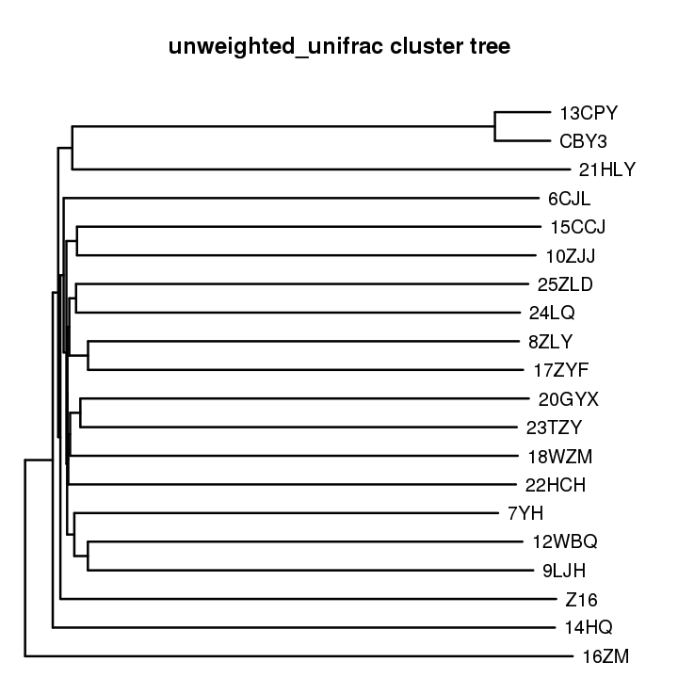
Additional file 10. UPGMA clustering of samples based on weighted UniFrac distances (grouped by description, weighted_unifrac)
Note: Samples with the same color in the diagram belong to the sample group; two samples showing greater similarity in bacterial composition were considered similar to each other and showed shorter branch lengths between the samples

Additional file 11. Electrophoretogram of PCR products specific to four bacterial species
Note: The PCR products confirmed the presence of Anoxybacillus kestanbolensis 1 (388 bp), Anoxybacillus kestanbolensis 2 (372 bp), Geobacillus vulcani 1 (213 bp), Geobacillus vulcani 2 (222 bp), Klebsiella oxytoca 1 (360 bp), Klebsiella oxytoca 2 (306 bp), Acinetobacter guillouiae 1 (340 bp), and Acinetobacter guillouiae 2 (840 bp)

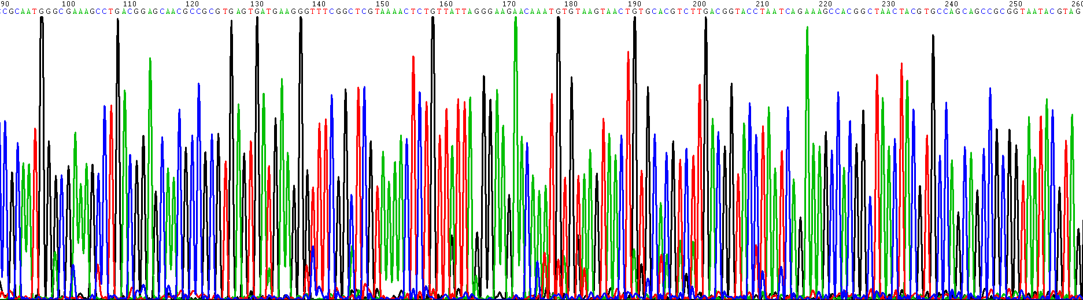
Additional file 12. Part of the Sanger sequencing chromatogram of PCR products of Anoxybacillus kestanbolensis amplified using its first pair of specific primers
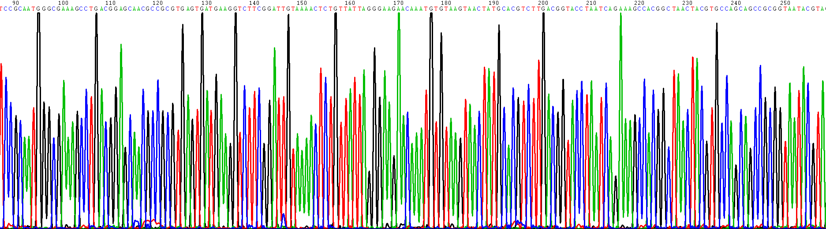
Additional file 13. Part of the Sanger sequencing chromatogram of polymerase chain reaction products of Anoxybacillus kestanbolensis amplified using second pair of specific primers

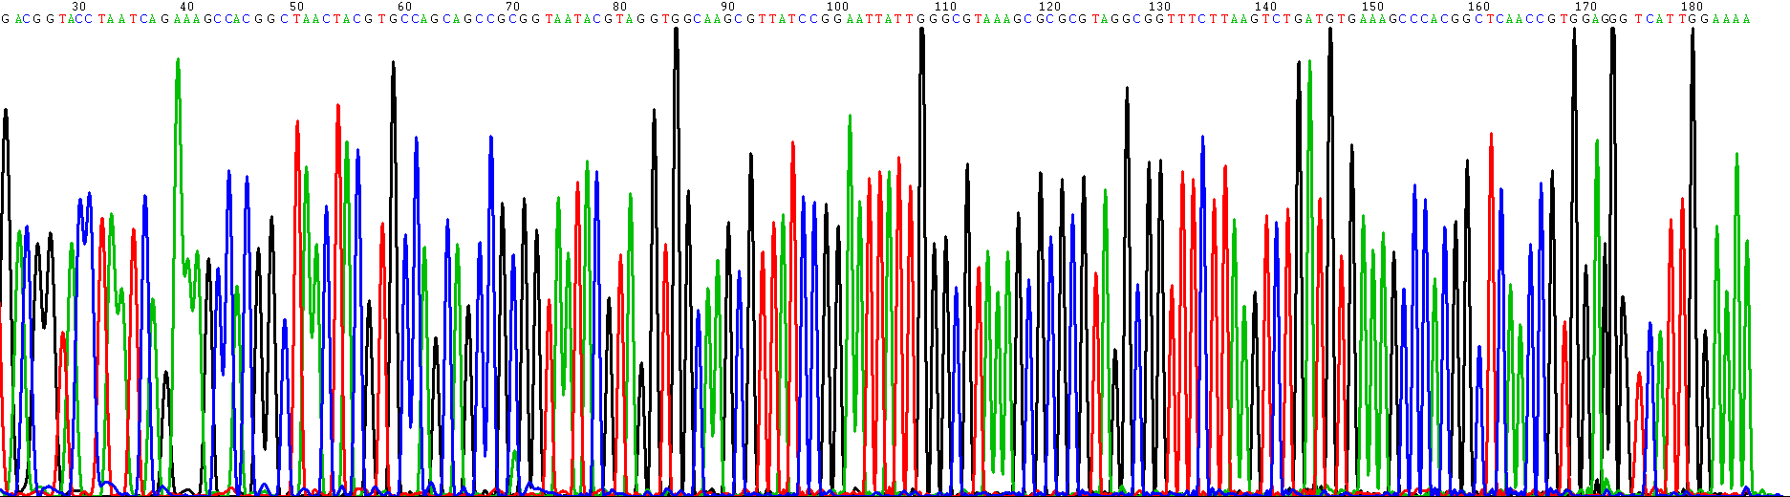
Additional file 14. Part of the Sanger sequencing chromatogram of PCR products of Geobacillus vulcani amplified using first pair of specific primers

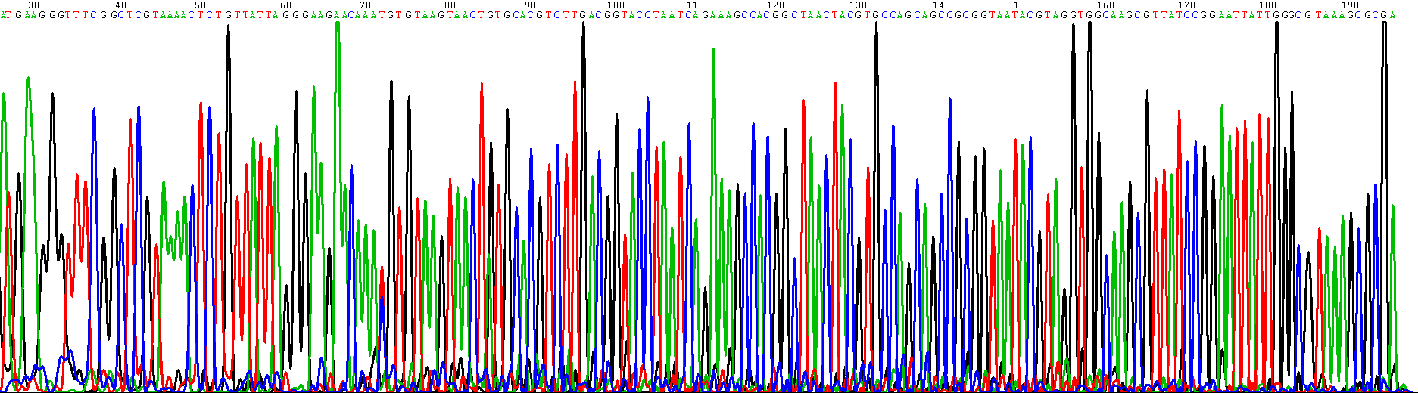
Additional file 15. Part of the Sanger sequencing chromatogram of polymerase chain reaction products of Geobacillus vulcani amplified using its second pair of specific primers

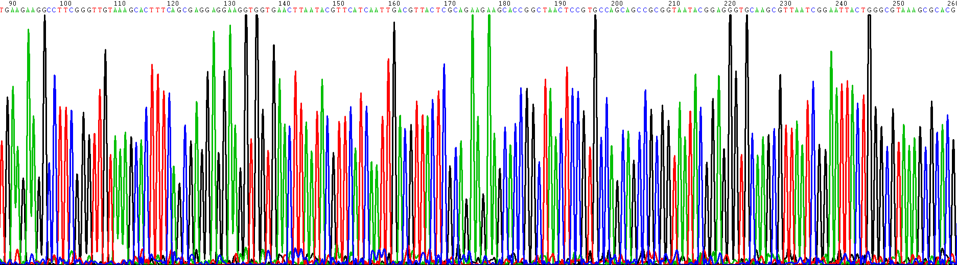
Additional file 16. Part of the Sanger sequencing chromatogram of polymerase chain reaction products of Klebsiella oxytoca amplified using first pair of specific primers

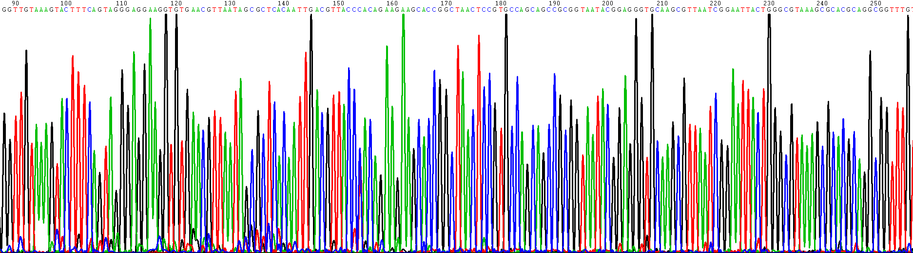
Additional file 17. Part of the Sanger sequencing chromatogram of polymerase chain reaction products of Klebsiella oxytoca amplified using second pair of specific primers

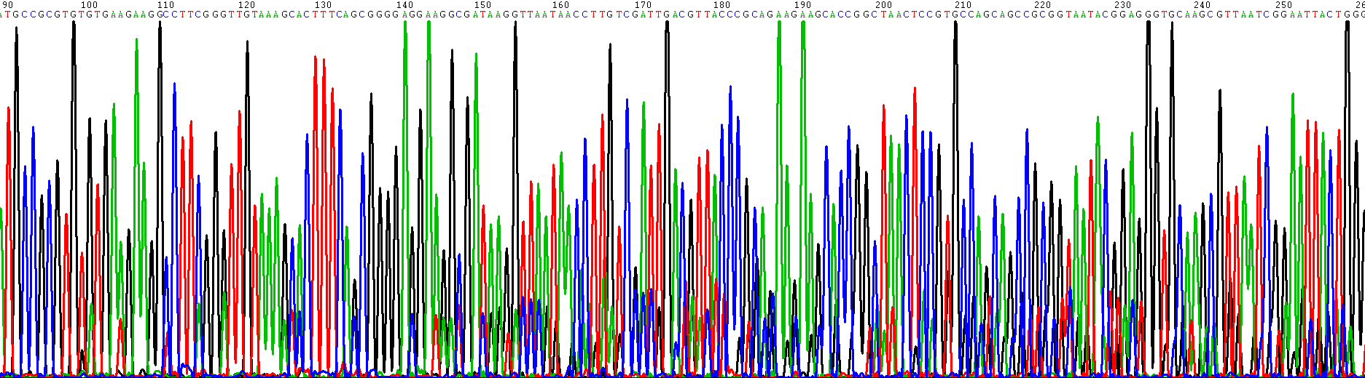
Additional file 18. Part of the Sanger sequencing chromatogram of polymerase chain reaction products of Acinetobacter guillouiae amplified using first pair of specific primers

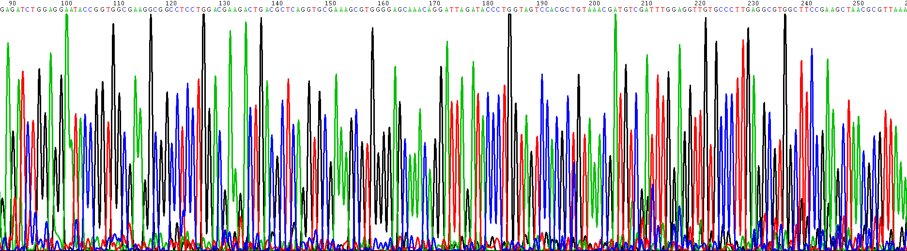

Additional file 19. Part of the Sanger sequencing chromatogram of polymerase chain reaction products of Acinetobacter guillouiae amplified using second pair of specific primers

