Direct bandgap emission from strain-doped germanium

Lin-Ding Yuan^{1†}, Shu-Shen Li^{1,2}, and Jun-Wei Luo^{1,2}*
¹State Key Laboratory for Superlattices and Microstructures, Institute of Semiconductors, Chinese Academy of Sciences, PO Box 912, Beijing 100083, China
²College of Materials Science and Opto-Electronic Technology, University of Chinese Academy of Sciences, Beijing, China
†Present address: Department of Materials Science and Engineering, Northwestern University, Evanston, Illinois 60208, USA
* jwluo@semi.ac.cn

- Implanted atom prefers to stay at the tetrahedral interstitial sites (T_{d} sites) in Si or Ge
In the main text, we have assumed without proof in our previous results that the implanted atoms stay at the tetrahedral interstitial sites (Td sites). We now provide some justification for this assumption. Table SI gives the calculated formation energy of different defects for which implanted atoms would form. We find that the formation energy of Li at the Td site in Ge is 0.21 eV which is the smallest among others. This means Li favors staying at the Td site, which justifies our assumption. A similar conclusion could be reached for Ge:He, Ge:Ne, and Ge:Ar systems. But we do notice the interstitial C site that has similar or sometimes even lower energy competing with the Td site. For Ge:Ar, the system also likes to form Frenkel (F) defects. The form of these defects could be detrimental to achieving direct bandgap Ge.

- Mixing of Γ and L valley in strain doped Ge

Figure S1 shows the calculated Bloch characteristic of Ge:Li with 3.1 at.% of Li in Ge. One can observe that the CBM is an admixture of Γ (58.3%) and L (41.2%) even though the VBM is still dominated by bulk Γ (99.8%). This strong valley-mixing in the CBM renders the Ge:Li system to have a strong optical emission before the indirect-to-direct transition. The mixing of Γ and L for the CBM state can be understood from a perturbative view. Let $H_{0}$ be the Hamiltonian of the pure Ge, $H_{1}$ be the perturbative term introduced by inserted foreign atoms. This perturbative term $H_{1}$ violates the primitive translation symmetry of the pure Ge, which couples the original conduction band edge states $|\left.Γ_{c}\right\rangle$ and $|\left.L_{c}\right\rangle$ of the pure Ge. The CBM state of the Ge:Li system can then be approximated as a superposition state of $|\left.Γ_{c}\right\rangle$ and $|\left.L_{c}\right\rangle$ of the pure Ge:
$$|\left.CBM\right\rangle =\left.|L_{c}\right\rangle +\frac{\left\langle Γ_{c}|\right.H_{1}|\left.L_{c}\right\rangle }{E\left(L_{c}\right)-E\left(Γ_{c}\right)}|\left.Γ_{c}\right\rangle$$
Because the energy separation between the $|\left.Γ_{c}\right\rangle$ and $|\left.L_{c}\right\rangle$ is small, the mixing is rather significant. This contrast to the situation for VBM where the $|\left.Γ_{v}\right\rangle$ and $|\left.L_{v}\right\rangle$ are far apart:
$$|\left.VBM\right\rangle =\left.|Γ_{v}\right\rangle +\frac{\left\langle L_{v}|\right.H_{1}|\left.Γ_{v}\right\rangle }{E\left(Γ_{v}\right)-E\left(L_{v}\right)}|\left.L_{v}\right\rangle ≈\left.|Γ_{v}\right\rangle$$
Consequently, the optical matrix element between CBM and VBM becomes finite, given that $\left\langle Γ_{v} | \hat{p} | Γ_{c}\right\rangle = Γ_{8}^{+}⨂Γ_{4}^{-}⨂Γ_{7}^{-}\sim Γ_{1}$.

- The effect of SixGe1-x substrate on the direct and indirect bandgap of the Ge:X systems.
Practically, the Ge:X material has to be fabricated onto a Si_{x}Ge_{1-x} substrate. However, this might change its direct bandgap back to indirect. Indeed, the main effect of the substrate is imposing a biaxial compress strain on the expanded crystal of Ge:X that enforces the in-plane lattice of Ge:Li to be fixed to match the substrate lattice. Such biaxial compress strain works opposite to the tensile strain, therefore imposing harsh constrain on obtaining direct bandgap for Ge systems. Figure S1 shows the direct and indirect bandgap in the Ge:Li system on the Si_{x}Ge_{1-x} substrate as a function of x. We note in Fig. S2 that a 3.1 at.% Li in Ge will no longer be a direct bandgap when placed on the Ge substrate. Compared with the freestanding Ge:Li, Ge:Li on Si_{x}Ge_{1-x} (x=0) substrate requires a larger implantation concentration of Li atoms to achieve a direct bandgap but at a smaller value. This adverse effect on the substrate becomes more severe when x becomes larger. When x becomes equal or larger than 0.4, our calculated results show the Ge:Li will never be turned into a direct bandgap semiconductor. Experimentalists who wish to fabricate direct bandgap Ge on SiGe shall avoid direct growth of Ge:X on Si but rather on a SiGe buffer layer that slowly varies from x=0 to x=1.

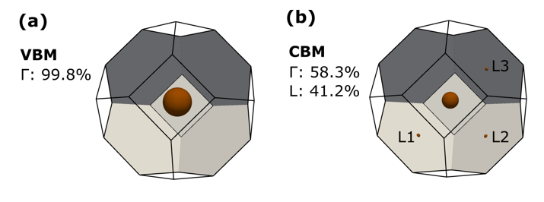
Figure S1 | Bloch characteristic of Ge:Li with 3.1 at.% of Li. The block character of (a) the CBM and (b) the VBM of the Ge:Li system decomposed onto the pure Ge primitive cell.

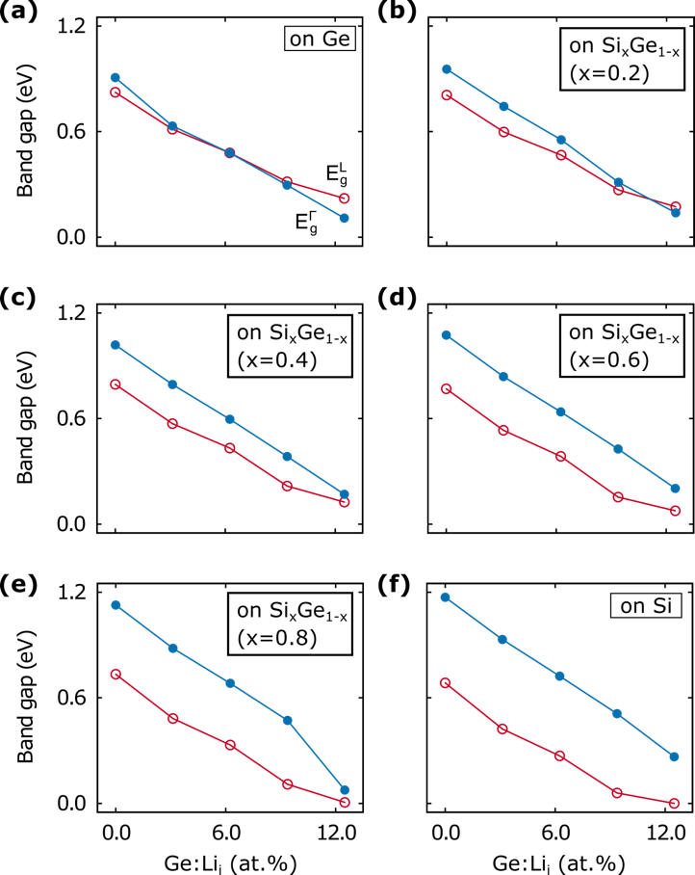
Figure S2: Effect of the substrate. Direct and indirect bandgap transition as a function of Li atom implantation concentration in Ge:Li system on Si_{x}Ge_{1-x} substrate (a) x=0; (b) x=0.2; (c) x=0.4; (d) x=0.6; (e) x=0.8; and (f) x=1.0.

Table SI. Formation energy (eV) of defects in Si or Ge. Defect types of dopant atoms in Si or Ge include, Tetrahedral (Td), Hexagonal (Hex), Anti-bonding (A), Bond-center (B), Center of the second nearest neighbor (C), and Midway (M) sites, Substitutional (S) defect and a Frenkel (F) defect.
System | Interstitial |  |  |  |  |  |  | Substitutional
System | Td | Hex | A | B | C | M |  | S | F
Si:Li | 0.508 | 0.952 | 0.508 | 2.688 | 0.508 | 0.952 |  | 7.931 | 2.508
Ge:Li | 0.207 | 0.487 | 0.218 | 2.398 | 0.207 | 0.487 |  | 5.993 | 1.749
Ge:He | 0.797 | 1.259 | 0.797 | 3.054 | 0.797 | 1.259 |  | 8.076 | 3.009
Ge:Ne | 1.687 | 2.298 | 1.687 | 2.947 | 1.687 | 2.298 |  | 7.409 | 2.947
Ge:Ar | 4.057 | 4.546 | 3.133 | 3.135 | 3.969 | 2.955 |  | 7.571 | 3.132

