Supplementary Information
Scaffold for the Minimally Invasive Repair of Soft Tissue Inspired by Soggy Shrunk Puffed Food

Supplementary Note 1 | Establishment of dampening treatment device
The dampening treatment device was composed of three functional parts: thermostatically dampening system, sample shelf and real-time detection system (Supplementary Fig. S1). The thermostatically dampening system provided vapor generated by deionized water and a heater controlled by PID algorithm. The sample shelf was used to place the freeze-dried samples. The real-time detection system displayed real-time heater temperature and humidity in the treatment space with electric thermo-hygrometer. The device was sealed by an acrylic box.
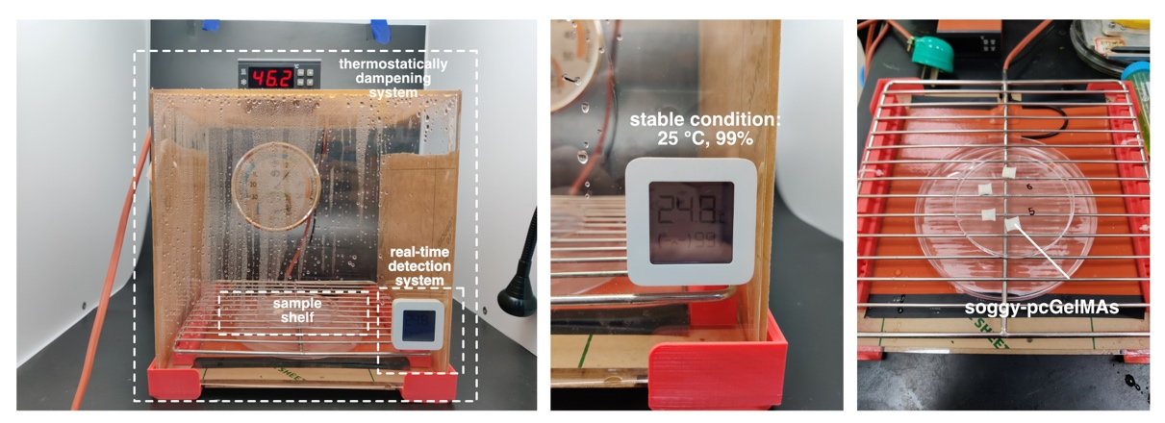
Supplementary Fig. 1 | Establishment of dampening treatment device

Supplementary Note 2 | Why choose vapor rather than liquid water to dampen the freeze-dried hydrogel scaffold?
To shrink the freeze-dried pcGelMAs, vaper dampening rather than directly immersing them in the liquid water was chosen in this work. From the pre-experiments, we put the freeze-dried pcGelMAs into the water. However, from the volume changing results (Supplementary Fig. S2), the freeze-dried pcGelMAs rapidly absorbed the water at first, but the absorbing speed suddenly decreased after 2 minutes. In 8 minutes, no obvious volume changing could be observed.
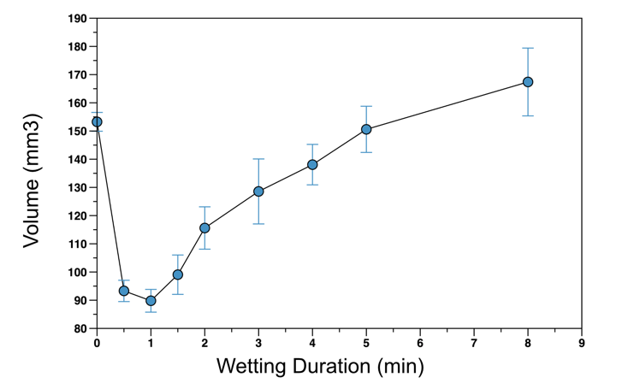
Supplementary Fig. 2 | Scaffold volume in wetting treatment in liquid water.
This phenomenon demonstrated that directly immersing the freeze-dried pcGelMAs could not be used to shrink them. It is because the existence of air bubble inside (Supplementary Fig. S3). For vapor, water molecules could easily get into the freeze-dried pcGelMAs and gradually drive out the air molecules inside. Nevertheless, when the freeze-dried pcGelMAs were directly immersed in the liquid water, the inside air molecules would be locked due to the pressure balance between air and liquid water. As a result, the water molecules could not further enter the inside hydrogel network, leading the dampening process failed. Therefore, vapor rather than liquid water was chosen in the dampening process in this work.
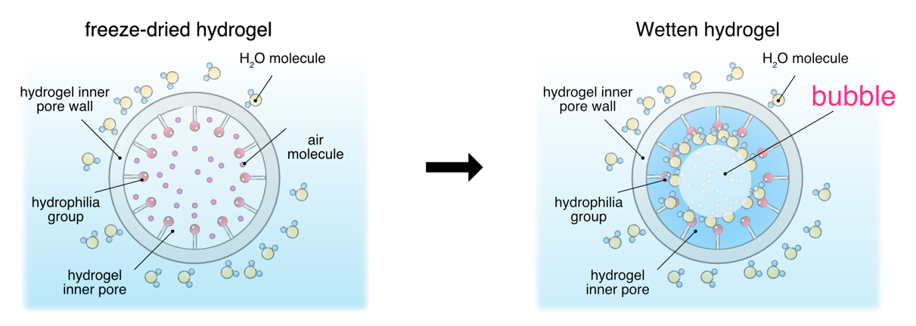
Supplementary Fig. 3 | Failure principle of wetting treatment in liquid water.

Supplementary Note 3 | Why not choose air-drying treatment to shrink the hydrogel scaffold?
As discussed in the Introduction section, the first requirement for minimally invasive injection of hydrogel scaffold is to decrease the general size of the scaffold. Besides the proposed lyophilization & dampening (L&D) treatment, air drying treatment can also shrink the hydrogel scaffold rapidly. Here, further experiment and discussion on air drying treatment is carried out.
The mechanism of hydrogel scaffold shrinking by air drying is due to the decline of the dissolved water inside the hydrogel network (Supplementary Fig. S4). Unless lyophilization in which the water firstly turns to be ice and occupy some space, the state of the dissolved water maintains liquid. Thus, during the whole air-drying process, the hydrophilia bonds on the inner pore walls can always bond to the left water molecules inside. Under the effect of hydrogen bonds, the inner pore walls will gradually shrink with the decline of liquid water inside, resulting in the general volume decreasing.
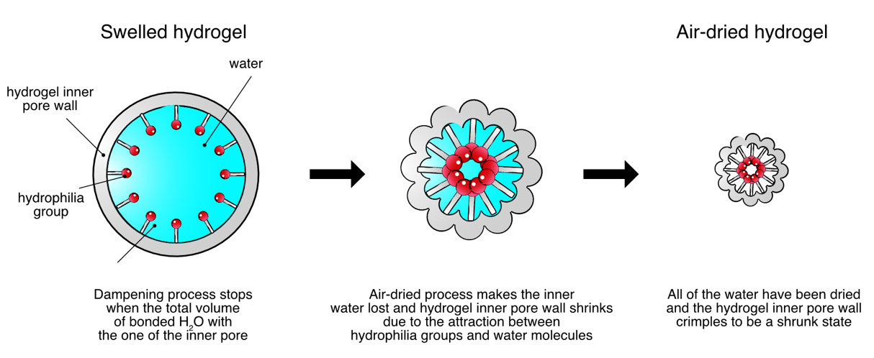
Supplementary Fig. 4 | Failure principle of air-drying treatment.
The pcGelMAs that reached swell equilibrium were placed in the blast drying box at the temperature of 50 ℃ for 3 hours. The results showed that the treated pcGelMAs gradually shrunk and transfer into dried and hard translucent pieces, accompanied by a slight change in appearance. The volume decreased from185.84 ± 10.66 mm³ reduced to 8.48 ± 0.32 mm³, around 95.44% decreased compared to the original volume (Supplementary Fig. S5), The water content results showed to be 12.39% (Supplementary Fig. S6).
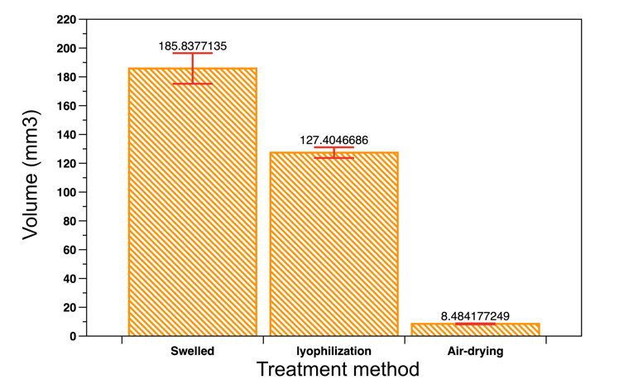
Supplementary Fig. 5 | Volume shrinking comparison of pcGelMA with different drying treatment methods.

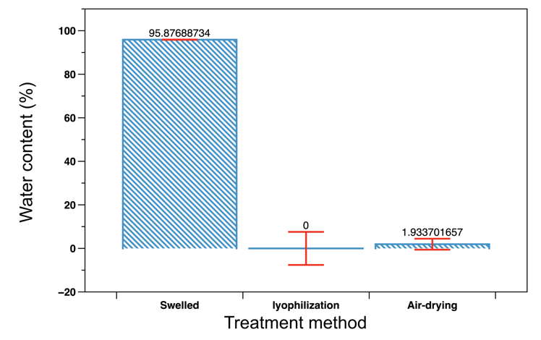
Supplementary Fig. 6 | Water content comparison of pcGelMA with different drying treatment methods.
Besides, the surface contact angle and re-swelling test results demonstrated that the air-drying treated pcGelMAs could also re-expand to the original size (Supplementary Fig. S8), although the surface hydrophilia and re-swelling speed were lower than the those of freeze-dried pcGelMAs (Supplementary Fig. S7). These results indicated that the air-drying treatment could applied to shrink the hydrogel scaffolds.
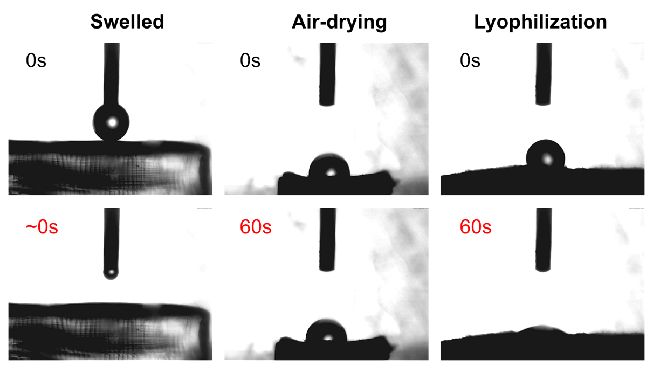
Supplementary Fig. 7 | Surface contact angle comparison of pcGelMA with different drying treatment methods.
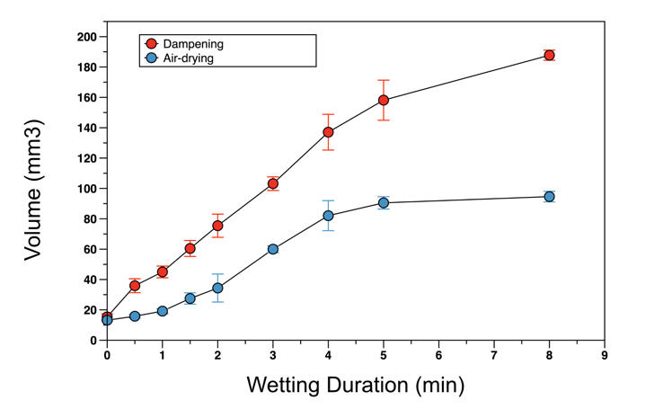
Supplementary Fig. 8 | Re-swelling volume comparison of pcGelMA with different treatment methods.
However, the mechanical property test results exposed the weakness of air-drying treatment in the fabrication of minimally invasive injection hydrogel scaffolds. The compressive curve showed that the pcGelMAs treated by air-drying process were much harder and owned higher compressive modulus than the those treated by freeze-dried process and L&D process (Supplementary Fig. S9). It would cause potential foreign body sensation after the scaffolds were injected into the soft tissue defect, which would bring pain or more dangers to patients. Therefore, the air-drying treatment was not suitable for the preparation of minimally invasive injection hydrogel scaffolds.
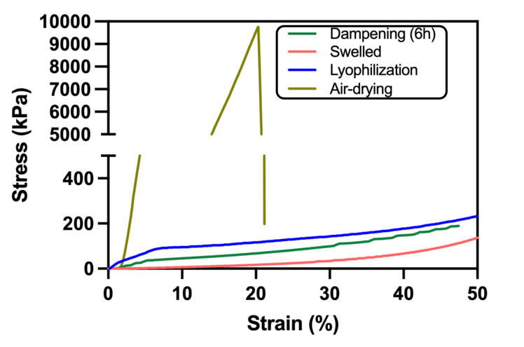
Supplementary Fig. 9 | Compressive curve comparison of pcGelMA with different treatment methods.

Supplementary Note 4 | Finite element analysis of dampening-driven shrinking process.
The porous freeze-dried GelMA hydrogels was abstracted as a novel analysis unit in this work, namely “constant material-volume truss (CMVT)” structure with hydrophilic bonds. With the bonding of water molecules, the rod of truss would gradually shrink to be short and thick state from long and thin state. On the condition of material volume unchanged, the volume of truss would gradually decrease, macroscopically resulting the shrinking of the freeze-dried hydrogel scaffold.
The total material volume $V_{material}$ (constant value) could be calculated as below:
$$V_{material}=12a_{rod}^{2}(t)(a_{truss}(t)-2a_{rod}(t))+8a_{rod}^{3}(t)$$
$a_{truss}(t)$ was the general length of the truss and $a_{rod}(t)$ was the side length of rod section. The dampening time is $t$.
Then, the relations between $a_{truss}(t)$ and $a_{rod}(t)$ was:
$$a_{truss}\left(t\right)=\frac{V_{material}}{12a_{rod}^{2}(t)}+\frac{4}{3}a_{rod}(t)$$
The boundary conditions of the above equation were:
$$\left\{\begin{aligned}a_{truss}\left(t\right)>2a_{rod}\left(t\right) \\ a_{rod}\left(t\right)>0 \\ t≥0\end{aligned}\right.$$
Take the derivative of the above equation to find the extreme point as below:
$$\frac{∂a_{truss}\left(t\right)}{∂a_{rod}\left(t\right)}=-\frac{V_{material}}{6a_{rod}^{3}\left(t\right)}+\frac{4}{3}$$
The extreme point was calculated as:
$$\left\{\begin{aligned}a_{rod}\left(t\right)=\frac{V_{material}^{\frac{1}{3}}}{2} \\ a_{truss}\left(t\right)=V_{material}^{\frac{1}{3}}\end{aligned}\right.$$
It could be found that the extreme point ($\frac{V_{material}^{\frac{1}{3}}}{2}$, $V_{material}^{\frac{1}{3}}$) went through the curve $a_{truss}\left(t\right)=2a_{rod}\left(t\right)$. Therefore, the function graph of $a_{truss}\left(t\right)$-$a_{rod}\left(t\right)$ was shown as below:
The curve displayed the monotonicity of the function relation between $a_{truss}\left(t\right)$ and $a_{rod}\left(t\right)$, indicating that when the material volume remained unchanged, the length of the truss would monotonically decrease with the increasing of the side length of the rod section.
To simulate the shrinking process during the dampening treatment, several hypotheses were set as below:
(i) The analysis model was set as the crisscross-distributed same trusses with five labs. The center truss represented the innermost pore of the freeze-dried hydrogel. The vapor came from the fifth lap (outermost) of trusses. The vapors would always connect with the neighbor trusses during shrinking.
(ii) The diffused water molecules concentration difference among the trusses in the same lap was ignored. Considering the water molecules diffusion difficulty for different laps of trusses, there would be gradients of water molecules bonding rates. Here, from the 1st to the 5th lap, the water molecules bonding rate $μ_{H_{2}O-bonding}$ was set as $\frac{1}{5}μ_{0}$, $\frac{1}{4}μ_{0}$, $\frac{1}{3}μ_{0}$ $\frac{1}{2}μ_{0}$, $μ_{0}$. Then, $n_{H_{2}O-bonding}\left(t\right)$ could be calculated as below:
$$n_{H_{2}O-bonding}\left(t\right)=μ_{H_{2}O-bonding}×t$$
(iii) The process of bonding water molecules would lead to the enlarging of rod section (shrinking in the longitudinal direction). The side length of the rod section was set to proportionally increase with the increasing of the amount of substance of the bonded water molecules $n_{H_{2}O-bonding}(t)$. Then, the side length of the rod section could be calculated as below:
$$a_{rod}\left(t\right)=a_{rod}\left(0\right)+∆L×μ_{H_{2}O-bonding}×t$$
The $∆L$ was increment of $a_{rod}\left(t\right)$ when the truss was bonded with 1 mol water molecules.
(iv) The process of bonding water molecules only occurred inboard surface of the trusses, that is, the trusses would only deform inwards.
(v) The shrinking process would be judged to be stopped when the general volume of the bonded water in one truss was equal to that of the pore space restricted by the truss rod. This boundary conditions could be calculated as below:
$$\int_{0}^{t}{\frac{M_{H_{2}O}×n_{H_{2}O-bonding}\left(t\right)}{ρ_{water}}dt}=a_{truss}^{3}\left(t\right)-V_{material}$$
$$\frac{M_{H_{2}O}×n_{H_{2}O-bonding}\left(t\right)}{ρ_{water}}×t={\left(\frac{V_{material}}{12a_{rod}^{2}\left(t\right)}+\frac{4}{3}a_{rod}\left(t\right)\right)}^{3}-V_{material}$$
$M_{H_{2}O}$ was the molar mass of water molecules. $ρ_{water}$ was the density of liquid water.
Parametric sweep was carried out in COMSOL Multiphysics. The parameters were set as below:
Supplementary Table. 1 | Parametric sweep setting in the finite element analysis of dampening-driven shrinking process.
Parameter | Value | Unit
$$t$$ | range (0,1,80) | s
$$V_{material}$$ | 1E-10 | m³
$$a_{rod}\left(0\right)$$ | 1E-4 | m
$$∆L$$ | 2.5 | m/mol
$$μ_{0}$$ | 2E-6 | mol/s
$$M_{H_{2}O}$$ | 18 | g/mol
$$ρ_{water}$$ | 1e6 | g/m³

As shown in the paper and in the supplementary videos, the general volume would gradually decrease during the dampening treatment. The 5th lap of trusses firstly finished the water molecules bonding process. When the 1st (innermost) lap of truss finished, the general volume of the analysis model remained unchanged.

Supplementary Note 5 | Finite element analysis of dampening-driven mechanical enhanced process.
In terms of mechanical property, single “constant material-volume truss (CMVT)” structure was chosen as the analysis model. Set the bottom surface as zero placement and gave the top surface a small displacement $D_{c}(t)$ to compress the truss which was calculated as below:
$$D_{c}(t)=ε(t)×a_{rod}\left(t\right)$$
The $ε(t)$ was the compressive strain.
Parametric sweep was carried out in COMSOL Multiphysics. The parameters were set as below:
Supplementary Table. 2 | Parametric sweep setting in the finite element analysis of dampening-driven shrinking process.
Parameter | Value | Unit
$$V_{material}$$ | 1E-10, 1.5E-10, 2E-10, | m³
$$a_{rod}\left(t\right)$$ | range (0.6E-4,0.2E-5,2.0E-4) | m
$ε$(t) | 0.01, 0.05 | -

Apart from the results shown in the paper, the distributions of von Mises stress $σ_{von Mises}$ related to different side length of the rod section under other parameter groups were shown as below.
The total force on the top surface in Z direction could be calculated as below;
$$F_{c}\left(t\right)=\iint_{S_{top}\left(t\right)}{σ_{normal}}(t)dS_{top}\left(t\right)$$
$σ_{normal}$ was the normal stress on the top surface. $S_{top}\left(t\right)$ was the view area of the top surface.
The compressive modulus could be calculated as below:
$$E_{c}\left(t\right)=\frac{{F_{c}\left(t\right)}/{S_{top}\left(t\right)}}{ε(t)}=\frac{\iint_{S}{σ_{normal}}(t)dS}{ε(t)×{(a_{truss}\left(t\right))}^{2}}$$
The parametric sweep results demonstrated that the compressive modulus monotonically increased with the truss shrinking, which indicating the mechanism of the mechanical strength increasing at the beginning of dampening treatment.

