a b
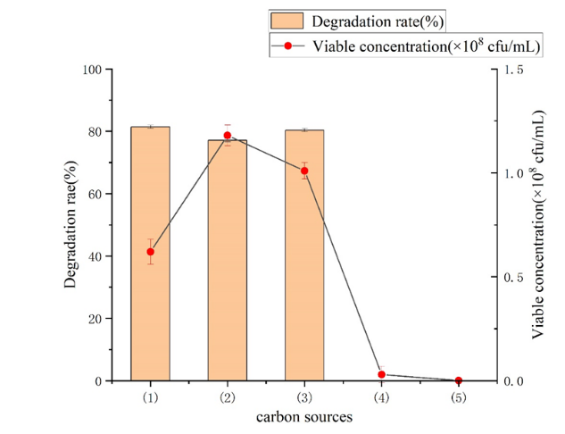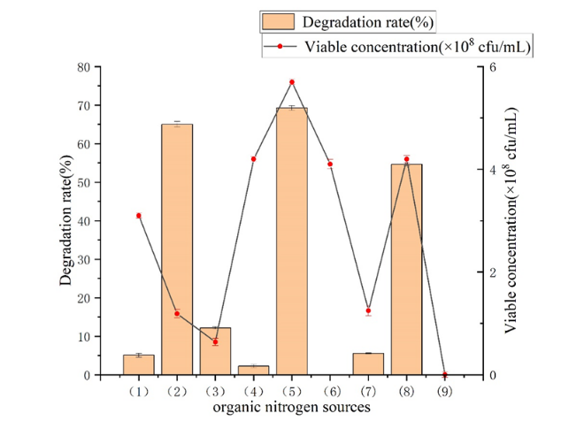
c d
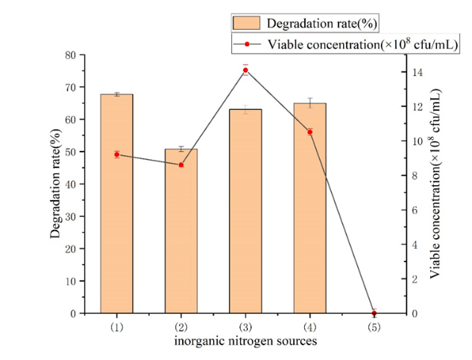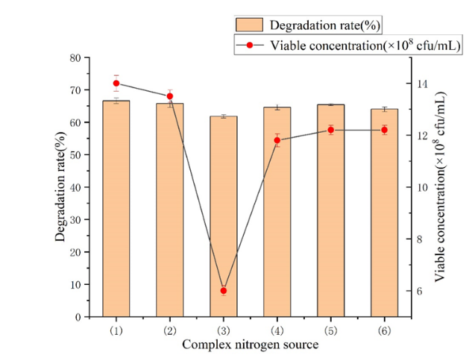
a Carbon sources: (1) sodium succinate (2) sodium citrate (3) sodium acetate (4) glucose (5) blank group;
b Organic sources :(1) beef paste (2) soybean meal powder (3) Corn syrup dry powder (4) yeast extract powder (5) fish meal (6) peptone (7) urea (8) tryptone (9) blank group;
c Inorganic nitrogen sources (1) 0.5 g/L ammonium sulfate; (2) 0.4 g/L ammonium chloride; (3) 1.0 g/L ammonium sulfate; (4) 0.8 g/L ammonium chloride; (5) blank group;
d Complex nitrogen sources (1) ammonium sulfate 0.45 g/L+ soybean meal powder 0.35g/L; (2) ammonium sulfate 0.45 g/L+ fish meal 0.23g/L; (3) ammonium sulfate 0.5g/L; (4) ammonium sulfate 0.9 g/L+ soybean meal powder 0.7g/L; (5) ammonium sulfate 0.9 g/L+ fish meal 0.46g/L; (6) Ammonium sulfate is 1.00 g/L;
Fig. S1 Optimization results of medium composition
a b
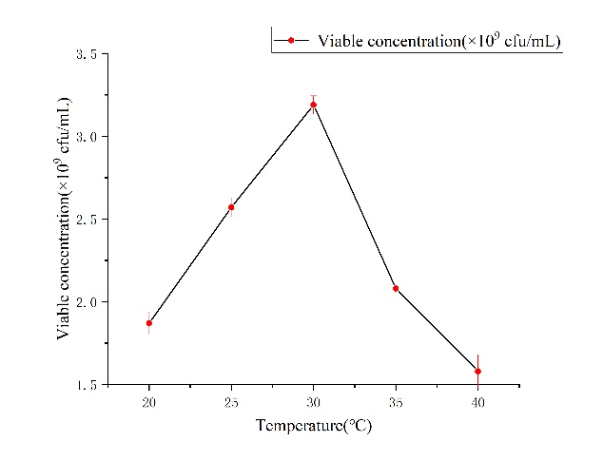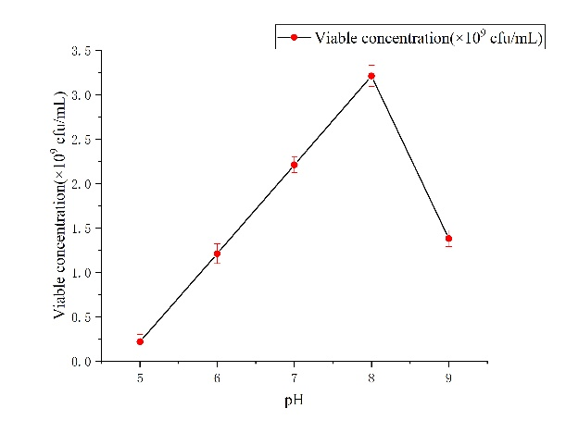
c d
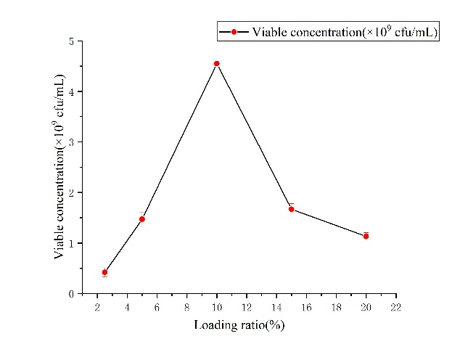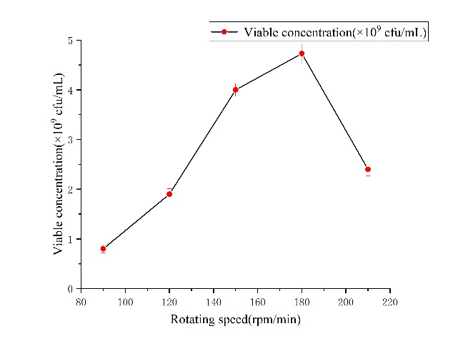
e
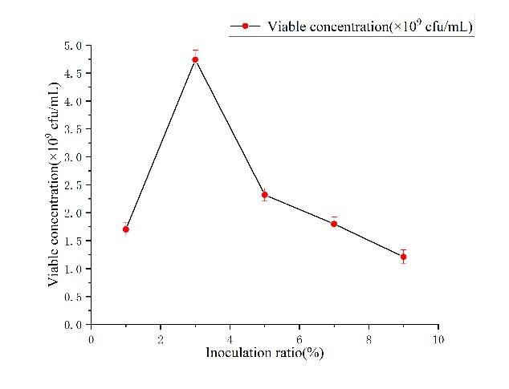
Fig. S2 Optimization results of culture conditions in shaking flask
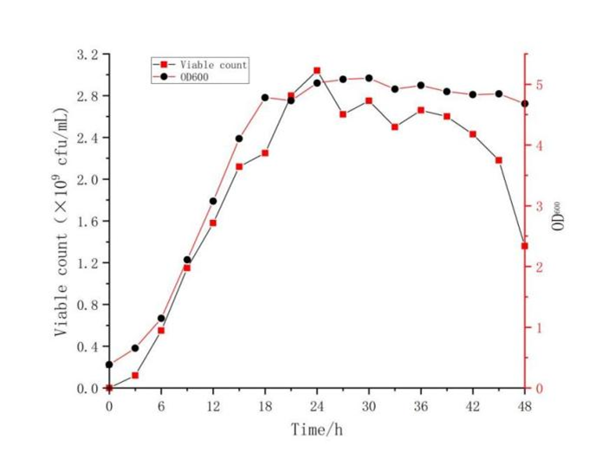
Fig. S3 The growth curve of the screened PDBF

