Supplementary Materials

Phonon promoted charge density wave in topological kagome metal ScV₆Sn₆
Yong Hu^{1,#,*}, Junzhang Ma^{2,3,4,#}, Yinxiang Li^{5,#}, Dariusz Jakub Gawryluk⁶, Tianchen Hu⁷, Jérémie Teyssier⁸, Volodymyr Multian⁸, Zhouyi Yin⁹, Yuxiao Jiang¹⁰, Shuxiang Xu⁷, Soohyeon Shin⁶, Igor Plokhikh⁶, Xinloong Han¹¹, Nicholas C. Plumb¹, Yang Liu¹², Jia-Xin Yin¹³, Zurab Guguchia¹⁴, Yue Zhao⁹, Andreas P. Schnyder¹⁵, Xianxin Wu^{16,*}, Ekaterina Pomjakushina⁶, M. Zahid Hasan¹⁰, Nanlin Wang^{7,17,18}, and Ming Shi^{1,12,*}
¹Photon Science Division, Paul Scherrer Institut, CH-5232 Villigen PSI, Switzerland
²Department of Physics, City University of Hong Kong, Kowloon, Hong Kong, China
³City University of Hong Kong Shenzhen Research Institute, Shenzhen, China
⁴Hong Kong Institute for Advanced Study, City University of Hong Kong, Kowloon, Hong Kong, China
⁵College of Science, University of Shanghai for Science and Technology, Shanghai, 200093, China
⁶Laboratory for Multiscale Materials Experiments, Paul Scherrer Institut, CH-5232 Villigen PSI, Switzerland
⁷International Center for Quantum Materials, School of Physics, Peking University, Beijing 100871, China
⁸Department of Quantum Matter Physics, University of Geneva, 24 Quai Ernest-Ansermet, 1211 Geneva 4, Switzerland
⁹Institute for Quantum Science and Engineering and Department of Physics, Southern University of Science and Technology of China, Shenzhen, Guangdong 518055, China
¹⁰Laboratory for Topological Quantum Matter and Advanced Spectroscopy (B7), Department of Physics, Princeton University, Princeton, NJ, USA
¹¹Kavli Institute for Theoretical Sciences, University of Chinese Academy of Sciences, Beijing 100190, China
¹²Center for Correlated Matter and Department of Physics, Zhejiang University, Hangzhou 310058, China
¹³Department of physics, Southern University of Science and Technology, Shenzhen, Guangdong 518055, China
¹⁴Laboratory for Muon Spin Spectroscopy, Paul Scherrer Institute, CH-5232 Villigen PSI, Switzerland
¹⁵Max-Planck-Institut für Festkörperforschung, Heisenbergstrasse 1, D-70569 Stuttgart, Germany
¹⁶CAS Key Laboratory of Theoretical Physics, Institute of Theoretical Physics, Chinese Academy of Sciences, Beijing 100190, China
¹⁷Beijing Academy of Quantum Information Sciences, Beijing 100913, China
¹⁸Collaborative Innovation Center of Quantum Matter, Beijing 100871, China
#These authors contributed equally to this work.
*To whom correspondence should be addressed:
Y.H. (yonghphysics@gmail.com); X.W. (xxwu@itp.ac.cn); M.S. (ming.shi@psi.ch)
Contents
1. Determination of surface terminations of ScV₆Sn₆
2. K_{z} dispersion in ScV₆Sn₆
3. ℤ₂ topological surfaces states in ScV₆Sn₆
4. VHS around the K point
5. Orbital character resolved band structure of ScV₆Sn₆
6. Evolution of the Raman modes in ScV₆Sn₆ across the CDW transition
1. Determination of surface terminations of ScV₆Sn₆
When cleaved along the (001) direction, ScV₆Sn₆ crystals exhibit three possible surface terminations, namely the vanadium kagome, ScSn³₂ and Sn² terminations [marked as kagome layer, ScSn and Sn layers in Fig. S1a(i)]. By using a small beam spot, we were able to resolve all three terminations probed their electronic structures separately. The measured Fermi surface (FS) on the cleaved sample surface associated with the three possible surface terminations is summarized in Figs. S1b-d. As previously established in GdV₆Sn₆ compound [32], we assign the FS shown in Fig. S1c to the ScSn layer based on the detected Sn 4d core level (Fig. 2H in the main text) and the observed topological Dirac surface states (TDSSs) (Figs. 2i, 3a, 3b, and Fig. S1c). The FS presented in Fig. S1b (also Fig. 2c) agrees well with the calculated FS contributed by V-3d states (Fig. S1e), leading us to suggest it belongs to the kagome layer. The FS shown in Fig. S1d is attributed to the Sn layer [Fig. S1a(ii)]. The band structure along the - $\overline{K}$ direction collected on the Sn layer is shown in Figs. S1f and S1g.
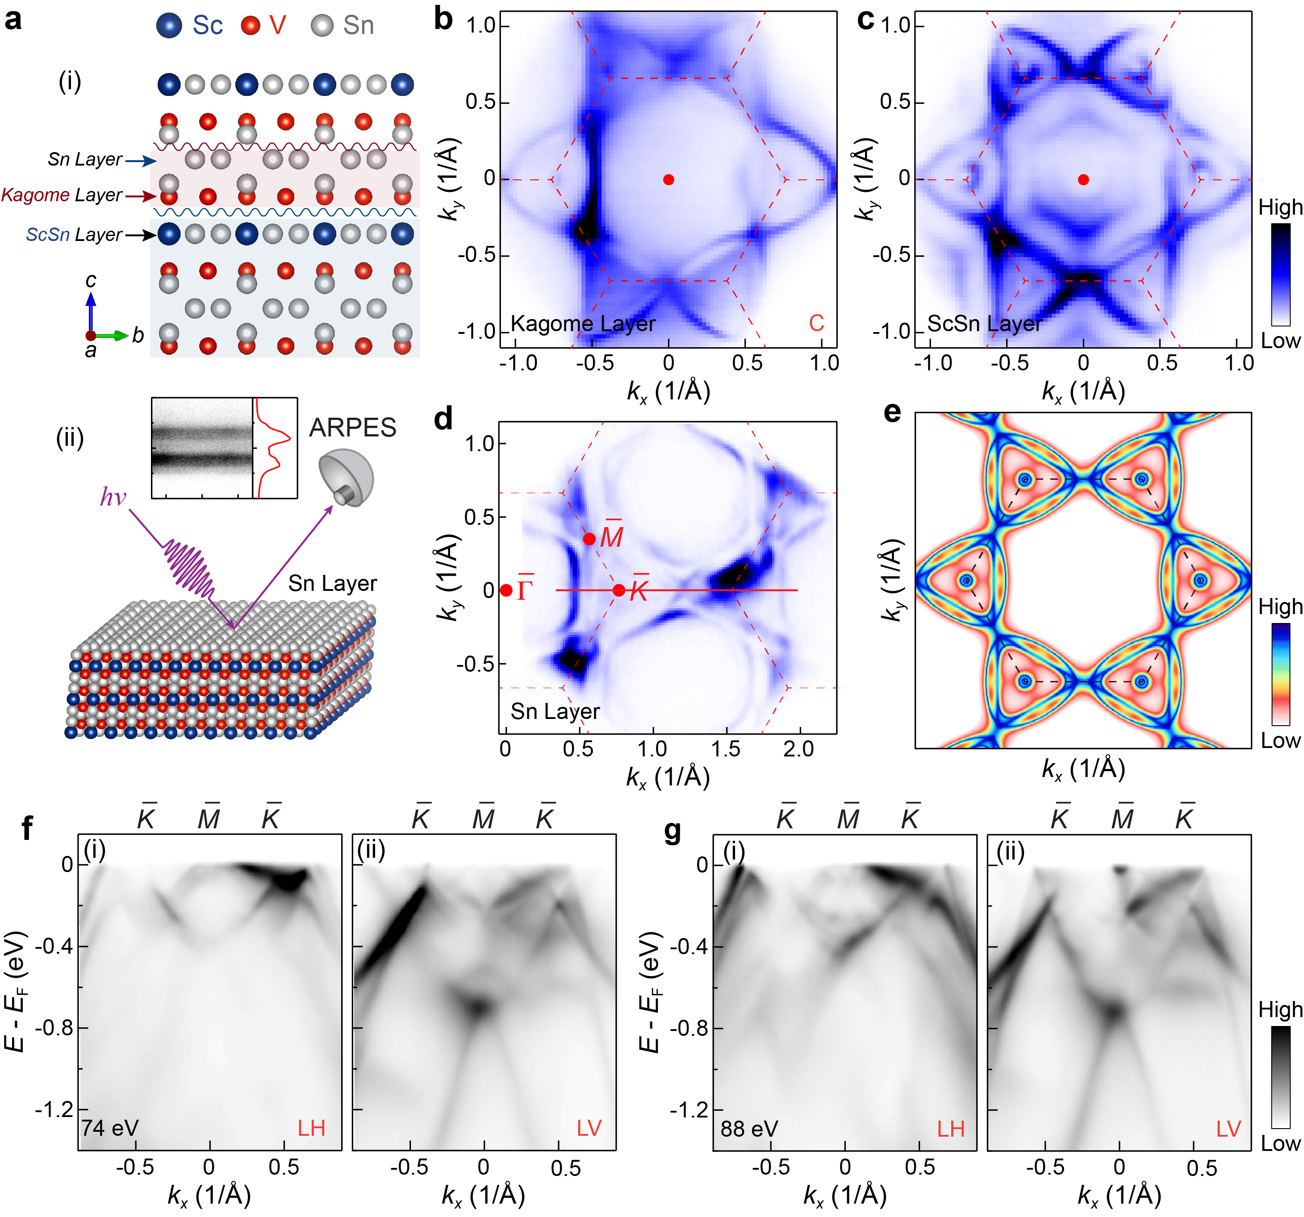Fig. S1| Electronic structure of the Sn² termination. a Crystal structure (side view) of ScV₆Sn₆ showing three possible surface terminations as indicated the arrows (i) and schematic of the Sn termination (ii). b-d Fermi surface (FS) mappings collected on the three terminations, measured with circular (C) polarized light. e Calculated FS of the bulk states. f Photoelectron intensity plots of the band structure taken along the - $\overline{K}$ - $\overline{M}$ direction on the Sn termination, measured with 74 eV linear horizontal (LH) (i) and linear vertical (LV) (ii) polarizations. g Same as (f), but measured with 88 eV. The momentum path is indicated by the red line in (d).
2. K_{z} dispersion in ScV₆Sn₆
Density functional theory (DFT) calculations reveal a noticeable dispersion along the c-direction in ScV₆Sn₆ (Fig. S2a), in contrast to the relatively weak k_{z} dispersion in CsV₃Sb₅ [34]. To determine the k_{z}, we performed photon energy–dependent ARPES measurements on the kagome termination over a broad energy range (40 to 120 eV) (Fig. S2b). The experimental k_{z} (Fig. S2c) is determined by examining the dispersion of the band bottom of the electron band around M point in the out-of-plane momentum direction, as shown by the red curve in Fig. S2c(i) and the blue curve in Fig. S2c(ii).
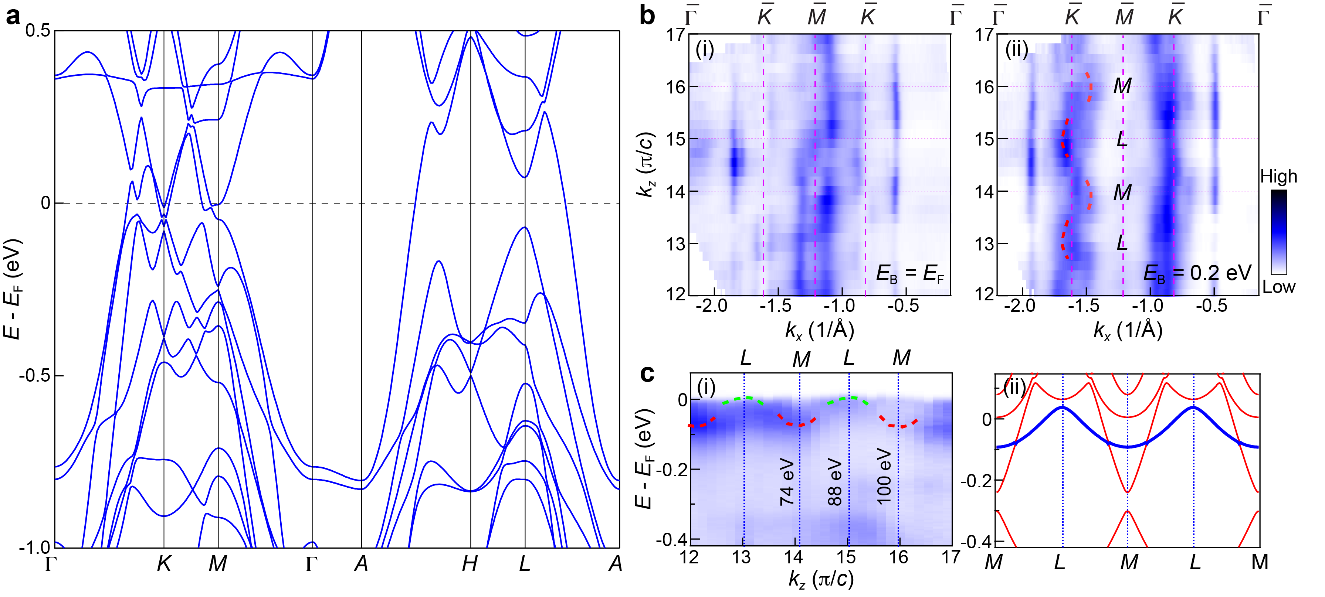
Fig. S2| K_{z} dispersion in ScV₆Sn₆. a DFT band structure of the pristine ScV₆Sn₆. b Photon energy-dependent ARPES spectral intensity map at the Fermi level (E_{F}) (i) and a binding energy (E_{B}) of 0.2 eV (ii), measured along the - $\overline{K}$ direction. c The measured (i) and calculated (ii) band dispersions along the M - L direction.
3. ℤ₂ topological surfaces states in ScV₆Sn₆
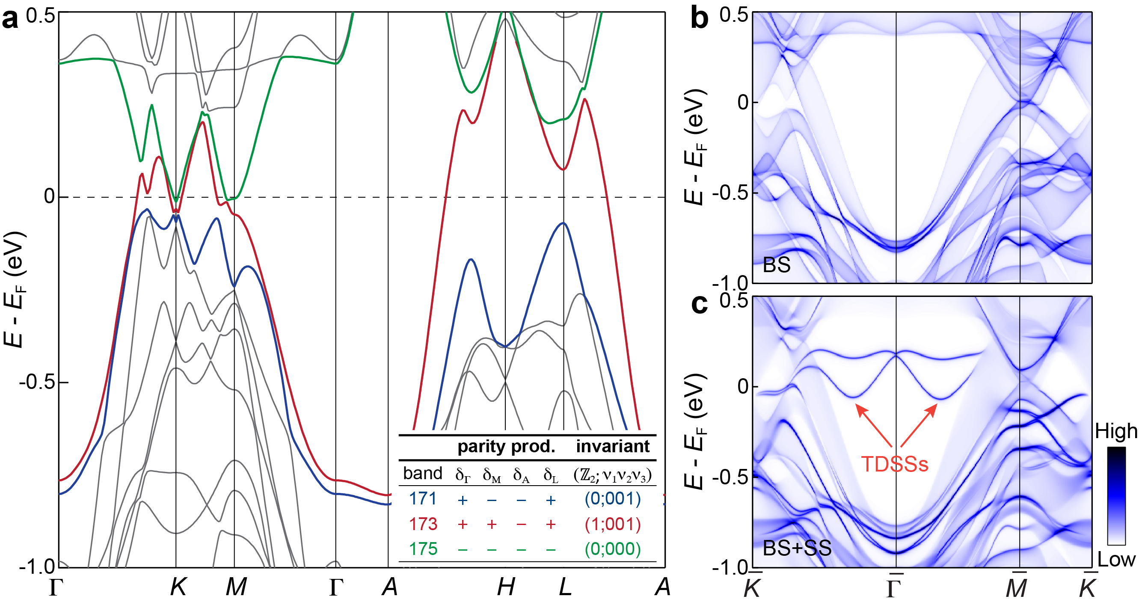
Fig. S3| ℤ₂ topological surfaces states in ScV₆Sn₆. a DFT calculated electronic structure of the pristine ScV₆Sn₆. The inset shows the parity products and the ℤ₂ invariant of different bands. Band 173 (red) is characterized by a strong topological invariant, ℤ₂ =1, while band 171 (blue) and 175 (green) are trivial with no topological invariants. TDSSs are expected to reside in the large local band gap at Γ. b, c The (001) surface Green’s function projection of pure bulk states (BS)(b) and the states comprising both BS and surface states (SS) on the ScSn termination (c). The red arrows highlight the TDSSs.
4. VHS around the K point
The experimental band dispersion along the - $\overline{K}$ - $\overline{M}$ - direction (Fig. S4a and Fig. 3D in the main text) is overall good consistent with the calculations (Fig. S4b and Fig. 3e). However, it should be noted that while the DFT calculations show a hybridization gap on the Dirac cone (DC) band around the K point (indicated by the black arrow in Fig. S4c), this gap is absent in the ARPES spectrum (Fig. 4a). To further investigate the VHS nature around the point, we plot the band dispersion along the - - M’ - direction (Fig. S4d), which clearly reveals a VHS (VHS3) around the point, as shown in Fig. 4e.
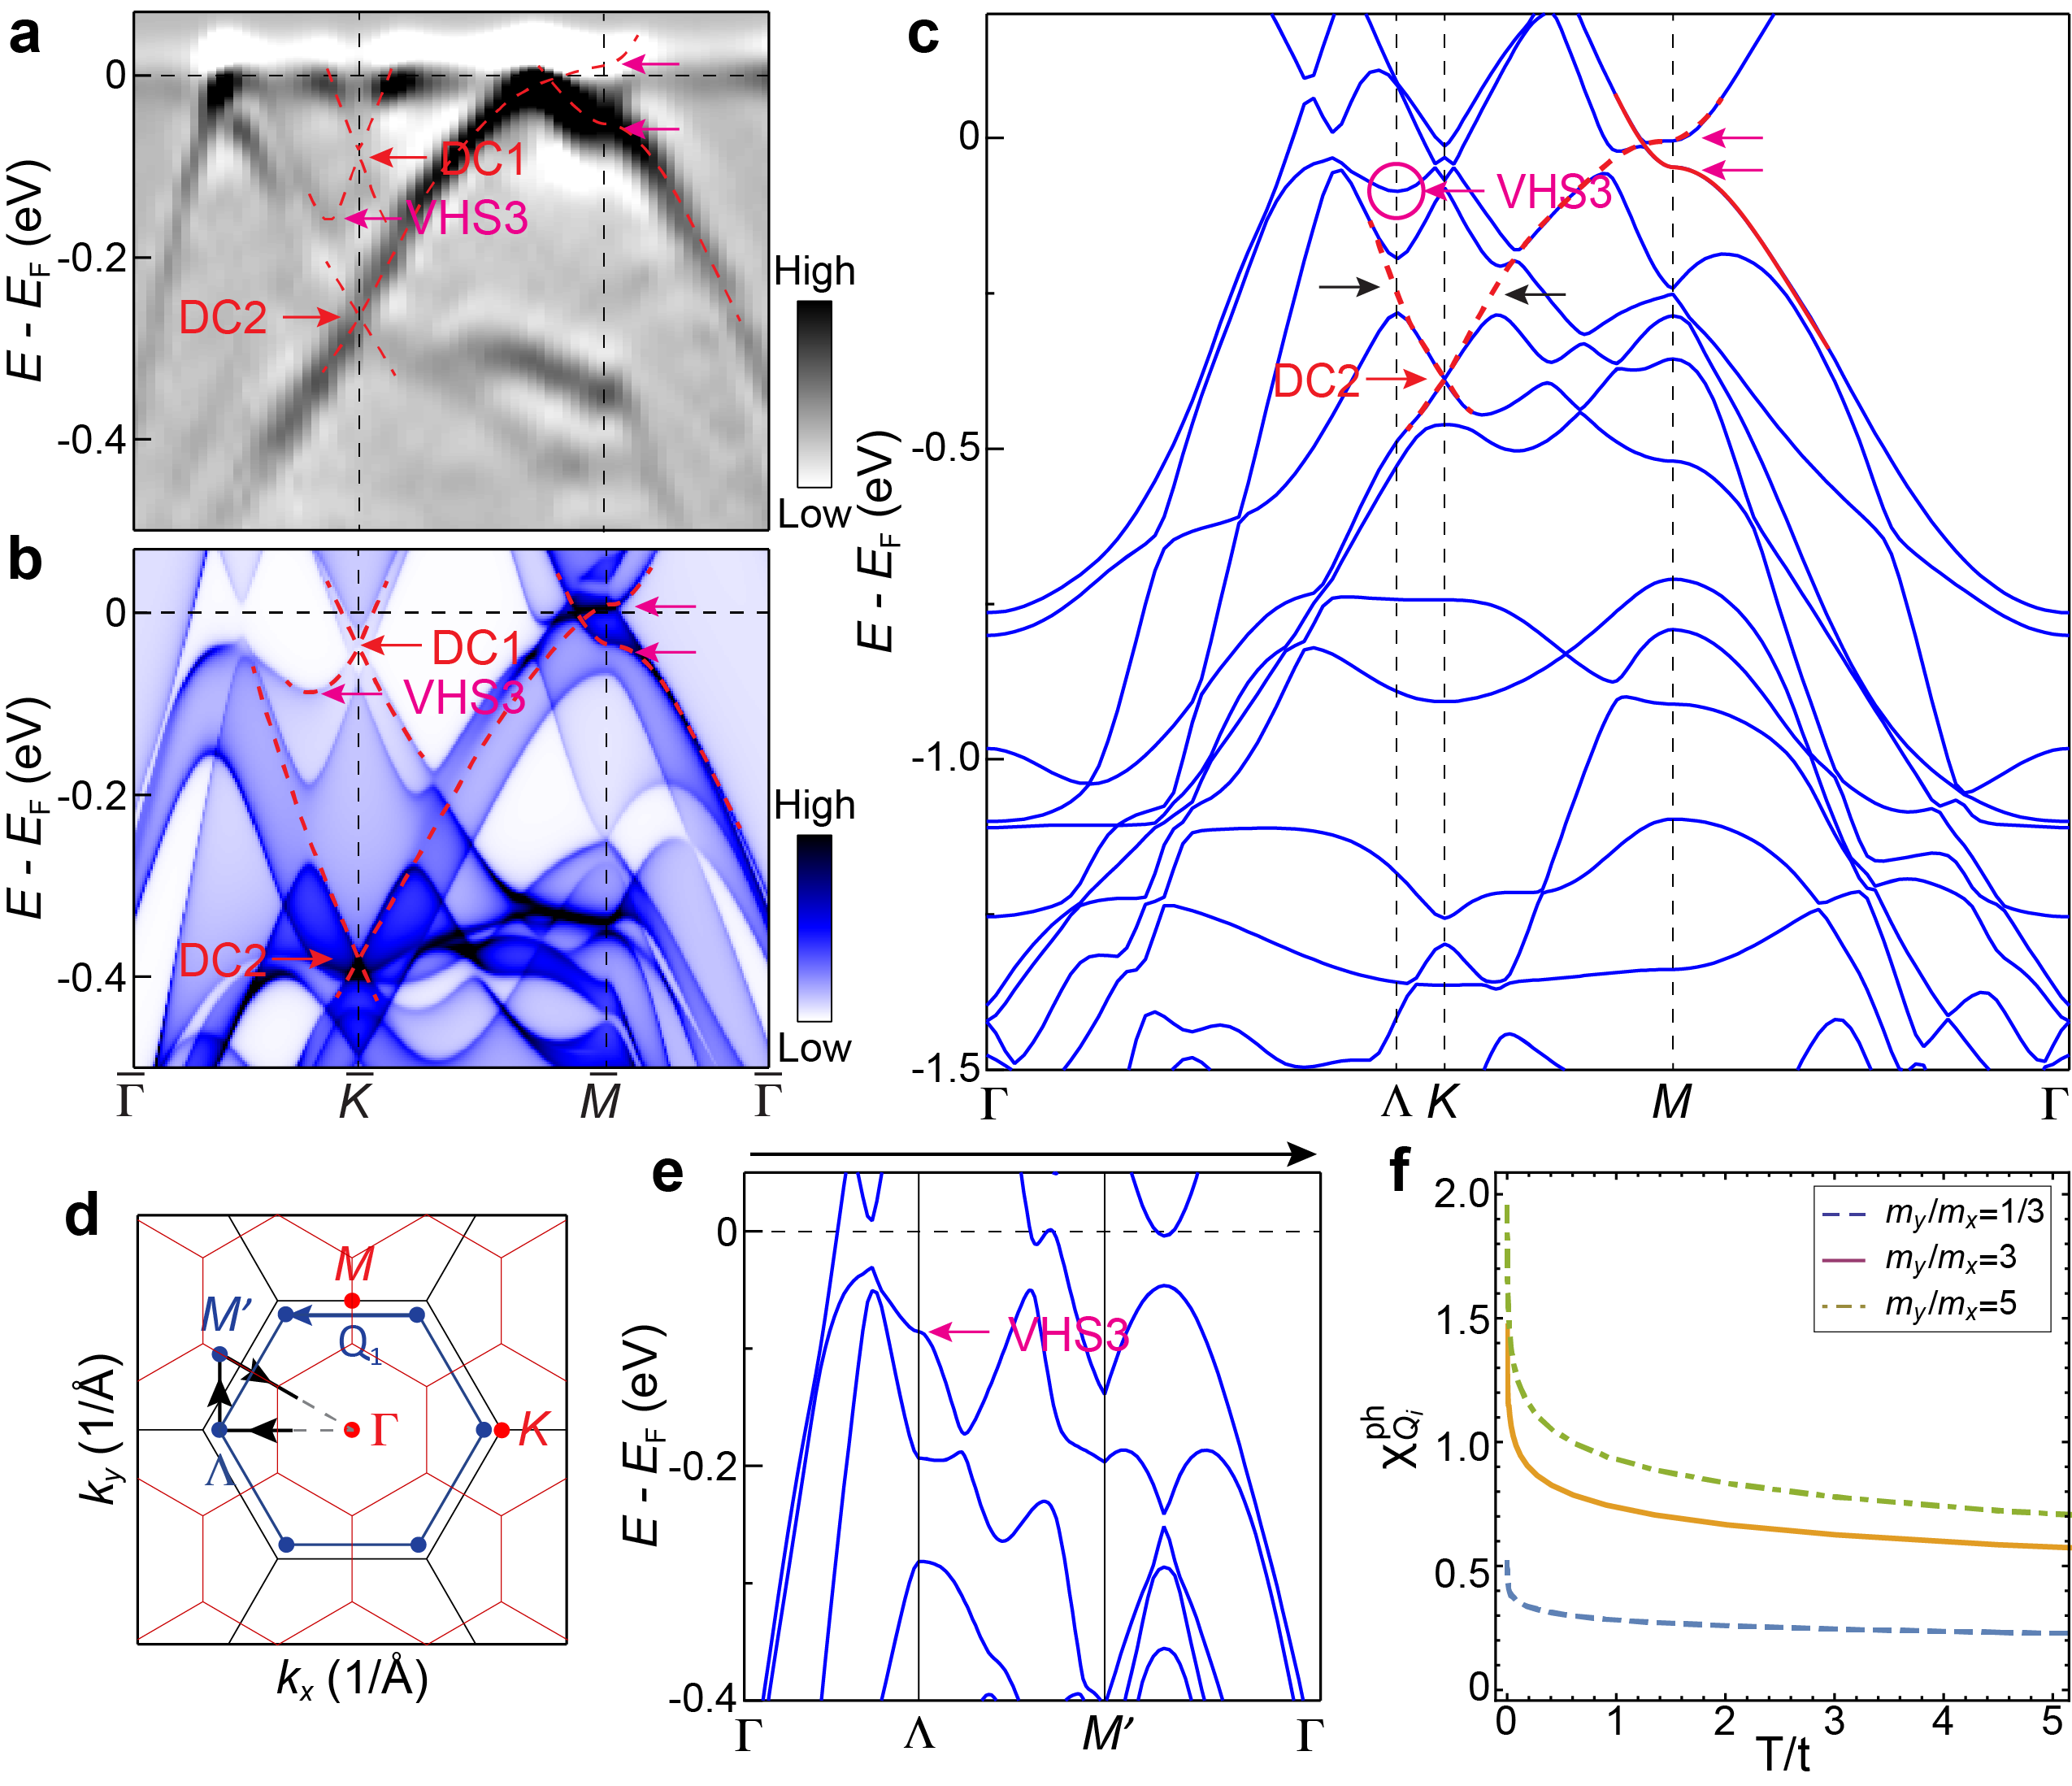
Fig. S4| Van Hove singularity around the K point. a Experimental band dispersion measured along the - $\overline{K}$ - $\overline{M}$ - direction. b Calculated band structure along the - $\overline{K}$ - $\overline{M}$ - direction, with red and pink arrows indicating the Dirac cone (DC) and Van Hove singularities (VHSs), respectively. c DFT calculated electronic structure along the Γ - K - M - Γ direction of the pristine ScV₆Sn₆. d Schematics of the Brillouin zone and VHSs around the K point. Black and red hexagons represent original BZ and CDW BZ, respectively. e DFT bands along the - - $M^{'}$direction. The momentum path is indicated by the black arrow in (d). f Susceptibilities as a function of temperature in the particle-hole channel with the momentum transfer Q₁ for the VHSs around K point [indicated in (d)].
5. Orbital character resolved band structure of ScV₆Sn₆
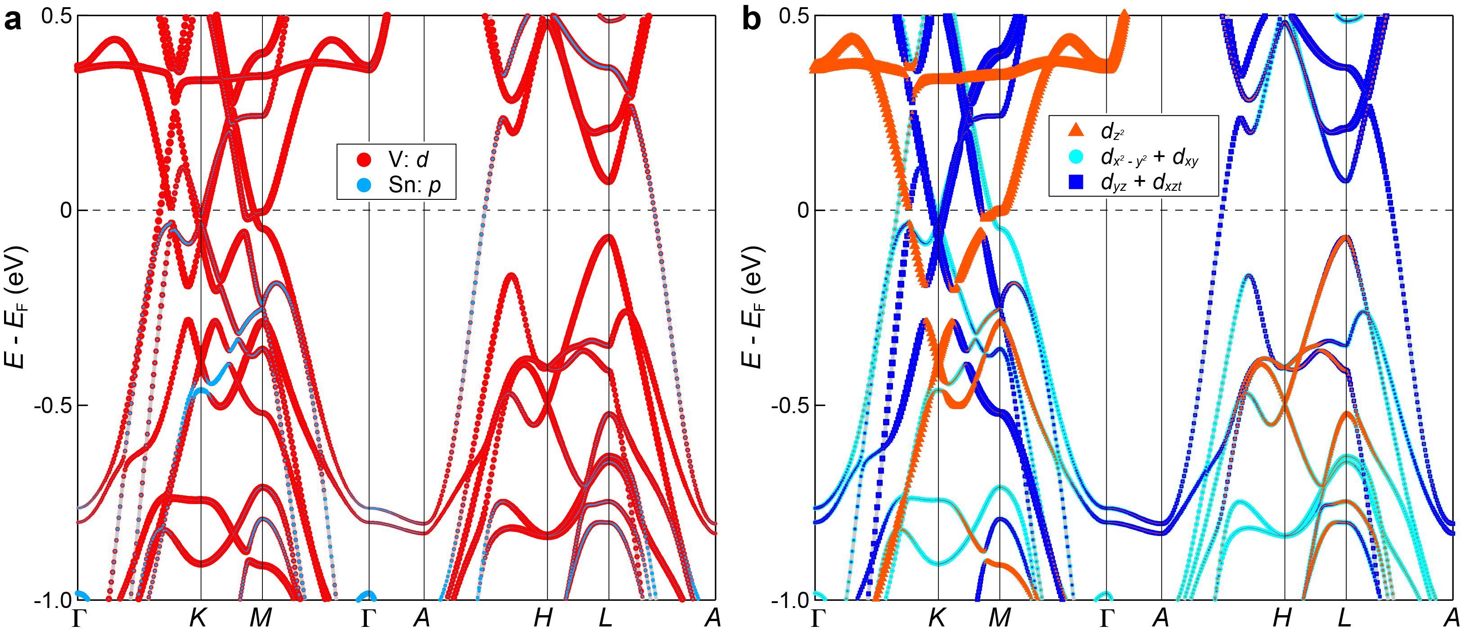
Fig. S5| Orbital character resolved band structure of ScV₆Sn₆. a Orbital projected band structure for the V d and Sn p orbitals. b Orbital projected band structure for the d orbitals of V atoms.
6. Evolution of the Raman modes in ScV₆Sn₆ across the CDW transition
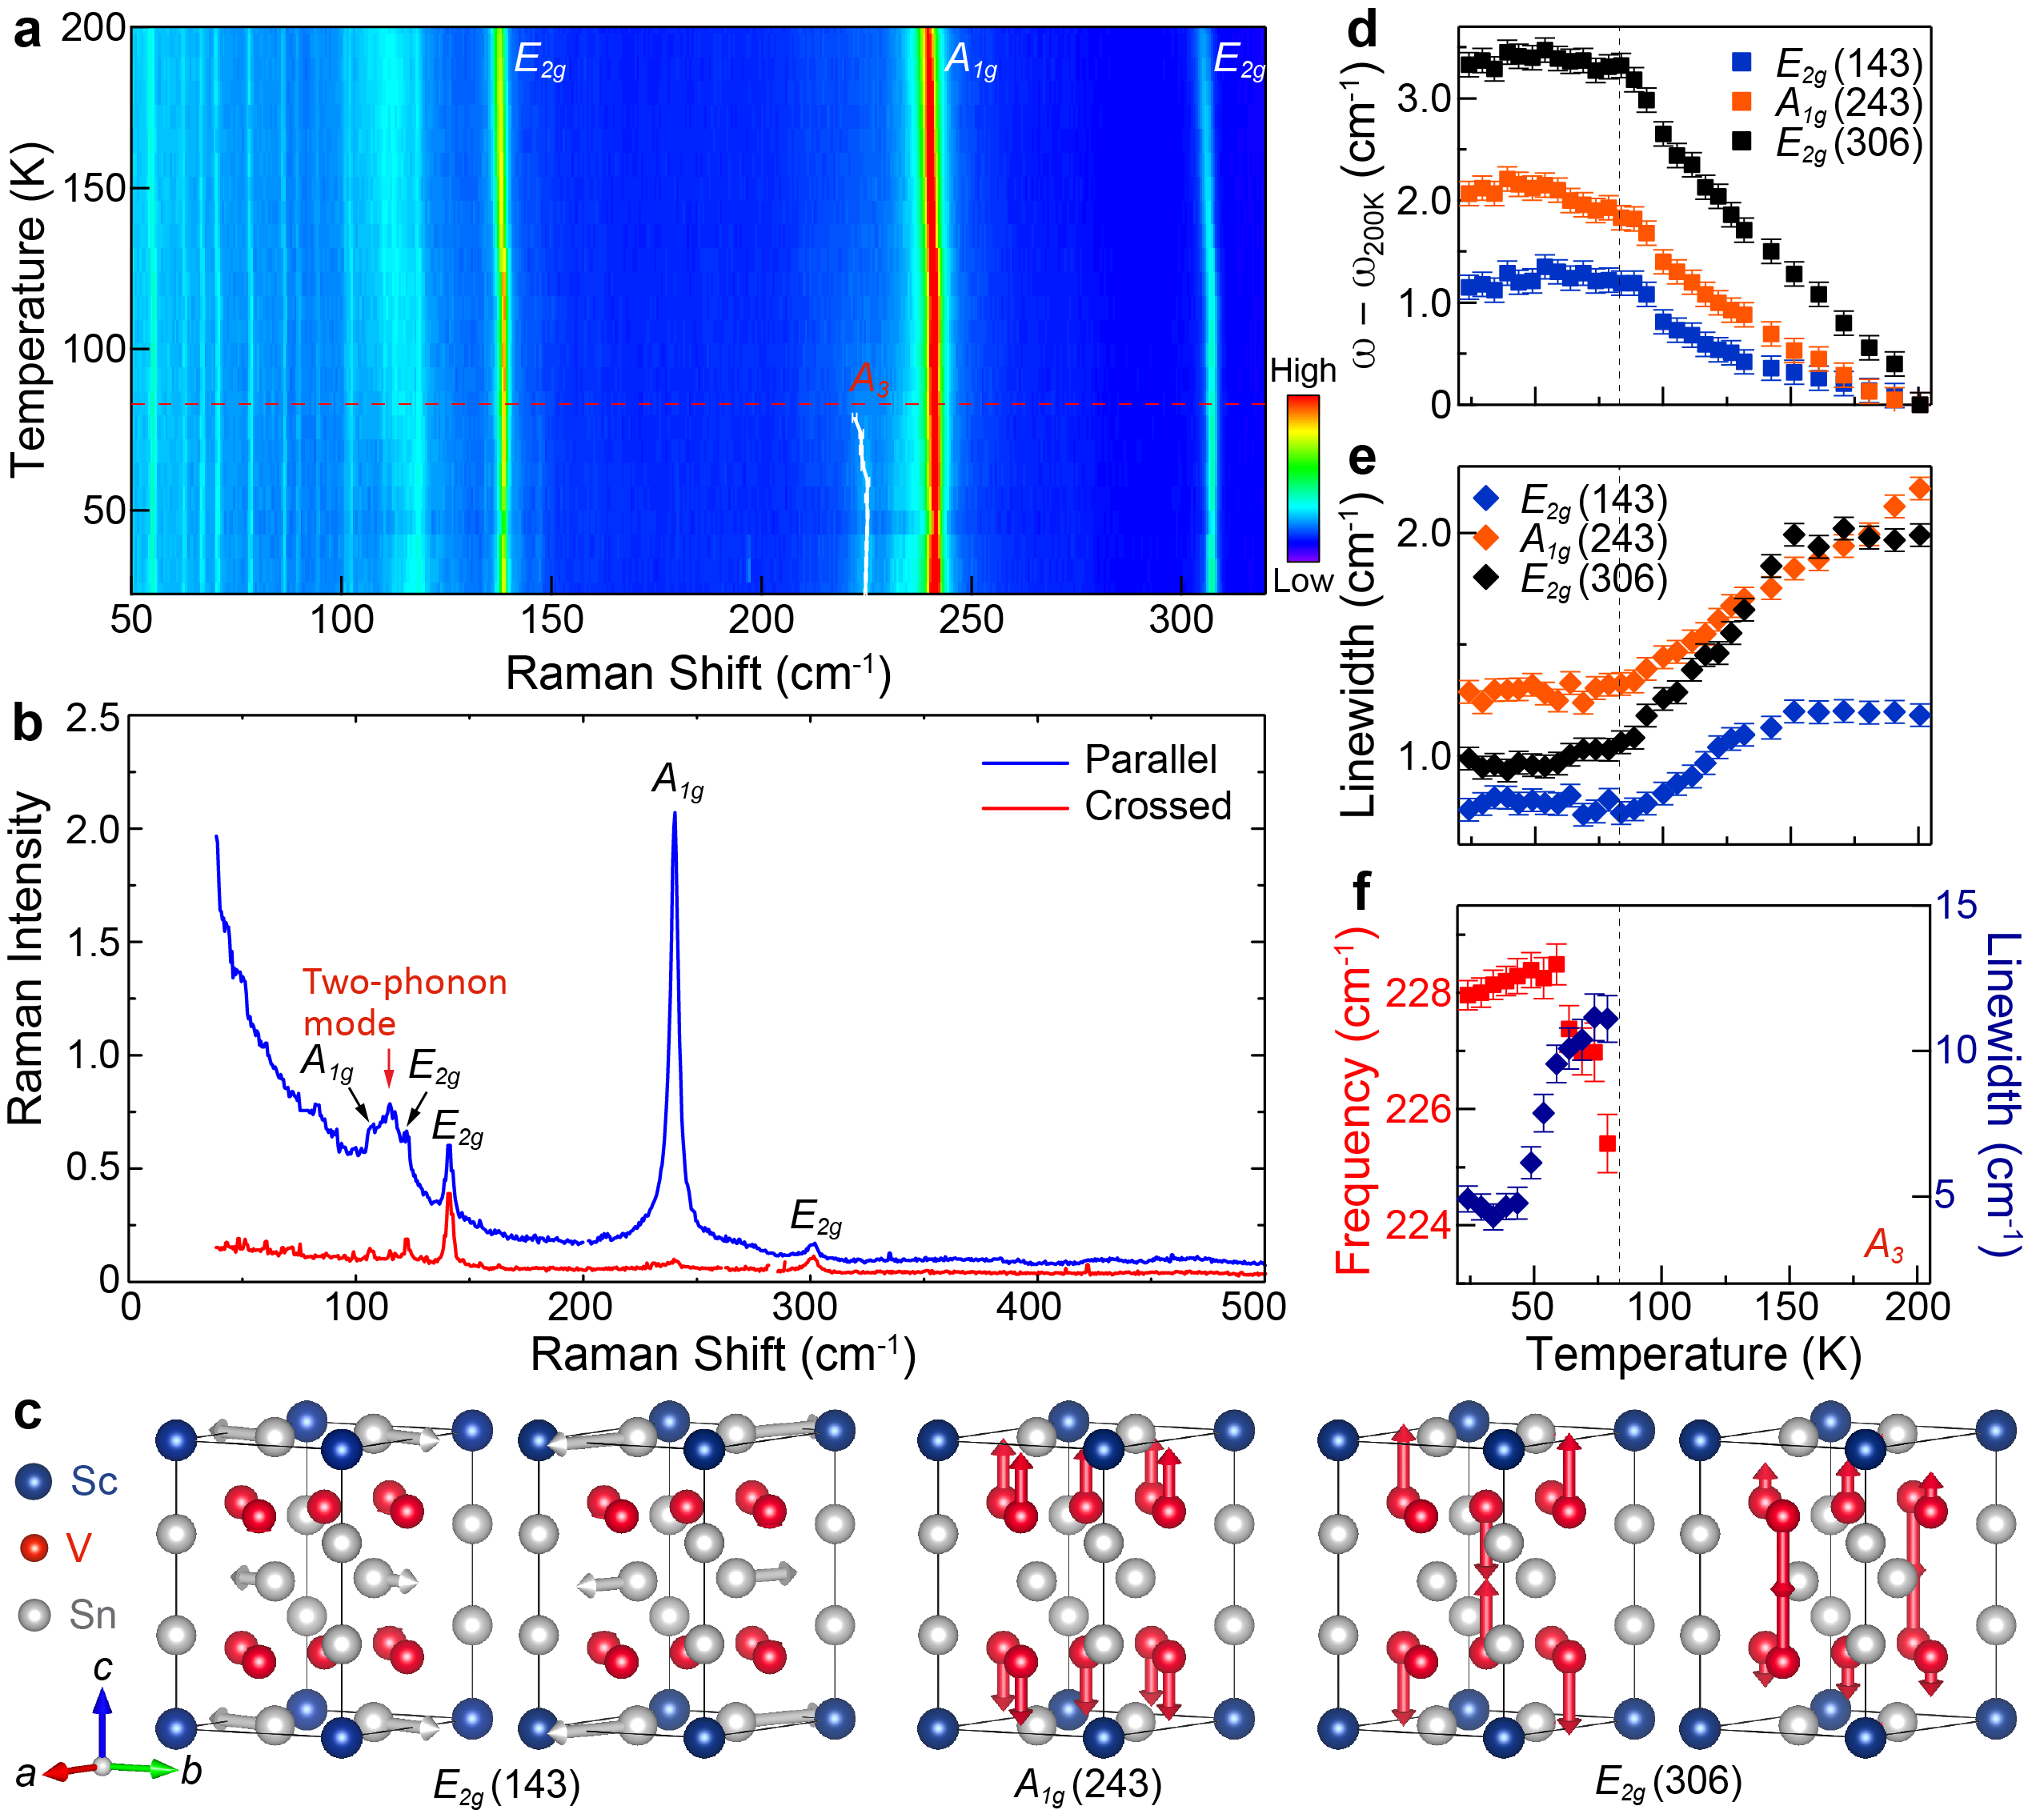
Fig. S6| Evolution of the Raman modes in ScV₆Sn₆ across the CDW transition. a Colormap of the Raman response recorded on ScV₆Sn₆ showing a temperature dependence, measured with parallel polarization. b Raman spectra measured on the ab-plane in parallel (4 K) and crossed (300 K) polarizations. c Crystal structure of ScV₆Sn₆, with different Wyckoff positions labeled. The vectors illustrate the vibration patterns of the main lattice E_{2g} (doubly degenerate) and A_{1g} modes. d,e Evolution of frequency (c) and linewidth (d) for the E_{2g} and A_{1g} main lattice phonons. The frequency is compared to the corresponding values at 200 K. f Temperature dependence of the frequency and linewidth of the A₃ mode.
Figure S6a displays a colormap of the Raman response, covering a temperature from 24 K to 200 K. As discussed in the main text, the multiple weak peak-like structures below 100 cm⁻¹ likely arise from rotational spectrum of O₂ and N₂ along the laser path [38]. Figure S6b compares the Raman spectra measured on the ab-plane in parallel and crossed polarizations. According to the polarization selection rules in backscattered geometry, E_{2g} modes are active in both crossed and parallel polarizations, and A_{1g} modes are only active in parallel polarization, while E_{1g} modes are not active in either polarization (only a very weak signal is observed in crossed polarization). Therefore, we attribute the observed two prominent Raman-active phonon peaks at 143 cm⁻¹ and 243 cm⁻¹ to the E_{2g} and A_{1g} modes, respectively. The former is attributed to the in-plane vibrations of Sn³ atoms, and the latter is due to the out-of-plane vibrations of V atoms (Fig. S6c).
In Figs. S6d and S6e, the frequency (with the corresponding value at 200 K subtracted) and linewidth (full width at half maximum) for the A_{1g} and E_{2g} modes, respectively, are shown, extracted from Lorentzian fits of the peaks. As the temperature increases, the frequency and linewidth of the two modes show little change below T_{CDW}. Above T_{CDW}, however, the frequency undergoes a marked reduction and the linewidth a significant increase, exhibiting a kink across the CDW transition. In contrast, the A₃ mode shows noticeable softening and broadening with warming towards T_{CDW} (Fig. S6f).

