Supplemental Materials

Facile Incorporation of Optical Sensitizers into Nitrocellulose Aerogels for Improved Laser Ignition and Combustion

Juchao Yan,*¹ Xin Zhang,*² Roya Baghi,³ Brandon L. Weeks,⁴ Louisa J. Hope-Weeks*⁵

¹Department of Physical Sciences, Eastern New Mexico University, Portales, New Mexico 88130, United States
²Physical Science Division, Pacific Northwest National Laboratory, Richland, Washington 99352, United States
³Department of Chemistry & Biochemistry, Texas Tech University, Lubbock, Texas 79409, United States
⁴Department of Chemical and Materials Engineering, University of Nevada-Reno, Reno, NV 89557, United States
⁵Department of Chemistry, University of Nevada-Reno, Reno, NV 89557, United States

Figure S1. Nitrocellulose gels prepared in the co-solvent of 2-propanol (a, b, c, and d) or 1-butanol (e, f, and g). The non-solvent is hexanes (a and e) or the hexanes containing 1-dodecanethiolate-capped gold nanoparticles (5 nm, b, c, d, f and g). We found that larger gold nanoparticles (10 and 20 nm) could not be phase-transferred into the organic layer of hexanes, due to their larger sizes.

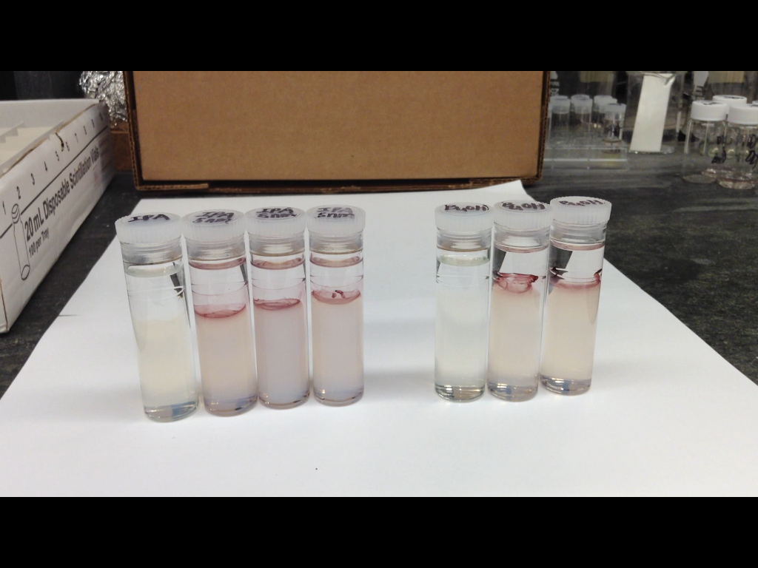
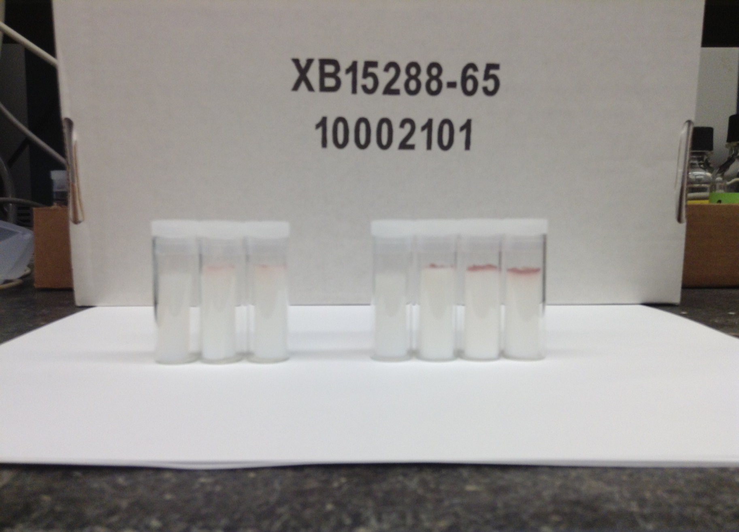
alcogel
aerogel
a
c
b
d
e
f
g
a
c
b
d
e
f
g

Figure S2. UV-vis spectra of n-alkanethiolate-capped gold nanoparticles (~ 3 nm) in hexanes. When 1,6-hexanedithiol, 1,8-octanedithiol and 1,10-decanedithiol were used as the capping alkanedithiols, the resulting capped gold nanoparticles could not be phase-transferred into the organic layer of hexanes, because of their multilayer formation and thus the giant sizes.
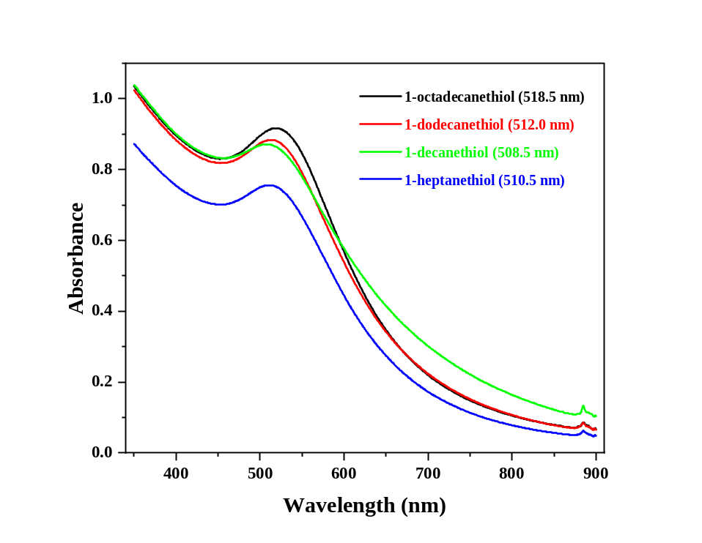

Figure S3. Heterogeneous nitrocellulose aerogels prepared in duplicates in the co-solvent of 2-propanol (a and b) or 1-butanol (c and d). The non-solvent is the hexanes containing 1-heptanethiolate- or 1-dodecanethiolate-capped gold nanoparticles (~3 nm). a and c are 1-dodecanethiol-capped gold nanoparticles, and b and d are for 1-heptanethiolate-capped gold nanoparticles.
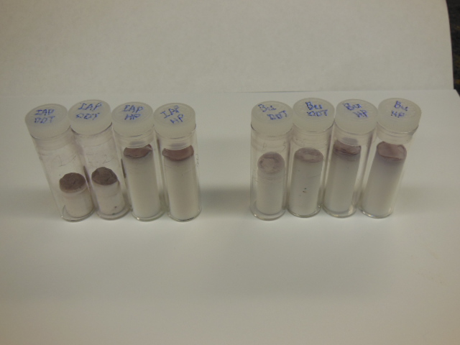
a
b
a
b
c
c
d
d

Figure S4. Photographs of AuNPs-infiltrated, homogeneous alcogels (top) and aerogels (bottom). The co-solvent for a and b is ethanol and ethanol with OH-AuNPs, respectively, and the non-solvent for a and b is hexanes; c, pure NC aerogel; d, NC aerogel with OH-AuNPs, and e, NC aerogels with COOH-AuNPs.

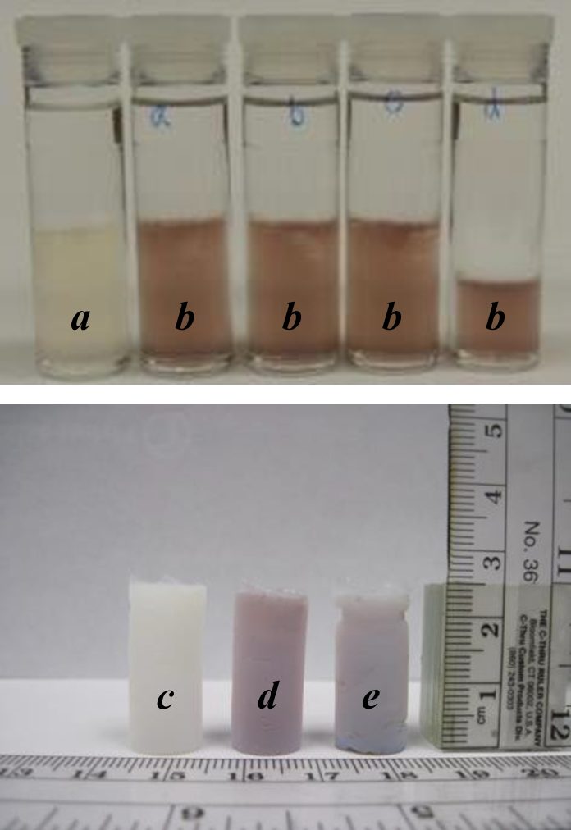

Figure S5. Photographs of c-MWCNTs-infiltrated, homogeneous alcogels (top) and aerogels (middle and bottom). The co-solvent for a is ethanol, and the co-solvent for b, c and d is ethanol with a c-MWCNT concentration of 0.26, 0.13, and 0.065 mg/mL, respectively. The non-solvent for a, b, c and d is hexanes. e, f, and g are NC aerogels obtained from the co-solvent of ethanol with a c-MWCNT concentration of 0.26, 0.13, and 0.065 mg/mL, respectively, and h, i, and j are NC aerogels obtained from the co-solvent of 2-propanol with a c-MWCNT concentration of 0.26, 0.13, and 0.065 mg/mL, respectively. k is pure NC aerogel.

