Appendices
Appendix A: DK-Lib CKD Trial Flow Chart
Appendix B: Automated Self-Administered 24-hour Canada (ASA24®) dietary assessment tool

Enrollment
Eligibility assessment
Excluded:
- Individuals do not meet the inclusion /exclusion criteria
- Declined to participate

Randomization sequence and Allocation (n: 30)
20 participants at SOGH and 10 participants at HSC

CY
Liberalized Dietary K Diet
(n=15)

Standard Dietary K Diet
(n=15)
- Standard ongoing multidisciplinary CKD care
- Oral sodium bicarbonate therapy

Data Analysis

Liberalized Dietary K Diet
(n=15)

6-weeks
Safety assessment at week 1-2 (day 10 ± 3 days):
- Clinical chemistry
- Blood pressure
Outcomes assessed at baseline, 1-2, 8, 10 and 16 weeks
- Chair stand time (STS5)
- Health related quality of life (KDQOL-SF)
- Clinical chemistry
- Blood pressure
- Dietary intake (ASA24®)

Standard Dietary K Diet
(n=15)

2-week washout period and treatment switch

CY
6-weeks
2-week run-in on Liberalized dietary K diet

Three day 24-hour food Log
Participant ID:
Day 1:
Time | Location (home, restaurant, work, etc.) | Were you watching TV or on your phone? | Were you eating alone or with someone else? Please state who (partner, co-worker, etc.) | Food (please include all information such as method of cooking, ingredients, etc.) | Amount (in cups, tbsp., tsp., pcs, etc.)
Time | Location (home, restaurant, work, etc.) | Were you watching TV or on your phone? | Were you eating alone or with someone else? Please state who (partner, co-worker, etc.) | Food (please include all information such as method of cooking, ingredients, etc.) | Amount (in cups, tbsp., tsp., pcs, etc.)
Time | Location (home, restaurant, work, etc.) | Were you watching TV or on your phone? | Were you eating alone or with someone else? Please state who (partner, co-worker, etc.) | Food (please include all information such as method of cooking, ingredients, etc.) | Amount (in cups, tbsp., tsp., pcs, etc.)

Appendix C: Health Related Quality of Life (QOL) using the physical function domain of the Kidney Disease Quality of Life Short Form (KDQOL-SF) questionnaire
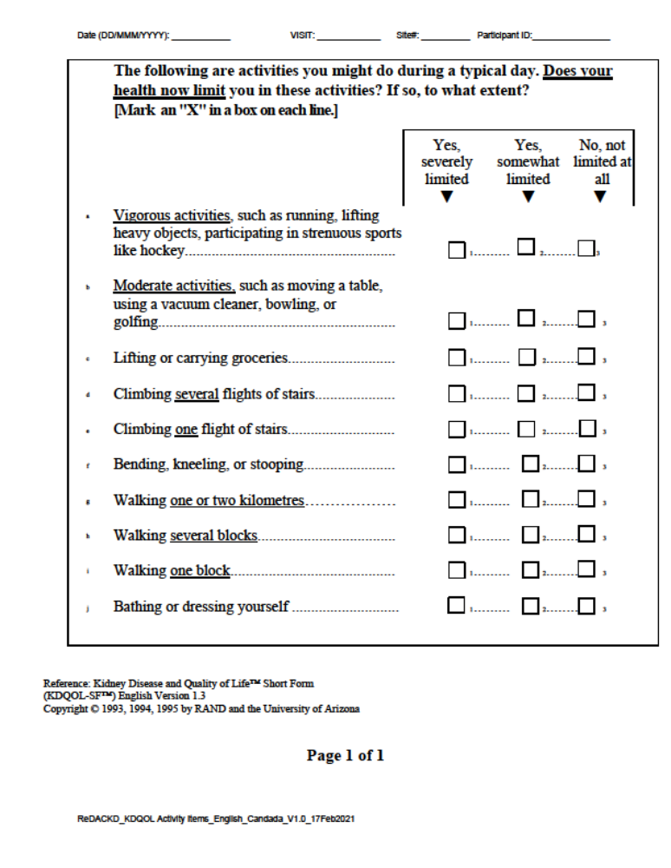

Appendix D: Trial Flow Design
