Design and synthesis of novel cycloalkanecarboxamide parabanic acid hybrids as anticonvulsants
Walaa Hamada Abd-Allah ^{1,} *, Mohamed Samir Abd El-Maksoud², Marawan A. Elbaset ³ , Alyaa F. Hessin ³, Rasha Mohamed Hassan ²
¹ Pharmaceutical Chemistry Department, Collage of Pharmaceutical Science and Drug Manufacturing, Misr University for Science and Technology, P.O. 77, 6th of October City, Giza, Egypt.
² Medicinal and Pharmaceutical Chemistry Department, Pharmaceutical and Drug Industries Research Institute, National Research Centre (ID: 60014618), P.O. 12622,
Dokki, Giza, Egypt.
³ Department of Pharmacology, Medical Research and Clinical Studies Institute, National Research Centre, Giza, Egypt.

*Corresponding author:
Walaa Hamada Abd-Allah: Email: Walaa.abdalla@must.edu.eg
ORCID: 0000-0003-2659-2764

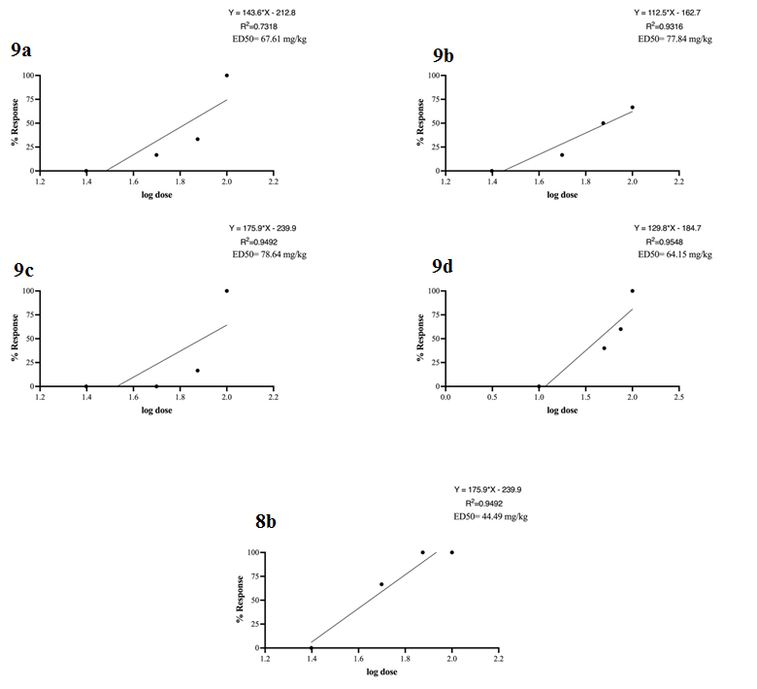
Figure. S 1: ED₅₀ for most potent compounds in MES.

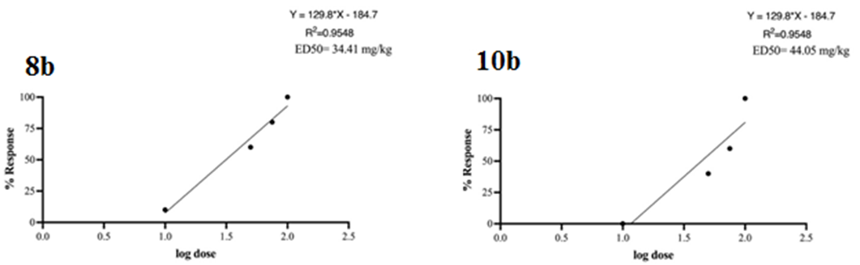

Figure.S 2: ED₅₀ for most potent compounds in PTZ.

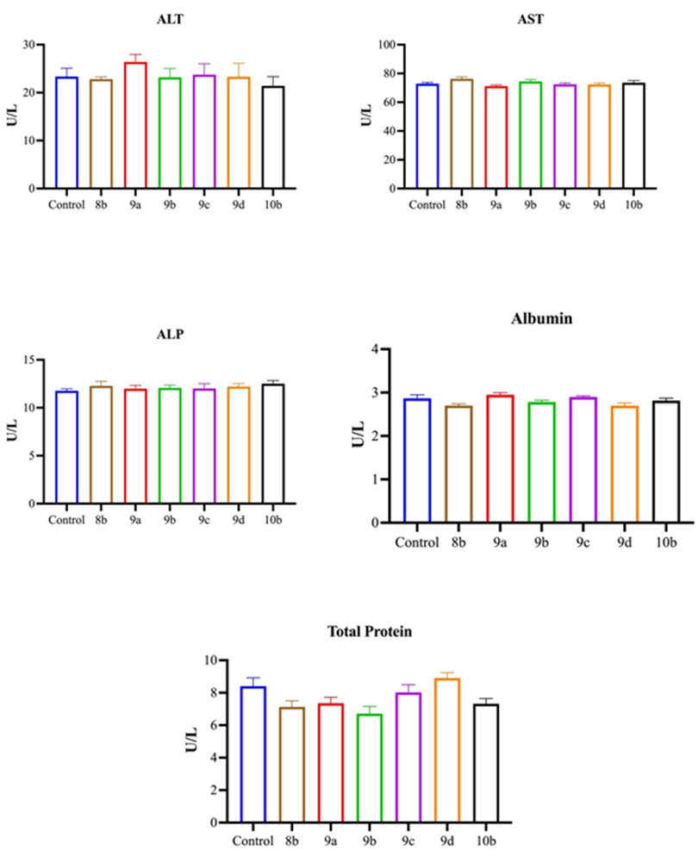
Figure.S 3: Serum levels of liver enzymes, total protein and albumin of substances 8b, 9a-d and 10b, data are illustrated as barchart ± SEM. * vs control group; < 0.05.

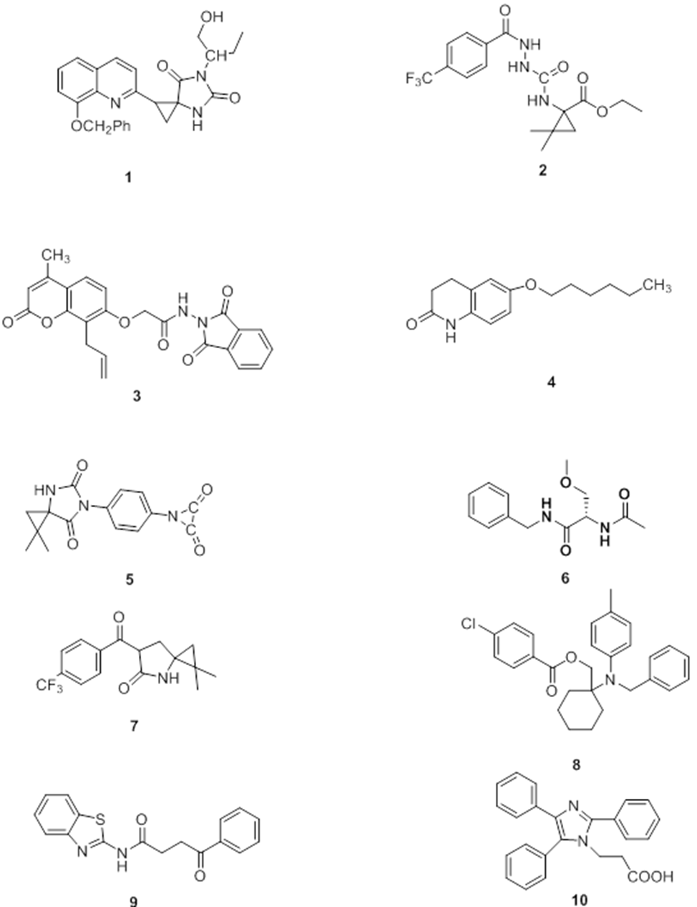

Figure.S 4: Structures of training set.

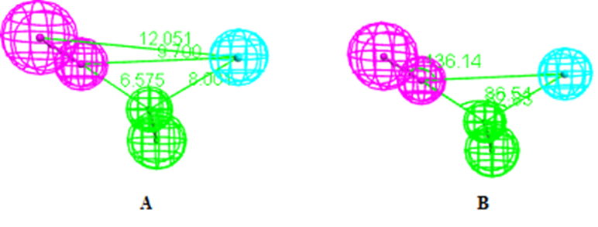
Figure. S 5: (A and B) Constraint distances and angels for the valid genereated pharmacophoric modeling of anticonvulsant. The features colored green, pink and light blue represent HBA, HBD and features HY, respectively.
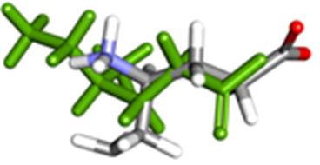

Figure.S 6: Superimposition of the co-crystalized (green) and the docking pose (grey) of vigabatrin on the binding site GABA-AT with RMSD of 0.9632 Å.

Spectral data for intermediate and final compounds
Compound 3a-¹H NMR
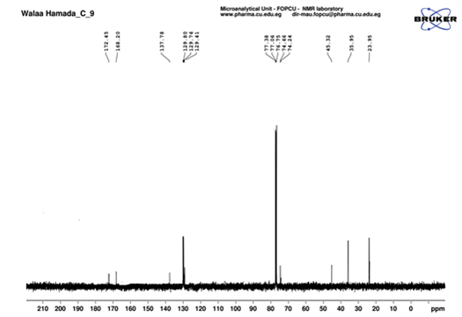
Figure SI 7: ¹³C-NMR spectra of compound 3a

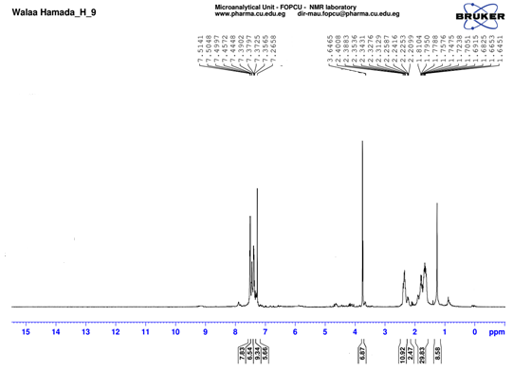

Figure S 8: ¹H-NMR spectra of compound 3a

Compound 4a-¹H NMR
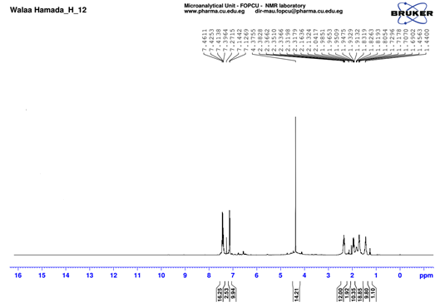
Figure S 9: ¹H-NMR spectra of compound 4a

Compound 5a-¹H NMR
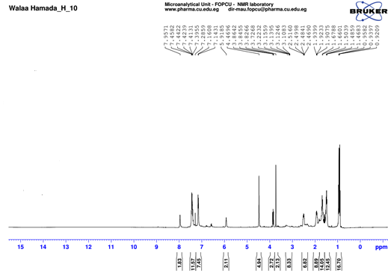
Figure S 10: ¹H-NMR spectra of compound 5a

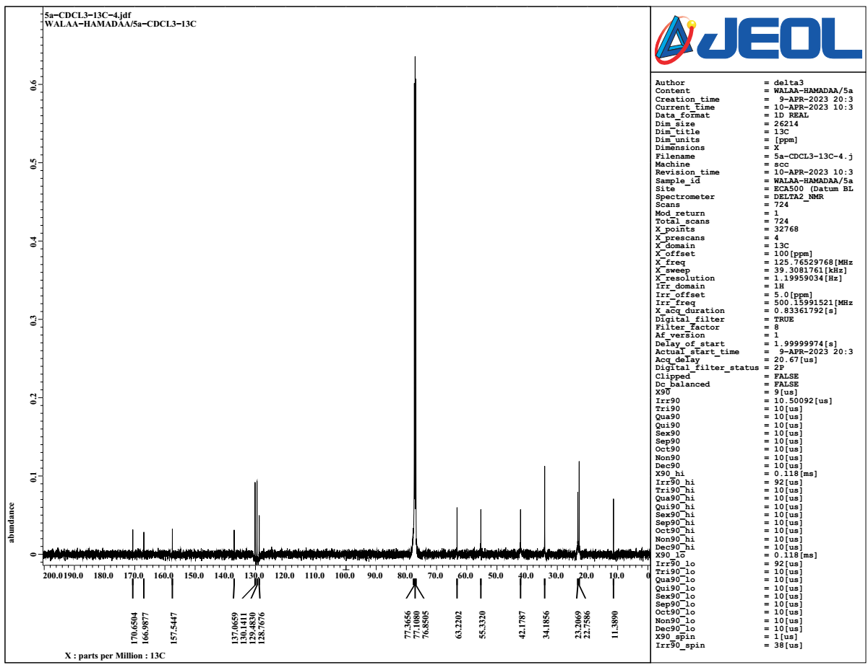
Figure S 11: ¹³C-NMR spectra of compound 5a

Compound 5b-¹³C NMR
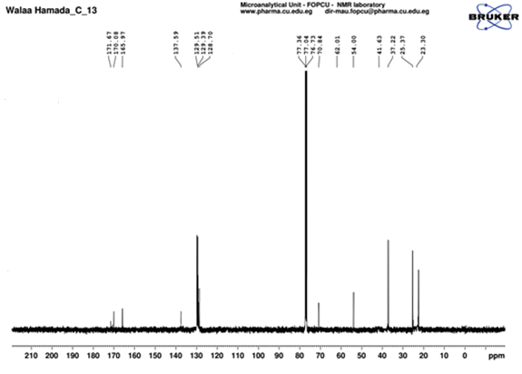
Figure S 12: ¹³C-NMR spectra of compound 5b

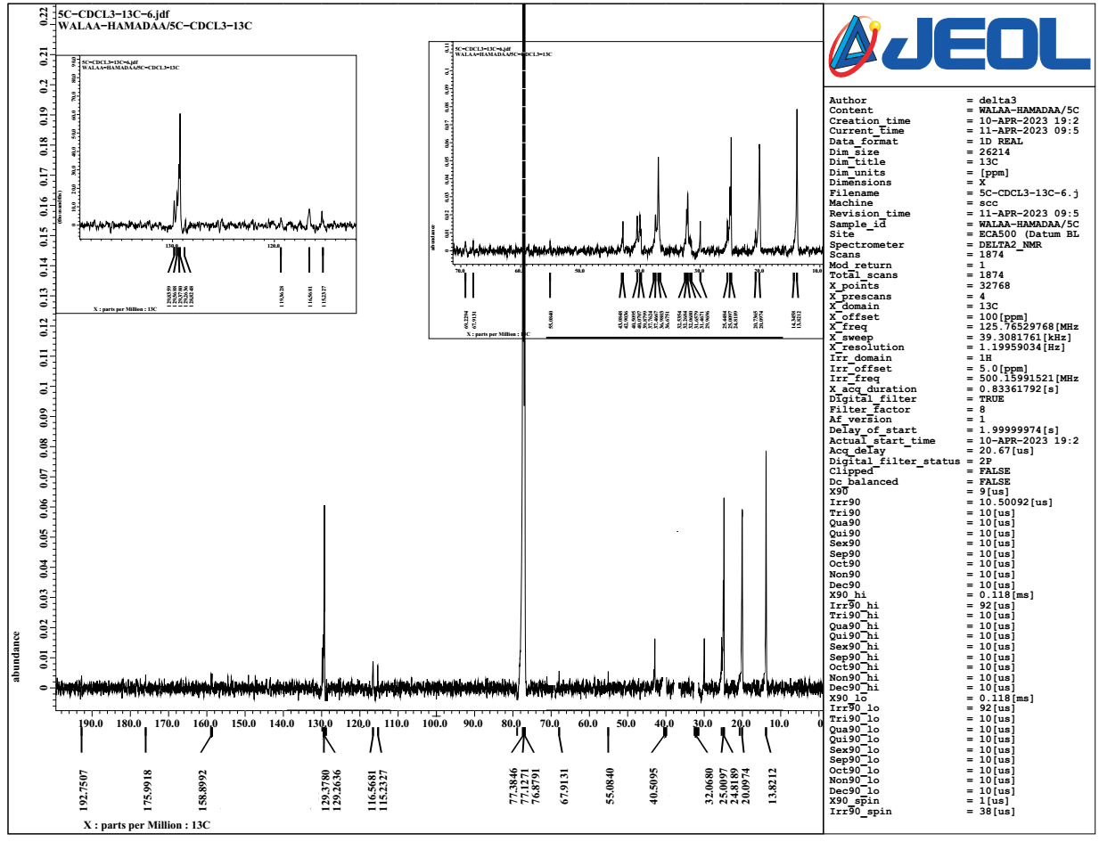

Figure S 13: ¹³C-NMR spectra of compound 5c

Compound 6a-¹H NMR
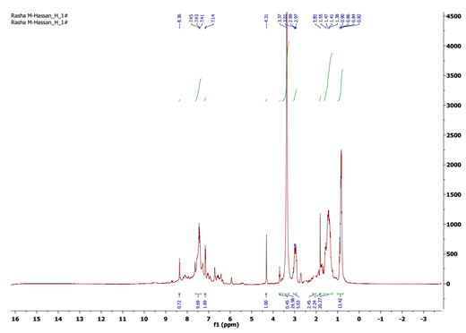

Figure S 14: ¹H-NMR spectra of compound 6a

Compound 6a-¹³C NMR
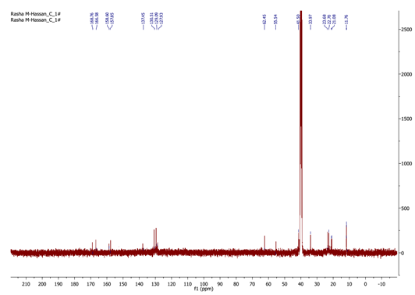
Figure S 15: ¹³C-NMR spectra of compound 6a

Compound 6b- ¹H NMR

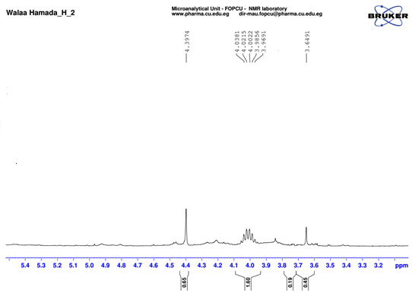
Figure S 16: ¹H-NMR spectra of compound 6b

Compound 6b-¹H NMR
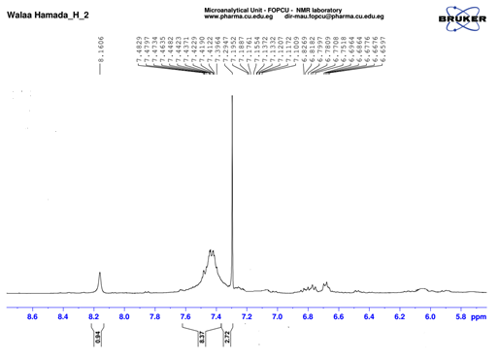
Figure S 17: ¹H-NMR spectra of compound 6b

Compound 6b- ¹³C NMR
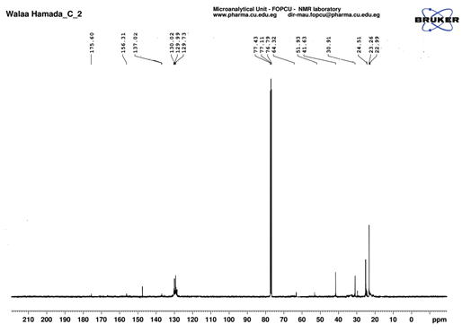
Figure S 18: ¹³C-NMR spectra of compound 6b

Compound 6c- ¹H NMR

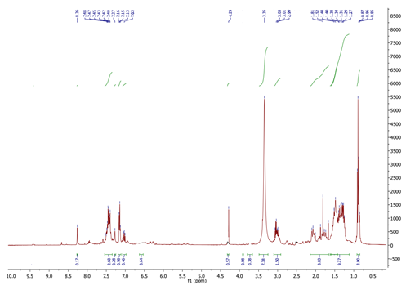

Figure S 19: ¹H-NMR spectra of compound 6c

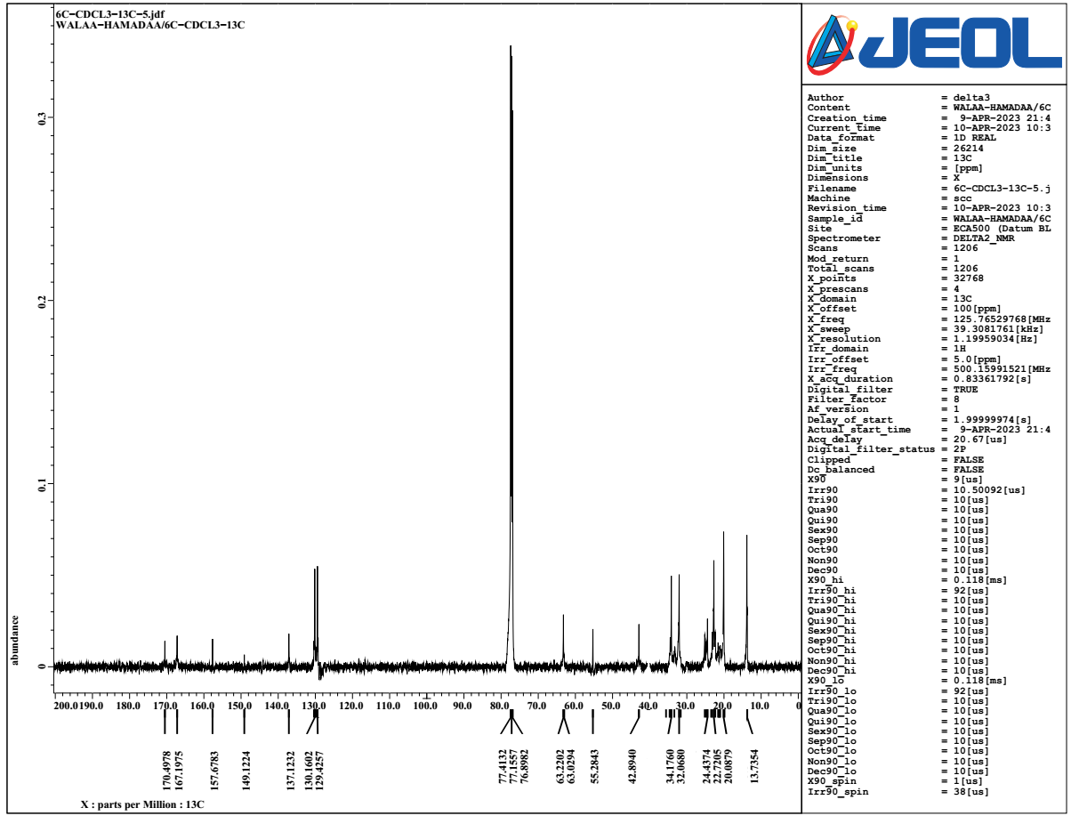
Figure S 20: ¹³C-NMR spectra of compound 6c

Compound 6d -¹H NMR
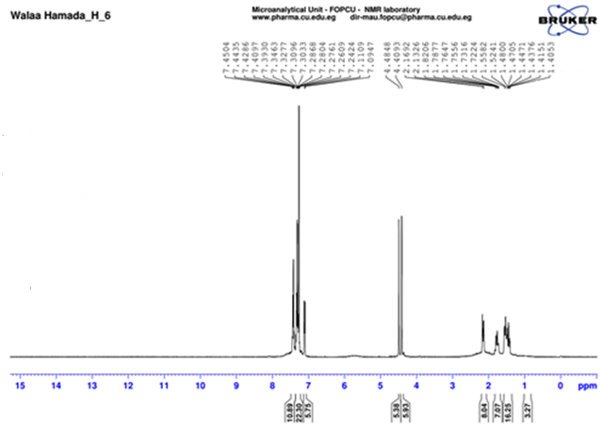
Figure S 21: ¹H-NMR spectra of compound 6d

Compound 7a-¹H NMR

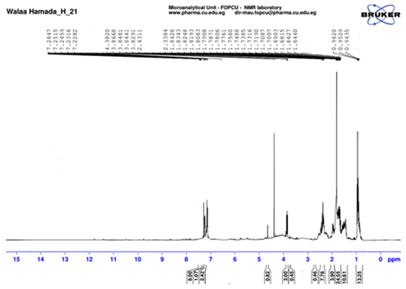
Figure S 22: ¹H-NMR spectra of compound 7a

Compound 7a-¹³C NMR
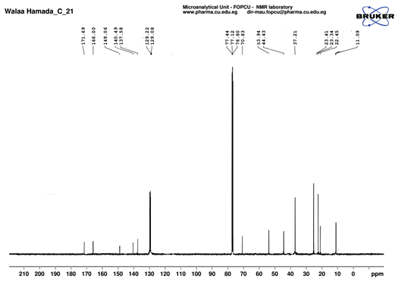
Figure S 23: ¹³C-NMR spectra of compound 7a

Compound 7b-¹H NMR
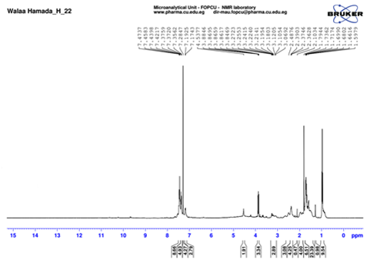
Figure S 24: ¹H-NMR spectra of compound 7b

Compound 7b-¹³C NMR
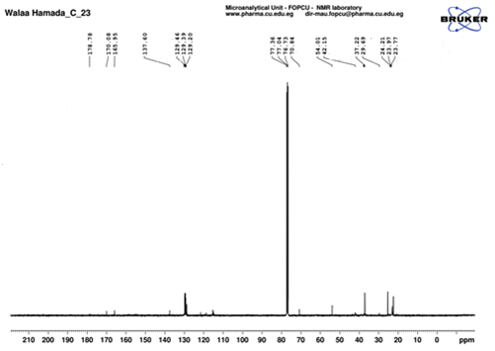
Figure S 25: ¹³C-NMR spectra of compound 7a

Compound 7d- ¹H NMR
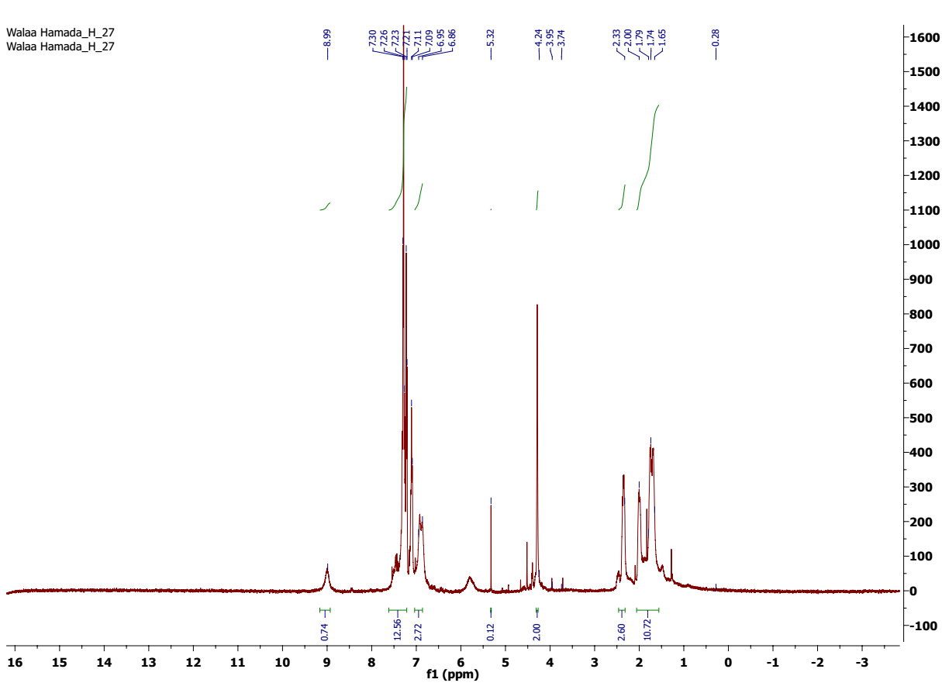
Figure S 26: ¹H-NMR spectra of compound 7d

Compound 8a ¹H-NMR
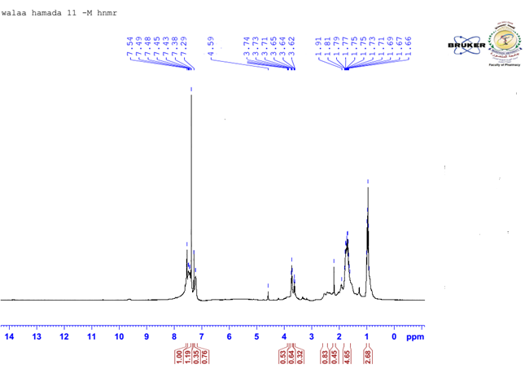
Figure S 27: ¹H-NMR spectra of compound 8a

Compd 8a-¹³C NMR
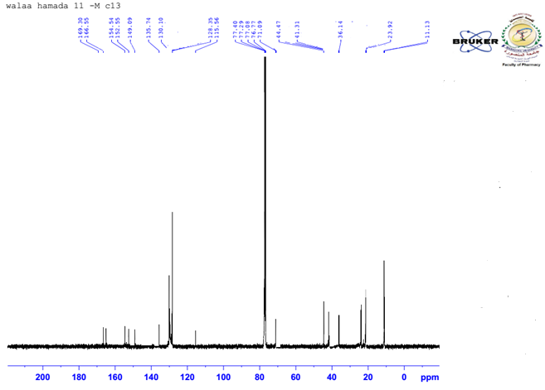
Figure S 28: ¹³C-NMR spectra of compound 8a

Compound 8b-¹³C NMR
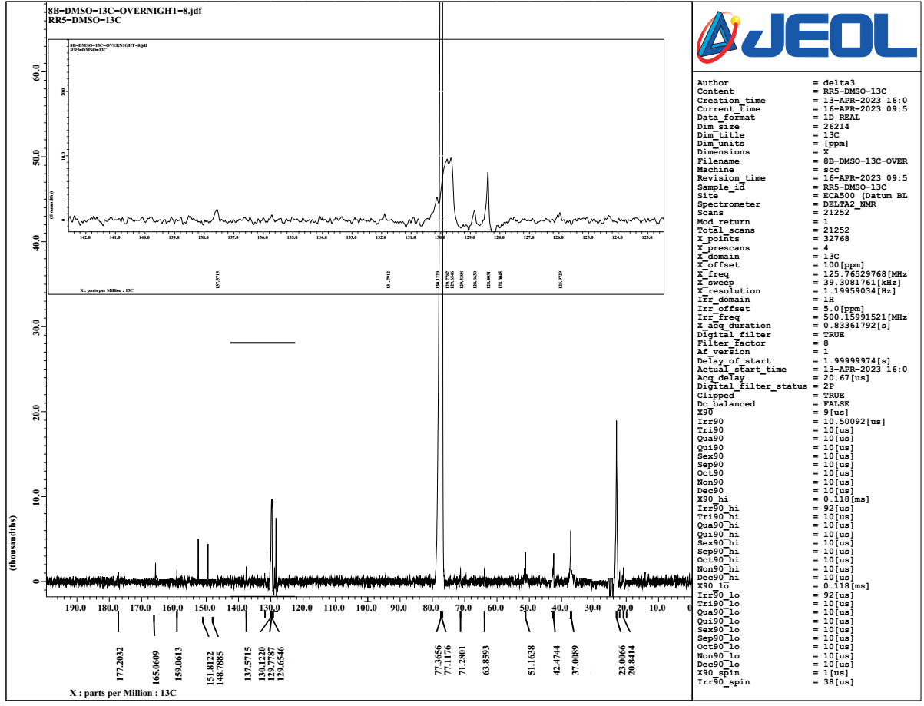
Figure S 29: ¹³C-NMR spectra of compound 8b

Compd 8c-¹H NMR

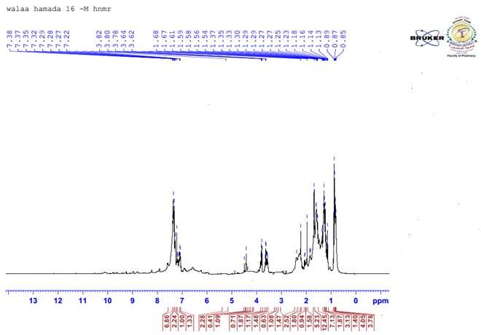
Figure S 30: ¹H-NMR spectra of compound 8c

Compound 8c-¹³C NMR
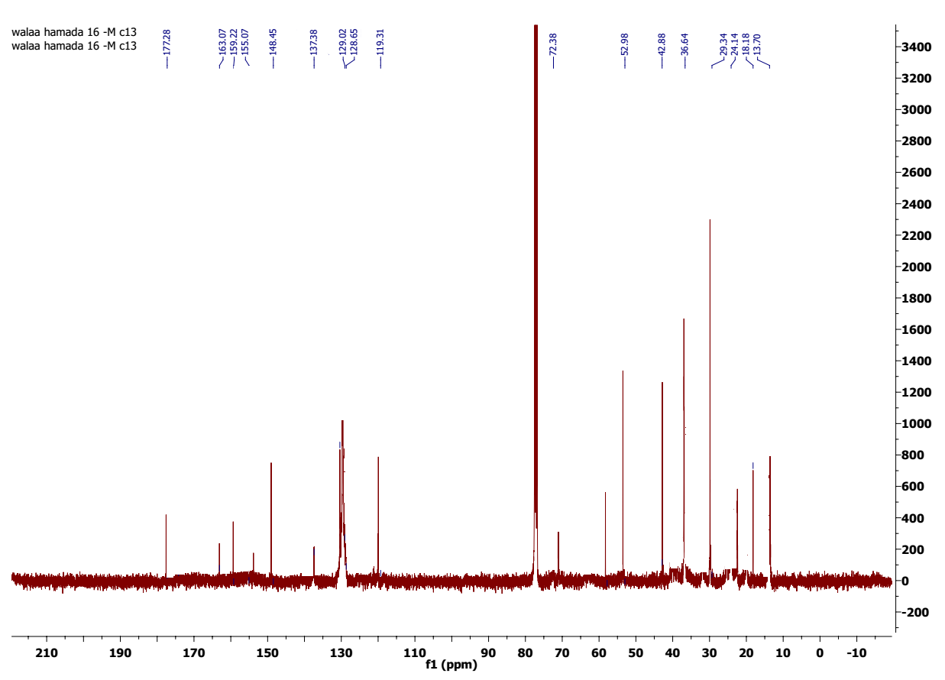
Figure S 31: ¹³C-NMR spectra of compound 8c

Compd 8d ¹H-NMR
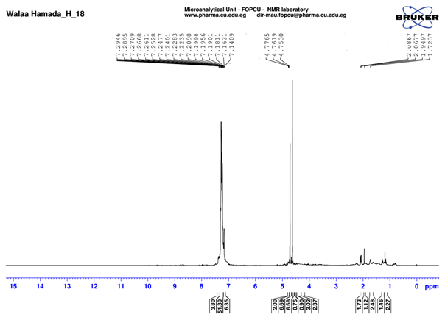
Figure S 32: ¹H-NMR spectra of compound 8d

Compd 9b ¹H-NMR
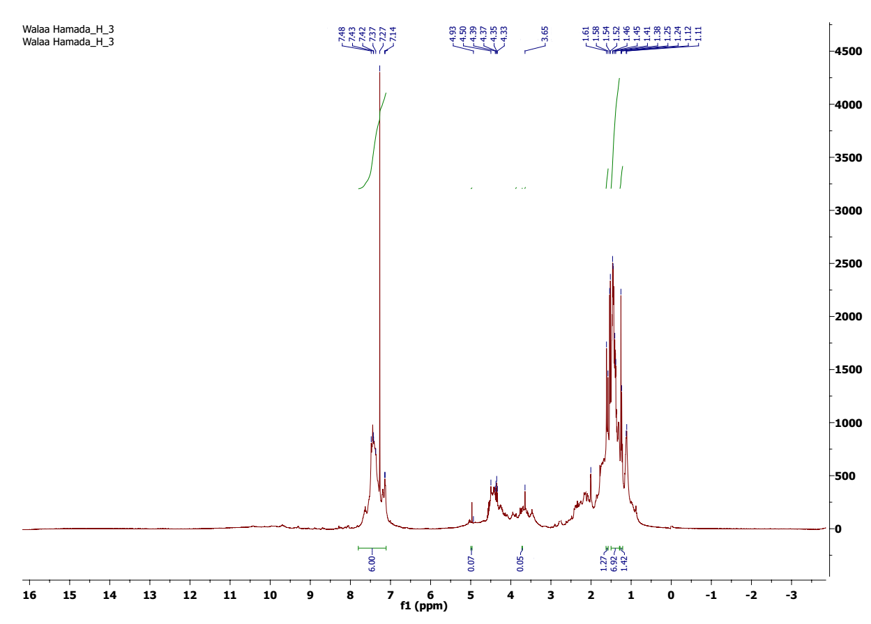
Figure S 33: ¹H-NMR spectra of compound 9b

Compd 9b-¹³C-NMR

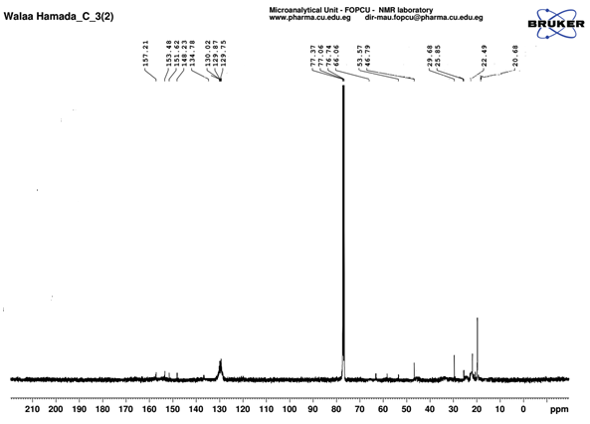
Figure S 34: ¹³C-NMR spectra of compound 9b

Compd 9c ¹H-NMR
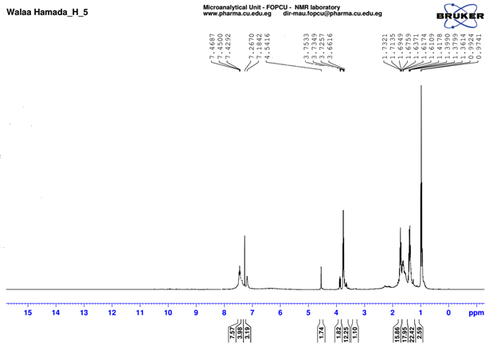
Figure S 35: ¹H-NMR spectra of compound 9c

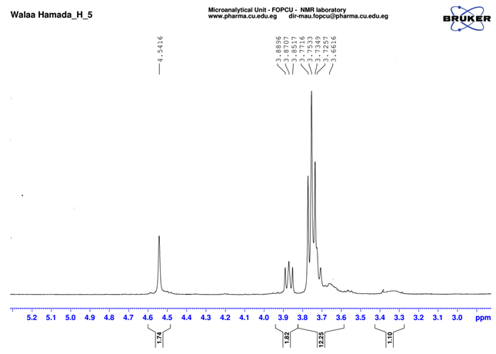
Figure S 36: ¹H-NMR spectra of compound 9c

Compound 9c-¹³C-NMR
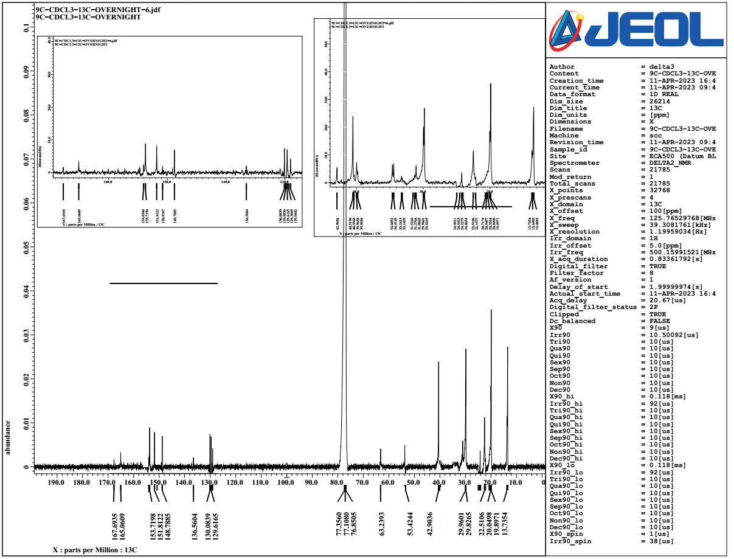
Figure S 37: ¹³C-NMR spectra of compound 9c

Compound 9d ¹H-NMR

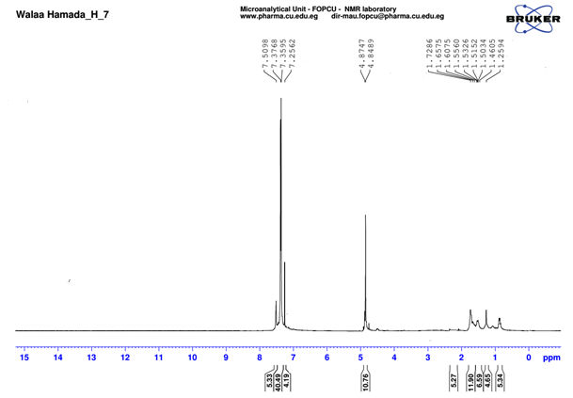
Figure S 38: ¹H-NMR spectra of compound 9d

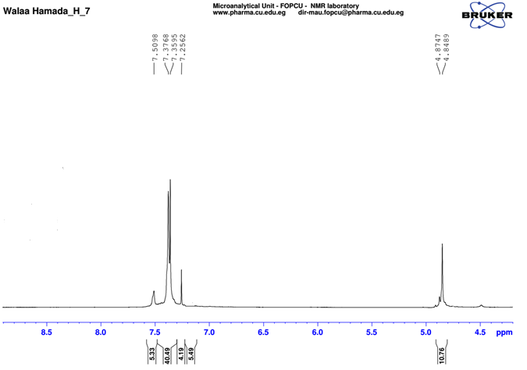
Figure S 39: ¹H-NMR spectra of compound 9d

Compound 10a ¹H-NMR
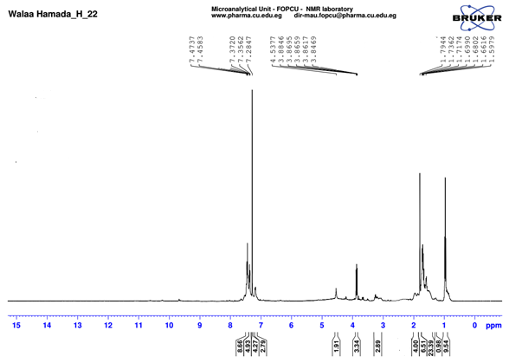
Figure S 40: ¹H-NMR spectra of compound 10a

Compound 10a ¹³C-NMR
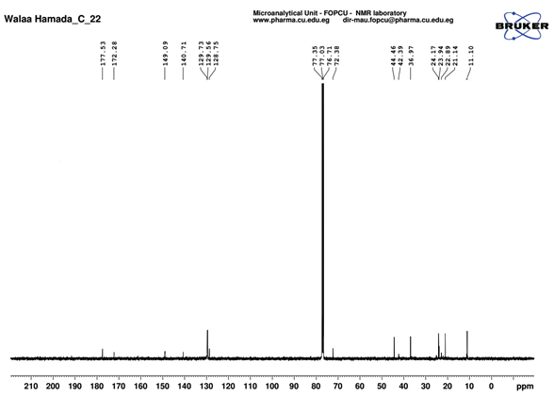
Figure S 41: ¹³C-NMR spectra of compound 10a

Compound 10b-¹H NMR
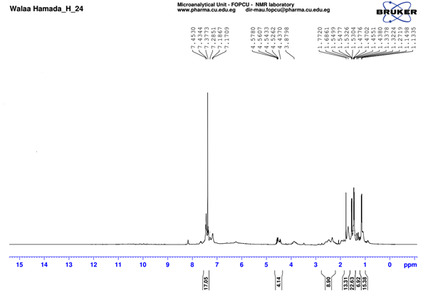
Figure S 42: ¹H-NMR spectra of compound 10b

Compound 10c-¹H NMR
Figure S 43: ¹H-NMR spectra of compound 10c

Table SI 1: Mapping of test compounds 8a-d, 9a-d and 10a-d with the generated hypothesis.
compound | Fit value | Pharmacophore
8a | 2.97 | 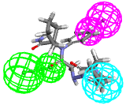
8b | 2.99 | 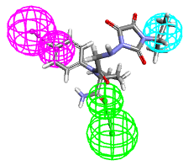
8c | 2.97 | 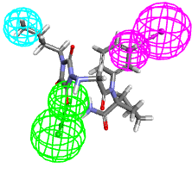
8d | 2.98 | 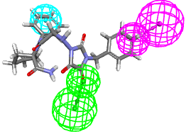
9a | 2.97 | 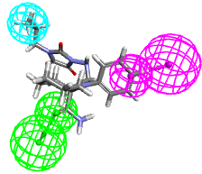
9b | 2.98 | 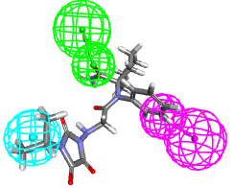
9c | 2.98 | 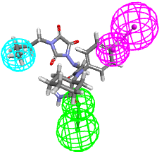
9d | 2.85 | 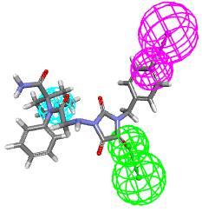
10a | 2.98 | 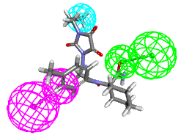
10b | 2.98 | 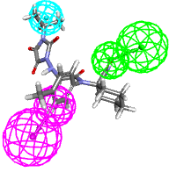
10c | 2.97 | 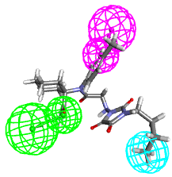
10d | 2.93 | 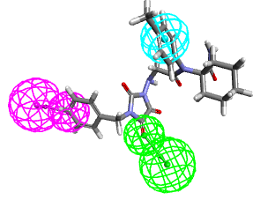

Table SI 2. 2 D and 3 D interactions for compounds (8a-d, 9a-d and 10a-d) at the of γ-aminobutyric acid aminotransferase GABA-AT (PDB: 1OHW).
Compd | 2D Interaction | 3D Interaction
8a | 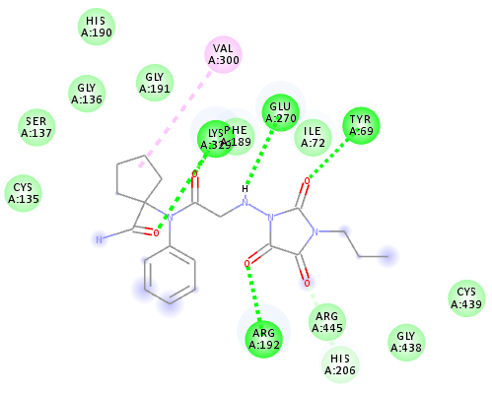 | 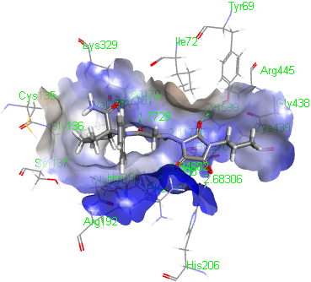
8b | 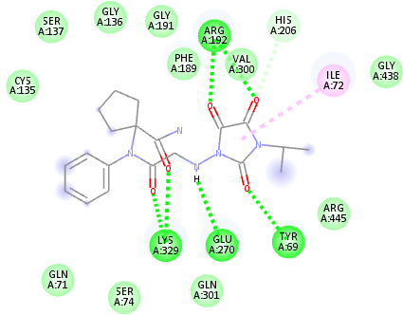 | 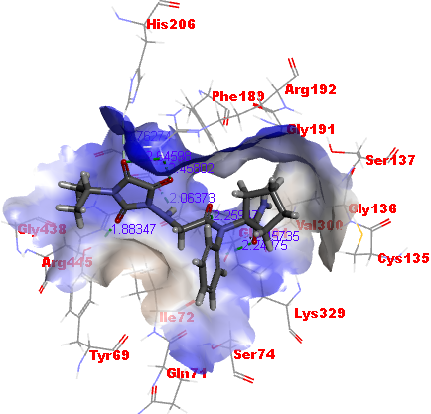
8c | 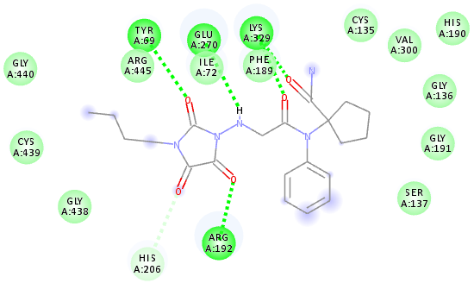 | 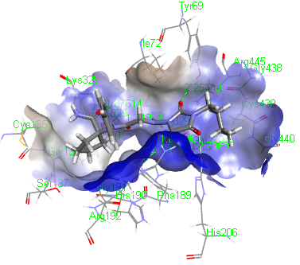
8d | 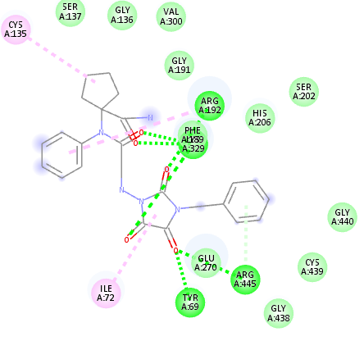 | 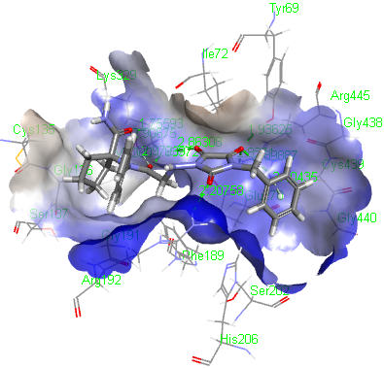
9a | 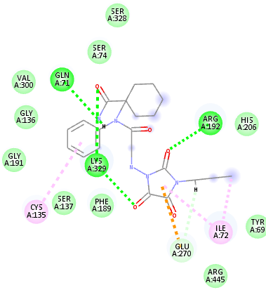 | 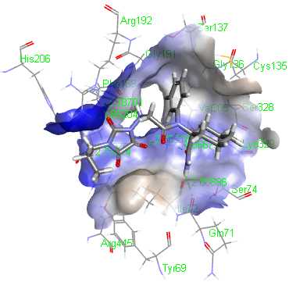
9b | 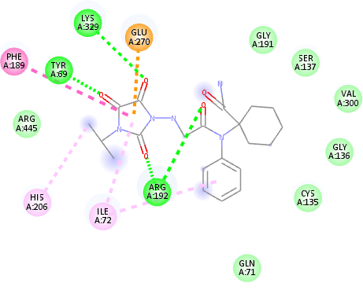 | 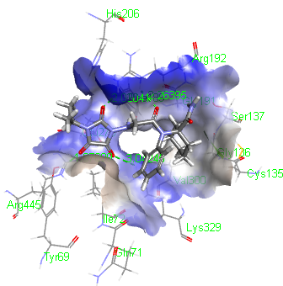
9c | 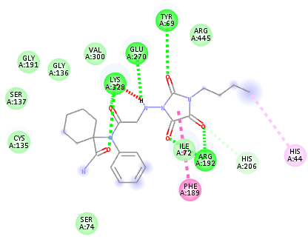 | 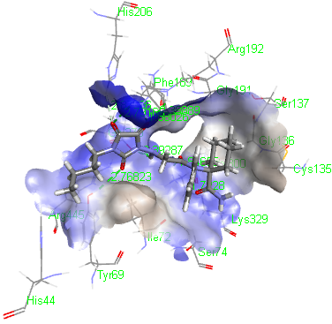
9d | 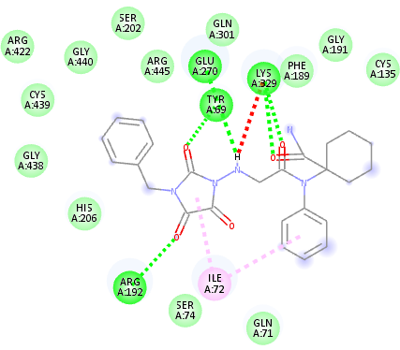 | 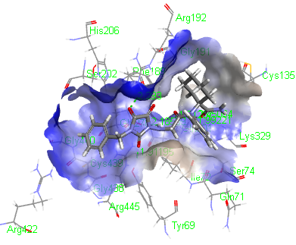
10a | 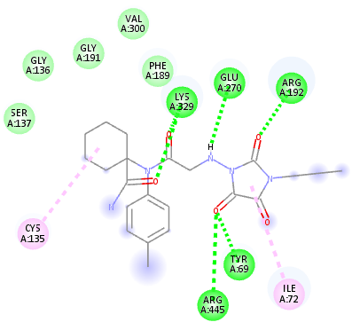 | 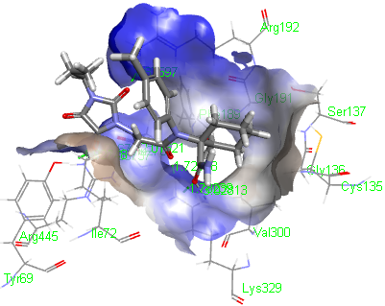
10b | 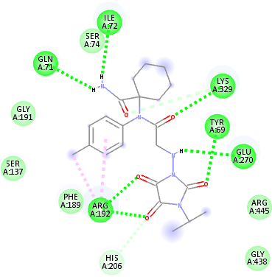 | 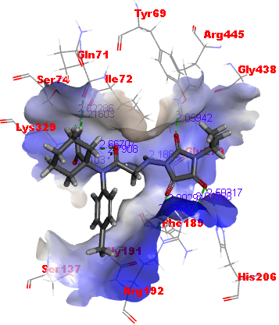
10c | 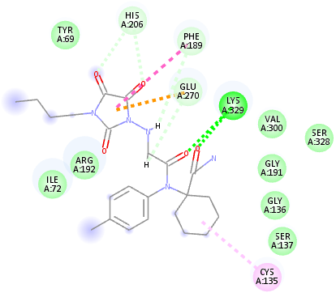 | 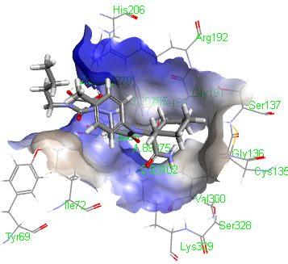
10d | 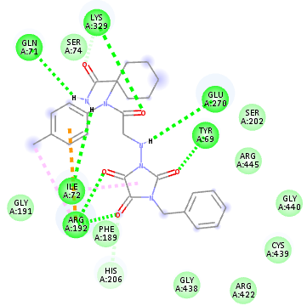 | 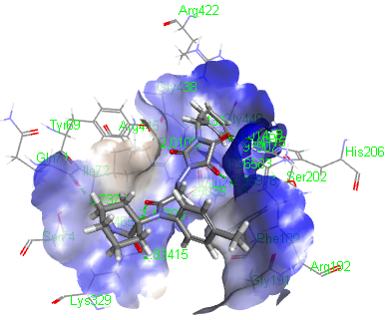
Ligand | 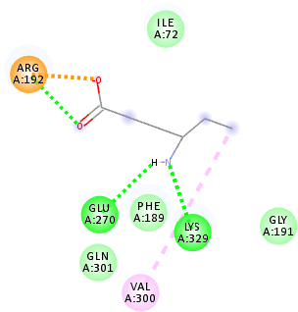 | 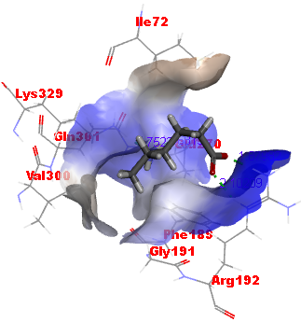

HPLC chromatograms of the final compounds
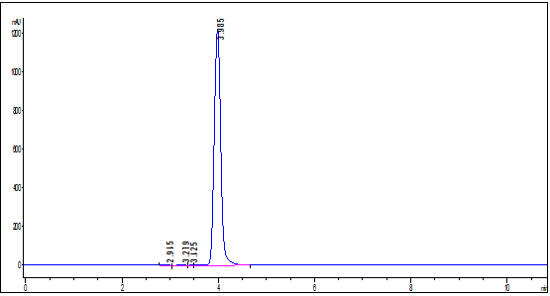
HPLC chromatogram for compound 8a
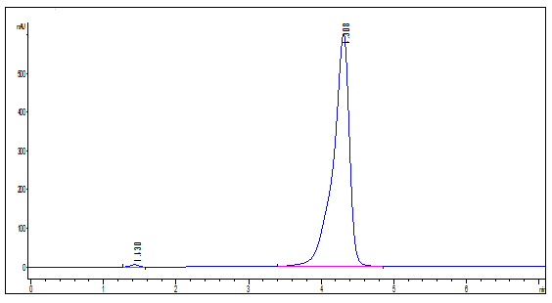
HPLC chromatogram for compound 8b
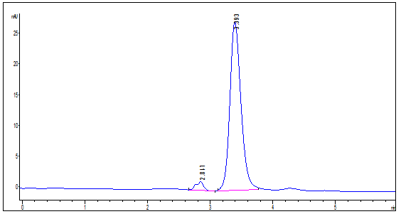
HPLC chromatogram for compound 8c

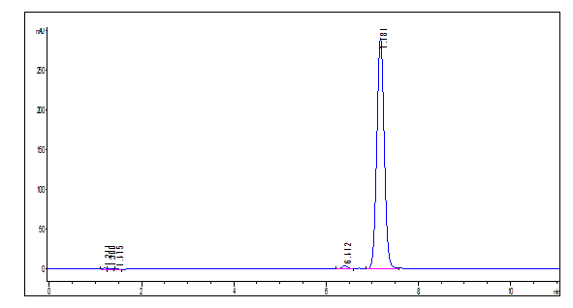
HPLC chromatogram for compound 8d
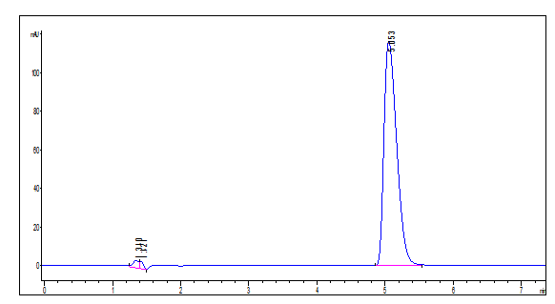
HPLC chromatogram for compound 9a
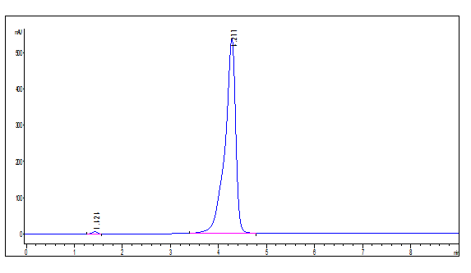
HPLC chromatogram for compound 9b

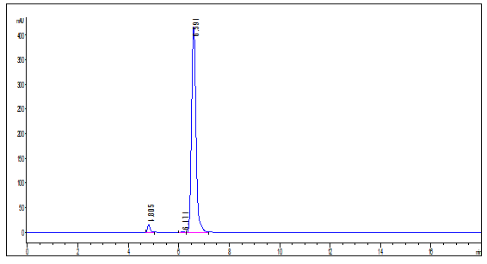
HPLC chromatogram for compound 9c

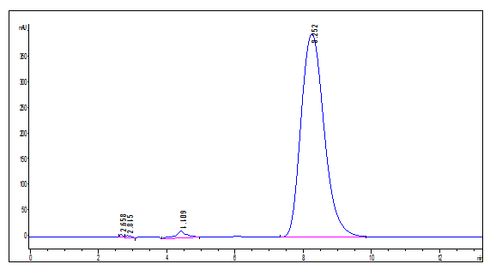
HPLC chromatogram for compound 9d

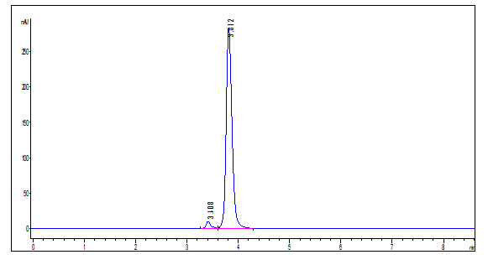
HPLC chromatogram for compound 10a

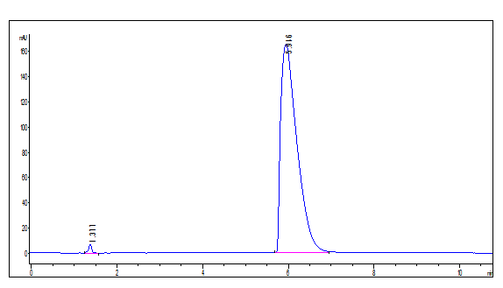
HPLC chromatogram for compound 10b

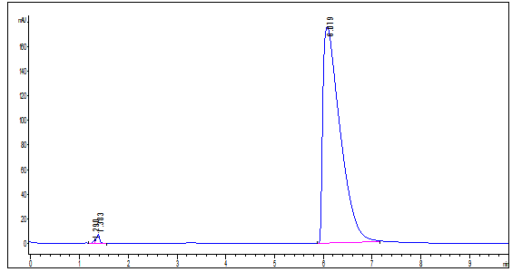
HPLC chromatogram for compound 10c

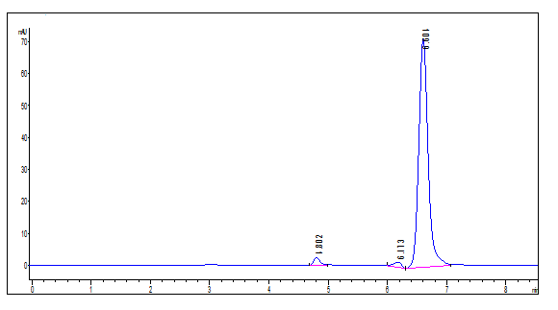
HPLC chromatogram for compound 10d

