Appendix. A: Adjoint sensitivity analysis

The physical model is discretized using finite element method, so we can write the resulting equations of the linear system as:

$S\left(ε_{r}\right)E_{z}=F$. (1)

Where the $S\left(ε_{r}\right)$ is the design dependent system matrix and $E_{z}$ is a vector of degrees of freedom for the electric field.

The gradient of the FOM with the design variable $ρ_{k}$ calculated as:

$\frac{dΦ}{d{\overset{ __}{\tilde{ρ}}}_{k}}=\frac{∂Φ}{∂E_{z,R}}\frac{∂E_{z,R}}{∂{\overset{ __}{\tilde{ρ}}}_{k}}+\frac{∂Φ}{∂E_{z,I}}\frac{∂E_{z,I}}{∂{\overset{ __}{\tilde{ρ}}}_{k}}$ . (2)

Where the $E_{z,R}$ and $E_{z,I}$ denotes the real and imaginary part of the electric field respectively. By adding zero the FOM twice,

$\tilde{Φ}=Φ+λ^{T}\left({SE}_{z}-F\right)+λ^{†}\left(S^{*}E_{z}^{*}-F^{*}\right)$ . (3)

Where the $λ^{T}$ is the transpose of the Lagrange multipliers (adjoint variables). Then taking the derivative of $\tilde{Φ}$ with respect to the design variables ${\overset{ __}{\tilde{ρ}}}_{k}$ the result is computed as:

$\begin{aligned}\frac{d\tilde{Φ}}{d{\overset{ __}{\tilde{ρ}}}_{k}}=&\frac{∂Φ}{∂E_{z,R}}\frac{∂E_{z,R}}{∂{\overset{ __}{\tilde{ρ}}}_{k}}+\frac{∂Φ}{∂E_{z,I}}\frac{∂E_{z,I}}{∂{\overset{ __}{\tilde{ρ}}}_{k}} \\ &+λ^{T}\left(\frac{∂S}{d{\overset{ __}{\tilde{ρ}}}_{k}}E_{z}+S\left(\frac{∂E_{z,R}}{∂{\overset{ __}{\tilde{ρ}}}_{k}}+i\frac{∂E_{z,F}}{∂{\overset{ __}{\tilde{ρ}}}_{k}}\right)\right) \\ &+λ^{†}\left(\frac{∂S^{*}}{∂{\overset{ __}{\tilde{ρ}}}_{k}}E_{z}^{*}+S^{*}\left(\frac{∂E_{z,R}}{∂{\overset{ __}{\tilde{ρ}}}_{k}}-i\frac{∂E_{z,I}}{∂{\overset{ __}{\tilde{ρ}}}_{k}}\right)\right).\end{aligned}$ (4)

Collecting the two terms $\frac{∂E_{z,R}}{∂{\overset{ __}{\tilde{ρ}}}_{k}}$ and $\frac{∂E_{z,I}}{∂{\overset{ __}{\tilde{ρ}}}_{k}}$ and reducing the remaining terms yields

$\begin{aligned}\frac{d\tilde{Φ}}{d{\overset{ __}{\tilde{ρ}}}_{k}}=&\frac{∂E_{z,R}}{∂{\overset{ __}{\tilde{ρ}}}_{k}}\left(\frac{∂Φ}{∂E_{z,R}}+λ^{T}S+λ^{†}S^{*}\right) \\ &+\frac{∂E_{z,s}}{{\overset{ __}{\tilde{ρ}}}_{k}}\left(\frac{∂Φ}{∂E_{z,S}}+iλ^{T}S+i^{†}S^{*}\right)+2R\left(λ^{T}\frac{∂S}{{\overset{ __}{\tilde{ρ}}}_{k}}E_{z}\right).\end{aligned}$ (5)

The elimination of the first two terms in eq.16 with the two derivates $\frac{∂E_{z,R}}{∂{\overset{ __}{\tilde{ρ}}}_{k}}$ and $\frac{∂E_{z,I}}{∂{\overset{ __}{\tilde{ρ}}}_{k}}$, the two parentheses must equal zero,

$\frac{∂Φ}{∂E_{z,R}}+λ^{T}S+λ^{†}S^{*}=0,\frac{∂Φ}{∂E_{z,S}}+iλ^{T}S+iλ^{†}S^{*}=0 .$ (6)

Multiplying the second equation by I, subtracting it from the first, and transposing it yields

$\frac{∂Φ}{∂E_{z,R}}-i\frac{∂Φ}{∂E_{z,I}}+2λ^{T}S=0⇔S^{T}λ=-\frac{1}{2}{\left(\frac{∂Φ}{∂E_{z,R}}-i\frac{∂Φ}{∂E_{z,I}}\right)}^{T}.$ (7)

When the requiring in eq. 18 is satisfied, the final expression of the eq.15 will be

$\frac{∂Φ}{∂{\overset{ __}{\tilde{ρ}}}_{k}}=2R\left[λ^{T}\frac{∂S}{{\overset{ __}{\tilde{ρ}}}_{k}}E_{Z}\right].$ (8)

Appendix. B: The convergence history

Fig.1 observes the convergence history of the normalized FOM respected to each wavelength in RBG color over the inverse design iteration. The FOM has a stable convergence until reaches the local optima and requires only 37 iterations.

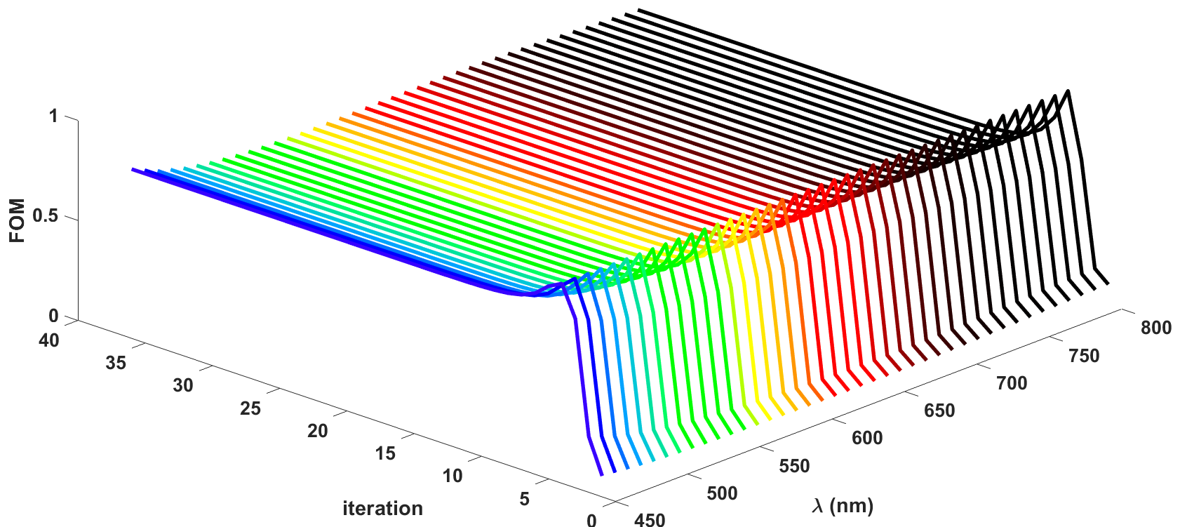

Figure1. The convergence history over the design iteration for meta-lens with NA = 0.7.

