Shedding light on conservation strategies for the invasive species Potamopyrgus antipodarum under changing climate
Supplementary data
Appendix A1
New Zealand mud snail Potamopyrgus antipodarum
Potamopyrgus antipodarum buries itself in the sediment when it is dry or cold, this snail is known as a mudsnail (Duft et al. 2003a). This mollusc has a small narrow shell measures 1 to 10 mm in length with a solid, well-formed operculum and a strong mobile and retractile foot (Winterbourn 1970; Kabat and Hershler 1993; Duft et al. 2003a, b). It can tolerate a wide range of environmental conditions in both native and invaded habitats (Winterbourn, 1969; Alonso and Castro-Díez, 2008; 2012). Its distribution in New Zealand appears to be limited by rather high-water temperatures (> 30 °C) (Winterbourn 1969; Alonso et al. 2023). Also, Clements et al. (2011) discovered the species populations in geothermal streams (Yellowstone National Park, USA) at water temperatures as high as 35.3 °C. Besides, Moffit and James (2012) reported that the size of the species population is regulated by near-to-below freezing winter.

Supplementary figures
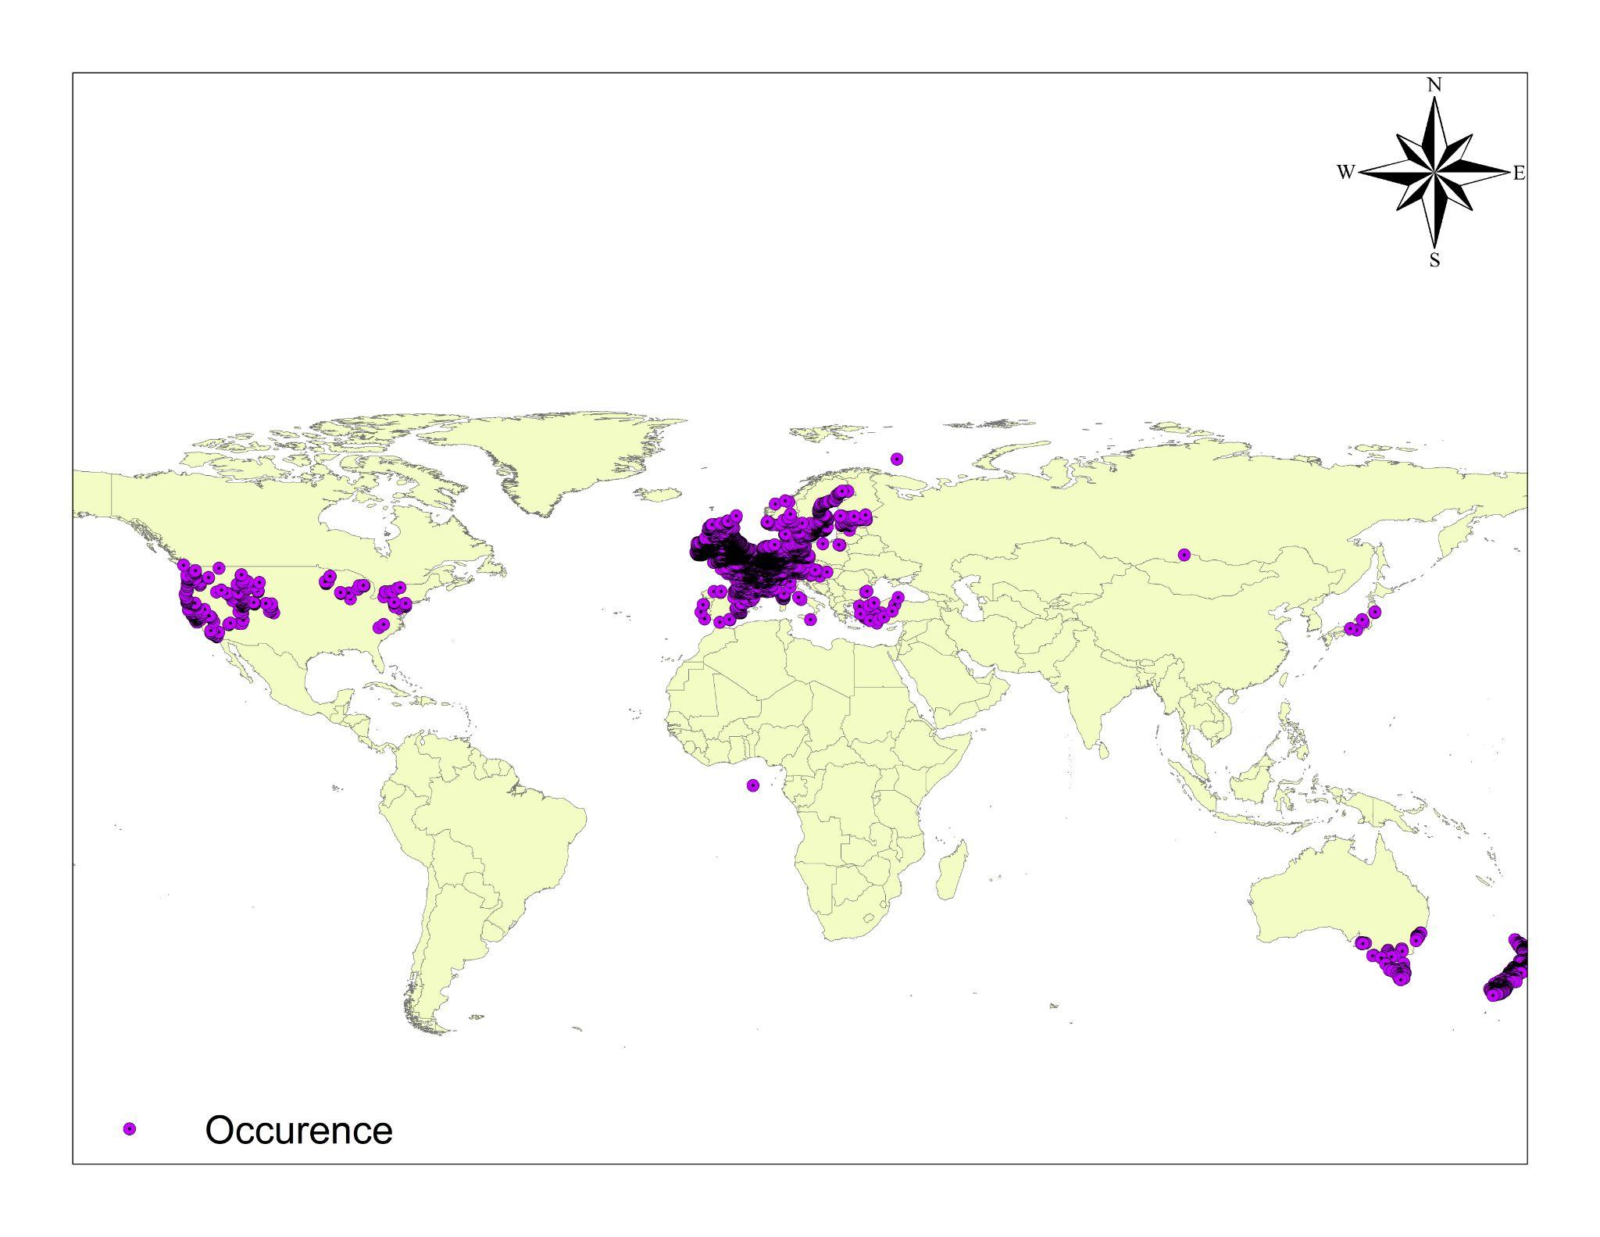Fig S1. Occurrence points of Potamopyrgus antipodarum.

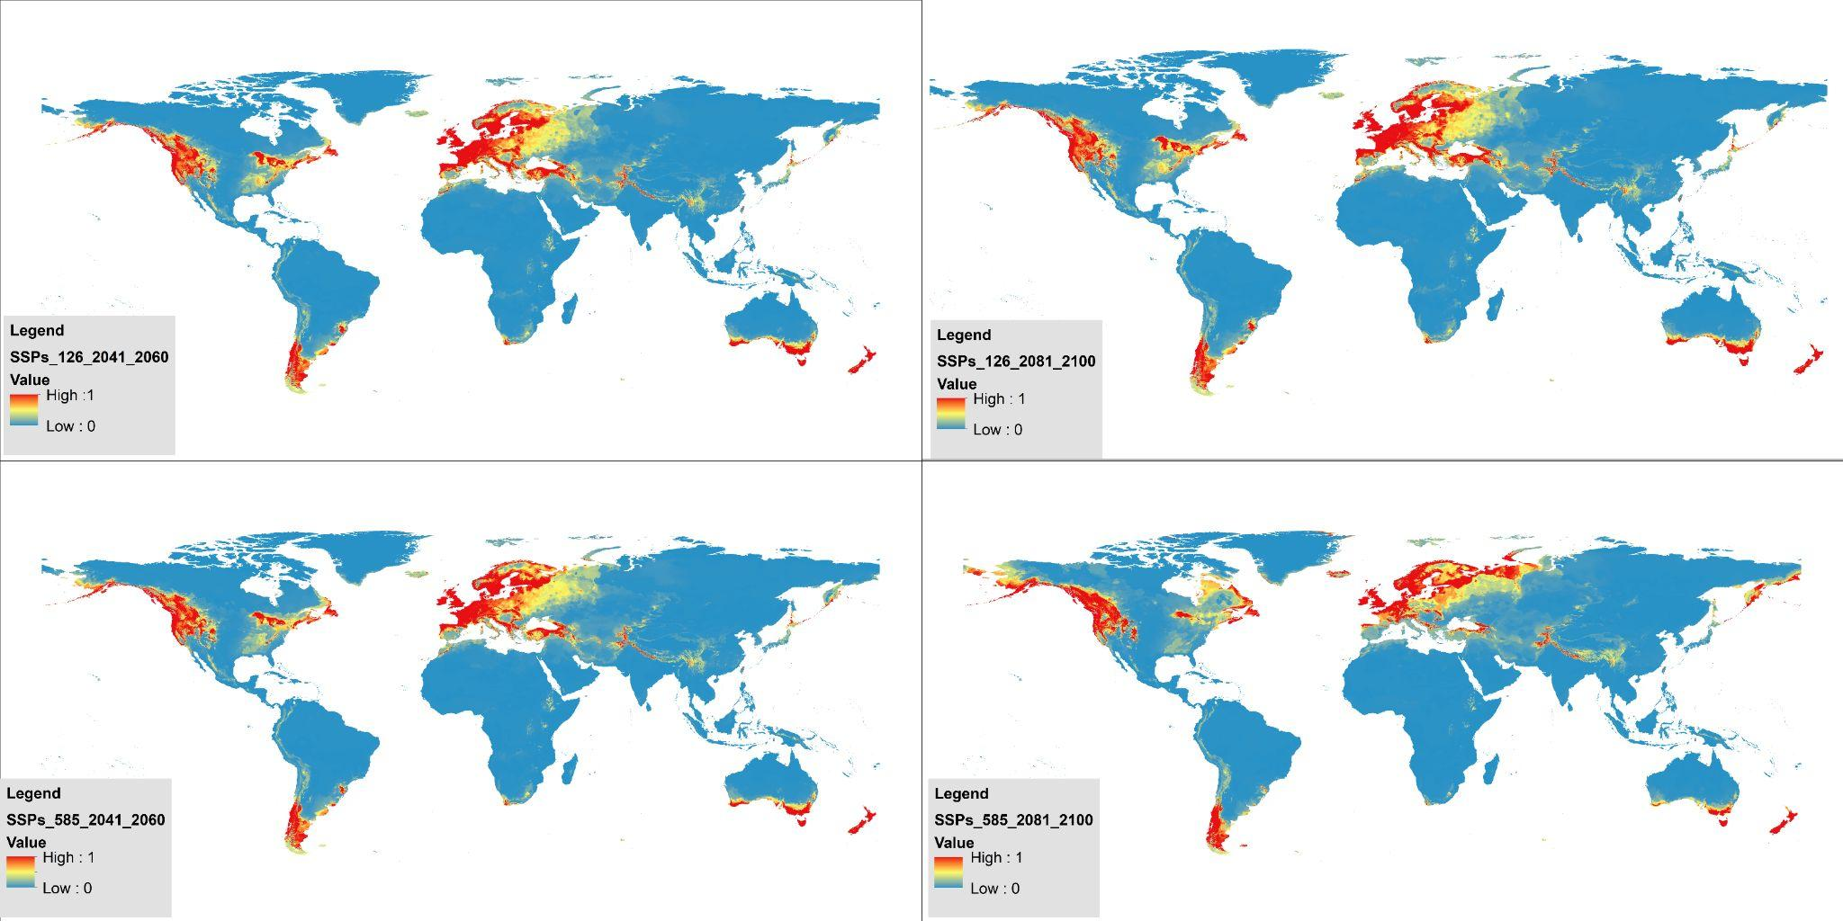
Fig S2. Globally suitable future habitat areas of Potamopyrgus antipodarum according to different emission scenarios (Bioclimatic).
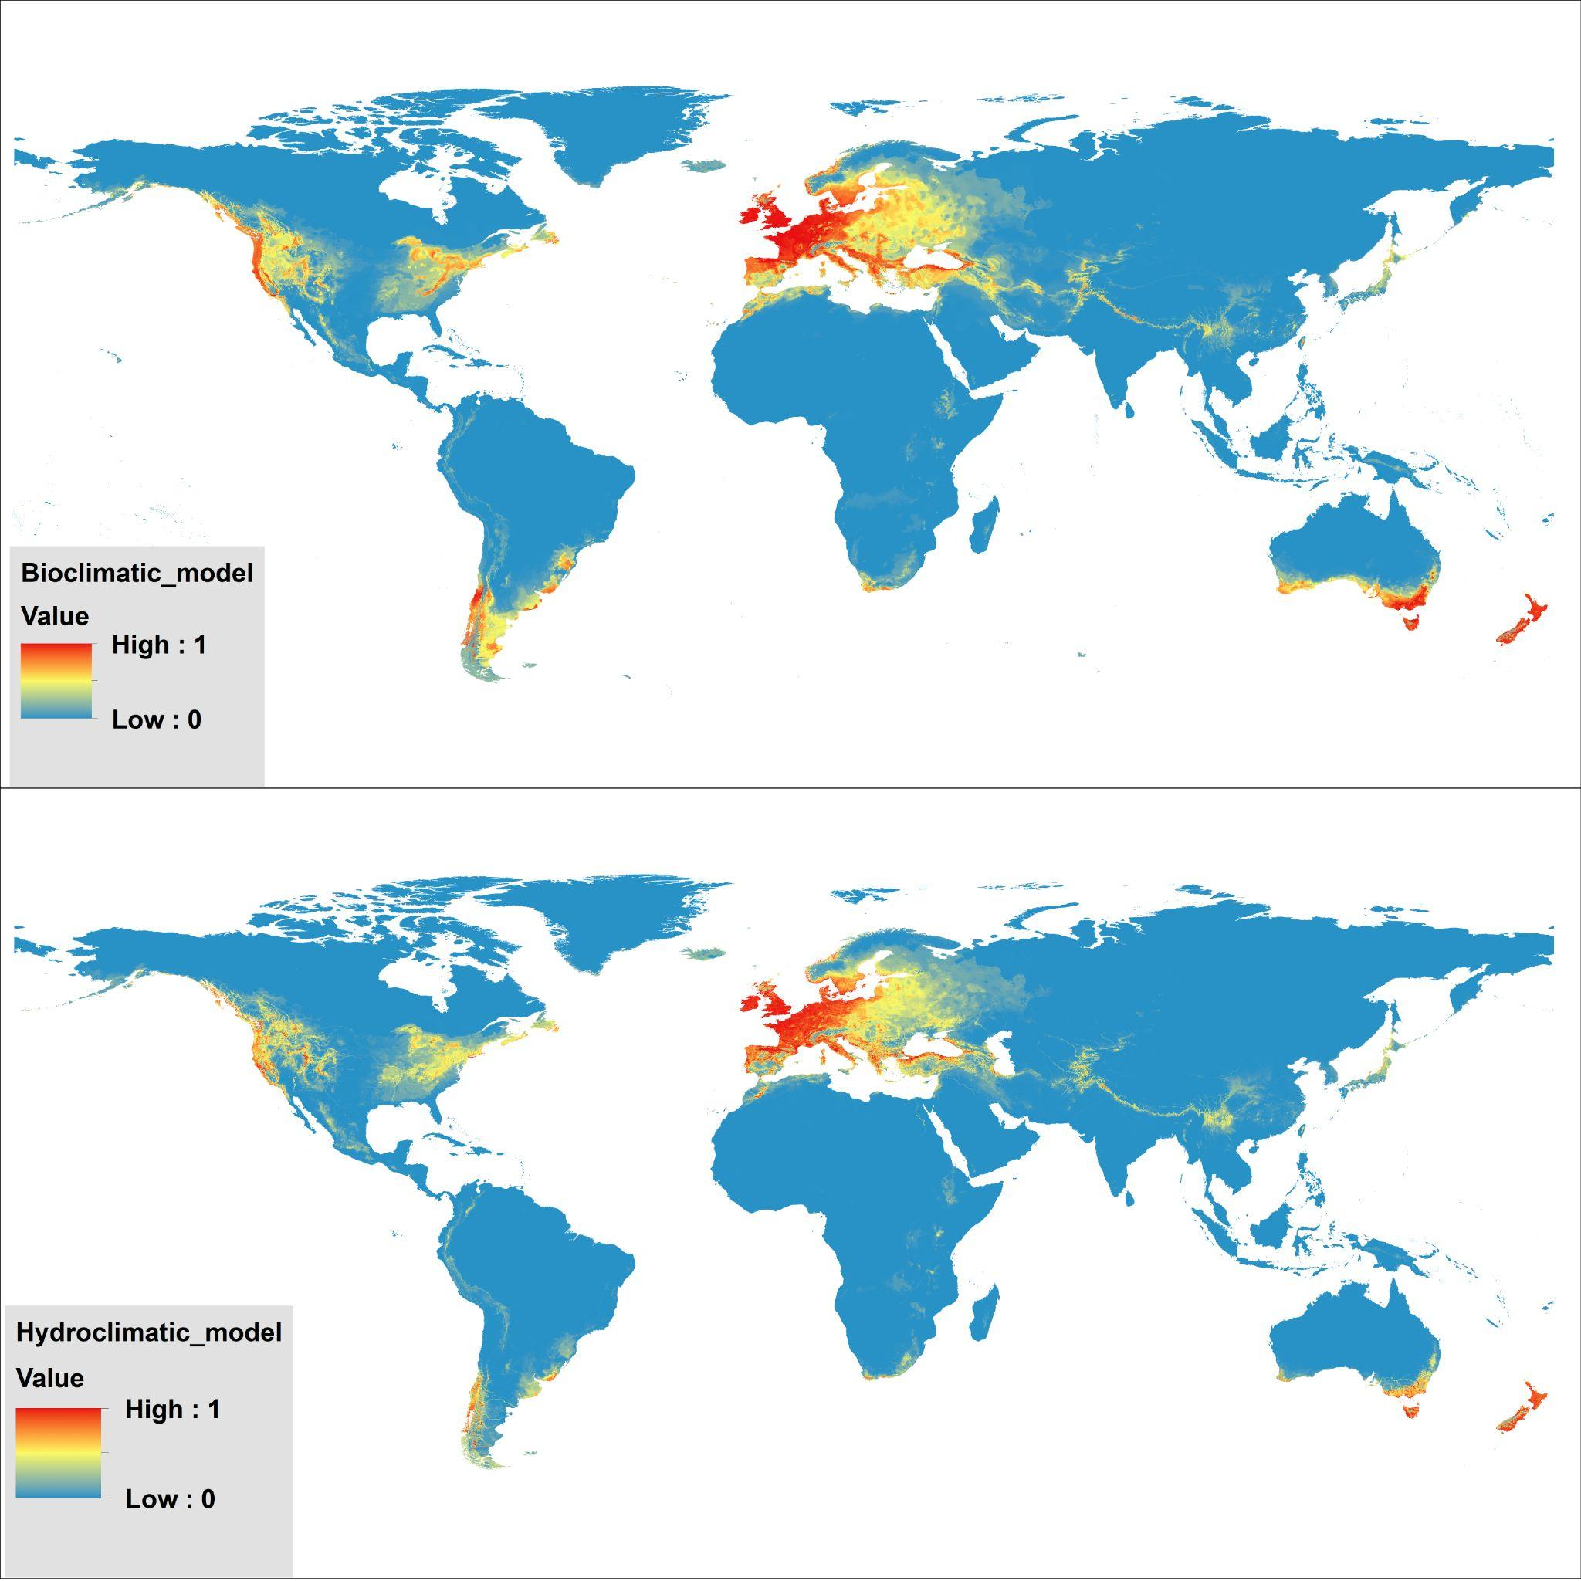
Fig S3. Current suitable habitats areas of Potamopyrgus antipodarum globally according to hydroclimatic and bioclimatic model.

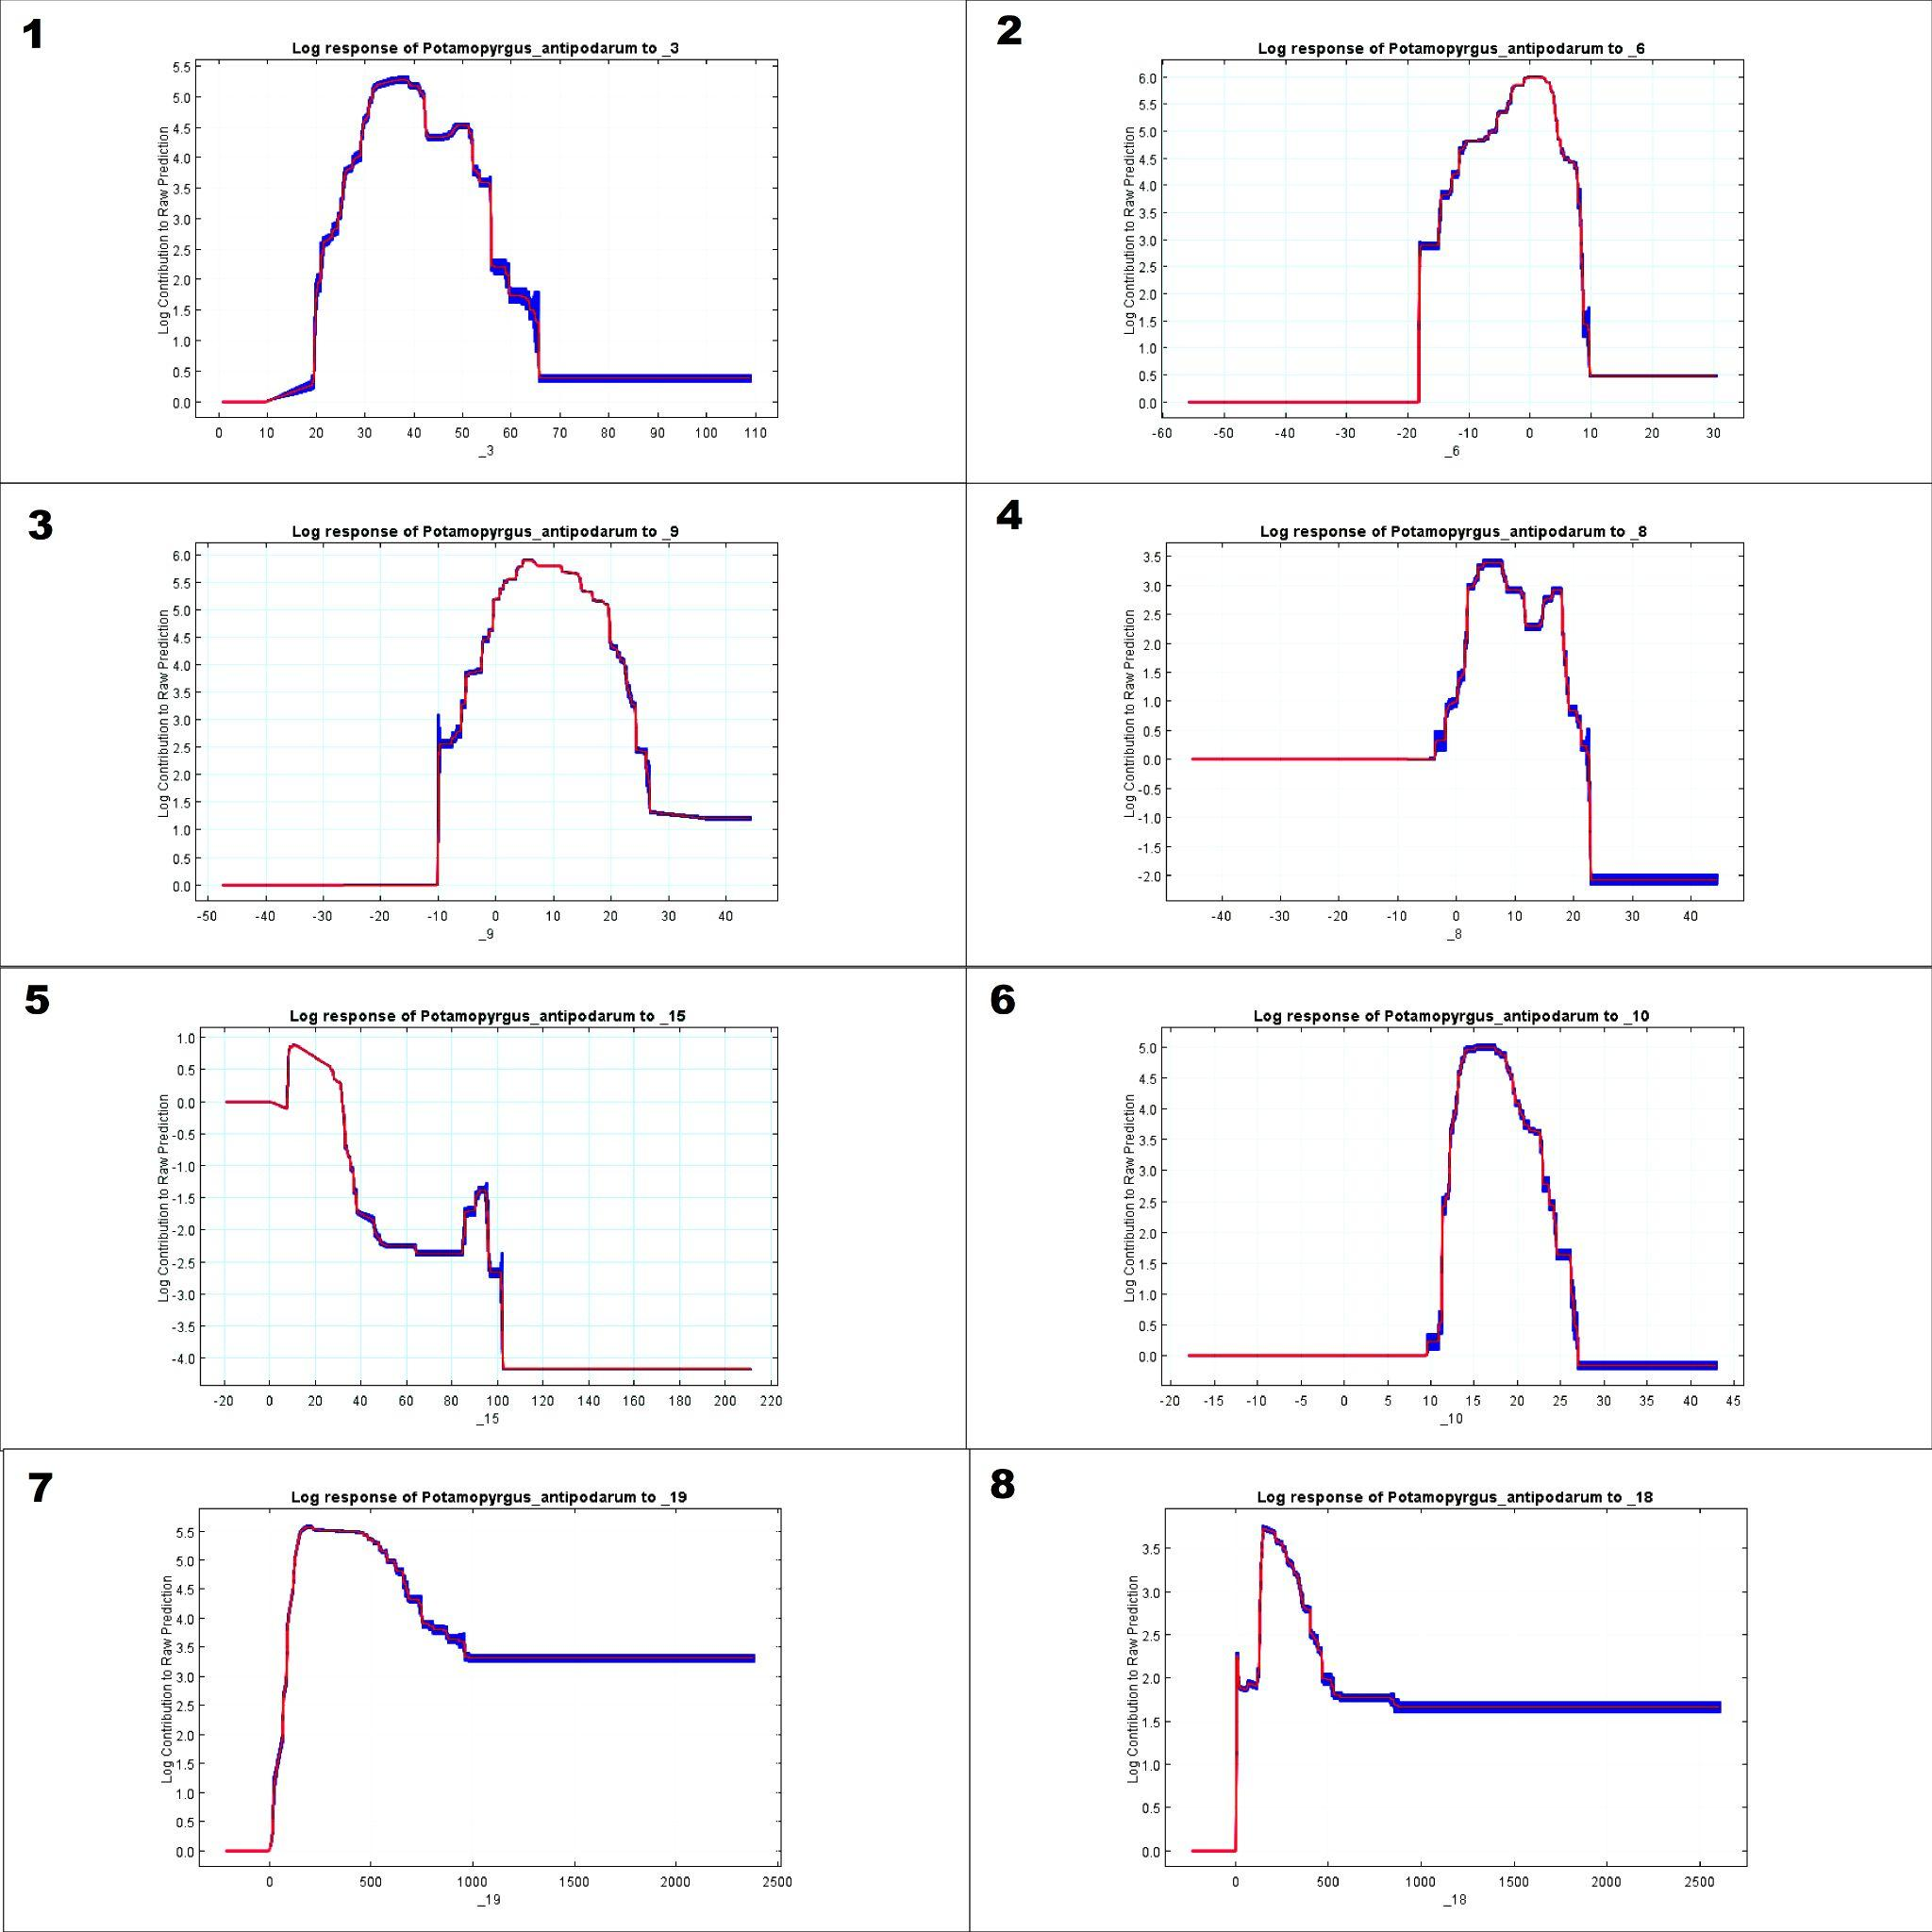
Fig S4. Response curves environmental variables.
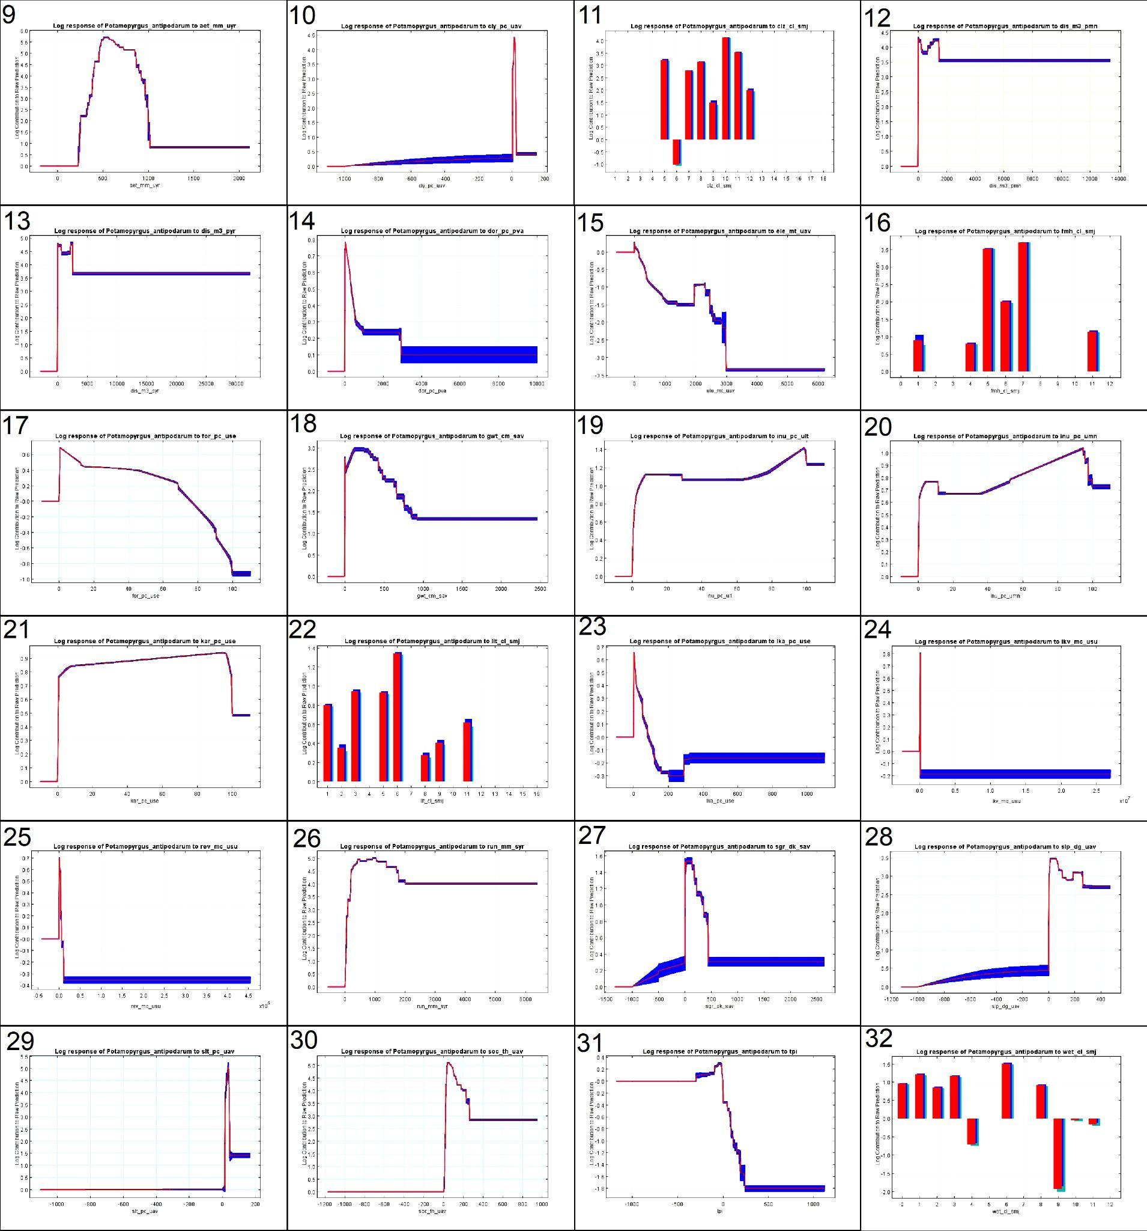
Fig S5. Response curves climatic variables.

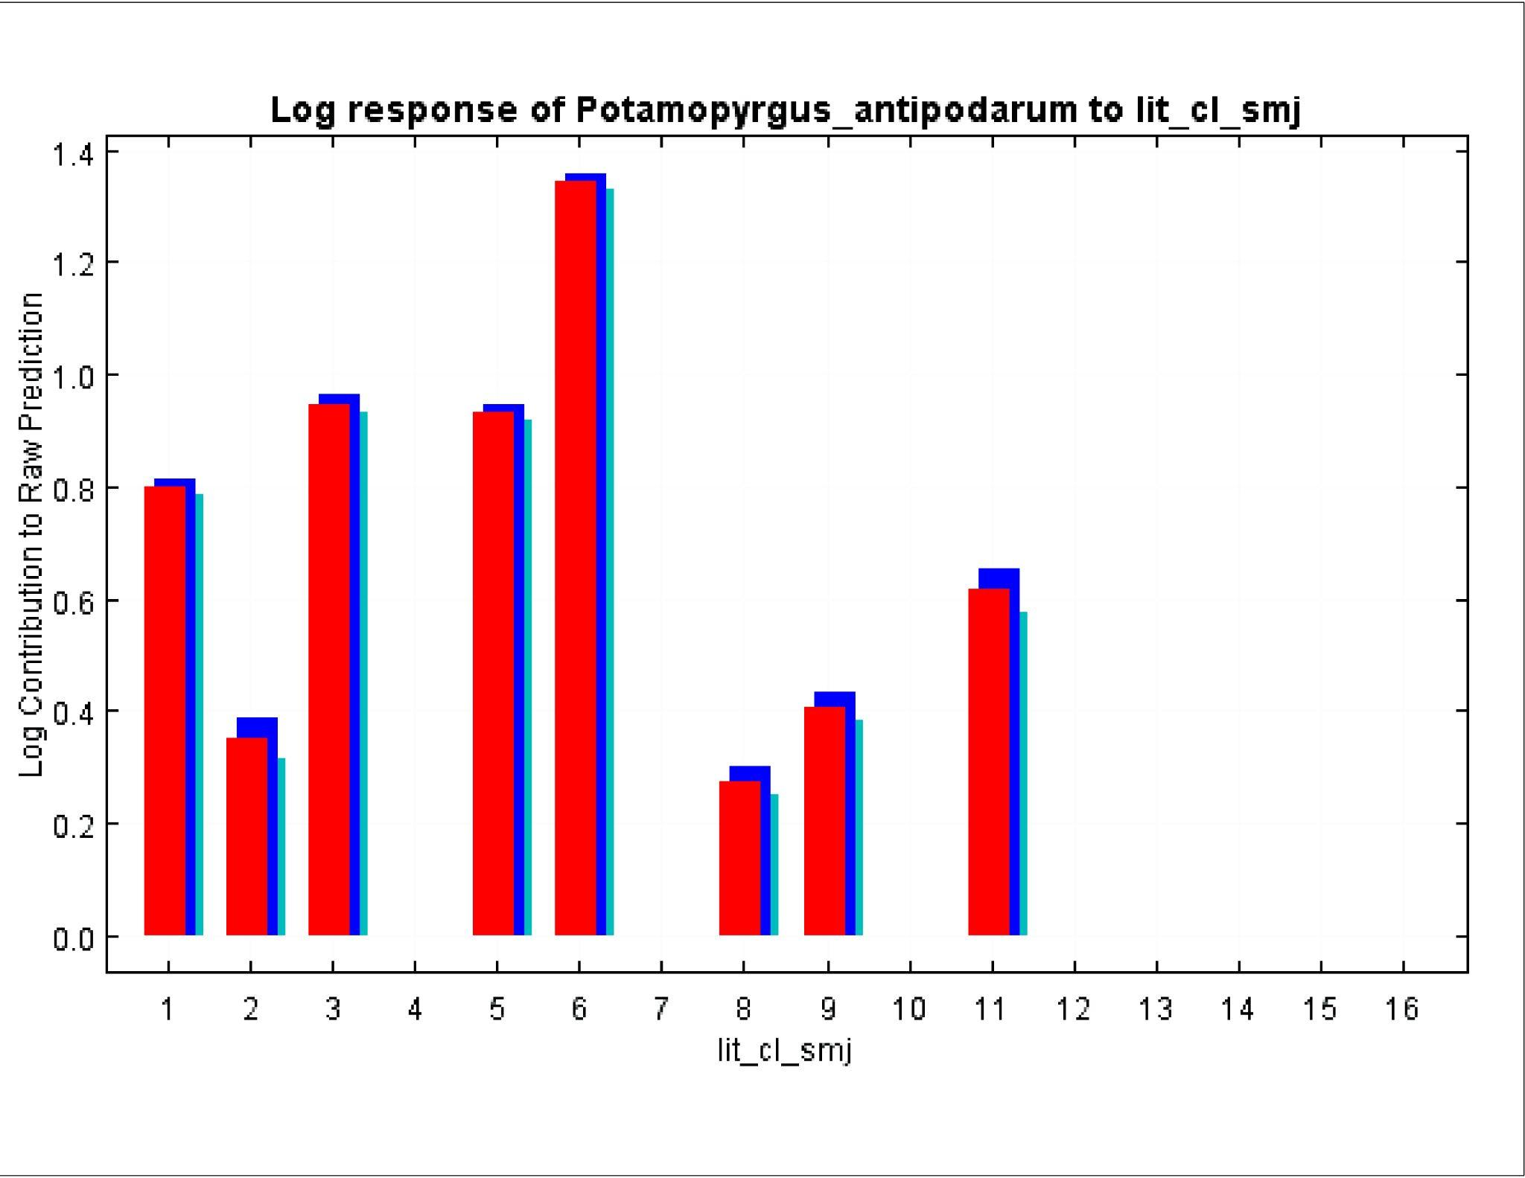
Fig S6. Response curves Soils & Geology Lithological classes.

Supplementary Tables
Table S1. Environmental variables and model selection
Variable name | Variable | Reference
BIO1 = Annual Mean Temperature | _1 | Fick, S.E. and R.J. Hijmans, 2017
BIO2 = Mean Diurnal Range (Mean of monthly (max temp - min temp)) | _2 | Fick, S.E. and R.J. Hijmans, 2017
BIO3 = Isothermality (BIO2/BIO7) (×100) | _3 | Fick, S.E. and R.J. Hijmans, 2017
BIO4 = Temperature Seasonality (standard deviation ×100) | _4 | Fick, S.E. and R.J. Hijmans, 2017
BIO5 = Max Temperature of Warmest Month | _5 | Fick, S.E. and R.J. Hijmans, 2017
BIO6 = Min Temperature of Coldest Month | _6 | Fick, S.E. and R.J. Hijmans, 2017
BIO7 = Temperature Annual Range (BIO5-BIO6) | _7 | Fick, S.E. and R.J. Hijmans, 2017
BIO8 = Mean Temperature of Wettest Quarter | _8 | Fick, S.E. and R.J. Hijmans, 2017
BIO9 = Mean Temperature of Driest Quarter | _9 | Fick, S.E. and R.J. Hijmans, 2017
BIO10 = Mean Temperature of Warmest Quarter | _10 | Fick, S.E. and R.J. Hijmans, 2017
BIO11 = Mean Temperature of Coldest Quarter | _11 | Fick, S.E. and R.J. Hijmans, 2017
BIO12 = Annual Precipitation | _12 | Fick, S.E. and R.J. Hijmans, 2017
BIO13 = Precipitation of Wettest Month | _13 | Fick, S.E. and R.J. Hijmans, 2017
BIO14 = Precipitation of Driest Month | _14 | Fick, S.E. and R.J. Hijmans, 2017
BIO15 = Precipitation Seasonality (Coefficient of Variation) | _15 | Fick, S.E. and R.J. Hijmans, 2017
BIO16 = Precipitation of Wettest Quarter | _16 | Fick, S.E. and R.J. Hijmans, 2017
BIO17 = Precipitation of Driest Quarter | _17 | Fick, S.E. and R.J. Hijmans, 2017
BIO18 = Precipitation of Warmest Quarter | _18 | Fick, S.E. and R.J. Hijmans, 2017
BIO19 = Precipitation of Coldest Quarter | _19 | Fick, S.E. and R.J. Hijmans, 2017
Climate Actual Evapotranspiration Global Soil-Water Balance | aet_mm_uyr | Trabucco & Zomer 2010
Climate Climate Zones GEnS | clz_cl_smj | Metzger et al. 2013
Climate Potential Evapotranspiration Global-PET | pet_mm | Zomer et al. 2008
Hydrology Degree of Regulation HydroSHEDS & GRanD | dor_pc_pva | Lehner et al. 2011
Hydrology Groundwater Table Depth Global Groundwater Map | gwt_cm_sav | Fan et al. 2013
Hydrology Inundation Extent GIEMS-D15 | inu_pc_ult | Fluet-Chouinard et al. 2015
Hydrology Inundation Extent GIEMS-D15 | inu_pc_umn | Fluet-Chouinard et al. 2015
Hydrology Lake Volume HydroLAKES | lkv_mc_usu | Messager et al. 2016
Hydrology Land Surface Runoff WaterGAP v2.2 | run_mm_syr | Döll et al. 2003
Hydrology Limnicity (Percent Lake Area) HydroLAKES | lka_pc_use | Messager et al. 2016
Hydrology Natural Discharge WaterGAP v2.2 | dis_m3_pmn | Döll et al. 2003
Hydrology Natural Discharge WaterGAP v2.2 | dis_m3_pyr | Döll et al. 2003
Hydrology Natural Discharge WaterGAP v2.2 | dis_m3_max | Döll et al. 2003
Hydrology Reservoir Volume GRanD v1.1 | rev_mc_usu | Lehner et al. 2011
Hydrology River Area HydroSHEDS & WaterGAP | ria_ha | Lehner & Grill 2013
Hydrology River Volume HydroSHEDS & WaterGAP | riv_tc | Lehner & Grill 2013
Landcover Forest Cover Extent GLC2000 | for_pc_use | Bartholomé & Belward 2005
Landcover Freshwater Major Habitat Types FEOW | fmh_cl_smj | Abell et al. 2008
Landcover Wetland Extent GLWD | wet_cl_smj | Lehner & Döll 2004
Physiography Elevation EarthEnv-DEM90 | ele_mt_uav | Robinson et al. 2014
Physiography Stream Gradient EarthEnv-DEM90 | sgr_dk_sav | Robinson et al. 2014
Physiography Terrain Slope EarthEnv-DEM90 | slp_dg_uav | Robinson et al. 2014
Soils & Geology Clay Fraction in Soil SoilGrids1km | cly_pc_uav | Hengl et al. 2014
Soils & Geology Karst Area Extent Rock Outcrops v3.0 | kar_pc_use | Williams & Ford 2006
Soils & Geology Lithological Classes GLiM | lit_cl_smj | Hartmann & Moosdorf 2012
Soils & Geology Organic Carbon Content in Soil SoilGrids1km | soc_th_uav | Hengl et al. 2014
Soils & Geology Sand Fraction in Soil SoilGrids1km | snd_pc | Hengl et al. 2014
Soils & Geology Silt Fraction in Soil SoilGrids1km | slt_pc_uav | Hengl et al. 2014
Topographic Position Index | tpi

Table S2. Environmental variables used in the model.
Variable name | Variable | Reference
BIO1 = Annual Mean Temperature | _1 | Fick, S.E. and R.J. Hijmans, 2017
BIO2 = Mean Diurnal Range (Mean of monthly (max temp - min temp)) | _2 | Fick, S.E. and R.J. Hijmans, 2017
BIO3 = Isothermality (BIO2/BIO7) (×100) | _3 | Fick, S.E. and R.J. Hijmans, 2017
BIO4 = Temperature Seasonality (standard deviation ×100) | _4 | Fick, S.E. and R.J. Hijmans, 2017
BIO5 = Max Temperature of Warmest Month | _5 | Fick, S.E. and R.J. Hijmans, 2017
BIO6 = Min Temperature of Coldest Month | _6 | Fick, S.E. and R.J. Hijmans, 2017
BIO7 = Temperature Annual Range (BIO5-BIO6) | _7 | Fick, S.E. and R.J. Hijmans, 2017
BIO8 = Mean Temperature of Wettest Quarter | _8 | Fick, S.E. and R.J. Hijmans, 2017
BIO9 = Mean Temperature of Driest Quarter | _9 | Fick, S.E. and R.J. Hijmans, 2017
BIO10 = Mean Temperature of Warmest Quarter | _10 | Fick, S.E. and R.J. Hijmans, 2017
BIO11 = Mean Temperature of Coldest Quarter | _11 | Fick, S.E. and R.J. Hijmans, 2017
BIO12 = Annual Precipitation | _12 | Fick, S.E. and R.J. Hijmans, 2017
BIO13 = Precipitation of Wettest Month | _13 | Fick, S.E. and R.J. Hijmans, 2017
BIO14 = Precipitation of Driest Month | _14 | Fick, S.E. and R.J. Hijmans, 2017
BIO15 = Precipitation Seasonality (Coefficient of Variation) | _15 | Fick, S.E. and R.J. Hijmans, 2017
BIO16 = Precipitation of Wettest Quarter | _16 | Fick, S.E. and R.J. Hijmans, 2017
BIO17 = Precipitation of Driest Quarter | _17 | Fick, S.E. and R.J. Hijmans, 2017
BIO18 = Precipitation of Warmest Quarter | _18 | Fick, S.E. and R.J. Hijmans, 2017
BIO19 = Precipitation of Coldest Quarter | _19 | Fick, S.E. and R.J. Hijmans, 2017
Climate Actual Evapotranspiration Global Soil-Water Balance | aet_mm_uyr | Trabucco & Zomer 2010
Climate Climate Zones GEnS | clz_cl_smj | Metzger et al. 2013
Climate Potential Evapotranspiration Global-PET | pet_mm | Zomer et al. 2008
Hydrology Degree of Regulation HydroSHEDS & GRanD | dor_pc_pva | Lehner et al. 2011
Hydrology Groundwater Table Depth Global Groundwater Map | gwt_cm_sav | Fan et al. 2013
Hydrology Inundation Extent GIEMS-D15 | inu_pc_ult | Fluet-Chouinard et al. 2015
Hydrology Inundation Extent GIEMS-D15 | inu_pc_umn | Fluet-Chouinard et al. 2015
Hydrology Lake Volume HydroLAKES | lkv_mc_usu | Messager et al. 2016
Hydrology Land Surface Runoff WaterGAP v2.2 | run_mm_syr | Döll et al. 2003
Hydrology Limnicity (Percent Lake Area) HydroLAKES | lka_pc_use | Messager et al. 2016
Hydrology Natural Discharge WaterGAP v2.2 | dis_m3_pmn | Döll et al. 2003
Hydrology Natural Discharge WaterGAP v2.2 | dis_m3_pyr | Döll et al. 2003
Hydrology Natural Discharge WaterGAP v2.2 | dis_m3_max | Döll et al. 2003
Hydrology Reservoir Volume GRanD v1.1 | rev_mc_usu | Lehner et al. 2011
Hydrology River Area HydroSHEDS & WaterGAP | ria_ha | Lehner & Grill 2013
Hydrology River Volume HydroSHEDS & WaterGAP | riv_tc | Lehner & Grill 2013
Landcover Forest Cover Extent GLC2000 | for_pc_use | Bartholomé & Belward 2005
Landcover Freshwater Major Habitat Types FEOW | fmh_cl_smj | Abell et al. 2008
Landcover Wetland Extent GLWD | wet_cl_smj | Lehner & Döll 2004
Physiography Elevation EarthEnv-DEM90 | ele_mt_uav | Robinson et al. 2014
Physiography Stream Gradient EarthEnv-DEM90 | sgr_dk_sav | Robinson et al. 2014
Physiography Terrain Slope EarthEnv-DEM90 | slp_dg_uav | Robinson et al. 2014
Soils & Geology Clay Fraction in Soil SoilGrids1km | cly_pc_uav | Hengl et al. 2014
Soils & Geology Karst Area Extent Rock Outcrops v3.0 | kar_pc_use | Williams & Ford 2006
Soils & Geology Lithological Classes GLiM | lit_cl_smj | Hartmann & Moosdorf 2012
Soils & Geology Organic Carbon Content in Soil SoilGrids1km | soc_th_uav | Hengl et al. 2014
Soils & Geology Sand Fraction in Soil SoilGrids1km | snd_pc | Hengl et al. 2014
Soils & Geology Silt Fraction in Soil SoilGrids1km | slt_pc_uav | Hengl et al. 2014
Topographic Position Index | tpi

Table S3. Environmental classes (Categorical data).
GLWD_ID | GLWD_Name (wet_cl) | GEnZ_ID | GEnZ_Name (clz_cl)
1 | Lake | 1 | Arctic 1
2 | Reservoir | 2 | Arctic 2
3 | River | 3 | Extremely cold and wet 1
4 | Freshwater marsh, floodplain | 4 | Extremely cold and wet 2
5 | Swamp forest, flooded dorest | 5 | Cold and wet
6 | Coastal wetland (incl. mangove, estuary, delta, lagoon) | 6 | Extremely cold and mesic
7 | Pan, brackish/saline wetland | 7 | Cold and mesic
8 | Bog, fen, mire (peatland) | 8 | Cool temperate and dry
9 | Intermittent wetland/lake | 9 | Cool temperate and xeric
10 | 50-100% wetland | 10 | Cool temperate and moist
11 | 25-50% wetland | 11 | Warm temperate and mesic
12 | Wetland complex (0-25%) | 12 | Warm temperate and xeric
 |  | 13 | Hot and mesic
 |  | 14 | Hot and dry
 |  | 15 | Hot and arid
 |  | 16 | Extremely hot and arid
 |  | 17 | Extremely hot and xeric
 |  | 18 | Extremely hot and moist
MHT_ID | MHT_Name (fmh_cl) | GLiM_ID | Class_Name (lit_cl)
1 | Large lakes | 1 | Unconsolidated Sediments (SU)
2 | Large river deltas | 2 | Basic Volcanic Rocks (VB)
3 | Montane freshwaters | 3 | Siliciclastic Sedimentary Rocks (SS)
4 | Xeric freshwaters and endorheic basins | 4 | Basic Plutonic Rocks (PB)
5 | Temperate coastal rivers | 5 | Mixed Sedimentary Rocks (SM)
6 | Temperate upland rivers | 6 | Carbonate Sedimentary Rocks (SC)
7 | Temperate floodplain rivers and wetlands | 7 | Acid Volcanic Rocks (VA)
8 | Tropical and subtropical coastal rivers | 8 | Metamorphic Rocks (MT)
9 | Tropical and subtropical upland rivers | 9 | Acid Plutonic Rocks (PA)
10 | Tropical and subtropical floodplain rivers and wetlands | 10 | Intermediate Volcanic Rocks (VI)
11 | Polar freshwaters | 11 | Water Bodies (WB)
12 | Oceanic islands | 12 | Pyroclastics (PY)
98 | Greenland | 13 | Intermediate Plutonic Rocks (PI)
99 | No Data | 14 | Evaporites (EV)
 |  | 15 | No Data (ND)
 |  | 16 | Ice and Glaciers (IG)

Table S4. Niche breadth (Levins’ B) values for hydro-environmental characteristics climate scenarios.
FILE | B1 (inverse concentration) | B2 (uncertainty)
new_zealand_env | 0.914162512042318 | 0.993594711710418
Türkiye_env | 0.708480930651308 | 0.980664901976915
Europe_env | 0.254042805709541 | 0.923283769552706
North_america_env | 0.210772268170236 | 0.915106212755716
Global | 0.128334177521377 | 0.897044381139796
South_america_env | 0.121105075367444 | 0.88709889697757
Australia_env | 0.0901821216777056 | 0.844921490227077

Table S5. Niche breadth (Levins’ B) values for climatic characteristics and climate scenarios.
FILE | B1 (inverse concentration) | B2 (uncertainty)
Avusturalia_126_2050 | 0.155702606637606 | 0.879815643249344
Avusturalia _126_2100 | 0.156658760216157 | 0.880033518789105
Avusturalia _585_2050 | 0.142047653968496 | 0.874966248756241
Avusturalia _585_2100 | 0.107062892957422 | 0.862509478949175
Avusturalia _current | 0.175829148784215 | 0.886899029204148
Global_126_2050 | 0.146016752022659 | 0.903467293416744
Global _126_2100 | 0.14449415342054 | 0.903025516221806
Global _585_2050 | 0.147492398928756 | 0.90418319107259
Global _585_2100 | 0.156341857369604 | 0.907997571640835
Global _current | 0.151748702101672 | 0.904236190867328
North America_126_2050 | 0.216419173628164 | 0.914875554505958
North America _126_2100 | 0.213257905906269 | 0.914097297650647
North America _585_2050 | 0.221598895960357 | 0.916748895133284
North America _585_2100 | 0.27232920077771 | 0.931604886278794
North America _current | 0.217300419770325 | 0.914968131394029
New Zealand_126_2050 | 0.959856551029199 | 0.997015074883545
New Zealand _126_2100 | 0.956647904792547 | 0.9967464693703
New Zealand _585_2050 | 0.968403482134532 | 0.997758353667803
New Zealand _585_2100 | 0.968309676769328 | 0.997934914017367
New Zealand _current | 0.932094480331734 | 0.994719947128184
Europe_126_2050 | 0.28471195165182 | 0.932381685889211
Europe_126_2100 | 0.280473847881404 | 0.931637712305957
Europe _585_2050 | 0.291395907683919 | 0.934399403246343
Europe _585_2100 | 0.280710683206472 | 0.933697660201023
Europe _current | 0.292331823273274 | 0.930463044568914
South America_126_2050 | 0.132096215017602 | 0.880868238974835
South America _126_2100 | 0.133293962338249 | 0.881285165157838
South America _585_2050 | 0.124903470680865 | 0.877107431645998
South America _585_2100 | 0.106316217730625 | 0.867169620330812
South America _current | 0.153971326834677 | 0.891776961358016
Türkiye_126_2050 | 0.752321919550765 | 0.983674780301745
Türkiye _126_2100 | 0.751030359991094 | 0.983654317086675
Türkiye _585_2050 | 0.704833879550934 | 0.980421458544746
Türkiye _585_2100 | 0.500286204965224 | 0.966450597339461
Türkiye _current | 0.84103319344942 | 0.989905979886489

Table S6. Analysis of variable contributions.
Variable | Percent contribution | Permutation importance
_15 | 23.9 | 5
_19 | 21.9 | 1.1
_6 | 19.9 | 54.4
_8 | 11 | 6.6
_10 | 8.2 | 8.5
clz_cl_smj | 5.9 | 1.2
aet_mm_uyr | 4.9 | 4.2
soc_th_uav | 1.7 | 5.2
slt_pc_uav | 0.5 | 3.4
_9 | 0.3 | 1.9
dor_pc_pva | 0.3 | 0.2
_18 | 0.3 | 1.1
cly_pc_uav | 0.2 | 1.3
_3 | 0.2 | 1.2
tpi | 0.2 | 0.5

Table S7. Scoring output from the Aquatic Species Invasiveness Screening Kit for Potamopyrgus antipodarum in the risk assessment area (Türkiye).

Section/category | Score
Biogeography/Historical | 10.0
Domestication/Cultivation | -2.0
Climate, distribution and introduction risk | 2.0
Invasive elsewhere | 10.0
Biology/Ecology | 12.0
Undesirable (or persistence) traits | 7.0
Resource exploitation | 0.0
Reproduction | 3.0
Dispersal mechanisms | 3.0
Tolerance attributes | -1.0

Supplementary references
Alonso A, Castro-Díez P (2008) What explains the invading success of the aquatic mud snail Potamopyrgus antipodarum (Hydrobiidae, Mollusca)? Hydrobiologia 614:107–116. https://doi.org/10.1007/s10750-008-9529-3
Alonso A, Castro-Díez P (2012) Tolerance to air exposure of the New Zealand mudsnail Potamopyrgus antipodarum (Hydrobiidae, Mollusca) as a prerequisite to survival in overland translocations. NeoBiota 14:67–74. https://doi.org/10.3897/neobiota.14.3140
Abell R, Thieme ML, Revenga C et al (2008) Freshwater ecoregions of the world: A new map of biogeographic units for freshwater biodiversity conservation. Biosci 58(5):403–414.
Alonso A, Collado GA, Gérard C, Levri EP, Salvador RB, Castro-Díez P (2023) Effects of the invasive aquatic snail Potamopyrgus antipodarum (Gray, 1853) on ecosystem properties and services. Hydrobiologia. https://doi.org/10.1007/s10750-022-05116-z
Bartholomé E, Belward AS (2005) GLC2000: A new approach to global land cover mapping from Earth observation data. Int J Remote Sens 26(9):1959–1977. https://doi.org/10.1080/01431160412331291297
Clements WH, Arnold JL, Koel TM, Daley R, Jean C (2011) Responses of benthic macroinvertebrate communities to natural geothermal discharges in Yellowstone National Park, USA. Aquat Ecol 45:137–149. doi:10.1007/s10452-010-9342-8
Döll P, Kaspar F, Lehner B (2003) A global hydrological model for deriving water availability indicators: model tuning and validation. J Hydrol 270:105–134. https://doi.org/10.1016/S0022-1694(02)00283-4
Duft M, Schulte-Oehlmann U, Tillman M, Markert B, Oehlmann J (2003a) Toxicity of triphenyltin and tributyltin to the freshwater mudsnail Potamopyrgus antipodarum in a new sediment biotest. Environ Toxicol Chem 22:145–152. doi: 10.1002/etc.5620220119
Duft M, Schulte-Oehlmann U, Weltje L, Tillmann M, Oehlmann J (2003b) Stimulated embryo production as a parameter of estrogenic exposure via sediments in the freshwater mudsnail Potamopyrgus antipodarum. Aquat Toxicol 64:437–449. doi: 10.1016/S0166-445X(03)00102-4.
Fan Y, Li H, Miguez-Macho G (2013) Global patterns of groundwater table depth. Science 339(6122): 940–943. https://doi.org/10.1126/science.1229881
Fick SE, Hijmans RJ (2017) WorldClim 2: New 1-km spatial resolution climate surfaces for global land areas. Int J Climatol 37:4302–15. https://doi.org/10.1002/joc.5086
Fluet-Chouinard E, Lehner B, Rebelo LM, Papa F, Hamilton SK (2015) Development of a global inundation map at high spatial resolution from topographic downscaling of coarse-scale remote sensing data. Remote Sens Environ 158:348–361. https://doi.org/10.1016/j.rse.2014.10.015
Hartmann J, Moosdorf N (2012) The new global lithological map database GLiM: A representation of rock properties at the Earth surface. Geochem Geophys Geosystems 13(12):Q12004. https://doi.org/10.1029/2012GC004370
Hengl T, de Jesus JM, MacMillan RA et al (2014) SoilGrids1km—global soil information based on automated mapping. PLoS ONE 9(8):e105992. https://doi.org/10.1371/journal.pone.0105992.
Kabat AR, Hershler R (1993) The prosobranch snail family Hydrobiidae (Gastropoda: Rissooidea): Review of classification and supraspecific taxa. Smithsonian Contributions to Zoology 547, 94 pp.
Lehner B, Döll P (2004) Development and validation of a global database of lakes, reservoirs and wetlands. J Hydrology 296(1):1–22. https://doi.org/10.1016/j.jhydrol.2004.03.028
Lehner B, Grill G (2013) Global river hydrography and network routing: baseline data and new approaches to study the world’s large river systems. Hydrol Process 27(15):2171–2186. https://doi.org/10.1002/hyp.9740.
Lehner B, Reidy Liermann C, Revenga C et al (2011) High- resolution mapping of the world’s reservoirs and dams for sustainable river-flow management. Front Ecol Environ 9(9):494–502. https://doi.org/10.1890/100125
Messager ML, Lehner B, Grill G, Nedeva I, Schmitt O (2016) Estimating the volume and age of water stored in global lakes using a geo-statistical approach. Nat Commun 7:13603. https://doi.org/10.1038/ncomms13603.
Metzger MJ, Bunce RG, Jongman RH, Sayre R, Trabucco A, Zomer R (2013) A high‐resolution bioclimate map of the world: a unifying framework for global biodiversity research and monitoring. Glob Ecol Biogeogr 22(5):630–638. https://doi.org/10.1111/geb.12022
Moffit CM, James CA (2012) Response of New Zealand mudsnails Potamopyrgus antipodarum to freezing and near-freezing fluctuating water temperatures. Freshw Sci 31:1035–1041. https://doi.org/10.1899/11-160.1
Robinson N, Regetz J, Guralnick RP (2014) EarthEnv-DEM90: A nearly-global, void-free, multi-scale smoothed, 90m digital elevation model from fused ASTER and SRTM data. ISPRS J Photogram Remote Sens 87:57–67. https://doi.org/10.1016/j.isprsjprs.2013.11.002.
Trabucco A, Zomer RJ (2010) Global soil water balance geospatial database. CGIAR Consortium for Spatial Information. Available from the CGIAR-CSI GeoPortal at https://cgiarcsi.community.
Williams PW, Ford DC (2006) Global distribution of carbonate rocks. Zeitschrift für Geomorphologie Supplementary Issue, 147:1–2.
Winterbourn M (1969) Water temperature as a factor limiting the distribution of Potamopyrgus antipodarum (Gastropoda- Prosobranchia) in the New Zealand thermal region. N Z J Mar Freshwater Res 3:453–458. https:// doi. org/ 10. 1080/ 00288 330. 1969.95153 10
Winterbourn MJ (1970) The New Zealand species of Potamopyrgus (Gastropoda: Hydrobiidae). Malacologia 10:283–321.
Zomer RJ, Trabucco A, Bossio DA, van Straaten O, Verchot LV (2008) Climate change mitigation: A spatial analysis of global land suitability for clean development mechanism afforestation and reforestation. Agric Ecosyst Environ 126(1):67–80. https://doi.org/10.1016/j.agee.2008.01.014

