Supplementary Information
Venlafaxine induces psychiatric disorders due to upregulation of cerebral catechol-O-methyltransferase via the PI3K/AKT/mTOR pathway
Liqiang Qian^{a,b,†}, Hanyu Yang^{a,b,†}, Qianli Ye^{a,b}, Zijun Xu^{b}, Yanlin Liu^{a,b}, Zehua Wang^{a,b}, Wenhan Wu^{a,b}, Xiaodong Liu^{a,b,*}, Li Liu^{a,b,*}
ªState Key Laboratory of Natural Medicines, Key Laboratory of Drug Metabolism and Pharmacokinetics, China Pharmaceutical University, Nanjing 210009, China
^{b}Department of Pharmacology, School of Pharmacy, China Pharmaceutical University, Nanjing 210009, China
*Corresponding authors. Tel./fax: +86 25 83271060.
E-mail addresses: xdliu@cpu.edu.cn (Xiaodong Liu), liulee@cpu.edu.cn (Li Liu).
†These authors made equal contributions to this work.

The summary of the supplementary information
The supplementary information mainly contains the determination method of monoamine neurotransmitters (DA, DOPAC, 5-HT, 5-HIAA, Trp, and HVA) and SAM, the materials required for all experiment in the manuscript, and some experimental results mentioned in the manuscript (Supplemental Figure. 1-5).

- Determination of DA, 5-HT, and their metabolites in the cortex of rats and mice
Levels of DA, DOPAC, 5-HT, 5-HIAA, Trp, and 5-HTP in the cortex were determined by the HPLC-FLU method described previously^{[1]}. Briefly, a 50-mg brain sample was homogenized in 450 μL of precipitant containing 0.35 mol/L perchloric acid and 1.5 mmol/L cysteine in a 1.5-mL tube. The supernatant was obtained by centrifuging at 15000 g for 10 min. The separation of DOPAC, 5-HT, 5-HIAA, Trp, and 5-HTP was achieved using a C18 column with a mobile phase consisting of 8% methanol and 92% water (50 mmol/L KH₂PO₄ and 0.08 mmol/L EDTA). The flow rate was set at 1 mL/min. Fluorescence detection was performed with an excitation wavelength of 290 nm and an emission wavelength of 330 nm. Separation of DA was performed on the C18 column, whose mobile phase consisted of 7% methanol and 93% water (500 mmol/L NaH₂PO₄ and 0.02 mol/L citric acid). Flow rate was set as 1 mL/min. The excitation wavelength of the fluorescence detector was 290 nm and the emission wavelength was 330 nm. The linear range of DOPAC, 5-HT, 5-HIAA, Trp, and 5-HTP was 15.625 to 4000 ng/mL, 31.25 to 8000 ng/mL, 31.25 to 8000 ng/mL, 31.25 to 8000 ng/mL and 31.25 to 8000 ng/mL, respectively.
Concentrations of HVA in the cortex were detected by the LC-MS method. Briefly, a 100-mg brain sample was homogenized in 200 μL of ultrapure water containing 1.5 mmol/L cysteine in a 2-mL tube. The above tissue homogenates were extracted with ethyl acetate and acidized using 0.01 mol/L HCl, the supernatant was obtained by centrifuging at 15000 g for 10 min. After volatilization, the sample was redissolved with mobile phase (35% methanol and 65% water [0.01% acetic acid]) at a constant flow rate (0.2 mL/min). The internal standard was lidocaine. The analyses [M+H]⁺ were measured at m/z 181 for HVA and m/z 235 for lidocaine. The linear range of HVA was 39.06 to 10,000 ng/mL. Lower relative standard deviation (less than 10%) was detected in both inter-day and intra-day. The recoveries of all analyses were larger than 95%.

- Determination of SAM in the cortexes of rats and mice
Levels of SAM in the cortexes of rats and mice were measured according to the procedure^{[2-4]} Briefly, a 50-mg brain sample was homogenized in 350 μL of precipitant containing 0.4 mol/L perchloric acid and 1.5 mmol/L cysteine in a 1.5-mL tube. The supernatant was obtained by centrifuging at 15000 g for 10 min. SAM was separated using a C18 column and a mobile phase of 12.5% acetonitrile and 87.5% water (50 mmol/L NaH₂PO₄, 10 mmol/L Sodium 1-heptane sulfonate, pH = 4.38) at a flow rate of 1 mL/min with detection at the UV wavelength of 254 nm. The linear range of SAM was 0.3125 to 40 µmol/L.

- Measurement of COMT activity
Preparation of brain homogenates and the COMT activity assay were prepared according to the previous method^{[5, 6]}. In brief, the brain homogenates were incubated at 37°C in 100 mM phosphate buffer (pH 7.4) containing 5 mM MgCl₂, 200 µM SAM, 1mM Pargyline, and 500 µM 3,4-dihydroxybenzoic acid in a volume of 250 µL for 2 h. The reaction was stopped using 100 µl of 2 M perchloric acid and the formation of vanillic acid was measured using an HPLC-UV method^{[7]}.

- Isolation and culture of rat primary cortical astrocytes
The isolation and culture of rat primary cortical astrocytes were operated according to the previously reported^{[8, 9]}. Briefly, neonatal rat pups (1 day old) were drowned in 75% ethanol. Cerebral cortices were obtained and digested with 0.125% trypsin (Gibco, Rockville, MD, USA). Following homogenizing using pipetting, the cells were obtained using centrifuging and re-suspended in DMEM supplemented with 10% FBS, containing 62.5 µg/mL penicillin and 100 µg/mL streptomycin. Then, the cells were seeded in 25 cm² tissue culture flasks and were maintained in a 10% CO₂ incubator at 37℃ for 7-9 days. Non-adherent neurons and microglia were removed via shaking at 200 rpm under 37℃ for 60 min. Adherent cells were trypsinized (0.125%) and re-seeded in 12-well plates at a density of 1×10⁶ cells in DMEM supplemented with 15% FBS, containing 62.5 µg/mL penicillin and 100 µg/mL streptomycin in 5% CO₂ at 37 °C.
- Determination of SAM in U251 cells, primary rat cortical astrocyte, and SH-SY-5Y cells
Concentrations of SAM in cells were detected by the HPLC-UV method. In brief, 50 µL precipitant (2 mol/L perchloric acid and 6 mmol/L cysteine) were added into 200 µL samples. The supernatant was obtained by centrifuging at 15000 g for 10 min. The SAM was separated using a C18 column and a mobile phase of 12.5% acetonitrile and 87.5% water (50 mmol/L NaH₂PO₄, 10 mmol/L Sodium 1-heptane sulfonate, pH = 4.38) at a flow rate of 1 mL/min with detection at the UV wavelength of 254 nm. The linear range of SAM was 0.078125 to 10 µmol/L.

Supplemental Table 1. Chemicals and reagents used in the study
Chemicals and reagents | Sources
Venlafaxine hydrochloride | Macklin Biochemical (Shanghai, China)
Dopamine hydrochloride | Macklin Biochemical (Shanghai, China)
3,4-Dihydroxyphenylacetic acid (DOPAC) | Macklin Biochemical (Shanghai, China)
Homovanillic acid (HVA) | Aladdin (Shanghai, China)
Serotonin hydrochloride | Alfa Aesar (Beijing, China)
5-hydroxyindoleacetic acid (5-HIAA) | Acros Organics (China)
5-hydroxytryptophan (5-HTP) | Adamas-beta (Shanghai, China)
4-Hydroxy-3-methoxy benzoic acid (VA) | Aladdin (Shanghai, China)
S-(5′-Adenosyl)-L-methionine chloride dihydrochloride | Aladdin (Shanghai, China)
BCA kit | Beyotime Biotechnology (Nanjing, China)
RIPA lysis buffer | Beyotime Biotechnology (Nanjing, China)
Loading buffer | Beyotime Biotechnology (Nanjing, China)
lipofectamine® 3000 | Invitrogen (Carlsbad, CA, USA)
MHY1485 | Aladdin (Shanghai, China)
LY294002 | MedChemExpress (Shanghai, China).
Rapamycin | Macklin Biochemical (Shanghai, China)
Insulin | Aladdin (Shanghai, China)
U251 cells | Cellcook Biotechnology(Guangzhou, China)
SH-SY-5Y cells | Cellcook Biotechnology(Guangzhou, China)
Fetal bovine serum | Gibco Thermo Fisher Inc (Waltham, MA, USA)

Supplemental Table 2. Antibody used in the study
Protein target | Name of antibody | Manufacturer | Dilution
COMT | Monoclonal antibody | Sigma-Aldrich (Shanghai, China) | 1:500
MAO-A | Monoclonal antibody | Abcam (Cambridge, UK) | 1:2000
MAO-B | Monoclonal antibody | Santa Cruz Biotechnology (Dallas, TX, USA) | 1:500
TH | Monoclonal antibody | Santa Cruz Biotechnology (Dallas, TX, USA) | 1:500
TPH | Monoclonal antibody | Sigma-Aldrich (Shanghai, China) | 1:1000
p-P65 | Monoclonal antibody | Wanleibio (Shenyang, China) | 1:1000
P65 | Monoclonal antibody | Wanleibio (Shenyang, China) | 1:1000
p-P38 | Monoclonal antibody | Cell Signaling Technology (Danvers, MA, USA) | 1:1000
P38 | Monoclonal antibody | Cell Signaling Technology (Danvers, MA, USA) | 1:1000
p-Erk | Monoclonal antibody | Cell Signaling Technology (Danvers, MA, USA) | 1:1000
Erk | Monoclonal antibody | Cell Signaling Technology (Danvers, MA, USA) | 1:1000
p-AKT | Monoclonal antibody | Wanleibio (Shenyang, China) | 1:2000
AKT | Monoclonal antibody | Wanleibio (Shenyang, China) | 1:2000
p-P70S6K | Monoclonal antibody | Cell Signaling Technology (Danvers, MA, USA) | 1:1000
P70S6K | Monoclonal antibody | Santa Cruz Biotechnology (Dallas, TX, USA) | 1:500
p-4EBP1 | Monoclonal antibody | Cell Signaling Technology (Danvers, MA, USA) | 1:1000
4EBP1 | Monoclonal antibody | Cell Signaling Technology (Danvers, MA, USA) | 1:1000
H3K4me3 | Monoclonal antibody | Abcam (Cambridge, UK) | 1:2000
H3K27me3 | Monoclonal antibody | Abcam (Cambridge, UK) | 1:2000
β-actin | Monoclonal antibody | Bioworld Technology (Bloomington, MN, USA) | 1:8000
GAPDH | Monoclonal antibody | Proteintech (Rosemont, IL, USA) | 1:5000
Goat anti-rabbit lgG | Secondary antibody | Bioworld Technology (Bloomington, MN, USA) | 1:3000
Goat anti-mouse lgG | Secondary antibody | Bioworld Technology (Bloomington, MN, USA) | 1:3000

Supplemental Figure. 1 Effects of tolcapone on the cerebral levels of DA, 5-HT, 5-HIAA, 5-HTP, and Trp in venlafaxine-treated rats. (a) DA, (b) 5-HT, (c) 5-HTP, (d) 5-HIAA, and (e) Trp levels in the cortexes of rats. Data are expressed as mean ± SD (n = 6). *P < 0.05 , ** P < 0.01 vs control rats , #P < 0.05 , ##P < 0.01 vs venlafaxine-treated rats. CON, control; TOL, tolcapone; VEN-L, venlafaxine-low dose; VEN-H, venlafaxine-high dose

Supplemental Figure. 2 Effects of venlafaxine on psychiatric behaviors and the metabolism of DA in cerebral cortexes of mice. (a) Total travelled distance, (b) outside travelled distance, and (c) inside travelled distance in the open-field test. (d) Immobile time in the tail-suspension test. (e) DOPAC, (f) HVA, and (g) SAM levels in cerebral cortexes of mice. (h) The expression of COMT in cerebral cortexes of mice. Data are expressed as mean ± SD (n = 6). *P < 0.05, **P < 0.01 vs control mice. CON, control; VEN-L, venlafaxine-low dose; VEN-H, venlafaxine-high dose
Supplemental Figure. 3 Effects of SAM with or without rapamycin on the protein expression of COMT, p-P70S6K, P70S6K, p-4EBP1, and 4EBP1 in U251 cells. Data are expressed as mean ± SD (n = 6). *P < 0.05, **P < 0.01 vs control cells; #P < 0.05, ##P < 0.01 vs SAM-treated cells. CON, control; Rapa, rapamycin
Supplemental Figure. 4 Effects of venlafaxine on the expression of H3K4me3 and H3K27me3 in cerebral cortexes of mice. Data are expressed as mean ± SD (n = 6). *P < 0.05, **P < 0.01 vs control cells. CON, control; VEN-L, venlafaxine-low dose; VEN-H, venlafaxine-high dose
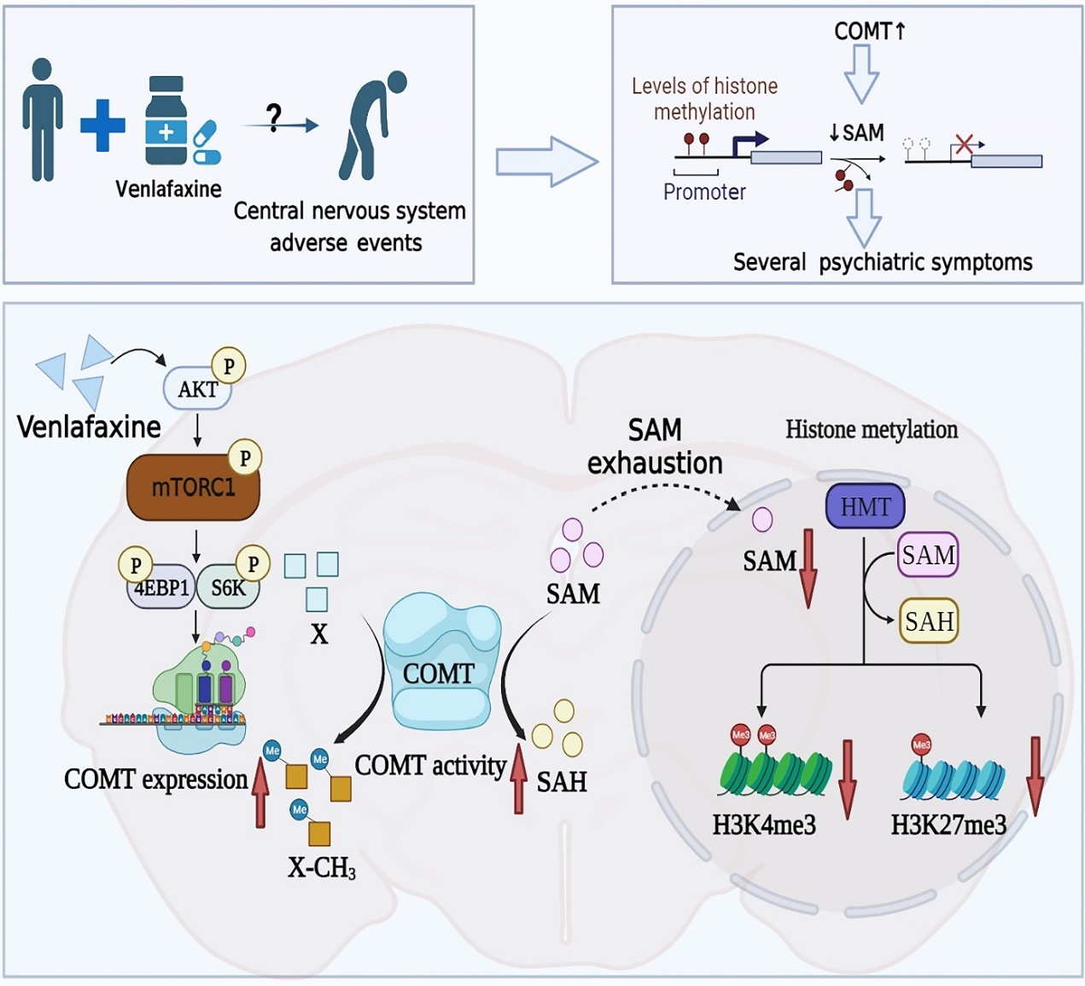
Supplemental Figure. 5 Schematic representation of a suggested model describing the role of the COMT induction in venlafaxine-induced psychiatric disorders.

Reference
1. Kong W, Sun X, Yu S, Liu P, Zheng X, Zhang J, et al. Bile duct ligation increased dopamine levels in the cerebral cortex of rats partly due to induction of tyrosine hydroxylase. Br J Pharmacol 2023; 180: 1690-1709.

2. Yassin MS, Cheng H, Ekblom J, Oreland L. Inhibitors of catecholamine metabolizing enzymes cause changes in S-adenosylmethionine and S-adenosylhomocysteine in the rat brain. Neurochem Int 1998; 32: 53-59.

3. Trolin CG, Löfberg C, Trolin G, Oreland L. Brain ATP:L-methionine S-adenosyltransferase (MAT), S-adenosylmethionine (SAM) and S-adenosylhomocysteine (SAH): regional distribution and age-related changes. Eur Neuropsychopharmacol 1994; 4: 469-477.

4. Huang X, Lv X, Song H, Yang Q, Sun Y, Zhang W, et al. The relationship between S-adenosylhomocysteine and coronary artery lesions: A case control study. Clin Chim Acta 2017; 471: 314-320.

5. Schultz E, Nissinen E. Inhibition of rat liver and duodenum soluble catechol-O-methyltransferase by a tight-binding inhibitor OR-462. Biochem Pharmacol 1989; 38: 3953-3956.

6. Kaenmaki M, Tammimaki A, Garcia-Horsman JA, Myohanen T, Schendzielorz N, Karayiorgou M, et al. Importance of membrane-bound catechol-O-methyltransferase in L-DOPA metabolism: a pharmacokinetic study in two types of Comt gene modified mice. Br J Pharmacol 2009; 158: 1884-1894.

7. Li K, Chen X, Jia Y, Bi K. Reverse-phase HPLC determination and pharmacokinetic study of vanillic acid in the plasma of rats treated with the traditional Chinese medicinal preparation Di-Gu-Pi decoction. Yakugaku Zasshi 2004; 124: 465-468.

8. Hong Y, Liu Q, Peng M, Bai M, Li J, Sun R, et al. High-frequency repetitive transcranial magnetic stimulation improves functional recovery by inhibiting neurotoxic polarization of astrocytes in ischemic rats. J Neuroinflammation 2020; 17: 150.

9. Schildge S, Bohrer C, Beck K, Schachtrup C. Isolation and culture of mouse cortical astrocytes. Journal of visualized experiments : JoVE 2013.

