

Supplement: Contact-separation-induced self-recoverable mechanoluminescence of CaF₂:Tb³⁺/PDMS elastomer

Wenxiang Wang, Shanwen Wang, Yan Gu, Jinyu Zhou, Jiachi Zhang

National & Local Joint Engineering Laboratory for Optical Conversion Materials and Technology, Lanzhou University, Lanzhou 730000, P. R. China

Content
Supplementary Note 1: Microstructure and elemental composition of CaF₂ 1
Supplementary Note 2: Spectra of CaF₂: Tb³⁺/Eu²⁺/Sm³⁺ 16
Supplementary Note 3: Two-dimensional stretching machine 24
Supplementary Note 4: Sample preparation 28
Supplementary Note 5: Properties of Lu₃Al₅O₁₂ and Y₂O₂S 29
Supplementary Note 6: Analysis of the contact interface 47
Supplementary Note 7: First-principles calculation of contact-separation 52
Supplementary Note 8: Additional first-principles calculations 62
Supplementary Note 9: Other factors affecting ML intensity 96
References 100

Supplementary Note 1: Microstructure and elemental composition of CaF₂
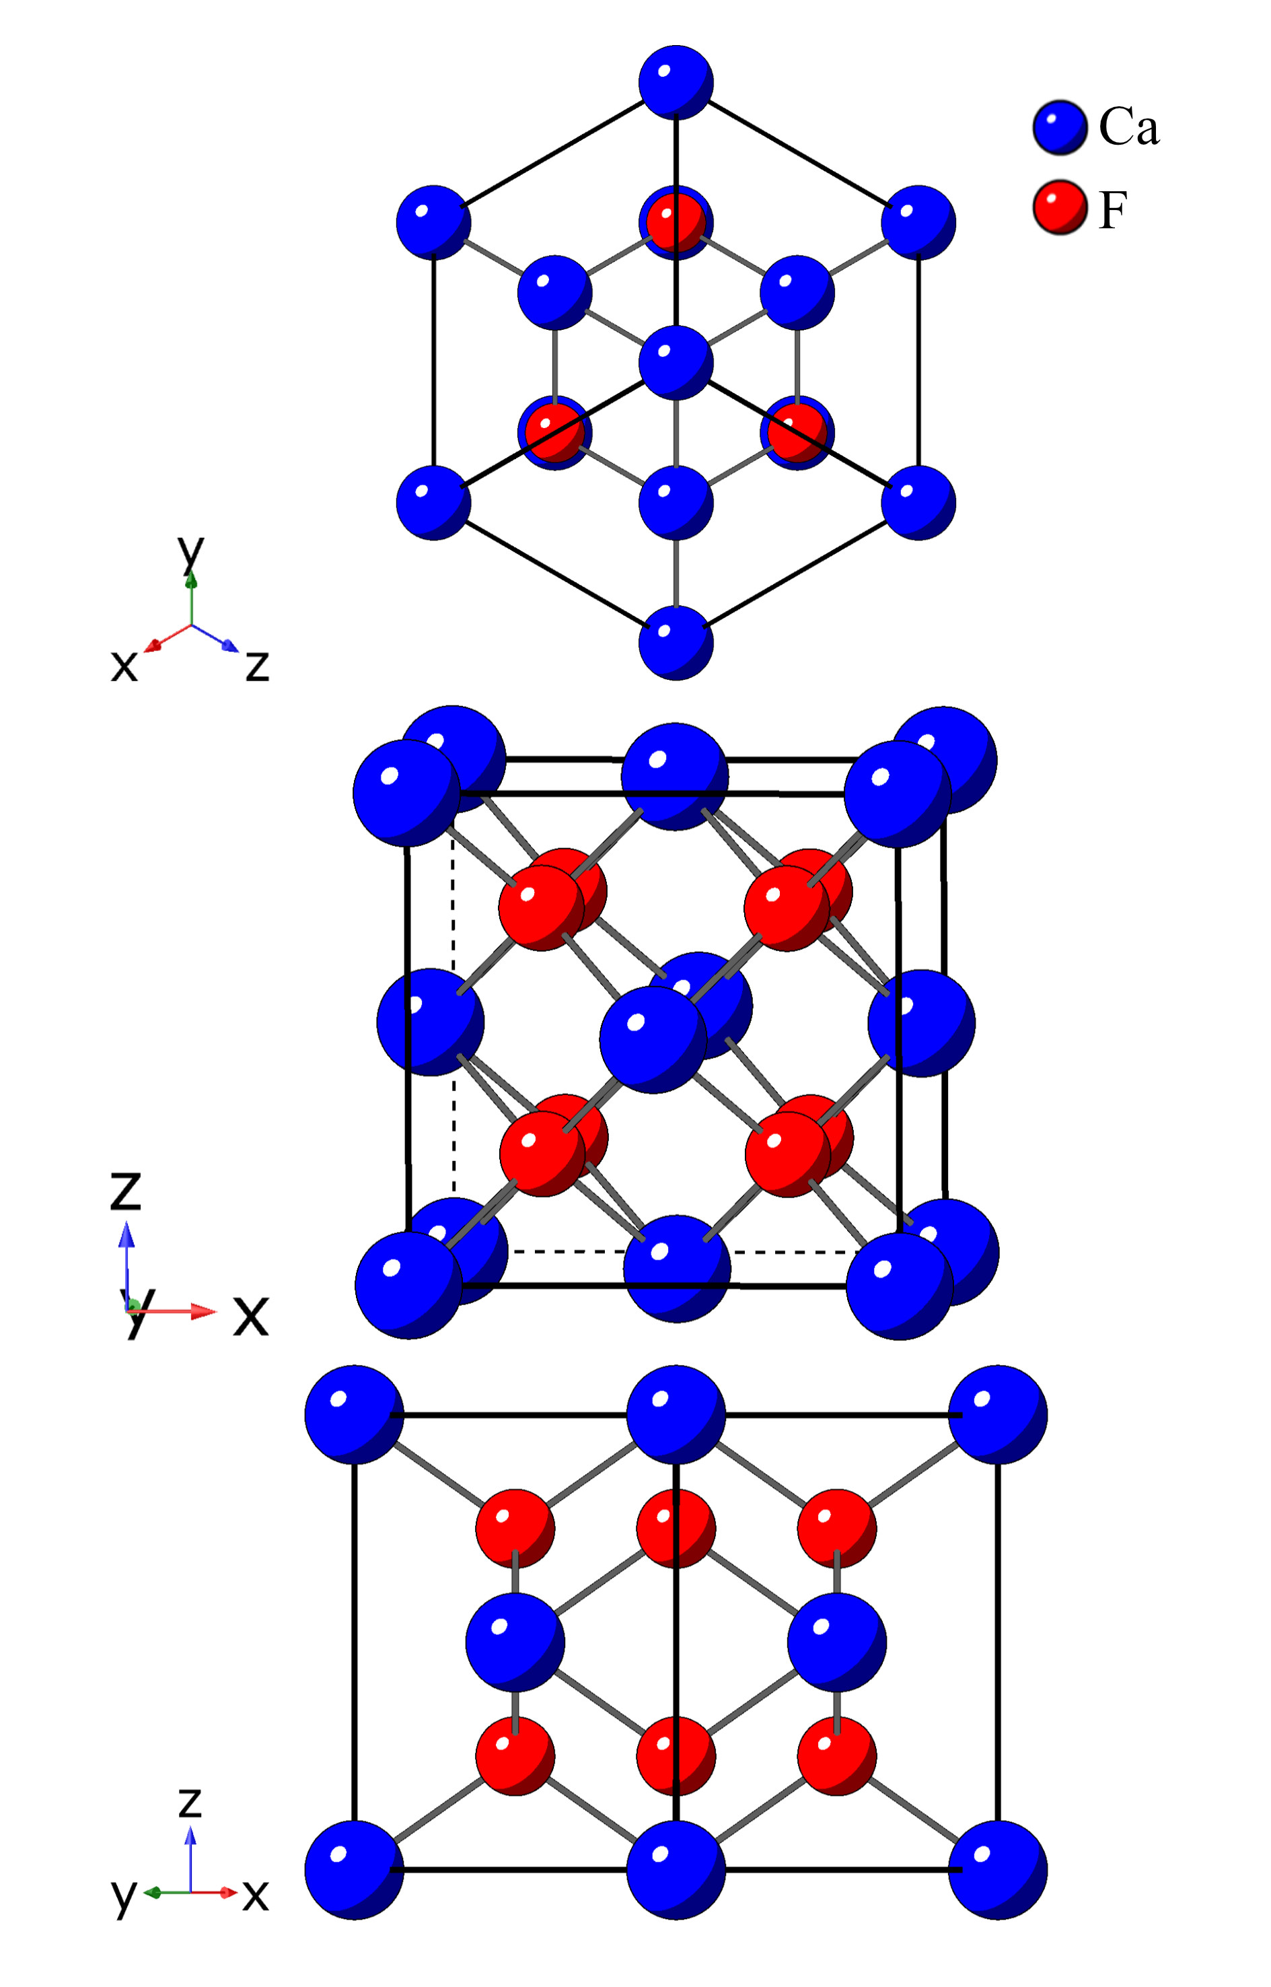

Figure S1-1. Crystal structure of CaF₂

Table S1-1. Crystallographic data of CaF₂
Formula | CaF₂
Crystal system | Cubic
Space group | Fm-3m (225)
Lattice parameters
a = b = c | 5.458 Å
α = β = γ | 90°
Cell volume | 162.634 Å³
T | 289 K
Diffractometer | Rigaku D/Max-2400
Radiation/Å | Cu-Ka (λ= 1.5405)
Absorption correction | multi-scan
2θ range | 8°-80°
Z | 4
Calculated Density | 3.189 g/cm³
R-factors
R_{wp} | 0.0943
R_{p} | 0.0672
χ² | 1.769

Table S1-2. Refined coordinates of all atoms, bond lengths of X-F and the unit cell parameters of the CaF₂ as determined by the GSAS program.
Space group |  | Fm-3m (225) - Cubic
Cell |  | a = b = c = 5.458 Å
Ion coordinates | x | y |  | z | Occupancy | Uiso
Ca | 0.0000(0) | 0.0000(0) |  | 0.0000(0) | 1.000(0) | 0.0100(0)
F | 0.2500(0) | 0.2500(0) |  | 0.2500(0) | 0.2500(0) | 0.0100(0)
The bond lengths of X-F
Vector |  |  | Length
Ca_F |  |  | 2.36358(4)

Table S1-3. The bandgap of CaF₂ calculated by
Vienna Ab-initio Simulation Package (VASP)
Band Character | Indirect
Band Gap (eV) | 7.3822
Eigenvalue of VBM (eV) | -0.4827
Eigenvalue of CBM (eV) | 6.8996
Fermi Energy (eV) | 0.4076
HOMO & LUMO Bands | 12 13
Location of VBM | 0.500000 0.000000 0.500000
Location of CBM | 0.000000 0.000000 0.000000

Figure S1-2. Calculated energy band structure of CaF₂

Figure S1-3. Partial density of states (Ca atoms) of CaF₂

Figure S1-4. Partial density of states (F atoms) of CaF₂
Figure S1-5. X-ray photoelectron spectroscopy(XPS) spectrum of CaF₂

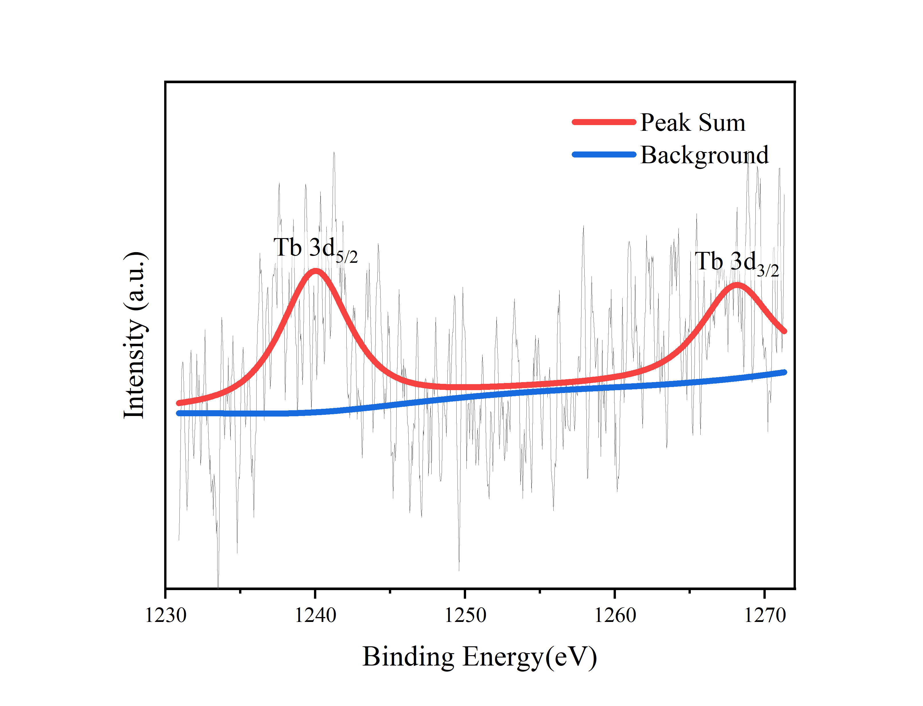
Figure S1-6. High-resolution XPS spectra of Tb 3d

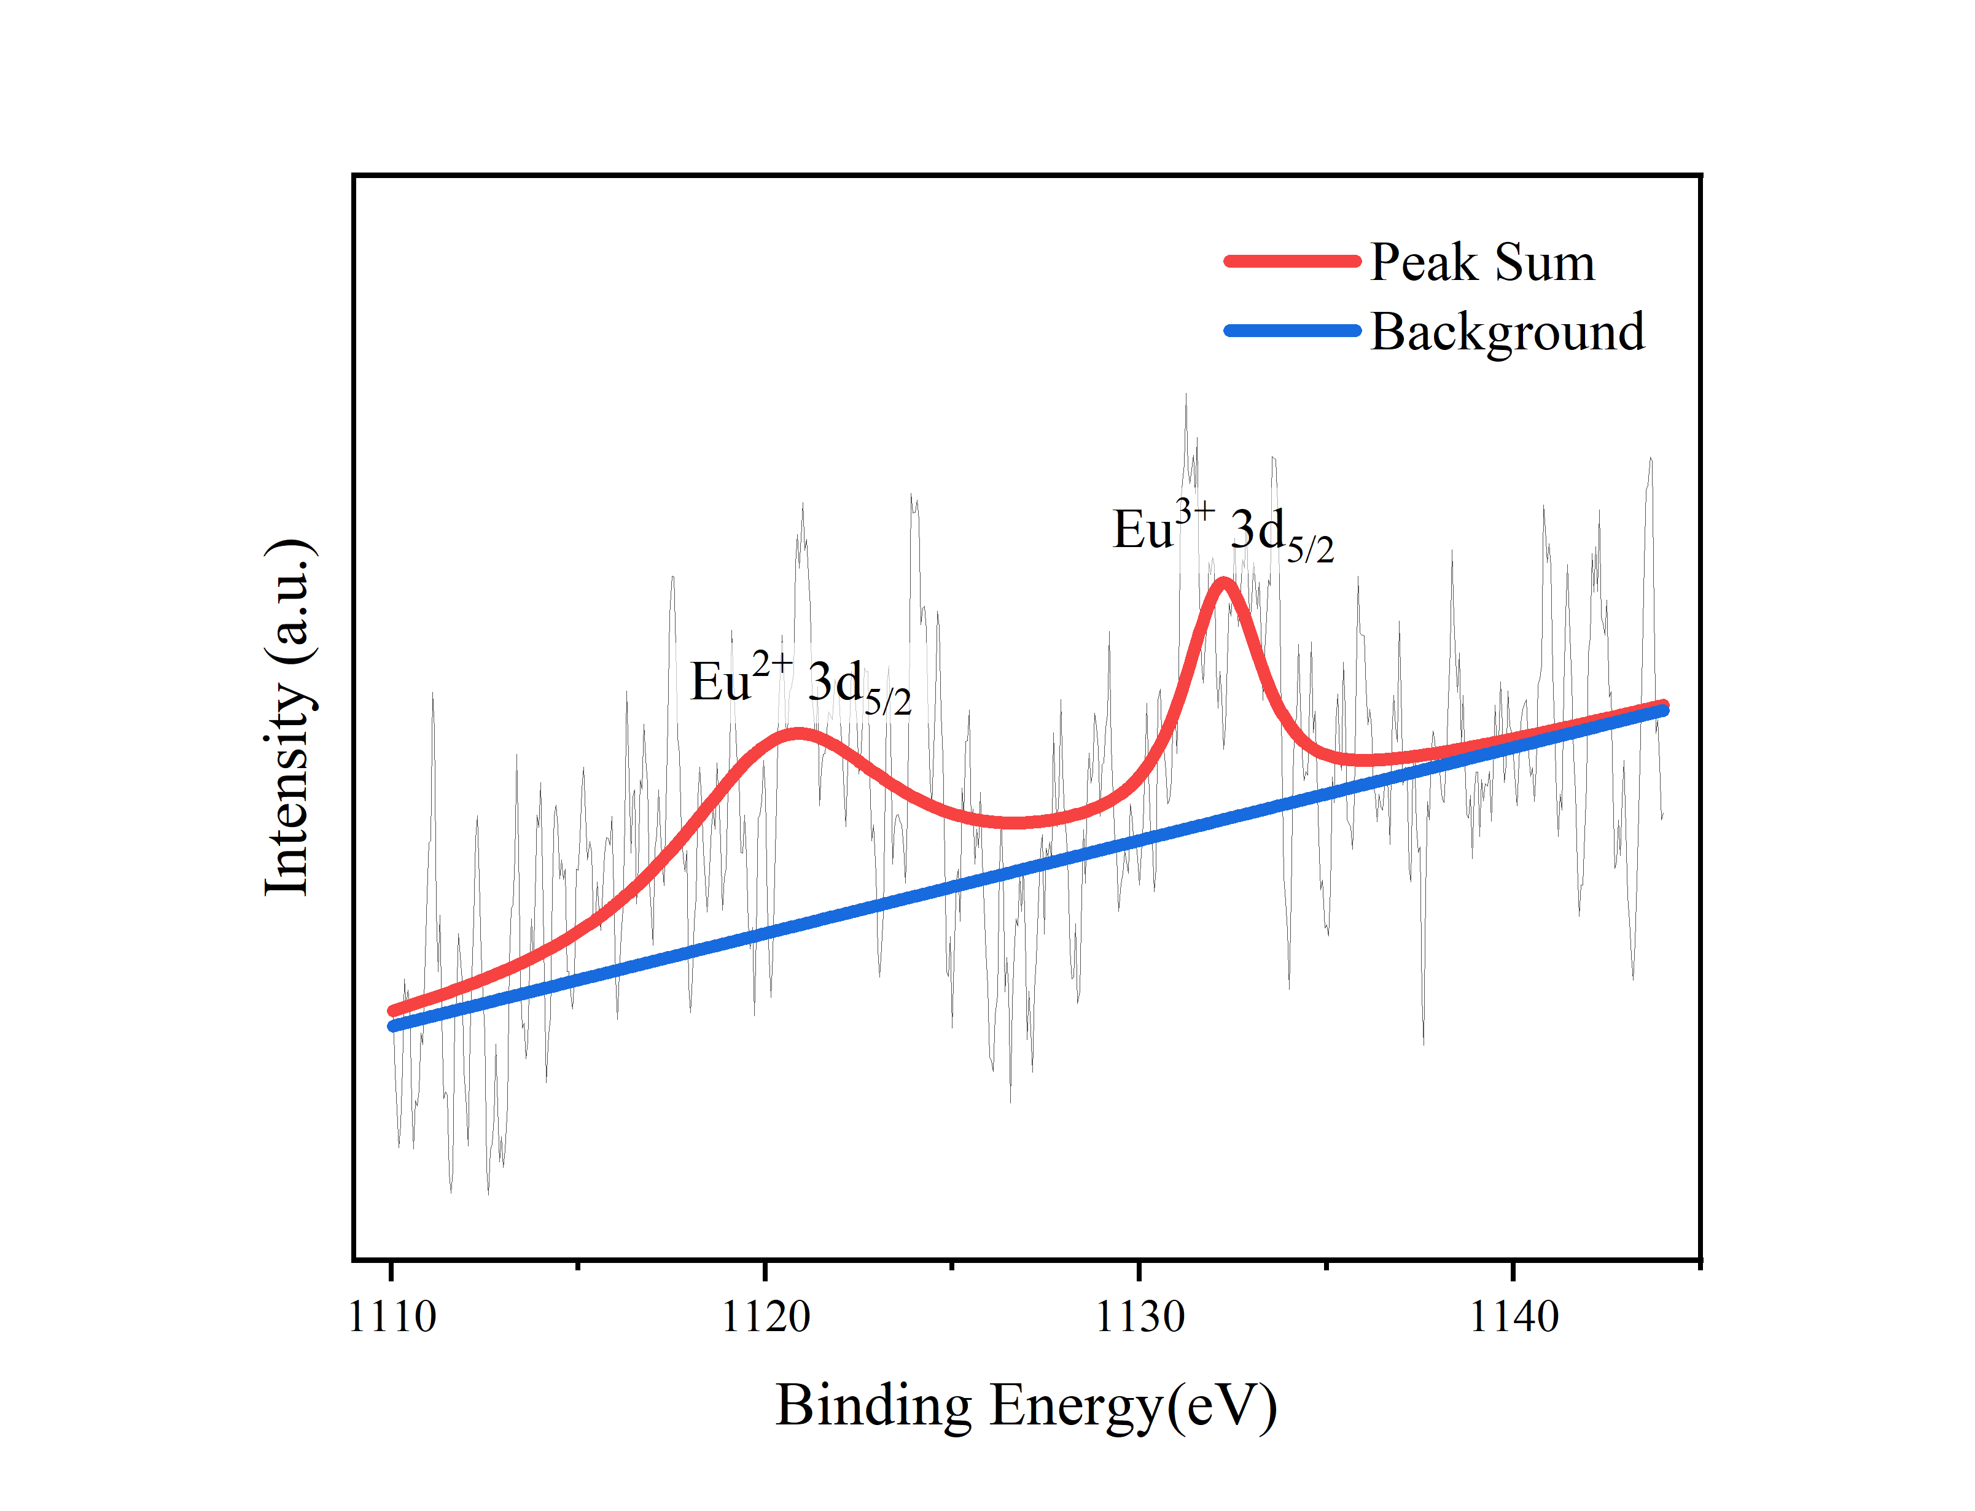
Figure S1-7. High-resolution XPS spectra of Eu 3d

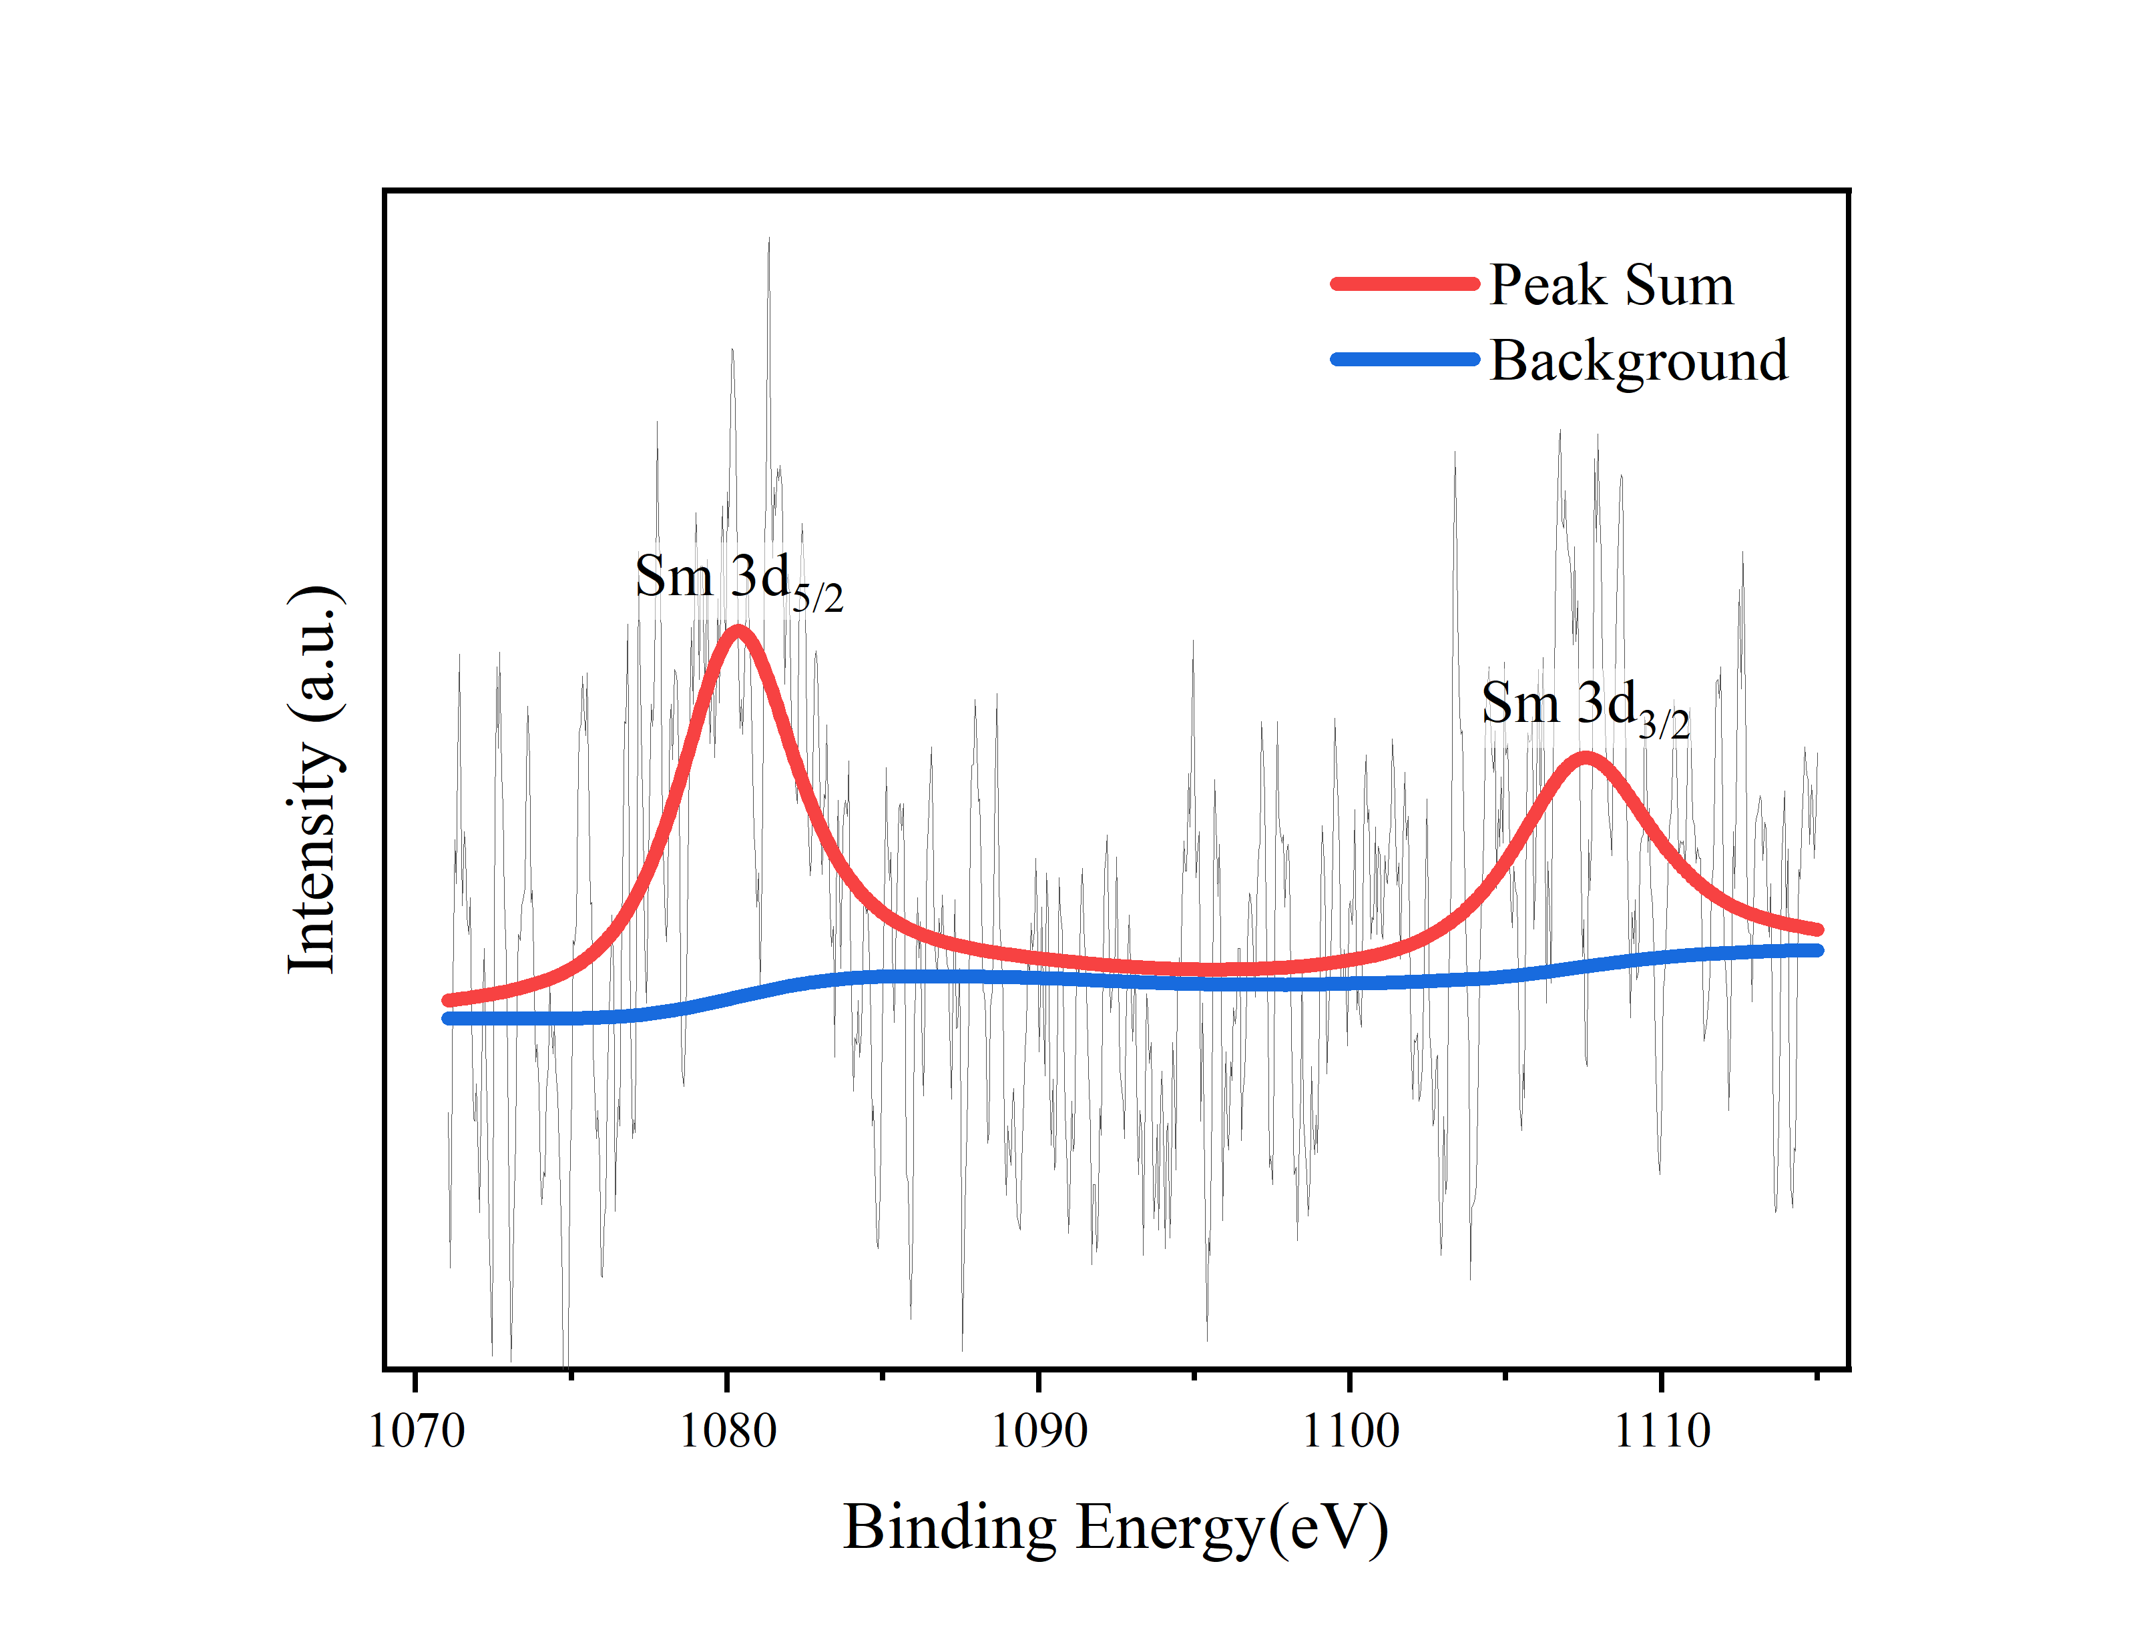
Figure S1-8. High-resolution XPS spectra of Sm 3d

Figure S1-9. Infrared absorption spectrum of PDMS
Figure S1-10. Infrared absorption spectrum of CaF₂:Tb³⁺
Figure S1-11. Raman spectroscopy of PDMS
Figure S1-12. Raman spectroscopy of CaF₂:Tb³⁺
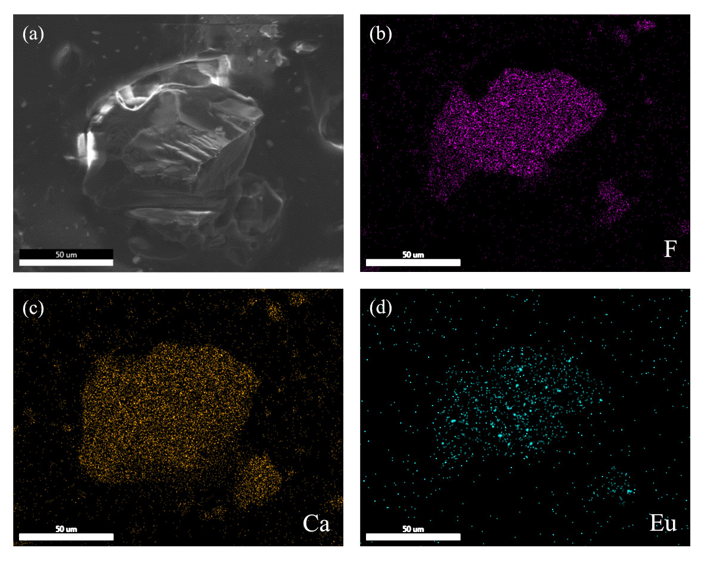
Figure S1-13. Elemental distribution map of CaF₂:Eu^{2+.}

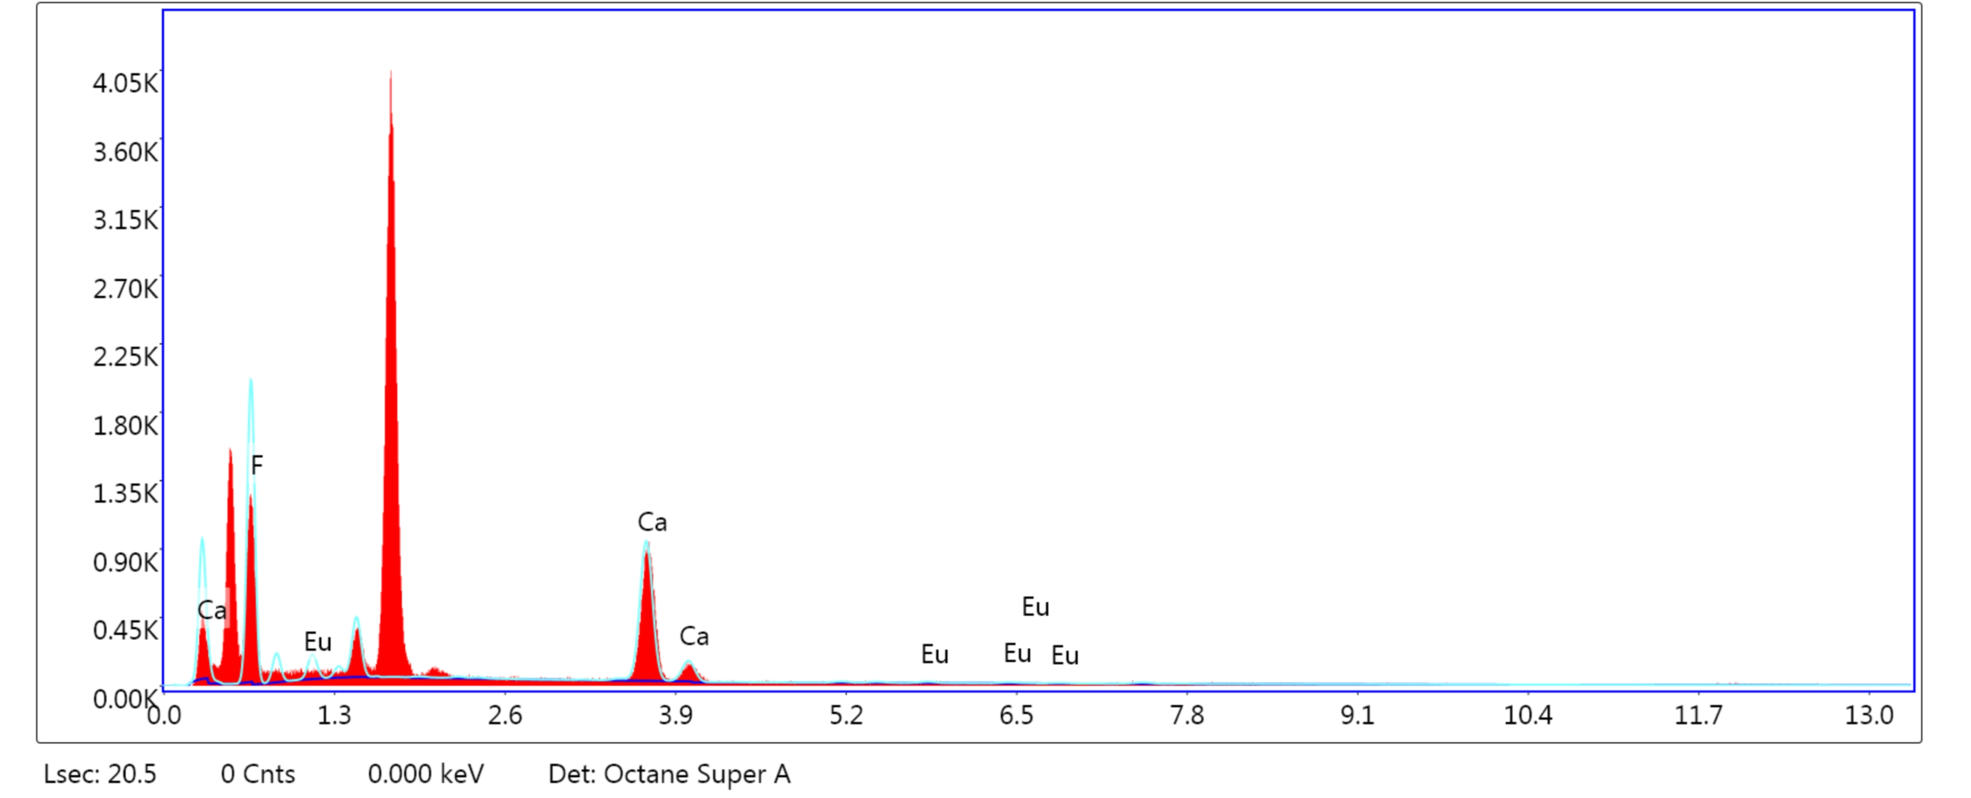
Figure S1-14. Energy dispersive spectra (EDS) of CaF₂:Eu²⁺

Table S1-4. Elements analysis of CaF₂:Eu²⁺
Element | Weight % | Atomic % | Error %
F | 64.94 | 80.04 | 8.68
Ca | 33.85 | 19.77 | 2.44
Eu | 1.21 | 0.19 | 57.30

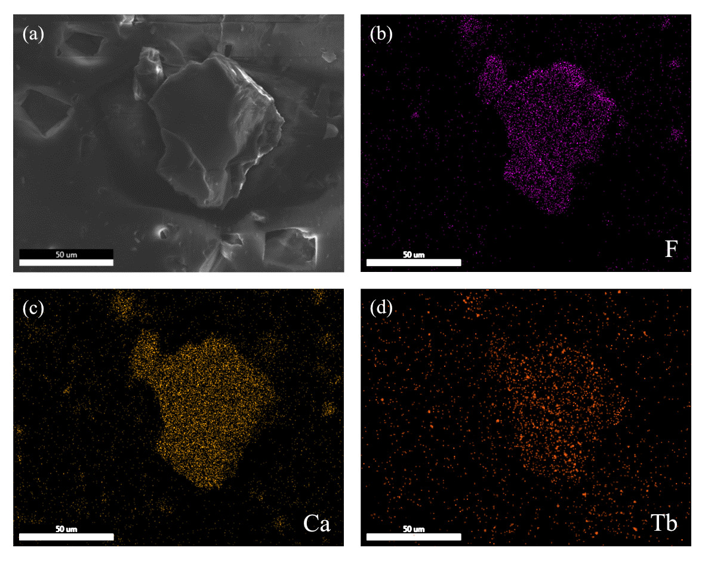
Figure S1-15. Elemental distribution map of CaF₂:Tb³⁺

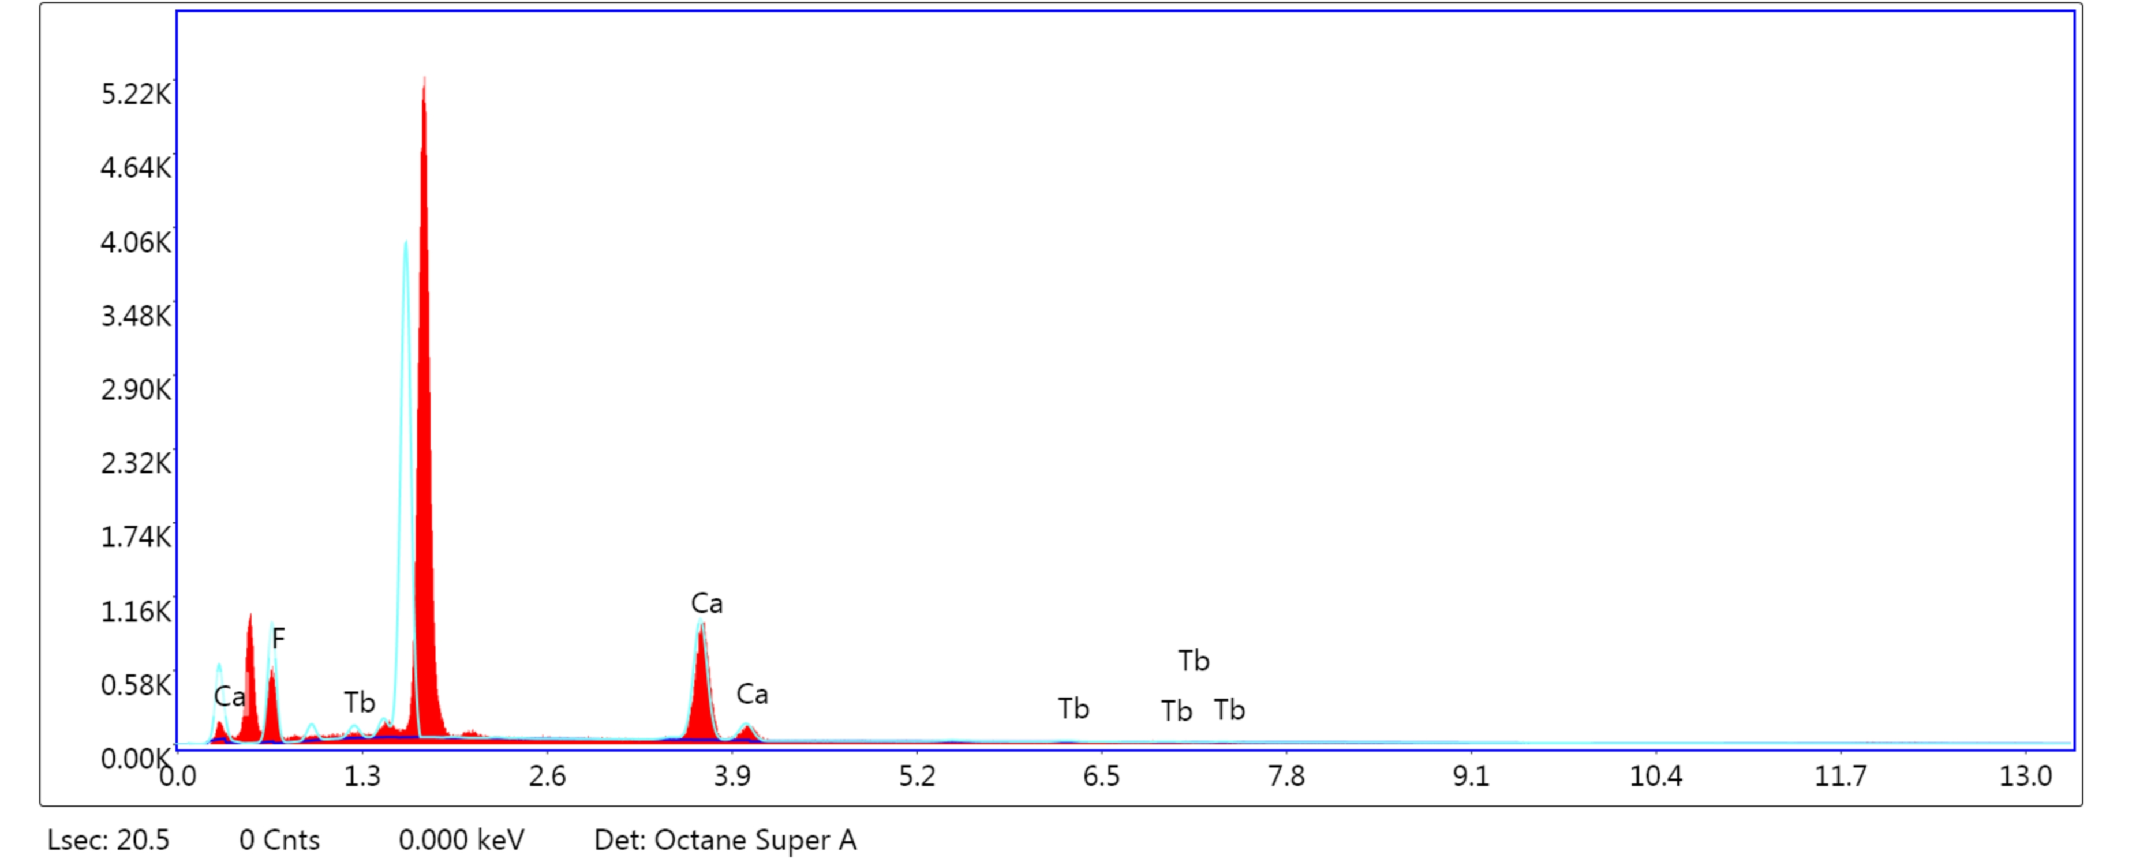
Figure S1-16. Energy dispersive spectra (EDS) of CaF₂:Tb³⁺

Table S1-5. Elements analysis of CaF₂:Tb³⁺
Element | Weight % | Atomic % | Error %
F | 51.83 | 70.21 | 9.78
Ca | 45.79 | 29.41 | 2.47
Tb | 2.38 | 0.39 | 56.76

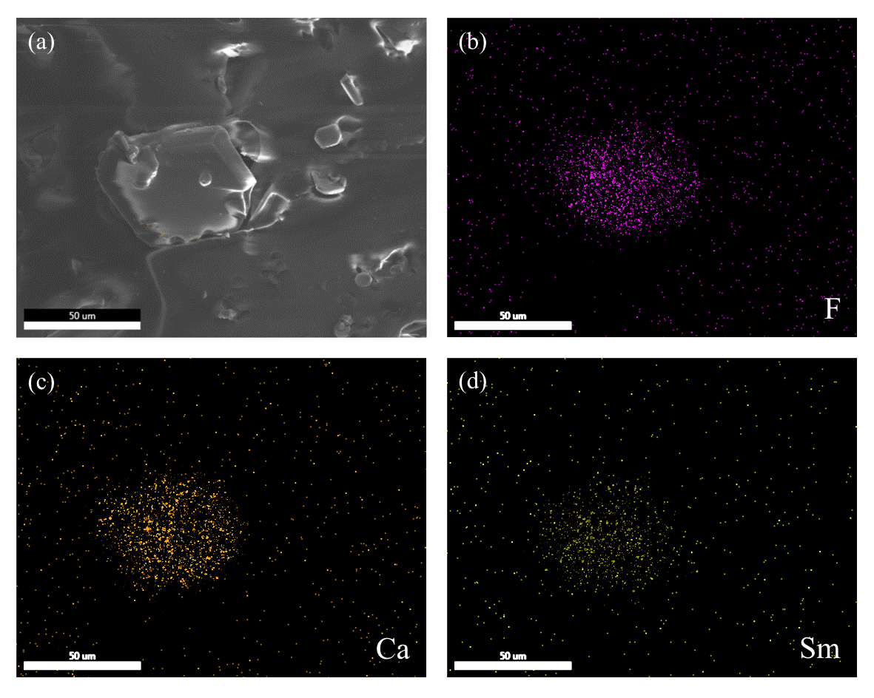
Figure S1-17. Elemental distribution map of CaF₂:Sm³⁺

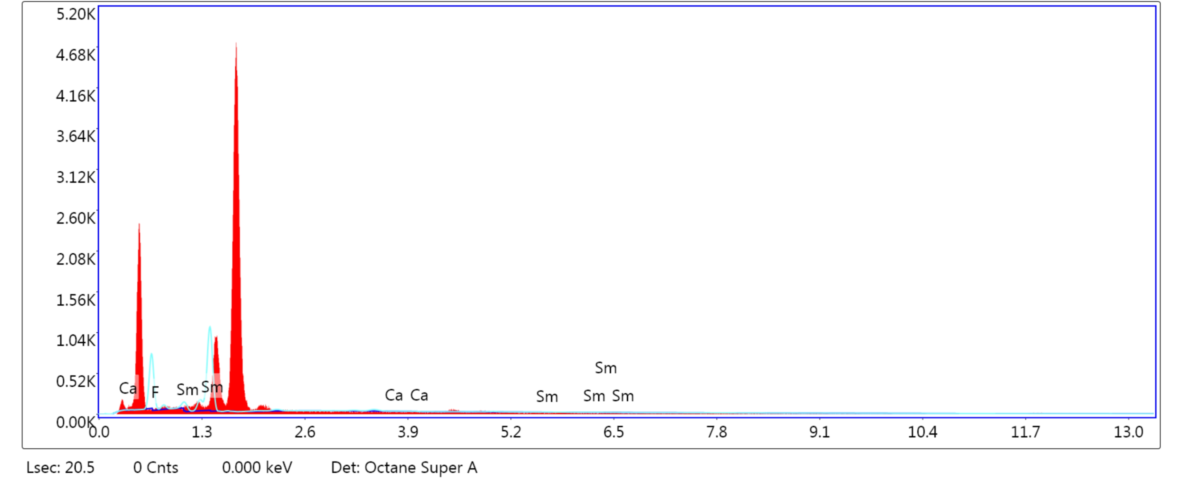
Figure S1-18. Energy dispersive spectra (EDS) of CaF₂:Sm³⁺

Table S1-6. Elements analysis of CaF₂:Sm³⁺
Element | Weight % | Atomic % | Error %
F | 89.15 | 98.17 | 4.50
Ca | 0.84 | 0.44 | 90.83
Sm | 10.01 | 1.39 | 42.73

Supplementary Note 2: Spectra of CaF₂: Tb³⁺/Eu²⁺/Sm³⁺
Figure S2-1. Excitation spectrum of CaF₂:Tb³⁺

Figure S2-2. Emission spectrum of CaF₂:Tb³⁺
Figure S2-3. ML spectrum of CaF₂:Tb³⁺

Figure S2-4. Luminescence decay curve of CaF₂:Tb³⁺

Figure S2-5. Excitation spectrum of CaF₂:Sm³⁺

Figure S2-6. Emission spectrum of CaF₂:Sm³⁺

Figure S2-7. ML spectrum of CaF₂:Sm³⁺

Figure S2-8. Luminescence decay curve of CaF₂:Sm³⁺

Figure S2-9. Excitation spectrum of CaF₂:Eu²⁺

Figure S2-10. Emission spectrum of CaF₂:Eu²⁺

Figure S2-11. ML spectrum of CaF₂:Eu²⁺

Figure S2-12. Luminescence decay curve of CaF₂:Eu²⁺

Figure S2-13. Schematic diagram of a falling ball experimental setup

Figure S2-14. ML intensity of CaF₂:Eu²⁺/PDMS in 50 repeated tests

Figure S2-15. ML intensity of CaF₂:Tb³⁺/PDMS in 50 repeated tests

Figure S2-16. ML intensity of CaF₂:Sm³⁺/PDMS in 50 repeated tests

Supplementary Note 3: Two-dimensional stretching machine
To investigate the ML self-recover ability of the composite under two-dimensional alternating stretching, we developed a dedicated stretching machine featuring a mechanical structure depicted in the figure below. To ensure utmost precision and force consistency during stretching, we equipped the machine with two high-precision stepping motors and a 1:19 planetary reducer. The control system is based on an MKS GEN-L V2.1 motherboard running on open source Marlin firmware^{6,7} which was made possible by the selfless dedication of the open source community. Following the debugging sessions, we achieved a stretching accuracy of 0.1 mm, which perfectly meets our experimental requirements.

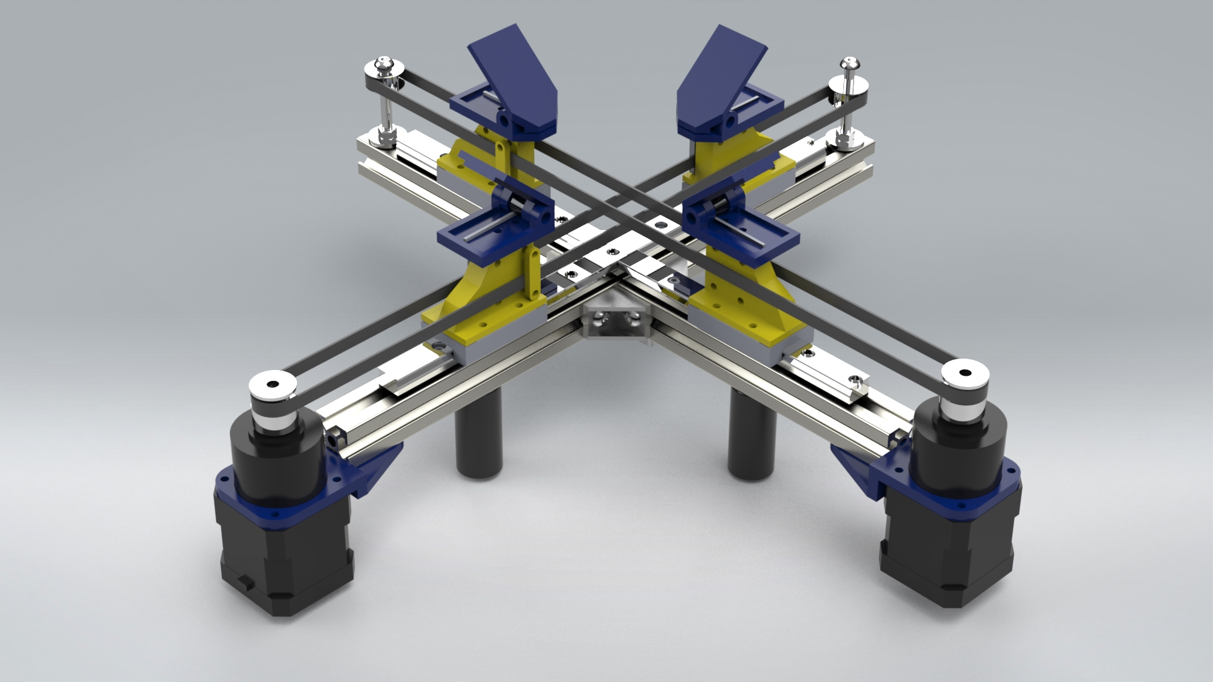

Figure S3-1. Top and bottom isometric isometric view of the 2D stretching machine

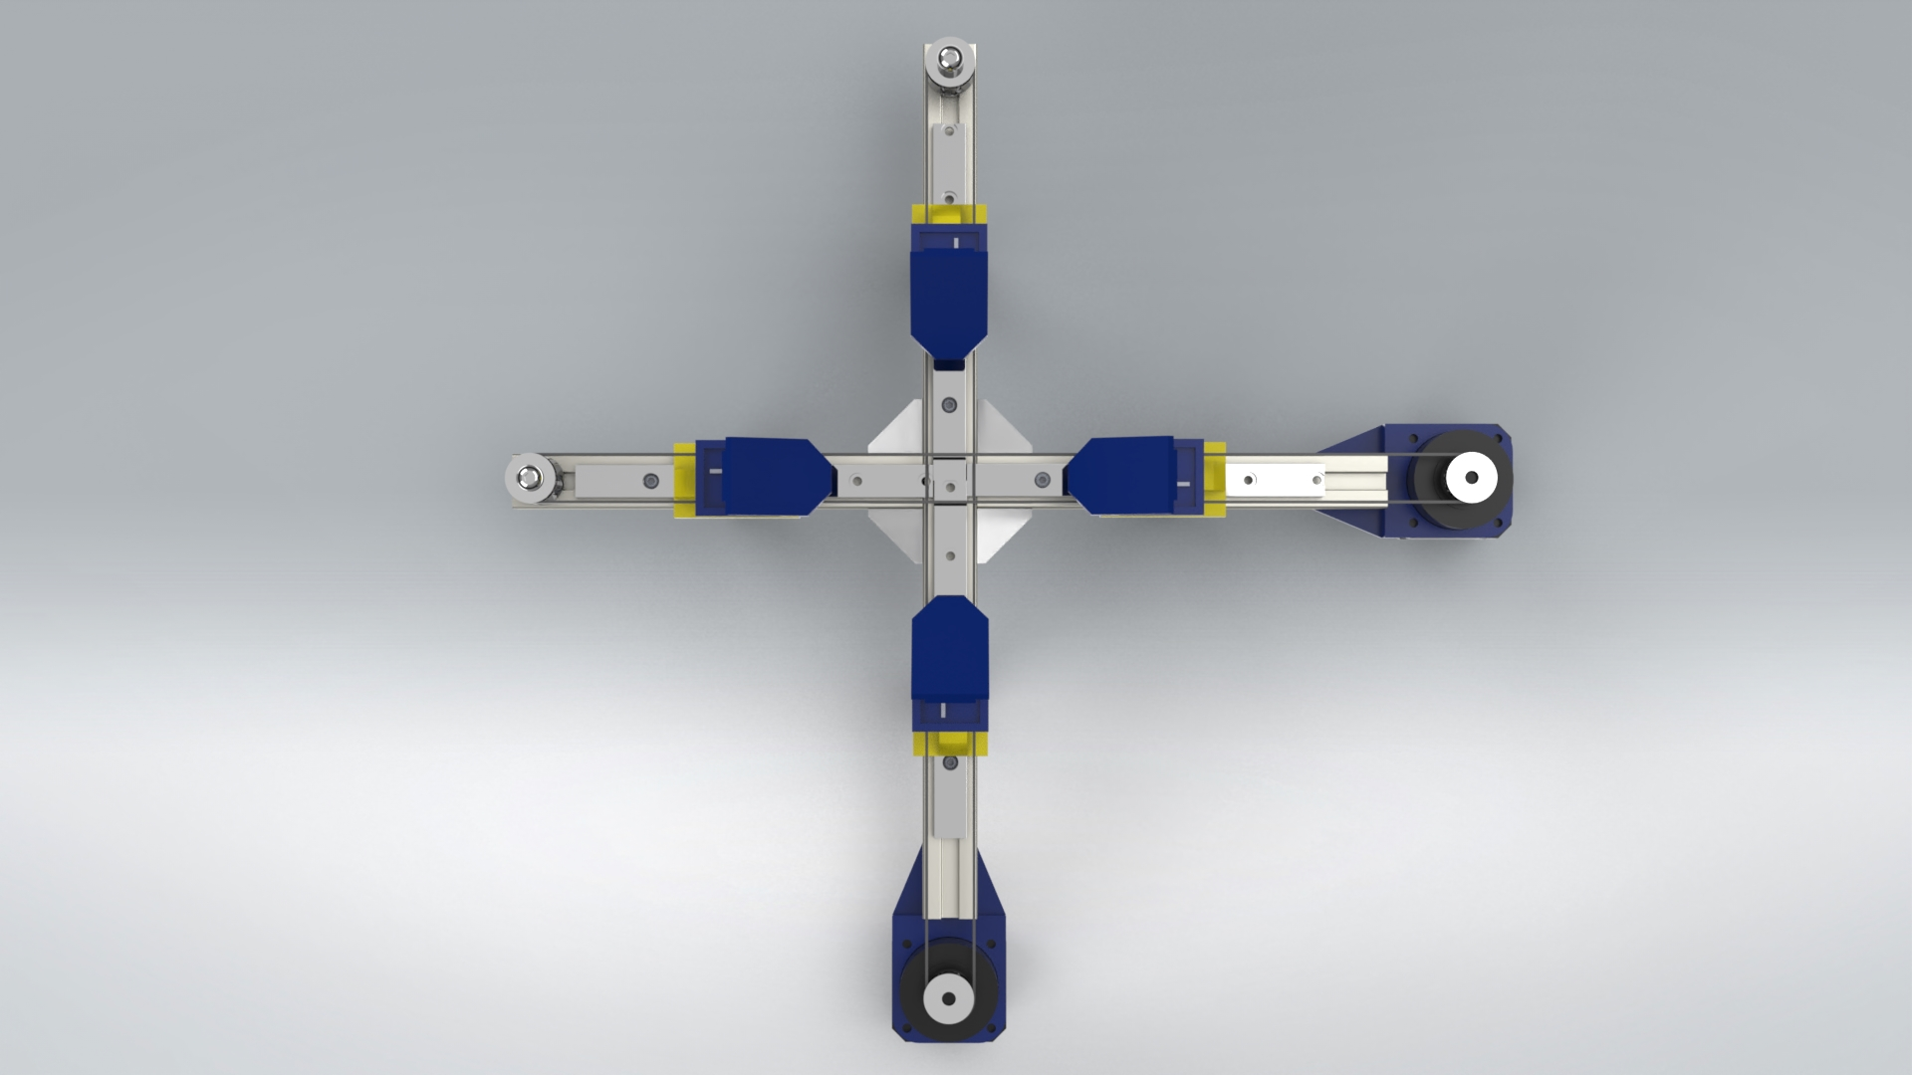

Figure S3-2. Top view of the 2D stretching machine

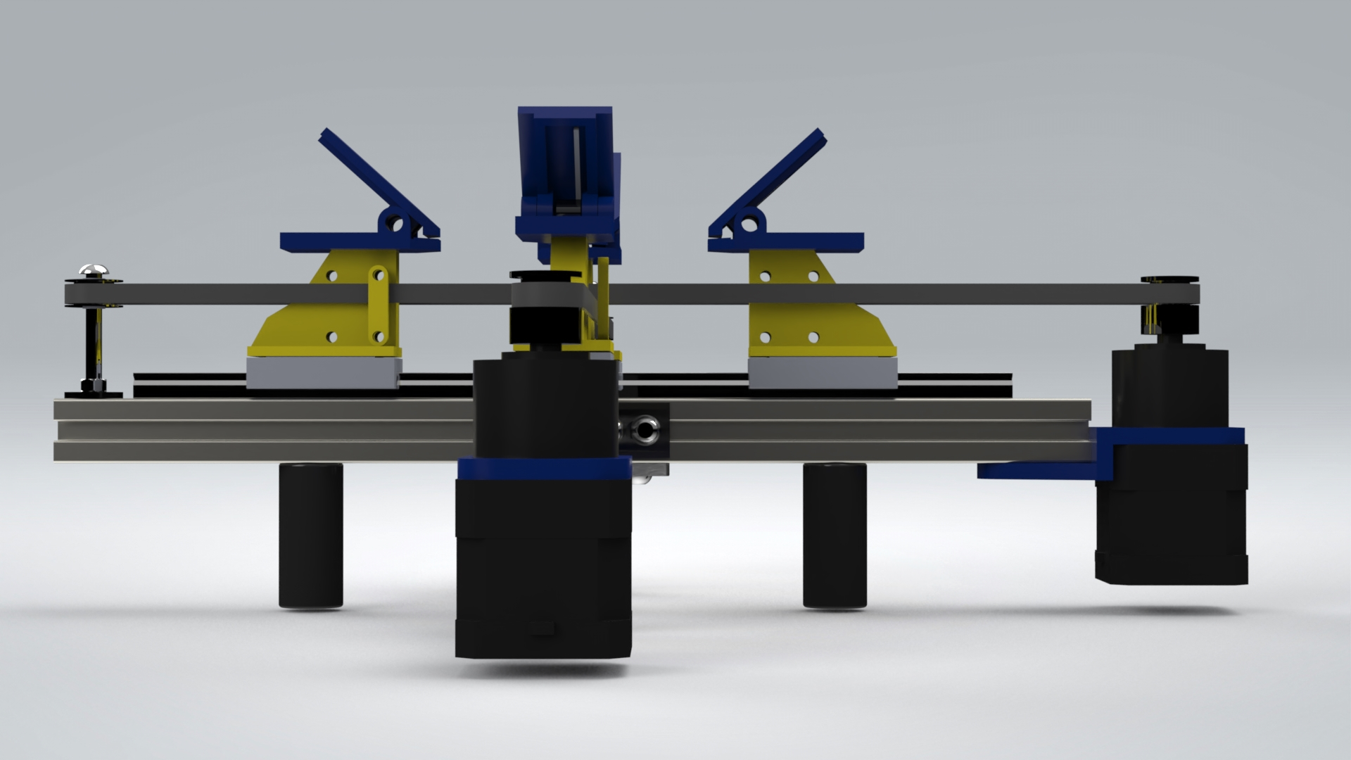

Figure S3-3. Left view of the 2D stretching machine

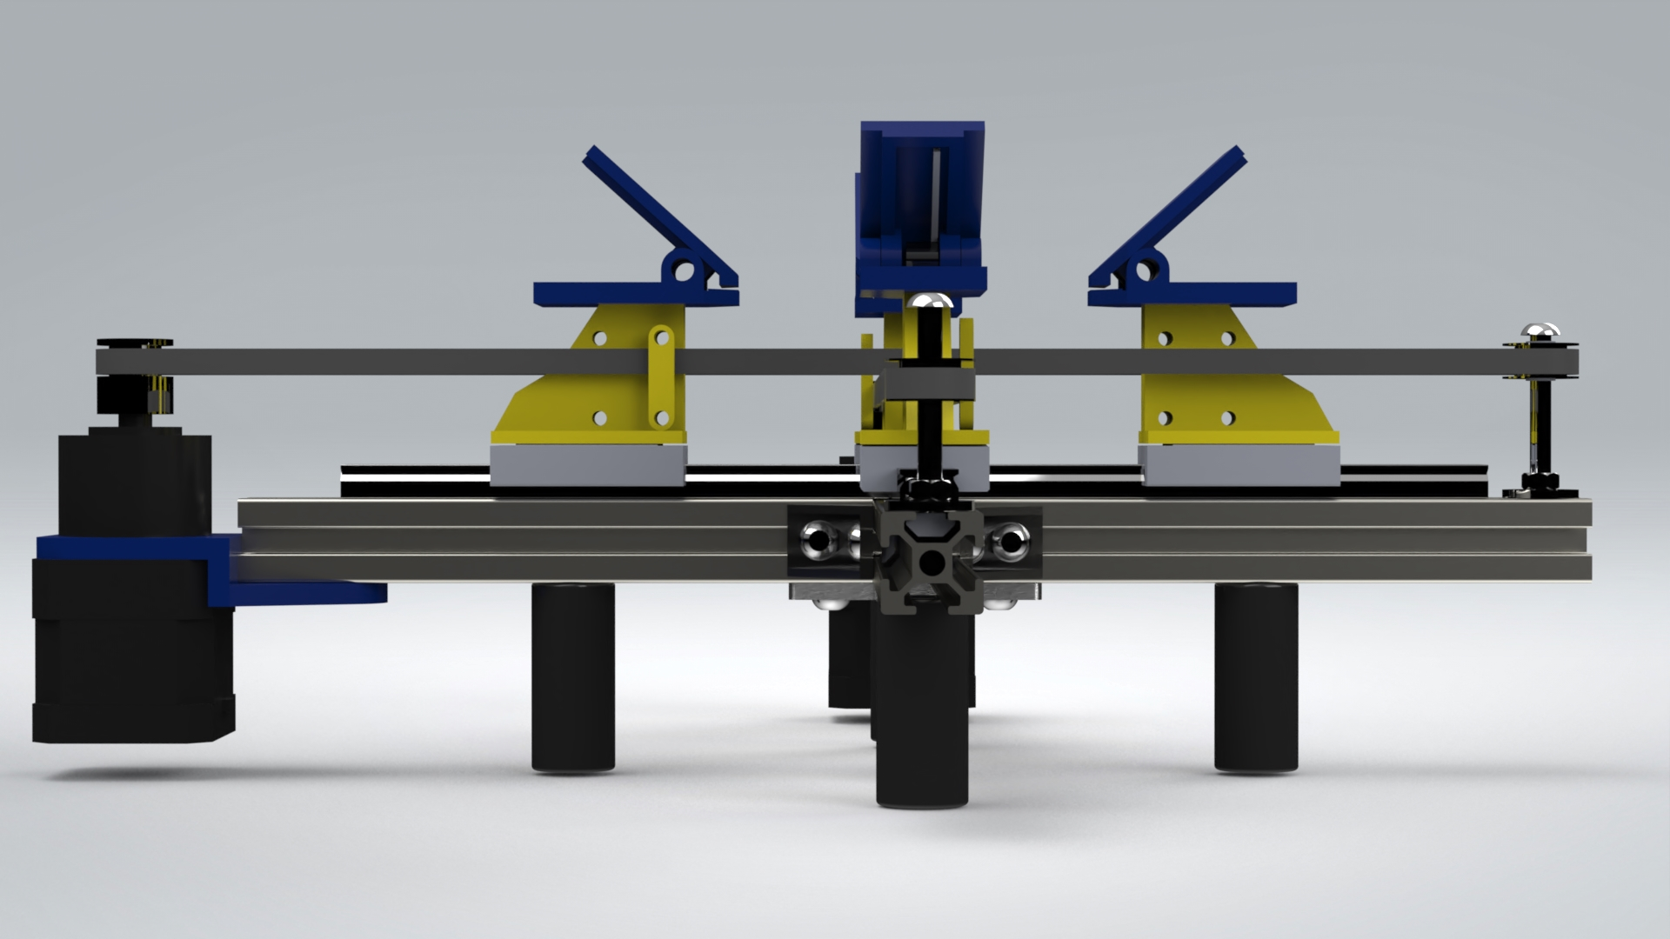

Figure S3-4. Right view of the 2D stretching machine

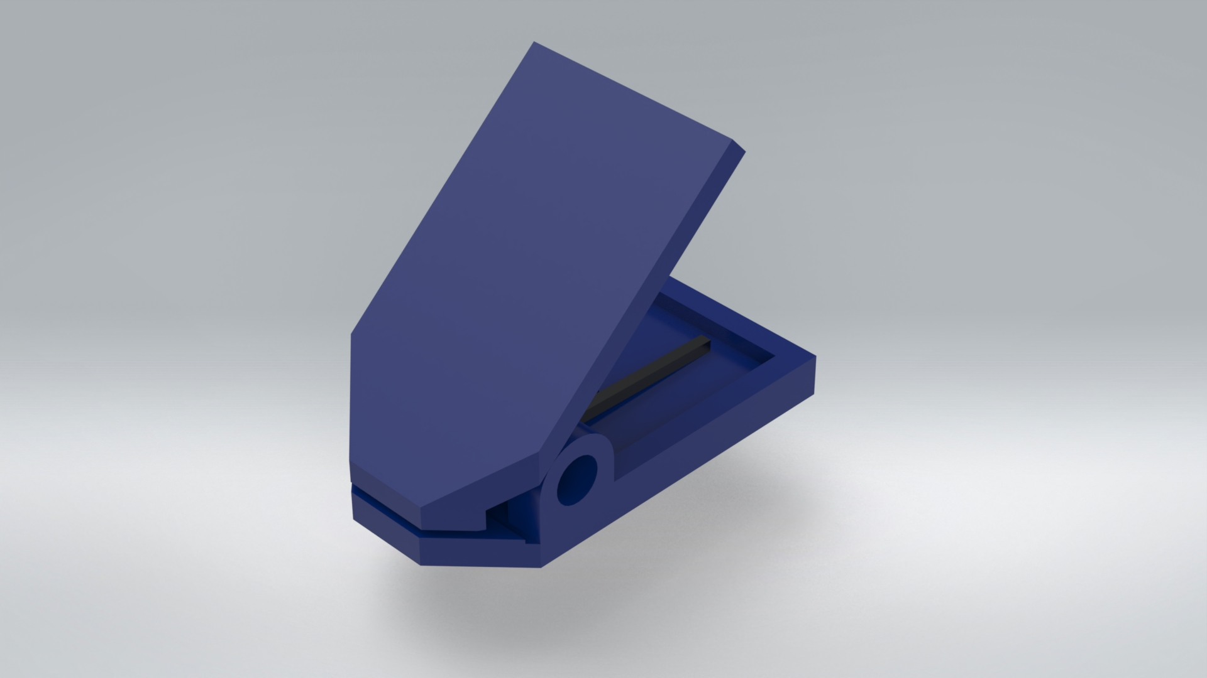

Figure S3-5. Top and bottom isometric isometric view of the fixture

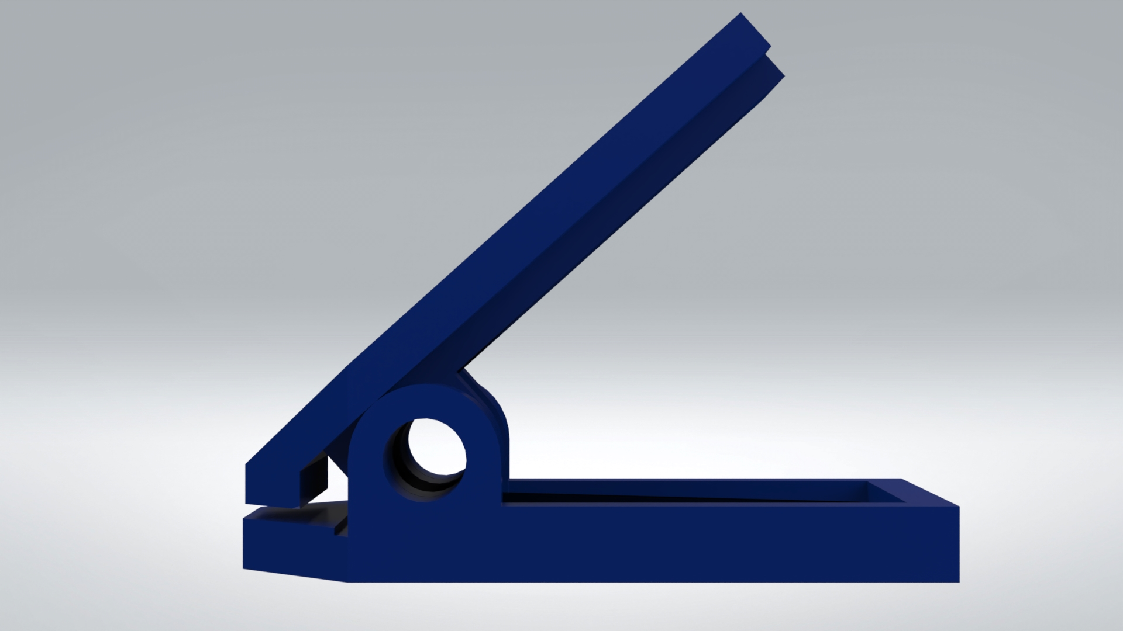

Figure S3-6. Right view of the fixture

Supplementary Note 4: Sample preparation

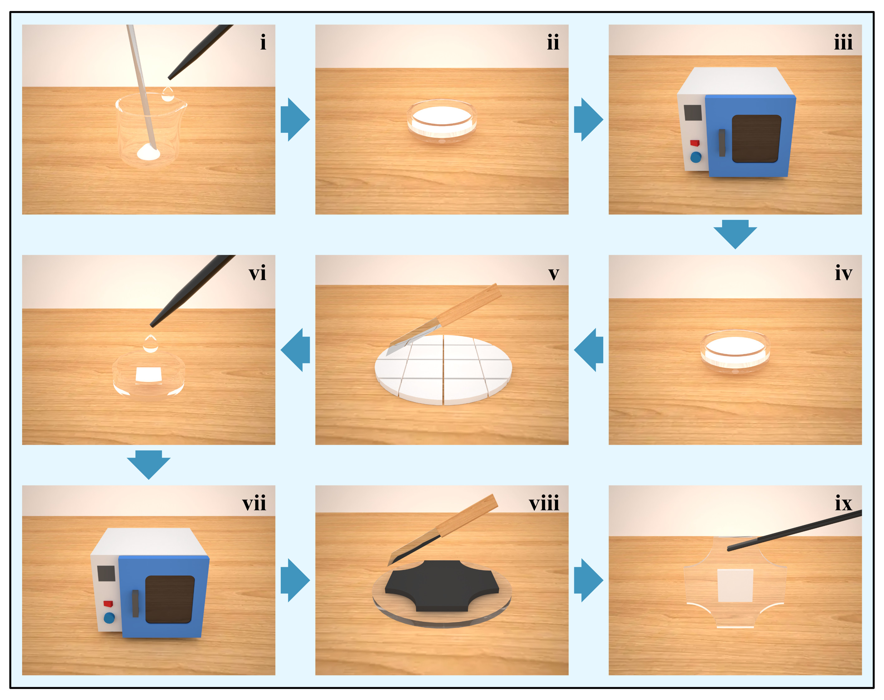

Figure S4-1. Preparation process of the four-leaf clover shape sample

First, weigh and mix the raw materials at a mass ratio of 10 (PDMS matrix) to 1 (PDMS curing agent) to 5.5 (phosphor powder) (i). Transfer the resulting slurry to a 35 mm petri dish (ii) and place it in a 60 °C oven for 5 hours to cure the PDMS (iii). Remove the cured PDMS from the petri dish (iv) and cut it into cubes (v). Take a square of the cured PDMS and place it in another petri dish. Add more PDMS to cover the square (vi), and put the petri dish back in the oven (vii). After curing, take out the sample and cut it according to the mold shape (viii) to obtain the sample (ix).

Supplementary Note 5: Properties of Lu₃Al₅O₁₂ and Y₂O₂S
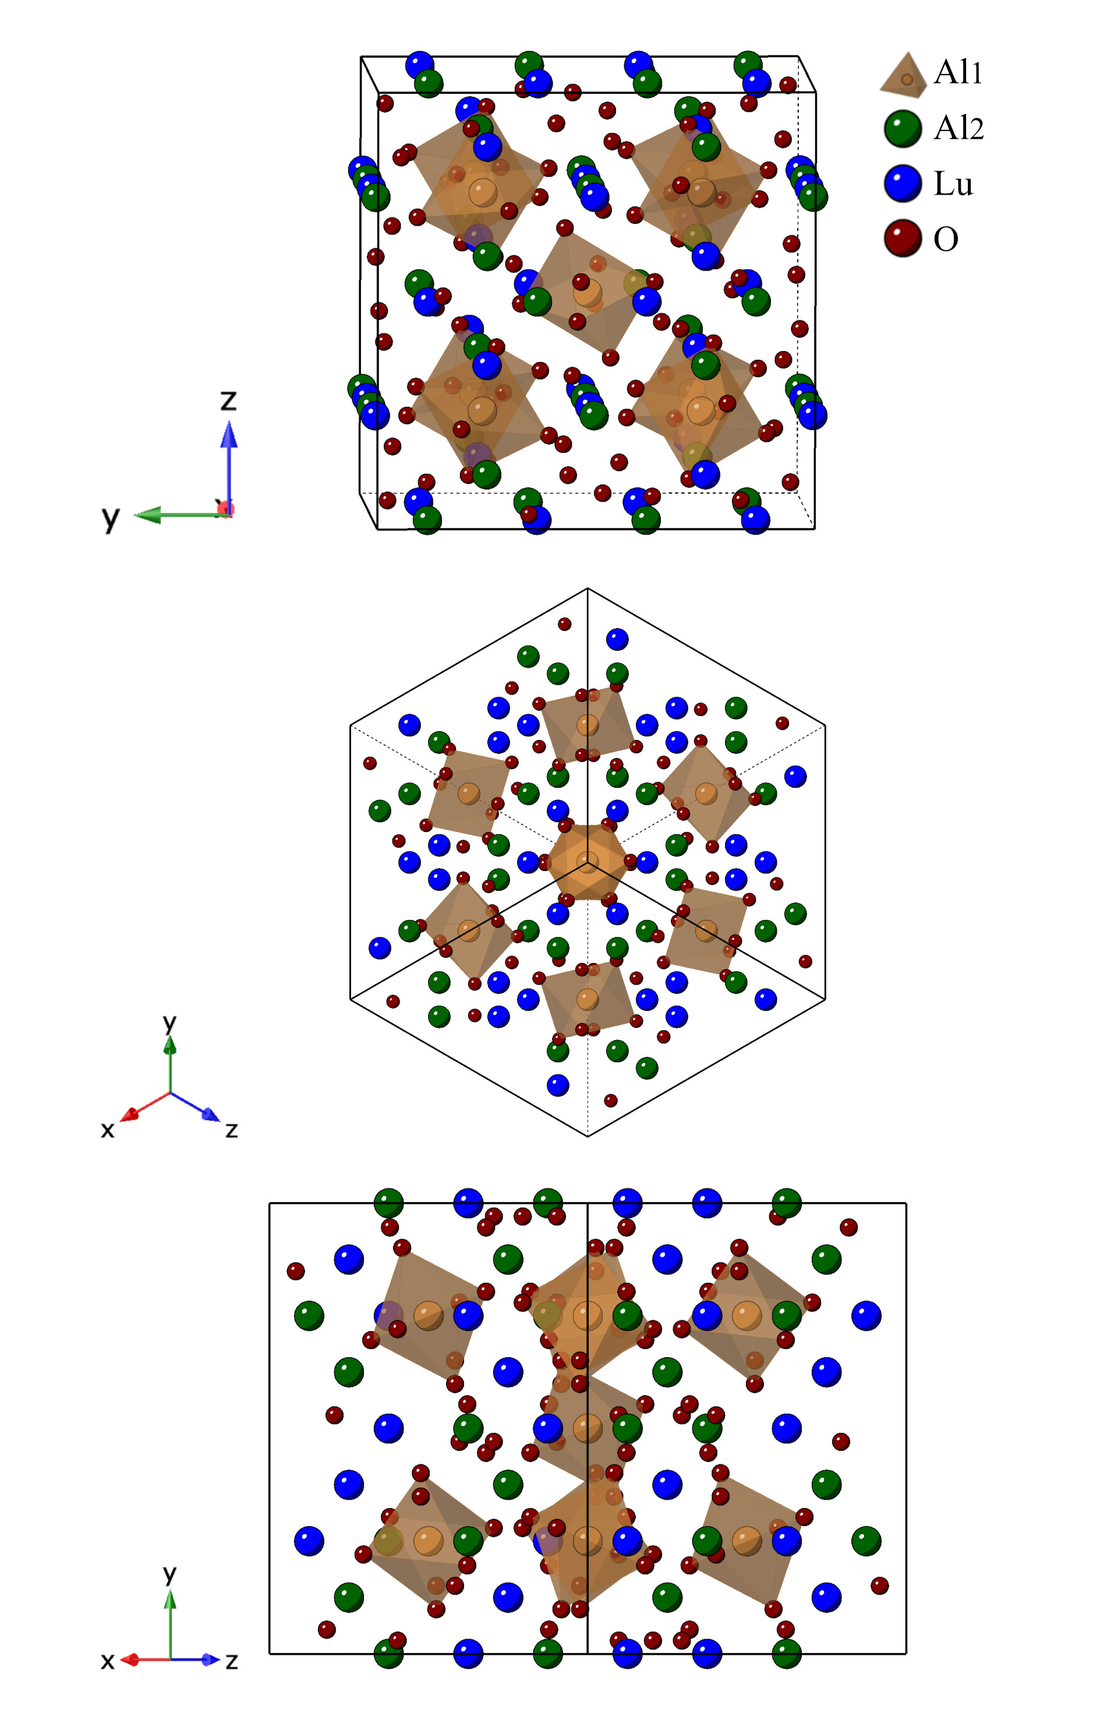
Figure S5-1. Crystal structure of Lu₃Al₅O₁₂
Figure S5-2. Rietveld refinement of the Lu₃Al₅O₁₂

Table S5-1. Crystallographic data of Lu₃Al₅O₁₂
Formula | Lu₃Al₅O₁₂
Crystal system | Cubic
Space group | I a -3 d
Lattice parameters
a（Å） | 11.9203
b（Å） | 11.9203
c（Å） | 11.9203
α° = β° = γ° | 90
Cell volume（Å3 ） | 1693.7978
T /K | 289
Diffractometer | Rigaku D /Max-2400
Radiation /Å | Cu-Ka（λ= 1.5405）
Absorption correction | multi-scan
2θ range° / | 10-100
Z | 8
Calculated Density | 6.6830 g/cm³
R-factors
Rwp | 0.096
Rp | 0.078

Table S5-2. Refined coordinates of all atoms, bond lengths of X-O and the unit cell parameters of the Lu₃Al₅O₁₂.
Space group |  |  | I a -3 d - Cubic
Cell |  |  | a = b = c = 11.9203
Ion coordinates | x |  | y |  | z | Occupancy |  | Uiso
Al1 | 0.000000 |  | 0.000000 |  | 0.000000 | 1.0000 |  | 0.03356
Al2 | 0.375000 |  | 0.000000 |  | 0.250000 | 1.0000 |  | 0.02022
Lu1 | 0.125000 |  | 0.000000 |  | 0.250000 | 1.0000 |  | 0.01093
O1 | 0.031599 |  | 0.051802 |  | 0.150646 | 1.0000 |  | 0.00573
The bond lengths of X-O
Vector |  | Length |  | Vector |  |  | Length
Al1-O1 |  | 1.936(8) |  | Lu1_O1 |  |  | 2.295(7)
Al2_O1 |  | 1.739(8) |  | Lu1_O1 |  |  | 2.412(10)

Table S5-3. The bandgap of Lu₃Al₅O₁₂ Calculated by Vienna Ab-initio Simulation Package (VASP)
Band Character | Direct
Band Gap (eV) | 5.0676
Eigenvalue of VBM (eV) | 3.5630
Eigenvalue of CBM (eV) | 8.6306
Fermi Energy (eV) | 3.7840
HOMO & LUMO Bands | 228 229
Location of VBM | 0.000000 0.000000 0.000000
Location of CBM | 0.000000 0.000000 0.000000

Figure S5-3. Calculated energy band structure of Lu₃Al₅O₁₂

Figure S5-4. Partial density of states (Lu atoms) of Lu₃Al₅O₁₂

Figure S5-5. Partial density of states (O atoms) of Lu₃Al₅O₁₂
Figure S5-6. Partial density of states (O atoms) of Lu₃Al₅O₁₂

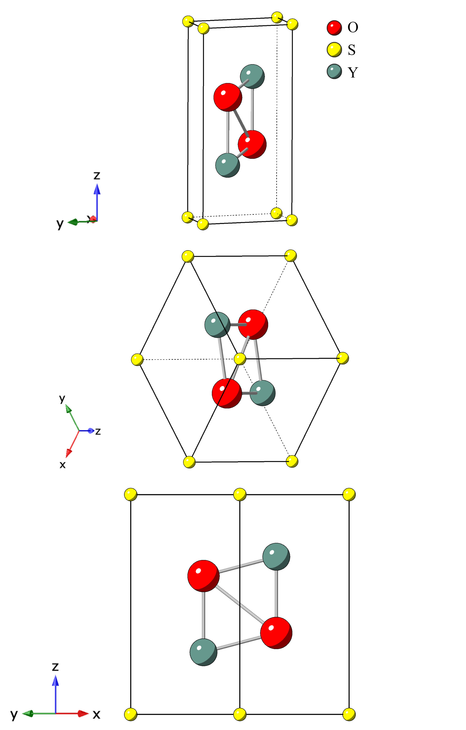
Figure S5-7. Crystal structure of Y₂O₂S
Figure S5-8. Rietveld refinement of the Y₂O₂S

Table S5-4. Crystallographic data of Y₂O₂S
Formula | Y₂O₂S
Crystal system | Trigonal
Space group | P -3 m 1
Lattice parameters
a（Å） | 3.7817
b（Å） | 3.7817
c（Å） | 6.5822
α° = β° | 90
γ° | 120
Cell volume（Å3 ） | 81.521
T /K | 289
Diffractometer | Rigaku D /Max-2400
Radiation /Å | Cu-Ka（λ= 1.5405）
Absorption correction | multi-scan
2θ range° / | 10-80
Z | 1
Calculated Density | 4.9270 g/cm³
R-factors
Rwp | 0.1205
Rp | 0.0932

Table S5-5. Refined coordinates of all atoms, bond lengths of X-O/S and the unit cell parameters of the Y₂O₂S.
Space group |  |  | P -3 m 1 - Trigonal
Cell |  |  | a = b = 3.7817 c = 6.5822
Ion coordinates | x |  | y |  | z | Occupancy |  | Uiso
Y1 | 0.333300 |  | 0.666700 |  | 0.282000 | 1.0000 |  | 0.00032
O1 | 0.333300 |  | 0.666700 |  | 0.631000 | 1.0000 |  | 0.00032
S1 | 0.000000 |  | 0.000000 |  | 0.000000 | 1.0000 |  | 0.00032
The bond lengths of X-O/S
Vector |  | Length |  | Vector |  |  | Length
Y1_O1 |  | 2.29719 |  | Y1_S1 |  |  | 2.86582
Y1_O1 |  | 2.25699 |  | Y1_S1 |  |  | 2.86557
Y1_O1 |  | 2.25762

Table S5-6. The bandgap of Y₂O₂S Calculated by Vienna
Ab-initio Simulation Package (VASP)
Band Character | Indirect
Band Gap (eV) | 3.0457
Eigenvalue of VBM (eV) | 3.5572
Eigenvalue of CBM (eV) | 6.6029
Fermi Energy (eV) | 3.7839
HOMO & LUMO Bands | 20 21
Location of VBM | 0.000000 0.000000 0.500000
Location of CBM | 0.333333 0.333333 0.000000

Figure S5-9. Calculated energy band structure of Y₂O₂S

Figure S5-10. Partial density of states (Y atoms) of Y₂O₂S

Figure S5-11. Partial density of states (O atoms) of Y₂O₂S
Figure S5-12. Partial density of states (S atoms) of Y₂O₂S

Figure S5-13. LPL spectrum of Lu₃Al₅O₁₂:Ce³⁺

Figure S5-14. ML spectrum of Lu₃Al₅O₁₂:Ce³⁺

Figure S5-15. LPL spectrum of Y₂O₂S:Eu³⁺
Figure S5-16. ML spectrum of Y₂O₂S:Eu³⁺

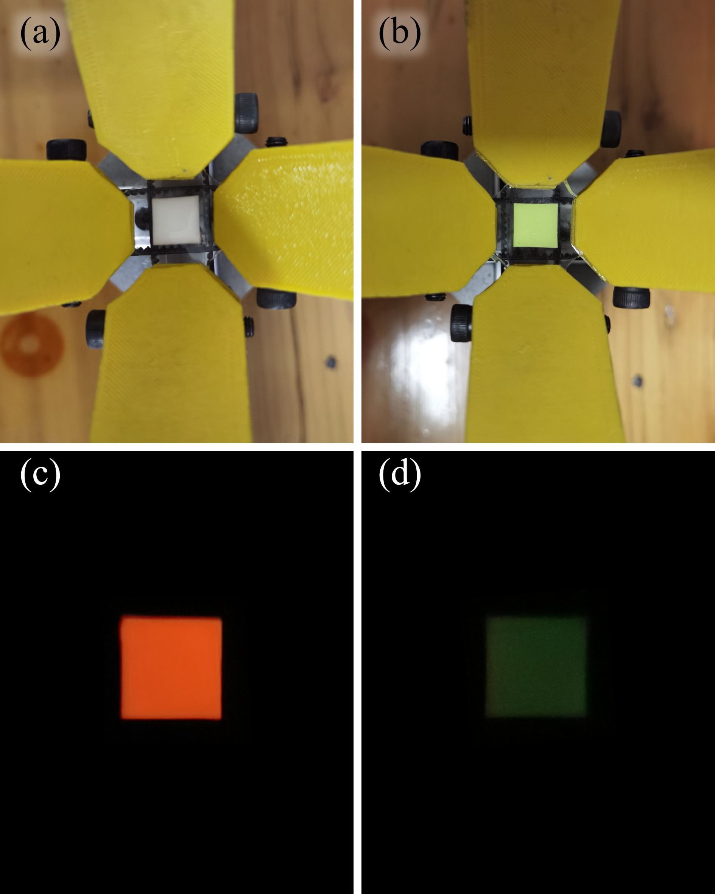

Figure S5-17. Bright field photographs(a, b) and dark field LPL photographs(c, d) of Y₂O₂S:Eu³⁺/PDMS(a, c) and Lu₃Al₅O₁₂:Ce³⁺/PDMS(b, d) elastomers

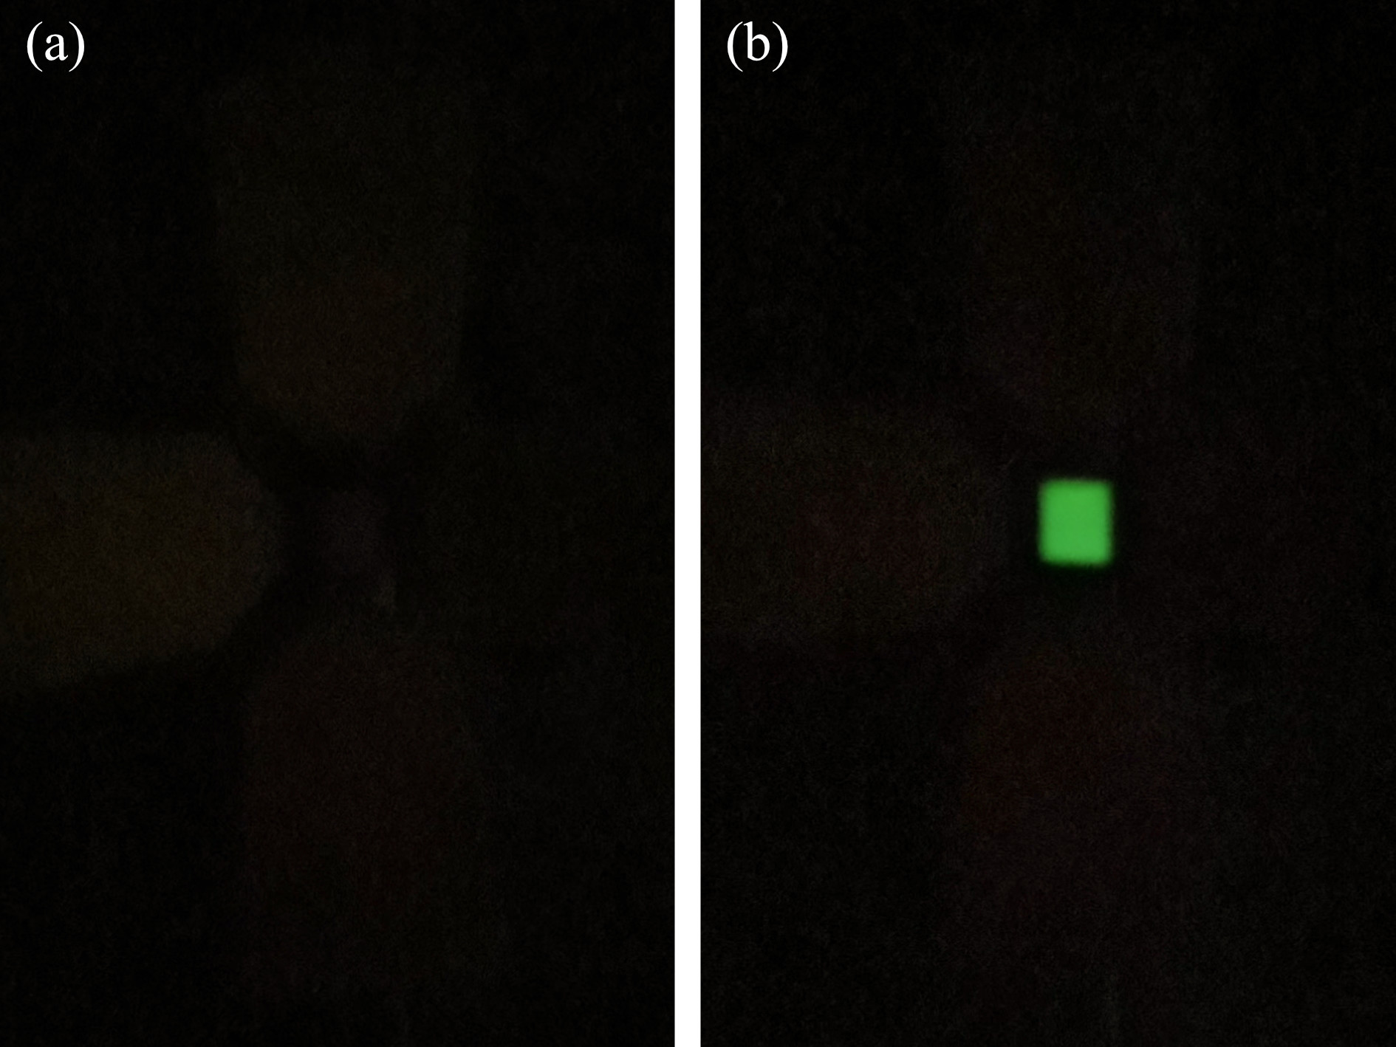
Figure S5-18. ML photographs of Y₂O₂S:Eu³⁺/PDMS(a) and Lu₃Al₅O₁₂:Ce³⁺/PDMS(b) elastomers

Lu₃Al₅O₁₂:Ce³⁺ is a commercially available phosphor with a centrosymmetric structure that exhibits excellent ML properties when used in a PDMS composite, as demonstrated in our previous work.⁸ Interestingly, it was found that the ML properties of this phosphor are independent of the trap level, making it an ideal candidate for comparison. In contrast, Y₂O₂S:Eu³⁺ is another commercially available phosphor with a centrosymmetric structure that is known for its excellent long persistent performance. While some reports have suggested that this phosphor exhibits ML, we did not observe any ML in the Y₂O₂S:Eu³⁺/PDMS composite(Figure S5-16, Figure S5-18), possibly due to the lower tensile and tear strengths of PDMS. Therefore, this phosphor was chosen to represent sulfide in our study.

Supplementary Note 6: Analysis of the contact interface
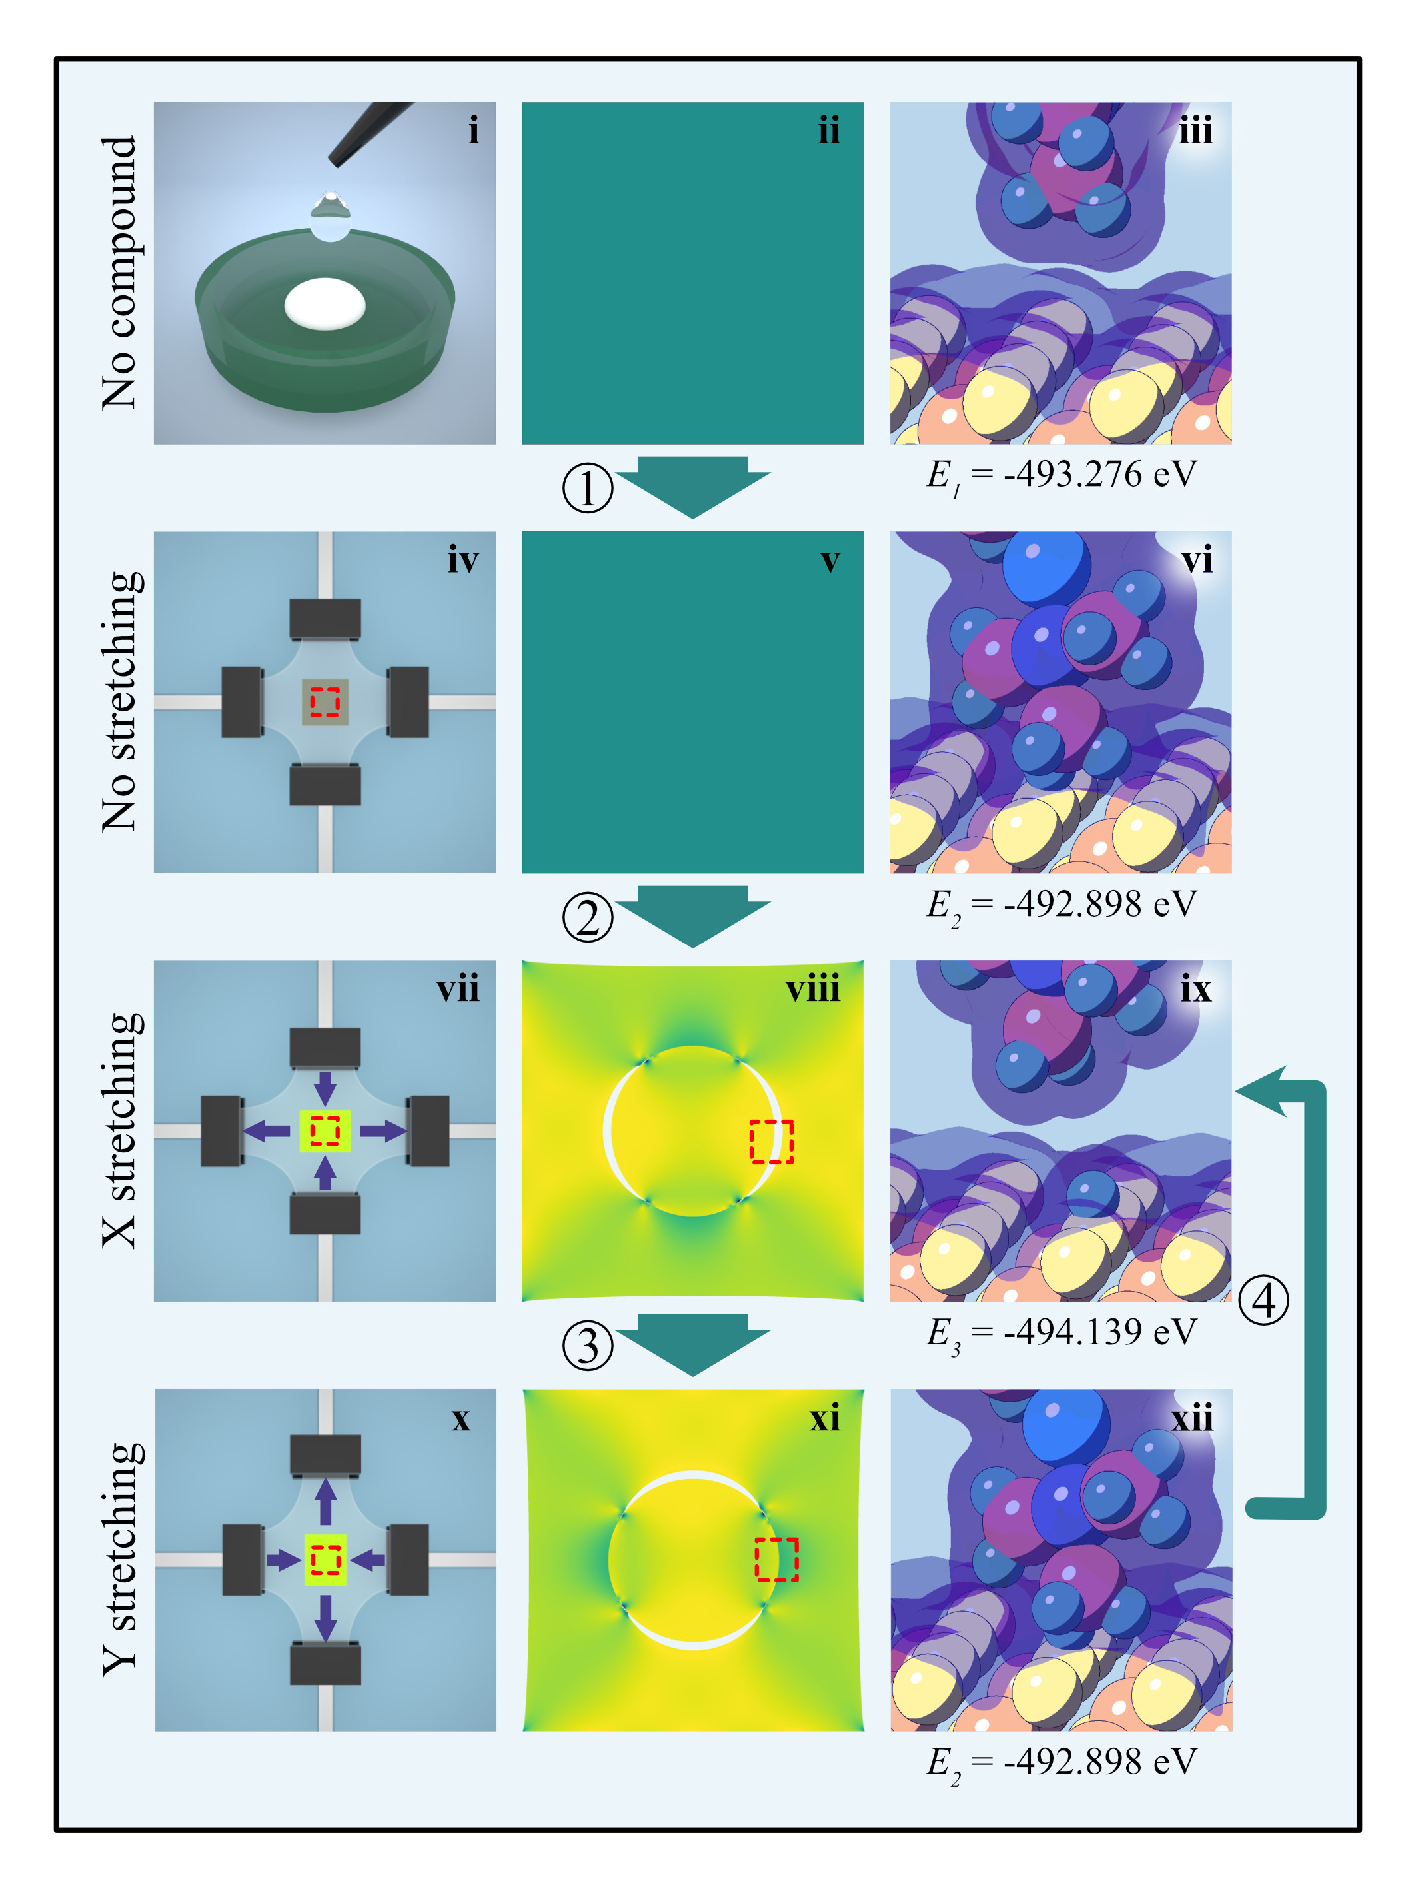
Figure S6-1. Stress distribution and binding energies of the elastomer

Figure S6-1 illustrates the states and binding energies of the complex at different stages during two-dimensional stretching. Originally, prior to incorporating the phosphor into PDMS (Figure S6-1 i), there was no contact between the phosphor and PDMS, hence no interfacial stress (Figure S6-1 ii). The binding energy of the complex was E₁ = -493.276 eV (Figure S6-1 iii). Upon incorporating the phosphor into PDMS (Figure S6-1 iv), the phosphor and PDMS were in contact but without interfacial stress (Figure S6-1 v). The binding energy of the complex was E₂ = -492.898 eV (Figure S6-1 vi). Subsequently, the complex was stretched horizontally (Figure S6-1 vii) and concurrently subjected to tensile forces in the horizontal direction and compressive forces in the vertical direction (Figure S6-1 viii). Horizontally, the phosphor and PDMS were stretched apart. Calculation showed that the complex had the lowest binding energy when hydrogen atoms remained on the surface of the phosphor. The binding energy at this stage was E₃ = -494.139 eV (Figure S6-1 ix), releasing energy of ΔE₂₃ = 1.241 eV. The complex was then stretched vertically (Figure S6-1 x) and simultaneously subjected to tensile forces in the vertical direction and compressive forces in the horizontal direction (Figure S6-1 xi). Under the effect of horizontal compression , the phosphor and PDMS came into close contact again. At this point, the complex absorbed energy of ΔE₂₃ = 1.241 eV and returned to E₂, completing one two-dimensional stretching cycle.
In summary, during the cycling process, energy was released when the phosphor and PDMS separated and absorbed when they came into contact again. The requisite energy was provided by the external tensile forces.

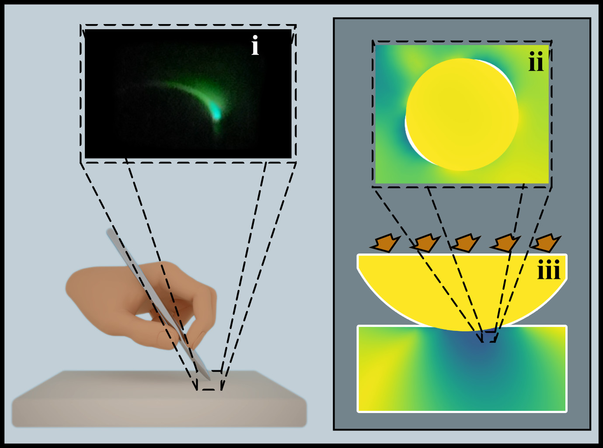

Figure S6-2. The stress distribution and ML photo for the elastomer under stretching

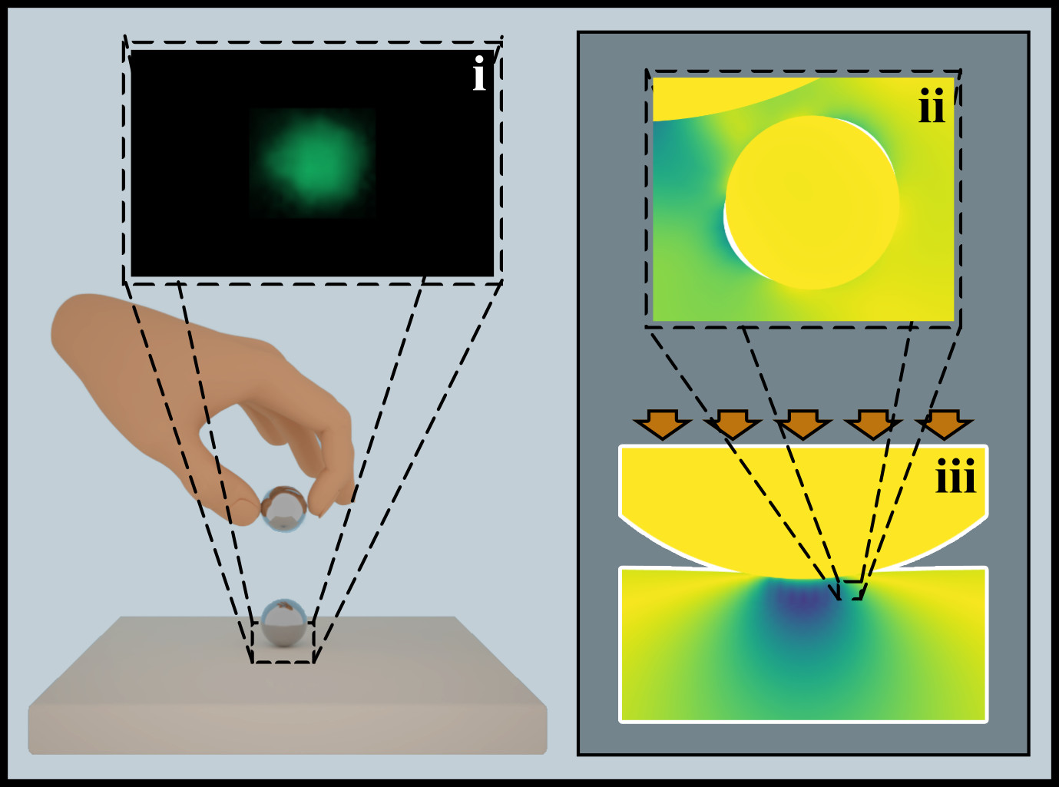

Figure S6-3. The stress distribution and ML photo for the elastomer under falling ball

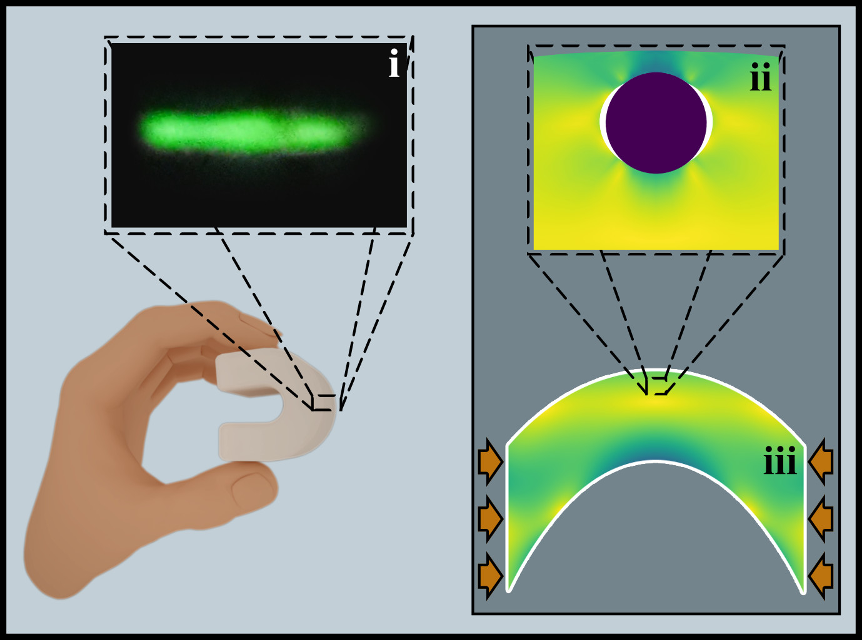

Figure S6-4. The stress distribution and ML photo for the elastomer under bending

Figures S7-2 to S7-4 present ML images of the complexes under different action modes, along with the corresponding stress distribution at the interface. The Figures indicate that the action modes which elicit ML also result in the separation of phosphor powder from the PDMS.
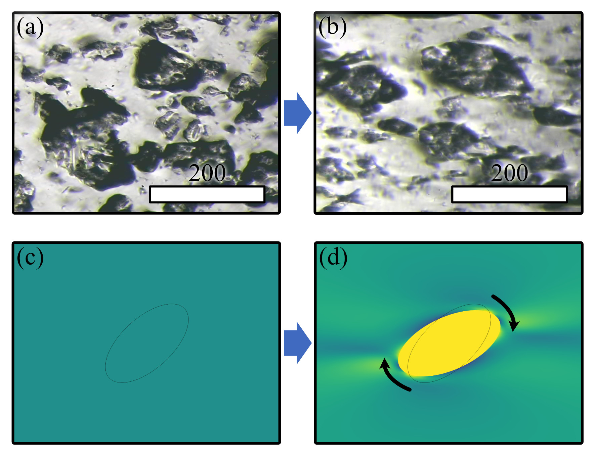

Figure S6-5. In situ micrographs(a, b) and stress distribution(c, d)
before(a, c) and after(b, d) stretching

When stretched, the randomly arranged phosphor particles (Figure S6-5 (a)) tend to become ordered, as shown in Figure S6-5 (b), which could be simulated by the finite element method as shown in Figure S6-5 (c-d).

Supplementary Note 7: First-principles calculation of contact-separation
Calculation Method：First-principles calculations are performed by vienna ab initio simulation package (VASP)^{1–5}. The generalized gradient approximation(GGA) of Perdew-Burke-Ernzerhof (PBE) is used to describe the exchange-correlation functional. The cut-off energy for the plane wave basis is set to 400 eV and a 2×2×1 mesh is employed. All the structures were fully relaxed (atomic position) up to 10⁻⁵ eV /Å force minimization and max force of 0.01 eV/Å.
All transition states were calculated using the Transition State Tools for VASP-VTST method, with the stretching frequencies analyzed in order to characterize whether a stationary point is a minimum state without imaginary frequency or a transition state with only one imaginary frequency. For the transition state structures, frequency analysis is carried out, and zero point energy correction is carried out for all the energy obtained to eliminate the impact of vibration on the energy.
The reaction energy are defined as:
ΔE₂₁ = E₂ – E₁
ΔE₃₁ = E₃ – E₁
E₂₃ = E₂ – E₃

Calculation parameters summary:
Cutoff energy: 400 eV
Electronic self-consistent convergence criterion: 10⁻⁵ eV/Å
Atomic relaxation convergence criterion: -0.01 eV/Å
K-point grid: 2×2×1
Functional: PAW-PBE

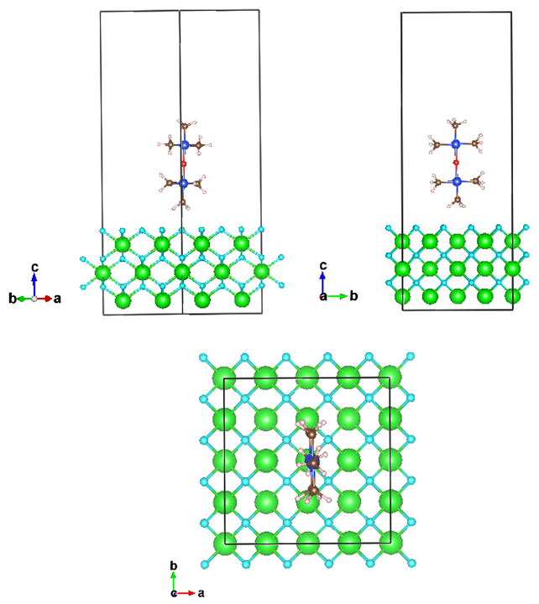
Figure S7-1. Initial state of CaF₂/PDMS elastomer

E₁ = -493.27614475 eV

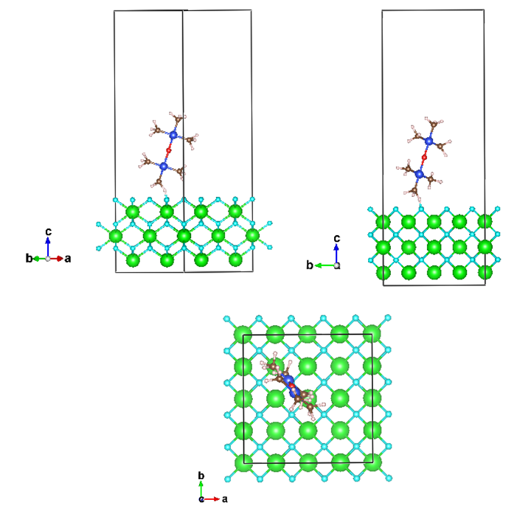
Figure S7-2. Contact state of CaF₂/PDMS elastomer

E₂ = -492.89820746 eV

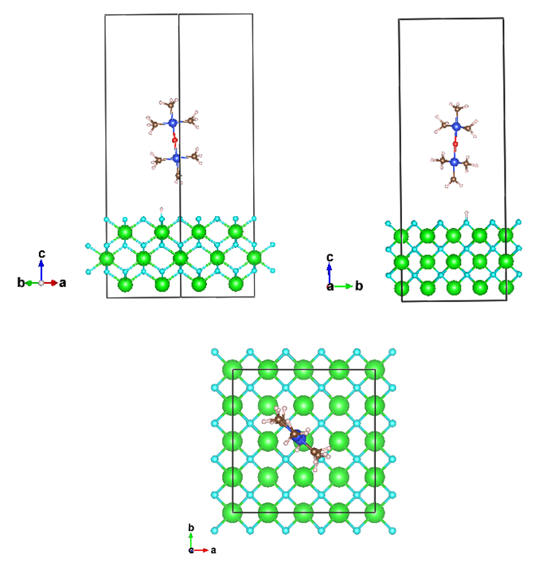
Figure S7-3. Separation state of CaF₂/PDMS elastomer

E₃ = -494.13918038 eV

Calculated to get:

ΔE₂₁ = E₂ – E₁ = -492.89820746 - -493.27614475 = 0.378 eV
ΔE₃₁ = E₃ – E₁ = -494.13918038 - -493.27614475 = -0.863 eV
ΔE₂₃ = E₂ – E₃ = -492.89820746 - -494.13918038 = 1.241 eV

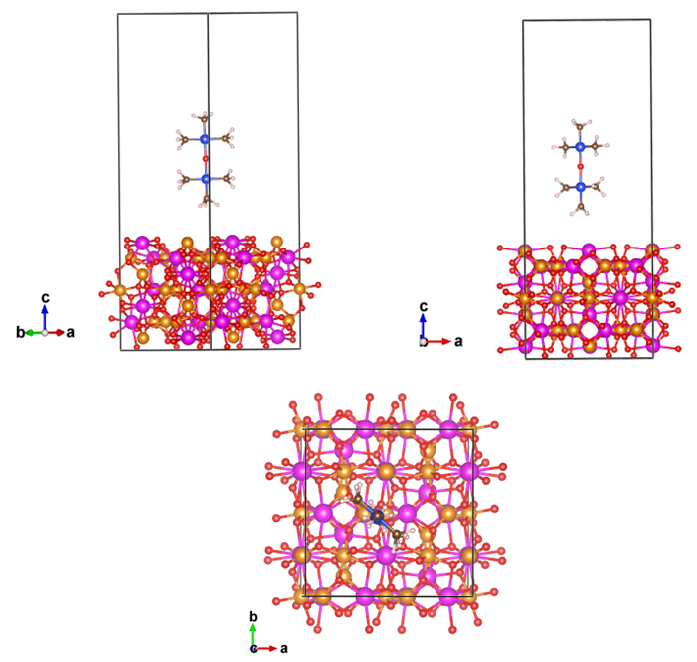

Figure S7-4. Initial state of Lu₃Al₅O₁₂/PDMS elastomer

E₁ = -1122.80316728 eV

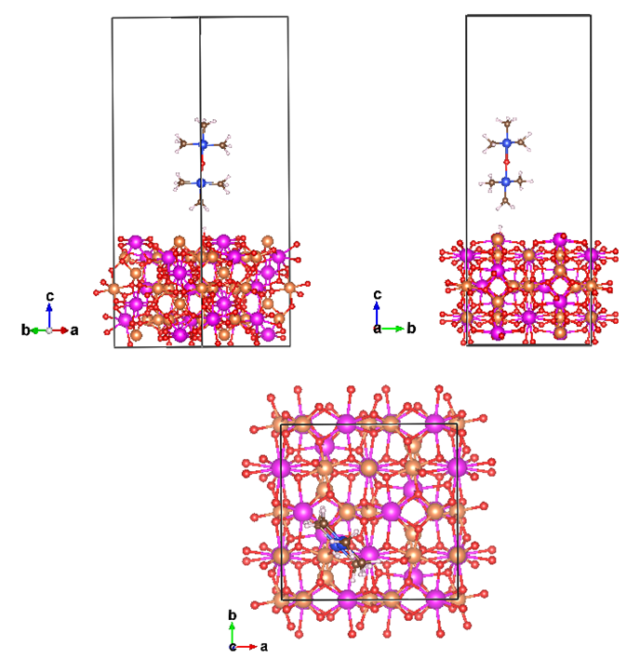

Figure S7-5. Contact state of Lu₃Al₅O₁₂/PDMS elastomer

E₂ = -1121.72060209 eV

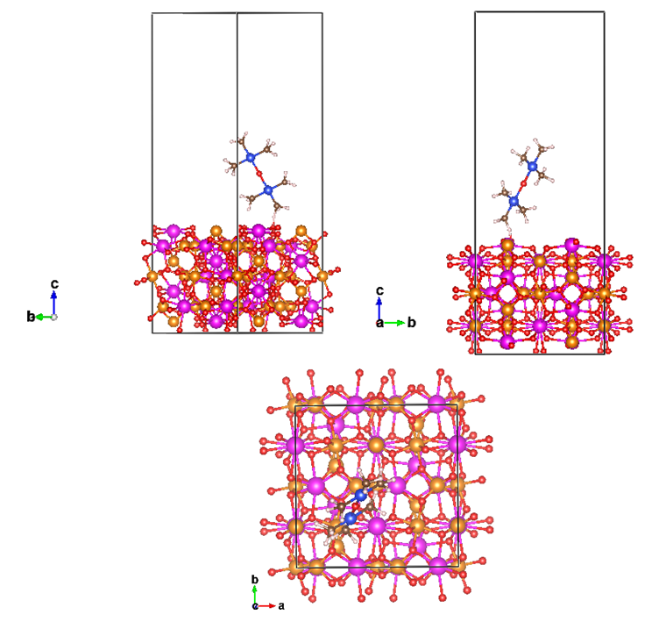

Figure S7-6. Separation state of Lu₃Al₅O₁₂/PDMS elastomer

E₃ = -1123.97150073 eV

Calculated to get:

ΔE₂₁ = E₂ – E₁ = -1121.72060209 - -1122.80316728 = 1.083 eV
ΔE₃₁ = E₃ – E₁ = -1123.97150073 - -1122.80316728 = -1.168 eV
ΔE₂₃ = E₂ – E₃ = -492.89820746 - -494.13918038 = 2.251 eV

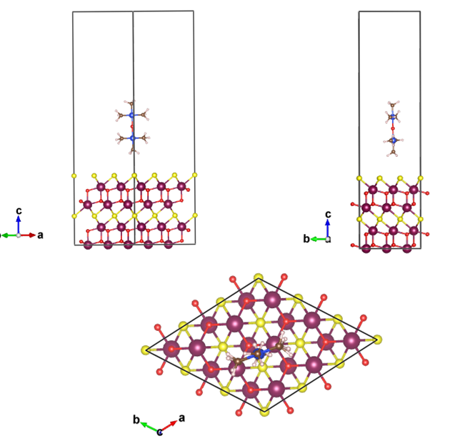

Figure S7-7. Initial state of Y₂O₂S/PDMS elastomer

E₁ = -860.42780451 eV

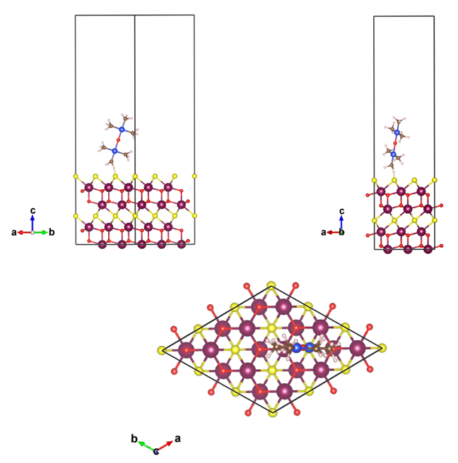

Figure S7-8. Contact state of Y₂O₂S/PDMS elastomer

E₂ = -858.92551482 eV

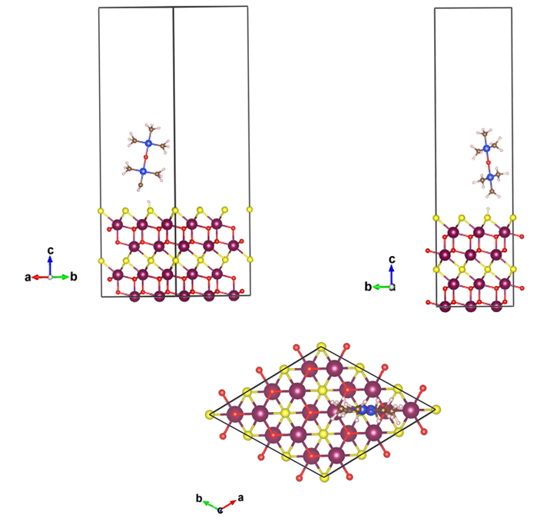
Figure S7-9. Separation state of Y₂O₂S/PDMS elastomer

E₃ = -861.16371424 eV

Calculated to get:
ΔE₂₁ = E₂ – E₁ = -858.92551482 - -860.42780451= 1.502 eV
ΔE₃₁ = E₃ – E₁ = -861.16371424 - -860.42780451 = -0.736 eV
ΔE₂₃ = E₂ – E₃ = -858.92551482 - -861.16371424 = 2.238 eV

Supplementary Note 8: Additional first-principles calculations
Calculation Method：First-principles calculations are performed by vienna ab initio simulation package (VASP)^{1–5}. The generalized gradient approximation(GGA) of Perdew-Burke-Ernzerhof (PBE) is used to describe the exchange-correlation functional. The cut-off energy for the plane wave basis is set to 400 eV and a 2×2×2 Monkhorst-pack mesh is employed. All the structures were fully relaxed (atomic position) up to 10-5 eV /Å force minimization and max force of 0.01 eV/ Å.
Molecular dynamics methodology: Each polymer chain consists of 14 DMS monomers arbitrarily cross-linked to represent a simplified photo-polymerization process. The choice of such a short chain with a consistent degree of polymerization is in accordance with many polymer composite models employed in MD simulations to improve computational efficiency whilst maintain essential polymer features such as contact resistance, glass transition behavior, and thermo-mechanical properties, etc.
And the nanorods were homogenously distributed in the resin matrix due to the periodic boundary conditions applied in the three dimensions.

Calculation parameters summary:
Cutoff energy: 400 eV
Electronic self-consistent convergence criterion: 10⁻⁵ eV/Å
Atomic relaxation convergence criterion: -0.01 eV/Å
K-point grid: 2×2×1
Functional: PAW-PBE

Figure S8-1. Structures used in calculations

a=4.485 nm, b=4.485 nm, c= 4.55 nm

Figure S8-2. CaF₂/PDMS composites with a mass ratios of 10.25%

a=4.773 nm, b=4.773 nm, c= 4.55 nm

Figure S8-3. CaF₂/PDMS composites with a mass ratios of 13.73%

a=4.972 nm, b=4.972 nm, c= 4.55 nm

Figure S8-4. CaF₂/PDMS composites with a mass ratios of 16.64%

a=5.462 nm, b=5.462 nm, c= 4.55 nm

Figure S8-5. CaF₂/PDMS composites with a mass ratios of 20.55%
a=6.342 nm, b=6.342 nm, c= 4.55 nm

Figure S8-6. CaF₂/PDMS composites with a mass ratios of 22.57%

a=7.154 nm, b=7.154 nm, c= 4.55 nm

Figure S8-7. CaF₂/PDMS composites with a mass ratios of 25.39%

Figure S8-8. Radius of gyration of CaF₂/PDMS composites dependent on mass ratios
Figure S8-9. Volumetric hydrogen bonds of CaF₂/PDMS composites
dependent on mass ratios
Figure S8-10. Volumetric binding energy of CaF₂/PDMS composites
dependent on mass ratios

Figure S8-11. Young’s modulus of CaF₂/PDMS composites dependent on mass ratios

Figure S8-12. Shear modulus of CaF₂/PDMS composites dependent on mass ratios

a=3.657 nm、b=3.657 nm、c= 4.55 nm

Figure S8-13. CaF₂/PDMS composites with a diameter of 1 nm

a=4.972 nm、b=4.972 nm、c= 4.55 nm

Figure S8-14. CaF₂/PDMS composites with a diameter of 1.5 nm
a=5.872 nm、b=5.872 nm、c= 4.55 nm

Figure S8-15. CaF₂/PDMS composites with a diameter of 2 nm

a=7.416 nm、b=7.416 nm、c= 4.55 nm

Figure S8-16. CaF₂/PDMS composites with a diameter of 2.5 nm
Figure S8-17. Radius of gyration of CaF₂/PDMS composites dependent on diameter
Figure S8-18. Volumetric hydrogen bonds of CaF₂/PDMS composites
dependent on diameter
Figure S8-19. Volumetric binding energy of CaF₂/PDMS composites
dependent on diameter
Figure S8-20. Young’s modulus of CaF₂/PDMS composites dependent on diameter
Figure S8-21. Shear modulus of CaF₂/PDMS composites dependent on diameter

a=5.462 nm、b=5.462 nm、c= 3.55 nm

Figure S8-22. CaF₂/PDMS composites with a length of 3 nm

a=5.462 nm、b=5.462 nm、c= 4.55 nm

Figure S8-23. CaF₂/PDMS composites with a length of 4 nm
a=5.462 nm、b=5.462 nm、c= 5.55 nm

Figure S8-23. CaF₂/PDMS composites with a length of 5 nm
a=5.462 nm、b=5.462 nm、c= 6.55 nm

Figure S8-24. CaF₂/PDMS composites with a length of 6 nm

Figure S8-25. Radius of gyration of CaF₂/PDMS composites dependent on length

Figure S8-26. Volumetric hydrogen bonds of CaF₂/PDMS composites
dependent on length
Figure S8-27. Volumetric binding energy of CaF₂/PDMS composites
dependent on length

Figure S8-28. Young’s modulus of CaF₂/PDMS composites dependent on length
Figure S8-29. Shear modulus of CaF₂/PDMS composites dependent on length

a=4.513 nm、b=4.513 nm、c= 4.55 nm

Figure S8-30. Lu₃Al₅O₁₂/PDMS composites with a mass ratios of 10.31%

a=4.773 nm, b=4.773 nm, c= 4.55 nm

Figure S8-31. Lu₃Al₅O₁₂/PDMS composites with a mass ratios of 13.78%

a=5.027 nm、b=5.027 nm、c= 4.55 nm

Figure S8-32. Lu₃Al₅O₁₂/PDMS composites with a mass ratios of 16.61%

a=5.496 nm、b=5.496 nm、c= 4.55 nm

Figure S8-33. Lu₃Al₅O₁₂/PDMS composites with a mass ratios of 20.57%
a=6.387 nm、b=6.387 nm、c= 4.55 nm

Figure S8-34. Lu₃Al₅O₁₂/PDMS composites with a mass ratios of 22.62%

a=7.208 nm、b=7.208 nm、c= 4.55 nm

Figure S8-35. Lu₃Al₅O₁₂/PDMS composites with a mass ratios of 25.43%

Figure S8-36. Radius of gyration of Lu₃Al₅O₁₂/PDMS composites
dependent on mass ratios

Figure S8-37. Volumetric hydrogen bonds of Lu₃Al₅O₁₂/PDMS composites
dependent on mass ratios
Figure S8-38. Volumetric binding energy of Lu₃Al₅O₁₂/PDMS composites
dependent on mass ratios
Figure S8-39. Young’s modulus of Lu₃Al₅O₁₂/PDMS composites
dependent on mass ratios
Figure S8-40. Shear modulus of Lu₃Al₅O₁₂/PDMS composites
dependent on mass ratios

a=3.692 nm、b=3.692 nm、c= 4.55 nm

Figure S8-41. Lu₃Al₅O₁₂/PDMS composites with a diameter of 1 nm

a=5.027 nm、b=5.027 nm、c= 4.55 nm

Figure S8-42. Lu₃Al₅O₁₂/PDMS composites with a diameter of 1.5 nm

a=5.916 nm、b=5.916 nm、c= 4.55 nm

Figure S8-43. Lu₃Al₅O₁₂/PDMS composites with a diameter of 2 nm

a=7.484 nm、b=7.484 nm、c= 4.55 nm

Figure S8-44. Lu₃Al₅O₁₂/PDMS composites with a diameter of 2.5 nm
Figure S8-45. Radius of gyration of Lu₃Al₅O₁₂/PDMS composites
dependent on diameter
Figure S8-46. Volumetric hydrogen bonds of Lu₃Al₅O₁₂/PDMS composites
dependent on diameter
Figure S8-47. Volumetric binding energy of Lu₃Al₅O₁₂/PDMS composites
dependent on diameter
Figure S8-48. Young’s modulus of Lu₃Al₅O₁₂/PDMS composites
dependent on diameter
Figure S8-49. Shear modulus of Lu₃Al₅O₁₂/PDMS composites dependent on diameter

a=5.496 nm、b=5.496 nm、c= 3.55 nm

Figure S8-50. Lu₃Al₅O₁₂/PDMS composites with a length of 3 nm

a=5.496 nm、b=5.496 nm、c= 4.55 nm

Figure S8-51. Lu₃Al₅O₁₂/PDMS composites with a length of 4 nm

a=5.496 nm、b=5.496 nm、c= 5.55 nm

Figure S8-52. Lu₃Al₅O₁₂/PDMS composites with a length of 5 nm
a=5.496 nm、b=5.496 nm、c= 6.55 nm

Figure S8-53. Lu₃Al₅O₁₂/PDMS composites with a length of 6 nm

Figure S8-54. Radius of gyration of Lu₃Al₅O₁₂/PDMS composites
dependent on length
Figure S8-55. Volumetric hydrogen bonds of Lu₃Al₅O₁₂/PDMS composites dependent on length
Figure S8-56. Volumetric binding energy of Lu₃Al₅O₁₂/PDMS composites
dependent on length
Figure S8-57. Young’s modulus of Lu₃Al₅O₁₂/PDMS composites dependent on length

Figure S8-58. Shear modulus of Lu₃Al₅O₁₂/PDMS composites dependent on length

Supplementary Note 9: Other factors affecting ML intensity

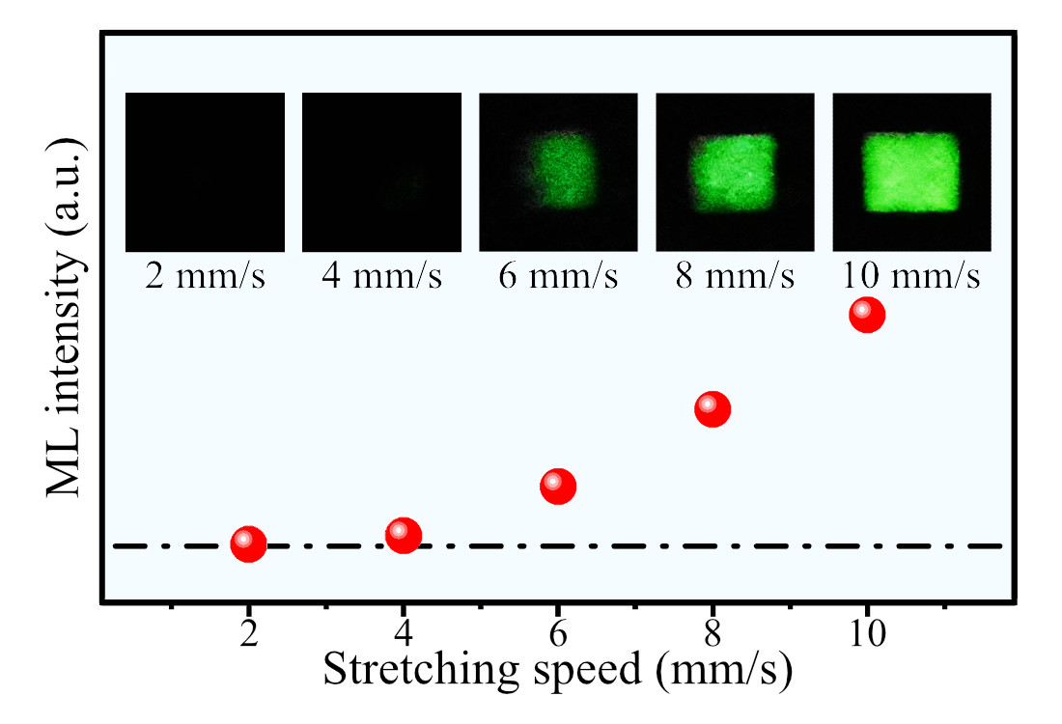
Figure S9-1. ML intensity of CaF₂:Tb³⁺/PDMS dependent on stretching speeds

The Figure S9-1 reveals a positive correlation between ML intensity and stretching speed, with greater ML intensity observed at higher stretching speeds. This can be attributed to the higher pulling force required for faster stretching speeds, which increases the probability of phosphor particles separation from the PDMS.
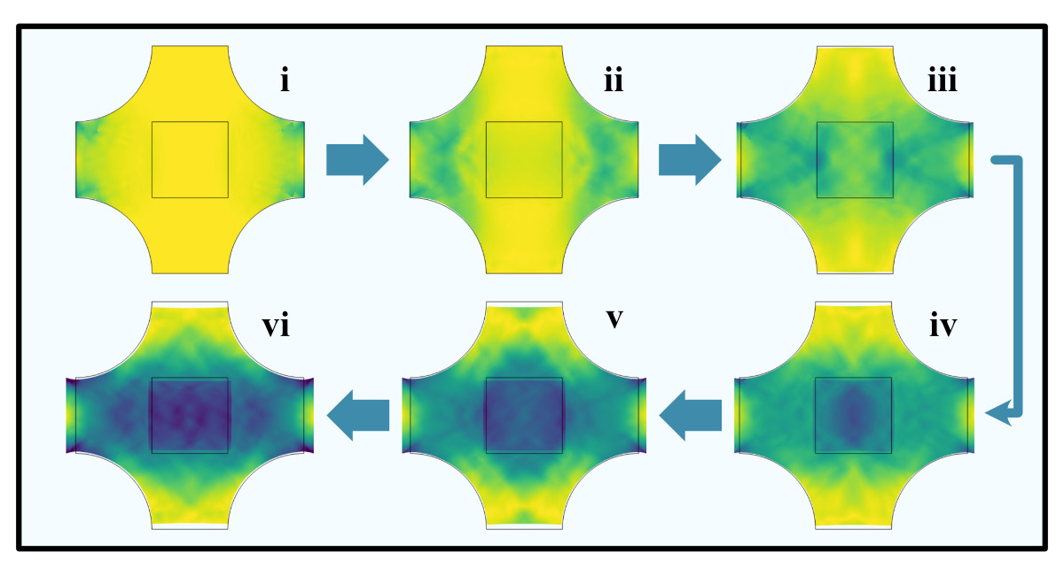
Figure S9-2. Transient stress distribution during stretching

Figure S9-2 displays the transient stress distribution of the sample during stretching, while Figure S9-3 depicts the stress curves of the composite center at various tensile speeds. The stress propagates in waves during stretching, and when the stretching speed is too slow (<6 mm/s), the stress is insufficient to excite ML, which agrees with the experimental findings.

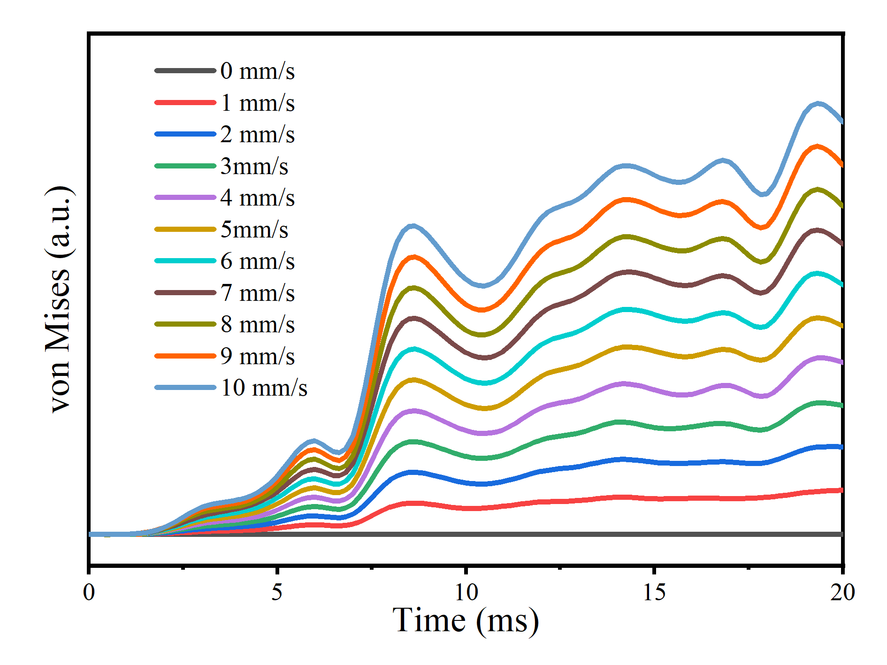
Figure S9-3. Stress curve at the center of the elastomer
dependent on stretching speeds

Figure S9-4. ML intensities of the elastomer dependent on temperature
Figure S9-5. ML intensities of the elastomer dependent on relative humidity.

References
1. Momma, K. & Izumi, F. VESTA 3 for three-dimensional visualization of crystal, volumetric and morphology data. Journal of applied crystallography 44, 1272–1276 (2011).
2. Wang, V., Xu, N., Liu, J.-C., Tang, G. & Geng, W.-T. VASPKIT: A user-friendly interface facilitating high-throughput computing and analysis using VASP code. Computer Physics Communications 267, 108033 (2021).
3. Perdew, J. P., Burke, K. & Ernzerhof, M. Generalized gradient approximation made simple. Physical review letters 77, 3865 (1996).
4. Kresse, G. & Joubert, D. From ultrasoft pseudopotentials to the projector augmented-wave method. Physical review b 59, 1758 (1999).
5. Kresse, G. & Furthmüller, J. Efficiency of ab-initio total energy calculations for metals and semiconductors using a plane-wave basis set. Computational materials science 6, 15–50 (1996).
6. https://github.com/makerbase-mks/MKS-GEN_L
7. https://github.com/MarlinFirmware/Marlin
8. Wang, W. et al. Contact electrification induced mechanoluminescence. Nano Energy 94, 106920 (2022).
9. Lin, F. et al. Modeling polyhedron distortion for mechanoluminescence in mixed-anion compounds RE₂O₂S: Ln³⁺. Chemistry of Materials 34, 5311–5319 (2022).
10. Huang, N.-J. et al. Efficient interfacial interaction for improving mechanical properties of polydimethylsiloxane nanocomposites filled with low content of graphene oxide nanoribbons. RSC advances 7, 22045–22053 (2017).

