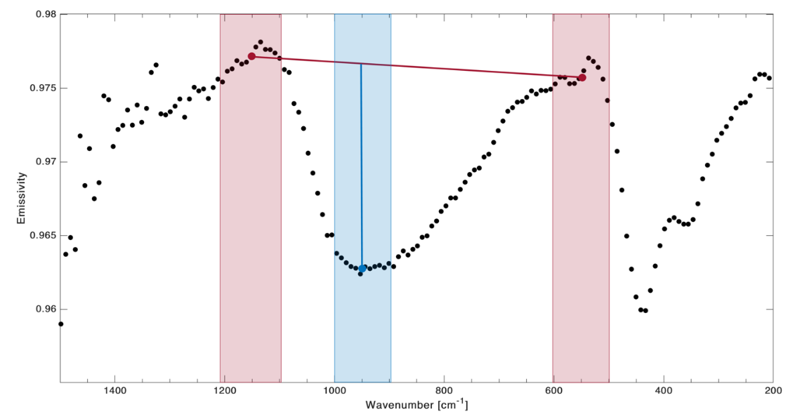
Extended Data Figure 1 Definition of spectral index for RB evaluation in OTES spectra. The index was defined as the difference between the mean value in the range 900–1000 cm-1 (blue band) and the mean value of the nearby continuum in the two ranges 500–600 cm-1 and 1100–1200 cm-1 (pink bands). Black dots are the global average spectrum of EQ2. The blue and red lines highlight the differences between the mean points used in the index evaluation.

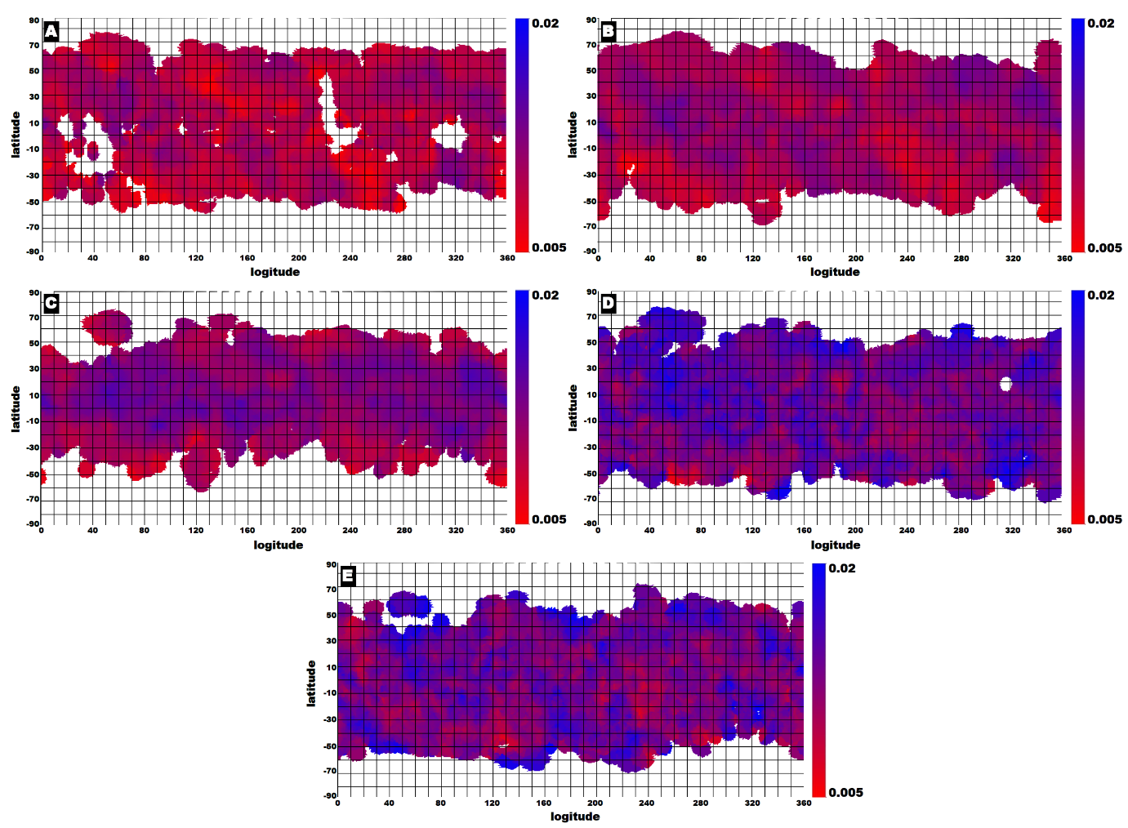
Extended Data Figure 2. Maps of RB intensities (color bar) across the surface of Bennu at different EQs: A, EQ4 (10:00 am); B, EQ3 (12:30 pm); C, EQ1 (3:00 pm); D, EQ6 (8:40 pm); and E, EQ2 (3:20 am). The RB intensities undergo changes as the surface moves from night (EQ2 and EQ6) to the hotter hours of the day (EQ1, EQ3, and EQ4).

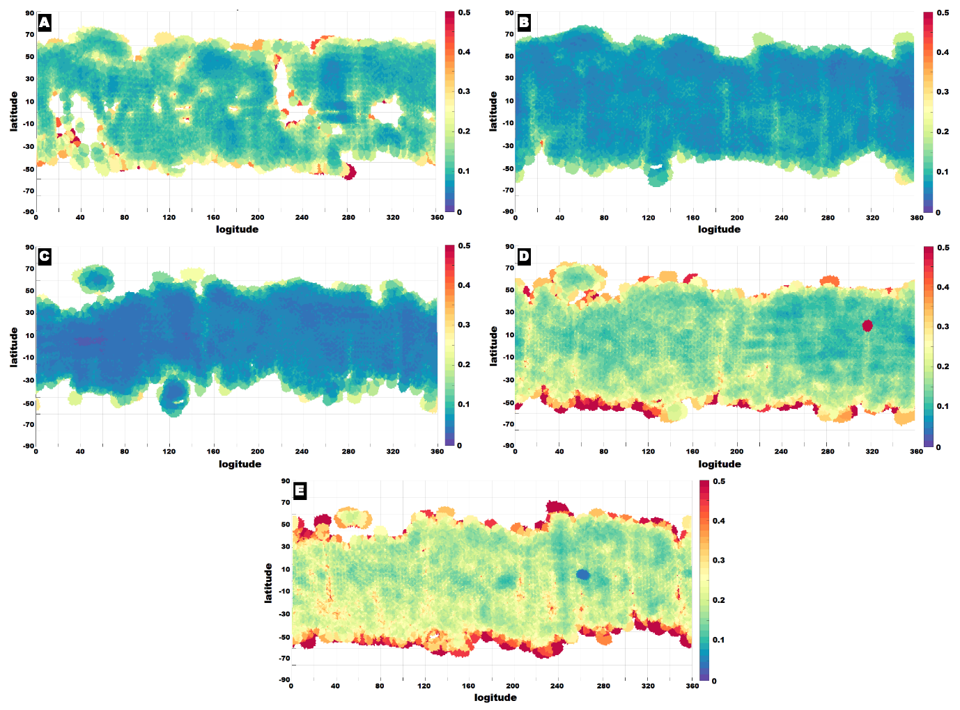
Extended Data Figure 3. RB intensity map errors added in quadrature and divided by the number of spots that cover the single shape model facet: A, EQ4 (10:00 am); B, EQ3 (12:30 pm); C, EQ1 (3:00 pm); D, EQ6 (8:40 pm); and E, EQ2 (3:20 am).

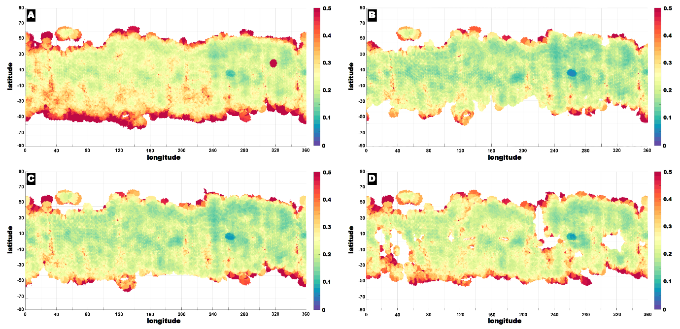
Extended Data Figure 4. RB intensity map errors added in quadrature and divided by the number of spots that cover the single shape model facet: A, EQ6 (8:40 pm) / EQ2 (3:20 am); B, EQ1 (3:00 pm) / EQ2 (3:20 am); C, EQ3 (12:30 pm) / EQ2 (3:20 am); and C, EQ4 (10:00 am) / EQ2 (3:20 am).

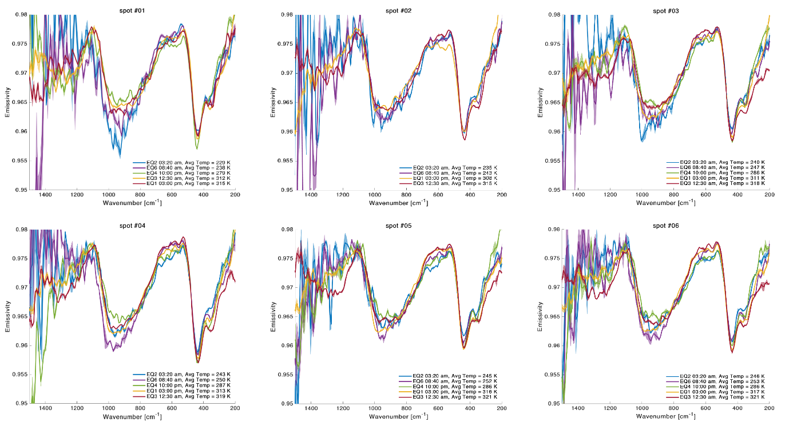
Extended Data Figure 5. EQ average spectra with error (shading) and average temperature (legend) in spot #01, #02, #03, #04, #05 and #06.
[table provided in separate file]

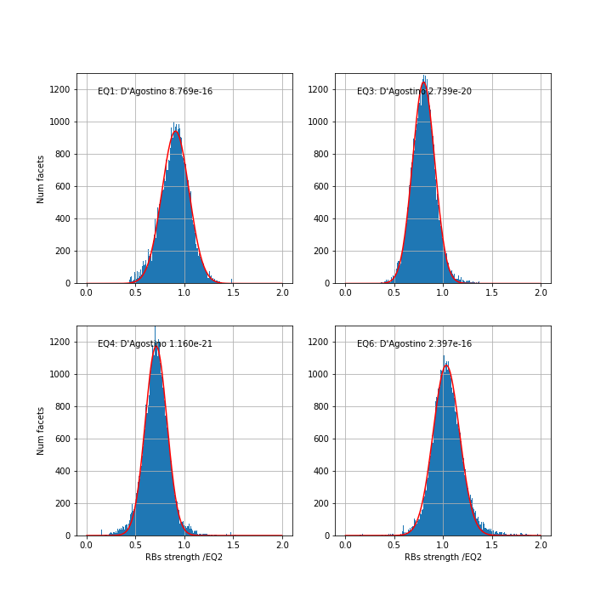

Extended Data Figure 6. Distributions of RB ratio for every facet for each of the EQs divided by EQ2 (blue data) and Phyton SciPy library best Gaussian fit for each distribution (red line).

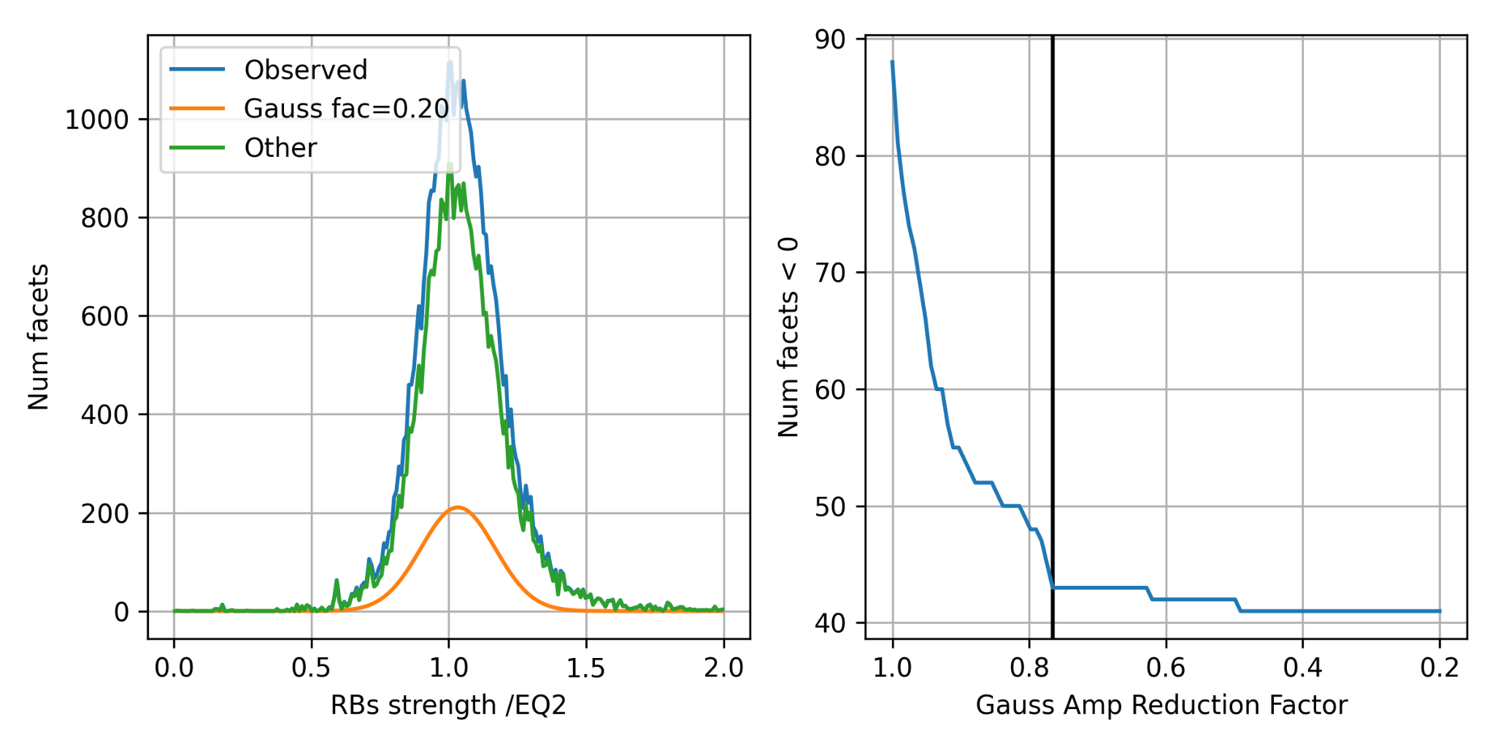

Extended Data Figure 7. Amplitude best fit using elbow analysis for RB ration EQ6/EQ2.

